What Is the Semantic Web 2

What Is the Ontology 2

The need for Ontology 2

RDF/S ve OWL Yapısı 2

OWL Levels and Logic 2

Semantic Web Applications 2

Developing a Semantic Web Application with a Sample Ontology 2

Inferencing 3

Good and Bad Modelling Practices 3

Notes 4

## What Is the Semantic Web

[1, 2]

### History of the Semantic Web

**{ [1]**

* Web was “invented” by Tim Berners-Lee (amongst others), a physicist working at CERN
* TBL’s original vision of the Web was much more ambitious than the reality of the existing (syntactic) Web:

“... a goal of the Web was that, if the interaction between person and hypertext could be so intuitive that the **machine-readable** information space gave an accurate representation of the state of people's thoughts, interactions, and work patterns, then **machine analysis** could become a very powerful management tool, seeing patterns in our work and facilitating our working together through the typical problems which beset the management of large organizations.”



* TBL (and others) have since been working towards realising this vision, which has become known as the Semantic Web
* E.g., article in May 2001 issue of Scientific American…

**}**

**{ [1,2]**

**Where we are Today: the *Syntactic* Web:**

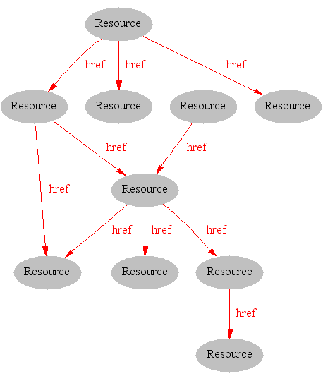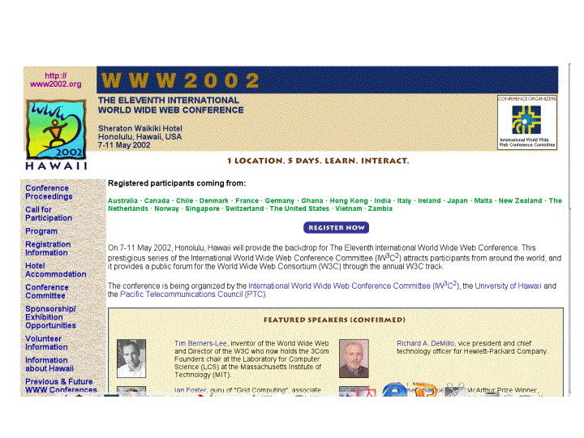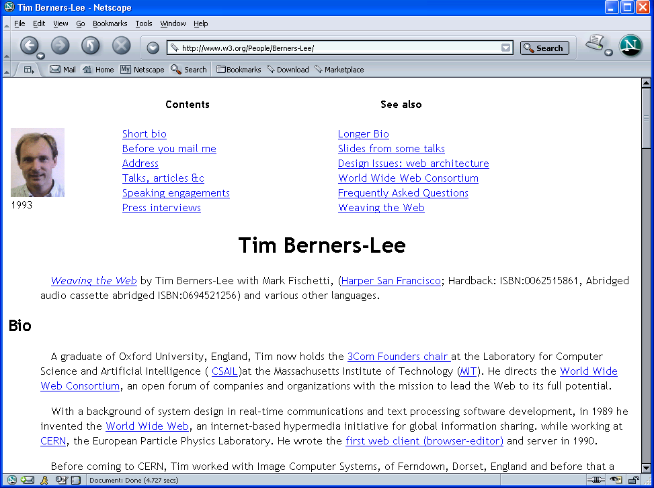

**}**

**{ [1]**

**The Syntactic Web is…**

**A place where computers do the presentation (easy) and people do the linking and interpreting (hard).**

* + **A hypermedia, a digital library**
    - **A library of documents called (web pages) interconnected by a hypermedia of links**
  + **A database, an application platform**
    - **A common portal to applications accessible through web pages, and presenting their results as web pages**
  + **A platform for multimedia**
    - **BBC Radio 4 anywhere in the world! Terminator 3 trailers!**
  + **A naming scheme**
    - **Unique identity for those documents**

**Why not get computers to do more of the hard work?**

**}**

**{ [1,2]**

**Hard Work using the *Syntactic* Web…**

* **Complex queries involving background knowledge**
  + **Find information about “animals that use sonar but are not either bats or dolphins”**
* **Locating information in data repositories**
  + **Travel enquiries**
  + **Prices of goods and services**
  + **Results of human genome experiments**
* **Finding and using “web services”**
  + **Visualise surface interactions between two proteins**
* **Delegating complex tasks to web “agents”**
  + **Book me a holiday next weekend somewhere warm, not too far away, and where they speak French or English**

**Almost impossible for machines and too hard for people without automation**

**}**

**{ [2]**

**Limitations of the Web today**



**Machine-to-human, not machine-to-machine**

**}**

sd

## What Is the Ontology

[2]

## The need for Ontology

search, taxonomies, knowledge maps vs ontology...

[4]

## RDF/S ve OWL Yapısı

[2]

{ Yöntem...

Ontolojideki property ve relation tipleri...

}

SWRL

Model vs. Data in ontology management

Ramifications of semantic web assumptions — open world and unique naming

## OWL Levels and Logic

[1]

{ OWL Dialects and Modelling Philosophy

OWL Full vs OWL DL

OWL Lite

Beyond OWL }

## Semantic Web Applications

[1] ... in the wild

[2]... anlamsal web uygulamaları

## Developing a Semantic Web Application with a Sample Ontology

Create Ontology, Query Ontology (by Protege & by Jena), Process Ontology Instances...

[1]: Ch4

{ RDF Parser,

RDF Store,

RDF Query (& Languages - SPARQL)

}

[2]: Bölüm 3.2

{

Protege’de ontolojinin oluşturulması

OWL’yi daha kolay yönetebilmek için yardımcı Java sınıflarının oluşturulması

Ontolojinin yönetilmesi ile ilgili servisler (sorgulama, yeni instance kaydı, vs...)

}

## Inferencing

[1]: Ch5 {

Asserted type vs Inferred Type

}

Inferencing vs Query

## Good and Bad Modelling Practices

[1]: Ch12

[3] ve google(ontology design patterns & best practices)

## Notes

To find some owl ontologies:

<http://www.google.com/search?q=filetype:owl+owl>

Swoogle (<http://swoogle.umbc.edu/>)

Protege owl trunk: <http://smi-protege.stanford.edu/svn/owl/trunk/?rev=1171>

Protege Ontology Library: <http://protegewiki.stanford.edu/index.php/Protege_Ontology_Library>

introProtege.ppt dokumanı güzel...

~~~~~~~~~

~~~~~~~~~

[1] D:\My Documents\SemanticWebWorkshop\kaynak\Ian Horrocks - CS646\intro-2004.ppt

[2] D:\My Documents\SemanticWebWorkshop\kaynak\VaganTerziyan-SW Course\SW_Tutorial_2004_Part_1.ppt

[1]: Semantic Web for the Working Ontologist,2008

[2]: TEZ

[3]: <http://irfgc.irri.org/pantheon/index.php?option=com_content&task=view&id=425&Itemid=263>

[4]: The Semantic Web Real World Applications from Industry,2007