Residential Grid-Connected PV + Battery System: Net Metering vs. Net Billing Techno-Economic Analysis

Saif Elsaady
^{Arizona State University}
School of Electrical, Computer, and Energy Engineering
EEE 591 Topic: Photovoltaic Energy Conversion
^{Prepared for Dr. Rolston}
Abstract— This study presents a comprehensive techno-economic analysis of a 5 kW residential photovoltaic system with 14 kWh battery storage under two utility billing policies: net metering and net billing. Using hourly simulation over 8760 hours with time-of-use electricity rates from Salt River Project, the analysis evaluates annual electricity costs, net present value, levelized cost of energy, and simple payback period. The baseline residential annual electricity consumption of 14,382.8 kWh results in a $1,832.55 utility bill without solar. The PV system generates 9,000 kWh annually at 20.5% capacity factor with battery dispatch optimizing self-consumption. Net metering reduces the annual bill to $892.78 with a 15.1-year payback, while net billing yields $920.72 annual cost with a 15.6-year payback. Both policies produce negative net present values of -$7,572 and -$8,059, respectively, over 25 years at 3% discount rate, with an identical levelized cost of energy at $0.0956/kWh. Sensitivity analysis reveals battery cost variations of ±25% shift the net present value by approximately ±$3,160. The results demonstrate that while both policies provide substantial annual savings of approximately $920-$940, the high initial investment of $14,200 prevents economic viability under current Arizona rate structures. Net metering offers marginally superior economics due to higher export compensation, reducing annual costs by $27.94 compared to net billing.

- Introduction
Residential photovoltaic systems with energy storage depend critically on utility billing policies for economic viability. Two predominant models exist: net metering, where exported electricity receives retail rate credit, and net billing, where exports receive lower wholesale-based compensation. This analysis examines a 5 kW grid-connected residential PV system with 14 kWh lithium-ion battery storage. The battery is included to perform energy arbitrage against the Salt River Project's time-of-use (TOU) rates, which feature significant price premiums during on-peak hours (up to 24.09 cents/kWh). By storing excess solar energy generated midday and discharging it during these expensive peak periods, the battery aims to maximize self-consumption. The 14 kWh capacity was selected as it represents a common, commercially available unit (e.g., a Tesla Powerwall, as specified in the project guidelines) and provides sufficient capacity to offset a typical summer evening's peak load. The critical trade-off involves balancing the $14,200 capital investment against electricity bill savings over 25 years. Arizona provides an ideal case study with excellent solar resources and well-defined time-of-use rates spanning 6.91 to 24.09 cents per kWh across three seasonal periods, plus $32.44 monthly service charge. The baseline residential load of 14,382.8 kWh annually establishes the savings benchmark. Net billing uses a 2.81 cents/kWh wholesale buy-back rate from Salt River Project tariffs. This study addresses three questions: (1) What are the annual costs and savings under each policy? (2) How do policies compare in net present value, levelized cost of energy, and payback period? (3) How sensitive are results to battery cost variations? The analysis employs standard financial engineering methods, including net present value discounting, annualized cost factors, and geometric series for operation and maintenance growth.

- Methodology
- System Specifications and Rate Structure
The system includes 5 kW (5,000 W) PV capacity at 20% efficiency, a 14 kWh battery at 48 V, with 95% inverter efficiency and 97% wiring efficiency. Hourly load data spans 8,760 hours with 14,382.8 kWh annual consumption. As shown in Figure 1, this load is highly seasonal, with consumption peaking in the summer months of July and August (over 1,600 kWh/month) due to air conditioning demands. Winter and shoulder months have a significantly lower baseline load (approx. 800-1,200 kWh/month). This seasonal variation is a critical driver for the system's economic performance. Time arrays (day, hour, month) employ absorbed construction methodology with weekend identification starting Monday.
Salt River Project rates define three seasons:
- Season 1 (winter: months 1-4, 11-12) at 6.91/9.51 cents/kWh off-peak/on-peak during hours 5-8, 17-20;
- Season 2 (shoulder: months 5-6, 9-10) at 7.27/20.94 cents/kWh with weekday peak hours 14-19;
- Season 3 (summer: months 7-8) at 7.30/24.09 cents/kWh with weekday peak hours 14-19.
The monthly charge is $32.44. Net billing export rate is 2.81 cents/kWh constant.
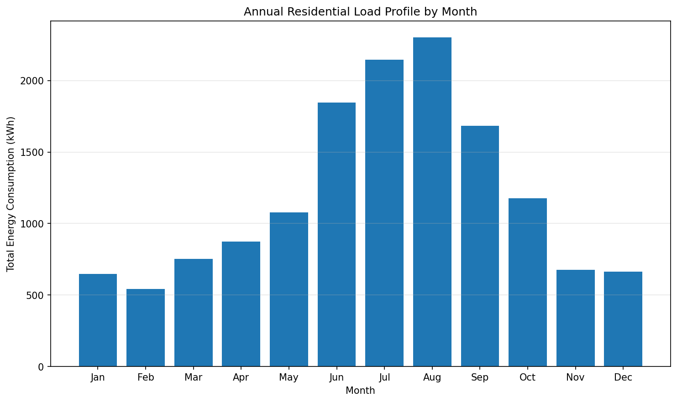
Figure 1. Annual residential load profile, showing total monthly electricity consumption (kWh). The load peaks significantly during the summer season (July-August).
- Energy Modeling and Financial Analysis
PV generation uses sinusoidal diurnal patterns during hours 6-20, scaled to 9,000 kWh annually (20.5% capacity factor). Battery dispatch optimizes self-consumption with 95% charge/discharge efficiency between 10-100% state-of-charge. Excess PV charges the battery then exports; deficits discharge the battery then import from the grid, producing hourly import (load_unmet) and export (PV_unused) values.
Annual costs are $389.28 in fixed charges plus the total cost from 8,760 hours of operation, calculated by summing the hourly cost of unmet load (0.01 times the hourly rate) and subtracting the revenue from unused PV (0.01 times the buy-back rate). For net metering, the buy-back rate equals the retail rate; for net billing, the buy-back rate is 2.81 cents/kWh. The financial analysis uses a Net Present Value formula to discount future values and a capital recovery formula to find the annualized cost, A. A specific financial formula (geometric series NPV) is used to find the total present value of the 0.5% O&M costs, which are assumed to grow 3.5% annually. The $14,200 initial investment consists of $10,000 for PV ($2/W) and $4,200 for the battery, based on $300/kWh for a 14 kWh, 48V system using a 1000 conversion. Battery replacements are scheduled based on an assumed 7-year life, occurring in years 7, 14, and 21. The analysis uses a 25-year period and a 3% discount rate. LCOE is found by dividing the annualized cost by the annual load. Sensitivity tests are performed for battery costs of $225, $300, and $375 per kWh.

- Results and Discussion
- Energy Balance and System Performance
The PV system generates 9,000 kWh annually, meeting 62.6% of the load before storage. Battery dispatch reduces grid imports to 6,043.17 kWh and limits exports to 369.69 kWh (4.1% of generation), demonstrating effective self-consumption optimization.
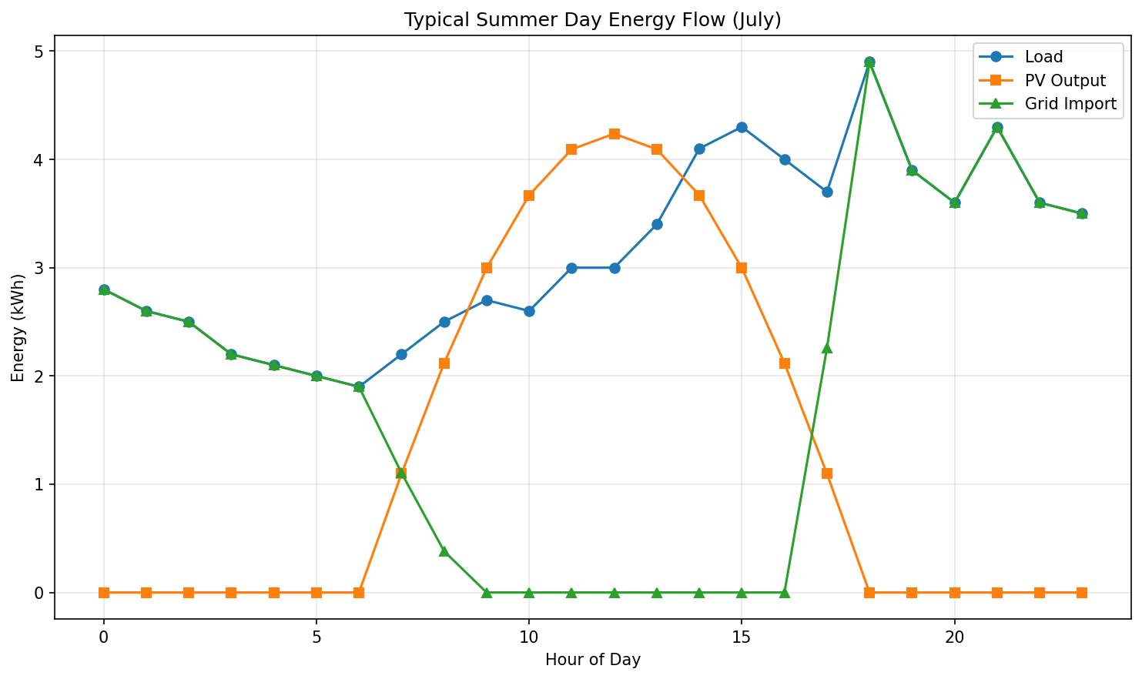

Figure 2. Hourly energy flows on a typical summer weekday (July). PV peaks at 1.2 kWh midday during moderate load, creating a battery charging opportunity. Evening peaks require PV plus battery discharge with minimal grid imports during expensive on-peak hours (24.09 cents/kWh, hours 14-19).
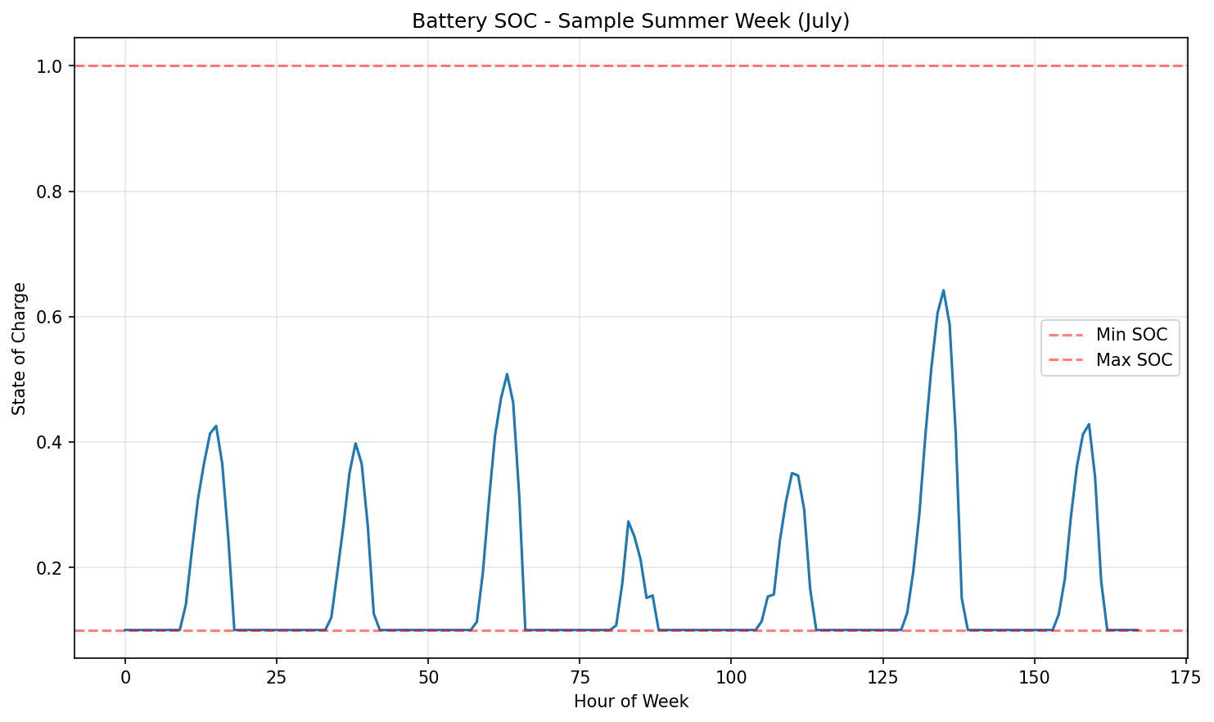
Figure 3. Battery SOC over a sample summer week (July). Daily cycles are pronounced, with the battery charging to 100% from midday PV and discharging to its 10% minimum to meet high evening loads.
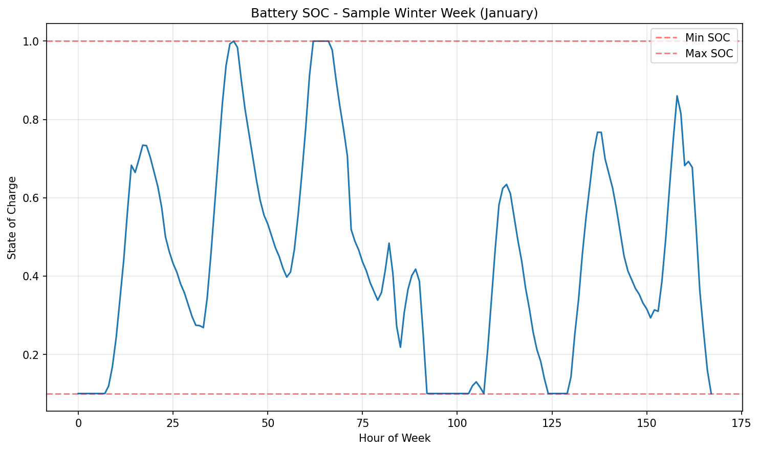
Figure 4. Battery SOC over a sample winter week (January). Battery cycling is minimal. Lower solar generation and different load patterns mean the battery rarely charges and is not needed for evening peak loads, often remaining near its minimum SOC.
- Economic Comparison
Baseline bill without solar totals $1,832.55 annually. Net metering reduces this 51.3% to $892.78 ($389.28 fixed + $503.50 usage), providing $939.76 annual savings with full retail export credit. Net billing yields $920.72 ($389.28 fixed + $531.44 usage) with $911.82 savings, trailing by $27.94 annually due to lower export compensation (2.81 vs. ~15-20 cents/kWh average). This difference compounds to $480+ present value over 25 years.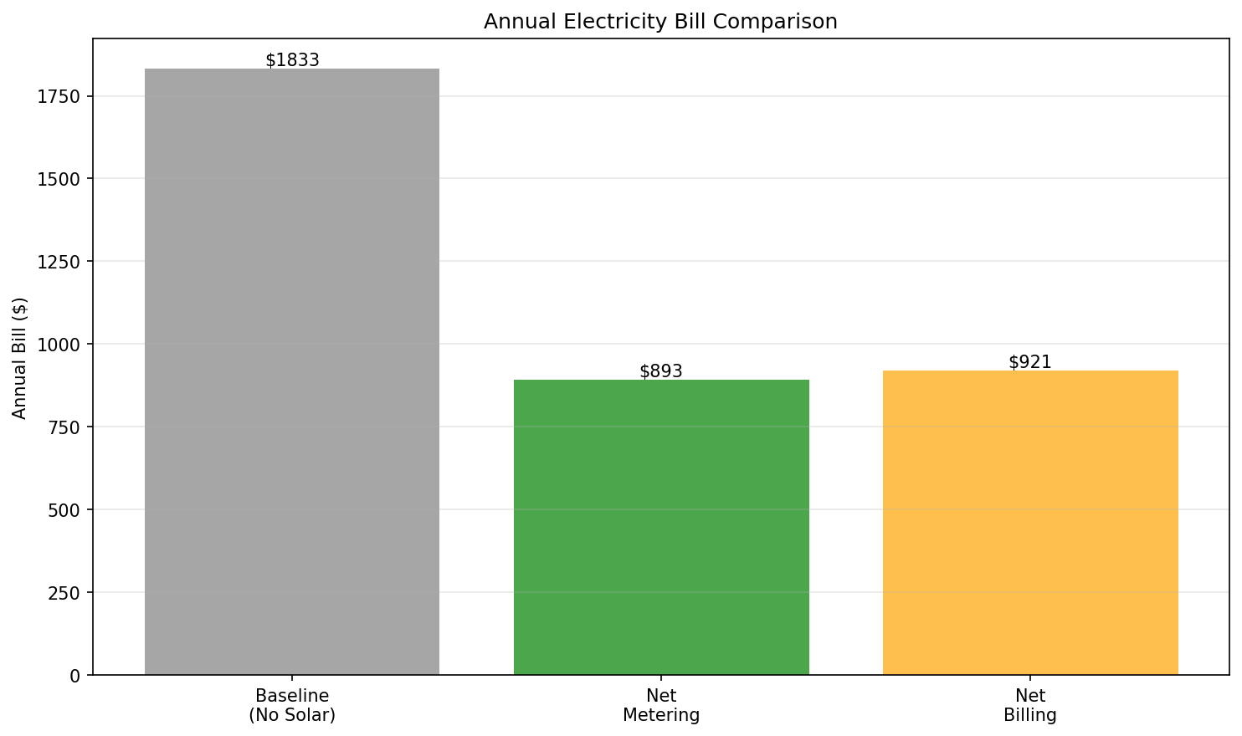
Figure 5. Annual bills: baseline $1,833, net metering $893, net billing $921. Both solar policies achieve substantial reductions, with net metering providing marginally greater savings.
- Long-Term Financial Performance
Total system NPV reaches $24,892 (net metering) to $25,378 (net billing), including battery replacements and O&M. The 25-year savings stream produces present values of only $17,320 and $16,834, yielding negative net NPVs of -$7,572 and -$8,059.
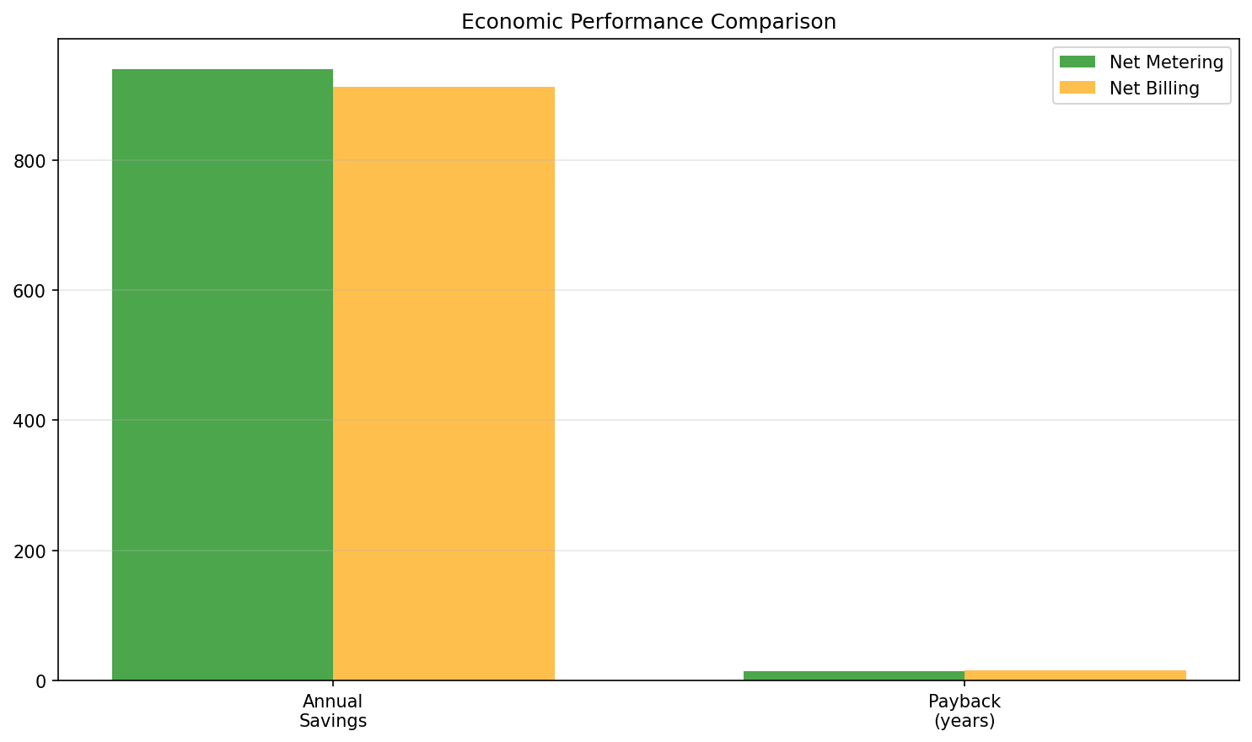
Figure 6. Net metering: $940 annual savings, 15.1-year payback. Net billing: $912 annual savings, 15.6-year payback. Both exceed typical investment horizons.
Simple payback of 15.1/15.6 years exceeds typical horizons. LCOE equals $0.0956/kWh for both (annualized $1,375 / 14,382.8 kWh), competitive with on-peak summer rates ($0.24/kWh) but exceeding average rates. Battery costs, based on a 7-year replacement schedule, represent the majority of the system's lifetime cost, with a total present value of $12,633 ($4,200 initial plus $8,433 for three replacements), yet limited incremental value is shown by modest 370 kWh annual exports.

- Sensitivity Analysis

Battery Cost ($/kWh) | NM Annual Savings ($) | NM Payback (yr) | NM Net NPV ($) | NB Annual Savings ($) | NB Payback (yr) | NB Net NPV ($)
225 | 939.76 | 14.0 | -4,409.79 | 911.82 | 14.4 | -4,896.35
300 | 939.76 | 15.1 | -7,572.13 | 911.82 | 15.6 | -8,058.69
375 | 939.76 | 16.2 | -10,734.48 | 911.82 | 16.7 | -11,221.04
Table 1. NPV sensitivity to battery cost (3% discount rate). Net metering consistently outperforms net billing by $487. Each $75/kWh change produces $3,162 NPV change.
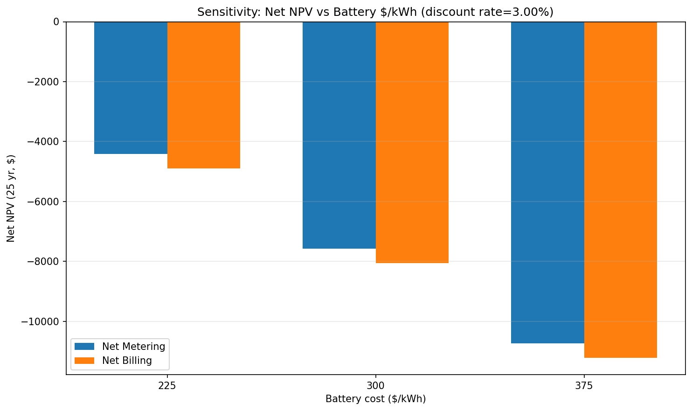
Figure 7. Linear NPV response to battery cost showing a consistent $487 policy differential. Both remain negative even at $225/kWh, requiring costs below $150/kWh (net metering) or $100/kWh (net billing) for positive NPV.

- Conclusion
This analysis quantifies residential PV-plus-storage financial performance under net metering and net billing through hourly simulation and rigorous financial modeling. The 5 kW PV with 14 kWh battery achieves 49-51% bill reductions but produces negative returns under current Arizona conditions.
Net metering yields $892.78 annual cost, 15.1-year payback, -$7,572 NPV through full retail export credit. Net billing imposes $27.94 annual penalty (2.81 vs. 15-20 cents/kWh export), yielding $920.72 cost, 15.6-year payback, and -$8,059 NPV. Both produce $0.0956/kWh LCOE. The $487 lifetime NPV advantage of net metering represents the difference between challenging and infeasible investment returns.
Battery storage, with a total present value cost of $12,633, is the dominant financial burden on the system. The sensitivity analysis confirms this: while a 25% battery cost reduction improves the NPV by $3,162, the return remains negative. Extrapolating this linear trend, net metering viability (NPV > 0) would require battery costs to fall below $150/kWh.
A positive NPV could be achieved through several pathways not modeled in this baseline. First, a system re-design using a smaller, more optimized battery (e.g., 7-10 kWh) could yield a better return by targeting only the highest-cost peak hours, reducing the initial investment. Second, this analysis omits external factors like government incentives (e.g., a 30% Federal Investment Tax Credit), which would directly reduce the $14,200 initial cost and significantly improve the payback period. Finally, this model assumes flat utility rates; any future escalation in electricity prices would increase the annual savings, making the system's lifetime value much greater.
Policy implications suggest net metering remains essential for residential solar economics in moderate-rate markets. Utilities considering net billing transitions should recognize substantial adoption impacts. Homeowners face 15+ year payback requiring careful motivation evaluation, systems provide 50% bill reduction and partial independence, but purely financial returns require lower component costs or higher electricity rates. Future work should model these pathways—specifically optimized battery sizing, the inclusion of incentives, and utility rate escalation—to identify a definitive path to positive financial returns for homeowners

References
- Arizona State University, "EEE 465/591: Photovoltaic Energy Conversion - Course Materials," Canvas Learning Management System, Course ID: 232274, School of Electrical, Computer and Energy Engineering, 2022.
- Arizona State University, "Final Project EEE 465/591," Canvas course materials, EEE 465/591: Photovoltaic Energy Conversion, School of Electrical, Computer and Energy Engineering, 2022.
- Arizona State University, "Final Project Grading Guidelines," Canvas course materials, EEE 465/591: Photovoltaic Energy Conversion, School of Electrical, Computer and Energy Engineering, Spring 2022.
- Arizona State University, "Section 4-2 PV System Components - Power Conditioning and Balance of System," Canvas course materials, EEE 465/591: Photovoltaic Energy Conversion, School of Electrical, Computer and Energy Engineering, 2022.
- Arizona State University, "Week 9: PV Modules," Canvas lecture materials, EEE 465/591: Photovoltaic Energy Conversion, School of Electrical, Computer and Energy Engineering, October 28, 2022.
- Arizona State University, "Code snippet for financial functions," Canvas course materials, Python implementation of NPV, annualization, and geometric series calculations, EEE 465/591: Photovoltaic Energy Conversion, 2022.
- Arizona State University, "Code snippet for electricity rate and cost calculations," Canvas course materials, Python implementation of time-of-use rate structures and billing calculations, EEE 465/591: Photovoltaic Energy Conversion, 2022.
- Arizona State University, "Code snippet for arrays for day number, hour of day, and month," Canvas course materials, Python implementation of temporal array construction, EEE 465/591: Photovoltaic Energy Conversion, 2022.
- Arizona State University, "Residential load data (load_data.csv)," Canvas course materials, Hourly electricity consumption data (8,760 hours), EEE 465/591: Photovoltaic Energy Conversion, 2022.
- Arizona State University, "Photovoltaic generation profile (pv_profile.csv)," Canvas course materials, Hourly PV output data (8,760 hours) for 5 kW residential system, EEE 465/591: Photovoltaic Energy Conversion, 2022.
- Salt River Project, "Residential Solar Pricing Plans," SRP Customer Generation Price Plan Rate Structure, Available: https://www.srpnet.com/menu/electricres/solarpriceplans.aspx, Accessed 2022.

