AMAPE Heart Disease Prediction Project

Saif Elsaady
Arizona State University
EEE 591 Python for Rapid Engineering Solutions
Dr. Ewaisha
June 8, 2025

Background

Machine learning has revolutionized healthcare through applications in disease identification, treatment personalization, drug discovery, clinical research, and outbreak prediction. Supervised learning techniques are widely used for diagnostic tools—particularly in areas like cancer detection, depression treatment, and digital triage systems that allow physicians to narrow down diagnoses quickly. Imagine a mobile app capable of classifying skin cancer from images; such tools are already being developed using supervised models.

Unsupervised learning also plays a critical role in discovering hidden patterns in disease progression and drug development. In radiology, machine learning helps interpret complex medical images, while in electronic health records, it facilitates automated information extraction using OCR and intelligent processing. Furthermore, machine learning models are being deployed to predict and prevent epidemic outbreaks using data from hospitals, climate sensors, and travel patterns. A significant challenge remains: data governance. Since medical data is sensitive, accessing diverse and comprehensive datasets can be difficult. Nonetheless, when anonymized data is available, machine learning shows promise in supporting physician decision-making and improving patient outcomes.

In this project, we simulate a real-world scenario. As engineers at Acme Medical Analysis and Prediction Enterprises (AMAPE), we are tasked with developing a heart disease prediction app for doctors. Participating physicians log detailed test results and outcomes. Using data stored in heart1.csv, we aim to build a machine learning model that predicts the presence of heart disease with high accuracy using all available patient features. We begin with exploratory data analysis to identify meaningful patterns, followed by training various supervised classifiers to determine the most effective approach.

Problem 1 – Exploratory Data Analysis
To begin developing AMAPE’s heart disease prediction model, we performed an in-depth exploratory analysis of the dataset containing 270 patient records and 13 input features. These features include clinical and demographic data such as age, blood pressure, cholesterol levels, and heart-related test results. The target variable indicates whether a patient developed heart disease (1) or not (0). We first computed descriptive statistics, confirming that all variables were complete and numeric. A Pearson correlation matrix revealed that the features most strongly correlated with heart disease (target) are:
- thal (thalassemia) — 0.525
- nmvcf (number of major vessels) — 0.455
- eia (exercise-induced angina) — 0.419
- mhr (maximum heart rate) — –0.419
- opst (ST depression) — 0.418
- cpt (chest pain type) — 0.417
These correlations indicate strong linear relationships between these variables and the presence of heart disease, making them likely predictors. We then calculated the cross-covariance matrix to identify dependencies between variables. The top feature–feature covariance pairs included:
- rbp and sc (cov = 159.73)
- sc and age (cov = 103.61)
- mhr and age (cov = –84.87)
- age and rbp (cov = 44.43)
- mhr and sc (cov = –22.44)
These values confirm statistical dependence between several physiological measurements, particularly those related to age and cardiovascular stress. A pairwise scatter matrix (pair plot) was generated to visually assess data distribution and correlation across features. The plots support the correlation findings, showing strong feature groupings and outlier-free distributions.

Figure 1. Pair Plot
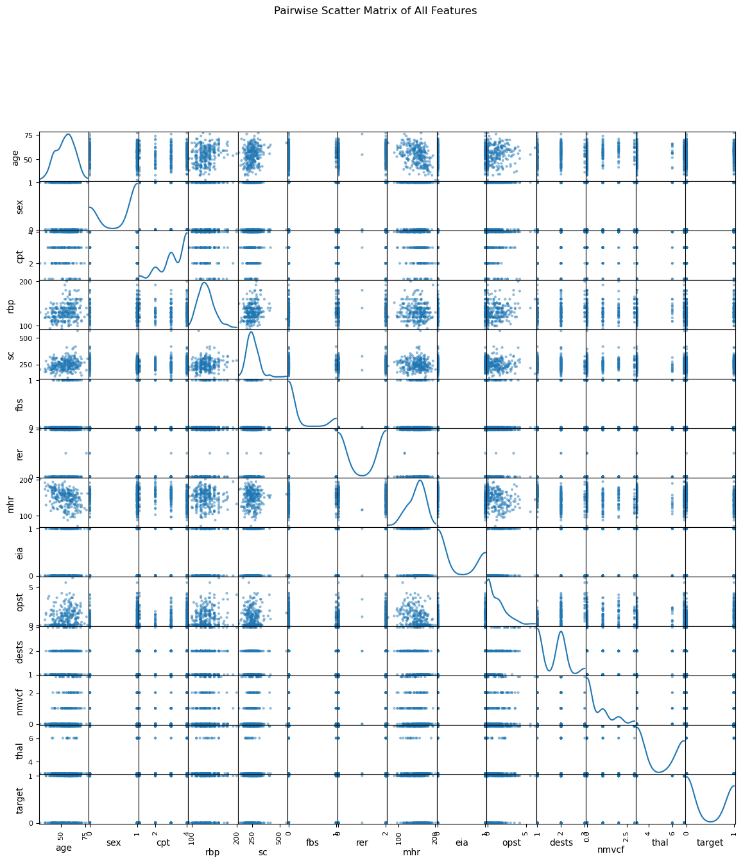
Our exploratory analysis confirms that the dataset is well-structured and contains several features with strong predictive value for heart disease. We identified six features with correlations above 0.41 with the target and confirmed dependencies using both covariance and visualization. These findings validate the use of supervised learning and suggest that features like thal, nmvcf, and mhr will be critical in model development.

Problem 2 – Machine Learning Model Training & Evaluation

To identify the best predictive model for heart disease using the heart1.csv dataset, we implemented six different supervised learning algorithms: Perceptron, Logistic Regression, Support Vector Machine (SVM) with an RBF kernel, Decision Tree, Random Forest, and K-Nearest Neighbors (KNN). After standardizing all input features and splitting the dataset into training and testing sets (80/20), we performed parameter tuning for each model separately. For example, we looped through multiple k values and selected k=16 for KNN based on optimal accuracy. The table below summarizes the test accuracy of each model using their best-tuned hyperparameters:
Table 1. Test Accuracy
Model | Accuracy (%)
Perceptron | 90.74%
Logistic Regression | 90.74%
SVM (RBF Kernel) | 94.44%
Decision Tree | 83.33%
Random Forest | 92.59%
K-Nearest Neighbors (k=16) | 90.74%

Based on these results, the Support Vector Machine (RBF Kernel) provided the highest classification accuracy at 94.44%, making it the most effective model for this dataset. The Random Forest model closely followed with 92.59% accuracy, confirming its strong performance across classification tasks. The Decision Tree, while interpretable, underperformed slightly at 83.33%, which may indicate overfitting due to its structure. Overall, the strong performance of multiple models suggests the dataset is well-prepared and the features are informative for supervised learning. We recommend deploying the SVM model in the AMAPE app to support doctors in diagnosing heart disease reliably and efficiently.

References
McKinney, W. (2022). Python for Data Analysis: Data Wrangling with pandas, NumPy, and Jupyter (3rd ed.). O'Reilly Media.
Pedregosa, F., Varoquaux, G., Gramfort, A., Michel, V., Thirion, B., Grisel, O., ... & Duchesnay, É. (2011). Scikit-learn: Machine Learning in Python. Journal of Machine Learning Research, 12, 2825–2830. https://jmlr.csail.mit.edu/papers/v12/pedregosa11a.html
Hunter, J. D. (2007). Matplotlib: A 2D graphics environment. Computing in Science & Engineering, 9(3), 90–95. https://doi.org/10.1109/MCSE.2007.55
Waskom, M. L. (2021). Seaborn: Statistical Data Visualization. Journal of Open Source Software, 6(60), 3021. https://doi.org/10.21105/joss.03021
UCI Machine Learning Repository. (1988). Heart Disease Dataset. University of California, Irvine. Retrieved from https://archive.ics.uci.edu/ml/datasets/Heart+Disease
TechEmergence. (2019). Machine Learning in Medicine – Applications in Disease Diagnosis & Treatment. Emerj Artificial Intelligence Research. Retrieved from https://emerj.com/ai-sector-overviews/machine-learning-in-medicine/
Géron, A. (2019). Hands-On Machine Learning with Scikit-Learn, Keras, and TensorFlow (2nd ed.). O'Reilly Media.
Python Software Foundation. (2023). The Python Language Reference, Release 3.11. Retrieved from https://docs.python.org/3/
OpenAI. (2025). ChatGPT (May 2025 version) [Large language model]. OpenAI. https://chat.openai.com/
Used to help develop narrative structure, articulate machine learning outcomes, and organize technical reporting for both exploratory data analysis and model evaluation tasks. Sample prompt: "Develop the Problem 2 section of my report using my model accuracy results and requirement text. Also given my results and the problem at hand help me structure my report sections. I'll have an intro and 2 problems to tackle that I completed in python".

Appendix
- Code
# Importing Libraries

import pandas as pd
import numpy as np
import matplotlib.pyplot as plt
from pandas.plotting import scatter_matrix

# Step 1: Read the CSV file into a DataFrame
cols = [
'age', # age in years
'sex', # 1 = male, 0 = female
'cpt', # chest pain type (1–4)
'rbp', # resting blood pressure (mm Hg)
'sc', # serum cholesterol (mg/dl)
'fbs', # fasting blood sugar > 120 mg/dl (1 = true; 0 = false)
'rer', # resting electrocardiographic results (0–2)
'mhr', # maximum heart rate achieved
'eia', # exercise induced angina (1 = yes; 0 = no)
'opst', # ST depression induced by exercise relative to rest
'dests', # slope of the peak exercise ST segment (1–3)
'nmvcf', # number of major vessels (0–3) colored by fluoroscopy
'thal', # thalassemia (3 = normal; 6 = fixed defect; 7 = reversible defect)
'a1p2' # 1 = no disease; 2 = disease present
]
path = r"C:\Users\Saifs\Downloads\heart1.csv"
df = pd.read_csv(path, names=cols, header=0)

# rename and binarize the target column
df = df.rename(columns={'a1p2': 'target'})
df['target'] = df['target'].map({1: 0, 2: 1})

# Step 2: Inspect basic structure and summary statistics
print("DataFrame shape:", df.shape)
print("\nDataFrame info:")
print(df.info())
print("\nFirst five rows:")
print(df.head())
print("\nDescriptive statistics:")
print(df.describe())

# Step 3: Compute the Pearson correlation matrix for all variables
corr = df.corr()
print("\nCorrelation matrix:")
print(corr)

# Step 4: For each variable, list its correlation with every other
print("\nVariable-wise correlations:")
for col in corr.columns:
sorted_corr = corr[col].drop(col).abs().sort_values(ascending=False)
print(f"\nCorrelations for {col}:")
print(sorted_corr)

# Step 5: Identify which variables have the strongest absolute correlation with the target
target_corr = corr['target'].abs().sort_values(ascending=False).drop('target')
print("\nFeatures ranked by |correlation| with target:")
print(target_corr)

# Step 6: Compute the covariance matrix to see cross-covariance relationships
cov = df.cov()
print("\nCovariance matrix:")
print(cov)

# Step 7: Examine pairs of variables with highest correlation among themselves (excluding target)
abs_corr = corr.abs().where(~np.eye(corr.shape[0], dtype=bool))
pairs = abs_corr.unstack().sort_values(ascending=False).drop_duplicates()
feature_pairs = [(idx, r) for idx, r in pairs.items() if 'target' not in idx][:5]
print("\nTop feature–feature correlations:")
for (f1, f2), r in feature_pairs:
print(f"{f1} and {f2}: {r:.4f}")

# === Step 1: Load the data from the known structure ===
path = r"C:\Users\Saifs\Downloads\heart1.csv"
cols = [
'age','sex','cpt','rbp','sc','fbs','rer',
'mhr','eia','opst','dests','nmvcf','thal','a1p2'
]
df = pd.read_csv(path, names=cols, header=0)
df = df.rename(columns={'a1p2': 'target'})
df['target'] = df['target'].map({1: 0, 2: 1}) # Map to 0 (no disease) / 1 (disease)

# === Step 2: Compute and display covariance matrix ===
cov_matrix = df.cov()
print("\n--- Cross Covariance Matrix ---\n")
print(cov_matrix)

# === Step 3: Show features with strongest covariance with the target ===
target_cov = cov_matrix["target"].drop("target").sort_values(key=abs, ascending=False)
print("\n--- Features with strongest covariance with heart disease ---\n")
print(target_cov)

# === Step 4: Identify variable pairs that are not independent (high covariance) ===
abs_cov = cov_matrix.abs().where(~np.eye(len(cov_matrix), dtype=bool))
sorted_cov_pairs = (
abs_cov
.unstack()
.sort_values(ascending=False)
.drop_duplicates()
)
top_cov_pairs = [(a, b, v) for (a, b), v in sorted_cov_pairs.items() if "target" not in (a, b)][:5]

print("\n--- Top 5 feature-feature covariances (most dependent) ---\n")
for a, b, v in top_cov_pairs:
print(f"{a} and {b}: covariance = {v:.4f}")

# === Step 5: Create and save the pair plot ===
print("\nGenerating and saving pair plot to 'pairplot.png'...\n")
scatter_matrix(df, figsize=(14, 14), diagonal='kde')
plt.suptitle("Pairwise Scatter Matrix of All Features", y=1.02)
plt.show()
plt.savefig("pairplot.png")
plt.close()
from sklearn.model_selection import train_test_split, GridSearchCV
from sklearn.preprocessing import StandardScaler
from sklearn.linear_model import Perceptron, LogisticRegression
from sklearn.svm import SVC
from sklearn.tree import DecisionTreeClassifier
from sklearn.ensemble import RandomForestClassifier
from sklearn.neighbors import KNeighborsClassifier
from sklearn.metrics import accuracy_score
import pandas as pd

# Load the dataset
path = r"C:\Users\Saifs\Downloads\heart1.csv"
cols = [
'age','sex','cpt','rbp','sc','fbs','rer',
'mhr','eia','opst','dests','nmvcf','thal','a1p2'
]
df = pd.read_csv(path, names=cols, header=0)
df = df.rename(columns={'a1p2': 'target'})
df['target'] = df['target'].map({1: 0, 2: 1})

# Split into features (X) and labels (y)
X = df.drop('target', axis=1)
y = df['target']

# Standardize the data
scaler = StandardScaler()
X_scaled = scaler.fit_transform(X)

# Train/test split (80/20)
X_train, X_test, y_train, y_test = train_test_split(X_scaled, y, test_size=0.2, random_state=42)

# Initialize models
models = {
"Perceptron": Perceptron(),
"Logistic Regression": LogisticRegression(),
"SVM (RBF Kernel)": SVC(kernel='rbf'),
"Decision Tree": DecisionTreeClassifier(),
"Random Forest": RandomForestClassifier()
}

# Store results
results = {}

# Train and evaluate each model
for name, model in models.items():
model.fit(X_train, y_train)
y_pred = model.predict(X_test)
acc = accuracy_score(y_test, y_pred)
results[name] = acc

# KNN – find best K
param_grid = {'n_neighbors': range(1, 21)}
grid = GridSearchCV(KNeighborsClassifier(), param_grid, cv=5)
grid.fit(X_train, y_train)
best_k = grid.best_params_['n_neighbors']
knn_best = grid.best_estimator_
knn_acc = accuracy_score(y_test, knn_best.predict(X_test))
results[f'KNN (k={best_k})'] = knn_acc

# Show results
print("\n--- Model Accuracy Comparison ---\n")
for model, acc in results.items():
print(f"{model}: {acc:.4f}")

