EGR-330
Design of Electrical Systems
Laboratory 1.17
Week 1
Thursday January 12, 2023
Due Thursday January 19, 2023
Names: Saif Elsaady, Abriana Poola, Ean Potter, Mason LaRosa, Jaden Nahoi-Baricar

In this Laboratory you will Construct and Demonstrate the Operation of Optocoupler Design Networks, Refer to Datasheets, and Multisim Models,

- Construct and Demonstrate Active High, Active Low Network, Please Refer to Provided Multisim Model, Include Network Images of Circuit

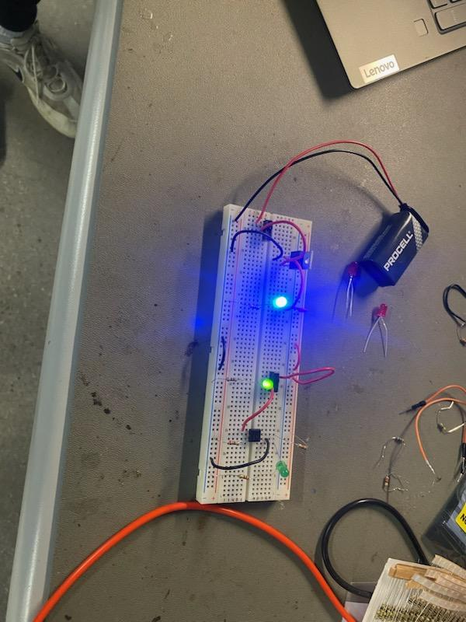
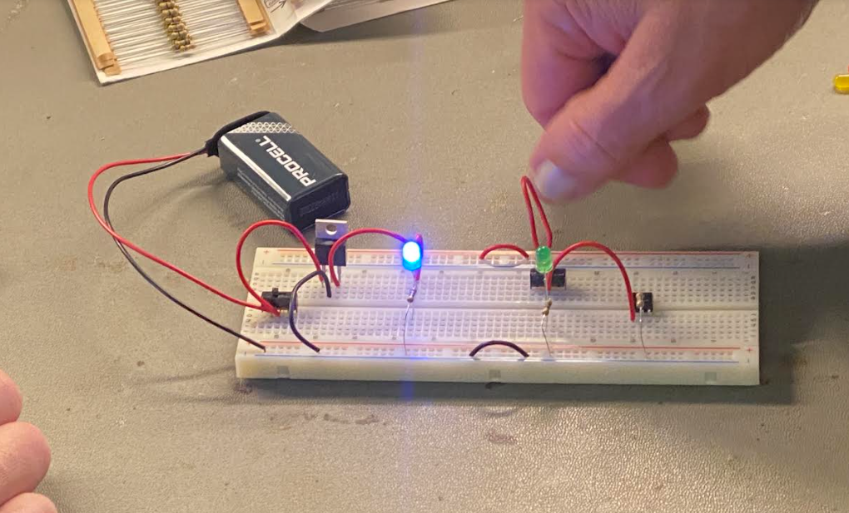
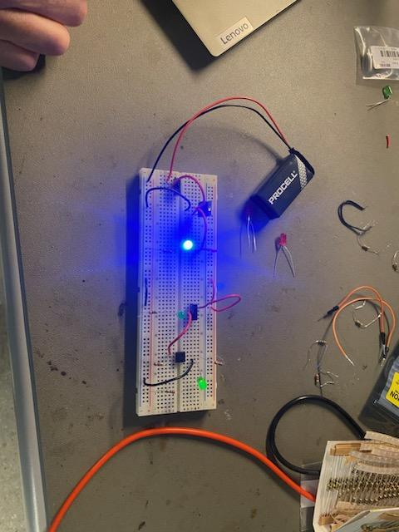
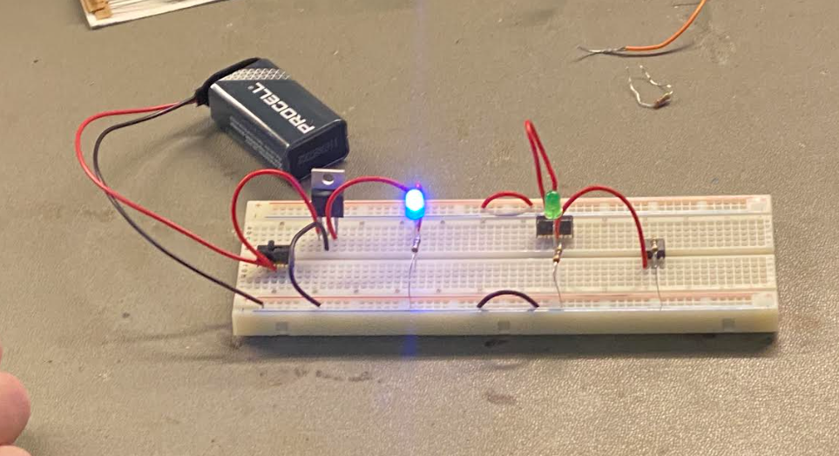

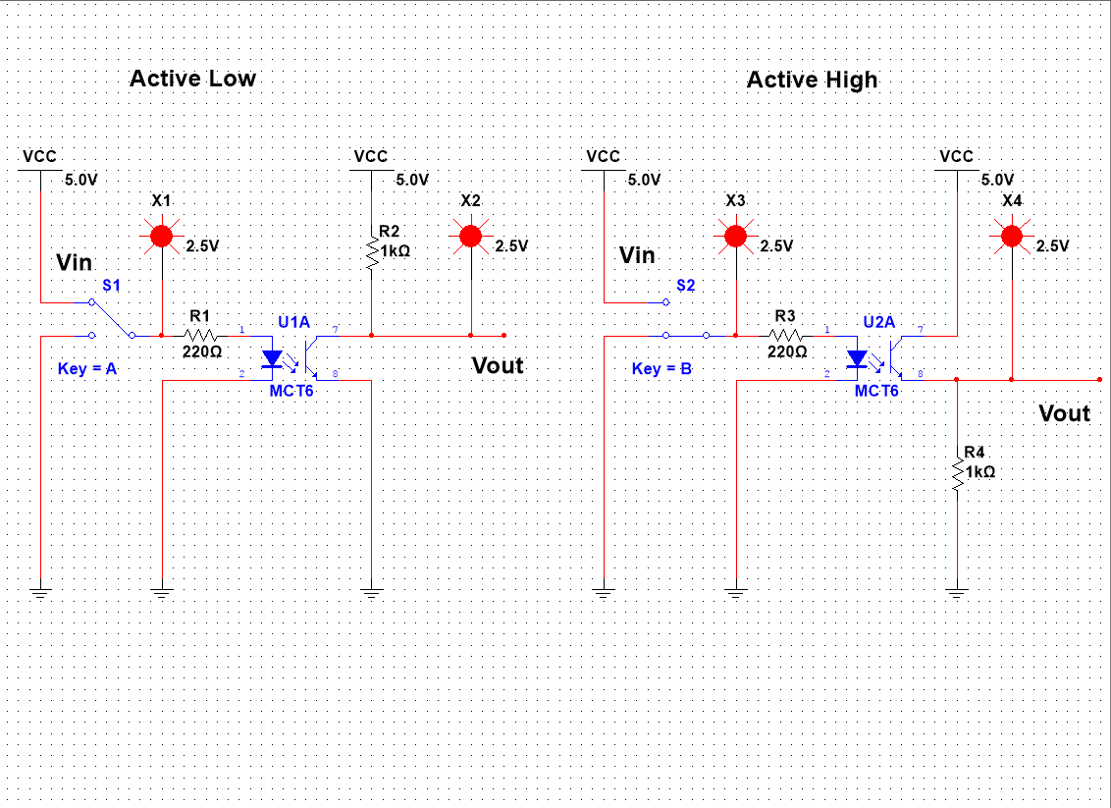

- Demonstrate Above Active High, Active Low Network Created in Part 1) Implementing a Square Waveform from Analog Discovery Board, Maintain Low Frequency, and Limited amplitude, (To Create a TTL Square Waveform, Waveform will Need to be Offset on Analog Discovery Board), Include Images from Input Channel, and Output Channel on Analog Discovery Board Screen)

- Construct and Demonstrate Optocoupler Sinewave Network, Please Refer to Provided Multisim Model, Include Network Images of Circuit

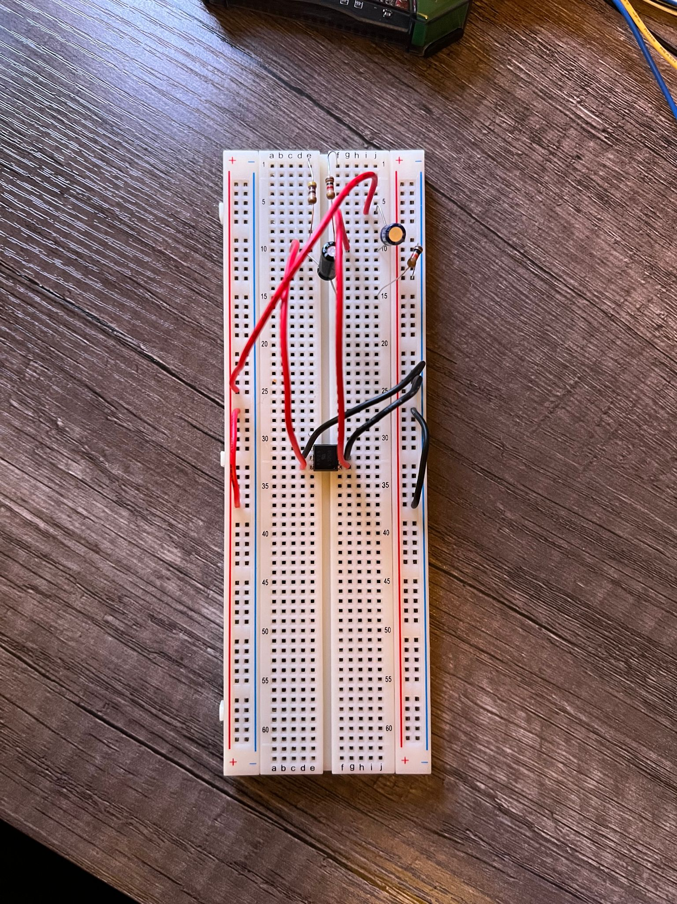
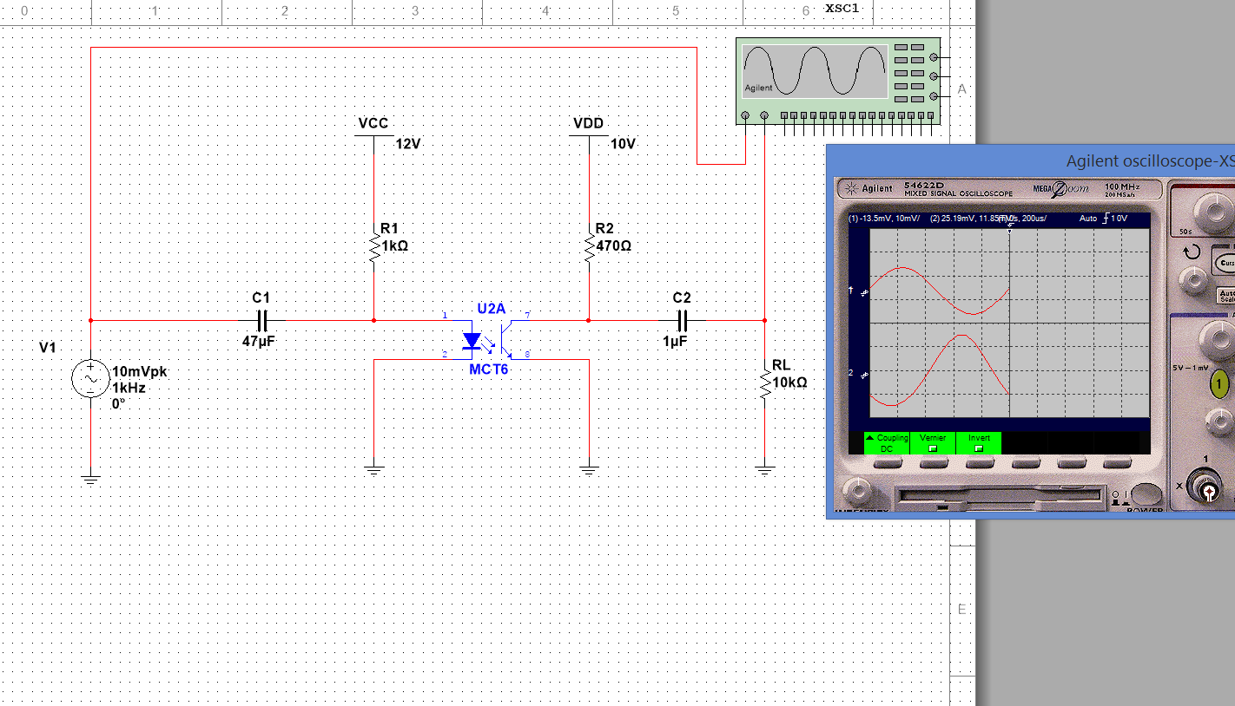

- Demonstrate Above Optocoupler Sinewave Network Created in Part 3) Implementing a Sinewave Waveform from Analog Discovery Board, Maintain Low Frequency, and Limited amplitude,, Include Images from Input Channel, and Output Channel on Analog Discovery Board Screen)

