EGR-338

Microcontrollers in Smart Systems

LABORATORY 3.19
Week 6
Wednesday February 14, 2024
Due Wednesday February 28, 2024
Names:
Scott Lidman
Kevis Seymore
Elton Salt
Marla Hawthorne
Saif Elsaady

UART SPI I2C
Serial Communication
Universal Asynchronous Receive Transmit
Serial Peripheral Interface
Inter-Integrated Circuit

Goals

The goal of this laboratory is to communicate via UART Serial Communication Universal Asynchronous Receive Transmit between Project Teams, SPI and I2C. That is, One Project Team will Program the PIC16F917 Transmitter TX and another Project Team will Program the PIC16F887 Receiver RX Microcontroller and Demonstrate, using each Project Teams respective PICKit3’s on the TX and RX ends.

Active Low Switches will be pushed at the PIC16F917 Transmitter TX and Received and thus indicated by the LED’s at the PIC16F887 RX.

The following C-Code is provided below:

- Laboratory 8.8 Week 12 True & Correct UART Master PIC16F917 C-Code
- Laboratory 8.8 Week 12 True & Correct UART Slave PIC16F887 C-Code
- uart.h

Note: You will need to add the Header File uart.h using the following method:

- Add to Header Files
  - Add Existing Item …. uart.h

Note: As you have progressed in study of Microcontrollers, you might need to edit the provided C-Code so that the System will operate as desired.

This is your responsibility.

Instructor Sign Off:

- Demonstrate UART Serial Communication Between PIC16F917 and PIC16F887:
Scope Reading from TX to RX
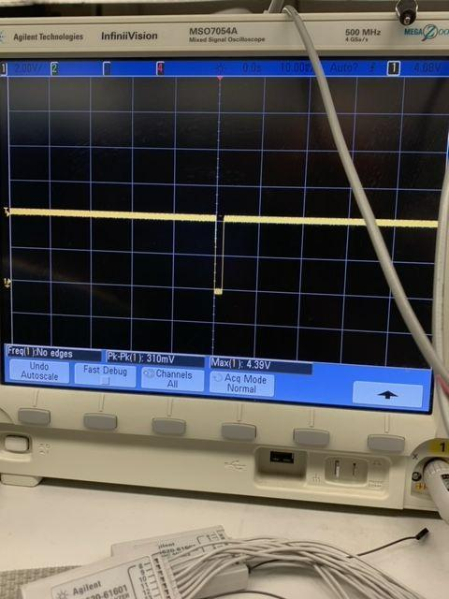

- Demonstrate SPI Serial Peripheral Interface Communication Between PIC16F917 and PIC16F887:
SPI scope and breadboard layout: (We connected the SCK’s, SS’s, and SI to SO, and SO to SI.)
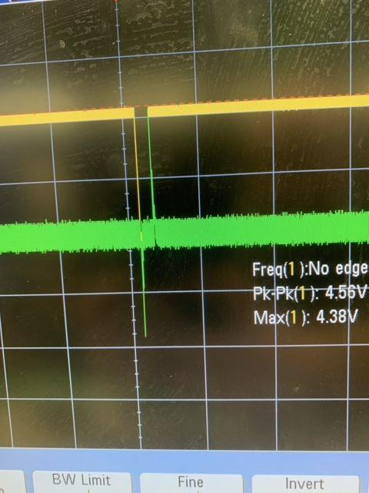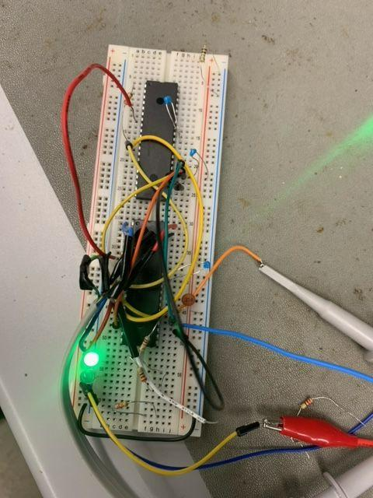

- Demonstrate I2C Inter-Integrated Circuit Communication Between PIC16F917 and PIC16F887:
I2C scope and breadboard layout: (We connected the I2C CLK’s and I2C Data’s.)
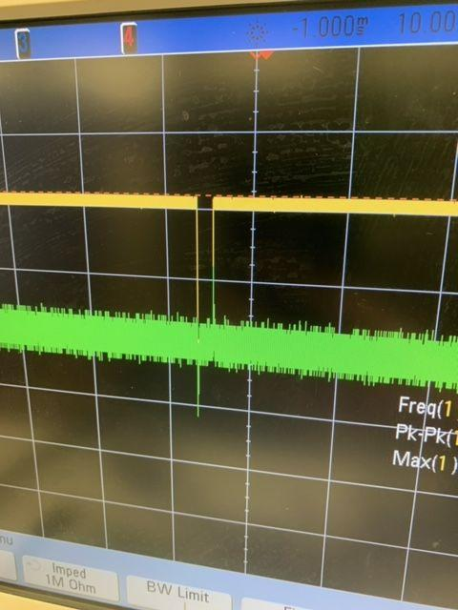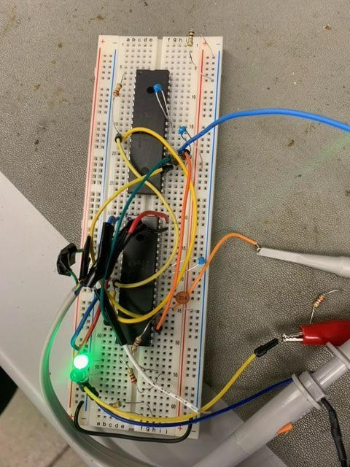

- Provide Oscilloscope Images of each Communication Protocol Between PIC16F917 and PIC16F887:
TX to RX:


SPI:

I2C:


