EGR-338

Microcontrollers in Smart Systems

LABORATORY 4/19
Week 11
Monday March 18, 2024
Due Monday April 1, 2024

Names:
Scott Lidman
Kevis Seymore
Elton Salt
Marla Hawthorne
Saif Elsaady

Digital Potentiometer Maxim DS1804-100
&
555 Timer Astable Multivibrator

Goals

The goal of this lab is to familiarize you with using digital devices to change circuit characteristics, such as Programmable Gain Control. You will be using the Maxim DS1804-100 Digital Potentiometer to verify a voltage output to a VOM with the internal IC Potentiometer as a voltage divider by changing the resistance (Increase and Decrease) with push button switches on the Mechatronics Board.

The second part of this lab is to utilize and apply the Maxim DS1804-100 Digital Potentiometer with the 555 Timer to develop a Programmable Square Wave Oscillator as seen in the below schematic. You will need to calculate and select your own component values for R1, R2 and C to design a circuit that will provide a range of desired frequencies. The circuit will then be demonstrated on the Oscilloscope with the designs full range of frequencies. This of course requires a complete overhaul of the Code.

Equations for calculating R1, R2 and C (Free Running Astable Multivibrator 555 Timer Configuration:

th = ln(2)(R1 + R2)C
tL = ln(2)(R2C)

DC = [(R1 + R2)/(R1 + 2R2)]100%

f = 1/[ln(2)(R1 + R2)C]

Requirements:

Jumper the following:

- RB0 to SW2
- RB1 to SW3
- RA0 to Potentiometer CS
- RA1 to Potentiometer INC
- RA2 to Potentiometer U/D

Very Important Note: On Circuit Diagram found below, RA3 is the incorrect label (There is not RA3), should be RA2.

Instructor Sign Off:

- Demonstrate Potentiometer:

  - Demonstrate pressing button two increases resistance and resulting VOM Voltage Change _________
insert pics

  - Demonstrate pressing button three decreases resistance and resulting VOM Voltage Change _________
insert pics

- Demonstrate 555 Timer Programmable Square Wave Oscillator (Astable):

  - Demonstrate Range of Frequencies of operation for 555 Timer Programmable Square Wave Oscillator (Astable) ___________

  - Provide calculations and calculated values for RA, RB, C, Frequency Range

R1 _________________

R2 _________________

C __________________

- Create and Demonstrate a Programmable Inverting Amplifier using Maxim DS1804-100

Circuit Diagram:

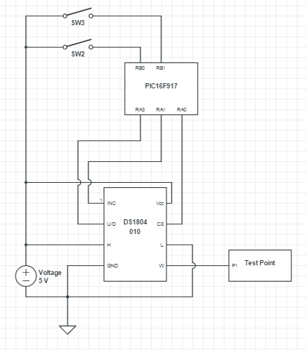

Circuit Diagram 555 Timer Programmable Square Wave Oscillator:

