Assignment 3 Report

Sarah Elsayed 202200347

MLflow UI Screenshots

Table View
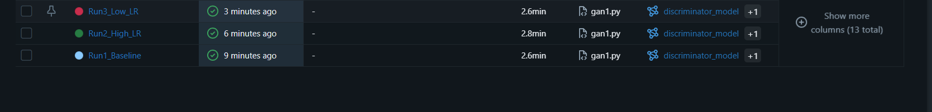
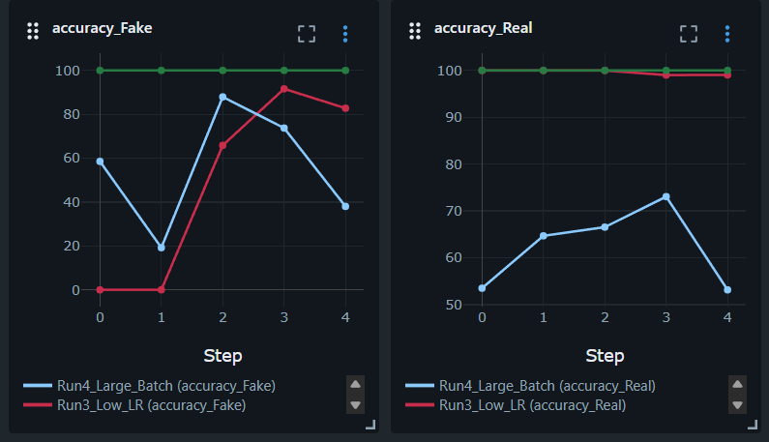

Comparison View
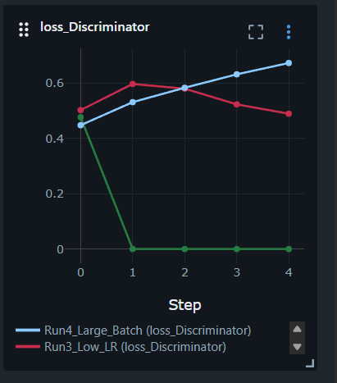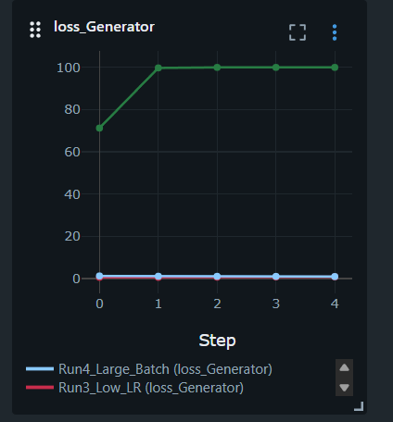

Artifact Gallery
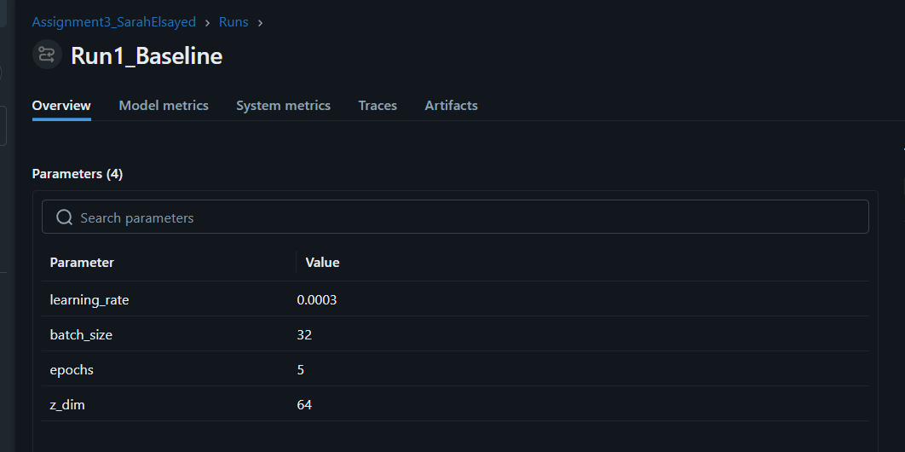
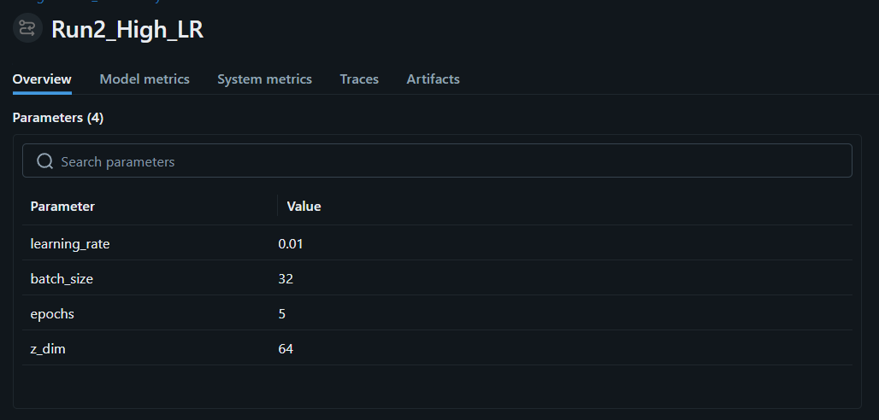
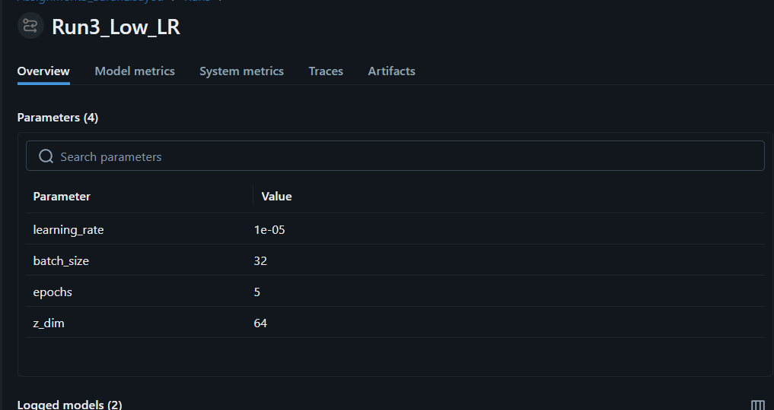

Short Analysis

Which run was the "Winner" and why?
The winner is the first run as the real accuracy was 50%
And this means that the discriminator shouldn’t be able to differ between the real and the fake ones and the loss for generator decreased from 1.21 to 0.94

Evidence of Overfitting, Underfitting, or Instability:
Run 1,3 are overfitting as the average for generator loss is almost 0
Run 2 is underfitting as the average for generator loss is almost 100 so there is no improvement

