How to compile TSC
W. Birkfellner
wbirkfellner@gmail.com

Let us assume you have a recent SD-card in the developer version – that is with all software installed for programming and building TSC; and let us assume that you have at least a Raspberry Pi 3 B+, as compiling the C++-sourcecode can be cumbersome.
- Download all data from https://github.com/selste/TwoStepperControl
- Go to you Downloads folder and extract the .zip file to /home/pi
- Open TwoStepperControl-master/C++Source/qdarkstyle and
- right-click rc.tar and select Extract here – see also Fig. 1. A new folder rc should become visible. These are the resources for the stylesheet defining the user interface
- Open TwoStepperControl.pro by double clicking it in TwoStepperControl-master/C++Source/. QtCreator will be invoked.
- Select Release and click on Build › Build project “TwoStepperControl”
- Ignore all warnings and wait until the compilation process is done as indicated by the progress bar in the lower right hand side. (Fig. 2).
- Go one directory up to TwoStepperControl-master/ and copy the Catalogs folder to the build-TwoStepperControl-Desktop-Release folder (Fig. 3).
- TSC can be started by double clicking the TSC icon on the desktop.

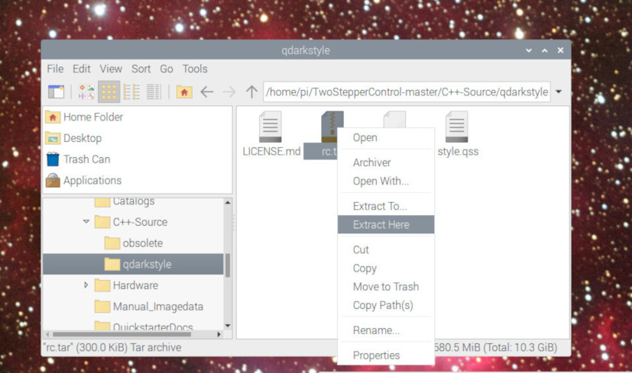 | Fig. 1: Extraction of the rc-folder from rc.tar – a new  folder named rc will appear.

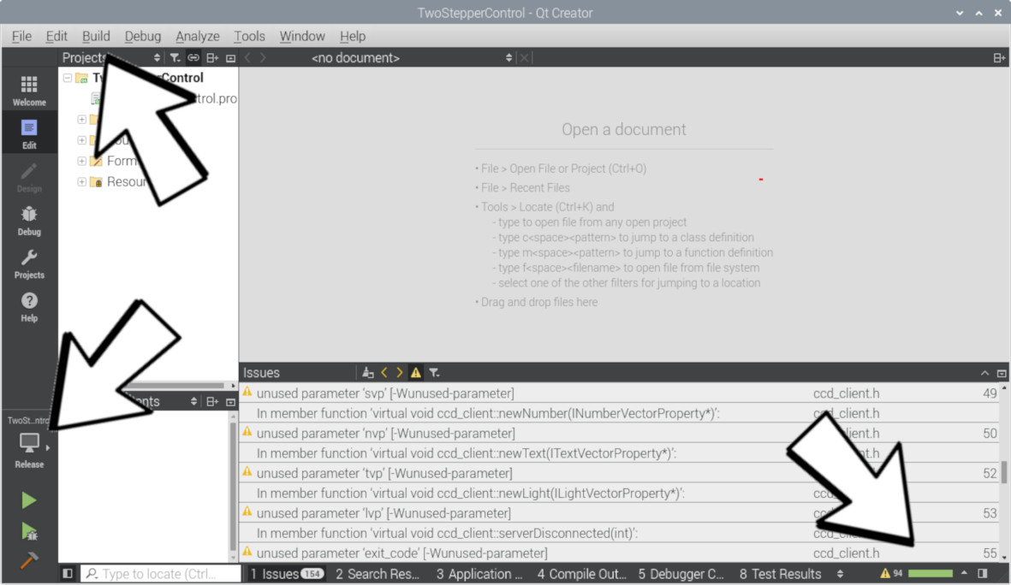 | Fig. 2: Compilation with QtCreator. Open TwoStepperControl.pro in the C++Source folder and take care that you are in Release mode (lower left hand) and start the compilation process in the Build menu.

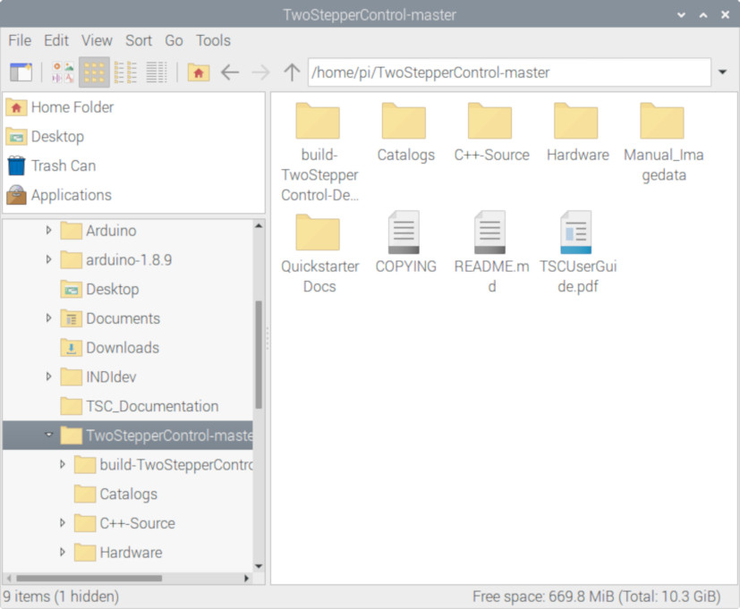 | Fig. 3: Copy the Catalogs folder to  build-TwoStepperControl-Desktop-Release.

