Starting with TSC – the bare minimum guide
W. Birkfellner, wbirkfellner@gmail.com
tscatm.wordpress.com

Let us assume that the TSC hardware is assembled and powered up – so here is a very short and minimalistic guide to get started with TSC.

1: Connect your drives
TSC operates bipolar stepping motors. These have two coils and four wires running out. Some have more, and then reading the documentation for the drives is recommended. Let us call the wire pairs AA’ and BB’. In order to find out which wires form a pair, one needs a documentation or a multimeter. A pair of wires always has a relative resistance of almost 0 Ohm. Connect these pairs to the terminals on the driver boards. If you figure out at a later stage that your drives are turning in the wrong direction, you may need to permutate A and A’ or B and B’ - or both. Fig. 1 shows the location of the terminal on the AMIS board.

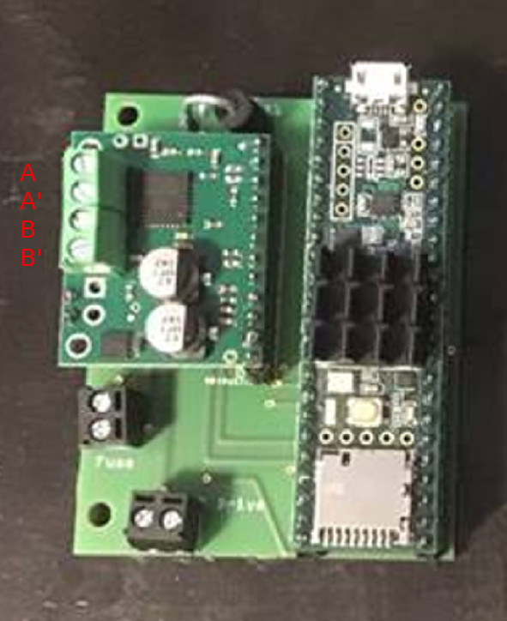 | Fig. 1: Connection terminals for the four wires of a bipolar stepper on one of the AMIS boards. This is an older board with a Teensy 3.5 as a microcontroller.

2: Set up current and gear ratios:
TSC can handle up to 3A per coil and a motor voltage up to 30V (the latter affects the maximum end speed). Your motor also has a maximum current rating. Do not set the current above 70% of this rating (for the time being). Fig. 2 shows how to adjust the current in the Settings dialog of TSC for both the right ascension (RA) and Declination drive. Also set an acceleration A in microsteps/second². 5000 msteps/s² is a good starting point. Set the gear and microstepping ratios and press Store gear data. A recommended setting for microsteps is 1/128 for Track and Guide, 1/16 for Move and 1 /4 for GoTo. Uncheck Northern Hemisphere if you are on the southern hemisphere. Leave Enable Meridian Flip disabled, even if you have a German equatorial, for the time being.

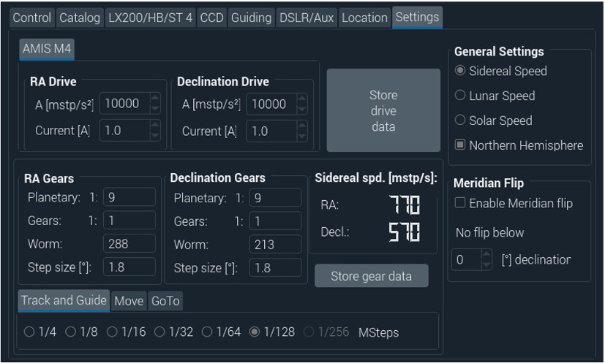 | Fig. 2: Adjustment of current, gears and microsteps for basic stepper operation. Start with 70 % of your rated stepper coil current. A value of 5000 microsteps/s² is a good value for the acceleration A of the steppers. Press Store drive data once you have found your settings. Leave the Enable Meridian Flip check box unchecked for the time being. Enter the gear ratio for you Planetary drive, your intermediate Gear (e. g. belts) and the number of teeth on you Worm wheel. Also enter the step size for a full step and the microstepping ratios for Tracking and Guide-ing, handbox Moves and GoTo. Press the Store gear data button once you are done.

3: Set up speeds and do fine adjustments:
Now, your mount should be ready for first moves using the direction buttons on the main screen (Fig. 3). Set V-Move to 50 (multiples of sidereal speed) and V-GoTo to 100. Press the Store Speeds button. Move the drives with Up, Down, Left and Right. Now fine adjust currents and maximum speed. A whining sound at maximum speed accompanied by no motion means that the speed is too high for this setup – reduce it. A rough motion of the drive, accompanied with heating the drive up, means that the current is to high – lower it. An irregular motion, accompanied by crackling sounds, means that the torque is too low and the motor loses steps – increase the current, but not beyond the maximum rating of the drive. An optimal setting is found when the drives operate quietly with the minimum current needed. Repeat this until the mount moves smoothly. Also check the maximum GoTo speed V-GoTo by setting V-Move to the same value – and always Store Speeds.
4: Check directions
Grossly point your scope to the south horizon using a level and a compass; if you have a German equatorial, make sure that it’s position (left or right of pier) is also indicated in the GEM left of pier checkbox (Fig. 3). Make sure that the hemisphere you are on (north or south) is indicated properly in the Settings (Fig. 1). If a press on the Right button moves the scope left (or if Up and Down are reversed) – go back to 1.) and permutate A with A’ or B with B’ or both.

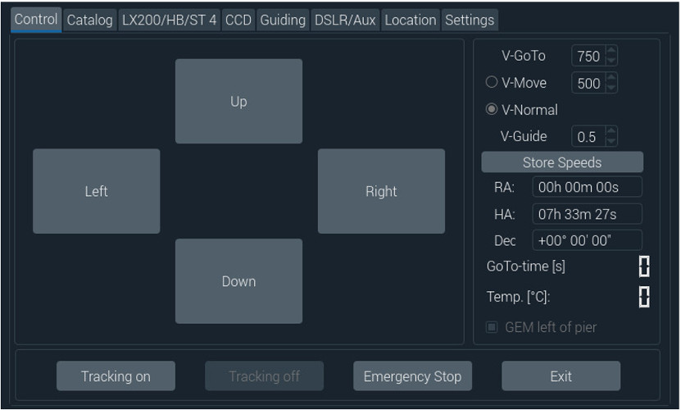 | Fig. 3: The main screen – adjust your desired speeds for motion (V-Move) and GoTo (V-GoTo) and fine tune your motor current. Don’t forget to Store Speeds if you changed them. The speed is selected with the radiobuttons left of V-Normal and V-Move. The direction buttons are latching – press them a second time to stop a motion. If you cannot enter a current or set a speed, then the drive or speed is active. Use Tracking off button to stop the mount compensating Earth’s rotation if you want to edit the RA-drive settings. Uncheck V-Move to change the speed.

5: Enable meridian flip (if needed)
If you have a German equatorial (GEM), point your scope to the south horizon, make sure that the scope position left/right of the pier matches the GEM left of pier checkbox (Fig. 3) and Enable the Meridian flip in the Settings tab (Fig. 2). Set No flip below to the minimum declination visible from your site (e. g. -42° if you are at a latitude of 48° as shown in Fig. 4).

6: Sync the scope
Make sure your clock is set up properly and your location is entered correctly (Fig. 4).

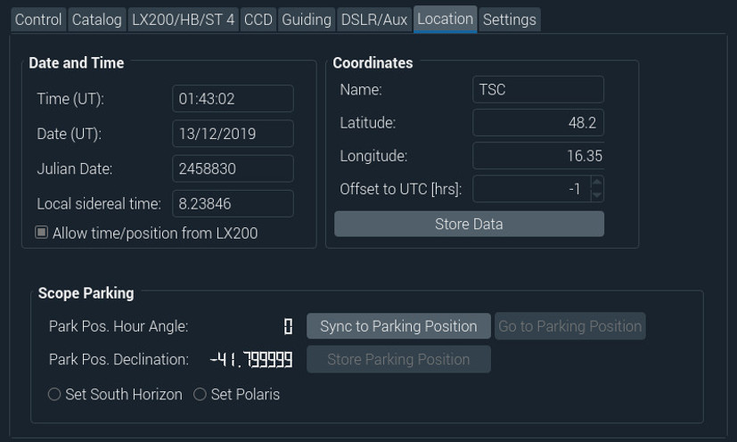 | Fig. 4: Set your location and make sure that the time (Universal time zone) is set correctly, or let SkySafari do this for you (in this case, the Allow time/position from LX200 checkbox needs to be checked). Don’t forget to Store the Data. If your scope is approximately looking to the south horizon, check Set South Horizon and press the Sync to Parking Position button. If you have not set your time yet and you don’t have SkySafari – connect your Raspberry Pi to a network via Ethernet and wait for an incoming time server signal.

Position your scope to the south horizon grossly using a compass and a level using the direction buttons (Fig. 3) as indicated in Section 4. Set the parking position to the South Horizon in the Location tab and Sync to this Parking Position. Your scope is now approximately synced. Identify a nearby bright star and go to the Catalog tab using the PreciseAlignmentStars or the BrightStars catalogue, click its name and press GoTo (Fig. 5).

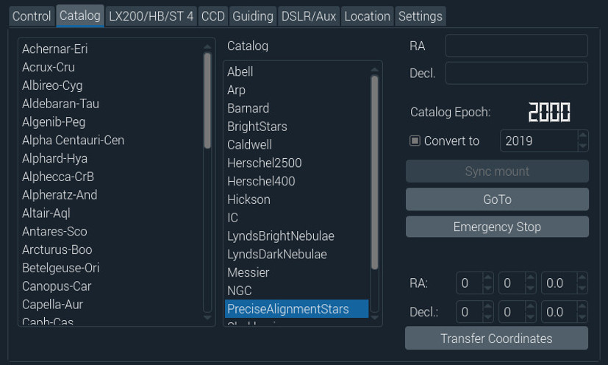 | Fig. 5: Precise syncing using a bright star and the BrightStars or the PreciseAlignmentStars catalog. Select a star you want to sync on and press GoTo. Fine align the star in the scope using a low to medium power eyepiece and the direction buttons (Fig. 3). Once the star is in the center of the eyepiece, press Sync mount again.

GoTo this bright star and locate it in the eyepiece or finder precisely by fine tuning the scope position with the direction buttons; once it is in the center of the eyepiece of your telescope, Sync the mount again. The scope should now perform GoTo-slews precisely if it is well aligned. Of course these steps can also be carried out through a planetarium program like Kstars.

