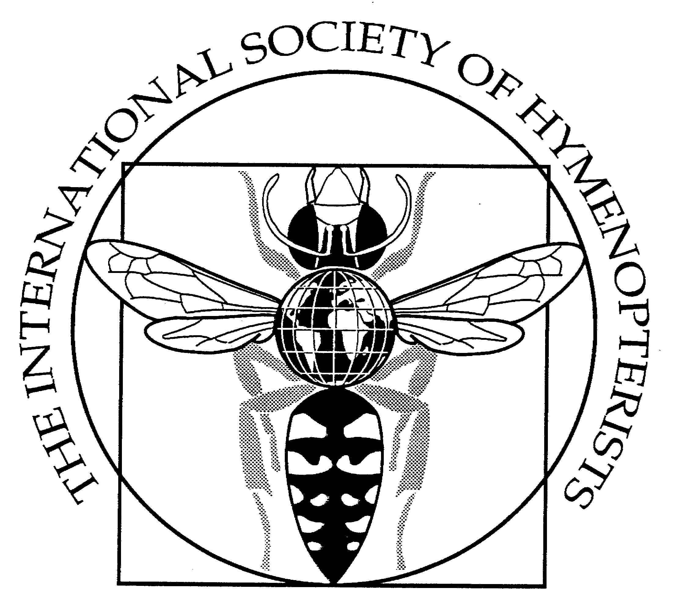

7th International Congress of Hymenopterists

20-26 June 2010
Köszeg, Hungary

The International Society of Hymenopterists gladly invites hymenopterists from all over the world, to the 7th International Congress of Hymenopterists, in Köszeg, Hungary, 20-26 June, 2010. This will be a forum for the dynamic exchange of information and ideas relevant to those interested in Hymenoptera. Your input is required to make this a success, and suggestions for symposia, special sessions and/or keynote speakers will be particularly welcomed.

Final Circular

The official Congress language is English.

Papers
Oral papers should be no longer than 15 minutes; additional discussion of 5 minutes will be allowed.
Posters
Posters will be grouped into subject sessions. The size should be no larger than A0 portrait (840 X 1176mm). Poster sessions will be announced in the congress Programme and Abstract brochure.

Abstracts
Abstracts should be submitted electronically by e-mail directly to melikageorge@gmail.com no later than 1st April 2010. They should not exceed 500 words, in the format: Title; Author(s) (presenter indicated by *); Affiliation(s) including e-mail addresses (linked to authors by superscripts); Text (no figures, tables, references).
Audio-Visual Aids
Data, slide and overhead projectors will be available as well as internet. Please indicate if you will need any other presentation equipment (for example, speakers to lap-top).
Presentations
PDF or PowerPoint files for presentations should be kept as small as possible and e-mailed by 1st June 2010 to melikageorge@gmail.com (up to 5MB as an e-mail attachment; if larger than with uploading onto http://www.yousendit.com), or mailed on CD to reach us by that date. Ensure that they are in a format compatible with Windows XP and PowerPoint 2003. They will be preloaded and can be checked upon arrival. Use of personal laptops for presentations will not be possible.
An appropriate venue for publication of Congress proceedings will be determined by the ISH Executive Committee.

Transport
We will provide shuttles from(to) Vienna and Budapest Intl. airports and Keleti Railway Station (Budapest) to(from) Köszeg only on June 20th (arrival), June 26th and June 29th (departure). We ask the participants to complete the attached form with flight numbers and scheduled arriving times after ticket reservations have been made and send it to melikageorge@gmail.com. According to the arriving schedules of flights, bus departure places and time will be announced for all participants later.

Parking in Köszeg during the congress for all, who will arrive by car will be free. Search for approach roads and Köszeg map on: http://www.iranymagyarorszag.hu/terkep/koszeg

Hotel Fees includes Accommodation, Dining and Bus Transfer.
Accommodation (6 nights, June 20-26) includes: breakfast, tourism tax; wellness section; wireless internet access, 4 conference rooms (with audio and visual equipment, poster boards, etc). No Accommodation Fees for children under 14 years age.

Dining (5 days, June 21-25) includes: x5 lunch, x2 dinner, x2 receptions, 1 grill party, and 8 tea breaks). Dining for children under 14 years – free. For participants, who mailed us their dietary restrictions and food allergies, allergent-free dishes would be served. For Companions, who had choose the full 5-day excursions, a rich lunch bag will be served, instead of a regular lunch at the hotel, and thus the Dining expenses are the same. Those, who will stay in Köszeg on their own, and don’t need hotel reservations announced, are kindly asked to pay Dining fees, catered by the congress. A badge, given to you after arriving, will allow to take part in all caterings.

No reduction of Accommodation and Dining Fees for students are available.

Accommodation + Dining Fees for the post-conference 3-day collecting trip are not included into the Fees announced here, they must be paid at the Hotel Irottkö Registration Desk after arriving, in cash or debit/credit card; bank cheques will be not accepted!

Bus Transfer. Participants and Companions, who will arrive and depart by air or train (either to/from Budapest or Vienna) and asked for a bus transfer to/from Köszeg, must pay the costs of airport transfers and the bus rent for June 24th, a whole day excursion to the Fertő-Hanság National Park (12000HUF). Those who will travel by car, paying for the bus rent for the 1-day excursion day only (9000HUF).
For Participants who prefer to use online PayPal payments in USD (from March 20th till May 15th, 2010), are kindly invited to visit: http://hymenopterists.org/congress_cart.php and do their payments.

Hotel Fees for those, who prefer the ordinary bank transfer or forced for late payments after arrival (double the amount if you are traveling with Companion):

Hotel: | Accommodation  6 nights  HUF | Dining  5 days HUF | Bus costs  HUF | Total  (HUF)
Irottkö & Arany Strucc:  single room  double room | 60000  30000 | 47400  47400 | 12000(9000*)  12000(9000*) | 119400  89400
AACS hostel:  single room  double room | 54000  27000 | 47400  47400 | 12000(9000*)  12000(9000*) | 113400  86400
*For those who will travel by car, the bus costs are 9000 HUF

To pay your Hotel Fees by ordinary bank transfer (from March 20th till May 15th 2010), please, submit your payment in Hungarian Forints (HUF) to:
K&H Bank Hungary
SWIFT CODE: OKHBHUHB
IBAN: 89 1040 0669 4954 4956 5254 1036
Bank Account owner: Irottkö Hotel Kft., Fö tér 4., 9730 Köszeg,
Reference Code: HymenCongress
When transferring, please, indicate your name. Kindly pay your bank charges over the amount announced. The payment document must be scanned and send to melikageorge@gmail.com

Late payments after arriving, at the Hotel Irottkö Registration Desk in cash or with credit/ debit card. Bank cheques will be not accepted!

Payment using a credit card can be done online using PayPal. The web address for payment is http://hymenopterists.org/congress_cart.php. Paypal and credit card fees are already incorperated into the cost.

Registration Fees includes congress documentation and other congress goodies. Those who pay the Student Fee must send certification by their supervisor to melikageorge@gmail.com. No Registration Fee for Companions. Companions, who had choose the full 5-day excursion option, will be contact by George Melika for making necessary arrangements.

For Participants who prefer to use online PayPal payments in USD (from March 20th till May 15th, 2010), are kindly invited to visit: http://hymenopterists.org/congress_cart.php and do their payments.

Late Registration Fees, after arrival can be paid only in cash:

Regular Fee | Student Fee
20000 HUF | 15000HUF
Credit/ debit card and bank cheques will be not accepted!

Registration Fees does not include fees for the post-congress 3-day collecting trip, they must be paid after arriving at the conference registration desk. The fee would be ca. 12000HUF, includes costs of bus rent for 2 days, prices of ethanol and ethyl acetate.

Congress Programme
2010. June 20 (Sunday) Arriving and Registration in Hotel Irottkö. Busses will take participants from arriving points to Kőszeg.
2010. June 21 (Monday) Registration till 8:30 am. Welcome and Opening. Work. Welcome Reception. “Hajnal csillag” dance-group.
2010. June 22-23 (Tuesday and Wednesday) Work from 8:30 am until late afternoon.
2010. June 24 (Thursday) A whole-day excursion, starts from 8:00 am. Fertö-Hanság National Park and visit Sopron town or insect collecting (on the border of the Fertö-Hansag National Park; remnants of a formerly continuous wetland with boggy, marshy/swampy habitats and wide plains reminiscent of the Asian steppes). Evening grill party in Kőszeg Mnt.
2010. June 25 (Friday) Work from 8:30 am, ISH Business Meeting, Congress Dinner. “Dance Jam” folk dance.
2010. June 26 (Saturday) Departure (shuttles to Schwechat Intl Airport, Vienna or to Budapest. Post-congress 3-day insect collecting trip starting.

Post-Congress Events
1. Work at the Natural History Museum in Budapest and/or Vienna should be pre-arranged on your own with the curators of the both collections.
2. Post-Congress 3-day Insect Collecting (June 26-28):
1st day (June 26)– vicinities of Kőszeg, Kőszeg Mountains -- start at 9:00 am, walking.
2nd day (June 27)-- Bakony Mnt., N of Balaton Lake -- departure at 8:30 am, bus.
3rd day (June 28)– vicinities of Örseg National Park – departure at 8:30 am, bus.
4th day (June 29) – morning shuttle to Vienna/Budapest airport.

Those who would like to stay for the post-congress 3-day insect collecting trip will be asked to arrange their further accommodation at the hotel registration desk. Participants will pay during the congress (payment of ca. 12000HUF is not included into the Reg. fee). We can provide 5-6 stereomicroscopes for the material presorting and ethyl-acetate for killing insects and ethanol (75% and/or absolute) for preserving the collected material. Please secure yourselves with raincoats, boots, sweep nets, vials, and any other equipment you require for collecting and presorting insects.

Programmes for Companions were announced in the First Circular and two options were proposed. All Companions pay the same Hotel fee (accommodation +dining +bus costs) as the Participants; no Registration Fees for Companions who had chosen Option 1 (free programme). For those who have chosen Option 2 (full 5-day excursions), the organizers will contact you personally via e-mail to discuss the payment form and other details.

Personal Insurance
All travelers to Hungary should take out comprehensive medical and travel insurance. Health and dental services are not free in Hungary, and travel insurance should cover the possibility of cancellation due to strikes and other causes.

Banking
All payments in Hungary are still in the national currency, Hungarian Forints (HUF). Banks are usually open from 9:30 am till 4:00 pm Monday to Friday, and closed on weekends. Automatic teller machines are widely available in the town and one is located at the Hotel Irottkő entrance. Hotel Irottkő will accept credit-cards. However, many shops and pubs downtown Kőszeg will ask for cash only.

Badges. During the Congress the local organizers will carry a distinctive red badge. Please do not hesitate to contact them with any questions. All participants (including Companions) will get an ordinary badge (after completing all payments). Please carry them in the hotel to avoid unnecessary questions from the hotel staff.
Refunds
Refunds of registration fees will only be considered if payments were done through PayPal and requests are received by 1st May 2010. Paypal fees will be deducted from refunds [refund inquiries must be sent to Katja Seltmann: katja_seltmann@ncsu.edu].
All those intending to take part in the Congress are kindly requested to complete this form and send to George Melika (melikageorge@gmail.com) by 15th May 2010
(neglecting the form filling out may cause you troubles with getting to the venue)

Title and Abstracts (should be submitted electronically by e-mail directly to melikageorge@gmail.com no later than 1st April 2010. They should not exceed 500 words, in the format: Title; Author(s) (presenter indicated by *); Affiliation(s) including e-mail addresses (linked to authors by superscripts); Text (no figures, tables, references)

Indicate, please, is it an oral presentation or poster

Name/Given Name
Companion Name/Given Name
Arrival: | Destination: | Date: | Time: | Flight #, from:
Arrival: | Schwechat Intl Airport, Vienna
Arrival: | Ferihegy II Intl, Airport Budapest
Arrival: | Keleti Railway St, Budapest
Arrival: | by car
Departure: | Destination: | Date: | Time: | Flight #, from:
Departure: | Schwechat Intl Airport, Vienna
Departure: | Ferihegy II Intl, Airport Budapest
Departure: | Keleti Railway St, Budapest
Departure: | by car
3-day Insect Collecting trip:  (indicate the dates) |  | 26 June | 27 June | 28 June
Payments by: |  | PayPal | bank transfer | after arriving
Indicate if you need a bill for: |  |  | Hotel fees | Reg Fees

For questions, comments, and suggestions, please, contact melikageorge@gmail.com.

