Lysianassoidea of the NEP (Equator to Aleutians, intertidal to abyss): a review
dbcadien – 15 February 2007 (Revised 15 July 2007)

Table of Contents
Pg
Introduction to the Superfamily...........................................................................................2
Diagnosis of the Superfamily...............................................................................................2
Ecological Commentary.......................................................................................................3
Key to NEP lysianassoid genera..........................................................................................7
Index to family and group placement of generic taxa........................................................11
List of NEP lysianassoids alphabetically by family/group................................................12
“alicellid group”.....................................................................................................12
Aristiidae................................................................................................................12
“cebocaris group”...................................................................................................12
“conicostomatid group”.........................................................................................12 Cyphocarididae......................................................................................................12
Endevouridae.........................................................................................................13
Eurytheneidae........................................................................................................13
Hirondelleidae........................................................................................................13
Hyperiopsidae........................................................................................................13
Lysianassidae.........................................................................................................13
Opisidae.................................................................................................................15
Pachynidae.............................................................................................................16
Scopelocheiridae....................................................................................................16
Uristidae.................................................................................................................16
“valettiopsid group”...............................................................................................17
Comments by Family/Group
“alicellid group”.....................................................................................................19
Aristiidae................................................................................................................19
“cebocaris group”...................................................................................................20
“conicostomatid group”.........................................................................................23
Cyphocarididae......................................................................................................25
Endevouridae.........................................................................................................26
Eurytheneidae........................................................................................................27
Hirondelleidae........................................................................................................28
Hyperiopsidae........................................................................................................30
Lysianassidae.........................................................................................................31
Opisidae.................................................................................................................40
Pachynidae.............................................................................................................42
Scopelocheiridae....................................................................................................43
Uristidae.................................................................................................................44
“valettiopsid group”...............................................................................................49
Lysianassoid References Cited..........................................................................................52

The superfamily Lysianassoidea contains a number of families, and also a number of taxa of uncertain status which may eventually be viewed either as subfamilies, or full families within the superfamily. The fauna of the NEP is rich in these species, with most species level diversity in the Lysianassidae and the Uristidae. Fifteen families or proposed family level groups are represented in the NEP, containing 59 genera and around 155 species level taxa. No members of these lysianassoid families were treated in the amphipod section of the Taxonomic Atlas.
Inclusion of the Hyperiopsidae within the lysianassoids is somewhat controversial. While viewed as belonging there by some (i.e. Bousfield and Shih 1994, Bousfield 2001), results of other analyses differ. Berge et al. (2000) found the Hyperiopsidae, as used here, to be paraphyletic, with Hyperiopsis and Parargissa falling into separate clades. Their results also suggest that neither of these two parts of the Hyperiopsidae (as currently construed) are closely related to the lysianassoids. These results need further verification before they are adopted, but provide a different point of view to that espoused by Bousfield. Inclusion of at least two other groups, the alicellids and the valettiopsids is also disputed and will be discussed later.
Bousfield (1979) raised the family Lysianassidae to superfamily status, but did not explicitly divide it into several different families. He mentioned the subfamilies Lysianassinae and Uristinae suggested by Hurley (1963), and opined they “could justifiably be elevated to family status”.
His diagnosis of the superfamily is: “Plesiomorphic, mainly smooth-bodied, weakly rostrate, often fossorial gammarideans, usually with strongly dimorphic terminal pelagic male bearing sensory brush setae on peduncular and basally conjoint flagellar segments of antenna 1, and both calceoli and brush setae on antenna 2; antenna 1 with strong accessory flagellum; eyes deep reniform, bulbous below; mouthparts highly modified; upper lip notched, epistome often anteriorly produced; lower lip tall, lacking inner lobes; mandibular molar reduced, palp slender; maxilla 1 inner plate narrow, 2-setose; outer plate with 9 apical spine-teeth; maxilla 2, plates narrow, weakly setose; maxilliped outer plate often enlarged, with strong cutting margin; coxal plates large, deep, 4th strongly excavate; coxae 5-7 posteriorly lobate; gnathopods 1 and 2 non-amplexing, markedly dissimilar, 1 variously subchelate, chelate or simple, 2 with characteristic elongate segment 3 and small microchelate propod and dactyl; pereopods 5-7 homopodous, bases expanded; brood plates sublinear; coxal gills often pleated, present on pereopod 7; pleopods normal; uropods lanceolate; rami subequal; uropod 3 foliaceous, outer ramus 2-segmented; telson lobes usually distally separated (narrowly), apices with minute notch and spine, or fused and entire, margin non spinose.”
He later relaxed some of the specificity he used above to include the broad diversity within the superfamily more completely (Bousfield 1982). At this point he suggested that the family Lysianassidae should be subdivided into at least 10 separate families, including elevation of the two extant subfamilies to full familial status.
By the time J. L. Barnard and Karaman (1991) covered the family, they were presenting keys to a series of coherent generic groups, the conicostomatins, pachynins, cyphocarins, and scopelocheirins, but did not treat these as subfamilies. They also did not choose to recognize the two subfamilies created earlier by Hurley, the Lysianassinae and the Uristinae. Their diagnosis of the family (still fully congruent with the superfamily concept of Bousfield) was much briefer and more inclusive: “Article 3 of gnathopod 2 elongate, remainder of appendage forming mitten apically; peduncle of antenna 1 short and stout, articles 2-3 much shorter than 1 and partly telescoped basally.”

Lysianassoid Ecology
The ecology of lysianassoids has often been investigated. Members of the superfamily occupy varied niches and pursue a variety of life styles. Some are parasitic, as blood ectoparasites of fishes, or as brood parasites of decapods. Others are inquilinous and/or closely associated commensally with sponges, cnidarians, tunicates or echinoids. Most are free-living detritivores or predatory or scavenging carnivores.

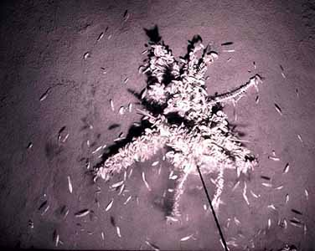
The lysianassoid Hirondellea gigas swarming bait at 9605m in the
Philippine Trench (Photo R. R. Hessler, SIO)

A large subset of the deep-sea species are known necrophages, and form the nucleus of the deep-sea necrophage community. This community, distributed world-wide in the deep sea, is important in recycling carcasses of larger organisms (Hessler et al. 1978; Ingram and Hessler, 1983; Jones et al. 1998; Klages et al. 2001; Lowry and Smith 2003; De Broyer et al. 2004; Smith and Baco 2003). A necrophage guild is also reported from shallow waters in some areas (Keable 1995, Ingólfsson and Agnarsson 1999). When the opportunity presents itself, lysianassoid species may act as opportunistic carnivores, feeding on sleeping (Stepien and Brusca 1985), or on injured fishes (Ide et al. 2006). Others routinely scavenge, even in areas inhospitable to their own metabolism. De Robertis et al. (2001) describe the behavior of a lysianassoid scavenger that feeds on carrion in the anoxic sub-sill portion of one Canadian fjord, essentially making feeding forays into the anoxic zone, then retreating into oxic waters to recover while digesting.
Necrophagic lysianassoids are usually taken in baited traps (Thurston 1979; Biernbaum and Wenner 1993). These animals are often gorged with bait upon retrieval (Shulenberger and J. L. Barnard 1976), sometimes to the extent that the brood is forced from the marsupium by the volume of the expanded gut. The larger, more distensible gut is a morphological adaptation of necrophages (Sainte-Marie 1984), as is a mandible designed for efficient slicing of flesh (Dahl 1979, Steele and Steele 1993, Sainte-Marie 1984). Movements to and accumulation around bait seems moderated by both current velocity and by presence of potential predators (Lampitt et al. 1983). Initial attraction to the bait, and by extension to naturally occurring carrion on the seafloor, is through chemosensory odor recognition (Smith and Baldwin 1982, Bushdosh et al. 1982, Meador 1989, Ide et al. 2007). Such chemoreception is localized in the callynophore (Lowry 1986, Kaufmann, 1994), where the receptors also track pheromones as males locate females during reproductive searching. Feeding rates have been examined experimentally in situ (Smith and Present 1983), while gut content and stable isotope analyses have been used to confirm dietary intake (Sainte-Marie and Lamarche 1985, Graeve et al. 2001, Nyssen et al. 2002). Combined analysis of guts and mouthpart morphology has been performed for a few species (Arndt et al. 2005).

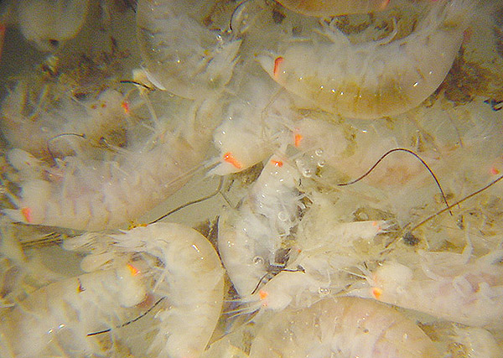
A writhing mass of lysianassoid necrophages retrieved from a baited trap in the west Atlantic
(Photo at http://oceanexplorer.noaa.gov/explorations/03bump/logs/aug12/aug12.html)

Biogeographic and bathymetric distributions of the deep-sea necrophages tend to be large, and some suggest that pan-oceanic or cosmopolitan distributions are probable (Thurston 1990). Morphological evidence is equivocal, with variation between sites often no larger than variation within sites. Within trenches vertical distributions seem more definite than they do on open abyssal plains (Perrone et al. 2002, Blankenship et al. 2006), with discrete limits to vertical excursions of the species, often without overlap. Such specificity, despite equivocal morphological evidence, is supported by genetic studies which find discrete haplotypes restricted to localized areas or narrow bathymetric zones in broadly distributed species or species complexes (Bucklin et al. 1987; France 1993, 1994; France and Kocher 1996; France et al. 1992).
Another sizeable subset of the lysianassoids are bathy-, bentho-, or meso-pelagic. Collections of these animals are often with plankton nets, or other midwater sampling devices. J. L. Barnard (1954) and Brusca (1967) discussed a few locally collected bathy-pelagic species, but more complete samplings (from other areas) are reported by Shoemaker (1945), Thurston (1976a,b), and Birstein & Vinogradov (1958, 1960, 1970). Baited traps many hundreds or thousands of meters off the bottom are also often a source of actively swimming lysianassoids (Blankenship et al 2006). Like some other nectonic animals spending significant time in the water column, some lysianassoids are bioluminescent (i.e. Cyphocaris challengeri, Bowman 1967).
The members of the Opisidae are notable as ectoparasites of fishes (Bousfield 1987, Bousfield and Kabata 1988). The local SCB representative, O. tridentata, is recorded from a variety of fish hosts including Sebastes mystinus (blue rockfish), S. maliger (quillback rockfish), S. ruberrimus (yellow-eye rockfish), Hexagrammos decagrammus (kelp greenling), and Squalus acanthias (spiny dogfish)(Bousfield 1987). They are usually located near the dorsal fin. A second species, Opisa odontochela, is known from the boreal waters of Southeast Alaska. The modified first gnathopod, which is large and ovate with a long curved dactyl forming a pincher, seems related to the ectoparasitic live-style. A second lysianassoid family, the Trischizostomatidae, has a similar overall appearance to the opisids, and is also ectoparasitic on fishes (Bousfield and Kabata 1988). It is known from the Atlantic, but not yet from the Pacific.
The cebocarid Paracyphocaris predator, not recorded from the NEP, is reported to be an egg predator of oplophorid shrimp (Bowman and Wasmer 1984). The amphipod consumes the eggs within the marsupium, and is then carried as a false brood by the shrimp. Local cebocarids do not seem to share a symbiotic life-style, although one member of the genus Lepidepecreela is reportedly associated with sea urchins (Berge et al. 2004). The local representative has only been taken once, and not in any obvious association with a sea urchin. Since Berge et al. (2004) record that the first gnathopod of the commensal species they describe is larger than in other species in the genus, the commensal habitus may be restricted to their species and not general within the genus. They summarize known relationships between amphipods and echinoderms, updating Vader (1978). They list Euonyx chelatus as a specialist commensal of the sea urchin Echinus esculentus in European waters. Although two members of this genus occur in the NEP, both are found at lower bathyal or abyssal depths, and are unlikely to be associated with an echinoid host.
Relationships between lysianassoids and sea anemones are well known, especially that between Allogaussia recondita (now Orchomenella) and the anemone Anthopleura elegantissima (Stasek 1958; Vader and Lönning 1973; Vader 1979, 1983; De Broyer and Vader, 1990). Associations of other lysianassoids with other anemones are reported (Ansel 1969, Vader 1983) but less well known. Some lysianassoids occur in commensal associations with sponges (Peattie and Hoare 1981, Vader 1984, Bellan-Santini 1990) including the local Aristias sp A, collected in abundance from within the vascular system of the hexactinellid sponge Staurocalyptus dowlingi. Other animals are also involved as hosts in symbiotic relationships with lysianassoid amphipods including brachiopods (Vader 1970), clams (Just 1979, Bellan-Santini 1990), and the solitary ascidian Ascidia paratropa (Schellenberg 1936). J. L. Barnard (1969a) mentions in most of his discussions of lysianassoid species from the California intertidal that they were taken in washings or scrapings of algae, sponges, bryozoans, or ascidians on or under rocks. He did not indicate individual host associations, however. Lowry and Stoddart (1983) suggest that the conical mouthparts of conicostomatid lysianassoids may be used as a buccal pump for pierce-and-suck feeding on anemone or sponge hosts. If true, this would make them ectoparasites or micropredators rather than commensals.
While a number of shallow-water lysianassoids are associated with algae, the nature of that association is unclear. In most instances they are probably associated with epizoites of the algae rather than the alga itself. One species has been reported to be a grazer on algal tissues (Haggitt and Babcock 2003).
Life history attributes of a number of lysianassoids are tabulated by Sainte-Marie (1991), and months in which gravid females were observed by Wesławski and Legezynska (2002). Conlan (1991) reports that lysianassoids are non-mate guarders, which do not engage in precopulatory behavior, and have little morphological difference in secondary sexual characters. In some members of the superfamily, pelagic searches by males for stationary females on the bottom are reported, with the callynophore and the antennal aesthetascs the assumed chemosensory guides to the male movements. Such mate seeking water-column excursions may explain much of the observed diel movement of lysianassoids (Takekawa et al. 2004).
Not all members of the superfamily are as presented by Conlan, with little secondary sexual difference between males and females. In the conicostomatid group several genera are known to be protandrous hermaphrodites, with considerable difference in appearance between the male and female stages (Lowry and Stoddart 1986). In our fauna the two genera and species Ocosingo borlus and Fresnillo fimbriata were found to be female and male of the same species (Lowry and Stoddart 1983). Both forms are now known as Ocosingo borlus. The more typical state alluded to by Conlan involves differences mainly in the antennae (see also Moore 1983).
In the absence of bait, the population density of soft-bottom lysianassoids is generally fairly low. They are encountered regularly in benthic samples, but in small numbers. In the intertidal zone populations are both more numerous and more aggregated (as in J. L. Barnard 1969a). Rarely lysianassoids may rise to the level of community dominants, as the cyphocaridid Cyphocaris challengeri does in Puget Sound (Lie 1974). It is in the necrophage community that lysianassoids are dominant, and almost exclusively there. One exception is the hydrothermal vent communities of the Pacific, where lysianassoids constitute over 99% of the amphipods taken (J. L. Barnard and Ingram 1990). Virtually all of this total is in one species, the lysianassid Ventiella sulfuris. This animal may also be a necrophage, but Mitcheli et al. 2002 suggest it is a grazer on bacterial films or a micropredator of larvae settled on the films. Interestingly, lysianassoids are totally absent from the vent areas of the Atlantic. Bellan-Santini and Thurston (1996) suggest that the ecological role of the Pacific vent lysianassoids is filled in the Atlantic by alvinocaridid shrimp.
Descriptions of some families and groups of lysianassoids are provided by Lowry and Springthorpe (2001). They include descriptions of the cebocarid group, Hirondellea group, Hyperiopsidae, Lysianassidae, Scopelocheiridae, and Valettiopsis group. Diagnoses of the following are located in the cited references: Aristiidae (Lowry and Stoddart 1997), conicostomatid group (Lowry and Stoddart 1983), Cyphocarididae (Lowry and Stoddart 1997), Endevouridae (Lowry and Stoddart 1997), Eurytheneidae (Stoddart and Lowry 2004), Lysianassidae (Lowry and Stoddart 1997), Opisidae (Lowry and Stoddart 1995), pachynid group (Lowry 1984), Uristidae (Hurley 1963). The diagnoses or description will be quoted in the discussions of the individual groups below. Other lysianassoid families and groups exist, but are not known to occur in the NEP. For instance the Amaryllidae are known from the West coast of South America (Lowry and Stoddart 1987) but are not known from north of the equator in this hemisphere.

Key to NEP lysianassoid genera – dbcadien 26 June 2007 (modified from keys by J. L. Barnard and Karaman 1991, Lowry 1984, Lowry and Stoddart 1997)
Note: to avoid use of mouthparts in this key, several genera occur in multiple couplets. Although awkward, this was preferred to examination of mouthparts. Where this occurs, the NEP species within the genus which key out there are indicated. Species in the genus from outside the NEP may not key correctly, and the key should be used with particular caution for any region outside the NEP.

1a. Third pereopod chelate.................................................................................Ensayara
1b. Third pereopod not chelate, simple............................................................................2
2a. First gnathopod chelate or subchelate.......................................................................3
2b. First gnathopod simple, or dactyl vestigial.............................................................41
3a. First gnathopod propod attached ventrally to carpus.........................................Opisa
3b. First gnathopod propod attached dorsally to carpus.................................................4
3c. First gnathopod propod attached terminally to carpus..............................................5
4a. G1 subchelate, palm oblique, defined by short tooth...........................Pachychelium
4b. G1 chelate, fixed finger linear, curved up at tip..........................................Pachynus
4c. G1 chelate, fixed finger curved downward distally.................................Prachynella
5a. G1 chelate..................................................................................................................6
5b. G1 subchelate............................................................................................................9
6a. G1 carpus and propod elongate, narrow, subequal.........................................Euonyx
6b. G1 carpus and propod not elongate, subquadrate, propod longer than carpus.........7
7a. Dactyl of G1 closing across the fixed finger, like scissors......................Sophrosyne
7b. Dactyl of G1 closing against fixed finger.................................................................8
8a. Coxa 1 not shorter than coxa 2, distally expanded...........................................Kyska
8b. Coxa 1 strongly shortened, distally rounded.............................................Aristiopsis
8c. Coxa 1 slightly shorter than coxa 2, distally tapering.......................Paronesimoides
9a. Mandibular palp absent.....................................................................Metacyphocaris
9b. Mandibular palp present.........................................................................................10
10a. Coxa 1 reduced or vestigial, partially or completely covered by coxa 2................11
10b. Coxa 1 not reduced, as long or nearly as long as coxa 2, roughly parallel to coxa 2,
sides parallel or distally expanded.........................................................................22
11a. Coxa 1 vestigial, scarcely wider than basis.............................................Eurythenes
11b. Coxa 1 reduced, but still much wider than basis...................................................12
12a. Coxa 1 not tapering distally...................................................................................13
12b. Coxa 1 tapering distally, usually strongly..............................................................14

13a. Coxa 1 slightly shorter than coxa 2, truncate, urosomite 1 with dorsodistal spine
...................................Tectovalopsis (wegeneri only, other species see couplet 21)
13b. Coxa 1 strongly shortened, rounded, urosomite 1 lacking ornament............Aristias
14a. Lateral cephalic lobe bluntly mamilliform.............................................................15
14b. Lateral cephalic lobe obtusely to acutely produced...............................................16
14c. Lateral cephalic lobe truncate.................................................................Diatectonia
15a. G2 propodus 90% of carpus length, both articles linear..........................Paralicella
(P. vaporalis only, for other species see couplet 25)
15b. G2 propodus ½ to 2/3 carpus length, both articles subquadrate.............Hirondellea
16a. Uropod 2 inner ramus incised.................................................................Schisturella
16b. Uropod 2 inner ramus not incised..........................................................................17
17a. Gnathopod 1 palm transverse.................................................................................18
17b. Gnathopod 1 palm oblique.....................................................................................21
18a. Gnathopod 1 articles 5 and 6 subequal..................................................................19
18b. Gnathopod 1 article 6 longer than article 5..............................................Cedrosella
19a. Telson cleft only 10% of length...................................................................Ventiella
19b. Telson cleft 50% or more.......................................................................................20
20a. Urosomite 1 with prominent posterodorsal tooth....................................Valettiopsis
20b. Urosomite 1 lacking tooth.........................................................................Valettietta
21a. Uropod 3 rami more than twice as long as peduncle, distal article of outer ramus
only about 10% of ramal length...........................................................Tectovalopsis
21b. Uropod 3 rami slightly longer than peduncle, distal article of outer ramus about
1/3 length of the ramus...........................................................................Tryphosella
22a. Eyelobe bluntly mammiliform...............................................................................23
22b. Eyelobe obtusely to acutely produced...................................................................26
23a. Telson emarginate, epimeron 3 subquadrate.................................................Koroga
23b. Telson cleft at least 60%, epimeron 3 rounded......................................................24
24a. G2 propod nearly as long (80%) as carpus............................................................25
24b. G2 propod more than half as long (60%) as carpus........................Abyssorchomene
25a. Urosomite 1 with a single posterior tooth............................................Transtectonia
25b. Urosomite 1 with at most a low hump.....................................................Paralicella
26a. Urosomite 1 with a single dorsally directed tooth.................................................27
26b. Urosomite 1 with a low hump or a carina, but not dorsally directed tooth............29
27a. Basis of pereopod 5 with two finger-like posterior spikes............Lepidepecreoides
27b. Basis of pereopod 5 with or without a posterior lobe, but lacking spikes.............28
28a. Epimeron 3 subquadrate.................................................................................Uristes
(entalladurus only, other species see couplets 33, 41)
28b. Epimeron 3 with posteroventral tooth...........................................Paracentromedon
29a. Epimeron 3 with posteroventral tooth....................................................................30
29b. Epimeron 3 subquadrate........................................................................................35
29c Epimeron 3 rounded................................................................................Orchomene
(obtusa only, other species see couplet 41)
30a. Urosomite 1 with at most a low hump...................................................................32
30b. Urosomite 1 with a carina......................................................................................31

31a. Epimeron tooth located on hind margin above posteroventral corner...........Anonyx
31b. Epimeron tooth at posteroventral corner, next to ventral margin.......Orchomenella
(pacifica only, for other species see couplets 34, 37, 39, 40)
32a. Antenna 1, basal flagellar segments fused; telson lobes well tapered, apices with a
single spine.............................................................................................................33
32b. Antenna 1, basal flagellar segments separate; telson lobes weakly or not tapering,
apices truncate with multiple spines.......................................................Psammonyx
33a. Telson apices notched, spines inserted subterminally....................................Uristes
(perspinis only, other species see couplets 28, 41)
33b. Telson apices entire, spines inserted terminally....................................................34
34a. Uropod 3 rami only slightly longer than peduncle.............................Orchomenella
(decipiens only, for other species see couplets 31, 37, 39, 40)
34b. Uropod 3 rami significantly longer than peduncle...............................Hippomedon
35a. Epimeron 3 posterior margin serrate......................................................................36
35b. Epimeron 3 posterior margin smooth....................................................................37
36a. Coxa 5 bearing posteroventral lobe.....................................................Orchomenella
(pinguis only, other species see couplets 31, 34, 39, 40)
36b. Coxa 5 lacking posteroventral lobe........................................................Rimakoroga
37a. Urosomite 1 carinate..............................................................................................38
37b. Urosomite 1 bearing at most a low rounded hump...............................................39
38a. Body widest at 5th coxa, presenting a “diamond” shape when viewed from above;
article 3 of antenna 2 elongate...........................................................Lepidepecreum
38b. Body not noticeably widest at the 5th coxa, at most fusiform rather than diamond
shaped; article 3 of antenna 2 not elongate.........................................Orchomenella
(holmesi and minuta only, other species see couplets 31, 34, 37, 40)
39a. Telson entire, emarginate, or cleft no more than 40% of its length....Orchomenella
(recondita and tabasco only, other species see couplets 31, 34, 37, 39)
39b. Telson cleft 50% or more.......................................................................................40
40a. Eyelobe acute, distally pointed.......................................................................Uristes
(dawsoni only, other species see couplets 28, 33)
40b. Eyelobe obtusely produced, rounded......................................................Orchomene
(all regional species except obtusa; see also couplet 29)
41a. Mouthparts formed into a conical bundle..............................................................42
41b. Mouthparts formed into a quadrate bundle............................................................45
42a. Telson cleft at least 40%........................................................................................43
42b. Telson entire or emarginate...................................................................................44
43a. Uropod 2 inner ramus incised................................................................Socarnoides
43b. Uropod 2 inner ramus not incised...........................................................Acidostoma
44a. Telson entire...............................................................................................Ocosingo
44b. Telson emarginate...............................................................................Stomacontion
45a. G1 dactyl vestigial, hooded and/or hidden by sheaf of spines or setae.................46
45b. G1 dactyl not vestigial, not hidden by hood, setae or spines................................49
46a. Coxae 1 and 2 reduced, partially hidden by coxa 3..........................Anisocallisoma.
46b. Coxae 1 and 2 not reduced....................................................................................47
47a. Antenna 1 peduncle article 1 bearing posterodistal tooth...........................Ichnopus
47b. Antenna 1 peduncle article 1 lacking posterodistal tooth......................................48
48a. G1 propod longer than carpus, tapering.............................................Paracallisoma
48b. G1 propod shorter than carpus, linear...........................................Scopelocheiropsis
49a. Coxa 1, 1 and 2, or 1-3 reduced.............................................................................50
49b. No anterior coxa reduced.......................................................................................55
50a. Coxa 1 reduced, coxa 2 not reduced.....................................................Centromedon
50b. Coxa 1 and two both reduced.................................................................................51
51a. Coxa 1, 2, and 3 all reduced and partially covered by coxa 4.................Cyphocaris
51b. Coxa 3 not reduced................................................................................................52
52a. Epimeron 3 with posteroventral tooth....................................................................53
52b. Epimeron 3 lacking posteroventral tooth...............................................................54
53a. Uropod 3 outer ramus uniarticulate..........................................................Parargissa
53b. Uropod 3 outer ramus biarticulate......................................................Procyphocaris
54a. Epimeron 3 subquadrate...........................................................................Cyclocaris
54b. Epimeron 3 posterior margin notched, truncate and serrate..............Lepidepecreela
55a. Telson cleft more than 50% of length....................................................................56
55b. Telson entire or emarginate...................................................................................59
56a, Urosomite1 with multiple posterior teeth...............................................Apotectonia
56b. Urosomite 1 lacking teeth, with saddle or low hump............................................57
57a. Eyelobe truncate............................................................................................Alicella
57b. Eyelobe obtusely to acutely produced...................................................................58
58a. Telson tapering to distal truncation, cleft 90%, each lobe tipped with multiple
large spines................................................................................................Waldeckia
58b. Telson acute to rounded, cleft not more than 70%, each lobe bearing a single
terminal spine..............................................................................................Socarnes
59a. Telson entire, uropod 2 inner ramus incised..........................................................60
59b. Telson emarginate, uropod 2 inner ramus not incised...........................................61
60a. Uropod 3 outer ramus uniarticulate.......................................................................62
60b. Uropod 3 outer ramus biarticulate........................................................Dissiminassa
61a. Uropod 3 outer ramus uniarticulate........................................................Hyperiopsis
61b. Uropod 3 outer ramus biarticulate...................................................................Aruga
62a. Eyelobe obtusely produced....................................................................................63
62b. Eyelobe truncate, slightly crenulate....................................Macronassa macromera
63a. Epimeron 3 quadrate, uropod 3 rami strongly attenuated .................Shoemakerella
63b. Epimeron 3 produced posteriorly into a quadrate plate, uropod 3 rami not strongly
attenuated...................................................................................Macronassa pariter

Index to family and group placement of generic taxa in the superfamily Lysianassoidea (synonyms are listed unbolded where they occur in NEP literature)

Abyssorchomene – Lysianassidae Metacyphocaris – cebocaris group
Acidostoma – conicostomatid group Ocosingo – conicostomatid group
Acontiostoma – conicostomatid group Opisa - Opisidae
Alicella – alicellid group Orchomene – Lysianassidae
Allogaussia – Lysianassidae Orchomenella – Lysianassidae
Anisocallisoma – Scopelocheiridae Pachychelium – Pachynidae
Anonyx – Uristidae Pachynus – Pachynidae
Apotectonia – valettiopsid group Paracallisoma - Scopelocheiridae
Aristias – Family Aristiidae Paracentromedon - Lysianassidae
Aristiopsis – Family Uristidae Paralicella – alicellid group
Aruga – Family Lysianassidae Parargissa – Hyperiopsidae
Cedrosella – Family Lysianassidae Paronesimoides - Lysianassidae
Centromedon – Uristidae Prachynella - Pachynidae
Cyclocaris – cebocaris group Procyphocaris – Cyphocarididae
Cyphocaris – Family Cyphocarididae Psammonyx – Lysianassidae
Diatectonia – valettiopsid group Pseudokoroga - Lysianassidae
Dissiminassa – Family Lysianassidae Rimakoroga – Lysianassidae
Ensayara – Endevouridae Schisturella - Uristidae
Euonyx – Uristidae Scopelocheiropsis – Scopelocheiridae
Eurythenes – Eurytheneidae Scopelocheirus - Scopelocheiridae
Fresnillo – see Ocosingo Shoemakerella – Lysianassidae
Hippomedon – Family Lysianassidae Socarnes - Lysianassidae
Hirondellea – Hirondelleidae Socarnoides – conicostomatid group
Hyperiopsis – Hyperiopsidae Sophrosyne – Uristidae
Ichnopus - Uristidae Stomacontion – conicostomatid group
Katius – see Eurythenes Tectovalopsis – valettiopsid group
Koroga – Uristidae Transtectonia – valettiopsid group
Kyska – Uristidae Tryphosella – Lysianassidae
Lepidepecreela – cebocaris group Uristes – Uristidae
Lepidepecreoides – Family Lysianassidae Valettietta – valettiopsid group Lepidepecreum – Family Lysianassidae Valettiopsis – valettiopsid group
Lysianopsis – Family Lysianassidae Ventiella - Uristidae
Macronassa – Family Lysianassidae Waldeckia – Lysianassidae
Wecomedon – Lysianassidae

Listed in the families and groups below are a series of provisional species recorded by Dickinson in his 1976 thesis. No descriptions of these species were ever circulated or published, and so no application of these names is possible. They are listed here as an indication of the diversity within the group only, and will not be keyed or otherwise discussed, except where they constitute the sole record of the genus within the NEP (i.e. Waldeckia sp a). He subsequently published a subset of his research dealing with the amphipods of the Cascadia Abyssal Plain (Dickinson and Carey 1978) but moved on to other things before describing the provisionals introduced in his thesis.

NEP Lysianassoidea from McLaughlin et al. (2005) augmented by known provisional taxa. *= Taxa on the SCAMIT Ed 4 list + addenda. Valid taxa bolded, synonyms not. (family/groups follow Ed. 5 revisionary suggestions; arrangement is alphabetical)

Family “alicellid group”
Alicella gigantea Chevreux 1899 – cosmopolitan; 1720-5865m
Paralicella caperesca Shulenberger and J. L. Barnard 1976 –North Atlantic,
NEP to San Clemente Basin; 1875-5940m
Paralicella tenuipes Chevreux 1908 – abyssal Pacific and Atlantic Oceans;
5720m
Paralicella vaporalis J. L. Barnard & Ingram 1990 – Hess Guyot to Jasper
Seamount; 706-1740m
Family Aristiidae
Aristias androgans J. L. Barnard 1964 – Aleutians; 890m
Aristias expers J. L. Barnard 1967 – Baja Abyssal Plain;2398-2475m
Aristias pacificus Schellenberg 1936 – British Columbia; 22-30m
Aristias tumidus (Krøyer 1846) – NWP to Aleutians; 30-270m
Aristias veleronis Hurley 1963 – Puget Sound; 0-18m
*Aristias sp A SCAMIT 1985§ - off Pt. Loma; 168m
Family “cebocaris group”
Cyclocaris guilelmi Chevreux 1899 – Cosmopolitan, meso-bathy-abysso-
pelagic; 200-2200m
Lepidepecreela charno J. L. Barnard 1966 – San Clemente Basin; 1895m
Metacyphocaris helgae W. M. Tattersall 1906 – Cosmopolitan, bathypelagic;
600-1200m
Family “conicostomatid group”
*Acidostoma hancocki Hurley 1963 – Monterey to Baja California; 18-182m
Acidostoma obesum ortum J. L. Barnard 1967 – Baja Abyssal Plain;
2398-2475m
Acontiostoma sp of Hurley 1963 (see Stomacontion sp)
Fresnillo fimbriata J. L. Barnard 1969 (see Ocosingo borlus)
*Ocosingo borlus J. L. Barnard 1964 – Central California to Northern Baja
California; 0-180m
*Socarnoides illudens Hurley 1963 – Oregon to SCB; 20-156m
Stomacontion sp (Hurley 1963) – San Pedro Seashelf; 20m
Family Cyphocarididae
Cyphocaris anonyx Boeck 1871 – Cosmopolitan, off Catalina in SCB;
1033-1182m
Cyphocaris challengeri Stebbing 1880 – Cosmopolitan, in NEP from Alaska
to SCB; 0-3000m
Cyphocaris faurei K. H. Barnard 1916 – Cosmopolitan, in the NEP off
Baja California; 554-1108m
Cyphocaris kincaidi Thorsteinson 1941 (see Cyphocaris challengeri)
Cyphocaris latirama Hendrycks and Conlan 2003 – off Pt. Conception; 3450-
4050m
Cyphocaris richardi Chevreux 1905 – Cosmopolitan, San Nicholas Basin to
Baja California; 1163-1790m
Procyphocaris indurata (K. H. Barnard 1925) – South Africa, Australia, New
Caledonia, NEP off Pt. Conception; 1280-4050m
Family Endevouridae
Ensayara ramonella J. L. Barnard 1964 – Bahia San Quintin; 2-3m
Family Eurytheneidae
Eurythenes gryllus (Lichtenstein in Mandt1822) – cosmopolitan; 870-7800m
Eurythenes obesus (Chevreux 1905) – cosmopolitan; 128-5610m
Gammarus gryllus Lichtenstein in Mandt 1822 (see Eurythenes gryllus)
Katius obesus Chevreux 1905 (see Eurythenes obesus)
Family Hirondelleidae
Hirondellea brevicaudata Chevreux 1910 – Atlantic Ocean, Pacific north of
Hawaii; 3000-5940m
Hirondellea fidenter J. L. Barnard 1966 – San Nicholas Basin; 1227m
Hirondellea glutonis J. L. Barnard and Ingram 1990 – East Pacific Rise at 13°N
to Galapagos; 2491-2635m
Hirondellea guyoti J. L. Barnard and Ingram 1990 – Hess Guyot; 1740m
Family Hyperiopsidae
Hyperiopsis sp of Hendrycks and Conlan 2003 – off Pt. Conception; 3450m
Hyperiopsis sp CS1 Cadien 2004§ - Oregon; 1372m
Parargissa americana J. L. Barnard 1961 – Gulf of Panama; 3570m
Family Lysianassidae s.s.
Abyssorchomene abyssorum (Stebbing 1888) - South Atlantic, New Zealand,
Galapagos; 550-4330m
Abyssorchomene distinctus (Birstein and Vinogradov 1960) - Palau to East
Pacific Rise at 13°N; 2000-4732m
Allogaussia recondita Stasek 1958 (see Orchomenella recondita)
Ambasiopsis fomes J. L. Barnard 1967 (see Cedrosella fomes)
Aruga dissimilis (Stout 1913) (see Dissiminassa dissimilis)
*Aruga holmesi J. L. Barnard 1955 – Florida, Monterey Bay to Ecuador; 0-
183m
Aruga macromerus Shoemaker 1916 (see Macronassa macromerus)
*Aruga oculata Holmes 1908 – Monterey to SCB; 1-457m
Cedrosella fomes (J. L. Barnard 1967) – Baja Abyssal Plain; 3705-3745m
*Dissiminassa dissimilis (Stout 1913) – Tomales Bay to Galapagos; 0-73m
Hippomedon coecus (Holmes 1908) – Monterey Bay; 102-105m
*Hippomedon columbianus Jarrett & Bousfield 1982 – British Columbia to
SCB; 4-67m
Hippomedon keldyshi Vinogradov 1994 – vents off California; 3041m
Hippomedon strages J. L. Barnard 1964 – Equador; 2861-2864m
*Hippomedon subrobustus Hurley 1963 – SCB; 30-150m
*Hippomedon tenax J. L. Barnard 1966 – SCB; 88m
Hippomedon tracatrix J. L. Barnard 1971 – Oregon; 2800m
Hippomedon wecomus J. L. Barnard 1971 (see Psammonyx wecomus)
*Hippomedon zetesimus Hurley 1963 – SCB; 30-150m
*Hippomedon sp A Diener 1990§ - SCB; 30-150m
Hippomedon sp b of Dickinson 1976 – Oregon, depth unknown
Lepidepecreoides nubifer J. L. Barnard 1971 – Oregon; 2860m
Lepidepecreum californiensis Vinogradov 1994 – East Pacific Rise; 2779m
Lepidepecreum comatum Gurjanova 1962 – NWP to Oregon; 40-950m
Lepidepecreum eoum Gurjanova 1938 – Sakhalin Id. NWP to Aleutians;
0-130m
*Lepidepecreum garthi Hurley 1963 – Oregon to SCB; 30-225m
*Lepidepecreum gurjanovae Hurley 1963 – Japan to SCB;135-950m
Lepidepecreum kasatka Gurjanova 1962 – NWP to Central California;
123-229m
Lepidepecreum magdalenensis (Shoemaker 1942) –Bahia San Ramon to Bahia
Magdalena, Baja California; 3-11m
*Lepidepecreum serraculum Dalkey 1998 – Alaska to Mexican border; 0-150m
Lepidepecreum n. sp. Cadien 2003§ - Slope of San Pedro Sea Shelf; 643m
Lepidepecreum sp a of Dickinson 1976 – Oregon, depth unknown
Lysianax cubensis Shoemaker 1897 (see Shoemakerella cubensis)
Lysianopsis holmesi J. L. Barnard 1955 (see Aruga holmesi)
Lysianopsis (?) macromerus (Shoemaker 1916) (see Macronassa macromerus)
Lysianopsis oculata Holmes 1908 (see Aruga oculata)
Lysianassa pariter J. L. Barnard 1969 (see Macronassa pariter)
Macronassa macromera (Shoemaker 1916) – Cayucos to Cabo San Lucas; 0m
Macronassa pariter (J. L. Barnard 1969) – Cayucos to La Jolla; 0m
Nannonyx dissimils Stout 1913 (see Dissiminassa dissimilis)
Orchomene abyssorum Stebbing 1888 (see Abyssorchomene abyssorum)
*Orchomene anaquelus J. L. Barnard 1964 – SCB; 38-92m
Orchomene distincta Birstein and Vinogradov 1960 (see Abyssorchomene
distinctus)
Orchomene gerulicorbis Shulenberger and J. L. Barnard 1976 – off Northern
Baja California; 5720m
Orchomene limodes Meador & Present 1985 – La Jolla; 55-176m
Orchomene magdalenensis (Shoemaker 1942) (see Lepidepecreum
magdalenensis)
Orchomene obtusa (G. O. Sars 1891) – North Atlantic, NWP, Monterey Bay;
200-1505m
Orchomene tabasco J. L. Barnard 1967 (see Orchomenella tabasco)
Orchomenella affinis Holmes 1908 (see Orchomene obtusa)
*Orchomenella decipiens Hurley 1963 – Monterey to Bahia San Cristobal, Baja
California; 35-793m
Orchomenella magdalenensis Shoemaker 1942 (see Lepidepecreum
magdalenensis)
Orchomenella minuta (Krøyer 1846) – Circumarctic, NEP to Chignik Bay, Gulf
of Alaska; 25-160m
*Orchomenella pacifica Gurjanova 1938 – NWP, Japan Sea, Okhotsk, NEP
from Monterey to SCB; 46-780m
*Orchomenella pinguis (Boeck 1861) – Mediterranean, amphi-Atlantic, NWP,
NEP Laguna Beach; 1-85m
Orchomenella recondita (Stasek 1958) – Southern Oregon to Moss Beach,
northern California; 0m
Orchomenella tabasco (J. L. Barnard 1967) – off Baja California; 1720-1748m
Orchomenopsis obtusa G. O. Sars 1895 (see Orchomene obtusa)
Paracentromedon sp a of Dickinson 1976 – Oregon, depth unknown
Paronesimoides voightae Larsen 2007 – Juan de Fuca Ridge vent area; 2213-
2656m
Psammonyx longimerus Jarrett & Bousfield 1982 – British Columbia to Oregon;
0-200m
Psammonyx similis (Jarrett & Bousfield 1982) – North Bering Sea to British
Columbia; 0-29m
Psammonyx wecomus (J. L. Barnard 1971) – SE Alaska to Oregon; 0-100m
Pseudokoroga rima J. L. Barnard 1964 (see Rimakoroga rima)
*Rimakoroga rima (J. L. Barnard 1964) – Port Hueneme to Punta Canoas;
2-30m
Shoemakerella cubensis (Stebbing 1897) – Trans-isthmic; Gulf of Mexico and
Caribbean, and NEP from Coronados Islands to Gulf of California; 6-20m
*Socarnes hartmanae Hurley 1963 – Central California to SCB; 89m
Socarnes vahlii (Krøyer 1838) – Circumarctic-Boreal, North Atlantic, NWPacific
NEP from Bahia San Cristobal, Baja California; 8-300m
Tryphosa coeca Holmes 1908 (see Hippomedon coecus)
Tryphosa index J. L. Barnard 1966 (see Tryphosella index)
Tryphosella californica (Hurley 1963) – SCB; 416-628m
Tryphosella index (J. L. Barnard 1966) – SCB; 1620m
Tryphosella metacaecula J. L. Barnard 1967 – off Baja California; 791-842m
Tryphosella sp a of Dickinson 1976 – Oregon; depth unknown
Waldeckia sp a of Dickinson 1976 – Oregon; depth unknown
Wecomedon similis Jarrett & Bousfield 1982 (see Psammonyx similis)
Wecomedon wecomus (J. L. Barnard 1971) (see Psammonyx wecomus)
Family Opisidae
Opisa odontochela Bousfield 1987 – SE Alaska; 73m
*Opisa tridentata Hurley 1964 – Aleutians to SCB; 17-183m

Family Pachynidae
Pachychelium sp SD1 Pasko & Nestler 2003 – Santa Barbara Channel to San
Diego; 75-88m
*Pachynus barnardi Hurley 1963 – Oregon to Baja California; 12-800m
*Prachynella lodo J. L. Barnard 1964 – Japan, Monterey to Bahia San Cristobal;
10-157m
Prachynella sp A SCAMIT 2007 – Tanner Basin to Baja California;
700-1150+m
Family Scopelocheiridae
Anisocallisoma armigera Hendrycks and Conlan 2003 – off Pt. Conception;
3450-4050m
Paracallisoma coecum (Holmes 1908) SCB; 1207-1902m
Paracallisoma spinipoda Hendrycks and Conlan 2003 – off Pt. Conception;
3450-4050m
Scopelocheiropsis abyssalis Schellenberg 1926 – Atlantic, Antarctic, NEP off Pt.
Conception; 3000-4000m
Scopelocheirus coecus Holmes 1908 (see Paracallisoma caecum)
Family Uristidae
Anonyx adoxus Hurley 1963 – Oregon to Monterey Bay; 18-98m
Anonyx anivae Gurjanova 1962 – Sea of Okhotsk to Vancouver Id.; 42-45m
Anonyx attenuatus Steele 1989 – Bering Sea and Aleutian Ids.; depth ?
Anonyx beringi Steele 1982 – Aleutian Islands to Gulf of Alaska; 16-22m
Anonyx carinatus (Holmes 1908) – Gulf of Alaska to San Diego; 15-225m
Anonyx comecrudus J. L. Barnard 1971 – Oregon; 80-150m
Anonyx dalli Steele 1983 – Bering Sea, Aleutian Islands to Gulf of Alaska;
depth ?
Anonyx dorotheae Hurley 1963 (see Schisturella dorotheae)
Anonyx eous Gurjanova 1962 - NWP, Sea of Okhotsk to northern British
Columbia; 42-45m
Anonyx epistomicus Kudrjashov 1965 – Okhotsk Sea to Aleutians; depth ?
Anonyx filiger Stimpson 1864 (a Lepidepecreum, and nomen dubium)
Anonyx gurjanovi Steele 1986 – NWP Sea of Japan, Okhotsk, Bering Sea
NEP southern British Columbia to outer coast of Washington; 10m
Anonyx hurleyi Steele 1986 – British Columbia to Puget Sound; shallow
Anonyx laticoxae Gurjanova 1962 – NWP, Kuriles, Okhotsk, NEP Alaska
to Vancouver Island; 150m
Anonyx lebedi Gurjanova 1962 – NWP Sea of Japan, to Vancouver Id.; 280m
*Anonyx lilljeborgi Boeck 1870 – Amphi North Atlantic, circumarctic, NWP
Sea of Japan to SCB in the NEP; 20-900m
Anonyx makarovi Gurjanova 1962 – Western boreal Atlantic, Arctic, NWP
Sea of Japan to Gulf of Alaska in NEP; 40-126m
Anonyx minutus Krøyer 1846 ( see Orchomenella minuta in Lysianassidae)
Anonyx multiarticulatus (Pearse 1913) – NWP to Puget Sound; depth ?
Anonyx nugax (Phipps 1774) - Boreal North Atlantic, circumarctic, NWP Sea
of Japan to SE Alaska in NEP; 0-1000m

Anonyx ochoticus Gurjanova 1962 – North Atlantic, Arctic, NWP Sakhalin Id.
to Vancouver Island in NEP; 250-2000m
Anonyx peterseni Steele 1986 – NWP to Vancouver Island; depth ?
Anonyx pinguis Boeck 1861 (see Orchomenella pinguis in Lysianassidae)
Anonyx pseudeous Steele 1991 – Arctic Alaska to northern British Columbia;
depth?
Anonyx sarsi Steele & Brunel 1968 – Boreal North Atlantic, circumarctic, NEP
Bering Sea, Aleutians to SE Alaska; 10-50m
Anonyx schaefferi Steele 1986 – NWP Sea of Japan, NEP Bering Sea to
Aleutian Islands; depth?
Anonyx sculptifer Gurjanova 1962 – Sea of Japan to Gulf of Alaska; 49m
Anonyx shoemakeri Steele 1983 - Aleutian Islands; depth ?
Anonyx tumidus Krøyer 1846 (see Aristias tumidus in Aristiidae)
Aristiopsis tacita J. L. Barnard 1961 – Tasman Sea, off Baja California;
842-3580m
Aristiopsis tacitus J. L. Barnard 1961 (see Aristiopsis tacita)
Cancer nugax Phipps 1774 (see Anonyx nugax)
Centromedon pavor J. L. Barnard 1966 – Oregon to Monterey Bay; 84-200m
Chironesimus multiarticulosus Pearse 1913 (see Anonyx multiarticulosus)
Euonyx laqueus J. L. Barnard 1967 – San Clemente Basin to 13° N on the East
Pacific Rise; 1187-2800m
Euonyx mytilus J. L. Barnard and Ingram 1990 – Galapagos; 2337-2635m
Ichnopus pelagicus Schellenberg 1926 – Southwestern Pacific, NEP from Costa
Rica south to equator; in upper 150m of water column offshore
Koroga megalops Holmes 1908 – Cosmopolitan; 500-2200m
Kyska dalli Shoemaker 1965 – Aleutians; 11-15m
Lakota carinata Holmes 1908 (see Anonyx carinatus)
Pseudonesimus abyssi Chevreux 1926 (see Schisturella abyssi)
Schisturella abyssi (Chevreux 1926) – Cosmopolitan, in NEP off Baja California
2667-2702m
Schisturella cedrosianus J. L. Barnard 1967 – Off Baja California; 1720-1748m
*Schisturella cocula J. L. Barnard 1966 – off Pt. Conception; 162m
*Schisturella dorotheae (Hurley 1963) – SCB; 111-406m
Schisturella grabensis J. L. Barnard 1967 – off Baja California; 1720-1748m
Schisturella hansgeorgi Larsen 2007 – Juan de Fuca Ridge vent area: 2213m
Schisturella spinirama Hendrycks and Conlan 2003 – off Pt. Conception; 3580m
Schisturella totorami J. L. Barnard 1967 – Santa Monica Bay; 183m
*Schisturella tracalero (J. L. Barnard 1966) – Santa Monica Bay; 167m
Schisturella zopa J. L. Barnard 1966 – Catalina Submarine Canyon; 914m
Sophrosyne robertsoni Stebbing and Robertson 1891 – North Atlantic, in NEP
from Tanner Basin; 1298m
Thrombasia tracalero J. L. Barnard 1966 (see Schisturella tracalero)
Uristes californicus Hurley 1963 (see Tryphosella californica in Lysianassidae)
Uristes dawsoni Hurley 1963 –SCB; 203-434m
*Uristes entalladurus J. L. Barnard 1963 – SCB; 0-18m

Uristes induratus K. H. Barnard 1925 (see Procyphocaris indurata in
Cyphocarididae)
Uristes perspinis J. L. Barnard 1967 – Baja California; 1720-1748m

Ventiella sulfuris J. L. Barnard and Ingram 1990 – Galapagos to East Pacific
Rise at 13°N; 2450-2676m
Family “valettiopsid group”
Apotectonia heterostegos J. L. Barnard and Ingram 1990 – Galapagos;
2451-2518m
Diatectonia typhodes J. L. Barnard and Ingram 1990 – Hamilton Guyot;
1790m
Tectovalopsis diabolus J. L. Barnard and Ingram 1990 – East Pacific Rise at
13°N; 2635m
Tectovalopsis fusilus J. L. Barnard and Ingram 1990 – off Pta. San Telmo,
Mexico; 2884m
Tectovalopsis nebulosus J. L. Barnard and Ingram 1990 – Jasper Seamount;
706m
Tectovalopsis regelatus J. L. Barnard and Ingram 1990 – Hess Guyot; 1740m
Tectovalopsis wegeneri J. L. Barnard and Ingram 1990 – East Pacific Rise at
13° N; 2635m
Transtectonia torrentis J. L. Barnard and Ingram 1990 – East Pacific Rise at
13°N; 2630-2635m
Valettietta cavernicola Stock and Iliffe 1990 – Galapagos, anchihaline caves;
17-29m
Valettiopsis concava Hendrycks 2007 – Monterey Bay to Pt. Conception; 3607-
4100m
Valettiopsis dentata Holmes 1908 – Cosmopolitan; 183-4300m

Comments by family/group on nep lysianassoid genera

“Alicellid” group – consisting only of the genera Alicella and Paralicella (as loosely defined by Dahl 1959), this group contains large scavenging necrophage species exclusively. Among them are the largest known amphipods, Alicella gigantea (see J. L. Barnard and Ingram 1986). They are similar in some respects to the cebocarids, the Eurytheneidae, and the valettiopsids. Lowry (in lit.) has indicated a paper is in press and expected out in 2007 which will redefine the group to include several taxa now placed with the valettiopsids, and remove them all to a separate family outside the lysianassoids. Until this is published, we retain the alicellids within the superfamily, and do not reallocate additional genera into the group.
Alicella – Monotypic, containing only the type Alicella gigantea. This huge animal (reaching a length of 340mm fide J. L. Barnard and Karaman 1991) lives in the abyss, apparently worldwide. Specimens taken from seabird stomachs are assumed to be from dead specimens floating at the surface. The animals are near neutrally buoyant due to lipid droplets between the flesh and the carapace. Addition of any gas generated by decomposition of a dead individual would rapidly make the corpse positively buoyant, and rocket it to the surface. A thorough redescription of the animal and discussion of the information known at the time is provided by J. L. Barnard and Ingram (1986).
Paralicella – Three of the five known members of the genus are reported from the NEP, all from deep water (see J. L. Barnard and Shulenberger 1976, Shulenberger and J. L. Barnard 1976). These large necrophagic scavengers are found on abyssal plains and in trenches. J. L. Barnard and Ingram (1990) characterize the genus as bathy- and abysso-pelagic. They provide a key to the species (loc. cit., pg. 39) which suffices to separate the NEP forms. Although P. vaporalis is known from as shallow as 706m, it is only known from offshore seamounts and guyots, and is extremely unlikely to venture into the Southern California Borderland where it might be captured in regional sampling. P. caperesca have been taken by trawling at 1875m over the San Clemente Basin, which has a fauna with abyssal rather than bathyal affinities (France 1994). Unless we push much deeper in future sampling, we will not encounter these animals.

Family Aristiidae - Diagnosis “Head: deeper than long. Antennae: calceoli absent. Epistome and upper lip: fused, usually with a central notch. Mandible: incisors small or large, usually asymmetrical, left straight, minutely serrate, right straight or slightly convex, smooth; left lacinia mobilis a small peg or absent; accessory setal row without distal setal tuft; molar present or absent, if present a smooth, weakly setose flap. Maxilla 1: inner plate usually strongly setose, always more than 2 pappose setae, outer plate broad or very broad; setal-teeth in a modified 7/4 arrangement; palp large, 2-articulate. Maxilliped: outer plate with or without apical simple, slender setae, without apical robust setae. Gnathopod 1: simple, subchelate or parachelate. Coxa 1: vestigial; coxa 2 small or large; coxa 3 large. Pereopods 3-7 simple, propodus with distal spur (rarely absent). Telson: entire or cleft.” (Lowry and Stoddart 1997)
Aristias - several representatives of the genus occur in the NEP, all probably associated symbiotically with other organisms. Aristias sp A (which may eventually prove to belong to one of the identified species) occurs in association with the hexactinellid sponge Staurocalyptus dowlingi at outer shelf depths in the SCB, living both inside the central cavity of the sponge, and within the sponge canal system. Aristias pacificus was described from the solitary ascidian Ascidia paratropa. Hosts of other NEP members of the genus are not yet known. Aristias tumidus, illustrated below, is known only from the NW Pacific east as far as the Aleutian Islands, not occurring in either the boreal or temperate portions of the NEP. It is reportedly taken in association with the tunicate Molgula retortiformis (Shoemaker 1955). A key to the genus in the NEP is provided below:

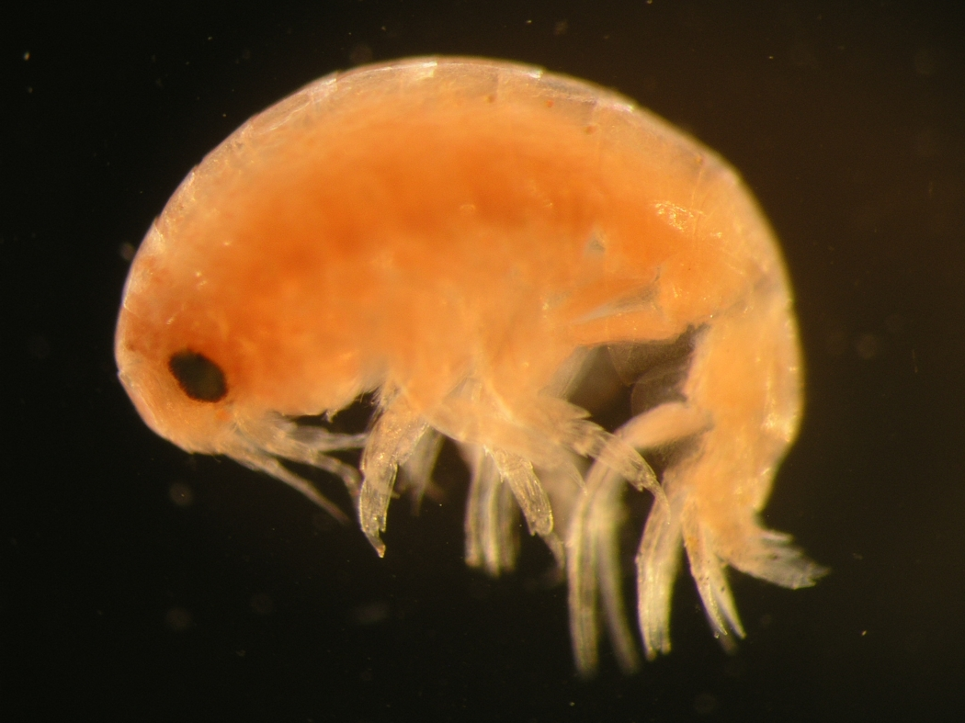
Aristias tumidus from the arctic NWP (Photo by Zosia Joanna Legezynska)

Key to NEP Aristias species (modified from Gurjanova 1962) dcadien, 6 Jan 2007

1a. Eyes absent or obscure, suggested only by tissue density.........................................2
1b. Eyes present, pigmented, obvious..............................................................................3
2a. Telson cleft 1/3 length or less.......................................................................A. expers
2b. Telson cleft 2/3 length or more...............................................................A androgans
3a. Inner ramus of uropod 3 shorter than segment 1 of outer ramus................A. tumidus
3b. Inner ramus of uropod 3 equal to or longer than segment 1 of outer ramus..............4
4a. Telsonic apices each bearing two stout spines..........................................A. pacificus
4b. Telsonic apices each bearing a single stout spine......................................................5
5a. Uropod 1 peduncle bearing 4-5 spines on lateral margins; posterior lobe of basis of
pereopod 7 with 4 posterior denticles; epimeron 1 shield shaped, bearing a small
but acute spine ventrally.........................................................................A. veleronis
5b. Uropod 1 peduncle bearing 12-14 spines on lateral margins; posterior lobe of basis
of pereopod 7 with 7-12 posterior denticles; epimeron 1 subquadrate, lacking
spine on posteroventral corner.......................................................................A. sp A
“Cebocaris” group – Members of this group are all swimmers, and are in general known as meso- or bathypelagic taxa. The group does contain, however, the genus Lepidepecreela, some members of which have demonstrated symbiotic relationships with benthic taxa. Whether or not the swimming habitus also applies to the commensal Lepidepecreela taxa is not known.
Description. “Head free, not coalesced with pereonite 1; exposed, or concealed or partially concealed; much deeper than long; rostrum absent; eyes absent. Body laterally compressed; cuticle smooth. Antenna 1 shorter than antenna 2, or subequal to antenna 2; peduncle with sparse robust and slender setae; 3-articulate; peduncular article 1 subequal to article 2, or longer than article 2; antenna 1 article 2 shorter than article 3, or subequal to article 3, or longer than article 3; peduncular articles 1-2 not geniculate; accessory flagellum present, or absent; antenna 1 callynophore present, or absent. Antenna 2 present; short, or medium length; articles not folded in zigzag fashion; without hook-like process; flagellum shorter than peduncle, or longer than peduncle; 5 or more articulate, or less than 5-articulate; not clavate; calceoli present, or absent. Mouthparts well developed or reduced. Mandible incisor smooth, or left minutely dentate, right smooth; lacinia mobilis present on left side only, or absent; accessory setal row without distal tuft; molar present or absent, medium, non-triturative; palp present. Maxilla 1 present; inner plate present, strongly setose along medial margin or weakly setose apically; palp present, not clavate, 2 -articulate. Maxilla 2 inner plate present; outer plate present. Maxilliped inner and outer plates well developed or reduced, palps present, well developed or reduced; inner plates well developed, separate; outer plates present, large or small; palp 4-articulate, article 3 without rugosities. Labium smooth. Pereon. Pereonites 1-7 separate; complete; sternal gills absent; pleurae absent. Coxae 1-7 well developed, none fused with pereonites. Coxae 1-4 longer than broad or as long as broad or broader than long, overlapping, coxae not acuminate. Coxae 1-3 not successively smaller, coxa 1 vestigial or coxae 1-2 vestigial or coxae 1-3 vestigial. Coxae 2-4 none immensely broadened. Gnathopod 1 not sexually dimorphic; smaller (or weaker) than gnathopod 2; smaller than coxa 2, or subequal to coxa 2; gnathopod 1 merus and carpus not rotated; gnathopod 1 carpus/propodus not cantilevered; subequal to propodus, or longer than propodus; gnathopod 1 not produced along posterior margin of propodus; dactylus large. Gnathopod 2 not sexually dimorphic; simple, or subchelate; coxa smaller than but not hidden by coxa 3, or smaller than and mostly hidden by coxa 3, or subequal to but not hidden by coxa 3; ischium elongate; merus not fused along posterior margin of carpus or produced away from it; carpus/propodus not cantilevered, carpus elongate, longer than propodus, not produced along posterior margin of propodus. Pereopods heteropodous (3-4 directed posteriorly, 5-7 directed anteriorly), some or all prehensile. Pereopod 3 well developed. Pereopod 4 well developed. 3-4 not glandular; 3-7 without hooded dactyli, 3-7 propodi without distal spurs. Coxa well developed, longer than broad or as long as broad or broader than long or expanded distally; carpus shorter than propodus or subequal to propodus, produced anteriorly; dactylus well developed. Coxa subequal to coxa 3 or larger than coxa 3, not acuminate, with well developed posteroventral lobe or without posteroventral lobe; carpus not produced. Pereopods 5-7 with few robust or slender setae; dactyli without slender or robust setae. Pereopod 5 well developed; shorter than pereopod 6; coxa smaller than coxa 4 or subequal to coxa 4 or larger than coxa 4, with ventrally produced posterior lobe or without posterior lobe; basis expanded or slightly expanded or linear, subrectangular or subovate, with posteroventral lobe or without posteroventral lobe; merus/carpus free; carpus linear; setae absent. Pereopod 6 subequal in length to pereopod 7; merus/carpus free; dactylus without setae. Pereopod 7 with 6-7 well developed articles; longer than pereopod 5; similar in structure to pereopod 6; with 7 articles; basis expanded or linear, without dense slender setae; dactylus without setae. Pleon. Pleonites 1-3 without transverse dorsal serrations, without dorsal carina; without slender or robust dorsal setae. Epimera 1-3 present. Epimeron 1 well developed. Epimeron 2 without setae. Urosome not dorsoventrally flattened; urosomites 1 to 3 free, or 1 free, 2 and 3 coalesced; urosomite 1 shorter than urosomite 2, or longer than urosomite 2; urosome urosomites not carinate; urosomites 1-2 without transverse dorsal serrations. Uropods 1-2 apices of rami without robust setae. Uropods 1-3 similar in structure and size. Uropod 1 peduncle without long plumose setae, without basofacial robust seta, without ventromedial spur. Uropod 2 well developed; without ventromedial spur, without dorsal flange; inner ramus shorter than outer ramus, or subequal to outer ramus, or longer than outer ramus. Uropod 3 not sexually dimorphic; peduncle short or elongate; outer ramus longer than peduncle, 1-articulate or 2-articulate, without recurved spines. Telson laminar; deeply cleft, or moderately cleft, or entire; longer than broad, or as long as broad, or broader than long; apical robust setae present, or absent. (Lowry and Springthorpe 2001)
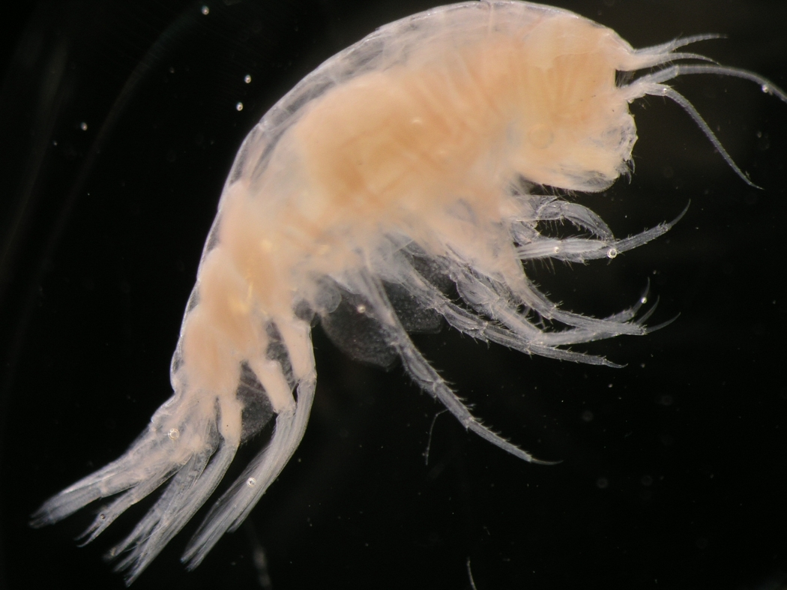
Cyclocaris guilelmi a cebocarid amphipod (Photo: Zosia Joanna Legezynska)
Cyclocaris – One of the two species in this genus occurs in the NEP, C. guilelmi (see photograph above). While this species seems cosmopolitan in the world ocean, its congener has a restricted distribution in the South Pacific (J. L. Barnard and Karaman 1991). This second species C. tahitiensis has been reported from vent collections along the East Pacific Rise at 21° N by Vinogradov (1993), the first record outside the type locality. Until more details are available, this record is viewed as provisional. These animals are pelagic, having an appearance similar to some hyperiids. Cyclocaris guilelmi was the most numerous of the species of pelagic gammaridians taken during the Vityaz cruises in the NWP (Birstein and Vinogradov 1970), but was smaller than many of the other lysianassoids at only 3-8mm length. J. L. Barnard (1959) figures the species well, but does not provide a whole body illustration (for which see the photograph above).
Lepidepecreela – The single NEP representative of the genus, L. charno, is probably a bathypelagic species. It was taken at 1895m in the San Clemente Basin; the female holotype remaining unique. J. L. Barnard (1966b, Figure 17) provides good illustrations, and also a key to the genus as known at the time. As mentioned earlier, at least one member of this genus is associated with an echinoid (Berge et al. 2004). There is nothing to suggest such an association for the local taxon, although several echinoids occur in abundance at the depth from which it was taken.
Metacyphocaris – Monotypic, containing only M. helgae. Shoemaker (1945) discusses this taxon, and repeats earlier records, including Thorsteinson’s (1941) record from the Gulf of Alaska, which established the presence of the species in the NEP. Hurley (1963) reproduces Tattersall’s figure of the anterior of the species, and provides additional records from the NEP. Another pelagic species taken in or over deep water, and unlikely to feature in collections made within the Southern California Borderland.
“Conicostomatid” group – Description “Species of the conicostomatid group...are characterized by robust bodies with the mouthparts grouped in a conical bundle beneath the head, deep coxae with short stocky legs and a compact urosome. The antennae are short in both males and females, but the accessory flagellum can be completely absent, small, or as long as the primary flagellum. Calceoli are not present. The head is small and may be completely or partially concealed by pereonite 1 and coxa 1. The conical or subconical mouthpart bundle is prominent. The mandible is narrow and elongate, with an incisor that may vary from well-developed to vestigial but always has a smooth cutting edge. The molar is vestigial or absent. The mandibular palp, which is always 3-articulate, is attached proximal to the molar and often extremely proximally. The palp of maxilla 1 may vary from 2-articulate to absent. The maxilliped dominates the mouthpart bundle with its greatly enlarged outer plates. The inner plates are usually elongate and styliform but occasionally are short and subquadrate. Maxillipedal palps are 3- or 4-articulate, but article 4, if present, is always small. The coxae are large and deep and coxa 4 has a well-developed posteroventral lobe. Gnathopod 1 is simple, moderately developed, neither styliform nor powerful. Gnathopod 2 may be minutely subchelate or minutely chelate and occasionally the dactyl is absent. The pereopods are short and stocky with article 4 of pereopods 5 to 7 expanded posteriorly. Gills are present from gnathopod 2 to pereopod 6, except in one genus, Phoxostoma, which has a vestigial gill on pereopod 7. The urosomites are compact, not coalesced and bear short uropods in which the rami may be reduced or absent. The telson is flat or hemiacetabulate, slightly to deeply incised, occasionally entire.” (Lowry and Stoddart 1983)
Acidostoma – Two species are reported from the NEP, one from shelf depths, and one from the Baja Abyssal Plain. Acidostoma hancocki is relatively common in coarse sediments with shell hash on the inner shelf in the SCB. Acidostoma obesum ortum is uncommon, known only from a few females and juveniles from the type locality. J. L. Barnard (1967) differentiates A. obesum ortum from A. hancocki by its longer telson and blunter tooth on the third epimeron. See Hurley (1963) for A. hancocki description.
Ocosingo – A single species is known from the NEP, and a second species from New Zealand (Lowry and Stoddart 1984). Ocosingo borlus was described by J. L. Barnard (1963a) from shallow water off northern Baja California and San Diego, California. He later refound it in intertidal samples from central California (J. L. Barnard 1969a). In the latter publication he described a new genus and species, Fresnillo fimbriatus, which he noted was quite similar to Ocosingo in many respects. Lowry and Stoddart (1983), in establishing the conicostomatid group, reviewed the existing genera. They synonymized the two genera, suggesting that Fresnillo was based on the secondary male form of Ocosingo borlus. This paralelled the morphology of secondary males seen in other genera within the group. They covered the sexual morphology of these animals again in a later publication (Lowry and Stoddart 1986) which reported on protandrous hermaphroditism in the lysianassoids. This was revisited (Lowry and Stoddart 1997) in their description of the genus Eclecticus. Good descriptions of O. borlus are presented in J. L. Barnard (1963a, 1969a), which should be consulted for identification.
Socarnoides – J. L. Barnard and Karaman (1991) place 4 species in this genus, excluding S. indentata Ledoyer 1986 (“not this genus”): the holotype S. kergueleni from the Subantarctic; S. unidentatus from the Magellanic region; S. eugenovi from the subArctic north Atlantic, and the Boreal NWP; and S. illudens from the NEP. The local species is infrequently taken although ocurring relatively broadly at shelf depths. No whole animal figure of S. illudens is presented by Hurley (1963), but the appropriate parts are illustrated, the animal is described, and a key to some related genera is provided.
Stomacontion – A single species of a single unnamed taxon is known from the NEP. It was reported as Acontiostoma sp by Hurley (1963) based on a single small specimen taken among tunicates on rocky bottom on the San Pedro Seashelf at 20m. He declined to name or fully describe the taxon based on this inadequate material. His illustration shows a typical urosome for either Acontiostoma or Stomacontion, two genera which have frequently been synonymized. Unfortunately he neither illustrated nor described the head of the specimen, which would have made the generic choice more obvious. The record has been transferred to Stomacontion based on Hurley’s statement that Acontiostoma pepini and A. kergueleni were the taxa most similar to the material at hand. Acontiostoma pepini is the generotype of Stomacontion, and A. kergueleni is a synonym of it. The two genera have been maintained valid since arguments in favor of that approach were made by Lowry and Stoddart (1983) in their review of the conicostomatid genera. In their allocation of species level taxa J. L. Barnard and Karaman (1991) did not place Hurley’s record in either Acontiostoma or Stomacontion, both of which they retained as valid genera. No additional material of this animal has come to light since, and it remains an undersampled mystery. If the specimen can be located in the collections of the Allan Hancock Foundation now on deposit at the Natural History Museum of Los Angeles County, perhaps more light can be shed on the proper placement of this taxon.

Family Cyphocarididae – members of this family are usually taken in midwater collections, but also figure prominently in some benthic collections. They are very common in Puget Sound, where they are routinely taken in benthic grab samples. It is likely that the animals spend a significant amount of their time swimming, although they are based on the bottom.
Diagnosis: “Head: much deeper than long. Antennae: calceoli present or absent. Epistome and upper lip separate. Mandible: incisors small, convex, symmetrical; left lacinia mobilis a stemmed, distally serrate blade; accessory setal row without distal setal tuft; molar columnar, triturating. Maxilla 1: inner plate usually strongly setose, always more than 2 pappose setae; outer plate broad, setal-teeth in a 6/5 arrangement; palp large, 2 articulate. Maxilliped: outer plate with or without apical slender pappose setae, without apical robust setae. Gnathopod 1: simple or weakly subchelate. Coxa 1: vestigial; coxa 2 very small; coxa 3 vestigial or large. Pereopods 3-7: simple or weakly prehensile, propodus without distal spur. Telson: deeply cleft.” (Lowry and Stoddart 1997)

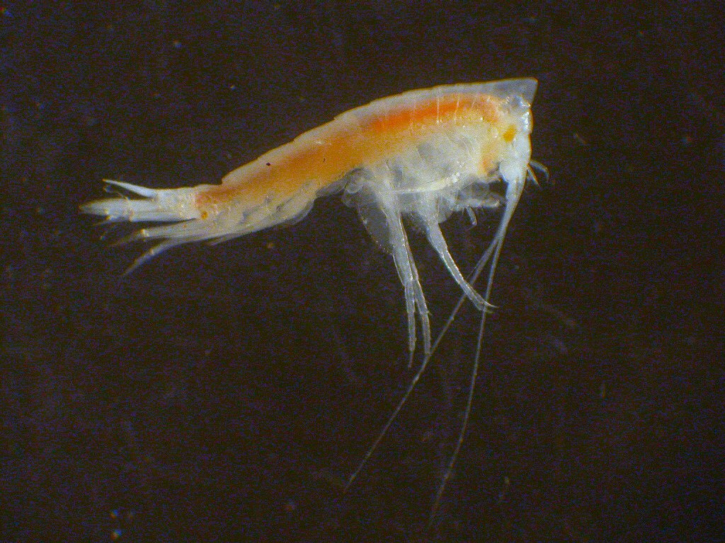
Cyphocaris challengeri, a common component in the benthic community of Puget Sound and
the west coast of British Columbia (Photo from Fisheries and Oceans Canada)

Cyphocaris – As can be seen in the accompanying photograph of C. challengeri, Cyphocaris species appear somewhat different from many lysianassoids, particularly benthic forms. Their swimming activities are facilitated by a slim, relatively elongate body, and a modified head somewhat reminiscent of the galeate head of synopiids. Adults are outlandishly outfitted with head spikes, large and often long saw-blades or smooth spikes extending back from the basis of the 5th pereopod, and other distinctive features. Conveniently, Schellenberg (1926b) provides in his Plate V whole body illustrations of each of four of the five species recorded from the NEP; C. anonyx, C. challengeri, C. faurei, and C. richardi (the fifth species, C. latirama, lacks both a produced head and a posterior projection on the basis of P5, so can be easily separated from the other species). He provides illustrations of the 5th legs of these species in Text Figure 2. Features of the head and the protuberance on the 5th leg (or lack thereof in C. richardi) seem highly distinctive. One should, however, also pay attention to the variation in these features illustrated by Schellenberg (1926b), Bowman and McCain (1967), and others (i.e. Shoemaker 1945, Fig. 1; J. L. Barnard 1954, Plt. 2). There is considerable variation with size and age in some features, and in proportions, so be careful in your examination and evaluation of these animals.
Behavior of males, females, and juveniles may also dictate that you will see only a small subset of the population in any given sample. Thurston (1976a) documents the distribution of various parts of the C. challengeri population over time during a series of midwater tows in the North Atlantic. He found that adult males and adult females occupied different vertical segments of the water column, and that they were both generally separated from the juveniles. Brusca (1967) summarized the day/night distribution of C. richardi off California, but did not segregate by sex.
Procyphocaris – Looks much more like a “typical” lysianassoid, lacking the head and leg extravagances of Cyphocaris. There is only a single NEP record for any member of the genus, from deep water off Pt. Conception (Hendrycks and Conlan 2003). They record P. indurata, originally known from Africa. The genus was erected by J. L. Barnard (1961) to house his P. primata, which has been recognized as a synonym of the earlier Uristes induratus of K. H. Barnard (1925). Records of P. indurata from elsewhere in the depths of the world ocean demonstrate it will probably prove to be cosmopolitan. The genus is now monotypic with the synonymy of the two species listed in J. L. Barnard and Karaman (1991) as comprising it. It is distinguished from other cyphocaridid genera by details of the mandibular palp and molar (J. L. Barnard 1961)

Family Endevouridae – Diagnosis: “Head: as long as deep or deeper than long. Antennae: calceoli absent. Epistome and upper lip separate. Mandible: incisors small, convex, symmetrical; lacinia mobilis absent; accessory setal row with distal setal tuft; molar smooth or weakly ridged; setose or not. Maxilla 1: inner plate with less than 2 apical setae; outer plate narrow, with setal-teeth in a modified 6/5 arrangement; palp large, 2-articulate. Maxilliped: outer plate without apical slender or robust setae. Gnathopod 1: simple. Coxae 1-4 large, longer than broad, overlapping. Pereopod 3: subchelate or chelate, propodus enlarged. Pereopods 4-7 simple, propodus without distal spur. Telson: entire.” (Lowry and Stoddart 1997). The family contains two genera, one in the NEP.
Ensayara – With the type E. ramonella in the NEP, and other species from New Zealand, Mauritius, and the Mediterranean (Lowry and Stoddart 1983). Four additional species have been described in the genus since: E. denarius from Japan (Hirayama 1985), E. microphthalma from Madagascar (Ledoyer 1986), E. entrichoma from Bermuda (Gable and Lazo-Wazem 1990), and E. jumanae from Belize (J. L. Barnard and Thomas 1990). Ensayara ramonella was described from Bahia San Quintin on the West coast of Baja California. The original description (J. L. Barnard 1964a) should be consulted for details. Like the type genus of the family Endevoura, Ensayara has a large chelate 3rd pereopod. This is much more prominent than either the simple 1st gnathopod, or the typically mitten-shaped 2nd gnathopod. No other NEP genus or species shares this character. Ensayara ramonella has been recorded only from the type locality to date. [Please note: Ledoyer (1986) listed the two species he discussed as Ensaraya throughout his text; a lapsus]
Eurytheneidae – The family, as defined by Stoddart and Lowry (2004), contains only the genus Eurythenes. Diagnosis “Head exposed, much deeper than long, not extending much below insertion of antenna 2, without cheek notch. Antennae with calceoli present in male, absent in female. Antenna 1 with well developed two-field callynophore in male and female. Antenna 2 peduncular article 3 without distal hook. Mouthpart bundle subquadrate. Epistome and upper lip separate. Mandible incisors present, well developed, symmetrical, convex, smooth; right lacinia mobilis absent; accessory setal row without distal setal tuft; molar a setose tongue, with small triturating surface; palp present, inserted approximately mid-anteriorly. Maxilla 1 inner plate with more than two apical pappose setae; outer plate narrow with setal-teeth in 8/3 crown arrangement, setal-teeth large, ST6 and ST7 slender, ST7 slightly displaced from ST6; palp large, with apical robust setae. Maxilla 2 inner plate significantly shorter than outer plate. Maxilliped outer plate present, medial setae small, blunt or bead-shaped; palp four-articulate, article 4 well developed. Gnathopod 1 subchelate to parachelate; coxa vestigial; merus and carpus not rotated; carpus short; propodus large, palm straight to convex; dactylus slightly curved, not hidden by setae. Gnathopod 2 coxa small, shorter than coxa 3. Pereopods all simple; distal spurs absent. Pereopod 3 coxa large. Pereopod 4 coxa large with well developed posteroventral lobe. Pereopod 5 coxa with anterior and posterior lobes subequal. Uropod 2 inner ramus without constriction. Uropod 3 biramus. Telson present, cleft.” (Stoddart and Lowry 2004)

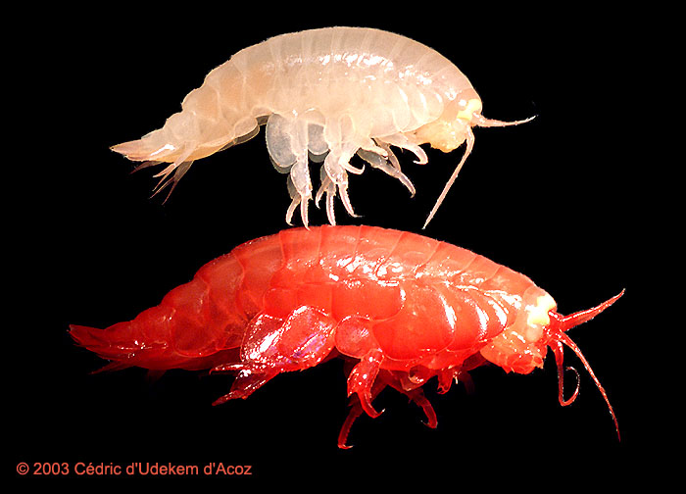
Eurythenes gryllus (Lichtenstein, 1822) - Young specimen (up) and mature specimen (down)
- Western Spitsbergen, off Kongsfjord, over 1000 m depth, September 2003 - Original picture:
Identification, photography, scanning, © Cédric d'Udekem d'Acoz

Eurythenes – Eurythenes are very widely distributed abyssal scavengers. Speciation in the genus has been controversial. We currently have two species listed as occurring in the NEP, E. gryllus and E. obesus. While some consider the two species synonyms, evidence presented by Thurston and Bett (1995, but see also J. L. Barnard 1961) validates their separation. E. obesus was originally described in a different genus, Katius, and is found under that name in some literature (i.e. Shoemaker 1920,1956). While E. gryllus is recorded from appropriate habitat all over the globe, genetic investigations (France and Kocher 1996) suggest that what is currently viewed as a single taxon morphologically has significant haplotype disparity genetically. One of these differing haplotypes has recently been separated as a third species in the genus (Stoddart and Lowry 2004) with a disjunct distribution in the southern Pacific and the tropical western Atlantic.
These amphipods grow quite large, with adult sizes to at least 120mm. They are active necrophagic scavengers, and are routinely taken in baited traps. In situ observations are reported by Bowman and Manning (1972), and Smith and Baldwin (1984) comment on the natural history of the animal. A thorough and extensive summary of the literature on E. gryllus is provided by Stoddart and Lowry (2004), which should be consulted for additional information not provided by the references cited above.
Family Hirondelleidae - Description. “Head free, not coalesced with pereonite 1; exposed; deeper than long; anteroventral margin rounded or oblique, anteroventral corner subquadrate or absent; rostrum absent; eyes present, well developed or obsolescent, or absent; not coalesced; 1 pair, or trioculate; not bulging. Body laterally compressed; cuticle smooth. Antenna 1 shorter than antenna 2, or subequal to antenna 2; peduncle with sparse robust and slender setae; 3-articulate; peduncular article 1 longer than article 2; antenna 1 article 2 longer than article 3; peduncular articles 1-2 not geniculate; accessory flagellum present; antenna 1 callynophore present. Antenna 2 present; short; articles not folded in zigzag fashion; without hook-like process; flagellum as long as peduncle; 5 or more articulate; not clavate; calceoli present, or absent (?). Mouthparts well developed. Mandible incisor smooth; lacinia mobilis present on left side only; accessory setal row without distal tuft; molar present, medium, non-triturative; palp present. Maxilla 1 present; inner plate present, weakly setose apically; palp present, not clavate, 2 -articulate. Maxilla 2 inner plate present; outer plate present. Maxilliped inner and outer plates well developed or reduced, palps present, well developed or reduced; inner plates well developed, separate; outer plates present, small; palp 4-articulate, article 3 without rugosities. Labium smooth. Pereon. Pereonites 1-7 separate; complete; sternal gills absent; pleurae absent. Coxae 1-7 well developed, none fused with pereonites. Coxae 1-4 longer than broad, overlapping, coxae not acuminate. Coxae 1-3 not successively smaller, coxa 1 vestigial. Coxae 2-4 none immensely broadened. Gnathopod 1 not sexually dimorphic; smaller (or weaker) than gnathopod 2; vestigial, hidden or partially hidden by coxa 2, or smaller than coxa 2; gnathopod 1 merus and carpus not rotated; gnathopod 1 carpus/propodus not cantilevered; shorter than propodus, or subequal to propodus; gnathopod 1 not produced along posterior margin of propodus; dactylus large. Gnathopod 2 not sexually dimorphic; subchelate, or chelate; coxa subequal to but not hidden by coxa 3; ischium elongate; merus not fused along posterior margin of carpus or produced away from it; carpus/propodus not cantilevered, carpus elongate, longer than propodus, not produced along posterior margin of propodus. Pereopods heteropodous (3-4 directed posteriorly, 5-7 directed anteriorly), none prehensile. Pereopod 3 well developed. Pereopod 4 well developed. 3-4 not glandular; 3-7 without hooded dactyli, 3-7 propodi without distal spurs. Coxa well developed, longer than broad; carpus shorter than propodus, produced anteriorly or not produced; dactylus well developed. Coxa larger than coxa 3, not acuminate, with well developed posteroventral lobe; carpus not produced. Pereopods 5-7 with few robust or slender setae; dactyli without slender or robust setae. Pereopod 5 well developed; subequal in length to pereopod 6; coxa smaller than coxa 4, without posterior lobe; basis expanded, subrectangular, without posteroventral lobe; merus/carpus free; carpus linear; setae absent. Pereopod 6 subequal in length to pereopod 7; merus/carpus free; dactylus without setae. Pereopod 7 with 6-7 well developed articles; subequal to pereopod 5, or longer than pereopod 5; similar in structure to pereopod 6; with 7 articles; basis expanded, without dense slender setae; dactylus without setae.
Pleon. Pleonites 1-3 without transverse dorsal serrations, without dorsal carina; without slender or robust dorsal setae. Epimera 1-3 present. Epimeron 1 well developed. Epimeron 2 without setae. Urosome not dorsoventrally flattened; urosomites 1 to 3 free; urosomite 1 subequal to urosomite 2, or longer than urosomite 2; urosome urosomites not carinate; urosomites 1-2 without transverse dorsal serrations. Uropods 1-2 apices of rami without robust setae. Uropods 1-3 similar in structure and size. Uropod 1 peduncle without long plumose setae, without basofacial robust seta, without ventromedial spur. Uropod 2 well developed; without ventromedial spur, without dorsal flange; inner ramus subequal to outer ramus, or longer than outer ramus. Uropod 3 not sexually dimorphic; peduncle elongate; outer ramus longer than peduncle, 2-articulate, without recurved spines. Telson laminar; moderately cleft; longer than broad; apical robust setae present, or absent” (Lowry and Springthorpe 2001)
Hirondellea – J. L. Barnard and Karaman (1991) list seven species in the genus, all of which are known from deep water, and most from trenches. Two additional species were described by J. L. Barnard and Ingram (1990) from vents in the NEP. All are necrophages, and are usually taken in large numbers in baited traps (see in situ photo of H. gigas at the bottom of the Philippine Trench on pg. 3). Hirondellea are an order of magnitude smaller than the largest of the alicellid necrophages (Alicella gigantea), and probably do not exceed 35mm in length.
Of the four species reported from the NEP, only one – H. fidenter is from an area which might reasonably be sampled by public agencies at some point in the future. It was taken from the San Nicholas Basin, within the Southern California Borderland. The other three are from much further afield; H brevicaudata from abyssal traps well away from shore, H. guyoti from the Hess Guyot, and H. glutonis from vents on the East Pacific Rise at 13°N and the Galapagos Rift zone. All species are keyed by J. L. Barnard and Ingram (1990), and their key should easily separate all of the NEP taxa.
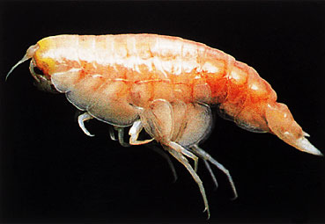 Hirondellea gigas from 10900m in the Challenger Deep section of the Mariana Trench, currently the deepest capture record of an amphipod
Family Hyperiopsidae – Diagnosis: “ Accessory flagellum well developed. Article 1 of primary flagellum on antenna 1 formed of fused basal articles, elongate. Article 5 of peduncle on antenna 2 very short. At least one palp of maxilla 1 bent or claviform. Gnathopods feeble. Article 4 of pereopods 3-4 greatly elongate relative to article 5. (J. L. Barnard and Karaman 1991)
The family consists of only two genera, both represented in the NEP. A key to separate the two is provided by J. L. Barnard and Karaman (1991, pg. 373). Inclusion of this family within the lysianassoids remains controversial, and is contraindicated by some phylogenetic analyses (i.e. Berge, Boxshall and Vader 2000).
Hyperiopsis – A small genus of seven described species (J.L. Barnard and Karaman 1991), none of which are known from the NEP. There are, however, records of several different taxa in the region which remain provisional. Hendrycks and Conlan (2003) record a species of Hyperiopsis from off Point Conception at 3450m. The specimen was immature. They noted it was similar to, but differed from, Hyperiopsis laticarpa from the Western Pacific. Since the single specimen was too immature to sex they declined to describe the material. Their H. sp. record does not reflect the same animal as the second regional provisional, Hyperiopsis sp CS1 from 1372m off Oregon. The later species is strongly characterized by a long rostrum, unusual in the genus. Parargissa – The genus contains 6 species, most described from the Western Pacific (J. L. Barnard and Karaman 1991). A single species is reported from the NEP, P. americana. We treat it here as a full species, although it is often only accorded subspecific status as P. galatheae americana (i.e. J. L. Barnard and Karaman 1991). The animal is known only from the initial collection at 3750m between Acapulco and Panama. The unique female holotype is rather large at 42mm. J. L. Barnard (1961) illustrates the differences between this and the closely related P. galatheae.

Family Lysianassidae - Diagnosis: “Head: exposed, concealed or partially concealed; as long as deep, longer than deep or deeper than long. Antennae: calceoli present or absent. Epistome and upper lip: separate or fused. Mandible: incisor smooth; lacinia mobilis present on left side only or absent; accessory setal row without distal setal tuft; molar present or absent, if present vestigial, small or medium size, setose with reduced triturating patch, fully setose, or a smooth nonsetose flap. Maxilla 1: inner plate weakly setose (6 or less) or without setae; outer plate narrow, with 11 setal-teeth in 6/5 or modified 6/5 arrangement; palp small or large, 1- or 2-articulate, with or without terminal robust setae. Maxilliped: without apical robust setae. Coxae 1 to 4 longer than broad, overlapping; coxa 1 fully developed or slightly reduced. Gnathopod 1: simple, occasionally weakly subchelate or parachelate. Pereopods simple. Telson usually entire, occasionally deeply moderately or weakly cleft or notched.” (Lowry and Stoddart 1997)

Within this family various authors have reached different conclusions regarding synonymy and validity at generic and subgeneric levels. This is particularly true in the cluster of genera including Orchomene, Orchomenella, Orchomenopsis, Allogaussia, and Abyssorchomene. Discussion of these issues will be provided under the genus Orchomene below. The best supported case appears to be that developed by De Broyer in a long series of papers dealing with Orchomene and related forms in the southern ocean. In general his conclusions will be followed here. Similar problems have persisted regarding the cluster of Aruga, Lysianopsis, and Shoemakerella. These genera were synonymized in Hurley (1963) following the suggestions of some earlier workers. Since then they have been treated as valid genera by Lowry and Stoddart (1997), and are so treated here. These two histories exemplify the trend of lysianassid taxonomy, with the recognition of increasingly small features as forming valid generic boundaries in convergent clusters of species. In particular, the separation of species typified by either the 7/4 or 6/5 terminal spine-seta arrangements on the maxilla 1 outer plate has helped recognition of evolutionary trajectories within the group. [The usage of spine formulae and the various arrangements are detailed in Lowry and Stoddart 1992]
Abyssorchomene – Created by De Broyer based on a cladistic analysis of the complex of species centered on Orchomene, this genus has two members in the NEP, and at least three others elsewhere (Bellan-Santini 1990). The NEP taxa are treated in J. L. Barnard and Ingram (1990) as Orchomene species, with Abyssorchomene relegated to subgeneric status. This placement is rejected here based on De Broyer’s findings, and Abyssorchomene is viewed as a valid generic level taxon (see discussion under Orchomene). They characterize the taxon as having a mandibular molar like that of Orchomene, a maxilliped like that of Orchomenella and a gnathopod 1 like that of Orchomenopsis. This sort of structural convergence is one of the factors that convinced J. L. Barnard that more information was needed before the systematics of the lysianassids could be firmly established. His untimely death prevented further contributions by him to this resolution. Both A. abyssorum and A. distinctus occur on abyssal plains, and were taken in association with hydrothermal venting areas in the NEP.
It is not clear if either of the two reported species are identical with the forms reported by France (1994) from the San Clemente Basin. His maintenance of two morphologically separable forms, Abyssorchomene sp. 1 and Abyssorchomene sp. 2 is suggestive, but must remain inconclusive. Since both were taken at significantly shallower depths than either of the two other species reported from the NEP, and in a different ecological context, it is more likely that they represent as yet unnamed species in the genus from the area.
Aruga – The genus is small, containing only three species (J. L. Barnard and Karaman 1991). Subsequently Aruga subantarctica was removed to the genus Lysianopsis (Lowry and Stoddart 1997) leaving only the two species from the NEP in the genus. These two, Aruga holmesi and A. oculata both occur in shallow waters within the SCB, and both are reported by local monitoring agencies. They can easily be distinguished by the condition of the third epimeron, which is convexly rounded in A. holmesi, and truncated subquadrate in A. oculata. Holmes (1908) and J. L. Barnard (1955) should be consulted for the original descriptions. The latter also presents the possibility that Nannonyx dissimilis of Stout might be an Aruga, a placement later rejected in favor of formation of a new genus to receive it (J. L. Barnard and Karaman 1991).
Hurley (1963, pp. 67-73) considered Aruga, along with the genus Shoemakerella, to be synonyms of the genus Lysianopsis. Some workers accepted his arguments, but in recent years Aruga has been viewed as valid, as has Shoemakerella (see Lowry and Stoddart 1997). Generic boundaries within the lysianassids are subject to frequent and heated debate, with a series of different views on the validity or invalidity of genera. We follow the revisionary treatments of Lowry and Stoddart here, accepting Aruga as valid and separable from other related genera within the family Lysianassidae.
Despite the prevalence of cognate species pairs in the tropical west Atlantic and east Pacific now separated by the closure of the Isthmus of Panama, Aruga holmesi is found across the barrier. It was reported as widely distributed on the Florida Middle Ground by Lowry and Stoddart (1997), and is even more broadly distributed in the eastern Pacific. Why this animal has not evolved into two distinct cognates since the closure of the land bridge as so many others have (i.e. cognate pairs in Ensayara, Rimakoroga, and Dissiminassa) remains an unanswered question.
Cedrosella – Originally described as Ambasiopsis fomes by J. L. Barnard 1967 (“the generic assignment of the species is uncertain” loc. cit. pg. 50), this species was transferred to the newly created Cedrosella by J. L. Barnard and Karaman (1987). The genus remains monotypic. C. fomes was taken on the Baja Abyssal Plain, and is known only from the small, unique male holotype. J. L. Barnard and Karaman (1991) contrast its characters with those of other similar lysianassoids.
Dissiminassa – The genus was created by J. L. Barnard and Karaman (1991) to house Nannonyx dissimilis Stout 1913. A second species has been described from Florida by Lowry and Stoddart (1997), D. homosassa. These are the only two species known for the genus. It appears to be closely related to Aruga (Lowry and Stoddart 1997). Shoemaker (1942) and J. L. Barnard (1969a) both provided good redescriptions and illustrations of D. dissimilis, and are probably better sources for information than the original description. J. L. Barnard also provided a key to separate the species of Lysianassa from California (loc. cit. pg. 186). These species are now allocated to the genera Aruga, Dissiminassa, and Macronassa, but the key still functions well and might be used for separation of these related forms. Known primarily from intertidal and fouling occurrences in California, members of the genus occur to 73m depths in both the eastern Pacific and western Atlantic.

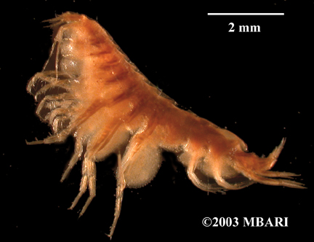
The lysianassid Hippomedon columbianus (Photo courtesy MBARI)

Hippomedon – One of the earlier lysianassoid genera, many species originally described as Hippomedon have been later removed to other genera. The concept of the genus was revised and (hopefully) refined by Jarrett and Bousfield in 1982. J. L. Barnard and Karaman (1991) seem to have accepted their redefinition of the genus. They list 49 species in the genus, with another 6 species described by 2004 (Vader 2004). The genus is known worldwide in cool or cold waters, and from the intertidal to abyssal plains. In the NEP there are records of 10 species assigned to Hippomedon. One of these taxa is a provisional from off Oregon erected by Dickinson, for which we have no information. A second species, H. keldyshi was described from deep water in the NEP. These two species are not covered in the key to the genus constructed for SCAMIT by Doug Diener when his H. sp A was introduced. While this key remains useful (and recommended for use) it includes a number of forms which are only known from the Arctic or the NW Pacific. When using the key please keep in mind that not all of the included species occur in our study area. If you arrive at an identification of one of these species, please carefully consult the description of the animal prior to accepting the indicated identification. We already have far too many spurious records of taxa which do not occur in our area (such as H. denticulatus) based on confusion introduced by previous misidentifications and misinterpretations in the literature (see for example the discussion of Hippomedon species in J. L. Barnard 1971). While the Dickinson species must remain unkeyed, H. keldyshi would key out to H. propinquus in the Diener key. Since H. propinquus is not currently known from validly identified NEP specimens, animals that key here may be presumed to be H. keldyshi and validated by checking against the illustrations of the species in Vinogradov (1994).
Lepidepecreoides – A small genus, consisting of four species (Lowry and Stoddart 2002b). Only L. nubifer is known from the NEP. Although at one time also reported from the Cape Basin off South Africa (Griffiths 1977), this animal has been subsequently described as a new species (Lowry and Stoddart 2002b), and L. nubifer remains endemic off Oregon. Our species is immediately recognizable from among other NEP lysianassoids by the combination of the fingerlike crest on the first urosomite and the narrow process on the hind margin of the basis lobe of P5. The species is well described by J. L. Barnard (1971).

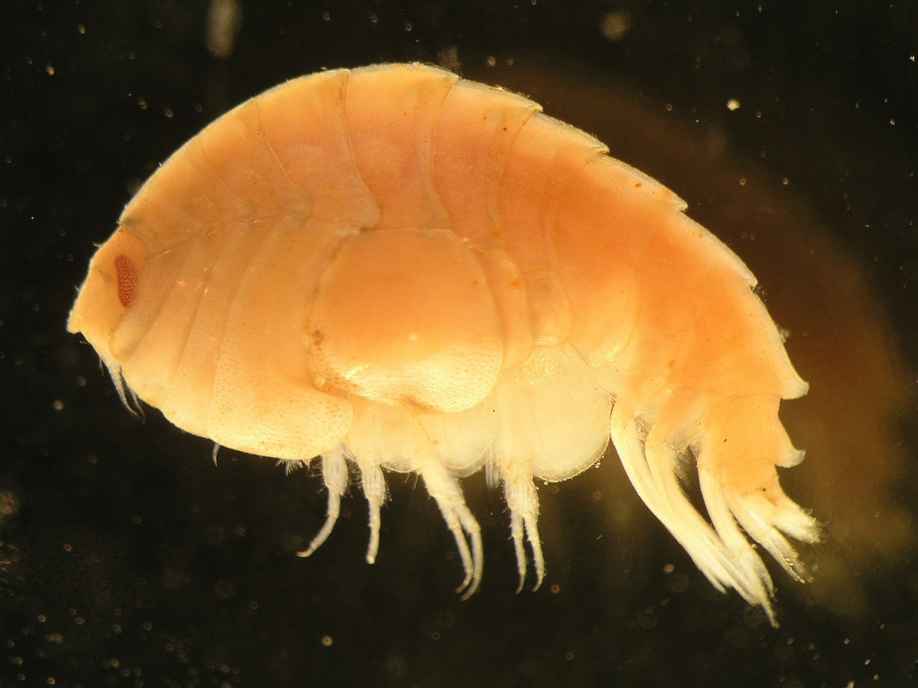
The lysianassid Lepidepecreum umbo (Photo: Zosia Joanna Legezynska)

Lepidepecreum – A large genus, with 37 described species worldwide (Lowry and Stoddart 2002b). Eight described and two provisional species in the genus are reported from the NEP, but one of the provisionals is moot due to lack of specimens or description (L. sp. a of Dickinson). There are, then, nine species level Lepidepecreum taxa in the NEP. The biology of these animals remains unknown (Lowry and Stoddart 2002b), but most species are associated with the waters of the Continental Shelf and slope. L. californiensis forms an exception, being taken at 2779m in association with hydrothermal activity, but not with active venting (Vinogradov 1994). Species can usually be distinguished by the shapes and patterns of teeth or dorsal cusps on the pereonites, pleonites, and urosomites. Four species are known from shelf and slope depths in the SCB, a fifth from the Central California slope, and a sixth from the Central California slope apron or near-shore abyssal zone. The species known as Lepidepecreum sp A in early SCAMIT lists and discussions was described as L. serraculum by Dalkey (1998).
No key to the members of the genus in the NEP is available except those of Gurjanova (1962) and Hurley (1963), neither of which is comprehensive. An attempt is made below to provide a comprehensive key to the known described and provisional species which occur in the NEP.

Key to the known Lepidepecreum from the NEP – dcadien 15 July 2007
(a provisional species will be added at a later date)

1a. No dorsal carination or dentition on posterior margin of any pleonal or
pereonal somite......................................................................magdalenensis
1b. Dorsum not smooth, bearing carina or posterodorsal teeth on some or
all pleonal or pereonal segments..................................................................2
2a. Third pleonal segment with prominent tooth or process distodorsally............4
2b. Third pleonal segment lacking prominent tooth or process, bearing at most a
low rounded knob distodorsally...................................................................3
3a. Urosomite 1 with dorsal process bluntly truncate............................serraculum
3b. Urosomite 1 with dorsal process posteriorly upswept and acuminate...............
.....................................................................................................gurjanovae
4a. No pereonites dorsally carinate or dentate, weak posterodorsal tooth on
pleonite 2, strong posteriorly directed tooth on pleonite 3................kasatka
4b Some pereonites dorsally carinate and/or dentate.............................................5
5a. Pereonites 4-7 bearing a low carina for at least some of their length, dorsal
processes or posterodorsal teeth lacking...............................................eoum
5b. Some pereonites bearing posterodistal teeth............................................. ......6
6a. Posterodistal teeth on only pereonites 5-7, pleon and urosomite 1...................
..................................................................................................californiensis
6b. Posterodistal teeth and/or processes beginning at pleonal segment 2-4..........7
7a. Posterodistal ornament beginning at pereonite 4; head bearing double carina
anteriorly, separated by furrow; coxa 5 lacking lateral plate-like boss ........................................................................................................comatum
7b. Posterodistal ornament beginning at pereonite 2 or 3; head lacking double
carina; coxa 5 bearing lateral plate-like boss......................................garthi

Macronassa – Like Aruga, Macronassa consists solely of two species from the NEP, M. macromerus and M. pariter. Both are predominantly intertidal, but range into the shallow shelf. They are associated with invertebrate turfs, or with mussel beds, algae or other complex habitats. J. L. Barnard and Karaman (1991) described the genus, and differentiate it from other related forms. The two species are described and characters which allow their separation are presented in J. L. Barnard (1969a), where both are called Lysianassa.
Orchomene – At least one of the forms listed as from the Pacific by McLaughlin et al, Orchomene nugax, is only known from the Bering Sea above the Aleutian chain, and is outside the coverage area of this review. Before considering the genus further, it might be wise to visit the results of the study of intraspecific variation in Orchomene limodes performed by Meador and Present (1985). Studies of this type are too rarely allowed by the collected material. Situations where the will to perform tiring and repeated analysis of numerous individuals exist are even less common. The above authors examined the variability of 35 different characters, and found no variation in the following: shape of lateral lobe of the head, shape of the epistome, ornamentation of posterior margin of third pleonal epimeron, shape of posterodistal corner of third pleonal epimeron, orientation of tip of dactyl to edge of palm in gnathopod 1, location of insertion of mandibular palp, extension of posteroventral lobe of article 1 of pereopod 6 relative to anterior lobe, number of spines or teeth on apex of maxilliped outer plate, number of spines on medial surface of maxilliped outer plate. These characters might be fruitfully examined in other members of the genus, with the implicit and unproven assumption that the pattern of variability will differ little among congeners.
The genus has been a source of confusion for some time. J. L. Barnard has alternatively combined and separated the genus from the similar genera Orchomenella and Orchomenopsis (see for instance his discussion of these groups in 1964a). De Broyer is involved in a long term analysis of the genus, and has separated Orchomene sensu J. L. Barnard 1969b into four genera: Orchomene s.s., Orchomenella, Allogaussia, and Abyssorchomene (De Broyer 1985a, b). His results have had a degree of acceptance, but some have reached other conclusions. Oleröd (1975), for instance, agrees with the retention of Orchomene and Orchomenella as valid genera, but also finds evidence in mouthpart structure for retention of Orchomenopsis as a separate genus rather than a subgenus as proposed by De Broyer. Both Allogaussia and Abyssorchomene have been treated as subgenera within Orchomene by some subsequent authors, and this is in part reflected in the placement of species by McLaughlin et al. (2005).
J. L. Barnard and Karaman (1991) opted to treat Orchomene as a “supergenus” and include within it those species placed in Orchomenella, Orchomenopsis, Allogaussia, Orchomenyx, and Abyssorchomene. This amalgamation produced a huge genus of 85 taxa. They did offer some preliminary guidelines for separation of the included taxa, which they viewed as either valid genera or valid subgenera of Orchomenella. They viewed Orchomene, Orchomenella, Allogaussia, and Abyssorchomene as valid taxa at the generic level, indicating acceptance of De Broyer’s proposal. J.L. Barnard and Ingram (1990) offered almost the same take on the generic taxa in the Orchomene s. l. complex as did J. L. Barnard and Karaman (1991), with some interesting tweaks. Since the final adjustments to the monograph published in 1991 were made in 1986, the paper with Ingram provided a view of J. L. Barnard’s evolving thinking on these issues. Virtually the same wording is used in describing the situation in the two papers, but the parenthetical entries in the synonymy were changed in some cases. Thus Orchomene, Orchomenella, Orchomenopsis, and Abyssorchomene are treated as valid subgenera of Orchomene, while Allogaussia was retained as a valid genus (J. L. Barnard and Ingram 1990, pg. 20). Why these changes in generic valuation were made is not clear from the content of the paper. The wording of his “summary of the sketchy details” separating the parts of Orchomene s. l. is identical in the 1990 and 1991 papers, with one exception – the substitution of “distinctions” for “details” in the paper with Ingram. Since the evidence remains precisely the same as discussed in J. L. Barnard and Karaman (1991) the rationale for the change is opaque. Without J. L. Barnard around to explain his thinking it seems unwise to accept the later changes (later although actually published earlier) embodied in J. L. Barnard and Ingram (1990), especially since De Broyer has shown no subsequent tendency to modify or question his cladistic results.
Consequently Allogaussia remains a valid genus, as do Orchomene, Orchomenella, and Abyssorchomene. The placement of Allogaussia recondita was discussed by De Broyer and Vader (1990). They made it clear that, while Allogaussia is a valid genus, it contains only three Antarctic species, and A. recondita belongs in Orchomenella.
J. L. Barnard (1964a) provides a key to the genus Orchomene as he viewed it at the time. This includes Orchomene, Orchomenella, and Abyssorchomene species as allocated here. Virtually all of the species known from the NEP are included in the key, exceptions being Abyssorchomene distinctus Birstein and Vinogradov 1960, Orchomene gerulicorbis Shulenberger and J. L. Barnard 1976, and Orchomene limodes Meador and Present 1985. As the key includes the world species it is a bit cumbersome, but workable. For routine use the pictorial key to the lysianassids taken in the San Diego program is very useful, and covers all of the taxa frequently encountered in the SCB within the Orchomene/Orchomenella/Abyssorchomene complex. The key will get you to species, but confirm generic allocation using the present document. Hirayama (1986) discusses the genus in Japan, where he reports only five species, one (Orchomene pinguis, now placed in Orchomenella) also occurring in the NEP.
Orchomenella – [see also discussion above under the genus Orchomene]. De Broyer (1985a, b) presented a part of his cladistic analysis of the “Orchomene” s. l. group. Within this he indicated that Orchomenella consisted of four subgenera; Orchomenella s. s., Orchomenopsis, Orchomenyx, and an unnamed group to house the species pacifica, magdalenensis, and tabasco. Lowry and Stoddart (2002a) have since transferred O. magdalenensis to Lepidepecreum, but did not also explicitly transfer the other two species. Given the similarities between them, this is likely to happen in future, and the unnamed subgenus of Orchomenella should conveniently disappear. As with the species of Orchomene, Orchomenella can be keyed using J. L. Barnard (1964a, pg. 86-89). Orchomenella tabasco is not included there, but should be recognizable using the characters mentioned by J. L. Barnard in his discussion of the species (1967, pg. 68). The remaining NEP taxa now placed in Orchomenella are all represented in the key.

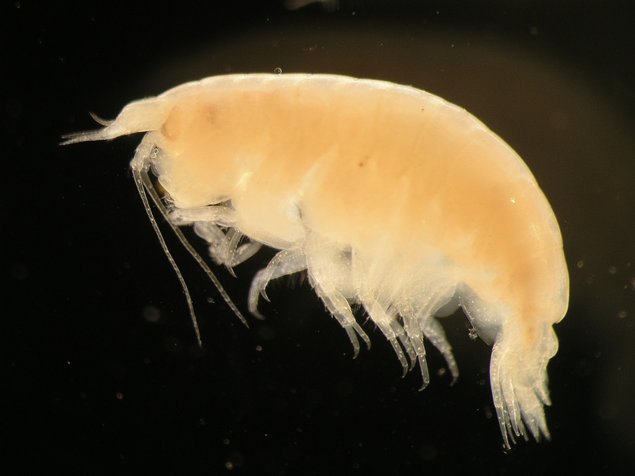
Orchomenella minuta, a lysianassid (Photo: : Zosia Joanna Legezynska)

Paracentromedon - The only record of the genus in the NEP is based on a provisional species erected by Dickinson in his thesis. The identity of this form is moot. J. L. Barnard and Karaman (1991) list 5 species in the genus, all from the Atlantic. If Dickinson’s generic allocation of his provisional is accurate, the record from off Oregon would be a considerable broadening of the range of the genus. Paracentromedon differs from closely related genera by the length of article 3 of the mandibular palp and the cleft in the telson (see key to genera in Jarrett and Bousfield 1982).
Paronesimoides – A very small genus of apparently obligate associates with submerged wood. A species was just described from submerged oak blocks placed on the bottom in the Juan de Fuca Ridge vent system (Larsen 2007). This is the first record of the genus in the NEP, and only the second member of the genus described. The generotype, P. lignivorus was described by Pirlot (1933) from the Celebes Sea. Both live at lower bathyal or upper abyssal depths. The genus is in the subfamily Tryphosinae. It is not closely related to any other lysianassoids known from the NEP, and can be differentiated from other genera as indicated in the generic key.
Psammonyx – The genus has been recently treated by Budnikova (2005) who described two new species. One of these bridged the small gap between Psammonyx and Wecomedon, forcing the collapse of that genus. The resulting Psammonyx now contains eleven species, of which only three are reported from the NEP. All three of these species are described and keyed by Jarrett and Bousfield (1982), who erected Wecomedon, and placed two of the species in their new genus. Both of these species are now placed in Psammonyx. Of the two P. similis is the more northern, distributed from the Bering Sea to British Columbia. Psammonyx wecomus overlaps the former in SE Alaska, and ranges south to Oregon. While the two species are quite similar, P. similis bears a much longer more slender tooth on the third epimeron, and other less visible differences. Both have a posteroventral tooth on the 3rd epimeron which lacks a defining notch. This is present in the similarly distributed P. longimeris, and allows its easy separation from the other two. All three look very much like species of Hippomedon, to which they are apparently closely related.
Rimakoroga – Originally described as Pseudokoroga rima by J. L. Barnard (1964a) it was later transferred to a new genus Rimakoroga by J. L. Barnard and Karaman (1987). There is now a second species in the genus, R. floridana Lowry and Stoddart 1997. The two are closely related, if not cognates. They can be distinguished by the structure of the male G1.
Socarnes – Two members of this genus are reported from the NEP, S. hartmanae, an endemic described from the SCB (Hurley 1963), and S. vahlii, a widely distributed form reported from the outer coast of Baja California (J. L. Barnard 1964a). The genus had five species in 1991 (J. L. Barnard and Karaman 1991) to which Lowry and Stoddart (1994) added another three. Hurley (1963) provides characters which separate his new species from other Socarnes, but does not provide a key. Socarnes hartmanae can be separated from S. vahlii easily on the basis of the third epimeron posterior margin; with a strong tooth in S. hartmanae, and rounded in S. vahlii (see description in Gurjanova 1962).

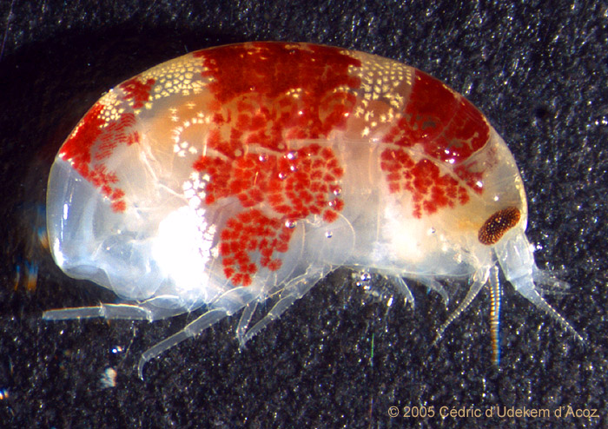
Socarnes vahlii, a species reported from the NEP (photo Cédric d’Udekem d’Acoz)

Tryphosella – A large genus badly in need of revision. J. L. Barnard and Karaman (1991) maintain it is not distinct from Uristes, which is now in another family. The genera need reevaluation; a continuing process (see discussion under Uristes in Uristidae as well). Lowry and Stoddart (1997) in their discussion of a new species of Tryphosella from Florida, casually transferred Uristes californicus Hurley 1963 to Tryphosella, then contrasted it with their new taxon

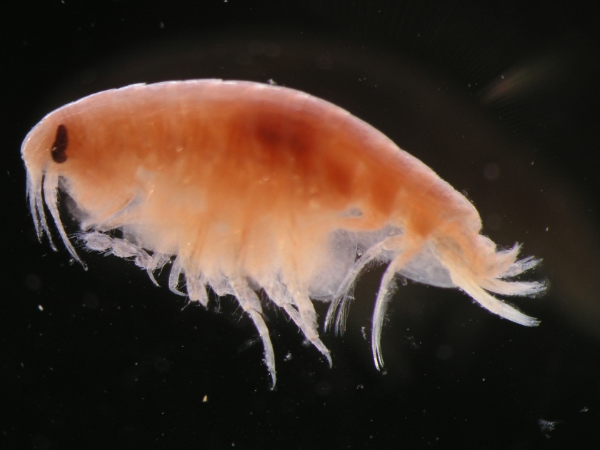
The lysianassid Tryphosella schneideri (Photo: Zosia Joanna Legezynska)
. This lead was not followed by McLaughlin et al 2005, but is adopted here. With that addition there are four species currently assigned to the genus in the NEP.
One of these is an unrecognizable provisional from off Oregon, so functionally there are three species; T. californicus, T. index, and T. metacaecula. Since the genus contained 54 species in 1991 (J. L. Barnard and Karaman 1991) and seven additional species were added by 2004 (Vader 2004), it is clear that the evolutionary center of the genus is not in the NEP. Tryphosella species are known from all over the world, and from the intertidal to the abyss. Interestingly, of the three local species, only the deepest dwelling (T. index, 1620m) bears noticeable eyes. The three species can be distinguished by the eyes (T. index), vs. eyes absent (T. californica and T. metacaecula); and the telson, which bears dorsal spines in T. californica and lacks them in T. metacaecula.
Waldeckia – The only record of this genus in the NEP is the provisional species Waldeckia sp a established by Dickinson in his 1976 thesis. No definition or description of the animal was ever offered, so its identity remains a mystery. The genus is known from the NW Pacific (Hirayama 1985, Hirayama and Kikuchi 1980), but there are no NEP records other than that of Dickinson from the slope and abyssal plain off Oregon. It is possible that what Dickinson had was the species later described by Hirayama and Kikuchi, but this remains only speculation. Such trans-oceanic distributions are not uncommon in gammarid amphipods, particularly in bathyal and abyssal forms.

Family Opisidae - Description “Head free, not coalesced with pereonite 1; exposed; deeper than long; rostrum absent; eyes present, well developed or obsolescent, or absent; not coalesced; 1 pair; not bulging. Body laterally compressed; cuticle smooth. Antenna 1 shorter than antenna 2, or subequal to antenna 2; peduncle with sparse robust and slender setae; 3-articulate; peduncular article 1 longer than article 2; antenna 1 article 2 longer than article 3; peduncular articles 1-2 not geniculate; accessory flagellum present; antenna 1 callynophore present. Antenna 2 present; short, or long; articles not folded in zigzag fashion; without hook-like process; flagellum shorter than peduncle, or as long as peduncle, or longer than peduncle; 5 or more articulate, or less than 5-articulate; not clavate; calceoli present, or absent. Mouthparts well developed. Mandible incisor smooth, or left minutely dentate, right smooth (?); lacinia mobilis present on left side only, or absent; accessory setal row without distal tuft; molar present or absent, medium, non-triturative; palp present. Maxilla 1 present; inner plate present, weakly setose apically or without setae; palp present, not clavate, 2 -articulate. Maxilla 2 inner plate present; outer plate present. Maxilliped inner and outer plates well developed or reduced, palps present, well developed or reduced; inner plates well developed, separate; outer plates present, very large or large; palp 4-articulate or 3-articulate, article 3 without rugosities. Labium smooth. Pereon. Pereonites 1-7 separate; complete; sternal gills absent; pleurae absent. Coxae 1-7 well developed, none fused with pereonites. Coxae 1-4 longer than broad, overlapping, coxae not acuminate. Coxae 1-3 not successively smaller, none vestigial or coxa 1 reduced. Coxae 2-4 none immensely broadened. Gnathopod 1 not sexually dimorphic; smaller (or weaker) than gnathopod 2, or subequal to gnathopod 2; smaller than coxa 2, or subequal to coxa 2; gnathopod 1 merus and carpus not rotated; gnathopod 1 carpus/propodus not cantilevered; shorter than propodus, or subequal to propodus; gnathopod 1 not produced along posterior margin of propodus; dactylus large. Gnathopod 2 not sexually dimorphic; subchelate, or chelate; coxa subequal to but not hidden by coxa 3; ischium elongate; merus not fused along posterior margin of carpus or produced away from it; carpus/propodus not cantilevered, carpus elongate, longer than propodus, not produced along posterior margin of propodus.
Pereopods heteropodous (3-4 directed posteriorly, 5-7 directed anteriorly), none prehensile. Pereopod 3 well developed. Pereopod 4 well developed. 3-4 not glandular; 3-7 without hooded dactyli, 3-7 propodi without distal spurs. Coxa well developed, longer than broad; carpus shorter than propodus, not produced; dactylus well developed. Coxa larger than coxa 3, not acuminate, with well developed posteroventral lobe; carpus not produced. Pereopods 5-7 with few robust or slender setae; dactyli without slender or robust setae. Pereopod 5 well developed; shorter than pereopod 6, or subequal in length to pereopod 6; coxa smaller than coxa 4, with ventrally produced posterior lobe; basis expanded or slightly expanded, subovate; merus/carpus free; carpus linear; setae absent. Pereopod 6 subequal in length to pereopod 7; merus/carpus free; dactylus without setae. Pereopod 7 with 6-7 well developed articles; subequal to pereopod 5, or longer than pereopod 5; similar in structure to pereopod 6; with 7 articles; basis expanded, without dense slender setae; dactylus without setae.
Pleon. Pleonites 1-3 without transverse dorsal serrations, without dorsal carina; without slender or robust dorsal setae. Epimera 1-3 present. Epimeron 1 well developed. Epimeron 2 without setae. Urosome not dorsoventrally flattened; urosomites 1 to 3 free; urosomite 1 longer than urosomite 2, or much longer than urosomite 2; urosome urosomites not carinate; urosomites 1-2 without transverse dorsal serrations. Uropods 1-2 apices of rami without robust setae. Uropods 1-3 similar in structure and size. Uropod 1 peduncle without long plumose setae, without basofacial robust seta, without ventromedial spur. Uropod 2 well developed; without ventromedial spur, without dorsal flange; inner ramus shorter than outer ramus, or subequal to outer ramus. Uropod 3 not sexually dimorphic; peduncle short or elongate; outer ramus shorter than peduncle or longer than peduncle, 1-articulate or 2-articulate, without recurved spines. Telson laminar; deeply cleft, or entire; longer than broad; apical robust setae present, or absent.” (Lowry and Springthorpe 2001)
Opisa – Species of Opisa are easily recognized in samples. They have very large first gnathopods, with an oval, almost circular propodus sporting a large defining tooth. Against this closes a large curved dactyl. The palm is excavate behind the defining tooth, leaving a large gape when the dactyl is closed. This is well illustrated by Hurley (1963) and by Bousfield (1987). This dactylar structure alone will identify them as Opisa in the NEP. In other areas another family, the Trischizostomatidae, has similar gnathopod 1 structure, and can be confused with Opisa. There are two species known from the NEP, O. odontochela from SE Alaska, and O. tridentata from the entire coast – from the Aleutians to the SCB. In the south, any Opisa is tridentata (but check against the description anyway). In the north, where the distribution of the two species overlaps, they can be differentiated without much difficulty by: 1) epimeron 3 posterior margin serrate (O. tridentata) or smooth (O. odontochela); and 2) G1 palm strongly excavate, dactylar gape pronounced (O. tridentata) vs. G1 palm hardly excavate, dactylar gape obscure, nearly lacking (O. odontochela). A key separating the species in the genus in North America is presented by Bousfield (1987). While members of the genus are known fish ectoparasites, we usually see them in benthic samples separated from the hosts. It is assumed that, like some other blood parasites, the animals drop off the host for bouts of digestion on the bottom, locating new hosts when they are again hungry.

Family Pachynidae – Description “ ...characterized by gnathopod 1, which has a peculiarly compressed carpus and enlarged propodus. The proximal articles of the flagellum of antenna 1 are usually fused and bear rows of aesthetascs; calceoli are never present on either antenna. On the mandible, the molar is always absent, the incisor has a smooth cutting edge, and the left lacinia mobilis and the accessory spines may or may not be present or a serrate blade (lamina dentata) may be present. The mandibular palp is always 3-articulate. On maxilla 1 the inner plate is usually small and may or may not have terminal setae, the outer plate has from 11 to 4 spine-teeth. The palp may be present or absent; if present it bears either terminal articulating spines or setae. The maxillipeds may or may not have inner plates, the outer plates are always at least moderately enlarged and the palp is usually 4-articulate, occasionally 4-articulate. Gnathopod 1 may be subchelate, parachelate or chelate and the palm may be defined by a simple spine, a complex spine, a projecting tooth or not at all, but the carpus is always compressed and the propodus is always enlarged. Gnathopod 2 is a typical lysianassoid mitten which is usually minutely subchelate, but occasionally the dactyl and palm are enlarged. Coxa 4 usually has a well developed posteroventral lobe but occasionally this lobe is absent or poorly developed. Article 4 of pereopods 5 and 6 is usually expanded posteriorly. Uropods 1 and 2 are biramus. Uropod 3 is usually biramus, occasionally uniramus, with the outer ramus always 2-articulate. The telson is small, entire, and slightly broader than long.” (Lowry 1984)

Pachychelium – Two specimens of an undescribed species in this genus are known from the NEP. Collected in the monitoring program of the City of San Diego, Pachychelium sp SD1 came from relatively shallow water off Pt. Loma. A second specimen was taken in the Bight ’03 regional monitoring off the east end of Anacapa Island in the Santa Barbara Channel. The animal is small, but bears the distinctive chela of the genus (Alonso de Pina 1993, Lowry 1984), clearly separating it from other members of the Pachynidae. Of the four species in the genus, the present specimen is most similar to P. davidis from the Davis Strait off Greenland. Lowry (1984) correctly states that the genus is bipolar, with the type species from the Arctic (Davis Strait), and the other three described forms from Antarctic or Subantarctic waters. The presence of a new species in the temperate waters of the NEP is zoogeographically anomalous, as was the detection and description of a 5th species in the genus from temperate waters off Argentina (Alonso de Pina 1993). That species, Pachychelium barnardi, was reported from shallow shelf waters in the holdfast of Macrocystis pyrifera. Perhaps the California species is similarly associated with kelp holdfasts, but many have been examined locally, without turning up other Pachychelium specimens. The bipolarity of the genus is becoming less marked as additional collections trickle in from cool, but non-polar waters. Given the scarcity of specimens for all species in the genus, the geographic records may only reflect inadequate material of animals that occupy a special and usually unsampled niche.

Pachynus – Bulycheva (1955) established the genus for P. chelatum from the shallow shelf of the Japan Sea in the NWP. Hurley (1963) described the second species, P. barnardi, from local waters. The two other members of the genus were described from Australian waters by Lowry (1984). As in most other genera of the family, the structure of gnathopod 1 is characteristic, separating P. barnardi from Pachychelium and Prachynella in the NEP.

Prachynella – Lowry (1984) noted the differences between the anoculate deep-water Prachynella described by J. L. Barnard 1967, and the oculate shallow-water form he described in 1964. He suggested that there were probably several species of Prachynella in Californian waters; I agree. Having additional material of Prachynella from the Tanner Basin, I am erecting a second species in the genus, Prachynella sp A SCAMIT 2007, to house the anoculate deep-water form. This is clearly not the same as the holotype (as redescribed by Lowry 1984), or other shallow water specimens of Prachynella lodo taken in SCB waters or in Japan (Hirayama 1985). John Chapman (in lit.) suggested the hypothesis that Pachynus barnardi and Prachynella lodo were just differing sexes of one species. This seems very unlikely, given the differences in mouthpart morphology which place the genera in different groupings within the family (Lowry 1984). It does, however, point out the lack of information on sexual dimorphism in the Pachynidae, and urges careful attention to sexing of collected individuals of both these taxa. While I am skeptical about the hypothesis, it deserves corroboration or refutation on the basis of complete and careful analysis of specimens.

Family Scopelocheiridae – Members of this family have very peculiar first gnathopods, which are simple, and characteristically end in a sheaf of setae or spines which obscures the dactyl. In some forms the dactyl itself is displaced ventrally, and inserted subterminally on the propod. The dactyls also frequently bear accessory teeth (see for instance the structure of the G1 dactyl in Anisocallisoma armifera). There are eight genera in the family, three of which occur in the NEP.

Diagnosis “Head: as long as or longer than deep. Antennae: calceoli present or absent. Epistome and upper lip separate. Mandible: incisors usually symmetrical, sometimes asymmetrical, large, with straight or convex margins; left lacinia mobilis a stemmed, distally expanded, smooth or irregularly cusped blade, occasionally a cusped ped; accessory setal row without distal setal tuft; molar present or absent, if present, a narrow column with small triturating surface or a small non-setose triangular flap. Maxilla 1: inner plate usually strongly setose, always more than 2 pappose setae; outer plate broad, with 6-11 setal-teeth in a 7/4 or modified 7/4 arrangement; palp large, 2-articulate. Maxilliped outer plate with or without apical slender simple or pappose setae, with or without apical robust setae. Gnathopod 1: simple, dactylus reduced, complex, setose. Coxae 1 to 4: large, longer than broad, overlapping. Pereopods 3-7: usually simple, sometimes prehensile, propodus without distal spur. Telson: moderately to deeply cleft.” (Lowry and Stoddart 1997)
Anisocallisoma – Erected by Hendrycks and Conlan (2003) for the NEP species armigera, the genus has closest resemblances to Eucallisoma. The two genera can be easily separated by the characters tablulated by Hendrycks and Conlan (Pg. 2315). The species has only been collected in sediment traps in very deep water off Pt. Conception, but may eventually prove to be more widespread as additional material becomes available.
Paracallisoma – Two NEP species are recorded in this genus; P. coecum, and P. spinipoda. Hurley (1963, pg. 62-64) considers the case presented by Birstein and Vinogradov (1960) and adopted by Gurjanova (1962) that P. coecum is a junior synonym of P. alberti. He declined to accept the case, feeling that additional information was needed. J. L. Barnard and Karaman (1991) follow this same path, treating both as valid taxa. Holmes (1908) described the female, and J. L. Barnard (1954) described a male P. coecum as well. Hendrycks and Conlan (2003) described only the male and an unsexed juvenile of their species P. spinipoda. They felt it could be clearly differentiated from the other species in the genus by the presence of subchelate pereopods 3-6 (among other characters), the elongate spinose propodi of which appear almost prehensile. This is very different from the condition described for P. coecum, and should allow the two taxa to be separated with ease. Distribution of P. coecum vertically off California is documented by Brusca (1967).

Scopelocheiropsis – The monotypic S. abyssalis, previously known from the Atlantic and the Antarctic (J. L. Barnard and Karaman 1991), was reported from off Pt. Conception by Hendrycks and Conlan (2003). Their material consisted of a single female from a sediment trap, but the condition of the specimen allowed confident allocation to this species. Not only was the specimen the first known from the Pacific, but it also represented a new depth record of 4000m. More complete illustrations of the species are found in Schellenberg (1926a, b).

Family Uristidae – Description “Body smooth, not carinate or rostrate, first segment not produced in cap or spine over head. Eyes normal or absent, may sometimes meet in midline. Urosome segments 2 and 3 not fused. Telson present, entire to deeply cleft. Pereopod 3 basis not produced in long spine or process posteriorly. Mouthparts not styliform. Antenna 1, peduncle generally not carinate. Antenna 2 peduncle, none of segments noticeably dilated. Mandible has distinct cutting edge which is not strongly dentate; molar process small or obsolete, palp of 3 segments. Maxilla 1, palp of 2 distinct segments. Maxilliped, inner plates well developed, may be almost as long as outer; outer plates , inner margin straight, crenulate, outer margin convex, distally rounded, generally not toothed; palp of 4 segments, 4th usually well-developed but may be rudimentary. Sideplates 1 and 2 not appreciably smaller than 3 and 4; sideplate 1, lower front angle not hidden by sideplate 2. Gnathopod 1, not enormously developed, subchelate or imperfectly subchelate, finger not concealed amongst setae. Gnathopod 2, minutely chelate or minutely subchelate, dactylus present. Pereopods not prehensile, segment 7 generally not noticeably long; pereopods 3-5 segments 3 to 7 not greatly expanded. Uropod 3 biramus.” (Hurley 1963)

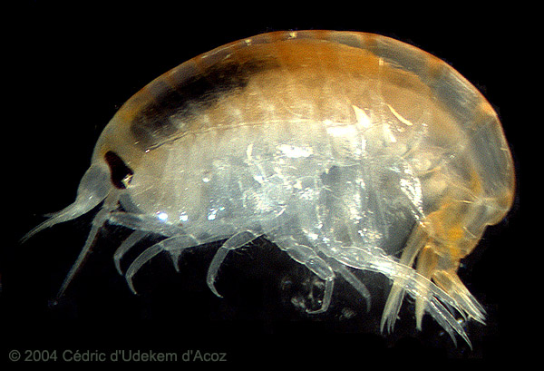
The North Pacific uristid Anonyx sarsi (Photo: Cédric d’Udekem d’Acoz)

Anonyx – A large genus, with 45 species (J. L. Barnard and Karaman 1991), which has since grown even larger (to 54 species, Vader 2004). A number of investigators, most prominently D. J. Steele, have worked with the group. The genus was treated extensively by Gurjanova (1962), who described several new Anonyx species, predominantly from the NWP. Steele (1979c) summarized the distribution of the genus in the NWP, NEP, and Arctic and indicated the north Pacific as the apparent center of origin of the genus. Work with Alaskan Anonyx material began with Steele and Brunels (1968) investigation of the Arctic and western North Atlantic species in the genus. Several forms which range into the boreal and even temperate waters of the NEP are included there. He added additional comments to that work (Steele 1969) before producing a series of papers on the taxonomy and zoogeography of Anonyx species from the North Pacific (Steele 1982, 1983, 1986, 1989, 1991). He has also commented on variability in some meristic characters within members of the genus (Steele 1979b).
A relatively large number of forms are listed in McLaughlin et al (2005) as being distributed in the NEP, but A. barrowensis and A. bispinosus apparently have distributions only within the Arctic zone above the Aleutians in the Bering Sea and are not represented in the present study area. Others should not be included in Anonyx. Lowry and Stoddart (2002a) treated A. filiger as a Lepidepecreum, designating it a nomen dubium and unrecognizable.
Among the uristids Anonyx is most closely related to Kyska (see below) and to Ichnopus in having a mandibular molar consisting of a setose tongue with no triturative surface (Lowry and Stoddart 1992). NEP species of Anonyx are mostly actic-boreal or boreal in distribution. Of the 24 species reported from the NEP, only seven range south of British Columbia, and only three into California waters. In the latter group only A. lilljeborgi has been placed on the SCAMIT list. [please note: the spelling of species named after Dr. Liljeborg can be correct either with or without the double “l”, depending on their original formulation. Since the difference stems from conventions of translitteration in different languages, there is no single correct way.] A key to the California forms is available in Hurley (1963, pg. 103). His Anonyx dorotheae has been removed to the genus Schisturella.
Aristiopsis – A single member of this genus has been reported from the NEP, taken on the Baja Abyssal Plain (J. L. Barnard 1967). This is a very significant range extension from the Tasman Sea where the holotype of Aristiopsis tacita was taken (J. L. Barnard 1961). The animal has not been seen since, although the distance between the two captures suggests that it is widespread if not common. The genus differs from Aristias in the nature of the mandibular molar, the attachment of the mandibular palp, and the condition of the inner lobes of maxilla 1 (J. L. Barnard 1961). The genus is sometimes placed in the family Aristiidae, but lacks the family level synapomorphy of distal pereopodal spurs.
Centromedon – A northern hemisphere boreo-arctic genus of five species (J. L. Barnard and Karaman 1991), with species submerging at increasing distance from the pole. A single species is known from the sub-arctic NEP, Centromedon pavor, described initially from 84m in Monterey Bay. It is now known from central California to central Oregon, and from depths of 84-200m. Despite its relatively shallow occurrence, the species lacks eyes. Only three specimens are mentioned in the literature; the holotype and a paratype from Monterey, and a small male from off Oregon. Both the illustrations of the original description (J. L. Barnard 1966a) and the later description (J. L. Barnard 1971) should be consulted to confirm identification.

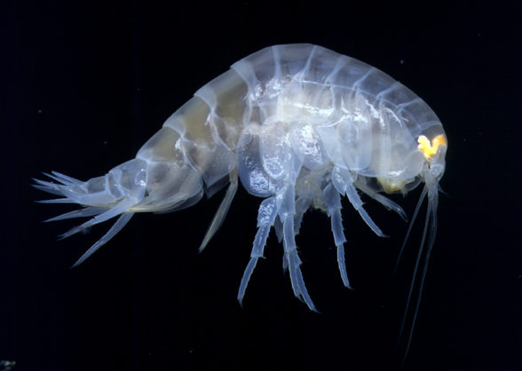
The uristid Euonyx laqueus photographed from the 13°N area of the East Pacific Rise.
The specimen was collected in the vicinity of hydrothermal vents (Photo: T. Haney)

Euonyx – A modest sized genus of 10 species (J. L. Barnard and Ingram 1990). Two of these, E. laqueus (see photo above) and E. mytilus occur in the NEP. The above authors provide a key to the genus as well as a detailed description of E. mytilus. J. L. Barnard (1967) describes and figures E. laqueus. France (1994) reported E. laqueus (as Stephonyx laqueus) from trawls in the San Clemente Basin at a depth of 1875m. The two NEP species are most easily separated grossly by the presence of a posteroventral tooth on the second epimeron of E. mytilus, absent in E. laqueus. Members of the genus are not easily distinguished from members of other similar genera, and the generic key should be used to place them in Euonyx.
Ichnopus – A predominantly Indo-Pacific genus of sixteen species (Lowry and Stoddart 1992) with a single species reported from the NEP, Ichnopus pelagicus. Most of the species are from the tropical Pacific, with Tethyan relicts in the eastern North Atlantic and Mediterranean. Barnard (1964c) illustrates I. pelagicus, and provides the record which places the species into the NEP. It is fully redescribed by Lowry and Stoddart (1992), who also provide a key to the genus worldwide. It is related to Kyska and Anonyx, but has gnathopodal characters which are of scopelocheirid form. In the NEP generic key it is found along with the other genera with vestigial or obscured dactyl on the first gnathopod. In the case of I. pelagicus, however, the dactyl is mostly visible, with some setae and accessory dactylar teeth serving to obscure it slightly. Most species with this gnathopod type are deep water and blind. Ichnopus pelagicus has well defined prominent eyes, and is found in the upper 200 m of the water column over off-shore deep bottoms.
Koroga – A monotypic cosmopolitan genus containing Koroga megalops. J. L. Barnard (1964b) illustrates the animal well, providing views of all the appendages and mouthparts illustrated in the original description (Holmes 1908) and adding more. The species was originally taken in deep-water in SE Alaska, but is now known virtually worldwide. J. L. Barnard and Karaman (1991) characterize it as abysso-/bathypelagic, with a reported depth range of 500-2200m.
Kyska - Consisting only of Kyska dalli, the genus is restricted to the NEP, in the shallows around Kyska Island in the Aleutians. Shoemaker (1964) fully illustrates the species, commenting that it is very like Anonyx nugax in general aspect. The genus is separated from other similar forms, including Anonyx, by the chelate G1 in both sexes, the short robust antennae, and the absence of calceoli in the male. Lowry and Stoddart (1992) characterize this as a member of the anonychine group within the uristids, which includes only the genera Anonyx, Ichnopus, and Kyska, and is characterized by a mandibular molar consisting of a setose tongue with no triturative surface.
Schisturella – The genus occurs world-wide, and had 12 species (J. L.Barnard and Ingram 1990), 9 of which were reported from the NEP. Those authors provide a key to species, including Ventiella sulfuris, a species that resembles Schisturella in most respects. We treat S. cedrosensis as a full species here, following McLaughlin et al (2005) rather than leaving it as a subspecies of S. robusta as do J. L. Barnard and Ingram. This was not followed by Larsen (2007) who retained it as a subspecies in his new key, which includes his newly described 13th species in the genus.
Descriptions of the reported NEP species are located as follows: abyssi (J. L. Barnard 1967, but see also Chevreux 1926), cedrosianus (J. L. Barnard 1967), cocula (J. L. Barnard 1966), dorotheae (Hurley 1963 [as Anonyx]), grabensis (J. L. Barnard 1967), hansgeorgi (Larsen 2007), spinirama (Hendryckx and Conlan 2003), totorami (J. L. Barnard 1967), tracalero (J. L. Barnard 1966 [as Thrombasia]), zopa (J. L. Barnard 1966).

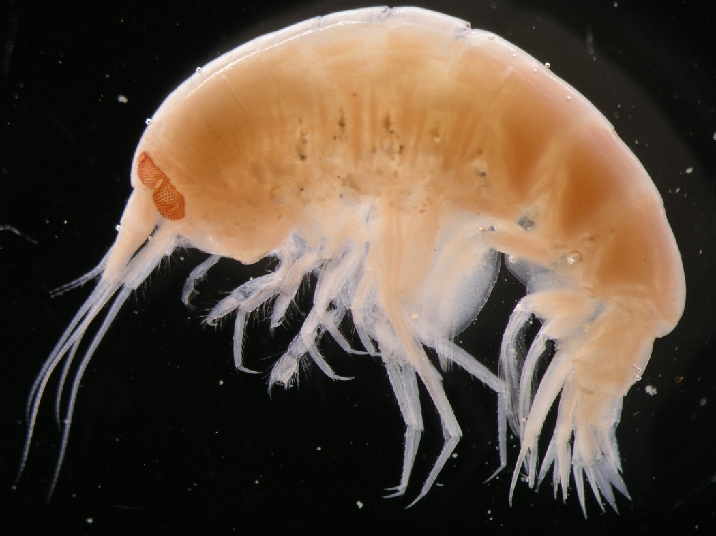
The uristid Schisturella pulchra, type species of the genus Schisturella
(Photo by Zosia Joanna Legezynska)

Shoemakerella – This small genus consists only of S. lowryi from Bermuda, and S. cubensis, a trans-isthmic species with populations in both the Caribbean/Gulf of Mexico, and in the Gulf of California/Baja California areas. The species appears to be rare in the western portion of its distribution. The genus is rather closely similar to Aruga, and was placed along with that genus in the synonymy of Lysianopsis Holmes 1905 by Hurley (1963, pg. 67). Barnard and Karaman (1991) and later Lowry and Stoddart (1997) consider all three valid and separable genera. All three occur in the Gulf of Mexico/Caribbean region, but only Aruga and Shoemakerella in the NEP. Shoemakerella differs from the two other very closely related genera in its broad inner plate of maxilla 2, and single article of the uropod 3 outer ramus.
Sophrosyne – J. L. Barnard and Karaman (1991) list three species in the genus; S. hispana from the temperate east Atlantic, S. murrayi from the sub-Antarctic Kerguelen Islands, and the widely distributed S. robertsoni. The later species has been taken in the NEP (J. L. Barnard 1966). He provides full illustration of it in that paper, but additional description can be found in Stebbing and Robertson (1891), and Lincoln (1979). Moore (1983) describes the male. It can be separated from its congeners by the relatively elongate tooth on the third epimeron, and from Scisturella and similar local forms by its unreduced coxa 1.
Uristes – As remarked under Tryphosella in Lysianassidae, J. L. Barnard and Karaman (1991) recommend that the species of Tryphosella and Uristes be pooled as species inquirenda pending reanalysis. Since this places together members of two genera now in separate families it presents us with a conundrum. The question which must be answered is whether or not a better method of separating these two genera has been found in the intervening years. The above authors present the “traditional” and presumably inadequate method as “(1) small head in Uristes, large in Tryphosella; (2) short carpus of gnathopod 1 in Uristes, longer in Tryphosella; and (3) small and ordinary prebuccal region in Uristes, large and protuberant epistome in Tryphosella.”
The genus had 22 species allocated to it by J. L. Barnard and Karaman (1991), of which four were from the NEP. One of these, U. californicus, has since been removed to Typhosella (Lowry and Stoddart 1997). J. L. Barnard (1967) mentions the close similarity in many characters of his Orchomene tabasco (now Orchomenella) and Uristes dawsoni. While the two do offer close resemblance, he provides a series of characters in which they differ. Since SCAMIT members have yet to record U. dawsoni from sampling off our coast, the most likely species we might encounter is U. entalladurus (J. L. Barnard 1963b). This is normally found on very shallow wave-swept sandy bottoms, and has been encountered in the most shallow samples taken in environmental monitoring surveys in the SCB. U. entalladurus can be easily distinguished from both U. dawsoni and U. perspinis by having a large acute reflexed process on the first urosomite (J. L. Barnard 1963b, Figure 5).
Ventiella – Newly established by J. L. Barnard and Ingram (1990) it remains monotypic. Ventiella sulfuris is present at NEP vent sites in huge numbers, forming over 99% of the amphipods sampled around vents (J. L. Barnard and Ingram 1990). Those authors studied material from both the Galapagos Rift zone, and from the East Pacific Rise, and did not detect sufficient morphological variability to establish two species. Genetic information (France et al. 1992) suggests that the populations in the two geographically separate areas are also genetically separate, and show virtually no evidence of gene flow between them. Within an area, such as at various sites along an axial ridge separated by up to 1200 km, genetic differences were very slight (France et al. 1992). This low level of genetic difference in contiguous or nearly contiguous portions of the population emphasizes the genetic differences between the populations of this “species” at the Galapagos and East Pacific Rise vent systems. No second species has yet been differentiated, but the genetic data suggest that perhaps new morphological characters might yield a separation which reflects the genetic makeup of the two populations. The genus bears considerable similarity in appearance to Schisturella, and is keyed with species of that genus in J. L. Barnard and Ingram (1990)(see under Schisturella above). Additional distributional information is presented by Vinogradov (1993).
“Valettiopsid” group - The composition of this group, and its placement, have been in dispute. Thurston (1989), for instance, has recommended that the genera Valettiopsis and Valettietta be removed from the lysianassoids because of their possession of a toothed incisor process. Lincoln and Thurston (1983) used the shared possession of a toothed incisor to place Alicella with Valettiopsis, Valettietta, and Valettia. While they viewed all these genera with a toothed incisor as having a “broadly similar facies”, they suggested that Valettia was not closely affiliated with the others. De Broyer (1985a) also raised the same concerns, stating that the group would be removed from the lysianassoids and placed in their own family. Lowry (in. lit.) has confirmed this, and a publication dealing with the placement of these genera is expected to be published in 2007. Relationships remain controversial, but the group is retained here within the lysianassoids pending publication of new information on placement.
Description. “Head free, not coalesced with pereonite 1; exposed; as long as deep, or deeper than long; anteroventral margin weakly recessed, anteroventral margin moderately excavate, anteroventral corner subquadrate; rostrum absent; eyes absent. Body laterally compressed; cuticle smooth. Antenna 1 subequal to antenna 2; peduncle with sparse robust and slender setae; 3-articulate; peduncular article 1 longer than article 2; antenna 1 article 2 longer than article 3; peduncular articles 1-2 not geniculate; accessory flagellum present; antenna 1 callynophore present. Antenna 2 present; short, or medium length; articles not folded in zigzag fashion; without hook-like process; flagellum longer than peduncle; 5 or more articulate; not clavate; calceoli present, or absent. Mouthparts well developed. Mandible incisor dentate; lacinia mobilis present on both sides; accessory setal row without distal tuft; molar present, medium, triturative; palp present. Maxilla 1 present; inner plate present, strongly setose along medial margin; palp present, not clavate, 2 -articulate. Maxilla 2 inner plate present; outer plate present. Maxilliped inner and outer plates well developed or reduced, palps present, well developed or reduced; inner plates well developed, separate; outer plates present, small; palp 4-articulate, article 3 without rugosities. Labium smooth. Pereon. Pereonites 1-7 separate; complete; sternal gills absent; pleurae absent. Coxae 1-7 well developed, none fused with pereonites. Coxae 1-4 longer than broad, overlapping, coxae not acuminate. Coxae 1-3 not successively smaller, none vestigial or coxa 1 reduced. Coxae 2-4 none immensely broadened. Gnathopod 1 not sexually dimorphic; smaller (or weaker) than gnathopod 2, or subequal to gnathopod 2; smaller than coxa 2, or subequal to coxa 2; gnathopod 1 merus and carpus not rotated; gnathopod 1 carpus/propodus not cantilevered; shorter than propodus, or subequal to propodus; gnathopod 1 not produced along posterior margin of propodus; dactylus large. Gnathopod 2 not sexually dimorphic; subchelate; coxa subequal to but not hidden by coxa 3; ischium elongate; merus not fused along posterior margin of carpus or produced away from it; carpus/propodus not cantilevered, carpus elongate, subequal to propodus or longer than propodus, not produced along posterior margin of propodus. Pereopods heteropodous (3-4 directed posteriorly, 5-7 directed anteriorly), none prehensile. Pereopod 3 well developed. Pereopod 4 well developed. 3-4 not glandular; 3-7 without hooded dactyli, 3-7 propodi without distal spurs. Coxa well developed, longer than broad; carpus shorter than propodus or subequal to propodus, not produced; dactylus well developed, or small or poorly developed. Coxa larger than coxa 3, not acuminate, with small posterior lobe; carpus not produced. Pereopods 5-7 with few robust or slender setae; dactyli without slender or robust setae. Pereopod 5 well developed; shorter than pereopod 6, or subequal in length to pereopod 6; coxa smaller than coxa 4, without posterior lobe or equilobate; basis expanded, subrectangular or subquadrate, with posteroventral lobe or without posteroventral lobe; merus/carpus free; carpus linear; setae absent. Pereopod 6 subequal in length to pereopod 7, or longer than pereopod 7; merus/carpus free; dactylus without setae. Pereopod 7 with 6-7 well developed articles; longer than pereopod 5; similar in structure to pereopod 6; with 7 articles; basis expanded or slightly expanded, without dense slender setae; dactylus without setae. Pleon. Pleonites 1-3 without transverse dorsal serrations, without dorsal carina; without slender or robust dorsal setae. Epimera 1-3 present. Epimeron 1 well developed. Epimeron 2 setose. Urosome not dorsoventrally flattened; urosomites 1 to 3 free; urosomite 1 longer than urosomite 2, or much longer than urosomite 2; urosome urosomite 1 carinate, or urosomites not carinate; urosomites 1-2 without transverse dorsal serrations. Uropods 1-2 apices of rami without robust setae. Uropods 1-3 similar in structure and size. Uropod 1 peduncle without long plumose setae, without basofacial robust seta, without ventromedial spur. Uropod 2 well developed; without ventromedial spur, without dorsal flange; inner ramus subequal to outer ramus, or longer than outer ramus. Uropod 3 not sexually dimorphic; peduncle short; outer ramus longer than peduncle, 2-articulate, without recurved spines. Telson laminar; deeply cleft; longer than broad; apical robust setae present.” (Lowry and Springthorpe 2001)
Apotectonia – J. L. Barnard and Ingram (1990) present a series of keys which separate the new valettiopsid taxa they propose from each other, and from other similar deep sea lysianassoid genera (Alicella, Paralicella, Eurythenes, Ventiella, Schisturella). These keys should be consulted in separating the genera of this group. A single species in the genus is known, A. heterostegas, taken from near vents in the Galapagos Rift area. It was not found at sites on the East Pacific Rise.
Diatectonia – The single species, D. typhodes, is known only from Hamilton Guyot. It should be keyed from other members of the valettiopsid group using the keys to genera in J. L. Barnard and Ingram (1990).
Tectovalopsis – Unlike the other new genera established in the group by J. L. Barnard and Ingram (1990). this genus has multiple members in the vent communities of the NEP. Five new species of Tectovalopsis were created. They can be separated by use of the specific keys produced by J. L. Barnard and Ingram (1990, pp. 57-58).
Transtectonia – Monotypic, with only the species T. torrentis. This form was not taken in the Galapagos Rift area, and is currently endemic at vent sites near 13°N on the East Pacific Rise. Once again, the keys in J. L. Barnard and Ingram (1990) can be used to separate the genus from others in the valettiopsid group.
Valettietta - The genus is only represented within the NEP fauna by a single species, V. cavernicola, an anchihaline form from the Galapagos (Stock and Iliffe 1990). The authors acknowledge that all other members of the genus are from deep water, but note that such deep-water/cave faunal connections are not uncommon. The species is known from a few small individuals, and is presumably restricted to its anchihaline habitat. It should not be taken in either fully saline waters, or outside caves.
Valettiopsis –Two recent treatments of the genus have appeared, that of Serejo and Wakabara (2003) and that of Horton (2004). Each described new taxa, bringing the total number of species in the genus to seven. Horton provides a key to all species. Hendrycks (2007) adds another species to the genus, and provides a new key which supercedes those of recent revisions. The best known species recorded from the NEP is V. dentata of Holmes. Horton reexamined the holotype, and provides some additional illustrations to augment those provided in the original description (Holmes 1908). Hurley (1963) examined a large lot of specimens from the Coronado Submarine Canyon, finding minor differences (not specified) from Holmes’ description. J. L. Barnard (1967) illustrates material taken off Baja California. Hendrycks new species is easily separable from Holmes species by the dorsal carinations of the pereonites and pleonites in V. concava, lacking in V. dentata.

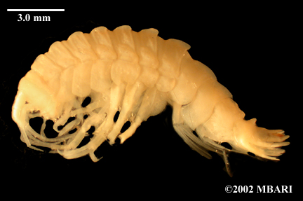
Valettiopsis concava (Photo courtesy MBARI)

Lysianassoid Reference List

Alonso de Pina, Gloria María. 1993. Pachychelium barnardi, new species, from Argentina, and the occurrence of other lysianassids on the Argentine continental shelf (Amphipoda: Lysianassidae). Journal of Crustacean Biology 13(2): 377-382.
Ansell, Alan D. 1969. Association of the amphipod Acidostoma neglectum Dahl with the anthozoan Peachia hastata Gosse. Journal of Natural History 3(5): 345-347.
Arndt, Carolin E., Jørgen Berge, and Angelika Brandt. 2005. Mouthpart-atlas of Arctic sympagic amphipods – trophic niche separation based on mouthpart morphology and feeding ecology. Journal of Crustacean Biology 25(3): 401-412.
Barnard, J. Laurens. 1954. Four species of bathypelagic Gammaridea (Amphipoda) from California. Allan Hancock Foundation Occasional Paper 13:52-69.
---------. 1955. Notes on the amphipod genus Aruga with the description of a new species. Bulletin of the Southern California Academy of Sciences 54(2): 97-103.
---------. 1959. Epipelagic and under-ice Amphipoda of the central Arctic Basin. Geophysical Research Papers No. 63 “Scientific Studies at Fletcher’s Ice Island, T-3, 1952-1955,” Volume I: 115-152.
———. 1961. Gammaridean Amphipoda from Depths of 400 to 6000 Meters. IN: Galathea Report 5: 23-128. Copenhagen: Danish Science Press, Ltd.

---------. 1963a. Los Anfipodos Bentonicos Marinos de la Costa Occidental de Baja California. Revista De La Sociedad Mexicana De Historia Natural XXIV: 205-251.
———. 1963b. Relationship of benthic Amphipoda to invertebrate communities of inshore sub-littoral sands of Southern California. Pacific Naturalist 3(15): 439-468.
———. 1964a. Marine Amphipoda of Bahia de San Quintin, Baja California. Pacific Naturalist 4(3): 55-139.
———. 1964b. Some Bathyal Pacific Amphipoda Collected by the U.S.S. Albatross. Pacific Science 18: 315-335.
---------. 1964c. Deep-sea Amphipoda (Crustacea) collected by the R/V “Vema” in the Eastern Pacific Ocean and the Caribbean and Mediterranean Seas. Bulletin of the American Museum ofNatural History 127(1):1-46.
———. 1966a. Benthic Amphipoda of Monterey Bay, California. Proceedings of the United States National Museum 119(3541): 1-41.
———. 1966b. Submarine Canyons of Southern California. Part V. Systematics: Amphipoda. Allan Hancock Pacific Expeditions 27(5): 1-166.
---------. 1967. Bathyal and Abyssal gammaridean Amphipoda of Cedros Trench, Baja California. United States National Museum Bulletin 260: 1-205.
———. 1969a. Gammaridean Amphipoda of the Rocky Intertidal of California: Monterey Bay to La Jolla. United States National Museum Bulletin 258: 1-230.
---------. 1969b. The families and genera of marine gammaridean Amphipoda. United
States National Museum Bulletin 271: 1-535.
———. 1971. Gammaridean Amphipoda from a Deep-Sea Transect off Oregon. Smithsonian Contributions to Zoology 61: 1-86.
---------, and Camilla L. Ingram. 1986. The supergiant amphipod Alicella gigantea Chevreux from the North Pacific Gyre. Journal of Crustacean Biology 6(4): 825-839.
---------, and ---------. 1990. Lysianassoid Amphipoda (Crustacea) from deep-sea thermal vents. Smithsonian Contributions to Zoology 499: 1-80.
---------, and Gordan S. Karaman. 1987. Revisions in classification of gammaridean Amphipoda (Crustacea), Part 3. Proceedings of the Biological Society of Washington 100(4): 856-875.
---------, and ---------. 1991 The Families and Genera of Marine Gammaridean Amphipoda (except marine gammaroids). Records of the Australian Museum Supplement 13 (Parts 1 and 2): 1-866.
---------, and Eric Shulenberger. 1976. Clarification of the abyssal amphipod, Paralicella tenuipes Chevreux. Crustaceana 31(3): 267-274.
---------. and James Darwin Thomas. 1990. Ensayara jumanae, a new species from Belize, Caribbean Sea (Amphipoda, Lysianassidae). Proceedings of the Biological Society of Washington 103(1): 120-126.
Barnard, Keppel Harcourt. 1925. Contributions to the crustacean fauna of South Africa. No. 8. Further additions to the list of Amphipoda. Annals of the South African Museum 20: 319-380.

Bellan-Santini, Denise. 1990. Nouvelles espèces d'Orchomene s.l. (Crustacea-Amphipoda) des fonds abyssaux. Affinites avec les autres Orchomene profonds. Beaufortia 41(3): 15-23.
---------, and Michael H. Thurston. 1996. Amphipoda of the hydrothermal vents along the mid-Atlantic ridge. Journal of Natural History 30: 685-702.
Berge, Jørgen, Geoffrey Boxshall, and Wim Vader. 2000. Cladistic analysis of the Amphipoda, with special emphasis on the origin of the Stegocephalidae. Polskii Archiwum Hydrobiologii 47(3): 379-400.
---------, Wim Vader, and Susanne Lockhart. 2004. A survey of amphipod associates of sea urchins, with description of new species in the genera Lepidepecreela (Lysianassoidea: Lepidepecreellid group) and Notopoma (Photoidea: Ischyroceridae) from Antarctic cidarids. Deep-Sea Research II 51: 1717-1731.
Biernbaum, Charles K., and Elizabeth L. Wenner. 1993. Trapping of necrophagous crustaceans on the upper continental slope off South Carolina, U.S.A. Journal of Crustacean Biology 13(3): 601-608.
Birstein, Yakov Avand'Evich, and M. E. Vinogradov. 1958. Pelagicheskie gammaridy (Amphipoda, Gammaridea) severo-zapadnoi chasti Tikogo Okeana. Trudy Instituta Okeanologii, Akademiia Nauk SSSR 27: 219-257.
---------, and ---------. 1960. Pelagicheskie gammaridy tropicheskoi chasti Tixogo Okeana. Trudy Instituta Okeanologii, Akademiia Nauk SSSR 34: 165-241.
---------, and ---------. 1970. On the fauna of pelagic gammarids in the Kurile-Kamchatka area of the Pacific Ocean. Academy of Sciences of the USSR, Proceedings of the Shirshov Institute of Oceanology 86: 419-438.
Blankenship, Lesley E., A. Aristides Yayanos, Donald B. Cadien, and Lisa A. Levin. 2006. Vertical zonation patterns of scavenging amphipods from the Hadal zone of the Tonga and Kermadec Trenches. Deep-Sea Research, Part I 56(1): 48-61.
Bousfield, Edward L. 1979. A revised classification and phylogeny of the amphipod Crustacea. Transactions of the Royal Society of Canada 4(14): 343-390.
---------. 1982. Amphipoda. Gammaridea. Pp. 254-285, 293-294 IN: Parker, Sybil P. (ed.). Synopsis and Classification of Living Organisms, Volume 2. McGraw Hill, New York, New York.
---------. 1987. Amphipod parasites of fishes of Canada. Canadian Bulletin of Fisheries and Aquatic Sciences 217: 1-37.
---------. 2001. An updated commentary on phyletic classification of the amphipod Crustacea and its application to the North American fauna. Amphipacifica 3(1): 49-119.
---------, and Zbigniew Kabata. 1988. Amphipoda. Pp. 149-163 IN: Margolis, Leo and Zbigniew Kabata (eds.). Guide to the parasites of fishes of Canada. Part II. Crustacea.. Canadian Special Publications in Fisheries and Aquatic Sciences. Ontario: National Museums of Canada.
---------, and C.-t. Shih. 1994. The phyletic classification of amphipod crustaceans: problems in resolution. Amphipacifica 1(3): 76-134.
Bowman, Thomas E. 1967. Bioluminescence in two species of pelagic amphipods. Journal of the Fisheries Research Board of Canada 24(3): 687-688.

---------, and Raymond B. Manning. 1972. Two arctic bathyal crustaceans: the shrimp Bythocaris cryonesus, new species, and the amphipod Eurythenes gryllus, with in situ photographs from Ice Island T-3. Crustaceana 23: 187-200.
---------, and John C. McCain. 1967. Variation and distribution of the pelagic amphipod Cyphocaris challengeri in the northeast Pacific (Gammaridea: Lysianassidae). Proceedings of the United States National Museum 122(3588): 1-14.
---------, and Robert A. Wasmer. 1984. The deep-sea amphipod Paracyphocaris predator (Gammaridea: Lysianassidae) associated with the pelagic shrimp Oplophorus novaezeelandiae as an egg-mimic. Proceedings of the Biological Society of Washington 97(4): 844-848.
Brusca, Gary J. 1967. The ecology of pelagic Amphipoda, I. Species accounts - vertical zonation and migration of Amphipoda from the waters off Southern California. Pacific Science 21(3): 382-393.
Bucklin, A., R. R. Wilson, and Ken L. Smith Jr. 1987. Genetic differentiation of sea-mount and basin populations of the deep-sea amphipod Eurythenes gryllus. Deep-Sea Research 34: 1795-1810.
Budnikova, L. L. 2005. Two new species of Psammonyx and the identity of the genus Wecomedon (Amphipoda, Gammaridea). Publications of the Seto Marine Biological Laboratory 40(3/4): 179-197.
Bulycheva, A. I. 1955. Novye vidy bokoplavov (Amphipoda, Gammaridea) iz Japonskogo Morja II. Akademia Nauk SSSR, Trudy Zoologicheskogo Instituta 21: 193-207.
Bushdosh, Michael, Gordon A. Robilliard, K. Tarbox, and C. L. Beehler. 1982. Chemoreception in an Arctic amphipod crustacean: a field study. Journal of Experimental Marine Biology and Ecology 62: 261-269.
Conlan, Kathleen E. 1991. Precopulatory mating behavior and sexual dimorphism in the amphipod Crustacea. Hydrobiologia 223: 255-282.
Dahl, Eric. 1959. Amphipoda from depths exceeding 6000m. Galathea Reports 1: 211-241.
---------. 1979. Deep-sea carrion feeding amphipods: evolutionary patterns in niche adaptation. Oikos 53: 167-175.
Dalkey, Ann. 1998. A new species of amphipod (Crustacea: Amphipoda: Lysianassoidea) from the Pacific Coast of North America. Proceedings of the Biological Society of Washington 111(3): 621-626.
De Broyer, Claude. 1985a. Description de Falklandia gen. n. de l'Océan Austral et définition des Lysianassoidea uristidiens. Zoologica Scripta 14: 303-312.
———. 1985b. Évolution du complexe Orchomene Boeck (Amphipoda, Lysianassidae). Annales De La Société Royale Zoologique De Belgique 114, Supplement 1: 197-198.
---------, Fabienne Nyssen, and Patrick Dauby. 2004. The crustacean scavenger guild in Antarctic shelf, bathyal and abyssal communities. Deep Sea Research Part II Topical Studies in Oceanography 51(14-16): 1733-52.
----------, and Wim Vader. 1990. Revision and notes on the biology of Orchomenella recondita (Stasek, 1958) (Amphipoda, Lysianassoidea) an associate of sea anemones. Beaufortia 41(5): 31-38.

De Robertis, Alex, Ketil Eiane, and Greg H. Rau. 2001. Eat and run: anoxic feeding and subsequent aerobic recovery by Orchomene obtusus in Saanich Inlet, British Columbia, Canada. Marine Ecology Progress Series 219: 221-227.
Dickinson, John J., and Andrew G. Carey Jr. 1978. Distribution of gammarid Amphipoda (Crustacea) on Cascadia Abyssal Plain (Oregon). Deep-Sea Research 25: 97-106.
France, Scott C. 1993. Geographic variation among three isolated populations of the hadal amphipod Hirondellea gigas (Crustacea: Amphipoda; Lysianassoidea). Marine Ecology Progress Series 92: 277-287.
---------. 1994. Genetic population structure and gene flow among deep-sea amphipods, Abyssorchomene spp. from six California Continental Borderland basins. Marine Biology 118:67-77.
---------, and T. D. Kocher. 1996. Geographic and bathymetric patterns of mitochondrial 16S rRNA sequence divergence among deepsea amphipods, Eurythenes gryllus. Marine Biology 126(4): 633-643.
---------, R. C. Vrijenhoek, and Robert R. Hessler. 1992. Genetic differentiation between spatially-disjunct populations of the deep-sea, hydrothermal vent-endemic amphipod Ventiella sulfuris. Marine Biology 114: 551-559.
Gable, Michael S. and Eric A. Lazo-Wasem. 1990. Lysianassidae (Amphipoda: Lysianassoidea) of Bermuda. Journal of Crustacean Biology 10(4): 721-734.
Graeve, M., Patrick Dauby, and Yves Scailteur. 2001. Combined lipid, fatty acid and digestive tract content analyses: a penetrating approach to estimate feeding modes of Antarctic amphipods. Polar Biology 24(11): 853-862.
Griffiths, C. L. 1977. Deep-sea amphipods from west of Cape Point, South Africa. Annals of the South African Museum 73(4): 93-104.
Gurjanova, Eupraxie F. 1962. Scud Shrimps (Amphipoda- Gammaridae) of the Northern Part of the Pacific Ocean. Leningrad: Academy of Sciences of the U. S. S. R. Publishing House.
Haggitt, T. R., and R. C. Babcock. 2003. The role of grazing by the lysianassid amphipod Orchomenella aahu in dieback of the kelp Ecklonia radiata in north-eastern New Zealand. Marine Biology 143(6): 1201-1211.
Hendrycks, Ed A. 2007. A new species of Valettiopsis Holmes, 1908 (Crustacea: Gammaridea: Lysianassoidea) from abyssal waters off California. Zootaxa 1501: 45-56
---------, and Kathleen Conlan. 2003. New and unusual abyssal gammaridean Amphipoda from the north-east Pacific. Journal of Natural History 37, no. 19: 2303-68.
Hessler, Robert R., Camilla L. Ingram, A. Aristides Yayanos, and B. R. Burnett. 1978. Scavenging amphipods from the floor of the Philippine Trench. Deep-Sea Research 25: 1029-1047.
Hirayama, Akira. 1985. Taxonomic studies on the shallow water gammaridean Amphipoda of west Kyushu, Japan. V. Leucothoidae, Liljeborgiidae, Lysianassidae (Prachynella, Aristias, Waldeckia, Ensayara, Lepidepecreum, Hippomedon, and Anonyx. Publications of the Seto Marine Biological Laboratory 30(4/6): 167-212.

———. 1986. Taxonomic studies on the shallow water gammaridean Amphipoda of west Kyushu, Japan. VI. Lysianassidae (Orchomene), Megaluropus family group, Melitidae (Cottesloe, Jerbarnia, Maera, Ceradocus, Eriopisella, Dulichiella). Publications of the Seto Marine Biological Laboratory 3(1/2): 1-35.
---------, and Taiji Kikuchi. 1980. A new gammaridean Amphipoda, Waldeckia elephas sp. nov., attaching to the set net in Tomioka Bay, Amakusa, Japan. Publications of the Amakusa Marine Biology Laboratory 5(2): 143-151.
Holmes, Samuel J. 1908. The Amphipoda Collected by the U. S. Bureau of Fisheries Steamer 'Albatross' off the West Coast of North America, in 1903 and 1904, with Descriptions of a New Family and Several New Genera and Species. Proceedings of the United States National Museum XXXV(1654): 489-543.
Horton, Tammy. 2004. Revision of the amphipod genus Valettiopsis Holmes, 1908 (Crustacea: Lysianassoidea), with the addition of three new species. Journal of Natural History 38(14): 1735-1755.
Hurley, Desmond E. 1963. Amphipoda of the family Lysianassidae from the West Coast of North and Central America. Allan Hancock Foundation Publications: Occasional Paper 25: 1-160.
Ide, Keiichiro, Kazutaka Takahashi. and Michio Omori. 2007. Direct observation of swimming behaviour in a shallow-water scavenging amphipod Scopelocheirus onagawae in relation to chemoreceptive foraging. Journal of Experimental Marine Biology and Ecology 340: 70-79.
---------, ---------, Koichi Sasaki, and Michio Omori. 2006. Predation by scavenging amphipods to injured hatchery raised juvenile Japanese flounder Paralichthys olivaceus under laboratory conditions. Fisheries Science 72: 1209-1214.
Ingólfsson, A., and I. Agnarsson. 1999. Anonyx sarsi: a major unrecognized scavenger and predator in the intertidal zone. Journal of the Marine Biological Association of the United Kingdom 79(6): 1127-1128.
Ingram, Camilla L., and Robert R. Hessler. 1983. Distribution and behavior of scavenging amphipods from the central North Pacific. Deep-Sea Research 30(A): 683-706.
Jarrett, Norma E., and Edward L. Bousfield. 1982. Studies on amphipod crustaceans of the Northeastern Pacific region. I. 4. Studies on the amphipod family Lysianassidae in the Northeastern Pacific region. Hippomedon and related genera: systematics and distributional ecology. National Museums of Canada, Publications in Biological Oceanography 10: 103-128.
Jones, Emma G., Martin A. Collins, Philip M. Bagley, Steven Addison, and Imants G. Priede. 1998. The fate of cetacean carcasses in the deep sea: observations on consumption rates and succession of scavenging species in the abyssal north-east Atlantic Ocean. Proceedings of the Royal Society of London, Series B. 265: 1119-1127.
Just, Jean. 1979. Anonyx affinis (Crust., Amphipoda: Lysianassidae), commensal in the bivalve Musculus laevigatus, with notes on Metopa glacialis (Amphipoda: Stenothoidae). Astarte 12: 69-74.
Kaufmann, Ronald S. 1994. Structure and function of chemoreceptors in scavenging lysianassoid amphipods. Journal of Crustacean Biology 14(1): 54-71.

Keable, S. J. 1995. Structure of the marine invertebrate scavenging guild of a tropical reef ecosystem: Field studies at Lizard Island, Queensland, Australia. Journal of Natural History 29(1): 27-45.
Klages, Michael, Kay Vopel, Hartmut Bluhm, Thomas Brey, Thomas Soltwedel, and Wolf E. Arntz. 2001. Deep-sea food falls: first observation of a natural event in the Arctic Ocean. Polar Biology 24:292-295.
Lampitt, R. S., N. R. Merrett, and Michael H. Thurston. 1983. Inter-relations of necrophagous amphipods, a fish predator, and tidal currents in the deep sea. Marine Biology 74: 73-78.
Larsen, Kim. 2007. Amphipoda (Crustacea: Peracarida) from the hydrothermal vent system of the Juan de Fuca Ridge, Escabana [sic] Trough and Gorda Ridge, Northeast Pacific. Part I. Lysiannassidae and Sebidae. Zootaxa 1445: 1-26.
Ledoyer, Michel. 1986. Crustaces Amphipodes Gammariens Families des Haustoriidae a Vitjazianidae. Faune de Madagascar 53(2): 599-1112.
Lie, Ulf. 1974. Distribution and structure of benthic assemblages in Puget Sound, Washington, USA. Marine Biology 26:203-223.
Lincoln, Roger J. 1979. British Marine Amphipoda: Gammaridea. British Museum (Natural History); London, England. 658pp.
---------, and Michael H. Thurston. 1983. Valettietta, a new genus of deep-sea amphipod (Gammaridea: Lysianassidae) with descriptions of two new species from the North Atlantic Ocean. Bulletin of the British Museum of Natural History (Zoology) 44(2): 85-101.
Lowry, James K. 1984. Systematics of the pachynid group of lysianassoid Amphipoda (Crustacea). Records of the Australian Museum 36(2): 51-105.
---------. 1986. The callynophore, a eucaridan/peracaridan sensory organ prevalent among the Amphipoda (Crustacea). Zoologica Scripta 75: 333-349.
---------., and S. D. A. Smith. 2003. Invertebrate Scavenging Guilds along the Continental Shelf and Slope of Eastern Australia - General Description, FRDC Project 96/280. Australian Museum, Sydney, Australia.
---------, and Roger T. Springthorpe (2001 onwards). Amphipoda: Families and Subfamilies. Version 1: 1 September 2001. http://crustacea.net/.
---------, and Helen E. Stoddart. 1983. The shallow-water gammaridean Amphipoda of the subantarctic islands of New Zealand and Australia: Lysianassoidea. Journal of the Royal Society of New Zealand 13(4): 279-394.
---------, and ---------. 1984. Taxonomy of the lysianassoid genera Phoxostoma K. H. Barnard, Conicostoma Lowry & Stoddart, and Ocosingo J. L. Barnard (Amphipoda, Gammaridea). Crustaceana 47(2): 192-208.
———, and ---------. 1986. Protandrous hermaphrodites among the lysianassoid Amphipoda. Journal of Crustacean Biology 6: 742-748.
———, and ---------. 1987. A new South American genus and species in the amaryllidid group of lysianassoid Amphipoda. Journal of Natural History 21(5): 1303-1309.
---------, and ---------. 1992. A revision of the genus Ichnopus (Crustacea: Amphipoda: Lysianassoidea: Uristidae). Records of the Australian Museum 44: 185-245.
———, and ---------. 1993. The Onisimus problem (Amphipoda, Lysianassoidea, Uristidae). Zoologica Scripta 22(2): 167-181.

---------, and ---------. 1994. Crustacea Amphipoda: lysianassoids from the tropical western South Pacific Ocean. Resultats des Campagnes Musorstom 12: 127-223.
---------, and ---------. 1995. The Amphipoda (Crustacea) of Madang Lagoon: Lysianassidae, Opisidae, Uristidae, Wandinidae and Stegocephalidae. Pp 97-174 IN: Lowry, J. K., ed. Amphipoda (Crustacea) of the Madang Lagoon, Papua New Guinea. Records of the Australian Museum, Supplement 22.
———, and ---------. 1997. Amphipoda Crustacea IV. Families Aristiidae, Cyphocarididae, Endevouridae, Lysianassidae, Scopelocheiridae, Uristidae. Memoirs of the Hourglass Cruises 9(1): 1-147.
---------, and ---------. 2002a. First records of lysianassoid amphipods (Crustacea) from the Andaman Sea. Pp. 165-188 IN: Bruce, Niel L., Mats Berggren, and S. Bussawarit. Proceedings of the International Workshop on the Crustacea in the Andaman Sea. Phuket Marine Biological Center, 29 November-20 December 1998. Phuket Marine biological Center Special Publication 23(1).
---------, and ---------. 2002b. The lysianassoid amphipod genera Lepidepecreoides and Lepidepecreum in southern waters (Crustacea: Lysianassidae: Tryphosinae). Records of the Australian Museum 54: 335-364.
McLaughlin, P. A., D. K. Camp, M. V. Angel, E. L. Bousfield, P. Brunel, R. C. Brusca, D. B. Cadien, A. C. Cohen, K. Conlan, L. G. Eldredge, D. L. Felder, J. W. Goy, T. A. Haney, B. Hann, R. W. Heard, E. A. Hendrycks, H. H. Hobbs III, J. R. Holsinger, B. Kensley, D. R. Laubitz, S. E. LeCroy, R. Lemaitre, R. F. Maddocks, J. W. Martin, P. Mikkelsen, E. Nelson, W. A. Newman, R. M. Overstreet, W. J. Poly, W. W. Price, J. W. Reid, A. Robertson, D. C. Rogers, A. Ross, M. Schotte, F. R. Schram, C.-T. Shih , L. Watling, and G. D. F. Wilson. 2005. Common and Scientific Names of Aquatic Invertebrates from the United States and Canada - Crustaceans. Bethesda, Maryland, U. S. A.: American Fisheries Society. 565pp.
Meador, J. P 1989. Chemoreception in a lysianassid amphipod: the chemicals that initiate food-searching behavior. Marine Behavior and Physiology 14: 65-80
---------, and T. M. C. Present. 1985. Orchomene limodes, new species, a scavenging amphipod from Scripps Canyon, California: species description and analysis of morphological variation. Journal of Crustacean Biology 5(3): 523-538.
Mitchell, Fiorenza, Charles H. Peterson, Lauren S. Mullineaux, Charles R. Fisher, Susan W. Mills, Gurka Sancho, Galen A. Johnson, and Hunter S. Lenihan. 2002. Predation structures communities at deep-sea hydrothermal vents. Ecological Monographs 72(3): 365-382.
Moore, P. Geoffrey. 1983. On the male of Sophrosyne robertsoni Stebbing & Robertson (Crustacea, Amphipoda). Zoological Journal of the Linnean Society 77(1): 103-109.
Nyssen, Fabienne, Thomas Brey, Gilles Lepoint, Jean-Marine Bouquegneau, Claude De Broyer, and Patrick Dauby. 2002. A stable isotope approach to the eastern Weddell Sea trophic web: focus on benthic amphipods. Polar Biology 25: 280-287.
Oleröd, Roy. 1975. The mouthparts in some north Atlantic species of the genus Orchomene Boeck (Crustacea, Amphipoda). Zoologica Scripta 4: 205-216.

Peattie, Martina E., and R. Hoare. 1981. The sublittoral ecology of the Menai Strait. II. The sponge Halichondria panicea (Pallas) and its associated fauna. Estuarine, Coastal and Shelf Science 13(6): 621-635.
Perrone, F. M., A. Dell'Anno, R. Danovaro, N. Della Croce, and Michael H. Thurston. 2002. Population biology of Hirondellea sp nov (Amphipoda : Gammaridea : Lysianassoidea) from the Atacama Trench (South-east Pacific Ocean). Journal of the Marine Biological Association of the United Kingdom 82(3): 419-425.
Pirlot, J. M. 1933. Les amphipodes de l’expedition du Siboga, deuxieme partie, Les amphipodes gammarides, II: Les amphipodes de la mer profonde, I (Lyssianassidae, Steocephalidae, Stenothoidae, Pleustidae, Lepechinellidae). Siboga Expedition, Monographie 33c:115-167
Sainte-Marie, Bernard. 1984. Morphological adaptations for carrion feeding in four species of littoral or circalittoral lysianassid amphipods. Canadian Journal of Zoology 62: 1668-1674.
---------. 1991. A review of the reproductive bionomics of aquatic gammaridean amphipods: variation of life history traits with latitude, depth, salinity and superfamily. Hydrobiologia 223: 189-227.
---------, and G. Lamarche. 1985. The diets of six species of the carrion-feeding lysianassid amphipod genus Anonyx and their relation with morphology and swimming behavior. Sarsia 70: 119-126.
Schellenberg, A. 1926a. Die gammariden der deutschen Südpolar-Expedition 1901-1903, Deutsch Südpolar-Expedition 18: 235-414.
---------. 1926b. Die Gammariden der Deutschen Tiefsee-Expedition. Wissenschaften Ergebnisse der Deutschen Tiefsee-Expedition auf dem Dampfer “Valdivia” 1898-1899 23(5): 195-243.
---------. 1936. Zwei neue Amphipoden des Stillen Ozeans und zwei Berichtigungen. Zoologischer Anzeiger 116: 153-156.
Serejo, Cristiana S., and Yoko Wakabara. 2003. The genus Valettiopsis (Crustacea, Gammaridea, Lysianassoidea) from the southwestern Atlantic, collected by the RV Marion Dufresne. Zoosystema 25(2): 187-196.
Shoemaker, Clarence R. 1916. Descriptions of three new species of amphipods from southern California. Proceedings of the Biological Society of Washington 29: 157-160.
---------. 1920. Part E: Amphipods. Report of the Canadian Arctic Expedition 1913-18 Volume VII: Crustacea: 3-30.
---------. 1942. Amphipod Crustaceans Collected on the Presidential Cruise of 1938. Smithsonian Miscellaneous Collections 101(11): 1-52.
---------. 1945. The Amphipoda of the Bermuda Oceanographic Expedition, 1929-1931. Zoologica 30(4)17:185-266.
---------. 1955. Amphipoda collected at the Arctic Laboratory, Office of Naval Research, Point Barrow, Alaska, by G. E. MacGinitie. Smithsonian Miscellaneous Collections 128(1): 1-78.
———. 1956. Notes on the Amphipods Eurythenes gryllus (Lichtenstein) and Katius obesus Chevreux. Proceedings of the Biological Society of Washington 69: 177-178.
———. 1964. Seven new amphipods from the West Coast of North America with notes on some unusual species. Proceedings of the United States National Museum 115(3489): 391-430.
Shulenberger, Eric, and J. Laurens Barnard. 1976. Amphipods from an abyssal trap set in the North Pacific Gyre. Crustaceana 31(3): 241-258.
Smith, Craig R., and A. R. Baco. 2003. Ecology of whale falls at the deep-sea floor. Oceanography and Marine Biology; an Annual Review 41: 311-354.
---------, and T. M. C. Present. 1983. In vivo marking of shallow-water and deep-sea amphipods by ingestion of bait mixed with fast green. Marine Biology 73: 183-192.
Smith Jr., Kenneth L., and R. J. Baldwin. 1982. Scavenging deep-sea amphipods: effects of food odor on oxygen consumption and a proposed metabolic strategy. Marine Biology 68: 287-298.
---------, and ---------. 1984. Vertical distribution of the necrophagous amphipod, Eurythenes gryllus, in the North Pacific: spatial and temporal variation. Deep-Sea Research 31(A): 1179-1196.
Stasek, Charles R. 1958. A new species of Allogaussia (Amphipoda, Lysianassidae) found living within the gastrovascular cavity of the sea-anemone Anthopleura elegantissima. Journal of the Washington Academy of Sciences 48(4): 119-126.
Stebbing, Thomas R. R., and David Robertson. 1891. On four new British Amphipoda. Transactions of the Zoological Society of London 13(1): 31-42.
Steele, Donald H. 1969. Additional comments on the genus Anonyx (Crustacea: Amphipoda) of the Atlantic and Arctic coasts of North America. Journal of the Fisheries Research Board of Canada 26(3): 683-686.
---------. 1979a. A new species of Psammonyx (Crustacea, Amphipoda, Lysianassidae) from the northwestern Atlantic. Canadian Journal of Zoology 57(6): 1215-1221.
---------. 1979b. Clinal variation in the morphology of Anonyx nugax (Phipps)(Crustacea, Amphipoda). Bulletin of the Biological Society of Washington, no. 3: 41-46.
———. 1979c. Zoogeography of the genus Anonyx (Crustacea, Amphipoda). Bulletin of the Biological Society of Washington 3: 47-53.
———. 1982. The genus Anonyx (Crustacea, Amphipoda) in the North Pacific and Arctic oceans: Anonyx nugax group. Canadian Journal of Zoology 60(7): 1754-1775.
———. 1983. The genus Anonyx (Crustacea, Amphipoda) in the North Pacific Ocean: Anonyx validus group. Canadian Journal of Zoology 61(12): 2921-2931.
———. 1986. The genus Anonyx (Crustacea, Amphipoda) in the north Pacific and Arctic oceans: Anonyx laticoxae group. Journal of the Fisheries Research Board of Canada 64: 2603-2623.
———. 1989. The genus Anonyx (Crustacea, Amphipoda) in the North Pacific and Arctic oceans: Anonyx compactus group. Canadian Journal of Zoology 67: 1945-1954.
---------. 1991. The Genus Anonyx (Crustacea, Amphipoda) in the North Pacific and Arctic Oceans - The Anonyx bispinosus Group. Canadian Journal of Zoology - Revue Canadienne De Zoologie 69(6): 1600-1611.

--------- and Pierre Brunel. 1968. Amphipoda of the Atlantic and Arctic coasts of North America: Anonyx (Lysianassidae). Journal of the Fisheries Research Board of Canada 25(5): 943-1060.
---------., and Virginia J. Steele. 1993. Biting mechanism of the amphipod Anonyx (Crustacea: Amphipoda: Lysianassoidea). Journal of Natural History 27(4): 851-860.
Stepien, Carol A., and Richard C. Brusca. 1985. Nocturnal attacks on nearshore fishes in southern California by crustacean zooplankton. Marine Ecology Progress Series 25: 91-105.
Stock, Jan H., and Thomas M. Iliffe. 1990. Amphipod crustaceans from anchihaline cave waters of the Galapagos Islands. Zoological Journal of the Linnean Society 98(2): 141-160.
Stoddart, Helen E., and James K. Lowry. 2004. The deep-sea lysianassoid genus Eurythenes (Crustacea, Amphipoda, Eurytheneidae n. fam.). Zoosystema 26(3): 425-468.
Takekawa, Atsushi, Koichi Sasaki, and Michio Omori. 2004. Diel activity and vertical distribution of lysianassoid amphipods dominant in Onagawa Bay, north-eastern Japan. Fisheries Science 70(6): 971-977.
Thorsteinson, Elsa D. 1941. New or noteworthy amphipods from the north Pacific Coast. University of Washington Publications in Oceanography 4: 50-96.
Thurston, Michael H. 1976a. The vertical distribution and diurnal migration of the Crustacea Amphipoda collected during the Sond Cruise, 1965. I. The Gammaridea. Journal of the Marine Biological Association of the United Kingdom 56: 359-382.
---------. 1976b. . The vertical distribution and diurnal migration of the Crustacea Amphipoda collected during the Sond Cruise, 1965. II. The Hyperiidea and general discussion. Journal of the Marine Biological Association of the United Kingdom 56: 383-470.
---------.1979. Scavenging abyssal amphipods from the North East Atlantic Ocean. Marine Biology 51: 55-68.
———. 1989. A new species of Valettia (Crustacea: Amphipoda) and the relationship of the Valettidae to the Lysianassoidea. Journal of Natural History 23(5): 1093-1107.
———. 1990. Abyssal necrophagous amphipods (Crustacea: Amphipoda) in the northeast and tropical Atlantic Ocean. Progress in Oceanography 24: 257-274.
---------, and Brian J. Bett. 1995. Hatchling size and aspects of biology in the deep-sea amphipod genus Eurythenes (Crustacea: Amphipoda). Internationale Revue der Gesamten Hydrobiologie 80(2): 201-216.
Vader, Wim.. 1970. The amphipod, Aristias neglectus Hansen, found in association with Brachiopoda. Sarsia 43: 13-14.
---------. 1978. Associations between amphipods and echinoderms. Astarte 11: 123-134.
---------. 1979. Allogaussia recondita Stasek (Amphipoda, Lysianassidae), an associate of the aggregating sea anemone, Anthopleura elegantissima (Brandt) in California. (A preliminary report and plan of work.)[draft].
———. 1983. Associations between amphipods (Crustacea: Amphipoda) and sea anemones (Anthozoa, Actiniaria). Records of the Australian Museum 18: 141-53.
———. 1984. Notes on Norwegian marine Amphipoda 7. Amphipod associates of Geodia sponges in western Norway. Fauna Norvegica, Series A 5: 14-16.
---------. 2004. New amphipod species and subspecies described in the years 1974-2004, ordered alphabetically by genus name. Amphipod Newsletter 28: 1-100 (available at http://www.imv.uit.no/amphipod/AN28.pdf.)
---------, and Sunniva Lönning. 1973. Physiological adaptations in associated amphipods. A comparative study of tolerance to sea anemones in four species of Lysianassidae. Sarsia 53: 29-40.
Vinogradov, G. M. 1993. Amphipoda (Crustacea) from the ‘black smokers’ from hydrothermal vent areas of the eastern Pacific. Zoologicheskii Zhurnal 72(2): 40-53.
---------. 1994. Amphipodes (Crustacea) from seep fields and nearby common benthic communities of the northern and eastern Pacific. Trudy Instituta Okeanologii 131: 100-125.
Wesławski, Marcin, and Joanna Legezynska. 2002. Life cycles of some Arctic amphipods. Polish Polar Research 23(3-4): 253-264.

