Hadzioidea of the NEP (Equator to Aleutians, intertidal to abyss): a review
Donald B. Cadien 31 August 2005 (revised 11Oct 2007)

Introduction to the Hadzioidea
The superfamily was originally constituted as the Melitoidea (Bousfield 1977). This concept was critiqued by J. L. Barnard and Karaman (1980), and in response Bousfield renamed the group Hadzioidea without changing its composition (Bousfield 1983). Only three families are included in this superfamily, although one of them (Hadziidae) is further divided into three unofficial groups – weckeliids, hadziids, and nuuanids. These were originally included in the broad concept of the gammaroids, but have been separated for several decades. The taxonomic position suggested by Bousfield (2001)is used here, but Barnard and Karaman and others retained them as several groups within the gammaroids s. l.. The discussion of the hadzioids in J. L. Barnard & C. M. Barnard (1983, pp. 137-140, and as “Melita Group” pp. 147-151) may help show how members of this superfamily differ from other gammaroids, and from each other.
The first family in the superfamily, the Allocrangonyctidae is confined to freshwater and is not covered here. The remaining two, Hadziidae and Melitidae, are primarily marine, and are both represented in the NEP.

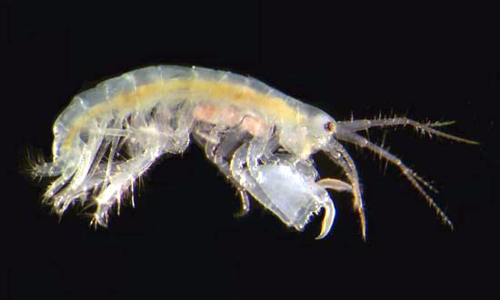
Maera sp an undescribed species from Guana Island (Photo Yale Peabody Museum)

Diagnosis of the Hadzioidea – “body not carinate nor rostrate, toothed on abdomen only (rarely on peraeon): urosome dorsal spine groups weak or lacking; sexual dimorphism strongly expressed in body size and in gnathopods, and in antenna 2 and peraeopods; antennae 2 lacking calceoli; antennae strongly developed, 1 usually much the longer, peduncular segment 2 elongate; accessory flagellum prominent (occasionally very reduced or lacking); inferior antennal sinus small or sharply incised; eye (when present) basically small, rounded, occasionally reniform. Mouthparts basic: mandibular palp slender, weakly armed, occasionally lacking, segment 3 not greatly shortened; lower lip, inner lobes variously developed, often strong; maxillae, plates often small, setose apically; maxilla 1, outer plate with 11-7 apical spine-teeth; maxilliped plates moderately strong, marginally spinose, palp dactylate,. Coxal plates 1-4 medium deep to shallow, contiguous, weakly setose; coxae 5-7, posterior lobe not deeper than anterior. Gnathopods 1 and 2 subchelate, 2 much the larger and more powerful (especially ♂) and of different form (especially in carpus and propodus); peraeopod 3 larger than 4, not sexually dimorphic; peraeopods 5-7, bases variously expanded, often sub-linear, 7 usually longest; pleopods usually well developed, peduncles slender; epimeral plates posteriorly acute. Uropod 1, peduncle with baso-facial spine strongly developed; uropod 3, rami variably developed, spinose, seldom setose; telson variously bilobed, lobes usually divergent, apices acute, spinose in apical notch. Coxal gills simple, often pedunculate, lacking on peraeon 7; sternal gills lacking; brood plates linear, often small, margins few- and short-setose.”(Bousfield 1977).

Ecological Commentary
Hadzioids are epifaunal animals, often found among algae or in fouling community masses. They do not construct even temporary tubes, living instead a fully mobile life in their chosen habitat, or exceptionally in burrows of their own construction in deeper offshore bottoms. While such epifauna typically have high oxygen demand, and are found in unimpacted areas, some hadzioids are more tolerant of polluted conditions. Sagasti et al (2000) found Melita nitida to be tolerant of low oxygen episodes in the York River. While they did not observe full anoxia, hypoxic conditions, with oxygen saturation as low as 0.5% occurred periodically during their study. As this species is a known invasive (Chapman 1988), and has demonstrated abilities to survive under hydrocarbon pollutant stress (Borowsky et al 1997), its tolerance of low-oxygen is not surprising. The animals must have good swimming ability, as they disperse primarily as adults, nearly 97% of the population colonizing new substrate arriving as adults. Of these, the majority were females and 50% were gravid at time of arrival. (Munguia et al 2007).
Hadzioids were among the groups considered by Saint-Marie (1991) in his review of reproductive behavior in the gammaroids. Most of the taxa for which evidence was available were judged to produce more than one brood per hear. In an investigation of the biology of the melitid Victoriopisa chilkensis Aravind et al (2007, as Eriopisa chilkensis) found it had 4-7 broods per year, lived less than one year on average. The amazingly prolific Melita zeylandica was estimated to bear 22 broods per year by Krishnan and John (1974)! The only NEP hadzioid considered was the introduced Melita nitida, which was suggested to bear an indeterminate number of broods per year, but more than one.
Members of the melitid genus Elasmopus are frequently present in large numbers among algae on intertidal rocks. Their taste in hosts is catholic, and the same species may be found on green algae such as Ulva, on filamentous red algal masses, on branching reds, and on calcareous reds. They are also found among surf-grass, and on larger brown algae such as Egregia and Macrocystis (J. L. Barnard 1969). These animals tend to have pigment patterning on their bodies, and especially on their legs. Unlike ampithoid corophioids that resemble the host plant in color, the patterning of the Elasmopus is not obviously cryptic. They do not seem to derive their pigments from the algae they are associated with, and probably do not feed directly on them. It is more likely they are either grazing on epiphytic diatoms on the algae, or harvesting detritus from within the algal interstices. One commensal melitid is known to feed on detritus along with its ophiuroid host (Lowry and Springthorpe 2005). Similar detrital feeding is reported for Melita obtusata which lives as a commensal between the tube feet of asteroids (Reibisch 1927). Enequist (1950) also observed this animal without its host in his aquaria, and saw it teasing detrital aggregates from chinks and crevices under shell debris and other objects. No sifting such is observed in burrowing forms was employed.
Some NEP melitoids are apparently specialized as lignivores, living and feeding on sunken wood. These deep-water forms such as Bathyceradocus and Melita lignophila (J. L. Barnard 1961), process sunken trees, branches, cocoanuts, etc.
While hadzioids are often found on fully submerged substrates, such as on the community fouling docks, pilings and other structures, they are also found in the intertidal. Algal density tends to increase as one moves lower in the intertidal, but even the mid-intertidal frequently has considerable growth, among which these amphipods are found. These forms tend to have a fairly waxy cuticle (Chapman 2007) which may help retard water loss during emersion at low tide. A number of the habitat records for melitids listed by J. L. Barnard (1969) did not mention algae or other growth. He instead recorded animals as “on the undersides of rocks”, a habit I have often observed in the intertidal zone of the SCB, especially when the rock is bedding in coarse sand. Overturned rocks will often have numbers of amphipods attempting to flee exposure by scooting along on their flat sides within the film of moisture coating the rock. These are often melitoids, although other groups are also represented.
In some cases such underrock habitat is shared with other organisms, particularly ophiuroids. Lowry and Springthorpe (2005) describe a new species of Melita found to live commensally on the oral surface of a large ophiuroid under rocks in Australia. The species is well adapted to this habitat, having color patterning which matches the host, and having reduced sexual dimorphism compared to other melitids. The authors suggest that this results from the constant association of the amphipods in male-female pairs on the ophiuroid. This association would make precopulatory mate guarding unnecessary, and render secondary sexual differentiation unneeded.
In her review of sexual dimorphism and behavior in amphipods Conlan (1991) classifies the melitid Elasmopus levis as an attending mate-guarder, but noted that attending of the female by the male is very limited. She also indicates Melita nitida as a mate-guarder carrier, engaging in precopulatory grasping of the female. There is apparently a range of sexual behavior in the family, which is accompanied by a range in sexual dimorphism. This is primarily expressed in the male first and second gnathopods, but in some groups of Melita is also expressed in the structure of the basis of the sixth pereopod of the female, which is grasped by the male gnathopod 1in pre-amplexus (Krisnan and John 1974, Borowsky 1984).
Direct observations of the activities of two genera of melitoids were made by Enequist (1950). He observed aquarium maintained Maera loveni and Eriopisa elongata. While his observations were made on individuals from the Northeast Atlantic, these same species also occur in the NEP. Both are apparently deposit feeding detritivores, that simultaneously burrow and feed. When offered bits of fish flesh, they would initially bury them, then consume them later when encountered in the burrow. They thus are also facultative scavengers on small decaying masses. This behavior suggests that they do not engage in opportunistic feeding on moribund animals, but require the appropriate bacterial flora on the tissue before it is found palatable by the amphipod.
The methods of burrowing used by the two are described at length by Enequist (1950), which should be consulted for additional detail. Both species are very agile burrowers, and reverse field within the burrows with ease. The burrows are double ended, with apertures at both ends providing for a slow respiratory water exchange. Movement of water by pleopods is not involved in feeding, which is performed by the sifting of organics from the sediment excavated by the animal. This is done primarily by the gnathopods, with some assistance from the second antennae. Both these forms are found on offshore soft bottoms of mixed silt and sand. The local Maera nelsonae, which lives in similar habitat, is presumed to share similar burrowing behavior, although this has not yet been observed.
Swimming in these two burrowers is clumsy, and may differ significantly from that in non-burrowing motile epifaunal melitoids. Enequist records their swimming as anterior posterior flexion, as used by caprellids. Swimming excursions were of short duration.
Another melitoid was also observed by Enequist, which excavate furrows without forming domicilary burrows; Melita othonis (now Othomaera othonis, see Krapp-Shickel 2000). The taxon were active at the surface, digging up the sediment and resuspending its finer portion by vigorous beating of the pleopods. This particle cloud was then harvested by the strongly setose gnathopods, which were used to strain out the organic particulates. These were then removed from the gnathopod setal comb by the mouthparts and ingested.

Key to NEP Hadzioid genera (modified from Jarrett and Bousfield 1996 and Krapp-

Schickel and Jarrett 2000)

- Inner ramus of U3 strongly reduced (”melita group”)............................................2
Inner ramus of U3 subequal to outer ramus (“maera/ceradocus groups”)............12
- Pleon segments 1-3 usually posteriodorsally toothed; urosome segments 1-2 with dorsal teeth...............................................................................................................3
Pleon segmens 1-3 smooth or weakly toothed; urosome segments 1 and 2 often
lacking dorsal teeth..................................................................................................6

3. U3 outer ramus rod-like, slender; maxilla 1 inner plate with tuft of apical setae, otherwise bare; one gnathopod 2 much enlarged (♂)..............................Dulichiella
U3 outer ramus normal; maxilla 1 inner plate inner margin setose; second
gnathopods subequal in size and shape in both sexes..............................................4

- Pleon segments 1-3 with posterodistal teeth; urosome segment 1 with 3+ postero-distal teeth...............................................................................................Megamoera
Pleon segments 1-3 lacking posterodorsal teeth; urosome segment 1 usually with single stout posterodistal tooth.................................................................................5
- G2 (♂) dactyl strongly setose on outer margin; carpus broader than deep; coxa 1 anterolobate............................................................................................Quasimelita
G2 (♂) dactyl lacking outer marginal setae; carpus narrow, deeper than broad; coxa 1 anteriorly subquadrate to rounded...............................................Desdimelita
- G1 (♂) propod and dactyl usually strongly differing from female; anterior lobe of coxa 6 (♀) modified, usually hook-like...........................................................Melita
G1 (♂) dactyl and propod normally sub-chelate, showing little or no sexually
dimorphism in structure; coxa 6 (♀) with little or no anterior modification...........7
- Uropod 3 outer ramus uniarticulate.........................................................................8
Uropod 3 outer ramus biarticulate.........................................................................10
- Pigmented eyes present............................................................................Netamelita
Pigmented eyes absent.............................................................................................9
- Uropod 3 outer ramus nearly twice as long as peduncle.........................Anchialella
Uropod 3 outer ramus equal to or slightly longer than peduncle..........Galapsiellus
- Uropod 3 outer ramus terminal article much shorter than first article, both
together less than ¼ body length..................................................................Dulzura
Uropod 3 outer ramus terminal and basal articles subequal in length, together
nearly ½ body lengh...............................................................................................11
- Article 3 of mandibular palp much longer than article 2.............................Eriopisa
Article 3 of mandibular palp shorter than article 2.....................Psammogammarus
12. With pigmented eyes..............................................................................................14
Lacking any trace of eyes......................................................................................13
13. Pleonites and urosome 1-2 posterodorsally dentate.........................Bathyceradocus
Pleonites and urosomites lacking teeth, cusps or denticles...................Wimvadocus
- Article 3 of mandibular palp strongly falcate...........................................Elasmopus
Article 3 of mandibular palp not falcate................................................................15
15. G2 dactylus outer margin setose; palmar angle ≈ 120º...................................Maera
G2 dactylus with single seta on outer margin; palmar angle various....................16
16. G2 propodus quadrangular, palmar angle 90º......................................Quadrimaera
G2 propodus oval, palmar angle exceeds 90º........................................................17
17. U3 rami shortened, 1.5 times longer than wide, slightly longer than peduncle;
antennal flagella reduced..........................................................................Lupimaera
U3 rami not shortened, 2-3 times peduncle length; antennal flagella not reduced
..................................................................................................................Ceradocus

NEP Hadzioidea from McLaughlin et al. (2005) augmented by known provisional taxa. *= Taxa on the SCAMIT Ed 4 list + addenda. Valid taxa bolded, synonyms not.

Family Allocrangonyctidae – no representatives in NEP

Family Hadziidae
Dulzura gal J. L. Barnard 1979 – Galapagos; 0-1m
Dulzura sal J. L. Barnard 1969 – California, Corona del Mar to La Jolla; 0m
Family Melitidae
Anchialella vulcanella J. L. Barnard 1979 – Galapagos anchihaline pool; 0m
Bathyceradocus stephenseni Pirlot 1934 – Indo-Pacific, Madagascar, Philipines;
NEP East Pacific Rise to Gulf of Panama: 1500-4930m
Caliniphargus sulcus Stout 1913 (see Melita sulca)
Ceradocus paucidentatus J. L. Barnard 1952 – Pacific Baja California to Gulf of
California: 0m
*Ceradocus spinicauda (Holmes 1908) – British Columbia to San Diego; 0-82m
Ceradocus torelli see Wimvadocus torelli
Desdimelita barnardi Jarrett and Bousfield 1996 – Vancouver Id.: 0m
Desdimelita californica (Alderman 1936) – Aleutians to Central California:
0-37m
*Desdimelita desdichada (J. L. Barnard 1962) – SE Alaska to SCB: 0-120m
Desdimelita microdentata Jarrett and Bousfield 1996 – SE Alaska to Central
Oregon: 0-35m
Desdimelita microphthalma Jarrett and Bousfield 1996 – SE Alaska: 0m
Desdimelita transmelita Jarrett and Bousfield 1996 – Vancouver Id.: 16-30m
*Dulichiella spinosa Stout 1912 – California, Goleta to Laguna Beach: 0-27m
Elasmopus antennatus (Stout 1913) – California, Carmel to Cabo San Lucas:
0-18m
*Elasmopus bampo J. L. Barnard 1979 – SCB to Gulf of California: 0-3m
Elasmopus ecuadoriensis Schellenberg 1936 – Galapagos Ids.: 0m
Elasmopus gracilis Schellenberg 1938 – NEP, Clipperton Id.; Indo-Pacific, Fiji
and Ellice Islands: 0m
Elasmopus holgurus J. L. Barnard 1962 – SCB: 0m
Elasmopus mayo J. L. Barnard 1979 – Gulf of California to Galapagos: 0m
*Elasmopus mutatus J. L. Barnard 1962 – Central to Southern California; 0m
Elasmopus ocoroni J. L. Barnard 1979 – Galapagos Ids.: 0m
Elasmopus rapax Costa 1853 – Mediterranean; introduced to NEP, occurring
in bays between Central California and Gulf of California: 0-100m
Elasmopus serricatus J. L. Barnard 1969 – Carmel California to Panama: 0m
Elasmopus spinidactylus Chevreux 1907 – NEP, Clipperton Id.; Indo-Pacific,
Tuamoto and Gilbert Islands: 0m
Elasmopus temori J. L. Barnard 1979 – Galapagos Ids.: 0m
Elasmopus tiburoni J. L. Barnard 1979 – Gulf of California: 0m
Elasmopus tubar J. L. Barnard 1979 – Cabo San Lucas to Galapagos Ids.: 0m
Elasmopus zoanthidea J. L. Barnard 1979 – Galapagos Ids.: 0m
Eriopis elongata Bruzelius 1859 ( see Eriopisa elongata)
Eriopisa elongata (Bruzelius 1859) – Boreal North Atlantic, North Pacific to
Oregon: 100 -1200m
Eriopisa garthi J. L. Barnard 1952 )(see Psammogammarus garthi)
Galapsiellus leleuporum (Monod 1970) – Galapagos Ids.: 0-29m
Gammarus dentatus Krøyer 1842 (see Megamoera dentata)
Gammarus loveni Bruzelius 1859 (see Maera loveni)
Gammarus subtener Stimpson 1864 (see Megamoera subtener)
Gammarus torelli Goës 1866 (see Wimvadocus torelli)
Leptothoe danae Stimpson 1853 (see Maera danae)
Lupimaera lupana (J. L. Barnard 1969) – SCB: 3m
Maera bousfieldi Krapp-Schickel and Jarrett 2000 – British Columbia: to 196m
Maera caroliniana Bynum & Fox 1977 (see Maera diffidentia)
Maera chinarra J. L. Barnard 1979 (see Quadrimaera chinarra)
Maera danae (Stimpson 1853) – Bering Sea to Gulf of Alaska: 0-110m
Maera diffidentia (J. L. Barnard 1969) – NEP, Gulf of California to Galapagos
Ids.; South Carolina to Florida: 0-125m
Maera fusca (Bate 1864) – Bering Sea to Washington: 0m
*Maera jerrica Krapp-Schickel & Jarrett 2000 – SE Alaska to La Jolla: 0-61m
Maera loveni (Bruzelius 1859) – North Atlantic; NEP, Puget Sound: 20-300m
Maera lupana J. L. Barnard 1969 (see Lupimaera lupana)
*Maera nelsonae Krapp-Schickel & Jarrett 2000 – Bering Sea to SCB: 75-732m
Maera reishi J. L. Barnard 1979
*Maera similis Stout 1913 –British Columbia to Sinaloa, Mexico: 0-221m
Maera spinicauda Holmes 1908 (see Ceradocus spinicauda)
Maera vigota J. L. Barnard 1969 (see Quadrimaera vigota)
Megamoera borealis Jarrett and Bousfield 1996 -Aleutian Ids. to British
Columbia: 0-66m
Megamoera bowmani Jarrett and Bousfield 1996 – SE Alaska to British
Columbia: 0-25m
Megamoera dentata (Krøyer 1842) – Western North Atlantic; Bering Sea to Sea
of Japan; NEP, Aleutian Ids.: 0-672m
Megamoera glacialis Jarrett and Bousfield 1996 – Aleutian Ids. to Prince
William Sound, Alaska: 0m
Megamoera kodiakensis (J.L. Barnard 1964) – Gulf of Alaska: depth not
recorded, but bathyal (200+m)
Megamoera mikulitschae (Gurjanova 1953) – NWPacific, Chucki Sea; NEP,
Aleutian Ids.: 0-10m
Megamoera rafiae Jarrett and Bousfield 1996 – SE Alaska: 0m
*Megamoera subtener (Stimpson 1856) – Prince William Sound Alaska to
Central California: 0-10m
Megamoera unimaki Jarrett and Bousfield 1996 – Aleutian Ids.: 0m
Melita alaskensis Jarrett and Bousfield 1996 – SE Alaska: 0m
Melita californica Alderman 1936 (see Desdimelita californica)
Melita dentata (Krøyer 1842) (see Megamoera dentata)
Melita desdichada J. L. Barnard 1962 (see Desdimelita desdichada)
Melita kodiakensis J. L. Barnard 1964 (see Megamoera kodiakensis)
Melita lignophila J. L. Barnard 1961 – Gulf of Panama: 915m
Melita mikulitschae Gurjanova 1953 (see Megamoera mikulitschae)
Melita nitida Smith 1874 – NW Atlantic; Introduced to NEP, British
Columbia to San Gabriel River: 0-10m
Melita oregonensis J. L. Barnard 1954 – British Columbia to Northern
California: 0m
Melita quadrispinosa Vosseler 1889 (see Quasimelita quadrispinosa)
Melita rylovae Bulycheva 1955 – NWPacific; NEP, introduced to San
Francisco Bay: 1-10m
*Melita sulca (Stout 1913) – British Columbia to Baja California 0-101m
Melita valida Shoemaker 1955 (see Melitoides valida)
Melita sp A Cadien 2007§ - Moss Landing, Central California: 0-3m
Meximaera diffidentia J. L. Barnard 1969 (see Maera diffidentia)
Neogammaropsis antennatus Stout 1913 (see Elasmopus antennatus)
Netamelita cortada J. L. Barnard 1962 – Pt. Conception to Gaviota: 22m
Paraniphargis lelouporum Monod 1970 (see Galapsiellus lelouporum)
Psammogammarus garthi (J. L. Barnard 1952)
*Quadrimaera carla Krapp-Schickel & Jarrett 2000 – British Columbia to
Venice, California; 27-33m
Quadrimaera chinarra (J. L. Barnard 1979) – Cabo San Lucas, Baja California
to Galapagos Ids.: 0m
*Quadrimaera reishi (J. L. Barnard 1979) – SCB to Galapagos: 0-10m
*Quadrimaera vigota (J. L. Barnard 1969) - Gulf of Alaska to Central
California: 0m
Quasimelita quadrispinosa (Vosseler 1889) - Chuckchi Sea NWPacific to
SE Alaska: 0m
Paraniphargus leleuporum Monod 1970 (see Galapsiellus leleuporum)
Wimvadocus torelli (Goës 1866) – Bering Sea to British Columbia: 0-57m

Family Carangoliopsidae – no NEP representatives

Comments by family on nep hadzioid genera

Family Allocrangonyctidae – The family contains only freshwater species, and both North American members are cave amphipods living far from the Pacific coast.

Family Hadziidae – Organization of the family was laid out by J. L. Barnard in 1976, providing a general guide to the distribution of genera within informal groupings. These groupings were further refined and often well defined by J. L. Barnard and C. M. Barnard (1983). The first group in the family Hadziidae (the weckeliids) is, like the Allocrangonyctidae, restricted to freshwater (see Bousfield 2001). The second group (the hadziids s.s.) contains both freshwater and marine species, but only two of the latter (Dulzura sal and D. gal) are from the NEP. Although Bousfield (2001) lists Netamelita species as members of the family Hadziidae, they more properly belong among the eriopisella group of the Melitidae. The third group of the family Hadziidae, the nuuanids, only occur along the margins of the Gulf of Mexico, and are thus outside our area of coverage. The family was reviewed by Stock (1977), who explored its zoogeography. Like the members of the family Bogidiellidae, hadziids show a zoogeographic distribution that reflects their origin in the Tethys Sea.
Diagnosis: “Head free, not coalesced with peraeonite 1; exposed; as long as deep, or longer than deep; anteroventral margin weakly recessed or rounded or straight or oblique, anteroventral margin shallowly excavate or not excavate, anteroventral corner rounded or subquadrate or absent; rostrum absent; eyes absent. Body laterally compressed, or subcylindrical; cuticle smooth.
Antenna 1 longer than antenna 2; peduncle with sparse robust and slender setae; 3-articulate; peduncular article 1 subequal to article 2, or longer than article 2; antenna 1 article 2 longer than article 3; peduncular articles 1-2 not geniculate; accessory flagellum present, or absent; antenna 1 callynophore absent. Antenna 2 present; short; articles not folded in zigzag fashion; without hook-like process; flagellum shorter than peduncle; less than 5-articulate; not clavate; calceoli absent.
Mouthparts well developed. Mandible incisor dentate; lacinia mobilis present on both sides; accessory setal row without distal tuft; molar present, medium, triturative; palp present. Maxilla 1 present; inner plate present, strongly setose along medial margin; palp present, not clavate, 2 -articulate. Maxilla 2 inner plate present; outer plate present. Maxilliped inner and outer plates well developed or reduced, palps present, well developed or reduced; inner plates well developed, separate; outer plates present, large or small; palp 4-articulate, article 3 without rugosities. Labium smooth.
Peraeon. Peraeonites 1-7 separate; complete; sternal gills absent; pleurae absent.
Coxae 1-7 well developed, none fused with peraeonites. Coxae 1-4 longer than broad or broader than long, overlapping, coxae not acuminate. Coxae 1-3 not successively smaller, none vestigial. Coxae 2-4 none immensely broadened.
Gnathopod 1 not sexually dimorphic; smaller (or weaker) than gnathopod 2; subequal to coxa 2; gnathopod 1 merus and carpus not rotated; gnathopod 1 carpus/propodus not cantilevered; subequal to propodus, or longer than propodus; gnathopod 1 not produced along posterior margin of propodus; dactylus large. Gnathopod 2 sexually dimorphic; subchelate; coxa subequal to but not hidden by coxa 3; ischium short; merus not fused along posterior margin of carpus or produced away from it; carpus/propodus not cantilevered, carpus short, shorter than propodus, slightly produced along posterior margin of propodus or not produced along posterior margin of propodus.
Peraeopods heteropodous (3-4 directed posteriorly, 5-7 directed anteriorly), none prehensile. Peraeopod 3 well developed. Peraeopod 4 well developed. 3-4 not glandular; 3-7 without hooded dactyli, 3-7 propodi without distal spurs. Coxa well developed, longer than broad or expanded distally; carpus subequal to propodus, not produced; dactylus well developed. Coxa subequal to coxa 3 or larger than coxa 3, not acuminate, with well developed posteroventral lobe; carpus not produced. Peraeopods 5-7 with few robust or slender setae; some or all dactyli with slender or robust setae. Peraeopod 5 well developed; shorter than peraeopod 6; coxa smaller than coxa 4, with posterodorsal lobe; basis expanded or slightly expanded, with posteroventral lobe; merus/carpus free; carpus linear; setae present along margin or setae absent or with a few subterminal setae. Peraeopod 6 subequal in length to peraeopod 7; merus/carpus free; dactylus with setae along margin, or without setae, or with a few subterminal setae. Peraeopod 7 with 6-7 well developed articles; longer than peraeopod 5; similar in structure to peraeopod 6; with 7 articles; basis expanded, without dense slender setae; dactylus with setae along margin or without setae or with a few subterminal setae.
Pleon. Pleonites 1-3 with transverse dorsal serrations or without transverse dorsal serrations, without dorsal carina; with slender or robust dorsal setae, or without slender or robust dorsal setae. Epimera 1-3 present. Epimeron 1 well developed. Epimeron 2 without setae.
Urosome not dorsoventrally flattened; urosomites 1 to 3 free; urosomite 1 longer than urosomite 2; urosome urosomites not carinate; urosomites 1-2 without transverse dorsal serrations. Uropods 1-2 apices of rami with robust setae. Uropods 1-3 radically dissimilar in structure and size, or similar in structure and size. Uropod 1 peduncle without long plumose setae, with 1 or 2 basofacial robust setae, without ventromedial spur. Uropod 2 well developed; without ventromedial spur, without dorsal flange; inner ramus subequal to outer ramus, or longer than outer ramus. Uropod 3 not sexually dimorphic; peduncle short; outer ramus longer than peduncle, 1-articulate or 2-articulate, without recurved spines. Telson laminar; deeply cleft; longer than broad, or as long as broad; apical robust setae present.” (Lowry and Springthorpe 2001).
Dulzura – Originally established by J. L. Barnard (1969) to house a single intertidal form from Central California, a second species was described from the Galapagos (J. L. Barnard 1979), and two Hawaiian species originally described in Eriopisa (J. L. Barnard 1970) were transferred to Dulzura by J. L. Barnard and C. M. Barnard (1983). All of these forms are closely related siblings from the Pacific. An additional species was added by Stock and Vonk (1991) from the Atlantic, the only non-Pacific member of the genus. Only D. sal from Central California and D. gal from the Galapagos fall within the NEP coverage area. The two can be distinguished most easily by the relative lengths of the telsonic terminal spines. These equal or exceed the telson length in D. gal, but are only about ½ telson length in D. sal. J. L. Barnard (1979) mentions that D. gal is nearly identical to D. hamakua from Hawaii, and may prove to be only subspecifically differentiable once more material is examined. Although not mentioned in the family description by Lowry and Springthorpe, the presence of a setal comb on the distal portion of the peduncle of uropod 2 was suggested as a unifying character of the hadziid group within the Hadziidae by J. L. Barnard and C. M. Barnard (1983, p. 146). The absence of eyes in these animals is unusual in an intertidal form, and reflects their affinities with other hadziid taxa occupying subterranean freshwaters.
Family Melitidae – Description: “Head free, not coalesced with peraeonite 1; exposed; as long as deep, or longer than deep; anteroventral margin notched (not complete), anteroventral corner rounded or subquadrate or hooked; rostrum present or absent, short; eyes present, well developed or obsolescent, or absent; not coalesced; 1 pair; not bulging. Body laterally compressed; cuticle smooth. Antenna 1 subequal to antenna 2, or longer than antenna 2; peduncle with sparse robust and slender setae; 3-articulate; peduncular article 1 shorter than article 2, or subequal to article 2, or longer than article 2; antenna 1 article 2 longer than article 3; peduncular articles 1-2 not geniculate; accessory flagellum present; antenna 1 callynophore absent. Antenna 2 present; short, or medium length; articles not folded in zigzag fashion; without hook-like process; flagellum shorter than peduncle; 5 or more articulate; not clavate; calceoli absent.
Mouthparts well developed. Mandible incisor dentate; lacinia mobilis present on both sides; accessory setal row without distal tuft; molar present, medium, triturative or non-triturative; palp present. Maxilla 1 present; inner plate present, strongly setose along medial margin; palp present, not clavate, 2 -articulate. Maxilla 2 inner plate present; outer plate present. Maxilliped inner and outer plates well developed or reduced, palps present, well developed or reduced; inner plates well developed, separate; outer plates present, large or small; palp 4-articulate, article 3 without rugosities. Labium smooth. Peraeon. Peraeonites 1-7 separate; complete; sternal gills absent; pleurae absent. Coxae 1-7 well developed, none fused with peraeonites. Coxae 1-4 longer than broad or broader than long, overlapping, coxae not acuminate. Coxae 1-3 not successively smaller, none vestigial. Coxae 2-4 none immensely broadened. Gnathopod 1 not sexually dimorphic; smaller (or weaker) than gnathopod 2, or subequal to gnathopod 2; subequal to coxa 2; gnathopod 1 merus and carpus not rotated; gnathopod 1 carpus/propodus not cantilevered; subequal to propodus, or longer than propodus; gnathopod 1 not produced along posterior margin of propodus; dactylus large. Gnathopod 2 sexually dimorphic; subchelate; coxa subequal to but not hidden by coxa 3; ischium short; merus not fused along posterior margin of carpus or produced away from it; carpus/propodus not cantilevered, carpus short, shorter than propodus, slightly produced along posterior margin of propodus or not produced along posterior margin of propodus. Peraeopods heteropodous (3-4 directed posteriorly, 5-7 directed anteriorly), none prehensile. Peraeopod 3 well developed. Peraeopod 4 well developed. 3-4 not glandular; 3-7 without hooded dactyli, 3-7 propodi without distal spurs. Coxa well developed, longer than broad; carpus subequal to propodus, not produced; dactylus well developed. Coxa subequal to coxa 3 or larger than coxa 3, not acuminate, with well developed posteroventral lobe or with small posterior lobe or without posteroventral lobe; carpus not produced. Peraeopods 5-7 with few robust or slender setae; dactyli without slender or robust setae. Peraeopod 5 well developed; shorter than peraeopod 6; coxa smaller than coxa 4, without posterior lobe; basis expanded, with posteroventral lobe or without posteroventral lobe; merus/carpus free; carpus linear; with a few subterminal setae. Peraeopod 6 subequal in length to peraeopod 7; merus/carpus free; dactylus with a few subterminal setae. Peraeopod 7 with 6-7 well developed articles; longer than peraeopod 5; similar in structure to peraeopod 6; with 7 articles; basis expanded, without dense slender setae; dactylus with a few subterminal setae. Pleon. Pleonites 1-3 with transverse dorsal serrations or without transverse dorsal serrations, without dorsal carina; without slender or robust dorsal setae. Epimera 1-3 present. Epimeron 1 well developed. Epimeron 2 setose, or without setae. Urosome not dorsoventrally flattened; urosomites 1 to 3 free; urosomite 1 longer than urosomite 2, or much longer than urosomite 2; urosome urosomite 1 bicarinate, or urosomites not carinate; urosomites 1-2 without transverse dorsal serrations. Uropods 1-2 apices of rami with robust setae. Uropods 1-3 radically dissimilar in structure and size, or similar in structure and size. Uropod 1 peduncle without long plumose setae, with 1 or 2 basofacial robust setae, without ventromedial spur. Uropod 2 well developed; without ventromedial spur, without dorsal flange; inner ramus subequal to outer ramus, or longer than outer ramus. Uropod 3 not sexually dimorphic; peduncle short; outer ramus longer than peduncle, 1-articulate or 2-articulate, without recurved spines. Telson laminar; deeply cleft; longer than broad, or as long as broad; apical robust setae present.” (Lowry and Springthorpe 2001).
The third NEP hadzioid family is the Melitidae, well represented in our area by a number of species in several genera. It has been recently revised by Jarrett & Bousfield (1996) and Krapp-Schickel & Jarrett (2000). These revisions have not yet extended to the genus Elasmopus, which was most recently treated in some detail by J. L. Barnard (1979). The most complete treatment of the melitids was by J. L. Barnard and C. M. Barnard (1983). They broke the family up into several component groups with no nomenclatural standing, but useful for discussion of evolution within the family and relationships between genera. They identified the prime group as melitids ss., which include the regional genera Melita, Galapsiellus, Dulichiella, Netamelita, Eriopisa, Psammogammarus, and Anchialella. They considered Megamoera to be a synonym of Melita, but it was resurrected by Jarrett and Bousfield (1996), who added Desdimelita as a new genera related to the melitids. Krapp-Schickel & Jarrett added Wimvadocus, a new genus with affinities to Megamoera in the melitid group. Jarrett & Bousfield provide a nice introduction to the family, touching on its history and current status, in the first part of their paper. They then lay out the group memberships within the family (p. 5) without providing a key. They do provide a key to the genera and species in the Melita group known to occur in the NEP (p. 7). Krapp-Schickel & Jarrett (2000), in a follow-up article, address the Maera group as laid out by Jarrett & Bousfield but only deal with a part of it. The genus Elasmopus is mentioned, and one species is discussed (Elasmopus cf. antennatus), but is neither fully treated or included in their key to Maera group genera from the northern Pacific (pg. 28). The genus Ceradocus is also considered, but other members of the Ceradocus group in the NEP are not. There is, therefore, no comprehensive key to the melitids from the NEP at genus level, or at group level. The currently accepted groups are not the same as those employed by J. L.Barnard and C. M. Barnard (1983), but they do provide a key to the hadzioids that includes all of the groups we are concerned with (pg. 612). Most of the California genera are covered in Jarrett & Bousfield’s key to the Melita group (1996, p. 7). With the exceptions of Elasmopus and Bathyceradocus, the genera of the Maera and Ceradocus groups are keyed by Krapp-Schickel & Jarrett (2000, p. 28). Anchialella – A monotypic genus based on an anchihaline species from the Galapagos Islands, where it was taken in a mangrove tidepool some distance from the shoreline. (J. L. Barnard 1979). It appears to be transitional between an Eriopisa-like ancestor and the apomorphic Galapsiellus, also found in anchihaline habitat in the Galapagos. Anchialella vulcanella, like Galapsiellus and the hadziid genus Dulzura, is blind despite its shallow habitat. Stock and Iliffe (1990) suggest that the differences between Anchialella vulcanella and Galapsiellus lelouporum are not of generic value, but that the two species can easily be distinguished on the basis of the length of the gnathopodal meri. If this proves true, with additional specimens demonstrating that the supposed generic boundaries are more a function of sexual dimorphism, as suggested by Stock and Iliffe, Galapsiellus will have priority and Anchialella will drop into synonymy.

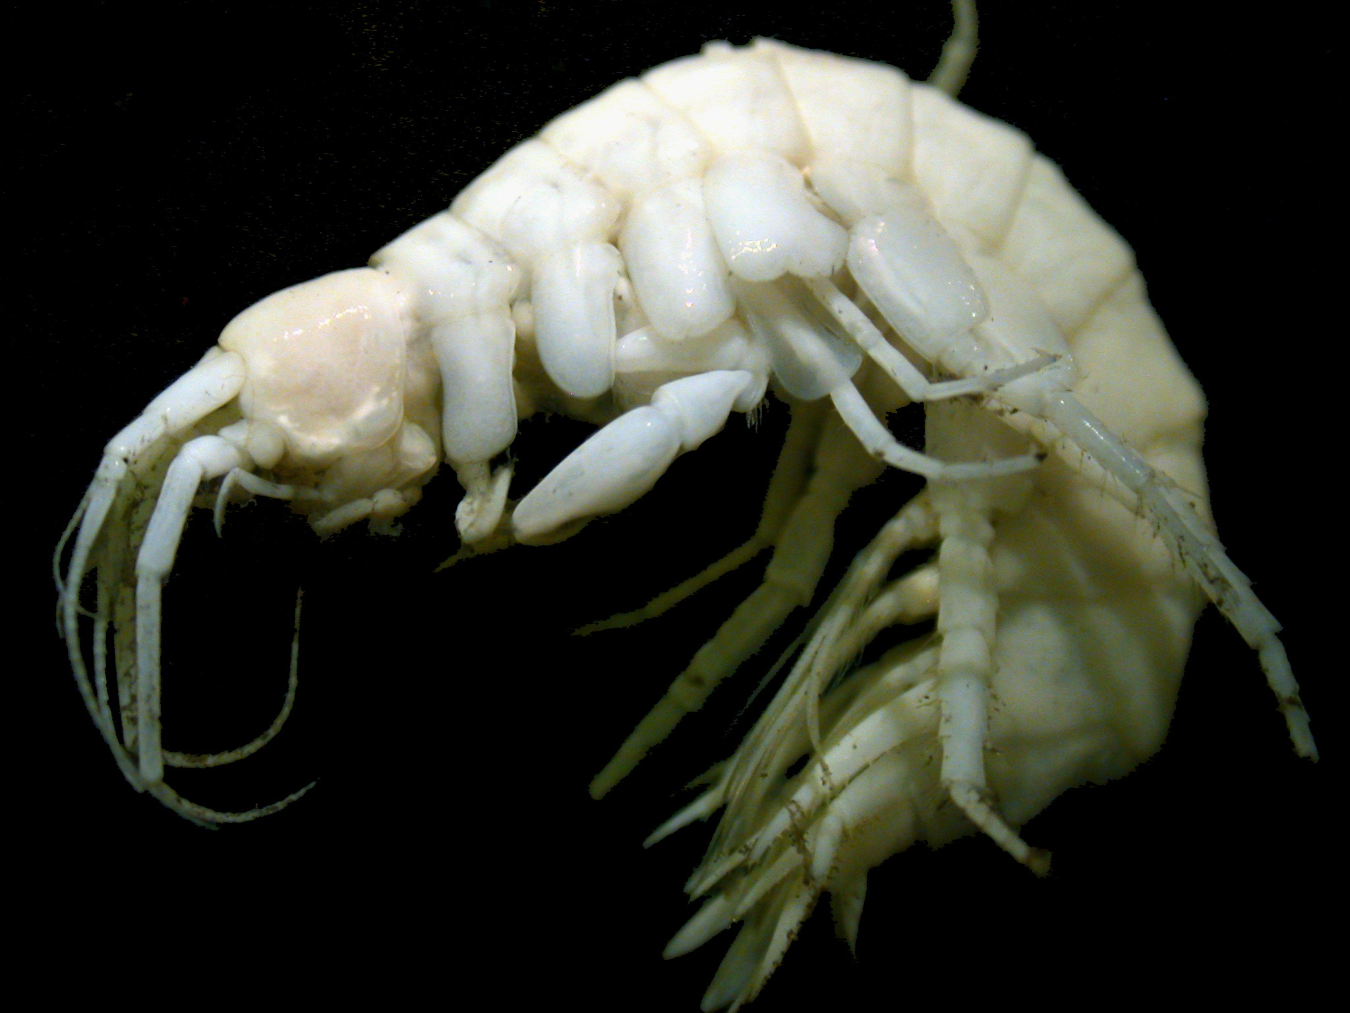
Bathyceradocus stephenseni from near hydrothermal vents at 13ºN (Photo Todd Haney)

Bathyceradocus – A single member of this genus is reported from the NEP, taken in deep water in the Gulf of Panama (J. L. Barnard 1961), and has since been taken near vents on the East Pacific Rise at 13ºN (see photo above). The same species has been reported from several other deepwater collections in the Indo-Pacific between Panama and Madagascar. The species, Bathyceradocus stephenseni, is a wood eater, and analyses of specimens recovered from a sunken log showed finely chopped cellulose in the gut. A second species was described from the deep Northeast Atlantic by Andres (1977).

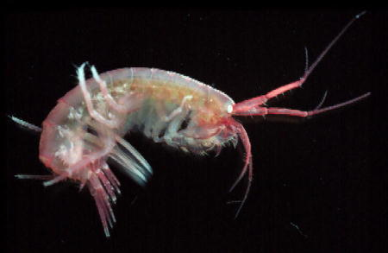
Ceradocus dooliba an Australian species (Photo Museum of Victoria)

Ceradocus - Prior to creation of the above comprehensive key to hadzioid genera in the NEP, the only way to key to Ceradocus, was in a general key to species such as that of Staude in Kozloff 1987 or J. L. Barnard in Light’s Manual (1975), or in the key to hadzioids provided by Chapman (2007, pp. 607-610). These keys will take you pragmatically to Ceradocus spinicauda (Holmes 1908), the only locally reported species in the genus. A second species is known from Baja California; Ceradocus (Denticeradocus) paucidentatus (J. L. Barnard 1952a). This has not yet been reported from north of Baja California. J. L. Barnard & C. M. Barnard (1983) recommended abandoning use of the subgenus as meaningless.
Ceradocus paucidentatus can be distinguished from C. spinicauda by: the shape of epimeron 3. In C. paucidentatus it is posteriorly subquadrate, with denticulations only along the posterior border. In C. spinicauda it is upswept to an acute point, with denticles both on the posterior border above, and on the ventral border below this point. Both species, and other members of the Maera-Ceradocus clade can be separated from the Melita group by their equiramose 3rd uropods.

Desdimelita - Key to genus provided by Jarrett & Bousfield (1996, p. 42). Two species reportedly occur in California. D. desdichada, the generotype, was described by J. L. Barnard (1962) from just north of the SCB; Monterey to Point Conception at 27-59fms. It has since been taken south of Pt. Conception, although the southern limit is not clear. Jarrett & Bousfield (1996) report it further north to Cordova Bay Alaska.
A second species, Desdimelita californica, is known from Central California north (originally described by Alderman 1936). The two can be separated using the key in Jarrett and Bousfield (1996, p. 42). Further north, however, four boreal Desdimelita species are reported. All are covered in the generic key mentioned above.

Dulichiella -This genus has a checkered history. It was originally established by Stout (1912) who believed the 3d uropods were lacking in the genus. They were in her type, but they had broken off. Prior to Karaman & J. L. Barnard 1979 the genus was viewed as a synonym of Melita. They resurrected it and redefined it. It was recently revised worldwide by Lowry & Springthorpe (2007).. Our local form was long considered to be Dulichiella appendiculata, a widely distributed Atlantic species redescribed and restricted by Lowry and Springthorpe (2007)(do not see Hirayama & Kikuchi 1979 for description of the taxon; the form they attribute to D. appendiculata was described as D. tomioka by Lowry and Springthorpe). The generotype, Dulichiella spinosa Stout 1912 has, however, been pulled from the synonymy of that species and is now viewed as the appropriate name of our local form (Lowry & Springthorpe 2007).
A very interesting genus, dorsally spinose on the posterior pereon, pleon, and urosome, and with profound sexual dimorphism in the second gnathopod. In adult males of Dulichiella one of the G2 gnathopods is grossly enlarged, as in snapping shrimp chelae. Some are left-handed, some right-handed. In females the G2 pair is symmetrical. Small juvenile males have a largely female G2 configuration. In pre adult males disparity in G2 sizes increases with moult number. Stout’s original description is lacking in particulars, and local material is redescribed by Lowry & Springthorpe (2007).
Members of the genus are usually algal associates. Material we have taken has come from algae in trawl samples, although it could easily have also been collected by divers from the rocky subtidal. The taxon does not occur on soft bottoms per se, and if encountered there, it will be on algal drift. The very small sprigs of algae that are attached to worm tube caps are not large enough to support a group of Dulichiella. They appear to be gregarious. If found at all they tend to be taken in number (for instance the aggregations noted by Munguia, 2007, on empty pen shells on otherwise open bottom [probably the species pictured below]). Their food habits are not yet known.

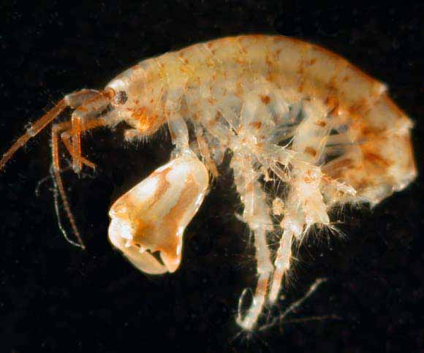
Dulichiella lecroyae from South Carolina (Photo SERTC)

Elasmopus - Five species of Elasmopus are recorded from California, two of which are currently on the SCAMIT list. A number of additional species are known from southern waters, bringing the NEP total for the genus to 15. While not discussed comparatively in Krapp-Schickel & Jarrett (2000), most of the reported species (exceptions being E. gracilis and E. spinidactylus of Schellenberg) were discussed in J. L. Barnard 1979. Males were keyed in that paper, but not females. J. L. Barnard (1969) provides a key to California Elasmopus species including both male and female character states. His nomenclature differs from present usage in listing mutatus, and serricatus as subspecies of E. rapax, and in treating E. bampo as the “Elasmopus rapax of Alamitos Bay, California”.
The SCB species can be distinguished (at least as mature males) by details of the gnathopod and telson. The second species on the SCAMIT list, E. mutatus can be easily separated from E. bampo by lacking a tooth at the posterior distal corner of epimeron 3. All Elasmopus species in the NEP are shallow-water, often intertidal, species associated with algae and/or fouling communities.

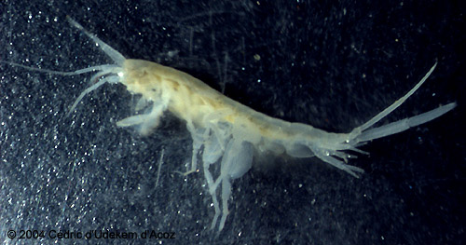
Eriopisa elongata (photo Cedric d’Udekem d’Acoz)

Eriopisa – While many species have been placed in this genus in the past it has been restricted, and a number of other genera created from most of its prior members. The sole remaining member is Eriopisa elongata, a widely distributed form in the Northern Hemisphere, which is reported from boreal waters in the NEP It is a bathyal species, taken from 100-800m (Gurjanova 1951). It is extremely magniramous, with the third uropods reaching nearly ½ the length of the body (see photo above).
The species is a burrower, and a selective deposit feeder on the sediment it excavates in burrowing (Enequist 1950).
Galapsiellus – Erected by J. L. Barnard (1976) to house Paraniphargus lelouporum of Monod (1970). The single species is an anchihaline to phreatic form from mangrove associated pools and groundwaters of the Galapagos. It is an apomorph, apparently descended from a Eriopisa-like ancestor through Anchialella (J. L. Barnard 1976). Additional material was collected by Stock and Iliffe (1990), which added information on sexual dimorphism in the species. In the process they called into question several of the characters invoked by J. L. Barnard (1979) to differentiate his Anchialella from Galapsiellus. They felt that these were associated with sex rather that valid characters separating the genera, and suggested that Anchialella might be a junior synonym of Galapsiellus. They are retained here separately, although the suggestion of synonymy is reasonably supported. There remain characters which seem to separate the two at more than specific level (see key to genera above). Additional material of both relatively rare forms should allow full resolution of the issue.

Lupimaera - A monotypic genus erected (J. L. Barnard & Karaman 1982, p. 174-176) to house a small shallow-water form from the SCB. It was originally described from kelp holdfast collected at Goleta. The genus is keyed from other members of the Maera group in Krapp-Schickel & Jarrett (2000, p. 28). Lupimaera lupana has not yet been added to the SCAMIT list. The specialized structure of this form, with antennae and uropods as well as pereopods condensed from the norm for the family is viewed as modification for life within interstices between the kelp haptera, or alternatively, crevice dwelling.

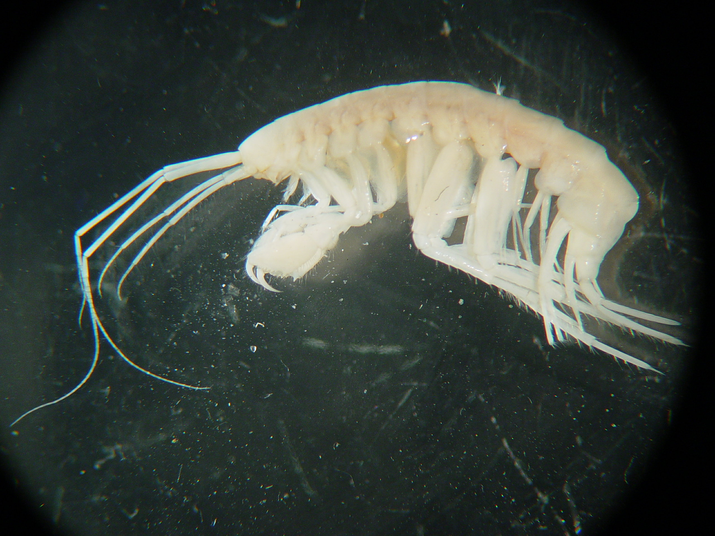
Maera nelsonae from off Palos Verdes, 305m (Photo John Miller, CSDLAC)

Maera - Seven species are reported from the NEP by Krapp-Schickel & Jarrett (2000), but only three are recorded for California. Several other species historically identified as Maera have now been transferred to related genera (eg. Maera reishi, Maera vigota – both moved to Quadrimaera; and Maera lupana – moved to Lupimaera by Karaman & J. L. Barnard 1979).
None of the three taxa is particularly well represented in the SCB. Maera nelsonae Krapp-Schickel & Jarrett 2000 has been taken only once, at 305m, in July 2003 on the south flank of the Redondo Submarine Canyon. A single individual was collected, photographed (see above), and vouchered. This would have been called Maera loveni earlier, and was illustrated as that in J. L. Barnard 1962. M. loveni remains a good species, but occurs only in the north, reaching it’s southern limit in Puget Sound. It is also known from the north Atlantic. SCB material of M. nelsonae marks its southernmost reported occurrence, with the type from Monterey Submarine Canyon, and additional material from Mugu Submarine Canyon. At least in this portion of its range it seems associated with canyons. The species also was taken off Oregon at 732m by OSU, with no apparent connection with a submarine canyon.
There are a number of SCB records of Maera similis. When initially described by Stout 1913, and in later treatments by J. L. Barnard, this species name was rendered M. simile. Krapp-Schickel & Jarrett show that the gender of Maera is feminine, and thus the appropriate gender ending for the adjective “similar” is the Latin “similis”. The “e” ending used previously is only appropriate for a neuter name.
This species, and the next (Maera jerrica) are very closely related, and fall out in the same couplet of the key provided by Krapp-Schickel & Jarrett. They were considered to be the same species by J. L. Barnard, who noted the two forms but didn’t name them. Maera jerrica ( a patronym for J. L. “Jerry” Barnard) has been taken on numerous occasions within the SCB. When M. jerrica is taken, there are generally several specimens (up to 10). These three species can be distinguished using the key in Krapp-Schickel & Jarrett (2000).
Megamoera – The genus is speciose in boreal waters, with 9 species recorded from the NEP (Jarrett & Bousfield 1996). A single species of Megamoera, M. subtener, is recorded from California waters. This species was listed as Melita dentata in some earlier works based on an incorrect synonymy with that species, now known as Megamoera dentata. It has an Arctic distribution with extensions into the extreme northern West Pacific and the Western North Atlantic, and does not occur in our area. Megamoera is in the complex of melitid genera around Abludomelita Karaman 1981. In that work Karaman considered Megamoera still a synonym of Melita. It was resurrected as a valid genus and redefined by Jarrett & Bousfield (1996), who figure the differences in dorsal ornamentation, male gnathopod, and maxilla 1 configuration between the genera in the Abludomelita complex (keyed on pg. 8). All of the members of the genus are boreo-arctic or Arctic in distribution except M. subtener, which ranges into the temperate zone. All ten species in the genus known from the North Pacific are included in the generic key in Jarrett & Bousfield (1996, p. 16).
Melita -Three species of Melita s.s. are recorded from California, and two more from more boreal waters in the NEP. A sixth deep-water species is known from the Gulf of Panama, Melita lignophila (J. L. Barnard 1961), and a seventh is a newly recognized provisional from Central California. Melita nitida has been reported as introduced to San Francisco Bay and other areas to the north, from its base range of the Western North Atlantic (Chapman 1988). This introduction apparently occurred prior to 1933, when the species was reported as established in San Francisco Bay. Since then it has expanded its range northward, being reported as established as far north as Puget Sound (USGS Non-indigenous Aquatic Species website http://nas.er.usgs.gov). It has not yet been reported from southern California harbors, but specimens have been taken since 2002 in the estuary of the San Gabriel River in southern California (Carol Paquette, personal communication).
A second exotic Melita, M. rylovae Bulycheva 1955, introduced from the North West Pacific, is also known from San Francisco Bay. It was probably introduced in ballast water as it was in Australia (Williams et al., 1996).
Melita sulca (Stout 1912) is a widely distributed coastal species within the SCB. It occurs from the intertidal down to at least middle Continental shelf depths. This species can easily be separated from other NEP species by possessing a strong dorsal tooth on the first urosomal segment. Melita species reported to occur in the NEP except M. lignophila, and M. rylovae, are keyed by Jarrett and Bousfield (1996, p. 53). The lower slope species M. lignophila is blind, and will not easily be confused with the other regional Melita species. Melita rylovae has a small terminal segment on the outer ramus of the third uropod, unlike the other eyed west coast Melitas As it is likely that additional introductions of these animals will occur, the key to the forms known from the Northwestern Pacific provided by Jarrett and Bousfield (1996, p. 61) should be checked if problematic specimens are encountered.

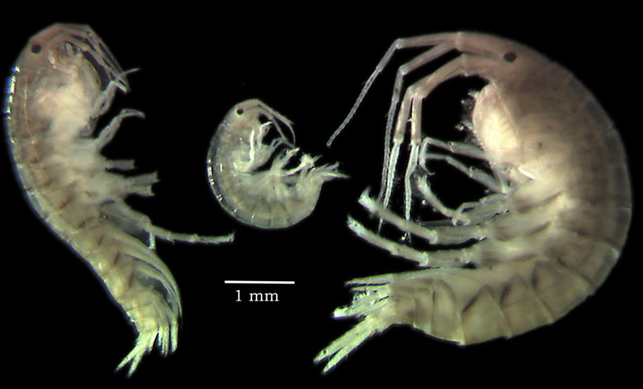
Melita nitida specimens from San Francisco Bay(www.calacademy.org/research/izg/sfbay2k)

Recent examination of fouling community samples in bays and estuaries has turned up a provisional taxon, Melita sp A Cadien 2007§. While this has some similarities to the North West Pacific species flock keyed in Jarrett and Bousfield (1996, p. 61), it differs from them in several respects. I am currently interpreting this as a likely undetected sibling endemic which has been misidentified as Melita oregonensis if previously seen. It bears a strong resemblance to that species, but differs in details of the dorsal dentition of the pleonites and urosome, and in the structure of the sixth coxa of the adult female. It is currently known only from a few samples in the vicinity of Moss Landing in Central California. Since the Jarrett and Bousfield key to NEP species is no longer comprehensive, a new key is provided below.

Key to the genus Melita in the NEP (modified from Jarrett and Bousfield 1996)
D. Cadien 15 September 2007

- Urosome 1 with dorsal tooth.......................................................................sulca
Urosome 1 lacking dorsal tooth, but may bear marginal teeth..........................2
- Bearing pigmented eyes.....................................................................................3
Lacking any trace of eyes....................................................................lignophila
- Uropod 3 outer ramus biarticulate...........................................................rylovae
Uropod 3 outer ramus lacking terminal article..................................................4
- Urosomite 1 bearing three marginal teeth; urosomite 2 smooth.................sp. A
Urosomite 1 smooth; urosomite 2 with or without teeth or spines....................5
- Urosomite 2 posterior margin with spines, but lacking teeth.....................nitida
Urosomite 2 posterior margin smooth, without teeth or spines..........alaskensis
Urosomite 2 posterior margin with pairs of acute teeth separated by thin
setae, but lacking spines...................................................................oregonensis

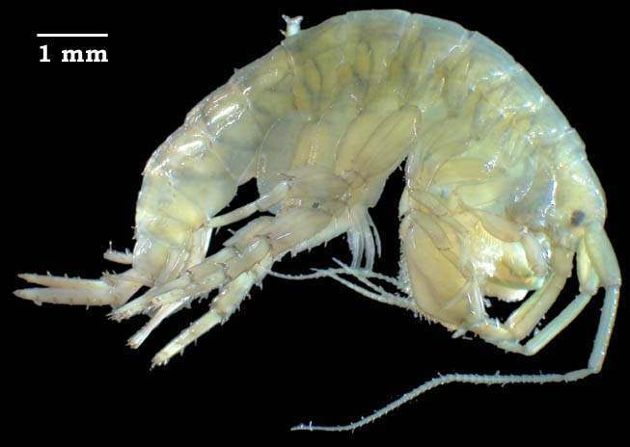
Melita rylovae specimen from San Francisco Bay (www.calacademy.org/research/izg/sfbay2k)

Netamelita - Jarrett and Bousfield (1996) include Netamelita in the Melitidae, while Bousfield (2001) listed it among the hadziids. Based on morphology the latter placement seems inappropriate. It is here retained within the Melitidae, with its closest affinities judged to be with the eriopisellids as suggested by J. L. Barnard and C. M. Barnard (1983). The genus has several members, but only one is known from the NEP, Netamelita cortada (J. L. Barnard 1962). It can be distinguished from related taxa using the generic key provided above.
Psammogammarus - A single species in this genus occurs intertidally along the outer coast of Baja California. It has not been reported since its original description as an Eriopisa by J. L. Barnard (1952b). It was explicitly removed from that genus by Karaman & J. L. Barnard 1979 (largely reiterated in J. L. Barnard & C. M. Barnard 1983), and placed in a revised Psammogammarus. The genus would key out to the Eriopisa complex in the generic key to the Melita group in Jarrett & Bousfield. It is the only member of that group known to occur in the NEP.
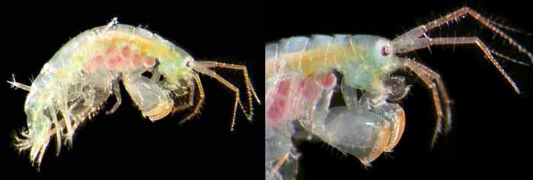
Quadrimaera sp an undescribed species from Guana Island (Photo Yale Peabody Museum)

Quadrimaera - Three species of the genus occur in California waters; Q. carla, Q. reishi, and Q. vigota. The last species is an intertidal form known from Central California to southeast Alaska (Krapp-Schickel & Jarrett 2000), questionably placed in this genus. It is the only species with simple rather than bifid dactyls of P5-P7, and can be easily recognized by this atypical character. See the original description (J.L. Barnard 1969).
The other two species are closely related siblings. Both were identified as Maera inaequipes in J. L. Barnard & Reish 1959. J. L. Barnard later recognized that this was not the same as Costa's Mediterranean taxon and renamed it Maera reishi (J. L. Barnard 1979, p. 83-86). In the process he pointed out differences between southern and northern populations. Krapp-Schickel & Jarrett (2000) divided the Barnard concept of M. reishi along his southern and northern lines, creating a second sibling species (carla) from within it. Both were included in the newly erected genus Quadrimaera (Krapp-Schickel & Ruffo 2000). While no key to the genus is presented in Krapp-Schickel & Jarrett (2000), a table (p. 49) compares a series of character states in three closely related sibling species; Q. reishi, Q. chinarra (from Mexico), and Q. carla. Probably the easiest character to use in separating Q. reishi and Q. carla is the relative length of the gland cone vs. article 3 of antenna 2. A key to the genus world-wide is provided by Krapp-Schickel (2000). The possibility that hybrids between some members of the genus have been seen is discussed among other topics by Krapp-Schickel et al 1996.
Quasimelita – Erected by Jarrett and Bousfield (1996) to contain three species, one of which. Quasimelita quadrispinosa is recorded from the Gulf of Alaska. The other two are from the NWP/Arctic, and the North Atlantic. The genus is separated from other melitoids in the key to the Abludomelita complex (Jarrett and Bousfield 1996, p. 8). Q. quadrispinosa can be separated from the NW Pacific/Arctic Q. formosa by the anteriorly and posteriorly convex basis of pereiopods 6 and 7 (vs. linear), by the more robust posterodistal tooth of epimeron 3, and by the much larger mediodorsal tooth on urosomite 1 which overarches urosomite 2 (vs. not overhanging urosomite 2 in Q. formosa).
Wimvadocus – Krapp-Schickel and Jarrett (2000) created this genus to house Ceradocus torelli, and it remains monotypic. It is differentiated from Ceradocus by (among other characters) the setation of the outer margin of the gnathopod dactyls; a character it shares with Maera (s.s.). Theirs is the first record of the species in the sub-arctic NEP, having identified specimens from British Columbia. This is another off-shore deeper water genus, blind, and assumed to be a burrower. Vader and Krarup Leth (1990) suspect that this species lives in deeply excavated galleries in clayey substrate.

Family Carangoliopsidae – The family is a small one, with no representatives reported from the NEP. The sole constituent species, Carangoliopsis spinosa is known from the Mediterranean from inner shelf to upper slope depths (see J. L. Barnard and Karaman 1991). It is an interesting hadzioid in that it shows convergence with the Haustoriidae in the Infraorder Gammarida, presumably associated with a fossorial mode of life in Carangoliopsis which is atypical for the hadzioids (Bousfield 1977).

Literature Cited

Alderman, A. L. 1936. Some new and little known amphipods of California. University of California Publications in Zoology 41(7): 53-74.
Andres, Hans Georg. 1977. Gammaridea (Crustacea, Amphipoda) aus dem Iberischen Tiefseebecken Auswertung des Materials der Fahrten 3 und 15 von F. S. “Meteor”. Meteor Forschungs-Ergebnisse, Reihe D 25: 54-67.
Aravind, Nisha P., P. Sheeba, K. K. C. Nair, and C. T. Achuthankutty. 2007. Life history and population dynamics of an estuarine amphipod, Eriopisa chilkensis Chilton (Gammaridae). Estuarine Coastal and Shelf Science 74: 87-95.
Barnard, J. Laurens. 1952a. A new amphipod of the genus Ceradocus (Denticeradocus) from Lower California. Bulletin of the Southern California Academy of Sciences 51(2): 55-59.
---------. 1952b. A new species of amphipod from Lower California (genus Eriopisa). Pacific Science 6(4): 295-299.
---------. 1954. Marine Amphipoda of Oregon. Oregon State Monographs, Studies in Zoology 8: 1-102.
———. 1961. Gammaridean Amphipoda from Depths of 400 to 6000 Meters. IN: Galathea Report 5: 23-128. Copenhagen: Danish Science Press, Ltd.
---------. 1962. Benthic marine Amphipoda of Southern California; 2. Families Tironidae to Gammaridae. Pacific Naturalist 3(2):73-115.
———. 1969. Gammaridean Amphipoda of the Rocky Intertidal of California: Monterey Bay to La Jolla. United States National Museum Bulletin 258: 1-230.
---------. 1970. Sublittoral Gammaridea (Amphipoda) of the Hawaiian Islands. Smithsonian Contributions to Zoology 34: 1-286.
---------. 1975. Identification of gammaridean amphipods. Pp. 314-366 IN: Smith, Ralph I., and James T. Carlton (eds.). Light’s Manual: Intertidal Invertebrates of the Central California Coast. 3rd Edition. University of California Press, Berkeley, California, U.S.A. 716pp.
---------. 1976. Affinities of Paraniphargus lelouporum Monod, a blind anchialine amphipod (Crustacea) from the Galapagos Islands. Proceedings of the Biological Society of Washinton 89(36): 421-432.
---------. 1979. Littoral gammaridean Amphipoda from the Gulf of California and the Galapagos Islands. Smithsonian Contributions to Zoology 271: 1-149.
---------, and Charline M. Barnard. 1983. Freshwater Amphipoda of the world, 1. Evolutionary patterns and II. Handbood and bibliography. Hayfield Associates, Mt. Vernon, Virginia, U.S.A. 830pp.
---------, and Gordan S. Karaman. 1980. Classification of gammarid Amphipoda. Crustaceana 6(Supplement): 5-16.
---------, and ---------. 1982. Classificatory revisions in gammaridean Amphipoda (Crustacea), Part 2. Proceedings of the Biological Society of Washington 95(1): 167-187.
---------, and ---------. 1991 The Families and Genera of Marine Gammaridean Amphipoda (except marine gammaroids). Records of the Australian Museum Supplement 13 (Parts 1 and 2): 1-866.
---------, and Donald J. Reish. 1959. Ecology of Amphipoda and Polychaeta of Newport Bay, Californi. Allan Hancock Foundation Publications, Occasional Paper 21: 1-106.
Borowsky, Betty. 1984. The use of the males’ gnathopods during precopulation in some gammaridean amphipods. Crustaceana 47: 245-250.
---------, P. Aiken-Anders, and John T. Tanacredi. 1997. Changes in reproductive morphology and physiology observed in the amphipod crustacean, Melita nitida Smith, maintained in the laboratory on polluted estuarine sediments. Journal of Experimental Marine Biology and Ecology 214(1-2): 85-95.
Bousfield, Edward L. 1977. A new look at the systematics of gammaroidean amphipods of the world. Crustceana Supplement 4: 282-316.
---------. 1983. An updated phyletic classification and palaeohistory of the Amphipoda. Pp. 257-277 IN: Schram, Frederick R. (ed.). Crustacean Phylogeny. Crustacean Issues 1. A. A. Balkema, Rotterdam, Netherlands. 372pp.
---------. 2001. An updated commentary on phyletic classification of the amphipod Crustacea and its application to the North American fauna. Amphipacifica 3(1): 49-119.
Bulycheva, A. I. 1955. Novye vidy bokoplavov (Amphipoda, Gammaridea) iz Japonskogo Morja II. Akademia Nauk SSSR, Trudy Zoologicheskogo Instituta 21: 193-207.
Chapman, John W. 1988. Invasions of the Northeast Pacific by Asian and Atlantic gammaridean amphipod crustaceans, including a new species of Corophium. Journal of Crustacean Biology 8(3): 364-382.
---------. 2007. Gammaridea. Pp. 545-618 IN: Carlton, James T. (ed.). The Light and Smith Manual: intertidal invertebrates from Central California to Oregon. 4th edition. University of California Press, Berkeley, California, U.S.A. 1001pp.
Conlan, Kathleen E. 1991. Precopulatory mating behavior and sexual dimorphism in the amphipod Crustacea. Hydrobiologia 223: 255-282.
Enequist, Paul. 1950. Studies on the soft-bottom amphipods of the Skagerak. Zoologische Bidrag Fran Uppsala 28: 297-492.
Gurjanova, Eupraxie F. 1951. Bokoplavy morey SSSR i sopredel’nykh vod (Amphipoda – Gammaridea). Opredeliteli Po Faune SSSR 41: 1-1029.
Hirayama, Akira, and Taiji Kikuchi. 1979. The first record of Melita appendiculata (Say) 1818, (Crustacea: Amphipoda: Gammaridae) from Japan. Publications of the Seto Marine Biological Laboratory 5(1): 67-77.
Holmes, Samuel J. 1908. The Amphipoda Collected by the U. S. Bureau of Fisheries Steamer 'Albatross' off the West Coast of North America, in 1903 and 1904, with Descriptions of a New Family and Several New Genera and Species. Proceedings of the United States National Museum XXXV(1654): 489-543.
Jarrett, Norma E., and Edward L. Bousfield. 1996. The amphipod superfamily Hadzioidea on the Pacific Coast of North America. Family Melitidae. Part I. The Melita group: systematics and distributional ecology. Amphipacifica 2(2): 3-74.
Karaman, Gordan S. 1981. Redescription of Melita planaterga Kunkel 1910 from Bermuda islands, with revision of genera Melita Leach and Abludomelita n. gen. (Contribution to the Knowledge of the Amphipoda 119). Poljoprivreda I Sumarstvo, Titograd 27(1): 29-50.
---------. and J. Laurens Barnard. 1979. Classificatory revisions in gammaridean Amphipoda (Crustacea), part 1. Proceedings of the Biological Society of Washington 92(1): 106-165.
Krapp-Schickel, Traudl. 2000. Pitfall genus Maera (Crustacea, Amphipoda, Melitidae). Polskie Archiwum Hydrobiologii 47(3-4): 413-440.
........., and Norma E. Jarrett. 2000. The amphipod family Melitidae on the Pacific coast of North America. Part II. The Maera-Ceradocus complex. Amphipacifica 2(4): 23-61.
---------, Amparo Marti, and Sandro Ruffo. 1996. Three new Mediterranean Maera with remarks on the quadrimana complex (Crustacea Amphipoda, Melitidae). Beaufortia 46(3): 27-51.
---------, and Sandro Ruffo. 2000. The Maera quadrimana complex (Crustacea, Amphipoda, Melitidae) demands a new concept: Quadrimaera n. gen. (with description of three new species from Western Atlantic). Bolletino del Museo Civico di Storia Naturale – Verona 24: 193-214.
Krishnan, L., and P. A. John. 1974. Observations on the breeding biology of Melita zeylanica Stebbing, a brackish water amphipod. Hydrobiologia 44(4): 413-430.
Lowry, James K., and Roger T. Springthorpe (2001 onwards). Amphipoda: Families and Subfamilies. Version 1: 1 September 2001. http://crustacea.net/.
---------, and ---------. 2005. New and little-known melitid amphipods from Australian waters (Crustacea: Amphipoda: Melitidae). Records of the Australian Museum 57: 237-302.
---------, and ---------. 2007. A revision of the tropical/temperate amphipod genus Dulichiella Stout, 1912, and the description of a new Atlantic genus Verdeia gen. nov. (Crustacea: Amphipoda: Melitidae). Zootaxa 1424: 1-62.

McLaughlin, P. A., D. K. Camp, M. V. Angel, E. L. Bousfield, P. Brunel, R. C. Brusca, D. B. Cadien, A. C. Cohen, K. Conlan, L. G. Eldredge, D. L. Felder, J. W. Goy, T. A. Haney, B. Hann, R. W. Heard, E. A. Hendrycks, H. H. Hobbs III, J. R. Holsinger, B. Kensley, D. R. Laubitz, S. E. LeCroy, R. Lemaitre, R. F. Maddocks, J. W. Martin, P. Mikkelsen, E. Nelson, W. A. Newman, R. M. Overstreet, W. J. Poly, W. W. Price, J. W. Reid, A. Robertson, D. C. Rogers, A. Ross, M. Schotte, F. R. Schram, C.-T. Shih , L. Watling, and G. D. F. Wilson. 2005. Common and Scientific Names of Aquatic Invertebrates from the United States and Canada - Crustaceans. Bethesda, Maryland, U. S. A.: American Fisheries Society. 565pp.
Monod, Theodore. 1970. Sur quelques crustaces malacostraces des iles Galapagos recoltes par N. et J. Leleup (1964-1965). Résults Scientifiques, Mission Zoologique Belge Aux Iles Galapagos Et En Ecuador 2(5): 11-53.
Munguia, Pablo. 2007. Spatial structure of communities on dead pen shells (Atrina rigida) in sea grass beds. Marine Biology 152(1): 149-156.
---------, Coleman Mackie, and Don R. Levitan. 2007. The influence of stage-dependent dispersal on the population dynamics of three amphipod species. Oecologia 153: 533-541.
Reibisch, J. 1927. Amphipoda. Kukenthal-Krumbach Handbuch der Zoologie 3(1).
Sagasti, Alessandra, Linda C. Schaffner, and J. Emmett Duffy. 2000. Epifaunal communities thrive in an estuary with hypoxic episodes. Estuaries 23(4): 474-487.
Sainte-Marie, Bernard. 1991. A review of the reproductive bionomics of aquatic gammaridean amphipods: variation of life history traits with latitude, depth, salinity and superfamily. Hydrobiologia 223: 189-227.
Staude, Craig P. 1987. Suborder Gammaridea. Pp. 346-386 IN: Kosloff, Eugene N. (ed.) Marine Invertebrates of the Pacific Northwest. University of Washington Press, Seattle Washington, U.S.A. 511pp.
Stock, Jan H. 1977. The taxonomy and zoogeography of the hadziid Amphipoda, with emphasis on the West Indian taxa. Studies on the Fauna of Curaçao 55: 1-130.
---------, and Thomas M. Iliffe. 1990. Amphipod crustaceans from anchihaline cave waters of the Galapagos Islands. Zoological Journal of the Linnean Society 98(2): 141-160.
---------, and Ronald Vonk. 1991. Une espèce nouvelle de Dulzura, genre d’Amphipodes hadzioïdes connu jusqu’ici seulement de l’Indo-Pacifique, découverte aux îles du Cap-Vert (océan Atlantique). Cahiers de Biologie Marine 32(4): 477-486.
Stout, Vinnie R. 1912. Studies in Laguna Amphipoda I. First Annual Report of the Laguan Marine Laboratory 74-84.
---------. 1913. Studies in Laguna Amphipoda. Zoologische Jahrbucher, Abtheilung für Systematik 34: 633-659.
Vader, Wim, and N. Krarup Leth. 1990. Notes on Norwegian marine Amphipoda 11. Ceradocus torelli (Goes, 1866), a new amphipod for Norway. Fauna Norvegica Series A 11: 59.
Williams, R. J., B. Griffiths, E. J. Van der Wal, and J. Kelly. 1996. Cargo vessel ballast water as a vector for the transport of non-indigenous marine species. Estuarine, Coastal and Shelf Science 26(4): 409-420.

