

**VIT – A Place to Learn; A Chance to Grow**

SCHOOL OF COMPUTER SCIENCE AND ENGINEERING

CSE1007- Java Programming

Assignment - 3

|  |  |
| --- | --- |
| **Name:** | **Selukash** |
| **Reg. No:** | **20BCB0056** |
| **Slot:** | **L39+40** |
| **Faculty Name:** | **Dr. Varalakshmi M** |

17. Assume there are two types of requests submitted by clients to a particular server. One type of request is for currency conversion. Second type of request is for loan emi calculation. Write a program using servlets to handle both the requests. For currency conversion, read the source currency and the one which it has to be converted to. For emi calculation, read the loan amount, interest rate and loan tenure (in years) and print the monthly installment.

Eg., if loan amount=40,00,000, interest rate =7.5% and tenure =20 years, then total interest for 20 years= (7.5/100)*40,00,000*20 =60,00,000.

Total amount to be paid =40,00,000+60,00,000=1,00,00,000

emi=1,00,00,000/240=41,666.

**CODE:**

Index.html

<!DOCTYPE html>

<html>

<head>

<meta charset="ISO-8859-1">

<title>Servlet</title>

</head>

<body>

<h1>Currency Converter</h1>

<form action="conversion" method="post">

<select name="sourceCur">

<option value="rupee">Rupee</option>

<option value="dollar">Dollar</option>

<option value="euro">Euro</option>

<option value="yen">Yen</option>

</select>

<select name="reqCur">

<option value="rupee">Rupee</option>

<option value="dollar">Dollar</option>

<option value="euro">Euro</option>

<option value="yen">Yen</option>

</select>

<input type="text" name="amount"/><br>

<input type="submit" name="Calculate">

</form>

<br><br><br><br>

<h1>Emi Calculater</h1>

<form action="emi" method="post">

<label>Loan amount: </label><input type="text" name="amount"/><br>

<label>Interest rate: </label><input type="text" name="rate"/><br>

<label>Loan tenure: </label><input type="text" name="tenure"/><br>

<input type="submit" name="Calculate">

</form>

</body>

</html>

Conversion , Emi servlet

import java.io.IOException;

import java.util.*;

import java.io.PrintWriter;

import javax.servlet.ServletException;

import javax.servlet.http.*;

public class conversion extends HttpServlet{

public void service(HttpServletRequest request,HttpServletResponse response) throws IOException,ServletException

{

HashMap<String,Double> map=new HashMap<String,Double>();

map.put("dollar",75.41);

map.put("rupee",1.0);

map.put("euro",85.16);

map.put("yen",0.67);

String so = request.getParameter("sourceCur");

String re = request.getParameter("reqCur");

int num1 = Integer.parseInt(request.getParameter("amount"));

//String id = request.getParameter("amount");

//int x = 0;

//if(id!=null){

// try{

// x = Integer.parseInt("" + id);

// }catch(Exception e){

// }

//

//}

double res = map.get(so)*num1;

res = res/map.get(re);

PrintWriter output = response.getWriter();

output.println("The converted currency is: "+res);

}

}

**import** java.io.IOException;

**import** java.util.*;

**import** java.io.PrintWriter;

**import** javax.servlet.ServletException;

**import** javax.servlet.http.*;

**public** **class** emi **extends** HttpServlet{

**public** **void** service(HttpServletRequest request,HttpServletResponse response) **throws** IOException,ServletException

{

**int** a = Integer.*parseInt*(request.getParameter("amount"));

**double** r = Double.*parseDouble*(request.getParameter("rate"));

**double** t = Double.*parseDouble*(request.getParameter("tenure"));

**double** interest = (a*t*r)/100;

**double** total = (a+ interest)/(t*12);

PrintWriter output = response.getWriter();

output.println("The monthly installment: "+total);

}

}

web.xml

<?xml version="1.0" encoding="UTF-8"?>

<web-app xmlns:xsi="http://www.w3.org/2001/XMLSchema-instance" xmlns="http://java.sun.com/xml/ns/javaee" xmlns:web="http://java.sun.com/xml/ns/javaee/web-app_2_5.xsd" xsi:schemaLocation="http://java.sun.com/xml/ns/javaee http://java.sun.com/xml/ns/javaee/web-app_2_5.xsd" id="WebApp_ID" version="2.5">

<display-name>first</display-name>

<welcome-file-list>

<welcome-file>index.html</welcome-file>

<welcome-file>index.htm</welcome-file>

<welcome-file>index.jsp</welcome-file>

<welcome-file>default.html</welcome-file>

<welcome-file>default.htm</welcome-file>

<welcome-file>default.jsp</welcome-file>

</welcome-file-list>

<servlet>

<description></description>

<display-name>conversion</display-name>

<servlet-name>conversion</servlet-name>

<servlet-class>conversion</servlet-class>

</servlet>

<servlet>

<description></description>

<display-name>emi</display-name>

<servlet-name>emi</servlet-name>

<servlet-class>emi</servlet-class>

</servlet>

<servlet-mapping>

<servlet-name>conversion</servlet-name>

<url-pattern>/conversion</url-pattern>

</servlet-mapping>

<servlet-mapping>

<servlet-name>emi</servlet-name>

<url-pattern>/emi</url-pattern>

</servlet-mapping>

</web-app>

**Output:**

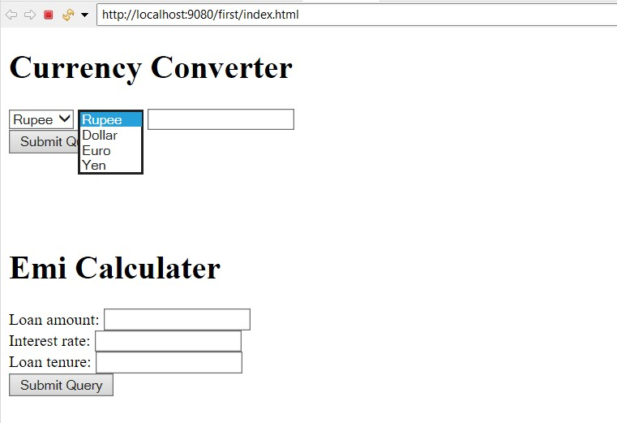

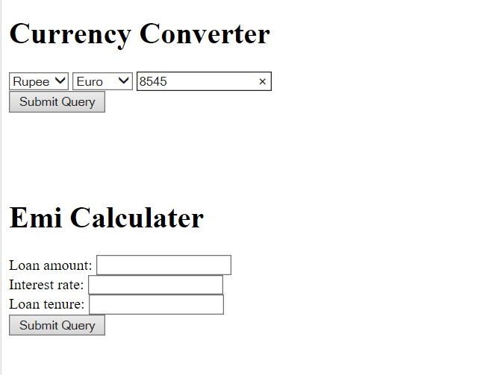

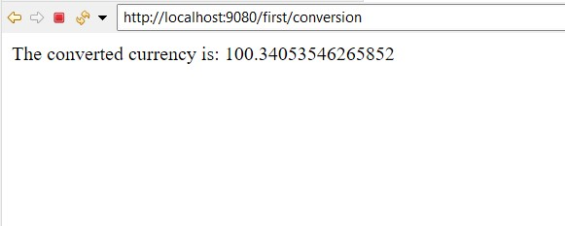

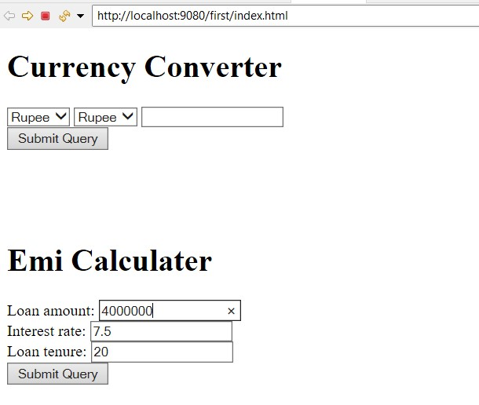

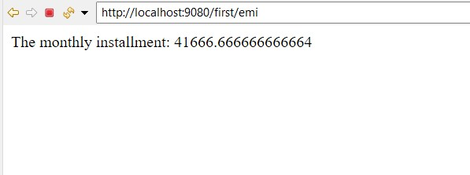

18. Create a database table named ‘SCOPE’ with the following attributes – registration number, name, year of admission and programme. Create another table named ‘PROGRAMME’ with the attributes – programme name and HoD. Populate the tables with adequate number of records. Develop a JSP application that reads the registration number of the student from the client and retrieves his/her details from the SCOPE table. Construct a Java bean with these details and use this bean in another jsp file that displays the student’s HoD name, by accessing the PROGRAMME table.

**CODE:**

Index.jsp

<%@ page language="java" contentType="text/html; charset=ISO-8859-1"

pageEncoding="ISO-8859-1"%>

<html>

<body>

<form action = "student.jsp" method = "GET">

Enter Reg. Number: <input type = "number" name = "reg">

<br/>

<input type = "submit" value = "Submit" />

</form>

</body>

</html>

Student.jsp

<%@ page language="java" contentType="text/html; charset=ISO-8859-1"

pageEncoding="ISO-8859-1"%>

<%@ page import="java.sql.*" %>

<%@ page import="hod.stdhod" %>

<HTML>

<HEAD>

<TITLE>Details</TITLE>

</HEAD>

<BODY BGCOLOR="#a1c4fd">

<H1>Student Details</H1>

<%

try{

Class.forName("oracle.jdbc.driver.OracleDriver");

Connection connection = DriverManager.getConnection(

"jdbc:oracle:thin:@localhost:1521:xe","system","0814");

Statement statement = connection.createStatement() ;

ResultSet resultset =

statement.executeQuery("select regNum,name,year,programme,hod from SCOPE,PROGRAMME where Pname=programme AND regNum="+request.getParameter("reg")) ;

%>

<TABLE BORDER="1">

<TR>

<TH>Registration Number</TH>

<TH>Name</TH>

<TH>Year</TH>

<TH>Programme</TH>

</TR>

<% while(resultset.next()){ %>

<TR>

<TD> <%= resultset.getInt(1) %></td>

<TD> <%= resultset.getString(2) %></td>

<TD> <%= resultset.getInt(3) %></td>

<% String pr = resultset.getString(4);%>

<% String ho = resultset.getString(5); %>

<TD> <%= pr %></td>

</TR>

<jsp:useBean id="bean" class="hod.stdhod">

<% bean.setProgrammeName(pr); %>

</jsp:useBean>

<% } }catch(Exception e){e.printStackTrace();} %>

</TABLE>

<form action = "bean.jsp" method = "GET">

<input type = "submit" value = "Get Hod details" />

</form>

</BODY>

</HTML>

stdhod.java

package hod;

import java.io.Serializable;

public class stdhod implements Serializable{

private String programmeName;

private String Hod;

public stdhod(){

}

public String getHod() {

return Hod;

}

public void setHod(String hod) {

Hod = hod;

}

public String getProgrammeName() {

return programmeName;

}

public void setProgrammeName(String programmeName) {

this.programmeName = programmeName;

}

}

bean.jsp

<%@ page language="java" contentType="text/html; charset=ISO-8859-1"

pageEncoding="ISO-8859-1"%>

<%@ page import="java.sql.*" %>

<%@ page import="hod.stdhod.*" %>

<!DOCTYPE html>

<html>

<head>

<meta charset="ISO-8859-1">

<title>Hod</title>

</head>

<BODY BGCOLOR="#a1c4fd">

<% String s; %>

<jsp:useBean id="be" scope="session" class="hod.stdhod">

<% s = be.getProgrammeName(); %>

</jsp:useBean>

<%

try{Class.forName("oracle.jdbc.driver.OracleDriver");

Connection connection = DriverManager.getConnection(

"jdbc:oracle:thin:@localhost:1521:xe","system","0814");

Statement statement = connection.createStatement() ;

ResultSet resultset =

statement.executeQuery("select programme,hod from PROGRAMME where Pname="+s) ;

%>

<% while(resultset.next()){ %>

<H1>Hod Details</H1>

<TABLE BORDER="1">

<TR>

<TH>Programme</TH>

<TH>Hod</TH>

</TR>

<TR>

<TD> <%= resultset.getString(1) %></td>

<TD> <%= resultset.getString(2) %></td>

</TR>

<%catch(Exception e){e.printStackTrace();} %>

</TABLE>

</jsp:useBean>

</BODY>

</html>

**OUTPUT:**

