Solution Development Approach Document
SAMP — Multi-Vertical Hospitality & Space Management Platform
Field | Detail
Companion To | SAMP Enterprise BRD/SRS — Multi-Vertical Edition
Prepared For | Engineering Leadership, Solution Architects, Delivery / Implementation Partner
Document Status | Draft for Kickoff Review
Covers Verticals | Star Hotels & Resorts | Service Apartments | Apartment Rental & Services | Workplace Management

1. Purpose & Scope of This Document
This Approach Document translates the SAMP BRD/SRS into an actionable plan for starting solution development. It is intended for whoever will build or oversee the build — an in-house engineering team, a delivery partner, or a hybrid — and answers four questions: how the work should be organised, what the system should be built on, in what order modules should be delivered, and what to do in the first few weeks.
It does not replace the BRD/SRS as the source of functional truth; every module and requirement referenced here points back to the corresponding BRD section. Treat this document as the bridge between “what to build” (BRD/SRS) and “how we start building it.”

2. Recommended Delivery Methodology
Agile, in 2-week sprints, organised around the four BRD delivery phases rather than as one continuous backlog. This keeps each phase shippable and demoable, and lets a pilot property go live on Core + Operations modules (Phase 1–2) while Financial Integrations and AI/Analytics (Phase 3–4) are still in build.
- Cross-functional pods, not one large team: form 2–3 small squads (Core Platform, Operations & Mobile, Finance & Integrations) that can work in parallel once the shared data model from Phase 1 is frozen.
- Vertical pilots, not big-bang rollout: validate each business vertical (Hotel/Resort, Service Apartment, Rental, Workplace) on one pilot property before scaling to the full portfolio — this surfaces vertical-specific gaps early and cheaply.
- Definition of Done includes the NFRs: no story is “done” until it meets the relevant non-functional bar from BRD Section 4 (API latency, audit logging, encryption), not just functional acceptance criteria.

3. Solution Architecture Approach

3.1 Architecture Principles
- Single core, configurable by vertical: one shared services layer (reservation, finance, maintenance, vendor, HRMS) parameterised by Vertical Type, rather than separate codebases per business line (per BRD Section 1.4).
- API-first: every module exposes a versioned REST/JSON API from day one, even before a UI exists, so mobile apps, partner integrations, and future modules consume the same contract.
- Event-driven where state must propagate: booking, checkout, and lease-status changes publish events so dependent modules (housekeeping, billing, channel sync) react without tight coupling.
- Modular monolith first, microservices where it earns its cost: start with a small number of well-bounded services (Property/Inventory, Reservation & Billing, Identity & Access, Operations) and only split further when a module's load or release cadence demands it — avoids premature infrastructure overhead.

3.2 High-Level Architecture Layers
A simplified view of how requests and data flow through the platform:
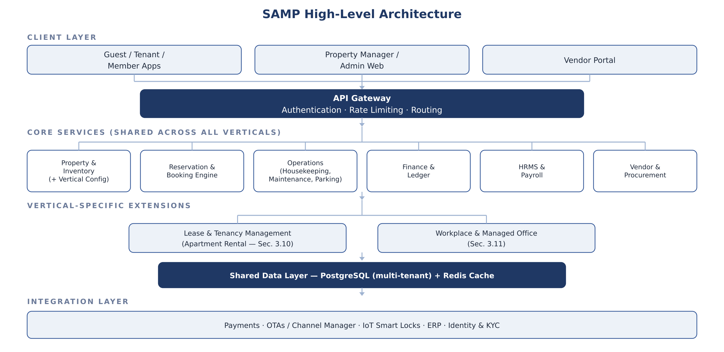

3.3 Recommended Technology Stack
Layer | Recommendation | Why
Web Console | React (Next.js) + Tailwind | Fast iteration, strong component ecosystem, good fit for dashboards and admin UIs.
Mobile Apps | React Native (or Flutter) | One codebase across Guest, Resident, Operations, and Facility apps reduces parallel-build cost.
Backend Services | Node.js (NestJS) or Java (Spring Boot) | Either supports modular-monolith-to-microservices growth; pick based on existing team strength.
Primary Database | PostgreSQL (multi-tenant, row-level security) | Relational integrity for financial/lease data; RLS enforces the property/tenant data separation in BRD Section 2.
Cache / Sessions | Redis | Sub-200ms read targets (BRD 4.1) need a cache layer in front of the relational store.
Eventing / Messaging | Kafka or RabbitMQ | Decouples booking/checkout events from housekeeping, billing, and channel-sync consumers.
API Gateway | Kong or cloud-native (AWS API GW / Azure APIM) | Centralises auth, rate limiting, and routing across all module APIs.
Identity & Auth | OAuth2/OIDC provider (e.g. Keycloak / Auth0) + MFA | Matches BRD Section 4.2 MFA and RBAC requirements without building auth from scratch.
Infrastructure | Kubernetes on a major cloud (AWS/Azure/GCP) | Meets the stateless, auto-scaling requirement in BRD Section 4.3.
CI/CD | GitHub Actions / GitLab CI + ArgoCD (GitOps) | Repeatable deploys across Dev/QA/UAT/Prod environments.

3.4 Multi-Tenancy & Vertical Configuration Model
Each property record carries a Vertical Type attribute (Hotel / Service Apartment / Rental / Workplace) as described in BRD Section 3.1. Recommended implementation: a shared schema with a tenant_id and vertical_type discriminator on core tables, plus vertical-specific extension tables (lease_agreements, desk_bookings) that join back to the same unit/inventory record. This avoids forking the schema per vertical while still letting Section 3.10/3.11 modules attach cleanly. Large enterprise clients with strict data-isolation needs can be offered a schema-per-tenant variant later without changing the application layer.

4. Phased Delivery Plan
Mapped directly to the roadmap in BRD Section 8, with delivery-specific exit criteria added:
Phase | Weeks | Key Deliverables | Exit Criteria
1. Core Engine | 1–12 | Data model, multi-tenant + vertical-config framework, Property/Asset Register, base RBAC. | A property can be onboarded end-to-end for any of the 4 verticals without a code change.
2. Operational Workflows | 13–20 | Front Desk UI, Channel Manager sync, Operations mobile app, Lease & Tenancy pilot, Workplace booking pilot. | One pilot property per vertical is running daily operations on the platform.
3. Financial & Integrations | 21–28 | Payment gateways, identity verification, ERP sync, HRMS/Payroll, Vendor portal. | Financial transactions reconcile automatically across all pilot properties with zero manual entries.
4. AI & Yield / Go-Live | 29–36 | Predictive maintenance & dynamic pricing models, Executive Dashboards, security pen-test. | NFR targets (99.9% uptime, <200ms reads) verified under load; full portfolio cut-over approved.

5. Team Structure & Governance
Role | Responsibility | Engaged From
Product Owner | Owns the backlog, prioritises against BRD modules, signs off on vertical pilot scope. | Phase 1
Solution Architect | Owns the shared core + vertical-configuration model; approves API contracts. | Phase 1
Business Analyst / Vertical SMEs | Validate hotel, leasing, and workplace workflows against real operational practice. | Phase 1–2
Backend / Frontend / Mobile Engineers | Build the module squads described in Section 2. | Phase 1 onward
DevOps / Platform Engineer | Environments, CI/CD, observability (Section 6). | Phase 1
QA / Test Engineer | Test strategy execution (Section 8), NFR verification before each phase exit. | Phase 1 onward
Security & Compliance Lead | MFA, encryption, audit-trail review, pen-test sign-off before go-live. | Phase 3–4

Governance cadence: a steering committee (Product Owner, Architect, Sponsor) reviews progress at each phase boundary; any change to BRD-defined scope goes through a lightweight change-control note rather than ad-hoc Slack agreement, so the BRD stays the single source of truth.

6. Environment & DevOps Strategy
- Four environments: Dev (per-feature ephemeral or shared), QA/Staging (integration testing), UAT (vertical-pilot sign-off), Production (blue-green deploys to avoid downtime during the 99.9% uptime window).
- Infrastructure as Code: Terraform (or equivalent) for all cloud resources so a new property's infrastructure footprint is reproducible, supporting the 48-hour onboarding target in BRD Section 1.3.
- Pipeline stages: build → unit test → static/security scan → deploy to staging → integration tests → manual UAT gate → production deploy.
- Observability: centralized logging (e.g. ELK/OpenSearch), metrics and dashboards (Prometheus/Grafana), and alerting wired to the same uptime/latency SLAs defined in BRD Section 4.1 from day one — not bolted on before go-live.

7. Data & Integration Strategy
- Canonical hierarchy first: implement the Global Enterprise → Region → Property → Vertical Type → Building → Floor → Unit/Desk model (BRD 3.1) before any module-specific schema, since every other module hangs off it.
- Migration plan if replacing a legacy PMS: run the new platform in shadow/parallel against one pilot property, reconcile nightly, and only cut over once ledgers match for two consecutive billing cycles.
- Integration sequencing: build Payments and Identity/KYC first (revenue- and compliance-critical), then OTA Channel Manager, then IoT smart-lock hardware, then ERP sync, and AI/predictive integrations last — mirrors the BRD Section 5 dependency order and the phased roadmap.

8. Testing & Quality Assurance Approach
- Unit & contract tests: per service, run in CI on every commit; contract tests guard the API boundaries between squads.
- End-to-end journeys: automate the user stories already defined in BRD Section 7 (e.g. Touchless Pre-Arrival Onboarding, Algorithmic Housekeeping Routing) plus equivalent journeys for Lease onboarding and Workplace desk booking.
- Performance & load testing: validate against the concrete NFR numbers in BRD Section 4.1 (200ms reads, 800ms writes, 10,000 concurrent sessions) before each phase exit, not only before final go-live.
- Security testing: a full penetration test is scheduled in Phase 4 per the roadmap, but basic dependency and static-analysis scanning runs in CI from Phase 1.
- Pilot UAT: each vertical's pilot property runs a 2–4 week parallel/shadow UAT with real operational staff before that vertical is marked ready to scale.

9. Risk Register
Risk | Impact | Mitigation
Vertical scope creep during build | Delays Phase 1 core freeze | Lock the shared data model at end of Phase 1; new vertical-specific needs go into Section 3.10/3.11-style extensions, not the core schema.
Hardware/IoT vendor delays (locks, LPR) | Blocks Workplace access-control and Hotel digital-key features | Select and contract hardware vendors during Phase 1, in parallel with software build, not after.
Regional regulatory variance (RERA, labour law, fire codes) | Compliance gaps for Rental and Hotel verticals across regions | Treat compliance rules as configurable data (BRD 3.1 Compliance Vault), not hard-coded logic, from the first schema design.
Legacy PMS migration data quality | Incorrect ledgers/occupancy at cutover | Run shadow/parallel reconciliation (Section 7) for at least two billing cycles before retiring the legacy system.
Ops staff resistance to new workflows | Low adoption despite a working system | Involve vertical SMEs (Section 5) from Phase 1 design, and run pilot UAT with the same staff who will use it daily.

10. Immediate Next Steps (First 2–4 Weeks)
- Hold a kickoff workshop to walk the BRD/SRS module-by-module with engineering, and formally sign off scope for Phase 1.
- Confirm one pilot property per vertical (one star hotel or resort, one service-apartment property, one rental community, one workplace/coworking site) to anchor UAT later.
- Finalise the technology stack and cloud provider (Section 3.3), and stand up the four environments (Section 6).
- Run an architecture spike to prove the Vertical Type configuration model (Section 3.4) against at least two verticals before building further modules on top of it.
- Stand up core repositories, CI/CD skeleton, and the API gateway shell.
- Define and circulate API contracts for the Property/Inventory and Reservation modules — these are the dependencies every other squad needs.
- Start vendor shortlisting for OTA Channel Manager, payment gateway, and smart-lock hardware in parallel (these have the longest external lead times).
- Break BRD Section 3 modules into epics and stories in the backlog, prioritised MoSCoW-style for Phase 1.
- Agree sprint cadence, Definition of Done (including NFR checks), and the steering-committee review schedule from Section 5.

11. MVP Success / Phase 2 Exit Criteria
Treat the platform as having reached a viable MVP when all of the following are true, not just when features are “code complete”:
- Functional: one pilot property per vertical is running real day-to-day operations (reservations/leases/bookings, housekeeping or facility requests, and billing) on the platform with no manual workaround spreadsheets.
- Data: the canonical hierarchy and vertical-configuration model support all four verticals without schema changes.
- Non-functional: staging load tests meet the BRD Section 4.1 latency and concurrency targets.
- Operational: ops staff at each pilot property can complete their daily workflow without engineering support for at least one full week.

