EHS Role Access Review and Workflow Evidence
Date: 2026-02-19
Tenant Scope: Enterprise Hospital Systems (EHS) only
Purpose: User-facing pre-delivery document with architecture context, role workflows, and screenshot evidence.

1. Technology Stack
- Frontend: React 18 with Vite build/runtime.
- Backend: Node.js + Express REST API.
- Database: PostgreSQL (shared schema with tenant isolation).
- Authentication: JWT + bcrypt password hashing.
- Authorization: Role-permission model + module/feature gating.
- Testing: Playwright E2E/smoke + integration scripts.

2. Architecture Summary
- Application pattern: Multi-tenant SPA + stateless API backend.
- Core frontend orchestrator: client/src/App.jsx.
- API routing: server/index.js.
- Security middleware: authenticate, requireTenant, requirePermission.
- Data access layer: server/db/repository.js using parameterized SQL.
- Tenant boundary: tenant_id scoping in middleware and repository access.

3. EHS Snapshot Execution Summary
Base URL: http://localhost:5175
Roles attempted: 8
Successful captures: 8
Failed captures: 0

4. Role-wise Workflow and Evidence

Admin - Enterprise Hospital Systems
User: admin.ehs@emr.local
Login status: success
Workflow steps:
- Log in to EHS tenant context.
- Review dashboard summary and operational status.
- Access administrative modules for users/settings/governance.
- Validate cross-module readiness for daily operations.
Screenshot evidence:
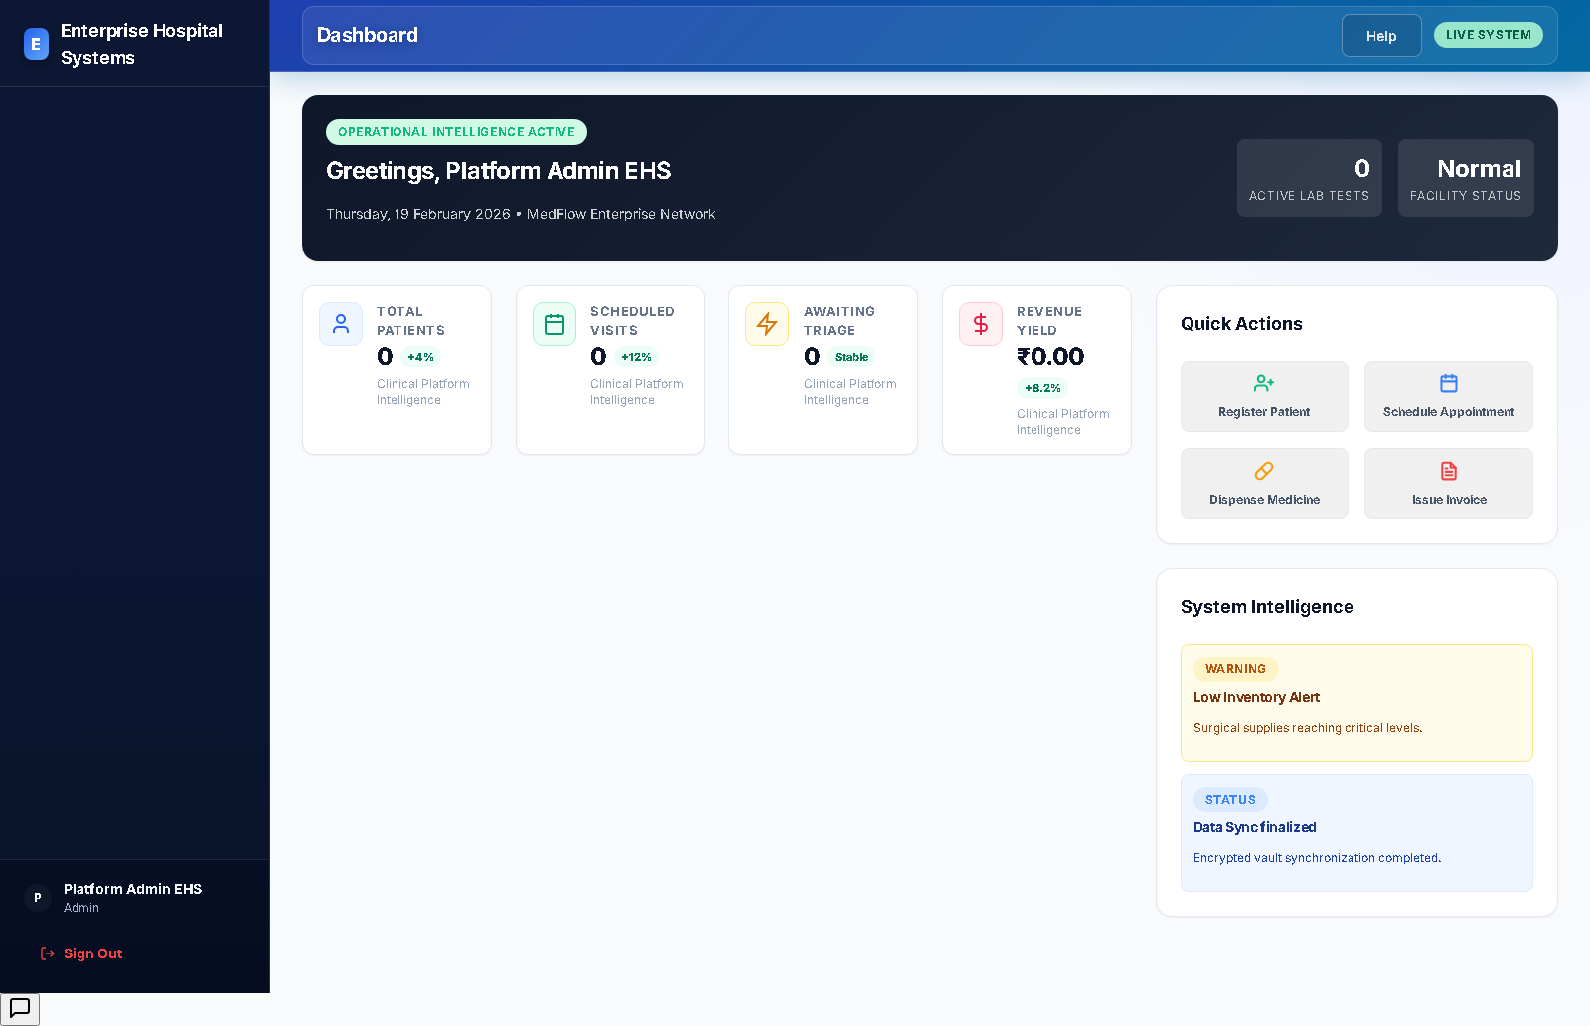

Nurse - Enterprise Hospital Systems
User: nurse.ehs@emr.local
Login status: success
Workflow steps:
- Log in to EHS and access patient-facing workflows.
- Review queue and patient records from allowed modules.
- Update clinical workflow data permitted to nursing role.
- Coordinate with doctor/lab and continue care pathway.
Screenshot evidence:
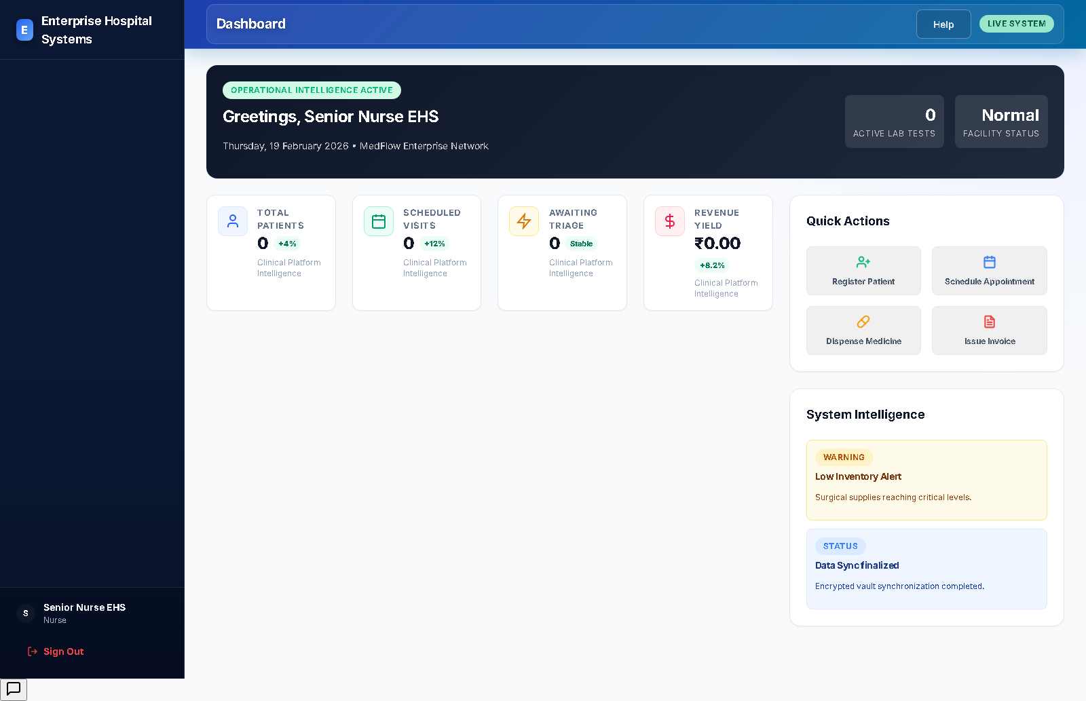

Lab - Enterprise Hospital Systems
User: lab.ehs@emr.local
Login status: success
Workflow steps:
- Log in to EHS and open lab-relevant modules.
- Review diagnostic workload and patient test context.
- Record and update test results in assigned workflow areas.
- Return control to clinician-facing workflow.
Screenshot evidence:
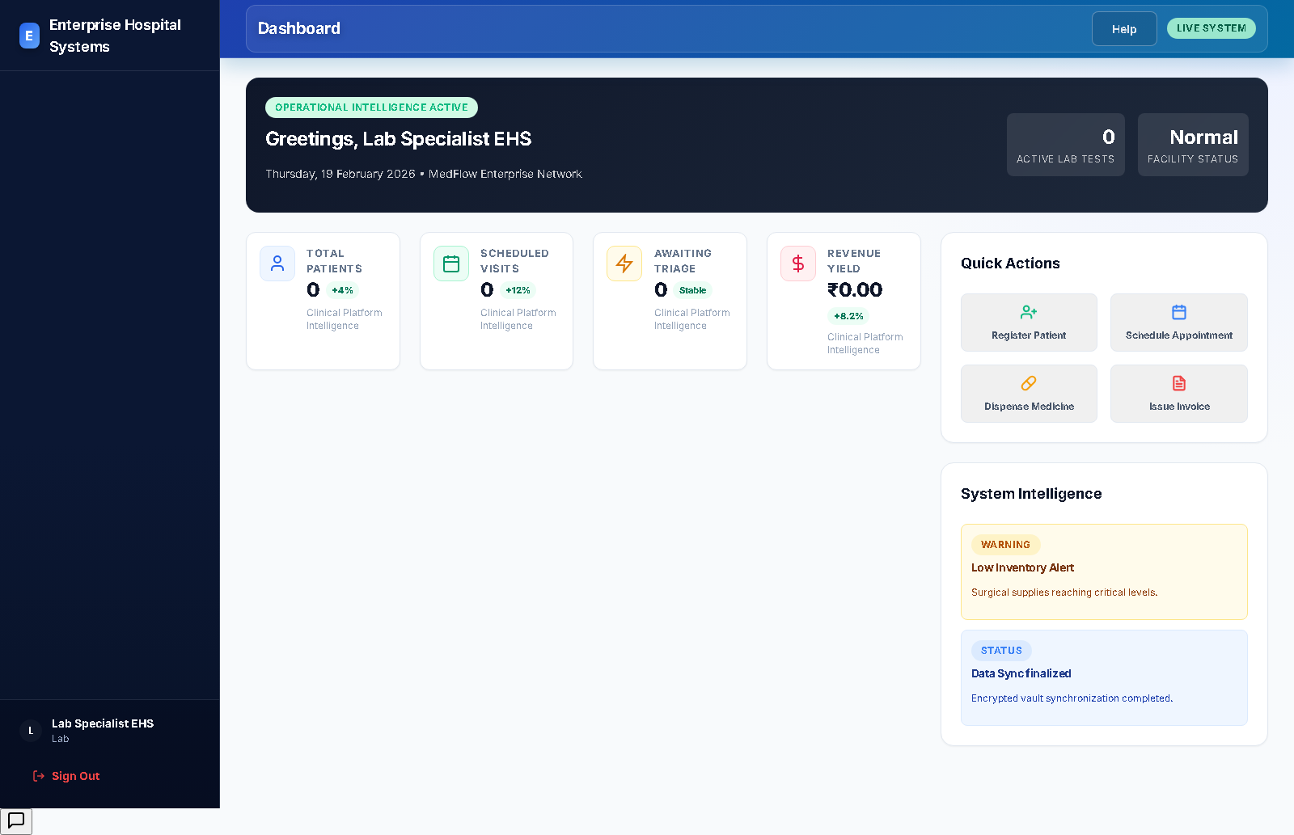

Insurance - Enterprise Hospital Systems
User: insurance.ehs@emr.local
Login status: success
Workflow steps:
- Log in and access insurance registry/claims modules.
- Review provider and claim records.
- Create or update claim lifecycle status.
- Share status with billing/accounts stakeholders.
Screenshot evidence:
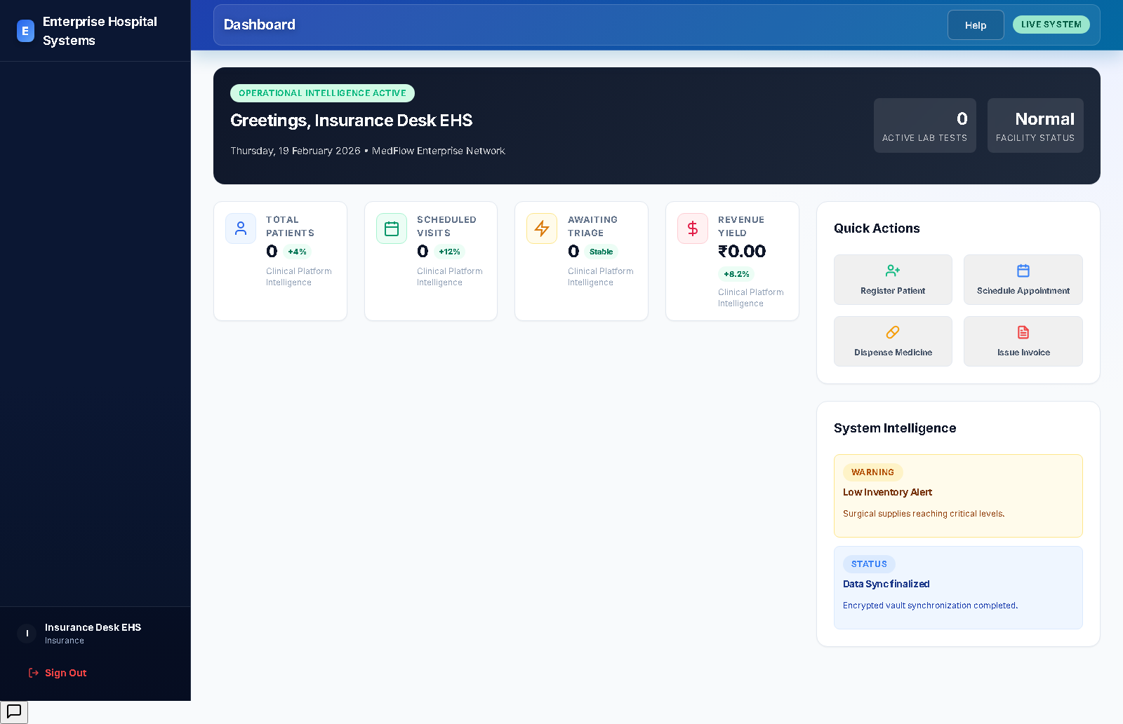

Billing - Enterprise Hospital Systems
User: billing.ehs@emr.local
Login status: success
Workflow steps:
- Log in and open billing-related modules.
- Review invoice queue and payment states.
- Issue invoices and update settlement status.
- Coordinate with accounts for reconciliation.
Screenshot evidence:
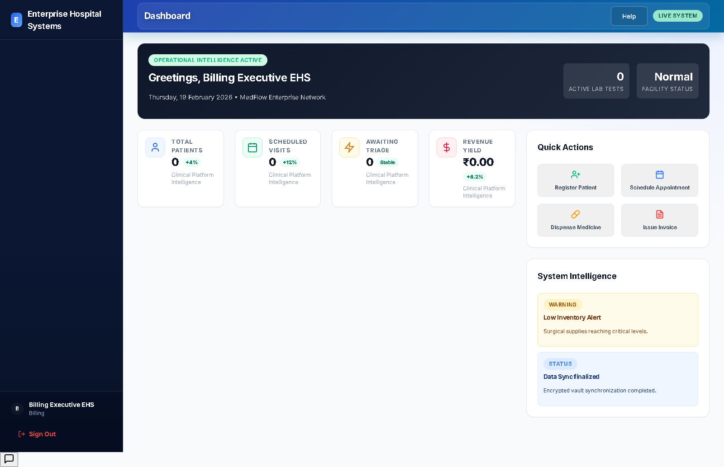

Accounts - Enterprise Hospital Systems
User: accounts.ehs@emr.local
Login status: success
Workflow steps:
- Log in and open accounts/financial modules.
- Review financial snapshot and expense flow.
- Track period financial performance and outflow.
- Report summary status to management.
Screenshot evidence:
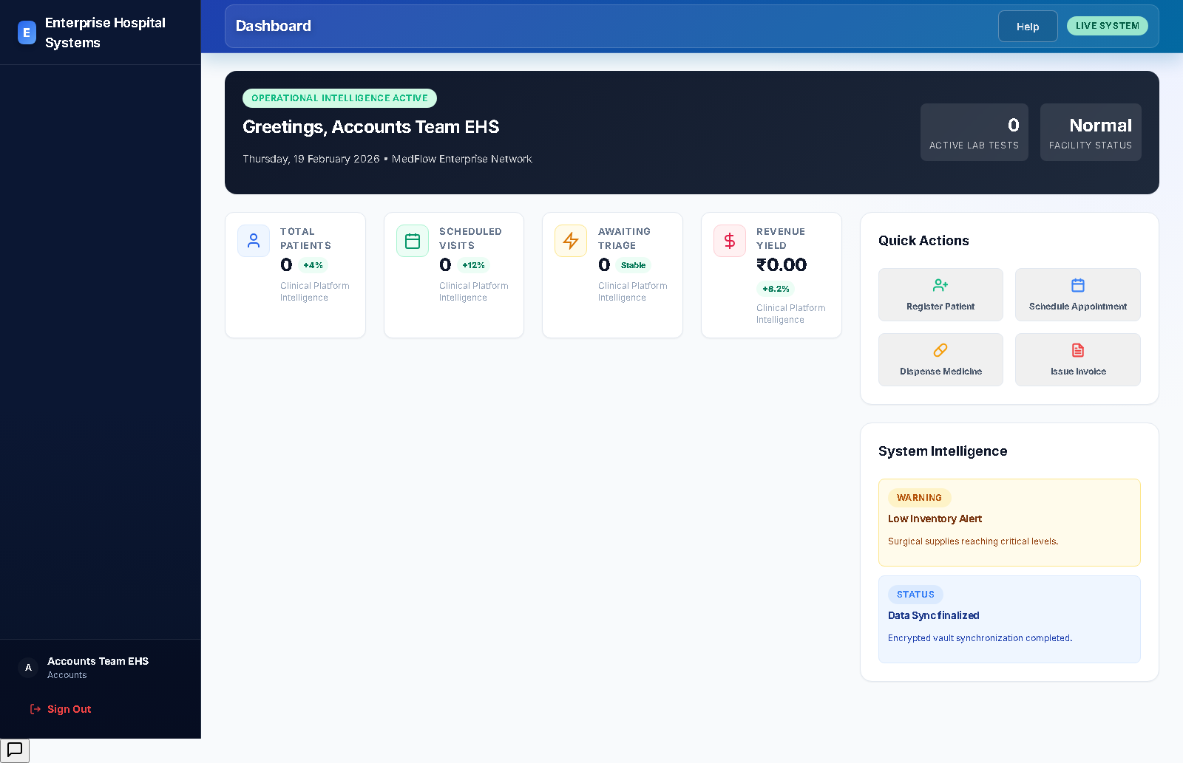

Auditor - Enterprise Hospital Systems
User: auditor.ehs@emr.local
Login status: success
Workflow steps:
- Log in with read-focused auditing context.
- Review report and compliance-relevant modules.
- Validate access boundaries and transactional traceability.
- Raise findings for governance follow-up.
Screenshot evidence:
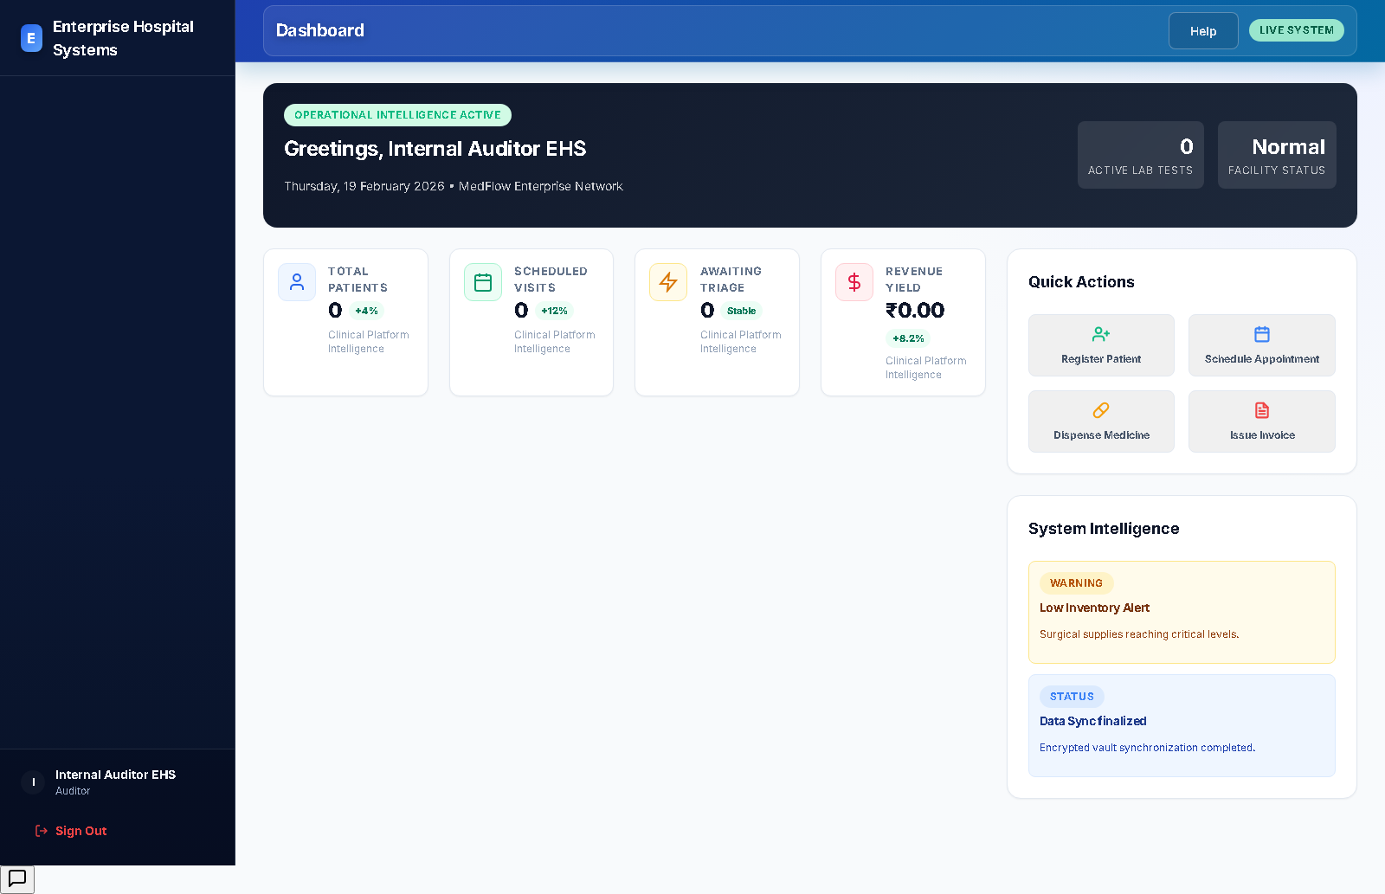

Management - Enterprise Hospital Systems
User: management.ehs@emr.local
Login status: success
Workflow steps:
- Log in and review executive dashboard metrics.
- Access reports and strategic operational views.
- Validate performance across clinical and financial tracks.
- Drive high-level decisions and escalations.
Screenshot evidence:
