MedFlow - EMR
MedFlow EMR is a multi-tenant healthcare platform built for secure, role-based hospital operations across clinical, administrative, and financial workflows. It combines a React single-page frontend with a Node.js/Express API and PostgreSQL backend, with tenant isolation enforced at the application and data-access layers. The system supports end-to-end care operations including patient registration, appointments, EMR charting, prescriptions, billing, insurance, inventory, HR, and analytics, while maintaining auditability and controlled access through permissions and feature gates. It is designed for scalable deployment and operational reliability, with structured testing and pre-deployment quality gates to support safer releases.

Tenant Scope: Enterprise Hospital Systems (EHS) only
Purpose: User-facing pre-delivery document with architecture context, role workflows, and screenshot evidence.

1. Technology Stack
- Frontend: React 18 with Vite build/runtime.
- Backend: Node.js + Express REST API.
- Database: PostgreSQL (shared schema with tenant isolation).
- Authentication: JWT + bcrypt password hashing.
- Authorization: Role-permission model + module/feature gating.
- Testing: Playwright E2E/smoke + integration scripts.

2. Architecture Summary
- Application pattern: Multi-tenant SPA + stateless API backend.
- Core frontend orchestrator: client/src/App.jsx.
- API routing: server/index.js.
- Security middleware: authenticate, requireTenant, requirePermission.
- Data access layer: server/db/repository.js using parameterized SQL.
- Tenant boundary: tenant_id scoping in middleware and repository access.

3. EHS Snapshot Execution Summary
Base URL: http://localhost:5175
Roles attempted: 8
Successful captures: 8
Failed captures: 0

4. Role-wise Workflow and Evidence

Admin - Enterprise Hospital Systems
User: admin.ehs@emr.local
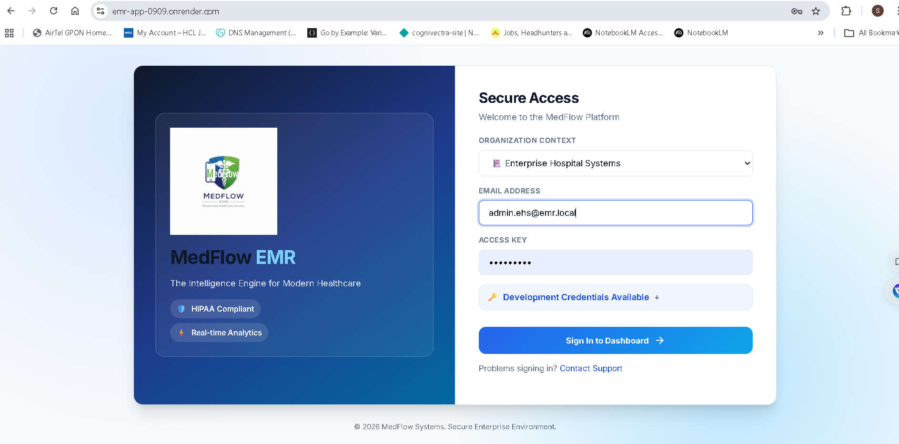

Login status: success
Workflow steps:
- Log in to EHS tenant context.
- Review dashboard summary and operational status.
- Access administrative modules for users/settings/governance.
- Validate cross-module readiness for daily operations.
Screenshot evidence:
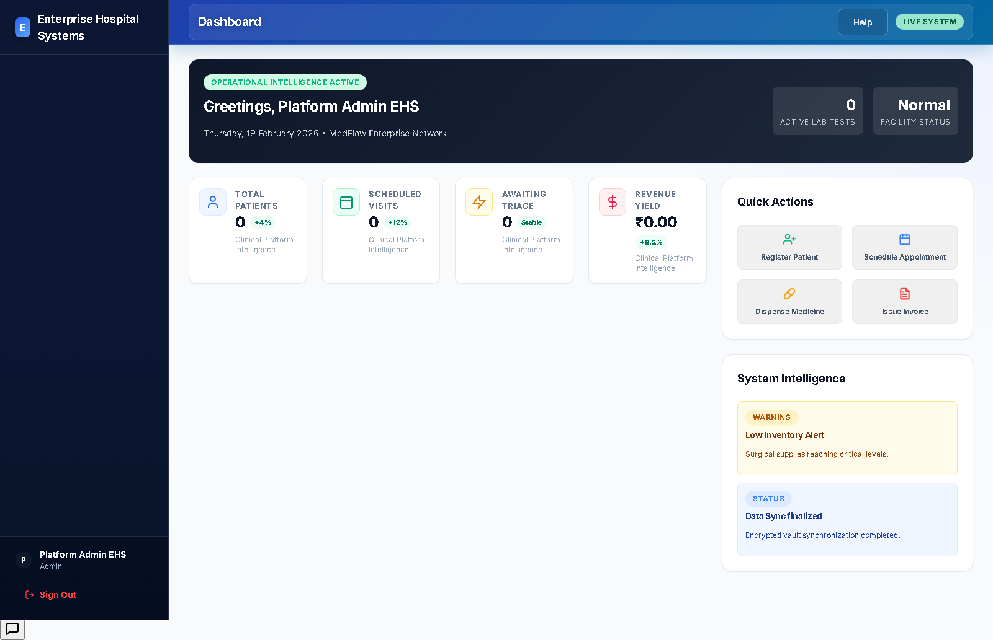

Nurse - Enterprise Hospital Systems
User: nurse.ehs@emr.local
Login status: success
Workflow steps:
- Log in to EHS and access patient-facing workflows.
- Review queue and patient records from allowed modules.
- Update clinical workflow data permitted to nursing role.
- Coordinate with doctor/lab and continue care pathway.
Screenshot evidence:
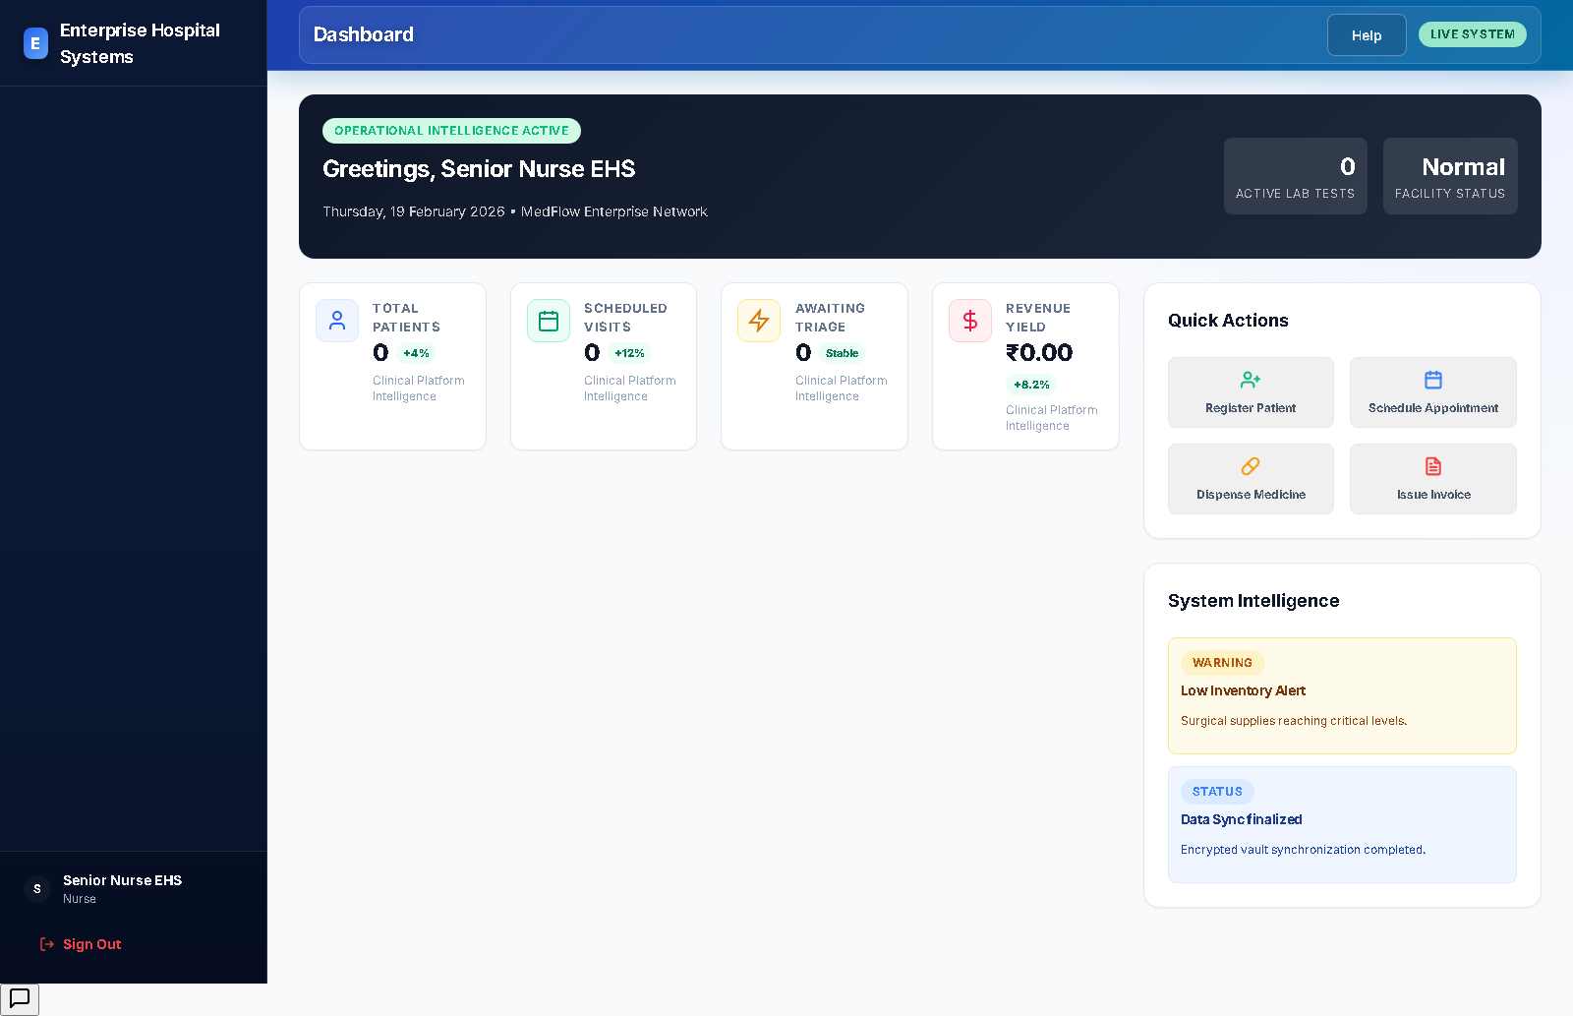

Lab - Enterprise Hospital Systems
User: lab.ehs@emr.local
Login status: success
Workflow steps:
- Log in to EHS and open lab-relevant modules.
- Review diagnostic workload and patient test context.
- Record and update test results in assigned workflow areas.
- Return control to clinician-facing workflow.
Screenshot evidence:
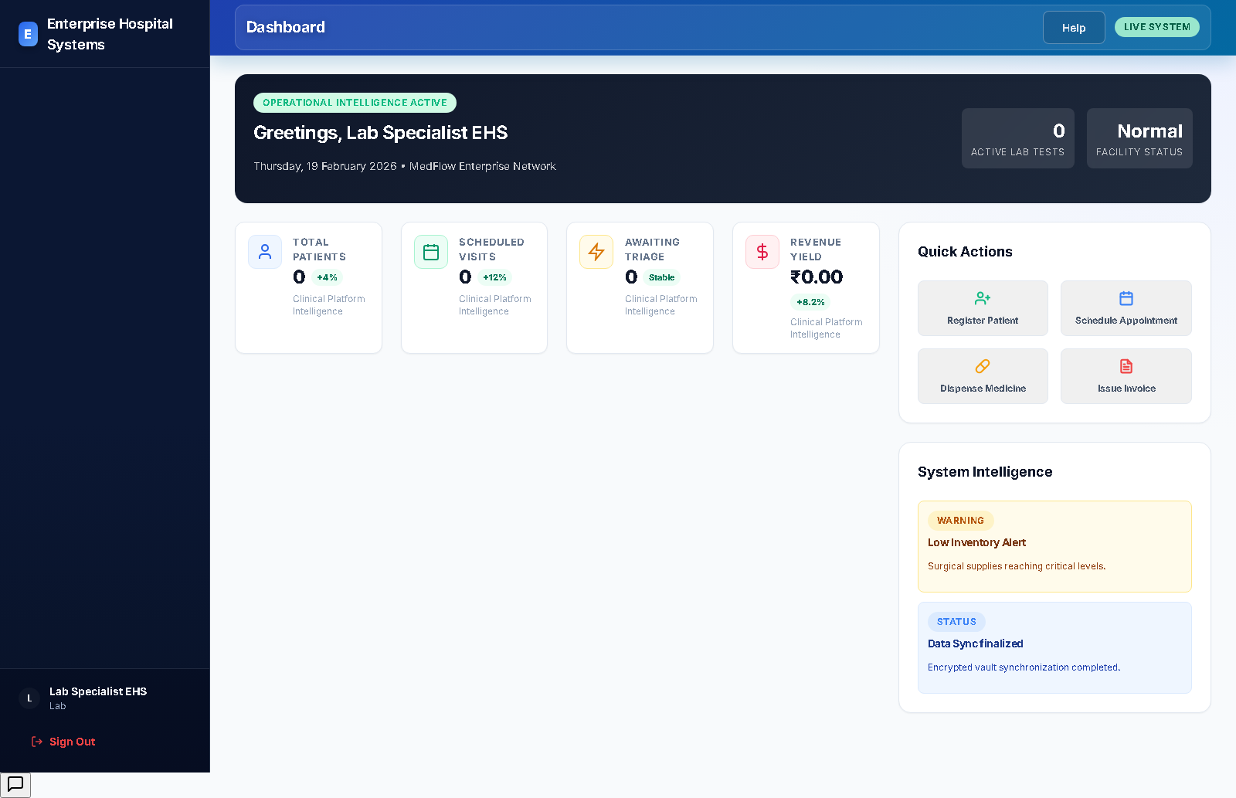

Insurance - Enterprise Hospital Systems
User: insurance.ehs@emr.local
Login status: success
Workflow steps:
- Log in and access insurance registry/claims modules.
- Review provider and claim records.
- Create or update claim lifecycle status.
- Share status with billing/accounts stakeholders.
Screenshot evidence:
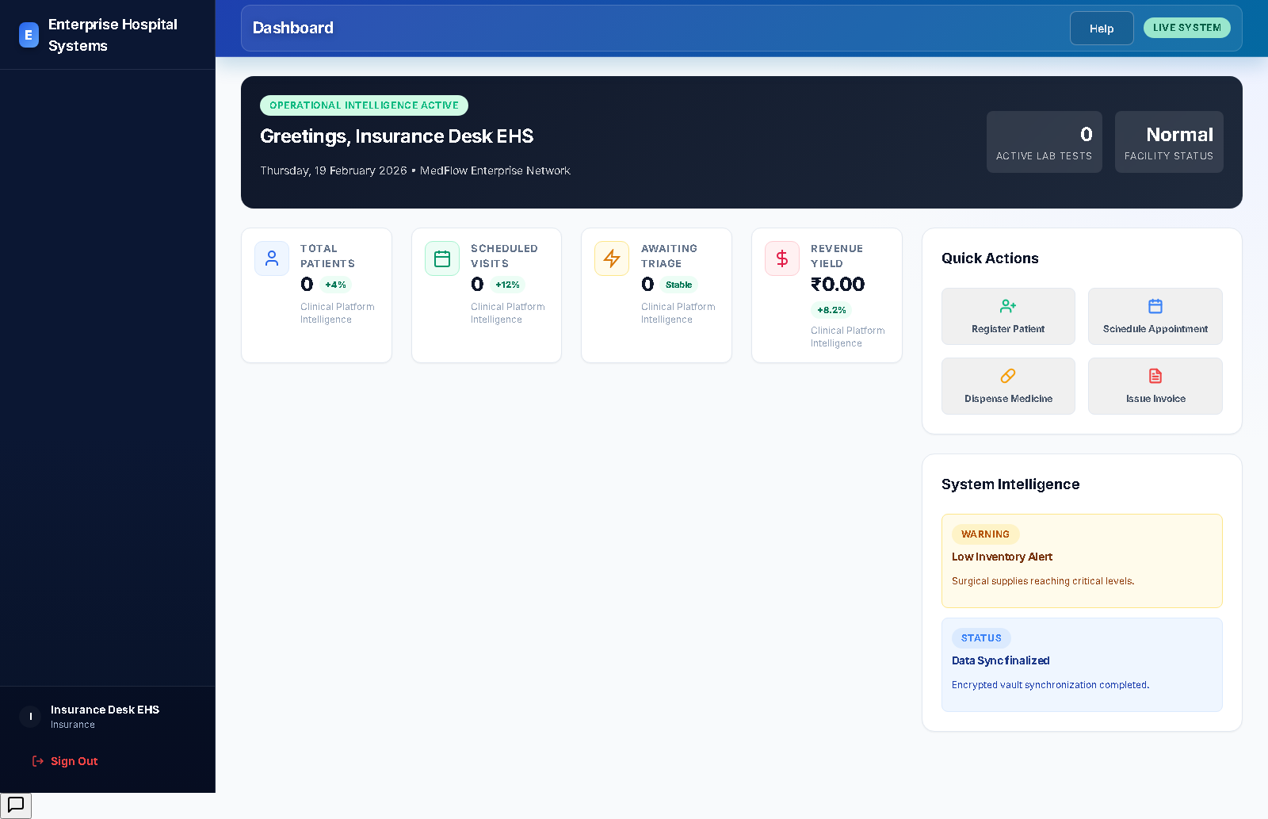

Billing - Enterprise Hospital Systems
User: billing.ehs@emr.local
Login status: success
Workflow steps:
- Log in and open billing-related modules.
- Review invoice queue and payment states.
- Issue invoices and update settlement status.
- Coordinate with accounts for reconciliation.
Screenshot evidence:
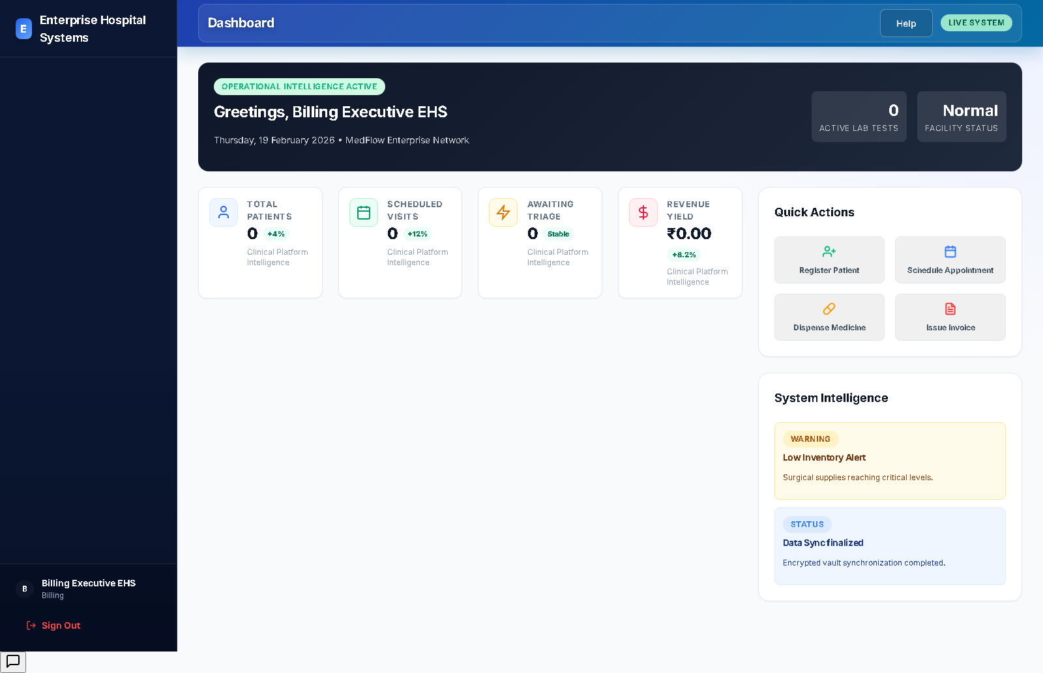

Accounts - Enterprise Hospital Systems
User: accounts.ehs@emr.local
Login status: success
Workflow steps:
- Log in and open accounts/financial modules.
- Review financial snapshot and expense flow.
- Track period financial performance and outflow.
- Report summary status to management.
Screenshot evidence:
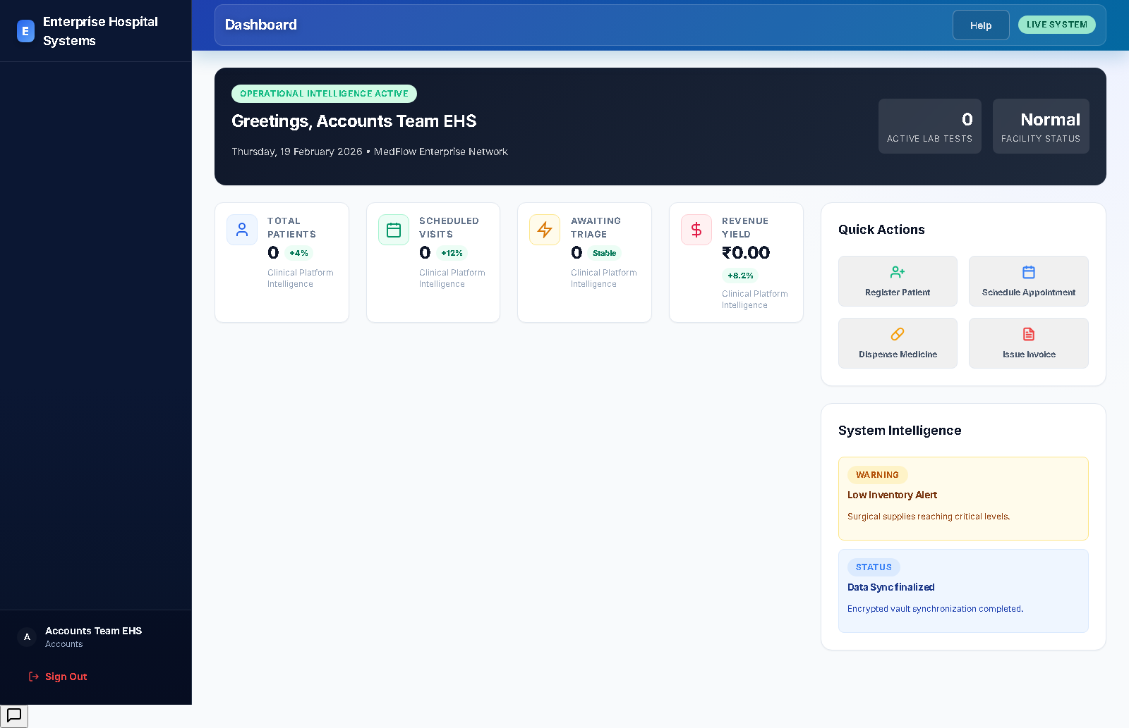

Auditor - Enterprise Hospital Systems
User: auditor.ehs@emr.local
Login status: success
Workflow steps:
- Log in with read-focused auditing context.
- Review report and compliance-relevant modules.
- Validate access boundaries and transactional traceability.
- Raise findings for governance follow-up.
Screenshot evidence:
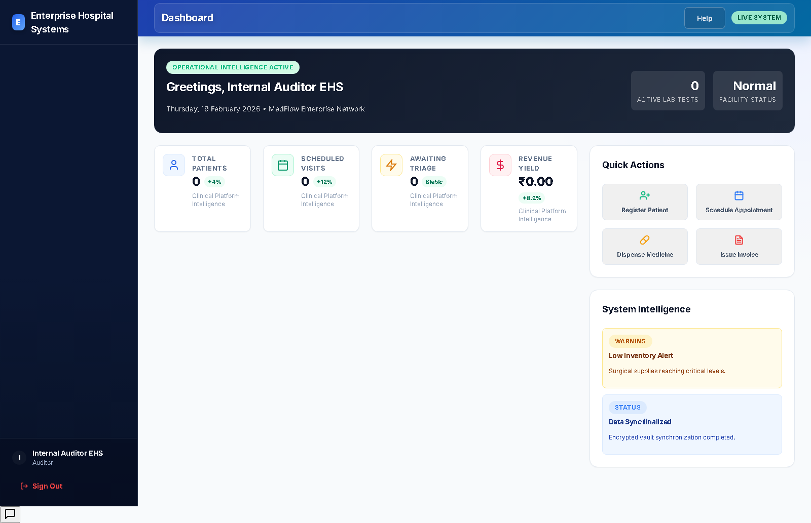

Management - Enterprise Hospital Systems
User: management.ehs@emr.local
Login status: success
Workflow steps:
- Log in and review executive dashboard metrics.
- Access reports and strategic operational views.
- Validate performance across clinical and financial tracks.
- Drive high-level decisions and escalations.
Screenshot evidence:
