StockSteward AI: Tech Stack, Role Workflows (Manual + Auto), and Reports
Date: 2026-02-19
Audience: Traders, Auditors, Business Owners, Super Admins

1. Purpose and Scope
This document defines the platform tech stack and clean operational workflows for Manual Mode and Auto Mode across four roles: Trader, Auditor, Business Owner, and Super Admin. It also standardizes report ownership, cadence, and escalation usage.

2. Platform Tech Stack

2.1 Frontend
- React 18 + TypeScript 4.9
- React Router for role-based routing and module navigation
- Tailwind CSS + PostCSS for UI styling
- Recharts for dashboard analytics and charting
- Socket.IO Client for near real-time updates
- Axios for backend API integration
- jsPDF / jsPDF-Autotable for downloadable report generation
- Cypress for E2E testing

2.2 Backend
- FastAPI + Uvicorn for API and service orchestration
- SQLAlchemy ORM + PostgreSQL driver (psycopg2-binary)
- Pydantic for schema validation and configuration management
- Redis + Celery/RQ + APScheduler for async tasks and scheduled jobs
- python-socketio/websockets for event streaming and notifications
- Risk/quant stack: NumPy, Pandas, SciPy, TA/TA-Lib, Statsmodels, scikit-learn
- Market/broker integrations: KiteConnect, CCXT, yfinance
- Security libraries: passlib, bcrypt, python-jose, cryptography

2.3 Runtime and Deployment
- Docker Compose service model (frontend + backend)
- Environment-driven controls: execution mode, live trading switch, kill switch, high-value thresholds, confidence thresholds
- Operational segregation for DEV/STAGING/PROD deployment practices

3. Role Responsibility Model
Role | Primary Objective | Manual Focus | Auto Focus | Escalates To
Trader | Trade execution and portfolio outcomes | Order-by-order decisioning | AI-assisted strategy execution and supervision | Business Owner / Auditor
Auditor | Compliance and control assurance | Case review and evidence capture | Automated surveillance and anomaly triage | Business Owner / Super Admin
Business Owner | Business profitability and controlled growth | Policy approvals and strategic interventions | Policy automation and exception-driven governance | Super Admin
Super Admin | System integrity, security, and governance | Platform administration and incident response | Auto-remediation, guardrails, and policy enforcement | Executive Governance

4. Unified Operating Modes

4.1 Manual Mode (Human-led)
- Human validates every major decision before execution.
- Ideal for volatile markets, new strategies, audit-sensitive periods, and onboarding.
- Higher control and explainability with slower execution throughput.

4.2 Auto Mode (System-led with guardrails)
- System executes pre-approved strategies and risk rules automatically.
- Humans monitor exceptions, breaches, and anomaly alerts instead of every transaction.
- Higher throughput and consistency; requires strong controls and observability.

5. Clean Workflow by Role

5.1 Trader

Manual Workflow
- Review market state, watchlist signals, and open risk exposures.
- Select symbol, side, quantity, and order type (market/limit/stop/trailing).
- Validate position sizing and risk/reward before order confirmation.
- Execute order and monitor fill quality, slippage, and intraday risk.
- Document rationale for non-standard trades and close/adjust positions.

Auto Workflow
- Enable approved strategy template and assign capital/risk limits.
- Set confidence threshold, daily loss cap, and kill switch behavior.
- System scans instruments, creates signals, and executes eligible orders.
- Trader supervises exceptions (rejections, threshold breaches, model drift alerts).
- End-of-session review signs off automated actions and performance attribution.

Key Reports Used / Produced
- Daily P&L Summary
- Order Execution Quality Report (slippage/reject/latency)
- Risk Limit Breach Log
- Strategy Performance Attribution

5.2 Auditor

Manual Workflow
- Pull transaction sample by risk score, size, and trader profile.
- Review decision trail, timestamps, approvals, and policy adherence.
- Capture findings, classify severity, and assign remediation actions.
- Validate closure evidence and retain immutable audit records.

Auto Workflow
- Run automated surveillance packs for anomaly detection.
- Triage alerts by severity and confidence band.
- Auto-route high-risk cases to Business Owner and Super Admin.
- Approve low-risk auto-closures where policy criteria are met.
- Publish periodic compliance trend report with recurring-pattern analysis.

Key Reports Used / Produced
- Daily Compliance Exceptions Report
- Suspicious Activity and Pattern Detection Report
- Open vs Closed Findings Aging Report
- Regulatory Filing Support Pack

5.3 Business Owner

Manual Workflow
- Review business-level portfolio, profitability, and drawdown profile.
- Approve strategy changes, capital reallocation, and risk policy updates.
- Review team performance and enforce accountability actions.
- Validate compliance posture and sign off escalation decisions.

Auto Workflow
- Enable policy-based auto allocation and strategy budget envelopes.
- Use exception-only management: intervene on breaches and outliers.
- Approve or rollback automated rule updates based on KPI drift.
- Monitor business scorecards and trigger strategic rebalance decisions.

Key Reports Used / Produced
- Business P&L and Margin Report
- Portfolio Concentration and Drawdown Report
- Trader Productivity and Outcome Report
- Compliance Health Scorecard

5.4 Super Admin

Manual Workflow
- Provision users, roles, and environment-level permissions.
- Manage platform configs: trading controls, API keys, and feature flags.
- Monitor system health, logs, queue depth, and security events.
- Execute maintenance, backup checks, and incident response actions.

Auto Workflow
- Enable auto-remediation for predefined operational incidents.
- Apply policy-as-code for access controls and configuration drift checks.
- Use automated scaling, alert routing, and service restart workflows.
- Review post-incident diagnostics and harden control baselines.

Key Reports Used / Produced
- System Uptime and Incident Report
- Access Governance and Privilege Change Report
- Security Event and Response Report
- Backup and Recovery Verification Report

6. Cross-Role Trade Lifecycle Workflow (Clean Flow)
- Signal Generation: Manual (trader analysis) or Auto (strategy engine).
- Pre-Trade Risk Check: Rule engine validates limits, exposure, and confidence.
- Execution: Trader confirms (manual) or system executes (auto) through broker adapters.
- Post-Trade Controls: P&L, slippage, and policy checks are computed and logged.
- Audit and Compliance: Exceptions are routed to Auditor queue for review/closure.
- Business Oversight: Business Owner reviews KPI deviation and policy effectiveness.
- Platform Governance: Super Admin monitors platform integrity and security posture.

7. Report Catalog and Ownership
Report Name | Primary Owner | Frequency | Mode | Primary Audience | Primary Action
Daily P&L Summary | Trader | Daily | Manual + Auto | Trader, Business Owner | Position and strategy adjustment
Execution Quality Report | Trader | Daily/Weekly | Manual + Auto | Trader, Auditor | Broker/rule tuning
Risk Breach Log | Trader + Auditor | Real-time + Daily rollup | Manual + Auto | Trader, Auditor, Owner | Immediate mitigation/escalation
Compliance Exceptions | Auditor | Daily | Manual + Auto | Auditor, Owner | Case assignment and closure
Suspicious Activity Report Pack | Auditor | Weekly/Monthly | Auto-assisted | Auditor, Regulator, Owner | Regulatory reporting
Business P&L and Margin | Business Owner | Weekly/Monthly | Manual + Auto | Owner, Leadership | Capital and target reset
Productivity and Outcome | Business Owner | Weekly | Manual + Auto | Owner, Team Leads | Performance coaching and staffing
System Health and Incident | Super Admin | Daily + Incident-driven | Manual + Auto | Super Admin, Owner | Stability and incident control
Security and Access Governance | Super Admin | Weekly/Monthly | Manual + Auto | Super Admin, Auditor | Privilege correction and policy hardening

8. Governance Controls for Auto Mode
- Global kill switch must be enabled and periodically tested.
- High-value trade thresholds require explicit owner-approved policy.
- Confidence threshold below policy floor routes trade to manual approval.
- Any repeated model anomaly triggers fallback to Manual Mode.
- Every automated decision must retain traceable inputs, rule results, and final action.

9. Recommended KPI Dashboard (Role-wise)
- Trader: hit rate, realized P&L, average slippage, risk-utilization ratio.
- Auditor: alert precision, case closure time, repeat finding rate, unresolved aging.
- Business Owner: net margin, drawdown, strategy contribution mix, compliance score.
- Super Admin: uptime, MTTD/MTTR, failed job rate, critical vulnerability aging.

10. Conclusion
Manual Mode is control-first and best for high-touch decisioning. Auto Mode is scale-first and best for repeatable execution under strict guardrails. The operating model should keep human oversight focused on exceptions, policy quality, and risk containment.

11. Screenshots
The following screenshots are taken from available project assets and Cypress execution artifacts.

Platform Brand / UI Kit Snapshot

Source: frontend/public/brand_kit.png

Strategy Selection Workflow - Navigation View
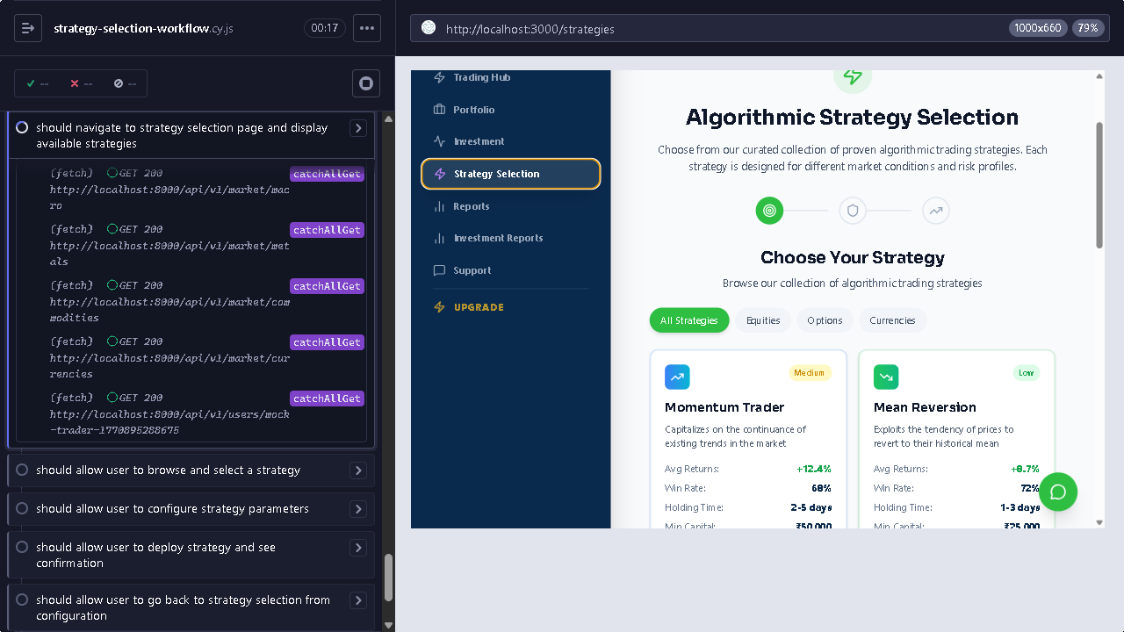
Source: frontend/cypress/screenshots/strategy-selection-workflow.cy.js/Strategy Selection Workflow -- should navigate to strategy selection page and display available strategies (failed).png

Strategy Selection Workflow - Attempt 2
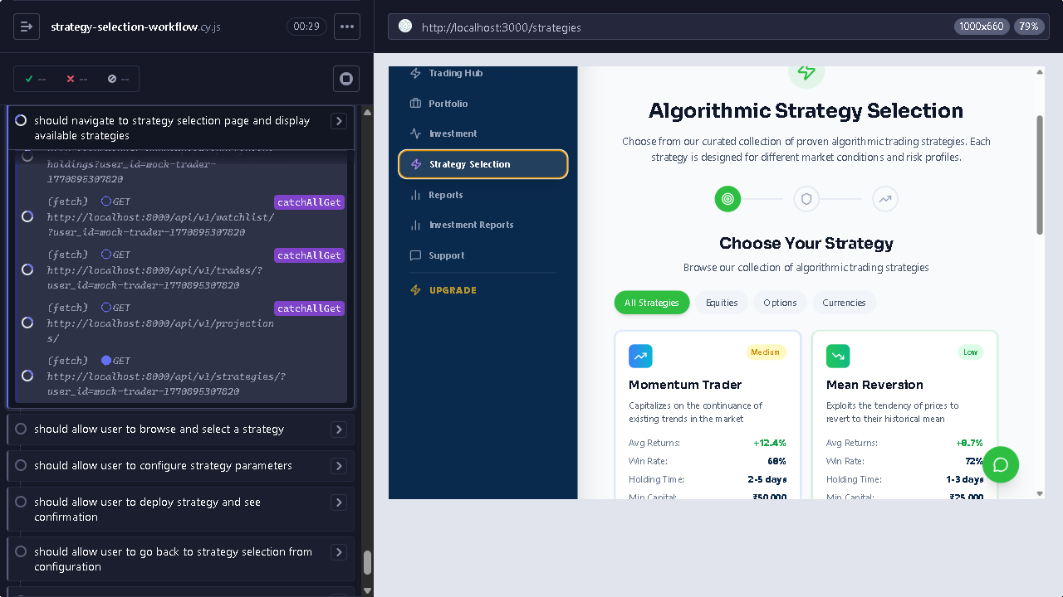
Source: frontend/cypress/screenshots/strategy-selection-workflow.cy.js/Strategy Selection Workflow -- should navigate to strategy selection page and display available strategies (failed) (attempt 2).png

Strategy Selection Workflow - Attempt 3
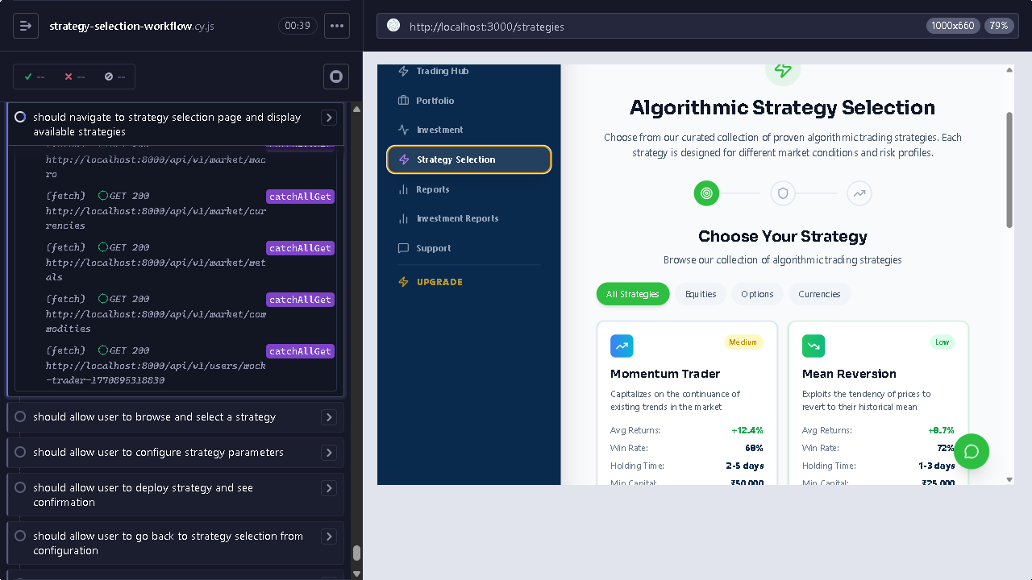
Source: frontend/cypress/screenshots/strategy-selection-workflow.cy.js/Strategy Selection Workflow -- should navigate to strategy selection page and display available strategies (failed) (attempt 3).png

Strategy Parameter Configuration View
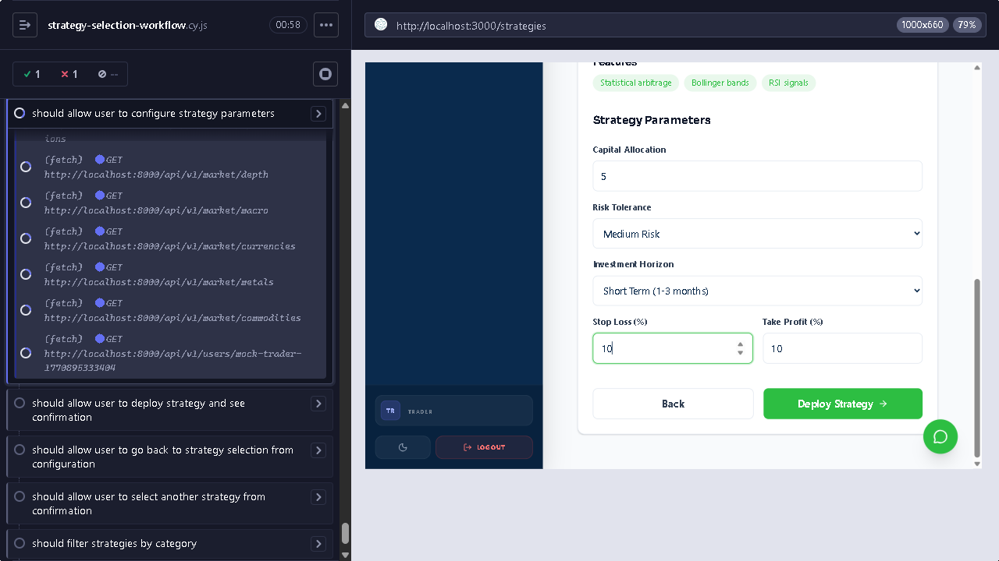
Source: frontend/cypress/screenshots/strategy-selection-workflow.cy.js/Strategy Selection Workflow -- should allow user to configure strategy parameters (failed).png

12. Workflow Progress Tracking (Applicable to All Roles)
This section standardizes how in-progress workflow states are displayed and monitored across Trader, Auditor, Business Owner, and Super Admin activities.

12.1 Progress View Reference Screenshot

Reference Source: frontend/cypress/screenshots/strategy-selection-workflow.cy.js/...configure strategy parameters (failed).png

12.2 Standard Progress States
- Queued: Workflow step accepted and waiting for execution.
- In Progress: Step currently running with live status updates.
- Awaiting Approval: Human confirmation required before next step.
- Completed: Step executed successfully and audit trail recorded.
- Failed: Step failed with error reason and retry/escalation path.
- Escalated: Step routed to higher role due to risk/policy/system threshold.

12.3 Role-wise Progress Checkpoints
Role | Typical In-Progress Checkpoint | Who Confirms | If Failed / Escalated
Trader | Order validation, placement, and fill monitoring | Trader | Escalate to Auditor / Business Owner on policy breach
Auditor | Case triage, evidence review, remediation tracking | Auditor Lead | Escalate to Business Owner / Super Admin for critical findings
Business Owner | Policy review, KPI deviation handling, approvals | Business Owner | Escalate to Super Admin for platform-level control action
Super Admin | Security event response, service health remediation | Super Admin | Escalate to executive governance for major incidents

12.4 Reporting of Progress Status
- Daily role dashboards must show open in-progress items by severity.
- Weekly review must include aging of in-progress and escalated items.
- All failed and escalated steps must map to owner, ETA, and closure evidence.

13. Dedicated Role Workflow Visuals
Each role below has a dedicated progression visual showing end-to-end workflow states and escalation path.

13.1 Trader
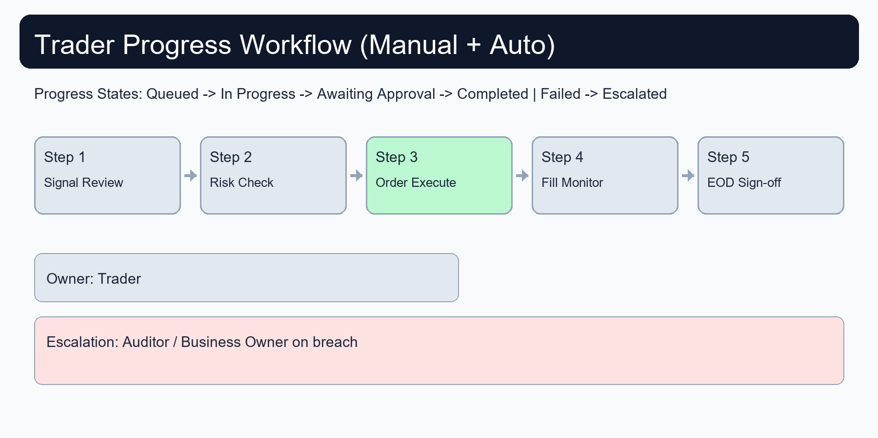
Source: docs/assets/role-workflow-visuals/trader_workflow_progress.png

13.2 Auditor
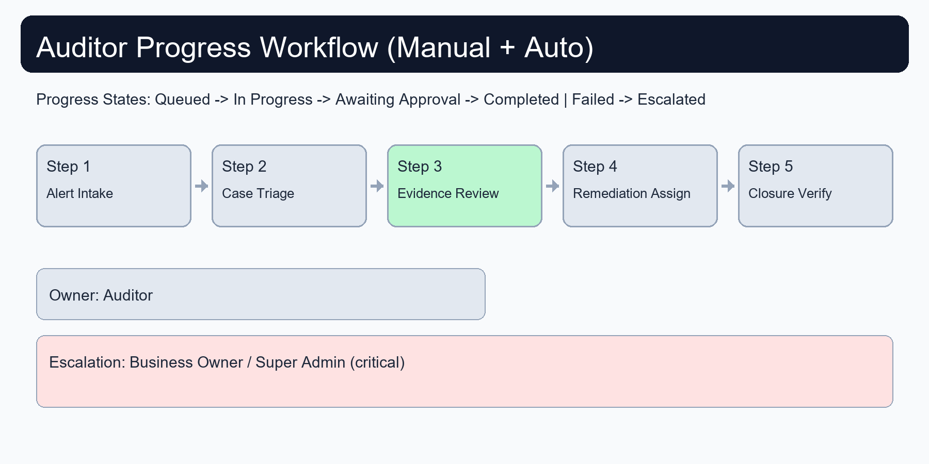
Source: docs/assets/role-workflow-visuals/auditor_workflow_progress.png

13.3 Business Owner
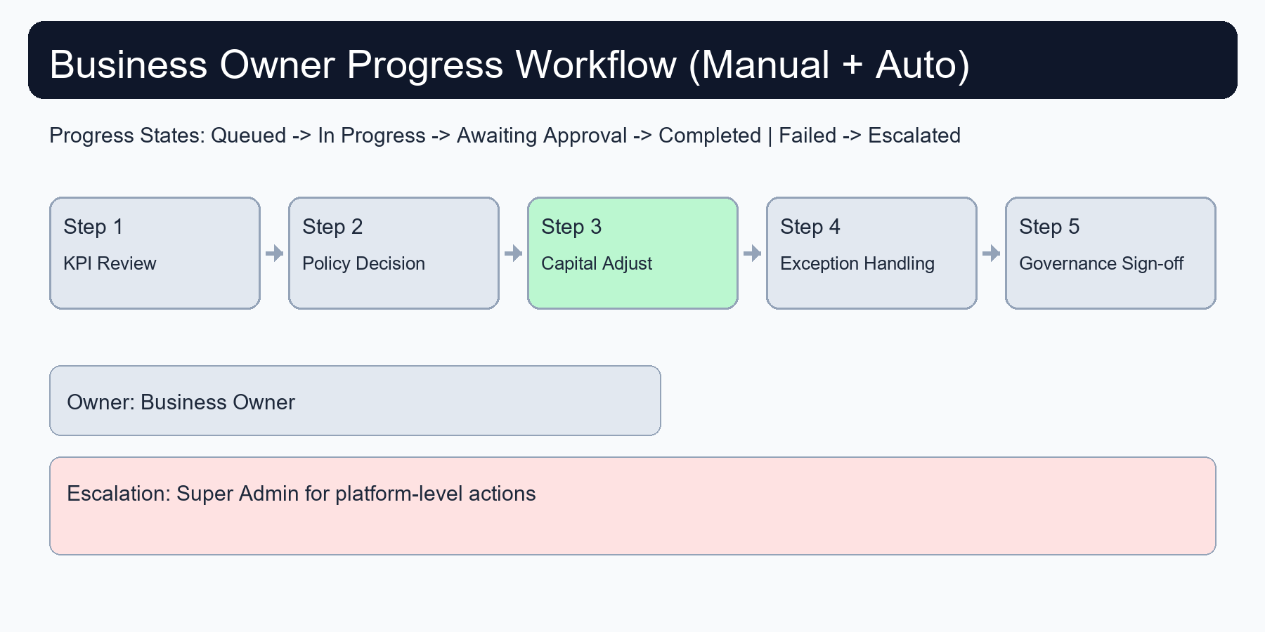
Source: docs/assets/role-workflow-visuals/business_owner_workflow_progress.png

13.4 Super Admin
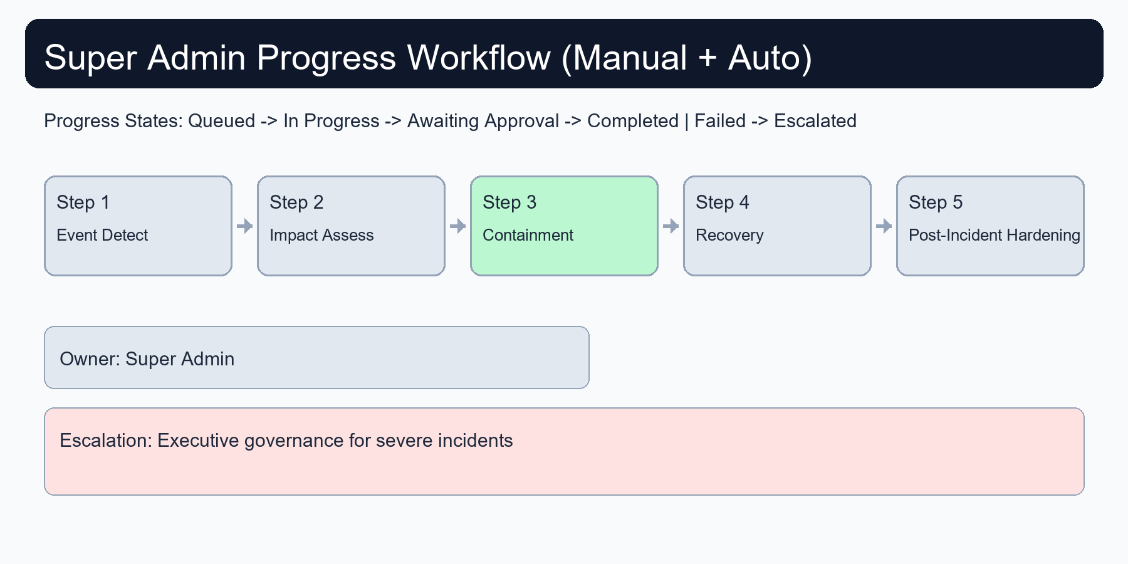
Source: docs/assets/role-workflow-visuals/super_admin_workflow_progress.png

