**SURF in Computer Vision  
  
Selvamani S  
Madras Institute of Technology**

# Introduction to Feature Detection

Feature detection is a key process in computer vision for identifying important points or patterns in images. These features help in various tasks such as object recognition, image matching, motion tracking, and 3D reconstruction. Algorithms like SIFT, SURF, and ORB are used to detect keypoints that are stable across transformations like scaling, rotation, and illumination changes.

# What is SURF?

SURF (Speeded-Up Robust Features) is an algorithm designed for feature detection and description. It was introduced in 2006 by Herbert Bay and his colleagues to offer faster computation compared to SIFT while maintaining robustness. SURF is suitable for real-time applications like object tracking and recognition.

# Key Concepts of SURF

1. Feature Extraction: Detects keypoints using a Hessian matrix approximation.  
2. Integral Images: A method for fast computation of pixel sums in a region.  
3. Hessian Matrix: Used for detecting scale-invariant keypoints.  
4. Scale-space Representation: Analysis using up-scaled filters for keypoint localization.

# Feature Extraction

SURF uses a Hessian matrix approximation to detect interest points in the image. By applying a Gaussian kernel and computing second-order derivatives, SURF identifies stable points across scales. Integral images allow for faster and more efficient computation of these derivatives.

# Integral Images

The integral image allows for quick calculation of pixel sums within any rectangular region. It enables fast convolution operations, which are central to the SURF method. This method is computationally efficient and is key to SURF's speed.

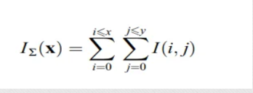

# Hessian Matrix-Based Interest Points

SURF uses the determinant of the Hessian matrix to select locations and scales of keypoints. By computing second-order derivatives and approximating them with box filters, SURF achieves computational efficiency while maintaining accuracy.

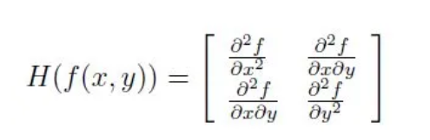

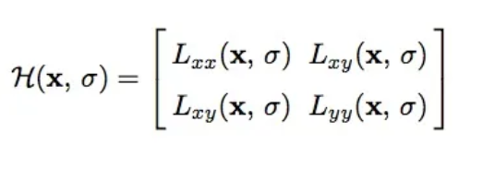

To calculate the determinant of the Hessian matrix, first we apply convolution with a Gaussian kernel, then compute the second-order derivative. SURF pushes the approximation further with box filters, which are computationally cheaper and still effective.

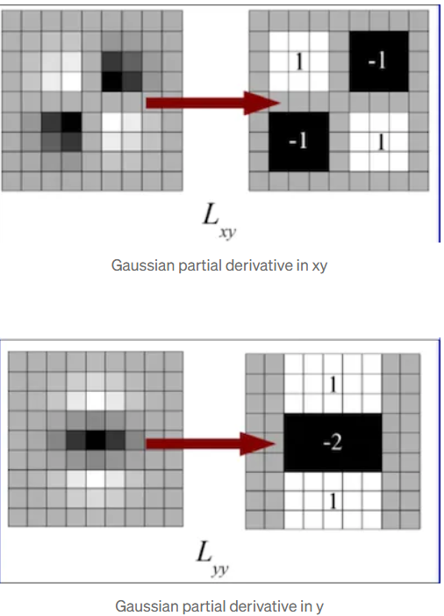

The 9×9 box filters approximate Gaussian second-order derivatives with σ = 1.2. These approximations (Dxx, Dyy, and Dxy) help represent the determinant of the Hessian.

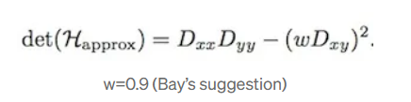

# Scale-Space Representation

Scale-space is represented using image pyramids, where the image is repeatedly smoothed and sub-sampled. SURF allows for up-scaling the filter size directly without reducing the image size, making it more efficient than methods that require reducing the image.

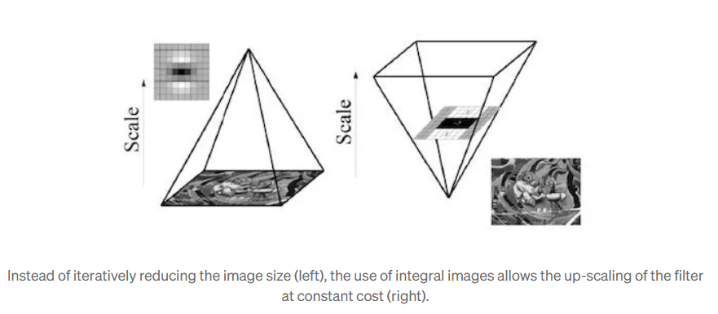

# Feature Description

To make SURF features rotation-invariant, an orientation is assigned to the keypoints based on Haar wavelet responses in a circular region around the keypoint. The SURF descriptor is then constructed by creating a square region around the keypoint, extracting wavelet responses, and forming a descriptor vector.

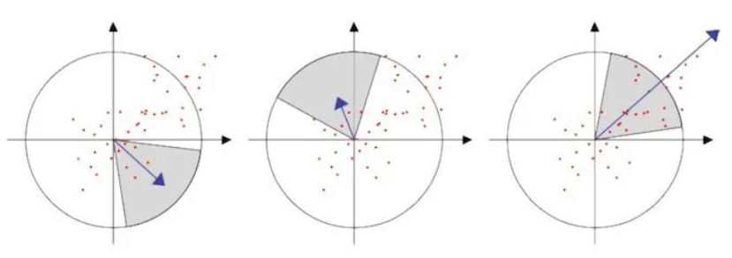

# Descriptor Components

Each keypoint descriptor is derived from wavelet responses (dx, dy) and their absolute values. These are summed over small sub-regions to create a 64-dimensional descriptor. Integral images help compute these descriptors efficiently.

Each sub-region has a four-dimensional descriptor vector v = (∑ dx, ∑ dy, ∑|dx|, ∑|dy|). This results in a descriptor vector for all 4×4 sub-regions of length 64. (SIFT uses a 128-dimensional vector, which is one reason why SURF is faster).

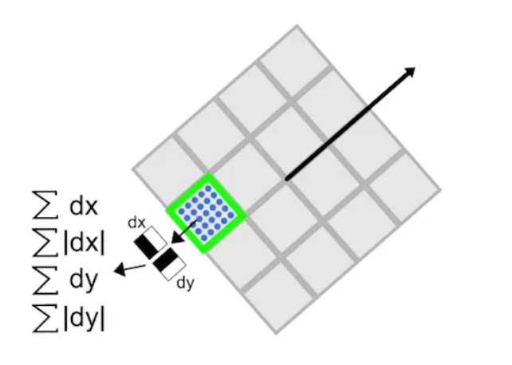

# Benefits of SURF

1. Speed: Faster than SIFT due to the use of box filters and integral images.  
2. Robustness: Performs well under various transformations like scale, rotation, and illumination changes.  
3. Real-Time Applications: Suitable for real-time systems such as object tracking and recognition.