**ONLINE E-LEANING DATA ANALYTICS DASHBOARD USING POWER BI**

**POWER BI PROJECT REPORT**

**Submitted by**

**SELVA J**

**(Reg.No:24MCR095)**

***In partial fulfilment of the requirements for award of the degree of***

**MASTER OF COMPUTER APPLICATION**

**IN**

**DEPARTMENT OF COMPUTER APPLICATION**

**KONGU ENGINEERING COLLEGE**

**(Autonomous)**

**PERUNDURAI ERODE – 638 060 DECEMBER 2024**

***"As technology continues to evolve, Power BI will undoubtedly play an even more crucial role in helping businesses harness the power of data to drive innovation and growth."***

# E-Learning Platform Performance Insights Dashboard Using Power BI

## Abstract

The E-learning Platform Performance Insights Dashboard, developed in Power BI, is designed to provide comprehensive, data-driven insights into key aspects of platform performance, including user engagement, course popularity, revenue generation, and user satisfaction. This interactive dashboard centralizes various metrics, allowing educational administrators and decision-makers to gain a holistic view of platform activity and effectiveness.

Through customizable filters and dynamic visualizations, users can delve into specific metrics such as enrollment rates, course completion rates, assessment outcomes, and feedback ratings. This dashboard supports granular exploration by allowing segmentation across demographics like age, region, and subscription type, offering actionable insights tailored to diverse user segments.

By consolidating data from multiple sources, the dashboard empowers administrators to make informed, timely decisions to enhance content delivery, optimize course offerings, and improve user engagement strategies. In addition, the dashboard aids in identifying revenue trends and opportunities for growth, helping administrators forecast effectively and refine pricing strategies. This comprehensive tool serves as a pivotal resource in fostering a continuously evolving e-learning environment that meets user needs, maximizes platform impact, and drives long-term success.

## Problem Statement

E-learning platforms manage diverse data points from course enrollments to assessment results and user feedback, often spread across multiple systems. This data complexity makes it challenging to visualize trends and patterns that are crucial for platform optimization and strategic decision-making. The E-learning Platform Performance Insights Dashboard simplifies data into a unified view, offering a clear and interactive interface to support operational goals and elevate learning outcomes. Through this tool, users can explore data by time frame, demographics, course category, and region to drive targeted improvements.

## Dashboard Overview

### User Engagement Insights Dashboard

**Purpose:** Offers insights into user interaction, such as login frequency, completion rates, and time spent on the platform. This data enables administrators to assess user engagement and pinpoint peak usage times.

**Key Visuals:**

* **Line Chart** for Daily Active Users: Tracks engagement trends by displaying daily active user counts over time.
* **Donut Chart** for Subscription Plan Breakdown: Shows user distribution across Free, Basic, and Premium plans, identifying popular choices.

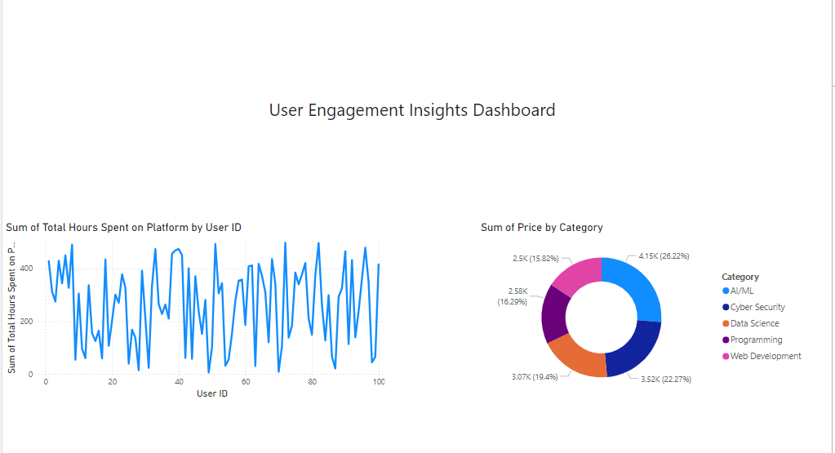

### Course Popularity & Completion Dashboard

**Purpose:** Analyzes enrollment trends and completion rates across various courses, highlighting top-performing content and areas for improvement.

**Key Visuals:**

* **Bar Chart** for Course Enrollment Trends: Compares enrollment numbers across courses to identify high-interest topics.
* **Stacked Bar** Chart for Completion Rates by Course Category: Analyzes completion rates within each course category, showcasing the highest and lowest completion rates.

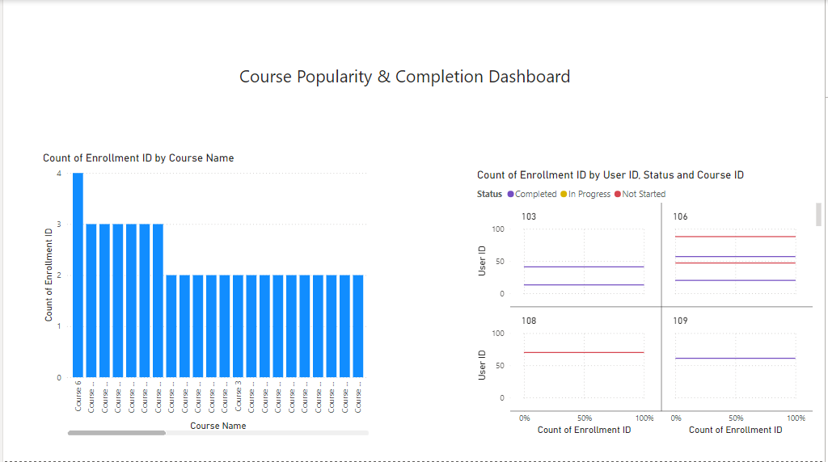

### Revenue Insights & Trends Dashboard

**Purpose**: Assesses revenue generation by subscription type and course sales, allowing administrators to forecast earnings and refine pricing strategies.

**Key Visuals:**

* **Funnel Chart** for Revenue by Subscription Type: Visualizes income by subscription level, illustrating conversion rates.
* **Line Chart** for Monthly Revenue Patterns: Tracks revenue changes over time, helping to pinpoint periods of high and low earnings.

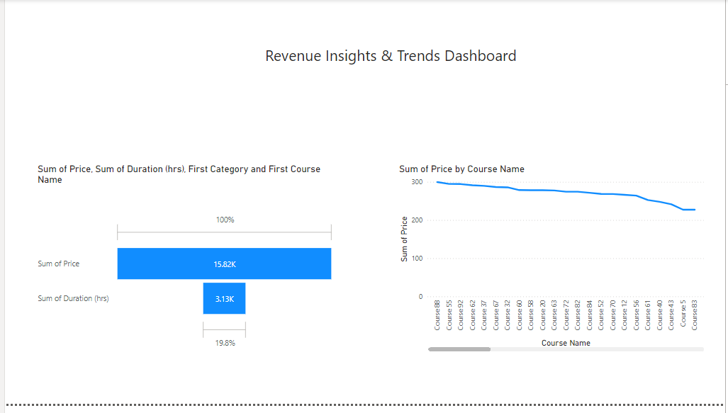

### Learning Performance & Assessment Dashboard

**Purpose:** Evaluates assessment outcomes, showing student performance trends and areas needing improvement.

**Key Visuals:**

* **Scatter Plot** for Assessment Scores by Attempt: Shows score distributions across attempts, tracking learning progress.
* **Bar Chart** for Average Scores by Course: Compares assessment averages across courses, highlighting where students excel or struggle.

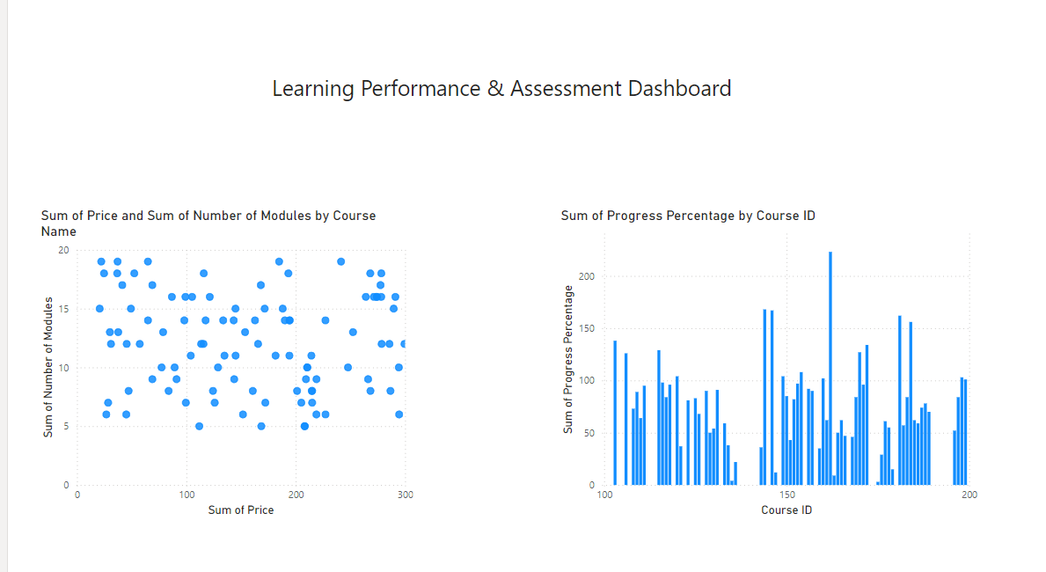

### User Satisfaction & Feedback Dashboard

**Purpose:** Analyzes user feedback to reveal satisfaction trends and identify areas for enhancement.

**Key Visuals:**

* **Pie Chart for Rating Distribution:** Summarizes course ratings to show overall satisfaction levels.
* **Word Cloud for Feedback Themes:** Highlights commonly mentioned terms in feedback, indicating common positive and negative themes.

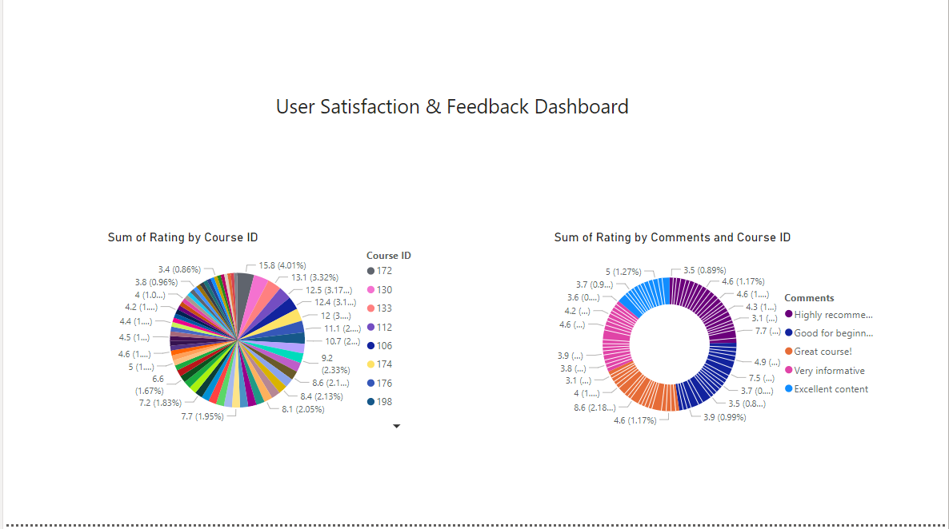

### User Retention & Loyalty Dashboard

Purpose: Tracks user retention rates and segments active users by engagement metrics to identify loyal users and areas for re-engagement.

**Key Visuals:**

* **Clustered Bar** **Chart for Retention by Age Group:** Analyzes retention patterns across demographics.
* **Table** **of Top Users by Engagement:** Lists highly active users, offering insights into potential platform ambassadors.

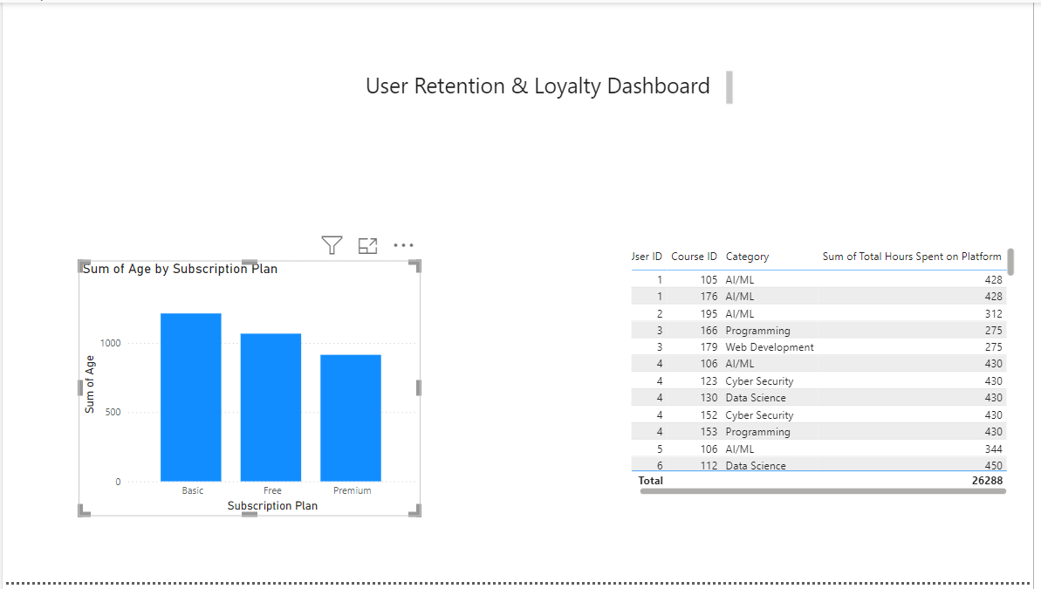

### Dynamic Exploration & Drilldown Dashboard

**Purpose:** Allows users to filter and explore data across dimensions like time, course type, and region, providing customized insights.

**Key Visuals:**

* **Interactive Filters:** Provides filtering options by Date, Region, Course Category, and Subscription Plan.
* **Dynamic Data Tables and Charts:** Updates in real-time to show filtered data, facilitating targeted analysis.

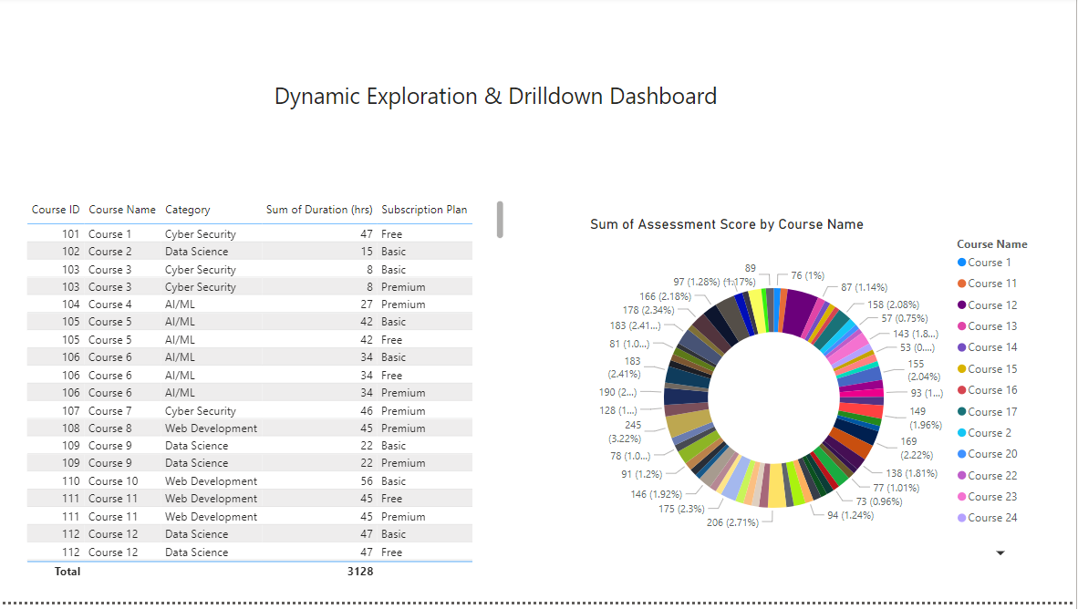

Git Link :

## Conclusion

This E-learning Platform Performance Insights Dashboard provides a robust solution for tracking and understanding the platform's core metrics. The suite of dashboards offers critical insights into user engagement, course performance, revenue growth, and user satisfaction, enabling administrators to make informed, data-backed decisions. By harnessing Power BI’s filtering and drill-down capabilities, users can explore specific metrics that contribute to strategic decisions and operational efficiency. The interactive design encourages proactive data exploration, promoting a culture of continuous improvement across the platform.