Computer Networks Lab Report
Submitted By
SELVASUDHARSAN SENGUTTUVAN
RA2411030050014
Under the guidance of
Dr. Mallika
(Assistant Professor, School of Computing)
in partial fulfilment for the award of the degree
of
BACHELOR OF TECHNOLOGY
in
DEPARTMENT OF COMPUTER SCIENCE AND ENGINEERING WITH CYBER SECURITY
Of
FACULTY OF ENGINEERING AND TECHNOLOGY

SRM INSTITUTE OF SCIENCE AND TECHNOLOGY,
TIRUCHIRAPPALLI
Academic Year: 2026–2027
Date: 23 October 2026

LAB REPORT

Experiment 1: Router Configuration: Passwords & Interface Setup

Tool: Cisco Packet Tracer

1. Objective
To configure a Cisco router in Packet Tracer by setting up security passwords (Console, Enable and VTY), configuring IP addresses on the Gigabit Ethernet interfaces, and verifying end-to-end communication across different subnets.

2. Network Topology & Addressing Table

2.1 Topology Overview
- Router: 1 Cisco ISR4331 (Router0)
- Hosts: 2 PCs (PC0 and PC1)
- Cabling: Copper Cross-Over cables connecting PC0 to Gig0/0/0 and PC1 to Gig0/0/1 (a PC-to-router link uses a cross-over cable).

2.2 Addressing Table
Device | Interface | IP Address | Subnet Mask | Default Gateway
Router0 | Gig0/0/0 | 192.168.1.1 | 255.255.255.0 | N/A
Router0 | Gig0/0/1 | 192.168.2.1 | 255.255.255.0 | N/A
PC0 | FastEthernet0 | 192.168.1.2 | 255.255.255.0 | 192.168.1.1
PC1 | FastEthernet0 | 192.168.2.2 | 255.255.255.0 | 192.168.2.1

3. Step-by-Step Implementation

Step 1: Device Placement & Cabling
- Dragged one router (ISR4331) and two PCs into the Cisco Packet Tracer workspace.
- Connected PC0 to the router's GigabitEthernet0/0/0 interface using a Copper Cross-Over cable.
- Connected PC1 to the router's GigabitEthernet0/0/1 interface using a Copper Cross-Over cable.

Step 2: Router Password Configuration
Opened the router's CLI tab and configured the management passwords:
Router> enable
Router# configure terminal

! Console Password Setup
Router(config)# line console 0
Router(config-line)# password cisco
Router(config-line)# login
Router(config-line)# exit

! Privileged EXEC Password Setup
Router(config)# enable password cisco

! VTY (Telnet/SSH) Password Setup
Router(config)# line vty 0 4
Router(config-line)# password cisco
Router(config-line)# login
Router(config-line)# exit

Step 3: Router Interface Configuration
Assigned IP addresses and activated both Gigabit Ethernet interfaces:
! Configure GigabitEthernet 0/0/0 (LAN 1)
Router(config)# interface gigabitEthernet 0/0/0
Router(config-if)# ip address 192.168.1.1 255.255.255.0
Router(config-if)# no shutdown
Router(config-if)# exit

! Configure GigabitEthernet 0/0/1 (LAN 2)
Router(config)# interface gigabitEthernet 0/0/1
Router(config-if)# ip address 192.168.2.1 255.255.255.0
Router(config-if)# no shutdown
Router(config-if)# end

Router# copy running-config startup-config

Step 4: PC Configuration
Configured static IP settings on both end devices under Desktop > IP Configuration:
- PC0: IP 192.168.1.2, Subnet Mask 255.255.255.0, Default Gateway 192.168.1.1
- PC1: IP 192.168.2.2, Subnet Mask 255.255.255.0, Default Gateway 192.168.2.1

4. Screenshot
The figure below shows the Packet Tracer workspace with the topology (PC0 and PC1 connected to Router0) and the router CLI displaying the password and interface configuration, including the link-state messages for GigabitEthernet0/0/0 changing to up.
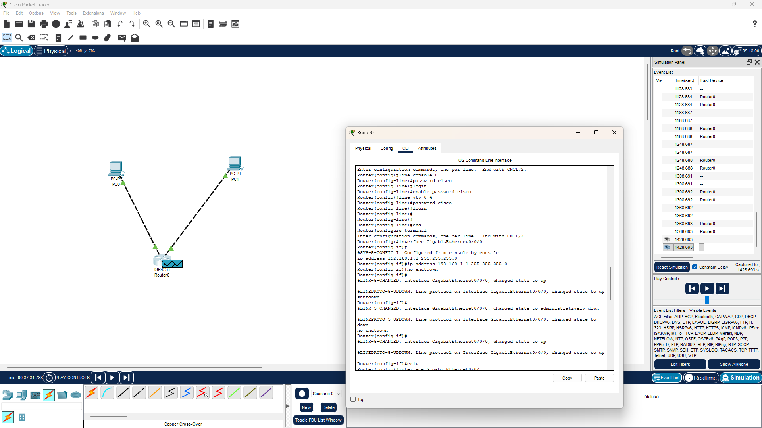
Figure 1: Network topology and Router0 CLI configuration in Cisco Packet Tracer
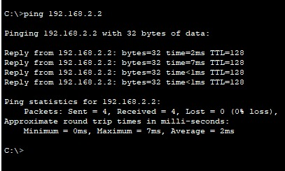

5. Verification & Testing
- Interface status check: executed show ip interface brief on the router. Both interfaces displayed Status: up and Protocol: up.
- Console password: after exiting EXEC mode (exit), re-entering user mode prompted for the console password (cisco).
- Enable password: entering enable prompted for the privileged mode password (cisco).
- End-to-end connectivity: opened the Command Prompt on PC0 (192.168.1.2) and executed:
PC> ping 192.168.2.2

Result: successful ICMP echo replies were received after the initial ARP resolution (4 packets transmitted, 4 received, 0% loss).

6. Conclusion
The network was successfully deployed. The router interfaces were brought up and assigned the correct gateway IP addresses, enabling routing between two distinct subnets (192.168.1.0/24 and 192.168.2.0/24). Router security was established through Console, Enable and VTY passwords

Experiment 2: IP Addressing and Subnetting using Variable Length Subnet Masking (VLSM)

Tool: Cisco Packet Tracer

1. Objective
- To build a triangular network topology connecting three Cisco routers in Cisco Packet Tracer.
- To design and calculate appropriate subnets using Variable Length Subnet Masking (VLSM) for point-to-point router links.
- To configure IP addresses on the respective router interfaces and bring them into an operational state.
- To verify interface status and test point-to-point link connectivity using the ping utility.

2. Tools & Equipment Required
- Cisco Packet Tracer simulation software
- 3 × Cisco ISR4331 routers (Router0, Router1 and Router2 in Packet Tracer; referred to as R1, R2 and R3 in this report)
- Copper Cross-Over cables for the router-to-router links

3. Network Topology & Subnet Design

3.1 Topology
The routers are interconnected in a full point-to-point triangle: R1 (Router0) at the top, R2 (Router1) at the bottom left and R3 (Router2) at the bottom right. Link 1 joins R1 and R2, Link 2 joins R1 and R3, and Link 3 joins R2 and R3.
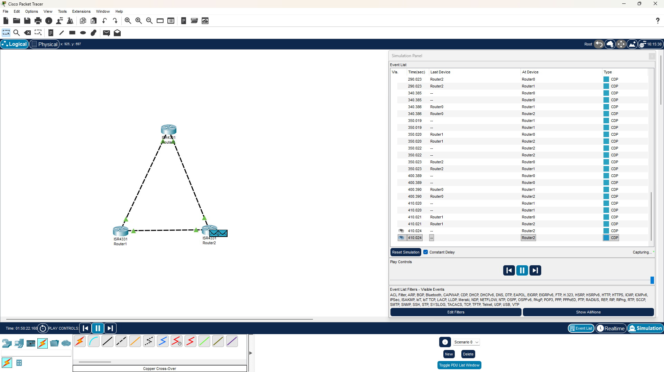
Figure 2: Triangular topology of three routers in Cisco Packet Tracer

3.2 VLSM Subnet Calculation
Each point-to-point link requires only 2 usable host IP addresses. A /30 subnet mask (255.255.255.252) provides 2⁽³²⁻³⁰⁾ − 2 = 2 usable addresses per link, minimizing address waste.
Link | Network ID | Subnet Mask | Usable Host Range | Broadcast Address
R1 – R2 | 192.168.1.0/30 | 255.255.255.252 | 192.168.1.1 – 192.168.1.2 | 192.168.1.3
R1 – R3 | 192.168.1.4/30 | 255.255.255.252 | 192.168.1.5 – 192.168.1.6 | 192.168.1.7
R2 – R3 | 192.168.1.8/30 | 255.255.255.252 | 192.168.1.9 – 192.168.1.10 | 192.168.1.11

3.3 Interface IP Assignment Scheme
Device | Interface | Connected To | Assigned IP Address | Subnet Mask
R1 | Gig0/0/0 | R2 (Gig0/0/0) | 192.168.1.1 | 255.255.255.252
R1 | Gig0/0/1 | R3 (Gig0/0/0) | 192.168.1.5 | 255.255.255.252
R2 | Gig0/0/0 | R1 (Gig0/0/0) | 192.168.1.2 | 255.255.255.252
R2 | Gig0/0/1 | R3 (Gig0/0/1) | 192.168.1.9 | 255.255.255.252
R3 | Gig0/0/0 | R1 (Gig0/0/1) | 192.168.1.6 | 255.255.255.252
R3 | Gig0/0/1 | R2 (Gig0/0/1) | 192.168.1.10 | 255.255.255.252

4. Configuration Steps

Router 1 (R1) Configuration
Router> enable
Router# configure terminal
Router(config)# hostname R1
R1(config)# interface gigabitEthernet 0/0/0
R1(config-if)# ip address 192.168.1.1 255.255.255.252
R1(config-if)# no shutdown
R1(config-if)# exit
R1(config)# interface gigabitEthernet 0/0/1
R1(config-if)# ip address 192.168.1.5 255.255.255.252
R1(config-if)# no shutdown
R1(config-if)# exit
R1(config)# end
R1# copy running-config startup-config

Router 2 (R2) Configuration
Router> enable
Router# configure terminal
Router(config)# hostname R2
R2(config)# interface gigabitEthernet 0/0/0
R2(config-if)# ip address 192.168.1.2 255.255.255.252
R2(config-if)# no shutdown
R2(config-if)# exit
R2(config)# interface gigabitEthernet 0/0/1
R2(config-if)# ip address 192.168.1.9 255.255.255.252
R2(config-if)# no shutdown
R2(config-if)# exit
R2(config)# end
R2# copy running-config startup-config

Router 3 (R3) Configuration
Router> enable
Router# configure terminal
Router(config)# hostname R3
R3(config)# interface gigabitEthernet 0/0/0
R3(config-if)# ip address 192.168.1.6 255.255.255.252
R3(config-if)# no shutdown
R3(config-if)# exit
R3(config)# interface gigabitEthernet 0/0/1
R3(config-if)# ip address 192.168.1.10 255.255.255.252
R3(config-if)# no shutdown
R3(config-if)# exit
R3(config)# end
R3# copy running-config startup-config

5. Verification & Testing

5.1 Interface Status Check
Executed show ip interface brief on each router to confirm proper IP assignment and operational state (Status: up, Protocol: up). Sample output from R1:
Interface | IP-Address | OK? | Method | Status | Protocol
Gig0/0/0 | 192.168.1.1 | YES | manual | up | up
Gig0/0/1 | 192.168.1.5 | YES | manual | up | up

5.2 Connectivity Testing (Ping)
Direct point-to-point connections were tested using the ping command:
From | To | Command | Success Rate
R1 | R2 | ping 192.168.1.2 | 100% (5/5)
R1 | R3 | ping 192.168.1.6 | 100% (5/5)
R2 | R1 | ping 192.168.1.1 | 100% (5/5)
R2 | R3 | ping 192.168.1.10 | 100% (5/5)
R3 | R1 | ping 192.168.1.5 | 100% (5/5)
R3 | R2 | ping 192.168.1.9 | 100% (5/5)

6. Result & Conclusion
The triangular 3-router topology was successfully constructed in Cisco Packet Tracer. By utilizing a /30 VLSM subnet mask (255.255.255.252), IP address space was efficiently allocated with zero waste for the point-to-point connections. All router interfaces were brought up, and bidirectional reachability across all adjacent links was verified with a 100% ping success rate.

