C Programming Mini Project Documentation

1. Title Page
- Project Title : LIBRARY MANAGEMENT SYSTEM
- Student Name : SELVA . S
- Register Number : 921724115040
- Department : CSD
- College Name : SETHU INSTITUTE OF TECHNOLOGY
- Course : Programming in C
- Guide / Trainer Name : BALAJI . B
- Submission Date : 26-02-2026

2. Abstract
The Library Management System is a mini project developed using the C programming language. The main objective of this project is to manage basic library operations such as displaying books, issuing books, and returning books.
The system uses structures and linked lists to store book and issue records. It includes a login authentication feature to restrict unauthorized access. The program also calculates fines for late book returns. This project demonstrates structured programming concepts and logical implementation using C.

3. Introduction

Problem Statement
Managing books manually in a small library can be time-consuming and error-prone. Keeping track of issued books, return dates, and fines becomes difficult without a proper system.

Why This Project is Useful
This project provides a simple automated solution to manage books efficiently. It reduces manual work and helps maintain accurate records.

Where It Can Be Used
- Small libraries
- School or college libraries
- Learning and academic practice
- Beginner-level software system development

4. Objectives
- To understand structured programming concepts
- To use loops and conditional statements
- To work with structures and functions
- To implement linked lists
- To improve logical thinking and problem-solving skills

5. Tools & Technology
- Programming Language: C
- Compiler: GCC / Turbo C / CodeBlocks
- Platform: Windows / Linux

6. System Requirements

Hardware:
- Basic computer
- Minimum 4GB RAM

Software:
- C Compiler
- IDE or Text Editor (CodeBlocks / VS Code / Turbo C)

7. Methodology / Algorithm
- Start the program
- Add default book records
- Login authentication
- Display main menu
- Read user choice
- Perform selected operation:
  - Display Books
  - Issue Book
  - Return Book
- Calculate fine if applicable
- Repeat menu until Exit
- End program

8. Flowchart

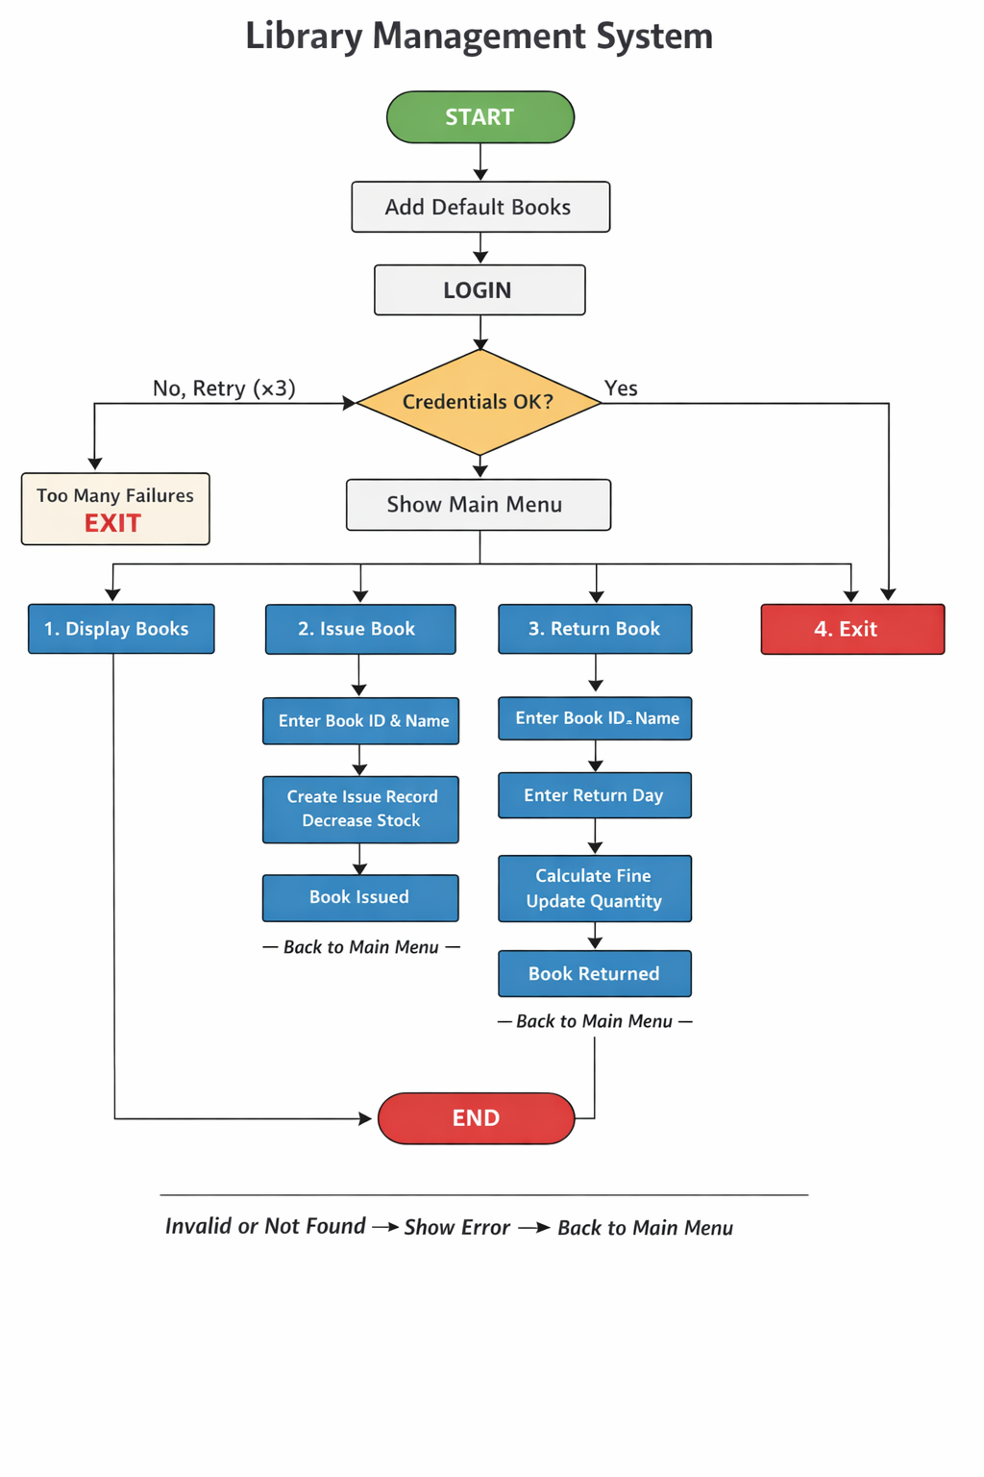

9. Program Code
(Attach the full C program code here — the code you provided.)
#include <stdio.h>
#include <stdlib.h>
#include <string.h>

#define USERNAME "admin"
#define PASSWORD "1234"
#define FINE_PER_DAY 2
#define MAX_LOGIN_ATTEMPTS 3

struct Book {
int id;
char title[50];
char author[50];
int quantity;
struct Book *next;
};

struct Issue {
int bookId;
char studentName[50];
int issueDay;
int returnDay;
struct Issue *next;
};

struct Book *bookHead = NULL;
struct Issue *issueHead = NULL;

struct Book* createBook(int id, char *title, char *author, int quantity) {
struct Book *newBook = (struct Book*)malloc(sizeof(struct Book));
if (newBook == NULL) {
printf("Memory Allocation Failed!\n");
exit(1);
}

newBook->id = id;
strcpy(newBook->title, title);
strcpy(newBook->author, author);
newBook->quantity = quantity;
newBook->next = NULL;

return newBook;
}

void addDefaultBooks() {
bookHead = createBook(101, "C Programming", "Dennis Ritchie", 5);
bookHead->next = createBook(102, "Data Structures", "Mark Allen", 3);
bookHead->next->next = createBook(103, "Operating System", "Galvin", 4);
}

void login() {
char user[20], pass[20];
int attempts = 0;

while (attempts < MAX_LOGIN_ATTEMPTS) {
printf("Username: ");
scanf("%19s", user);
printf("Password: ");
scanf("%19s", pass);

if (strcmp(user, USERNAME) == 0 && strcmp(pass, PASSWORD) == 0) {
printf("Login Successful!\n");
return;
} else {
printf("Invalid Credentials! Try Again.\n");
attempts++;
}
}

printf("Too Many Failed Attempts. Exiting...\n");
exit(0);
}

struct Book* findBook(int id) {
struct Book *temp = bookHead;
while (temp != NULL) {
if (temp->id == id)
return temp;
temp = temp->next;
}
return NULL;
}

void displayBooks() {
struct Book *temp = bookHead;

if (temp == NULL) {
printf("\nNo Books Available!\n");
return;
}

printf("\n================ AVAILABLE BOOKS ================\n");
printf("%-10s %-20s %-20s %-10s\n", "Book ID", "Title", "Author", "Quantity");
printf("---------------------------------------------------------------\n");

while (temp != NULL) {
printf("%-10d %-20s %-20s %-10d\n",
temp->id,
temp->title,
temp->author,
temp->quantity);
temp = temp->next;
}

printf("===============================================================\n");
}

void issueBook() {
int id, day;
char name[50];

printf("Enter Book ID to Issue: ");
scanf("%d", &id);

struct Book *book = findBook(id);

if (book == NULL) {
printf("Book Not Found!\n");
return;
}

if (book->quantity <= 0) {
printf("Out of Stock!\n");
return;
}

printf("Enter Student Name: ");
scanf(" %[^\n]", name);

printf("Enter Issue Day: ");
scanf("%d", &day);

if (day < 0) {
printf("Invalid Day!\n");
return;
}

struct Issue *newIssue = (struct Issue*)malloc(sizeof(struct Issue));
if (newIssue == NULL) {
printf("Memory Allocation Failed!\n");
return;
}

newIssue->bookId = id;
strcpy(newIssue->studentName, name);
newIssue->issueDay = day;
newIssue->returnDay = 0;
newIssue->next = issueHead;
issueHead = newIssue;

book->quantity--;

printf("Book Issued Successfully!\n");
}

void returnBook() {
int id, returnDay;
char name[50];
struct Issue *temp = issueHead;

printf("Enter Book ID to Return: ");
scanf("%d", &id);

printf("Enter Student Name: ");
scanf(" %[^\n]", name);

while (temp != NULL) {
if (temp->bookId == id &&
strcmp(temp->studentName, name) == 0 &&
temp->returnDay == 0) {

printf("Enter Return Day: ");
scanf("%d", &returnDay);

if (returnDay < temp->issueDay) {
printf("Invalid Return Day!\n");
return;
}

temp->returnDay = returnDay;

int lateDays = returnDay - temp->issueDay - 7;
int fine = 0;

if (lateDays > 0)
fine = lateDays * FINE_PER_DAY;

struct Book *book = findBook(id);
if (book != NULL)
book->quantity++;

printf("Book Returned Successfully!\n");
printf("Fine = %d\n", fine);
return;
}
temp = temp->next;
}

printf("Issue Record Not Found!\n");
}

int main() {

addDefaultBooks();
login();

int choice;

while (1) {
printf("\n=========== LIBRARY MANAGEMENT SYSTEM ===========\n");
printf("1. Display Books\n");
printf("2. Issue Book\n");
printf("3. Return Book\n");
printf("4. Exit\n");
printf("Enter Choice: ");

if (scanf("%d", &choice) != 1) {
printf("Invalid Input!\n");
break;
}

switch (choice) {
case 1: displayBooks(); break;
case 2: issueBook(); break;
case 3: returnBook(); break;
case 4:
printf("Exiting Program...\n");
exit(0);
default:
printf("Invalid Choice!\n");
}
}

return 0;
}

10. Sample Output
Username: admin
Password: 1234
Login Successful!
=========== LIBRARY MANAGEMENT SYSTEM ===========
1. Display Books
2. Issue Book
3. Return Book
4. Exit
Enter Choice: 1
================ AVAILABLE BOOKS ================
Book ID Title Author Quantity
---------------------------------------------------------------
101 C Programming Dennis Ritchie 5
102 Data Structures Mark Allen 3
103 Operating System Galvin 4
===============================================================
Enter Book ID to Issue: 101
Enter Student Name: John
Enter Issue Day: 5
Book Issued Successfully!
Enter Book ID to Return: 101
Enter Student Name: John
Enter Return Day: 15
Book Returned Successfully!
Fine = 6
Enter Choice: 4
Exiting Program...

11. Result
The program was compiled and executed successfully.
All operations such as login, display books, issue book, return book, and fine calculation worked correctly and produced the expected output.

12. Applications
- Learning C programming concepts
- Academic mini projects
- Understanding data structures
- Beginner software development practice

13. Conclusion
The Library Management System project successfully demonstrates the use of C programming concepts such as structures, linked lists, functions, loops, and conditional statements. It provides a simple and effective way to manage basic library operations.

14. Future Enhancements
- Add file handling to store records permanently
- Improve user interface
- Add search functionality
- Add admin options to add/delete books
- Implement graphical interface

15. References
- C Programming Textbooks
- Online C Programming Tutorials
- Class Notes and Lab Manuals

