1. SET THE FOLLOWING IN CONFIG FOLDER
   * DbConfig -> Mongo DB connection String
   * jwtSecret -> Secret for JWT Token
2. SET THE FOLLOWING IN .ENV FILE

* SEND_GRID_KEY -> Nodemailer API key

1. In Client , endpoint.json set the sysendpoint to the backend API host address
2. Test Account created are [ to test duplicate error messages]
   1. [test1@gmail.com](mailto:test1@gmail.com)
   2. [test2@gmail.com](mailto:test2@gmail.com)
3. Snapshot of the UI

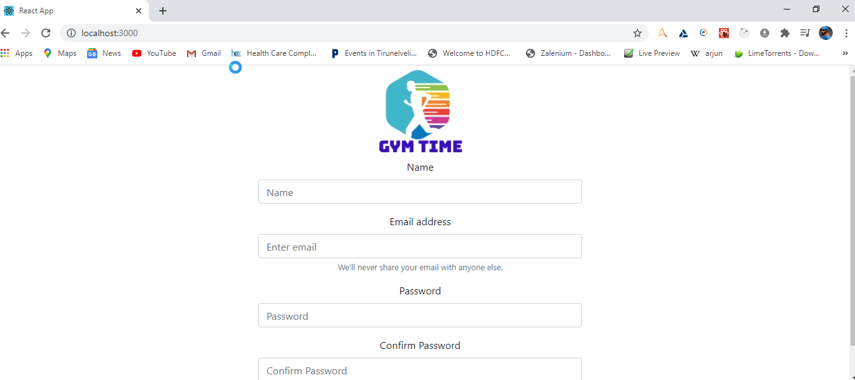

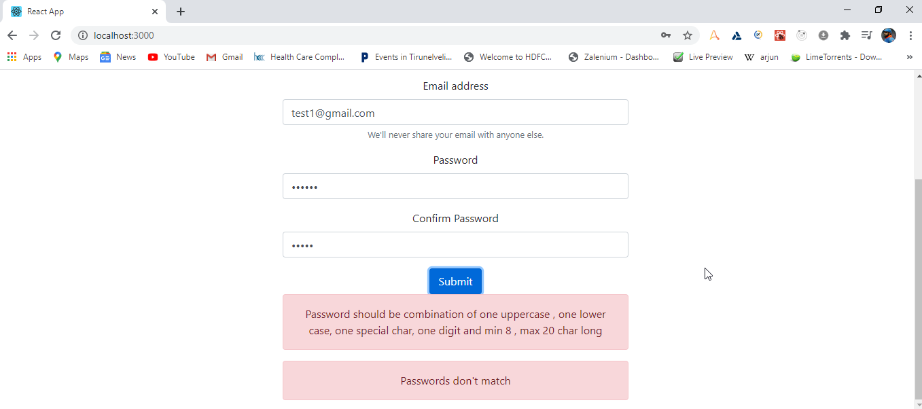

Duplicate message Id:

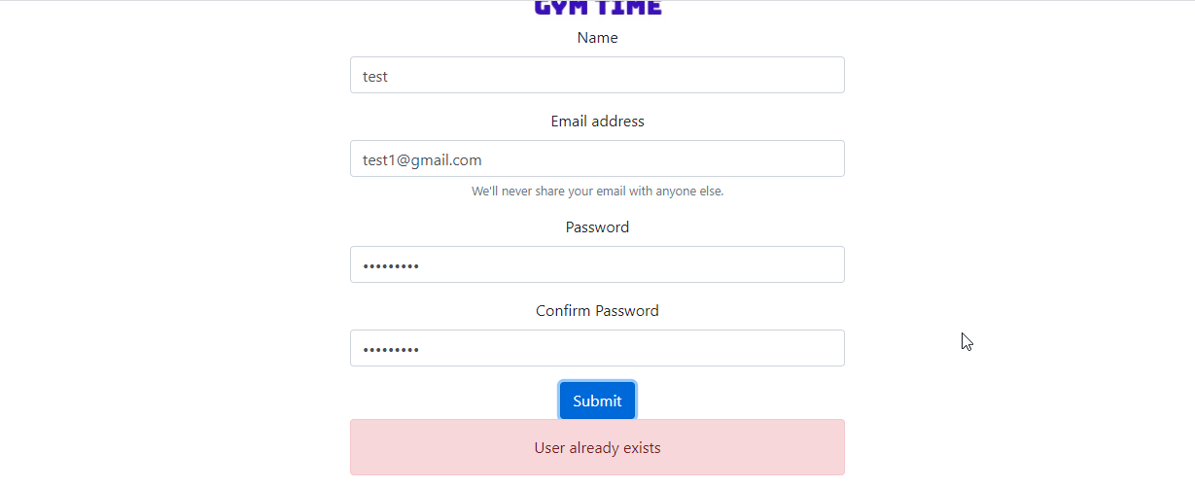

Success message:

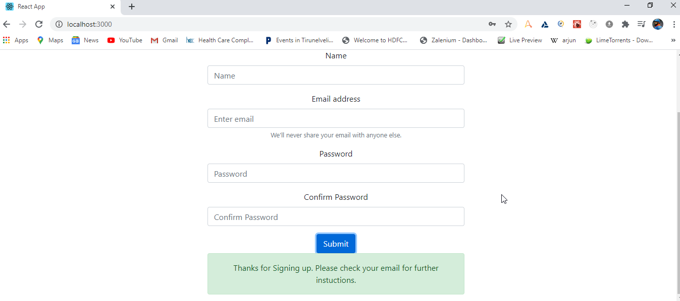

DB Values:

