TECH4 – Task  
  
1) welcome page 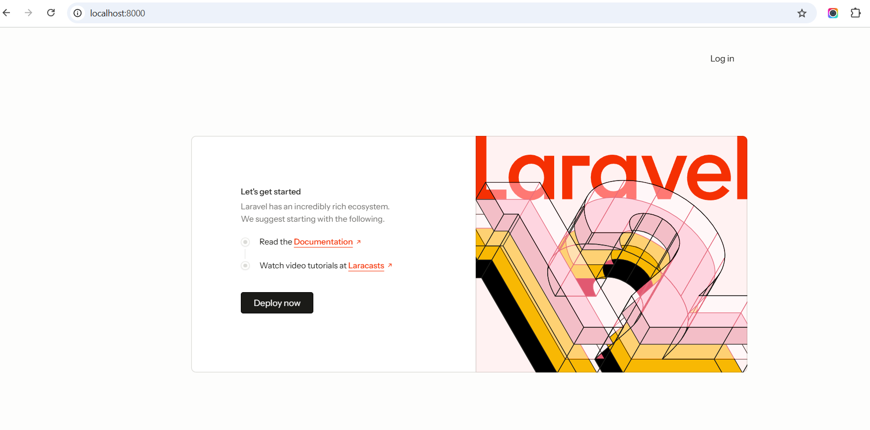  
  
then click login page  
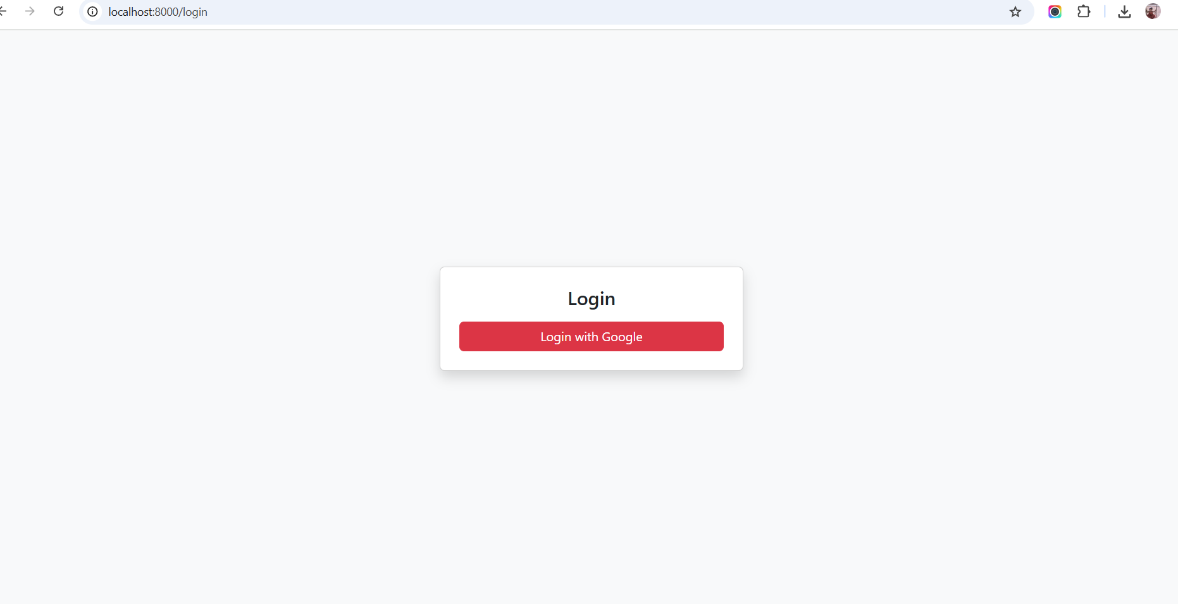  
  
Login with google   
  
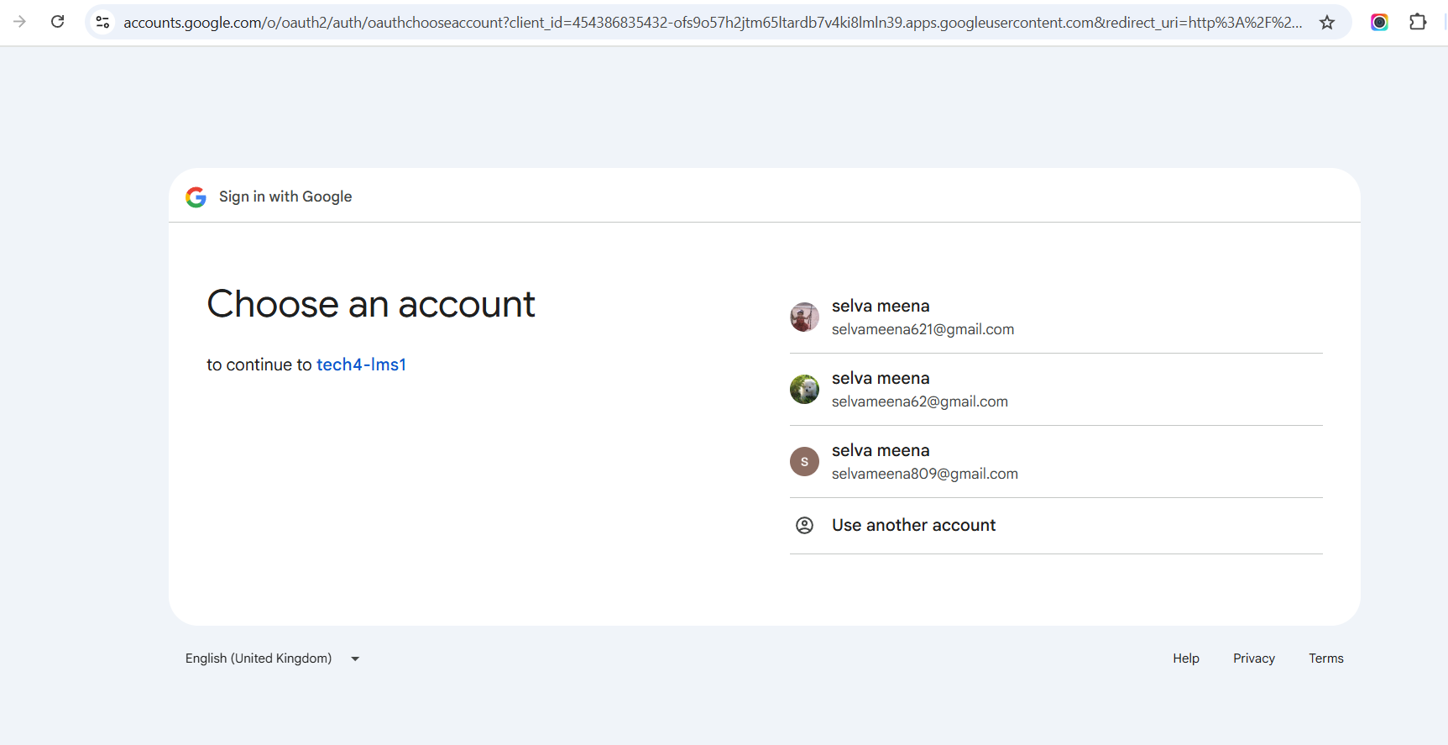  
  
  
  
continue to mail id then go for dashboard page  
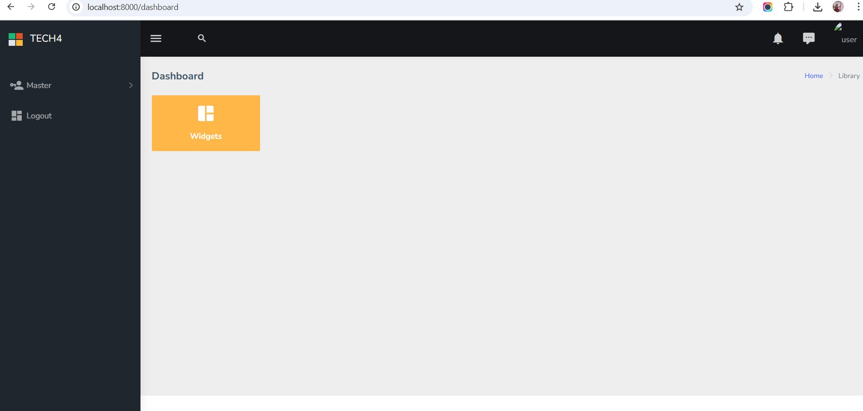  
  
click master to user page show for user datatable  
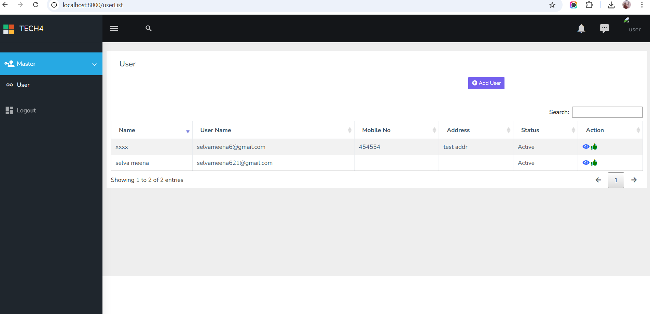  
  
Add user  
  
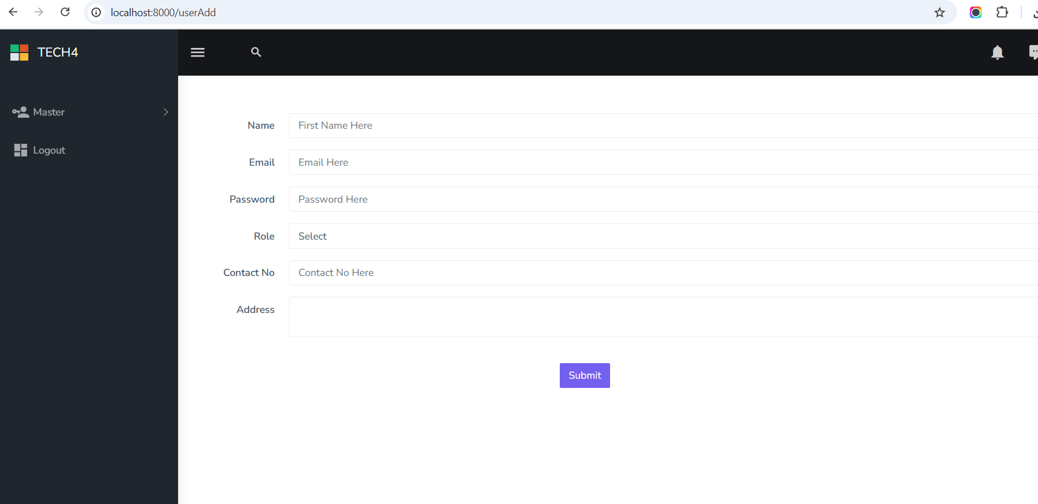  
  
  
click eye icon in datatable the go for edit page  
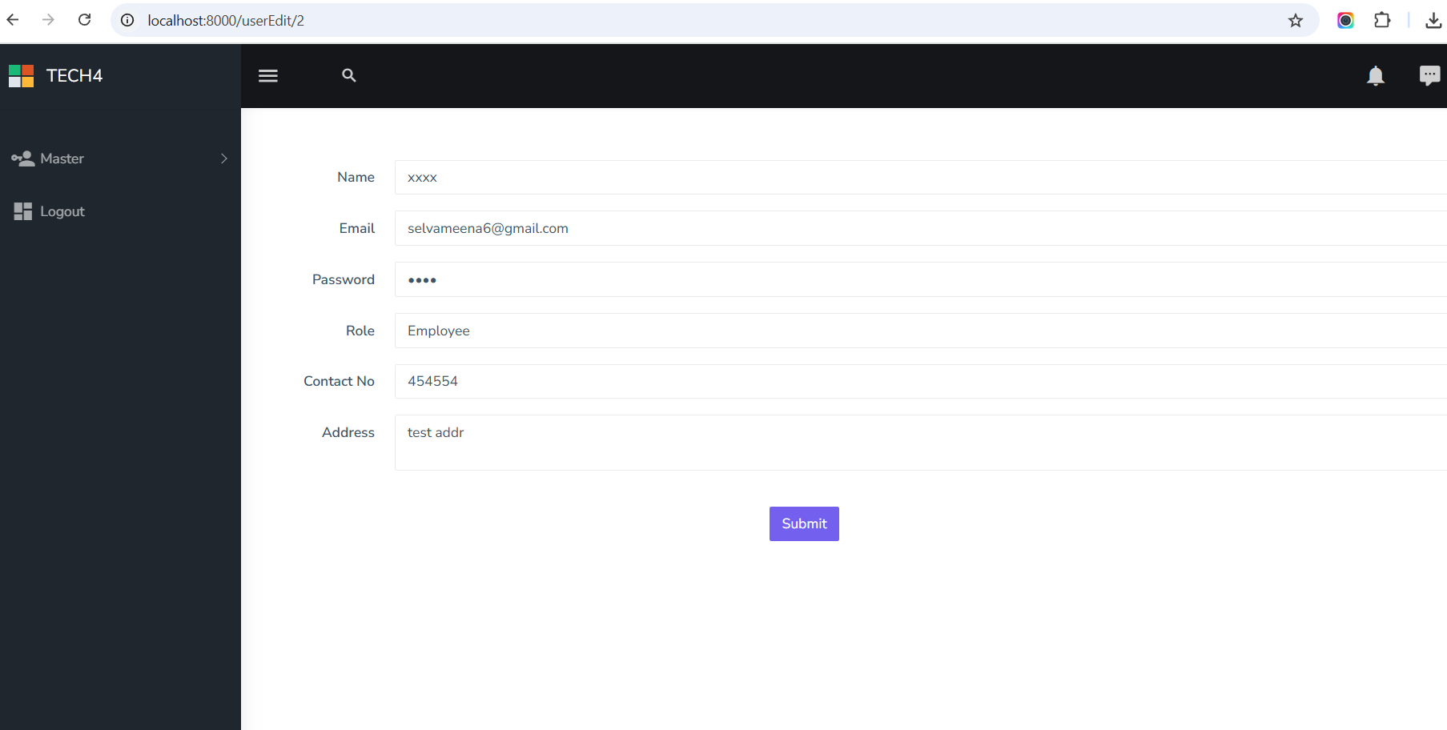  
  
  
user active – inactive  
  
