SQL

- Create database and table

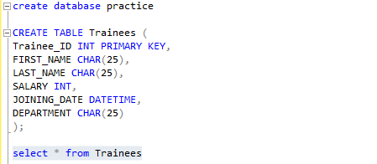

- Enter 20 records

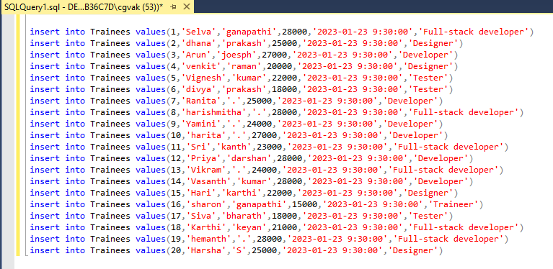

- Preview

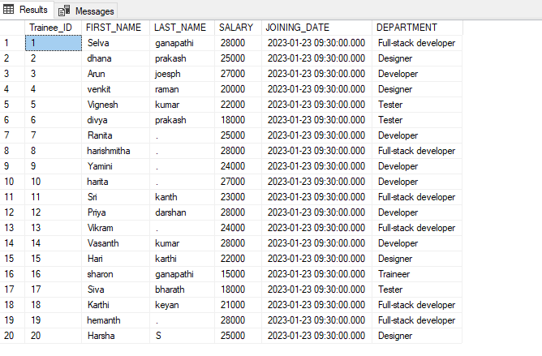

Task:

- Retrieve all FIRST_NAME STARTING WITH J-T and should differentiate between Uppercase and lowercase.

Query: select FIRST_NAME from Trainees where FIRST_NAME LIKE '[j-t]%' COLLATE SQL_Latin1_General_CP1_CS_AS order by FIRST_NAME desc;
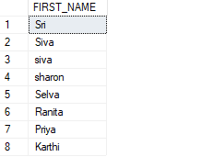

- Retrieve all SALARY BETWEEN 20000 TO 50000

Query: select FIRST_NAME,SALARY from Trainees where SALARY between 20000 and 50000

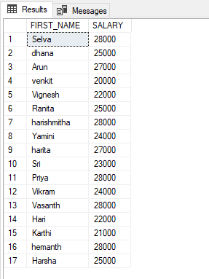

- Retrieve all FIRST_NAME ending with i

Query: select FIRST_NAME from Trainees where FIRST_NAME like '%i'

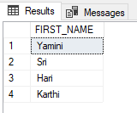

- Retrieve all salary without duplications

Query: select distinct SALARY from Trainees

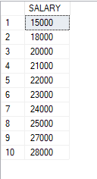

- Retrieve all records whose department is Developer and Designer

Query: select FIRST_NAME,DEPARTMENT from Trainees where DEPARTMENT='Developer' or DEPARTMENT='Designer'order by DEPARTMENT desc
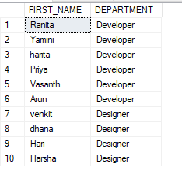

- Retrieve all Trainee_ID less than 5

Query: select * from Trainees where Trainee_ID<5

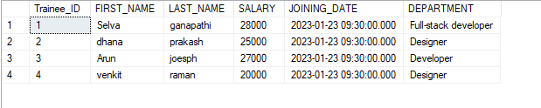
- Limit the records by retrieving the 6 to 15 records

Query: select * from Trainees order by Trainee_ID offset 5 rows fetch next 10 rows only

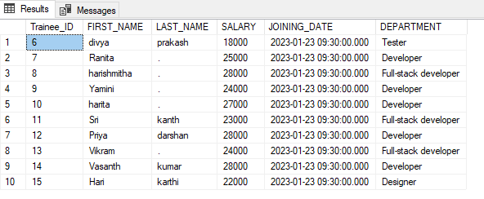

- Retrieve the top 5 records with Ties

Query: select top 5 with ties * from Trainees order by SALARY

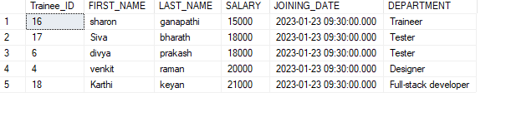

- Retrieve the records in descending order based on the department column.

Query: select Trainee_ID,FIRST_NAME,DEPARTMENT from Trainees order by DEPARTMENT desc

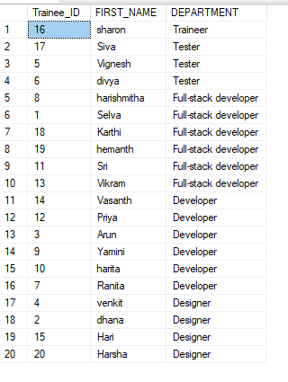

- Retrieve all last_name with 3rd character as 'a.'

Query: select LAST_NAME from Trainees where LAST_NAME like '__a%'

