How to launch a sub domain in AngularJs/GoDaddy:-
1. First you have add sudomain ownership in GoDaddy,
Add a ‘A’ record in GoDaddy with Host as ‘*’,
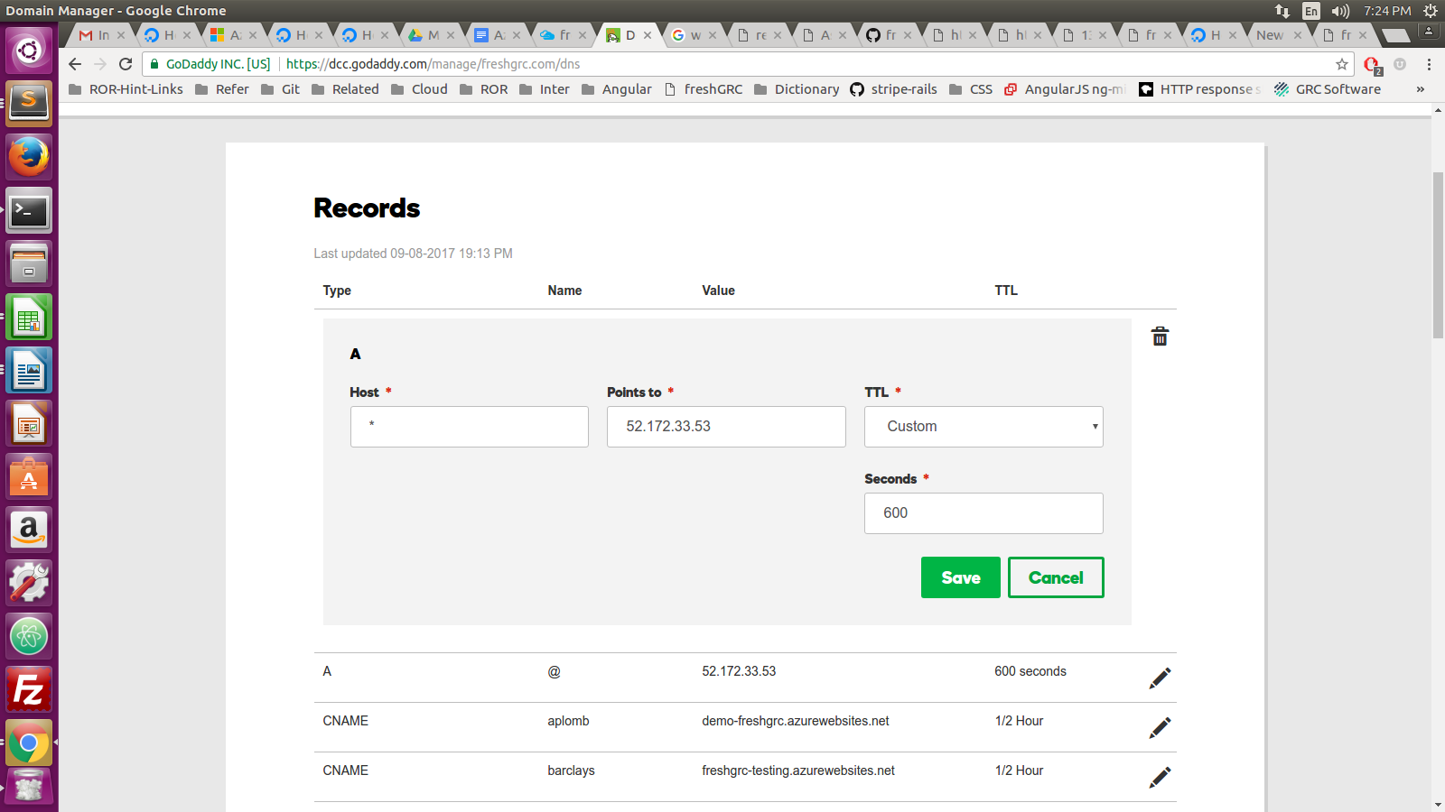

2. Next you need to change the starting page of AngularJs in app.config.js

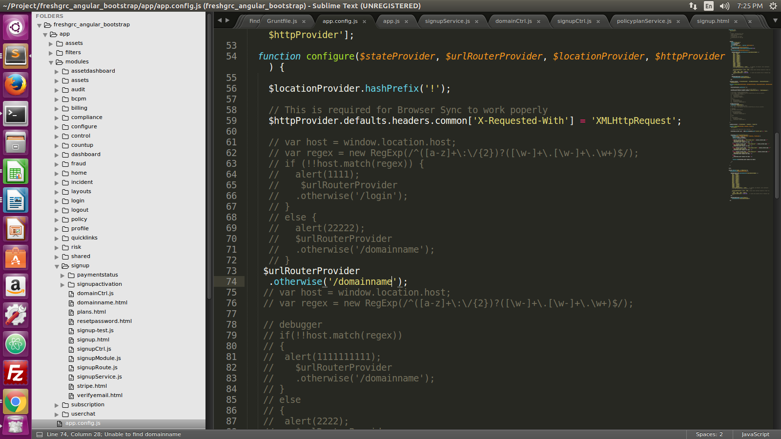
Whatever mention in “.otherwise('/domainname');”, this should starting page of AngularJs.

3. Next need to change to domainCtrl.js file,
window.location= "http://"+vm.company_name+".localhost:4000/#!/login";
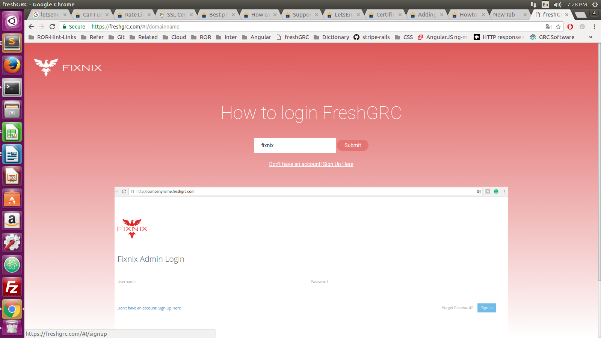

4. In SessionController.rb need to change the following code,
def login
@user = Authenticator.user?(params[:email], params[:password])
if @user
if @user.company_admin.nil?
subdomain = @user.company.sub_domain
else
subdomain = @user.company_admin.company.sub_domain
end
subdomain = ''
subdomain = @user.get_company.sub_domain if @user
val = request.headers['HTTP_REFERER']
sub_domain = ''
unless val.index(".").nil?
start_index = val.index("//")+2
end_index = val.index(".")-1
sub_domain = val[start_index..end_index]
end
if @user && subdomain == sub_domain
update_tracked_fields(@user)
else
render json: { message: 'Invalid email/password/sub_domain', status: 401 }, status: 401
end
=begin if @user
update_tracked_fields(@user)
else
render json: { message: 'Invalid email/password/sub_domain', status: 401 }, status: 401
end
=end
else
render json: { message: 'Invalid email/password/sub_domain', status: 401 }, status: 401
end
end

5. How to add let’s encrypt certicate with subdomain also,

