Project Design Phase-II
Technology Stack (Architecture & Stack)

Date | 6 march 2026
Team ID | SWTID-2026-9594
Project Name | SpendWise – Simple CRUD & JWT Backend
Maximum Marks | 4 Marks

Technical Architecture:
The Deliverable shall include the architectural diagram as below and the information as per the table1 & table 2
Table-1 : Components & Technologies:
S.No | Component | Description | Technology
 | User Interface | API testing interface or optional web UI | Postman / Thunder Client / (Optional) React
 | Application Logic | Handles authentication, CRUD operations, and business logic | Node.js, Express.js
 | Database Layer | Stores users and records/transactions | MongoDB, Mongoose
 | Authentication | Secures APIs using token-based authentication | JWT (JSON Web Token), bcrypt
5. | Configuration | Environment variables and DB connection setup | dotenv, Node.js
6. | API Layer | Exposes REST APIs for register, login, and CRUD operations | Express.js, REST APIs

Table-2: Application Characteristics:
S.No | Characteristics | Description | Technology
 | Open-Source Frameworks | Uses open-source backend frameworks and libraries | Node.js, Express.js, Mongoose
 | Secure Authentication | Protects routes using token-based authentication | JWT, bcrypt
3. | Database Integration | Connects and performs operations on NoSQL database | MongoDB
4. | RESTful Architecture | Follows REST principles for API design | HTTP, Express.js
5. | Scalable Structure | Organized folder structure for controllers, models, routes, middleware | Node.js Project Structure
6. | Environment Configuration | Keeps secrets and config outside code | dotenv (.env file)

Functional Requirements:
Following are the functional requirements of the proposed solution.
FR No. | Functional Requirement (Epic) | Sub Requirement (Story / Sub-Task)
FR-1 | User Authentication | User can register using name, email, and password
 |  | User can login using email and password
 |  | System generates JWT token after successful login
FR-2 | Secure Access | User can access protected APIs only with valid JWT token
 |  | Middleware verifies JWT token before allowing access
FR-3 | Data Management (CRUD) | User can create a new record/transaction
 |  | User can view all their records/transactions
 |  | User can update their own record/transaction
 |  | User can delete their own record/transaction
FR-4 | User Data Isolation | Each user can access only their own data
 |  | One user cannot see or modify another user’s data
FR-5 | Database Integration | System stores user and record data in MongoDB
 |  | System retrieves and updates data using Mongoose

Non-functional Requirements:
Following are the non-functional requirements of the proposed solution.
FR No. | Non-Functional Requirement | Description
NFR-1 | Usability | The APIs should be simple and easy to understand for beginners. The project structure should be clear and well-organized.
NFR-2 | Security | All protected APIs must require JWT authentication. User passwords must be stored in encrypted (hashed) form.
NFR-3 | Reliability | The system should work consistently without crashes and handle valid and invalid requests properly.
NFR-4 | Performance | API responses should be returned within a short time for normal requests under student-level usage.
NFR-5 | Availability | The backend server should be available whenever it is running locally or deployed, allowing users to access APIs.
NFR-6 | Scalability | The project structure should allow adding more features (like filters, summary, frontend) in the future without major changes.
NFR-7 | Maintainability | Code should be modular (controllers, routes, models, middleware) so it is easy for beginners to understand and modify.

Data flow diagrams:

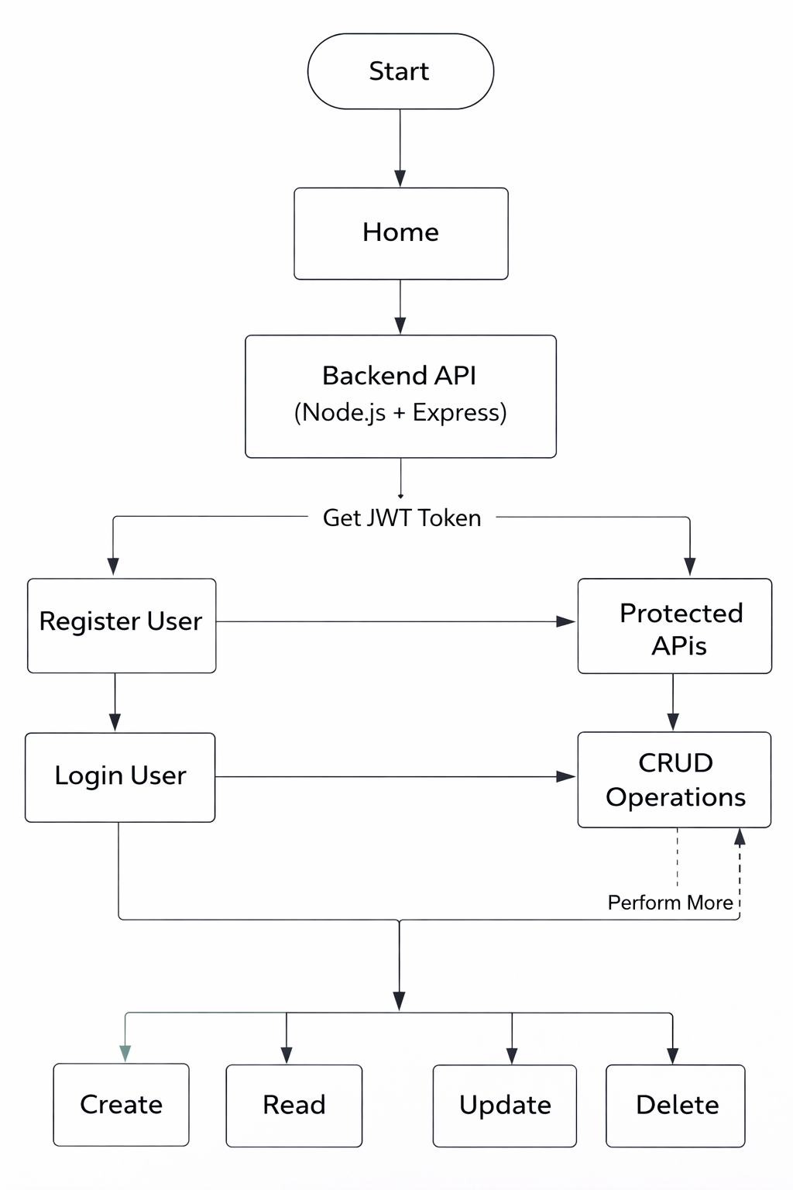
User Type | User Story Number | User Story / Task | Acceptance criteria | Priority | Release
User  (API User) | USN-1 | As a user, I can register using name, email, and password | User is able to create an account and receives a success response | High | Sprint-1
User  (API User) | USN-2 | As a user, I can login using email and password | User receives a valid JWT token after successful login | High | Sprint-1
User  (API User) | USN-3 | As a user, I can access protected APIs using JWT token | Requests without token are rejected; valid token allows access | High | Sprint-2
User  (API User) | USN-4 | As a user, I can create a new record/transaction | Record is saved in database and returned in response | High | Sprint-2
User  (API User) | USN-5 | As a user, I can view all my records/transactions | User receives only their own records from the system | High | Sprint-2
User  (API User) | USN-6 | As a user, I can update my record/transaction | Selected record is updated and new data is returned | Medium | Sprint-3
User  (API User) | USN-7 | As a user, I can delete my record/transaction | Selected record is removed and success message is returned | Medium | Sprint-3
User  (API User) | USN-8 | As a user, I cannot access other users’ data | System blocks access to data that does not belong to the user | High | Sprint-3

