**Project Report Template**

**1. INTRODUCTION**

* 1. **Overview :-**

Material studies to inspire your own adoption of Material Theming and components. These studies explore real-world design and product limitations through the examination of a set of fictional apps, each designed with unique properties and use cases. Each study illustrates how multiple design decisions are made and how different brands express themselves across a variety of product categories, including retail, music, productivity, finance, on-demand services, and education. A dedicated page explains the rationale behind each Material study’s design, the choice of components, and how each study uses Material Theming. By choosing the right kind of color combination reflects the application’s brand and style. For example, the application’s main or primary color is the Green, then in the whole application, the green color will be frequently shown. Choosing the color for the application, there are three types of colors to be chosen for developing the android application.

* 1. **Purpose :-**

As with any well-established design system, there are some major pros to using Material Design that designers should consider. Material Design is effectively an entire design ecosystem, rather than just a set of style guidelines. If there’s a potential design situation that exists, Material Design likely has a comprehensive set of rules for how to handle it. That includes complex use cases that are often overlooked by less comprehensive design systems. This can be very comforting for designers who want that kind of structure. Google maintains Material Design and keeps extensive documentation for how to use and implement it. This kind of support and documentation can be lacking for many modern design systems

1. **Problem Defnition & Design Thinking:-**

**2.1 Empathy Map:-**

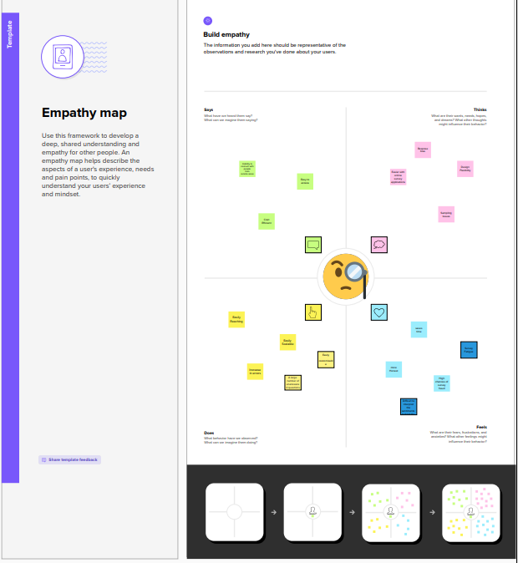

**2.2 Brainstorming Map:-**

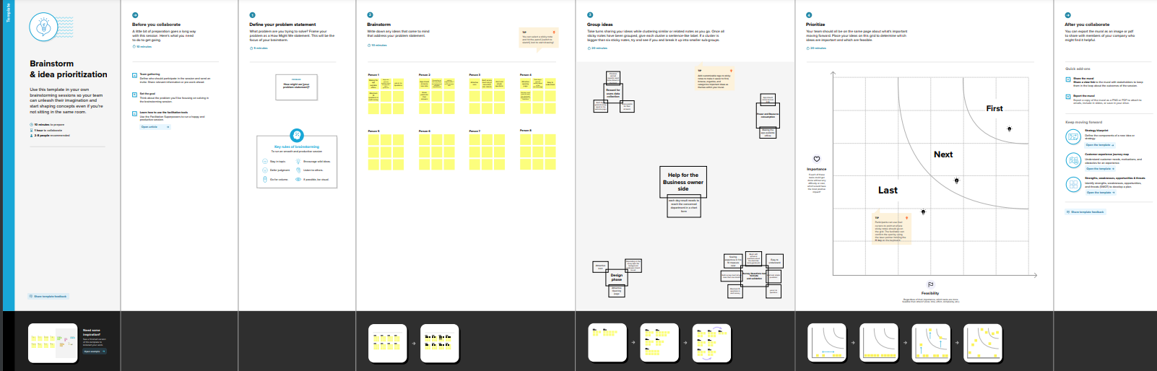

1. **Result :-**

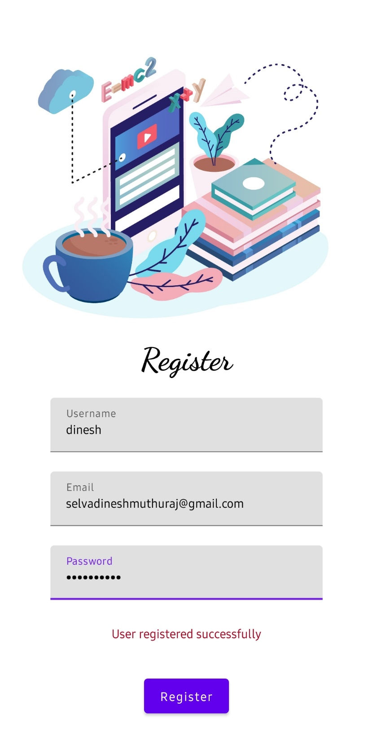

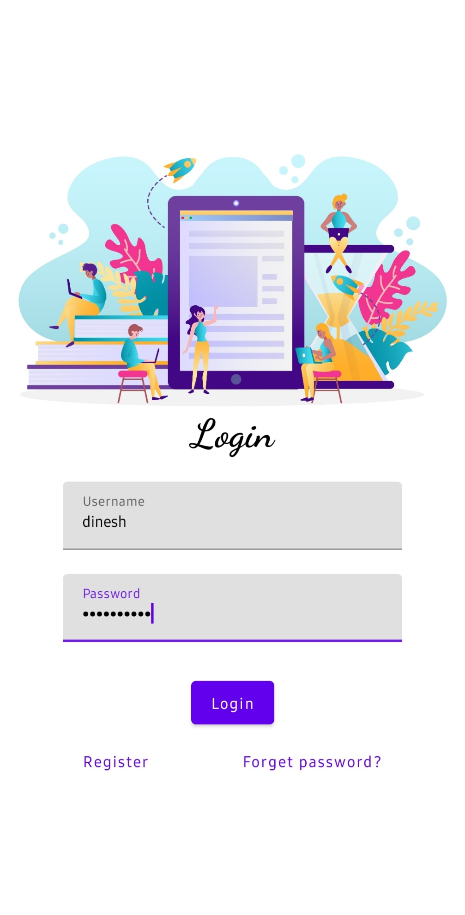

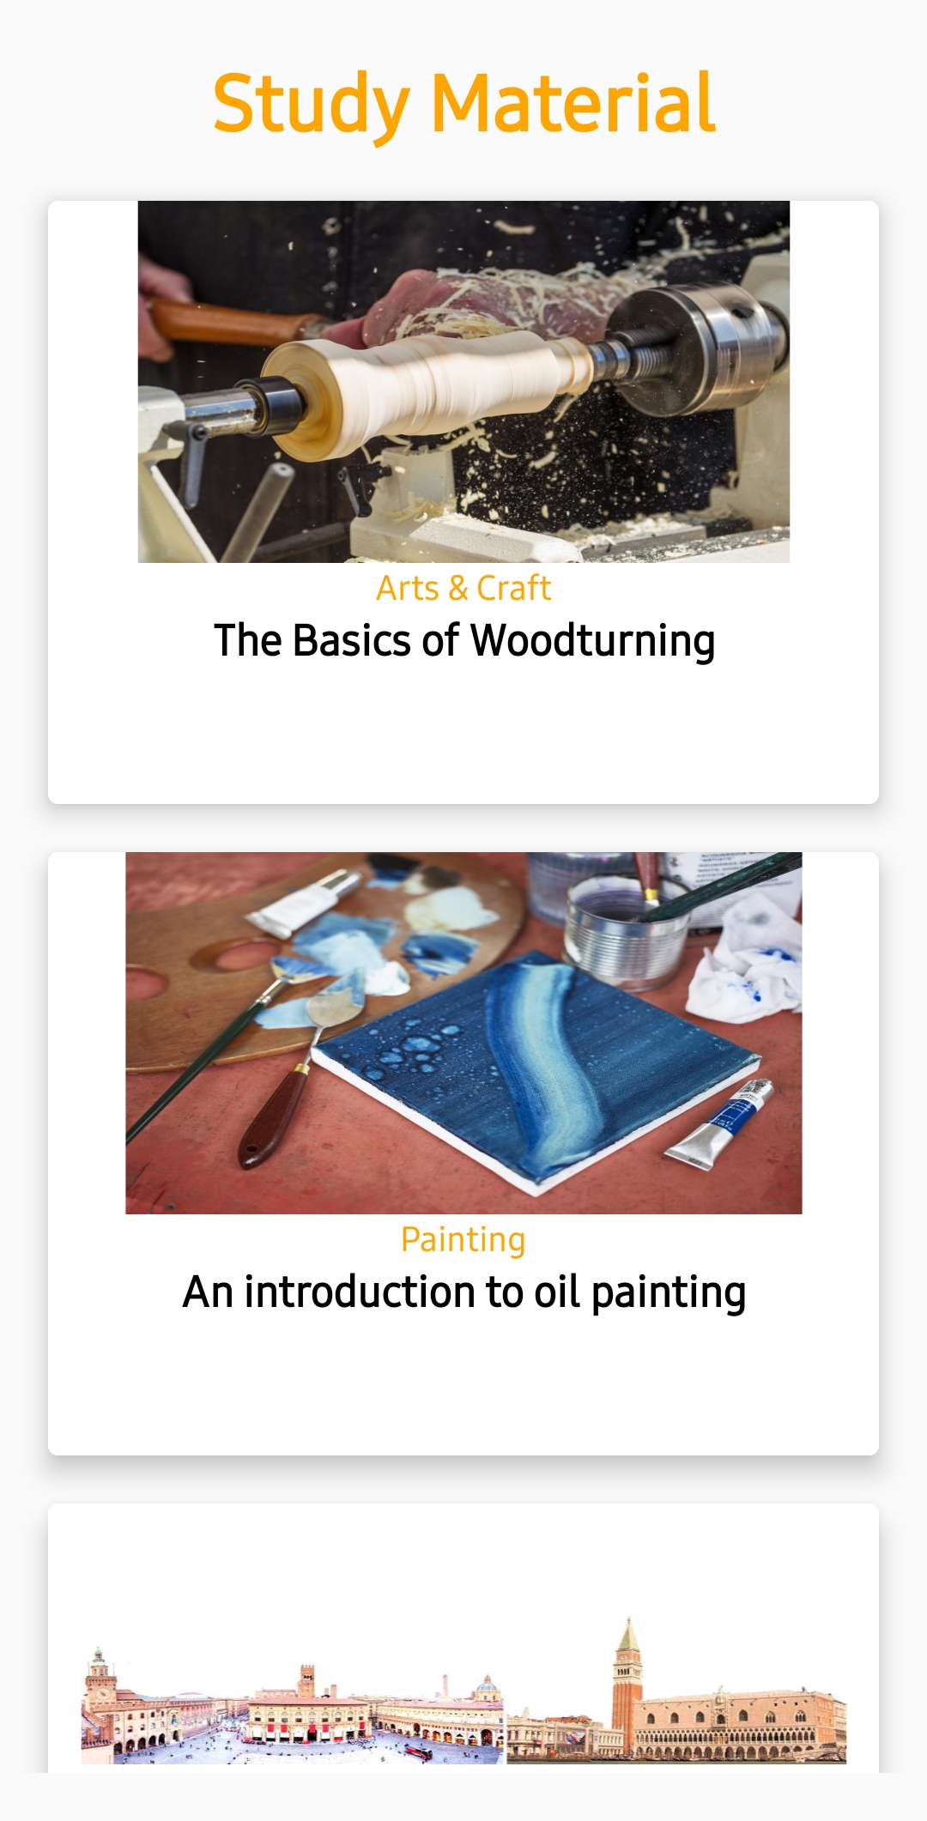



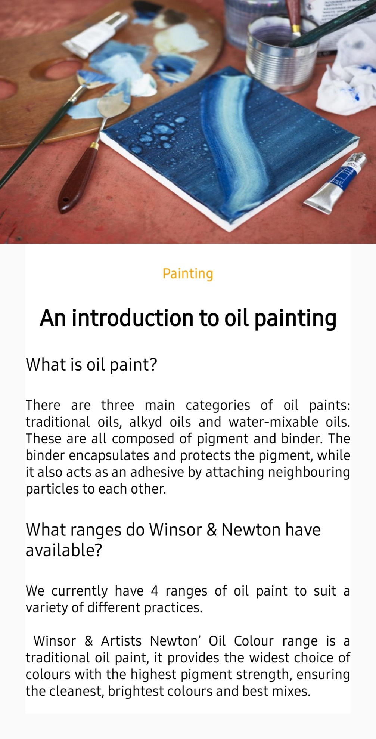

**Advantage :-**

* Material Design include things like subtle skeuomorphism, which sets it apart from flat design and makes it more intuitive for many users.
* Another user-friendly feature is that user feedback in the form of [haptic feedback](https://www.toptal.com/designers/ui/why-use-material-design), subtle animations, and similar things are built into the guidelines

**Disdvantage :-**

* One big reason that it might be a negative is that it limits the effectiveness of other

branding while using the design system.

* designers can incorporate logos, color palettes (within the Material Design guidelines), and other differentiating factors to support the brand identity.

1. **Application :-**

The materials and methods section should include **a clear and brief description of your research procedures**. One important purpose of this section is to convince the readers that your work is valid. Another purpose is for researchers to use your methodology to guide his or her own experiments.

1. **Conclusion :-**

If an app is being built primarily for the Android platform, then using Material Design is an easy choice. Because of Google’s widespread adoption, any app based on Material Design principles is going to feel like a native app.

1. **Future Scope:-**

After introduction of Educational android Apps has become High-Quality graphics are available. The Android OS is capable of execution of various this High-Quality graphics very easily. The Enhancement of Technology has made the developers to program or design at a Standard Level benchmark. The Mobile Application can be accessed virtually from Remote Place with no requirement of additional Hardware which result in faster downloading and good user interface along with increase in number of user. The Mobile App are on the Best way to move forward as the 90% of Students Carry application very efficiently as they are more social with respect to studies. Global Universities are willing to have good students worldwide for such circumstances; they can apply for the choice course form any part of the Globe.

**8.Appendix**

**Source code :-**

<https://github.com/selvadinesh2002/Owl-M-A-Material-Design-Study-App.git>

**code :-**

loginactivity.kt

package com.example.owlapplication  
  
import android.content.Context  
import android.content.Intent  
import android.os.Bundle  
import androidx.activity.ComponentActivity  
import androidx.activity.compose.setContent  
import androidx.compose.foundation.Image  
import androidx.compose.foundation.background  
import androidx.compose.foundation.layout.*  
import androidx.compose.material.*  
import androidx.compose.runtime.*  
import androidx.compose.ui.Alignment  
import androidx.compose.ui.Modifier  
import androidx.compose.ui.graphics.Color  
import androidx.compose.ui.layout.ContentScale  
import androidx.compose.ui.res.painterResource  
import androidx.compose.ui.text.font.FontFamily  
import androidx.compose.ui.text.font.FontWeight  
import androidx.compose.ui.text.input.PasswordVisualTransformation  
import androidx.compose.ui.tooling.preview.Preview  
import androidx.compose.ui.unit.dp  
import androidx.compose.ui.unit.sp  
import androidx.core.content.ContextCompat  
import com.example.owlapplication.ui.theme.OwlApplicationTheme  
  
class LoginActivity : ComponentActivity() {  
 private lateinit var databaseHelper: UserDatabaseHelper  
 override fun onCreate(savedInstanceState: Bundle?) {  
 super.onCreate(savedInstanceState)  
 databaseHelper = UserDatabaseHelper(this)  
 *setContent* **{** LoginScreen(this, databaseHelper)  
 **}** }  
}  
@Composable  
fun LoginScreen(context: Context, databaseHelper: UserDatabaseHelper) {  
  
 var username by *remember* **{** *mutableStateOf*("") **}** var password by remember **{** *mutableStateOf*("") **}** var error by remember **{** *mutableStateOf*("") **}** Column(  
 modifier = Modifier.*fillMaxSize*().*background*(Color.White),  
 horizontalAlignment = Alignment.CenterHorizontally,  
 verticalArrangement = Arrangement.Center  
 ) **{** *Image*(painterResource(id = R.drawable.*study_login*), contentDescription = "")  
  
 Text(  
 fontSize = 36.*sp*,  
 fontWeight = FontWeight.ExtraBold,  
 fontFamily = FontFamily.Cursive,  
 text = "Login"  
 )  
 Spacer(modifier = Modifier.*height*(10.*dp*))  
  
 TextField(  
 value = username,  
 onValueChange = **{** username = **it }**,  
 label = **{** Text("Username") **}**,  
 modifier = Modifier.*padding*(10.*dp*)  
 .*width*(280.*dp*)  
 )  
  
 TextField(  
 value = password,  
 onValueChange = **{** password = **it }**,  
 label = **{** *Text*("Password") **}**,  
 visualTransformation = PasswordVisualTransformation(),  
 modifier = Modifier.*padding*(10.*dp*)  
 .*width*(280.*dp*)  
 )  
  
 if (error.*isNotEmpty*()) {  
 Text(  
 text = error,  
 color = MaterialTheme.colors.error,  
 modifier = Modifier.*padding*(vertical = 16.*dp*)  
 )  
 }  
  
 *Button*(  
 onClick = **{** if (username.*isNotEmpty*() && password.*isNotEmpty*()) {  
 val user = databaseHelper.getUserByUsername(username)  
 if (user != null && user.password == password) {  
 error = "Successfully log in"  
 context.startActivity(  
 Intent(  
 context,  
 MainActivity::class.*java* )  
 )  
 *//onLoginSuccess()* }  
 else {  
 error = "Invalid username or password"  
 }  
  
 } else {  
 error = "Please fill all fields"  
 }  
 **}**,  
 modifier = Modifier.*padding*(top = 16.*dp*)  
 ) **{** Text(text = "Login")  
 **}** Row **{** TextButton(onClick = **{**context.startActivity(  
 Intent(  
 context,  
 RegisterActivity::class.*java* )  
 )**}** )  
 **{** *Text*(text = "Register") **}** *TextButton*(onClick = **{  
 }**)  
  
 **{** Spacer(modifier = Modifier.*width*(60.*dp*))  
 Text(text = "Forget password?")  
 **}  
 }  
 }**}  
private fun startMainPage(context: Context) {  
 val intent = Intent(context, MainActivity::class.*java*)  
 ContextCompat.startActivity(context, intent, null)  
}

mainactivity1.kt

package com.example.owlapplication  
  
import android.content.Context  
import android.content.Intent  
import android.os.Bundle  
import androidx.activity.ComponentActivity  
import androidx.activity.compose.setContent  
import androidx.compose.foundation.Image  
import androidx.compose.foundation.clickable  
import androidx.compose.foundation.layout.*  
import androidx.compose.foundation.rememberScrollState  
import androidx.compose.foundation.verticalScroll  
import androidx.compose.material.Card  
import androidx.compose.material.Text  
import androidx.compose.runtime.Composable  
import androidx.compose.ui.Alignment  
import androidx.compose.ui.Modifier  
import androidx.compose.ui.draw.scale  
import androidx.compose.ui.graphics.Color  
import androidx.compose.ui.res.painterResource  
import androidx.compose.ui.res.stringResource  
import androidx.compose.ui.text.font.FontWeight  
import androidx.compose.ui.text.style.TextAlign  
import androidx.compose.ui.unit.dp  
import androidx.compose.ui.unit.sp  
  
class MainActivity : ComponentActivity() {  
 override fun onCreate(savedInstanceState: Bundle?) {  
 super.onCreate(savedInstanceState)  
 *setContent* **{** *StudyApp*(this)  
 **}** }  
}  
  
@Composable  
fun StudyApp(context: Context) {  
  
 Column(  
 modifier = Modifier  
 .*padding*(20.*dp*)  
 .*verticalScroll*(*rememberScrollState*())  
  
 ) **{** Text(text = "Study Material",  
 fontSize = 36.*sp*,  
 fontWeight = FontWeight.Bold,  
 color = *Color*(0xFFFFA500),  
 modifier = Modifier.*align*(Alignment.CenterHorizontally))  
  
 *Spacer*(modifier = Modifier.*height*(20.*dp*))  
  
  
*// 01* Card(  
 modifier = Modifier  
 .*fillMaxWidth*()  
 .*height*(250.*dp*)  
 .*clickable* **{** context.startActivity(  
 Intent(context, MainActivity2::class.*java*)  
  
 )  
 **}**,  
 elevation = 8.*dp* )  
 **{** Column(  
 horizontalAlignment = Alignment.CenterHorizontally  
 ) **{** Image(  
 painterResource(id = R.drawable.*img_1*), contentDescription = "",  
 modifier = Modifier  
 .*height*(150.*dp*)  
 .*scale*(scaleX = 1.2F, scaleY = 1F)  
 )  
 Text(text = stringResource(id = R.string.*course1*),color = *Color*(0xFFFFA500),  
 fontSize = 16.*sp*)  
  
 Text(  
 text = *stringResource*(id = R.string.*topic1*),  
 fontWeight = FontWeight.Bold,  
 fontSize = 20.*sp*,  
 textAlign = TextAlign.Center,  
 )  
 **}  
 }** Spacer(modifier = Modifier.*height*(20.*dp*))  
  
*// 02  
 Card*(  
 modifier = Modifier  
 .*fillMaxWidth*()  
 .*height*(250.*dp*)  
 .*clickable* **{** context.startActivity(  
 Intent(context, MainActivity3::class.*java*)  
  
 )  
 **}**,  
 elevation = 8.*dp* )  
 **{** *Column*(  
 horizontalAlignment = Alignment.CenterHorizontally  
 ) **{** *Image*(  
 *painterResource*(id = R.drawable.*img_2*), contentDescription = "",  
 modifier = Modifier  
 .*height*(150.*dp*)  
 .*scale*(scaleX = 1.4F, scaleY = 1F)  
 )  
 Text(text = stringResource(id = R.string.*course2*),color = *Color*(0xFFFFA500),  
 fontSize = 16.*sp*)  
  
 Text(  
 text = stringResource(id = R.string.*topic2*),  
 fontWeight = FontWeight.Bold,  
 fontSize = 20.*sp*,  
 textAlign = TextAlign.Center,  
 )  
 **}  
 }** Spacer(modifier = Modifier.*height*(20.*dp*))  
  
*// 03* Card(  
 modifier = Modifier  
 .*fillMaxWidth*()  
 .*height*(250.*dp*)  
 .*clickable* **{** context.startActivity(  
 Intent(context, MainActivity4::class.*java*)  
  
 )  
 **}**,  
 elevation = 8.*dp* )  
 **{** *Column*(  
 horizontalAlignment = Alignment.CenterHorizontally  
 ) **{** *Image*(  
 *painterResource*(id = R.drawable.*img_3*), contentDescription = "",  
 modifier = Modifier  
 .*height*(150.*dp*)  
 .*scale*(scaleX = 1.2F, scaleY = 1F)  
 )  
 Text(text = *stringResource*(id = R.string.*course3*),color = *Color*(0xFFFFA500),  
 fontSize = 16.*sp*)  
  
 *Text*(  
 text = *stringResource*(id = R.string.*topic3*),  
 fontWeight = FontWeight.Bold,  
 fontSize = 20.*sp*,  
 textAlign = TextAlign.Center,  
 )  
 **}  
 }**  
  
  
 Spacer(modifier = Modifier.*height*(20.*dp*))  
  
*// 04* Card(  
 modifier = Modifier  
 .*fillMaxWidth*()  
 .*height*(250.*dp*)  
 .*clickable* {  
 context.startActivity(  
 Intent(context, MainActivity5::class.*java*)  
  
 )  
 },  
 elevation = 8.*dp* )  
 {  
 *Column*(  
 horizontalAlignment = Alignment.CenterHorizontally  
 ) {  
 *Image*(  
 *painterResource*(id = R.drawable.*img_4*), contentDescription = "",  
 modifier = Modifier  
 .*height*(150.*dp*)  
 .*scale*(scaleX = 1.2F, scaleY = 1F)  
 )  
 Text(text = stringResource(id = R.string.*course4*),color = *Color*(0xFFFFA500),  
 fontSize = 16.*sp*)  
  
 Text(  
 text = *stringResource*(id = R.string.*topic4*),  
 fontWeight = FontWeight.Bold,  
 fontSize = 20.*sp*,  
 textAlign = TextAlign.Center,  
 )  
 }  
 }  
  
  
  
 }  
}

mainactivity2.kt

package com.example.owlapplication  
  
import android.os.Bundle  
import androidx.activity.ComponentActivity  
import androidx.activity.compose.setContent  
import androidx.compose.foundation.Image  
import androidx.compose.foundation.background  
import androidx.compose.foundation.layout.*  
import androidx.compose.foundation.rememberScrollState  
import androidx.compose.foundation.verticalScroll  
import androidx.compose.material.Text  
import androidx.compose.runtime.Composable  
import androidx.compose.ui.Alignment  
import androidx.compose.ui.Modifier  
import androidx.compose.ui.draw.scale  
import androidx.compose.ui.graphics.Color  
import androidx.compose.ui.res.painterResource  
import androidx.compose.ui.res.stringResource  
import androidx.compose.ui.text.font.FontWeight  
import androidx.compose.ui.text.style.TextAlign  
import androidx.compose.ui.unit.dp  
import androidx.compose.ui.unit.sp  
import com.example.owlapplication.ui.theme.OwlApplicationTheme  
  
class MainActivity2 : ComponentActivity() {  
 override fun onCreate(savedInstanceState: Bundle?) {  
 super.onCreate(savedInstanceState)  
 *setContent* **{** Greeting()  
 **}** }  
}  
@Composable  
fun Greeting() {  
 Column(  
 modifier = Modifier.*padding*(start = 26.*dp*, end = 26.*dp*, bottom = 26.*dp*)  
 .*verticalScroll*(rememberScrollState())  
 .*background*(Color.White),  
 verticalArrangement = Arrangement.Top  
 ) **{** Image(  
 painterResource(id = R.drawable.*img_1*),  
 contentDescription = "",  
 modifier = Modifier.*align*(Alignment.CenterHorizontally)  
 .*scale*(scaleX = 1.5F, scaleY = 1.5F)  
 )  
  
 Spacer(modifier = Modifier.*height*(60.*dp*))  
  
 Text(  
 text = stringResource(id = R.string.*course1*),  
 color = *Color*(0xFFFFA500),  
 fontSize = 16.*sp*,  
 modifier = Modifier.*align*(Alignment.CenterHorizontally)  
 )  
  
 Spacer(modifier = Modifier.*height*(20.*dp*))  
  
 *Text*(  
 text = stringResource(id = R.string.*topic1*),  
 fontWeight = FontWeight.Bold,  
 fontSize = 26.*sp*,  
 modifier = Modifier.*align*(Alignment.CenterHorizontally)  
  
 )  
 Spacer(modifier = Modifier.*height*(20.*dp*))  
 *Text*(  
 text = stringResource(id = R.string.*subheading1_1*),  
 modifier = Modifier.*align*(Alignment.Start),  
 fontSize = 20.*sp* )  
  
 Spacer(modifier = Modifier.*height*(20.*dp*))  
  
 *Text*(  
 text = stringResource(id = R.string.*text1_1*),  
 modifier = Modifier.*align*(Alignment.Start),  
 textAlign = TextAlign.Justify,  
 fontSize = 16.*sp* )  
  
 Spacer(modifier = Modifier.*height*(20.*dp*))  
 Text(  
 text = stringResource(id = R.string.*subheading1_2*),  
 modifier = Modifier.*align*(Alignment.Start),  
 fontSize = 20.*sp* )  
  
 Spacer(modifier = Modifier.*height*(20.*dp*))  
  
 *Text*(  
 text = stringResource(id = R.string.*text1_2*),  
 modifier = Modifier.*align*(Alignment.Start),  
 textAlign = TextAlign.Justify,  
 fontSize = 16.*sp* )  
  
  
  
  
 **}**}

mainactivity3.kt

package com.example.owlapplication  
  
import android.os.Bundle  
import androidx.activity.ComponentActivity  
import androidx.activity.compose.setContent  
import androidx.compose.foundation.Image  
import androidx.compose.foundation.background  
import androidx.compose.foundation.layout.*  
import androidx.compose.foundation.rememberScrollState  
import androidx.compose.foundation.verticalScroll  
import androidx.compose.material.Text  
import androidx.compose.runtime.Composable  
import androidx.compose.ui.Alignment  
import androidx.compose.ui.Modifier  
import androidx.compose.ui.draw.scale  
import androidx.compose.ui.graphics.Color  
import androidx.compose.ui.res.painterResource  
import androidx.compose.ui.res.stringResource  
import androidx.compose.ui.text.font.FontWeight  
import androidx.compose.ui.text.style.TextAlign  
import androidx.compose.ui.unit.dp  
import androidx.compose.ui.unit.sp  
  
class MainActivity3 : ComponentActivity() {  
 override fun onCreate(savedInstanceState: Bundle?) {  
 super.onCreate(savedInstanceState)  
 *setContent* **{** Greeting1()  
 **}** }  
}  
@Composable  
fun Greeting1() {  
 Column(  
 modifier = Modifier.*padding*(start = 26.*dp*, end = 26.*dp*, bottom = 26.*dp*)  
 .*verticalScroll*(rememberScrollState())  
 .*background*(Color.White),  
 verticalArrangement = Arrangement.Top  
 ) **{** Image(  
 painterResource(id = R.drawable.*img_2*),  
 contentDescription = "",  
 modifier = Modifier.*align*(Alignment.CenterHorizontally)  
 .*scale*(scaleX = 1.2F, scaleY = 1F)  
 )  
  
 Spacer(modifier = Modifier.*height*(20.*dp*))  
  
 Text(  
 text = stringResource(id = R.string.*course2*),  
 color = *Color*(0xFFFFA500),  
 fontSize = 16.*sp*,  
 modifier = Modifier.*align*(Alignment.CenterHorizontally)  
 )  
  
 Spacer(modifier = Modifier.*height*(20.*dp*))  
  
 *Text*(  
 text = stringResource(id = R.string.*topic2*),  
 fontWeight = FontWeight.Bold,  
 fontSize = 26.*sp*,  
 modifier = Modifier.*align*(Alignment.CenterHorizontally)  
  
 )  
 Spacer(modifier = Modifier.*height*(20.*dp*))  
 *Text*(  
 text = stringResource(id = R.string.*subheading2_1*),  
 modifier = Modifier.*align*(Alignment.Start),  
 fontSize = 20.*sp* )  
  
 Spacer(modifier = Modifier.*height*(20.*dp*))  
  
 *Text*(  
 text = stringResource(id = R.string.*text2_1*),  
 modifier = Modifier.*align*(Alignment.Start),  
 textAlign = TextAlign.Justify,  
 fontSize = 16.*sp* )  
  
 Spacer(modifier = Modifier.*height*(20.*dp*))  
 Text(  
 text = stringResource(id = R.string.*subheading2_2*),  
 modifier = Modifier.*align*(Alignment.Start),  
 fontSize = 20.*sp* )  
  
 Spacer(modifier = Modifier.*height*(20.*dp*))  
  
 *Text*(  
 text = stringResource(id = R.string.*text2_2*),  
 modifier = Modifier.*align*(Alignment.Start),  
 textAlign = TextAlign.Justify,  
 fontSize = 16.*sp* )  
  
  
  
  
 **}**}

mainactivity4.kt

package com.example.owlapplication  
  
import android.os.Bundle  
import androidx.activity.ComponentActivity  
import androidx.activity.compose.setContent  
import androidx.compose.foundation.Image  
import androidx.compose.foundation.background  
import androidx.compose.foundation.layout.*  
import androidx.compose.foundation.rememberScrollState  
import androidx.compose.foundation.verticalScroll  
import androidx.compose.material.MaterialTheme  
import androidx.compose.material.Surface  
import androidx.compose.material.Text  
import androidx.compose.runtime.Composable  
import androidx.compose.ui.Alignment  
import androidx.compose.ui.Modifier  
import androidx.compose.ui.draw.scale  
import androidx.compose.ui.graphics.Color  
import androidx.compose.ui.res.painterResource  
import androidx.compose.ui.res.stringResource  
import androidx.compose.ui.text.font.FontWeight  
import androidx.compose.ui.text.style.TextAlign  
import androidx.compose.ui.tooling.preview.Preview  
import androidx.compose.ui.unit.dp  
import androidx.compose.ui.unit.sp  
import com.example.owlapplication.ui.theme.OwlApplicationTheme  
  
class MainActivity4 : ComponentActivity() {  
 override fun onCreate(savedInstanceState: Bundle?) {  
 super.onCreate(savedInstanceState)  
 *setContent* **{** Greeting2()  
 **}** }  
}  
@Composable  
fun Greeting2() {  
 Column(  
 modifier = Modifier.*padding*(start = 26.*dp*, end = 26.*dp*, bottom = 26.*dp*)  
 .*verticalScroll*(rememberScrollState())  
 .*background*(Color.White),  
 verticalArrangement = Arrangement.Top  
 ) **{** Image(  
 painterResource(id = R.drawable.*img_3*),  
 contentDescription = "",  
 modifier = Modifier.*align*(Alignment.CenterHorizontally)  
 .*scale*(scaleX = 1.5F, scaleY = 2F)  
 )  
  
 Spacer(modifier = Modifier.*height*(60.*dp*))  
  
 Text(  
 text = stringResource(id = R.string.*course3*),  
 color = *Color*(0xFFFFA500),  
 fontSize = 16.*sp*,  
 modifier = Modifier.*align*(Alignment.CenterHorizontally)  
 )  
  
 Spacer(modifier = Modifier.*height*(20.*dp*))  
  
 *Text*(  
 text = stringResource(id = R.string.*topic3*),  
 fontWeight = FontWeight.Bold,  
 fontSize = 26.*sp*,  
 modifier = Modifier.*align*(Alignment.CenterHorizontally)  
  
 )  
 Spacer(modifier = Modifier.*height*(20.*dp*))  
 *Text*(  
 text = stringResource(id = R.string.*subheading3_1*),  
 modifier = Modifier.*align*(Alignment.Start),  
 fontSize = 20.*sp* )  
  
 Spacer(modifier = Modifier.*height*(20.*dp*))  
  
 *Text*(  
 text = stringResource(id = R.string.*text3_1*),  
 modifier = Modifier.*align*(Alignment.Start),  
 textAlign = TextAlign.Justify,  
 fontSize = 16.*sp* )  
  
 Spacer(modifier = Modifier.*height*(20.*dp*))  
 Text(  
 text = stringResource(id = R.string.*subheading3_2*),  
 modifier = Modifier.*align*(Alignment.Start),  
 fontSize = 20.*sp* )  
  
 Spacer(modifier = Modifier.*height*(20.*dp*))  
  
 *Text*(  
 text = stringResource(id = R.string.*text3_2*),  
 modifier = Modifier.*align*(Alignment.Start),  
 textAlign = TextAlign.Justify,  
 fontSize = 16.*sp* )

mainactivity5.kt

package com.example.owlapplication  
  
import android.os.Bundle  
import androidx.activity.ComponentActivity  
import androidx.activity.compose.setContent  
import androidx.compose.foundation.Image  
import androidx.compose.foundation.background  
import androidx.compose.foundation.layout.*  
import androidx.compose.foundation.rememberScrollState  
import androidx.compose.foundation.verticalScroll  
import androidx.compose.material.MaterialTheme  
import androidx.compose.material.Surface  
import androidx.compose.material.Text  
import androidx.compose.runtime.Composable  
import androidx.compose.ui.Alignment  
import androidx.compose.ui.Modifier  
import androidx.compose.ui.draw.scale  
import androidx.compose.ui.graphics.Color  
import androidx.compose.ui.res.painterResource  
import androidx.compose.ui.res.stringResource  
import androidx.compose.ui.text.font.FontWeight  
import androidx.compose.ui.text.style.TextAlign  
import androidx.compose.ui.tooling.preview.Preview  
import androidx.compose.ui.unit.dp  
import androidx.compose.ui.unit.sp  
import com.example.owlapplication.ui.theme.OwlApplicationTheme  
  
class MainActivity5 : ComponentActivity() {  
 override fun onCreate(savedInstanceState: Bundle?) {  
 super.onCreate(savedInstanceState)  
 *setContent* **{** Greeting3()  
 **}** }  
}  
@Composable  
fun Greeting3() {  
 Column(  
 modifier = Modifier.*padding*(start = 26.*dp*, end = 26.*dp*, bottom = 26.*dp*)  
 .*verticalScroll*(rememberScrollState())  
 .*background*(Color.White),  
 verticalArrangement = Arrangement.Top  
 ) **{** Image(  
 painterResource(id = R.drawable.*img_4*),  
 contentDescription = "",  
 modifier = Modifier.*align*(Alignment.CenterHorizontally)  
 .*scale*(scaleX = 1.5F, scaleY = 1.5F)  
 )  
  
 Spacer(modifier = Modifier.*height*(60.*dp*))  
  
 Text(  
 text = stringResource(id = R.string.*course4*),  
 color = *Color*(0xFFFFA500),  
 fontSize = 16.*sp*,  
 modifier = Modifier.*align*(Alignment.CenterHorizontally)  
 )  
  
 Spacer(modifier = Modifier.*height*(20.*dp*))  
  
 *Text*(  
 text = stringResource(id = R.string.*topic4*),  
 fontWeight = FontWeight.Bold,  
 fontSize = 26.*sp*,  
 modifier = Modifier.*align*(Alignment.CenterHorizontally)  
  
 )  
 Spacer(modifier = Modifier.*height*(20.*dp*))  
 *Text*(  
 text = stringResource(id = R.string.*subheading4_1*),  
 modifier = Modifier.*align*(Alignment.Start),  
 fontSize = 20.*sp* )  
  
 Spacer(modifier = Modifier.*height*(20.*dp*))  
  
 *Text*(  
 text = stringResource(id = R.string.*text4_1*),  
 modifier = Modifier.*align*(Alignment.Start),  
 textAlign = TextAlign.Justify,  
 fontSize = 16.*sp* )  
  
 Spacer(modifier = Modifier.*height*(20.*dp*))  
 Text(  
 text = stringResource(id = R.string.*subheading4_2*),  
 modifier = Modifier.*align*(Alignment.Start),  
 fontSize = 20.*sp* )  
  
 Spacer(modifier = Modifier.*height*(20.*dp*))  
  
 *Text*(  
 text = stringResource(id = R.string.*text4_2*),  
 modifier = Modifier.*align*(Alignment.Start),  
 textAlign = TextAlign.Justify,  
 fontSize = 16.*sp* )  
  
  
  
  
 **}**}

registeractivity.kt

package com.example.owlapplication  
  
import android.content.Context  
import android.content.Intent  
import android.os.Bundle  
import androidx.activity.ComponentActivity  
import androidx.activity.compose.setContent  
import androidx.compose.foundation.Image  
import androidx.compose.foundation.background  
import androidx.compose.foundation.layout.*  
import androidx.compose.material.*  
import androidx.compose.runtime.*  
import androidx.compose.ui.Alignment  
import androidx.compose.ui.Modifier  
import androidx.compose.ui.graphics.Color  
import androidx.compose.ui.layout.ContentScale  
import androidx.compose.ui.res.painterResource  
import androidx.compose.ui.text.font.FontFamily  
import androidx.compose.ui.text.font.FontWeight  
import androidx.compose.ui.text.input.PasswordVisualTransformation  
import androidx.compose.ui.tooling.preview.Preview  
import androidx.compose.ui.unit.dp  
import androidx.compose.ui.unit.sp  
import androidx.core.content.ContextCompat  
import com.example.owlapplication.ui.theme.OwlApplicationTheme  
  
class RegisterActivity : ComponentActivity() {  
 private lateinit var databaseHelper: UserDatabaseHelper  
 override fun onCreate(savedInstanceState: Bundle?) {  
 super.onCreate(savedInstanceState)  
 databaseHelper = UserDatabaseHelper(this)  
 *setContent* **{** RegistrationScreen(this, databaseHelper)  
 **}** }  
}  
  
@Composable  
fun RegistrationScreen(context: Context, databaseHelper: UserDatabaseHelper) {  
  
 var username by *remember* **{** *mutableStateOf*("") **}** var password by remember **{** *mutableStateOf*("") **}** var email by remember **{** *mutableStateOf*("") **}** var error by remember **{** *mutableStateOf*("") **}** Column(  
 modifier = Modifier.*fillMaxSize*().*background*(Color.White),  
 horizontalAlignment = Alignment.CenterHorizontally,  
 verticalArrangement = Arrangement.Center  
 ) **{** *Image*(painterResource(id = R.drawable.*study_signup*), contentDescription = "")  
  
 Text(  
 fontSize = 36.*sp*,  
 fontWeight = FontWeight.ExtraBold,  
 fontFamily = FontFamily.Cursive,  
 text = "Register"  
 )  
  
 Spacer(modifier = Modifier.*height*(10.*dp*))  
 *TextField*(  
 value = username,  
 onValueChange = **{** username = **it }**,  
 label = **{** Text("Username") **}**,  
 modifier = Modifier  
 .*padding*(10.*dp*)  
 .*width*(280.*dp*)  
  
 )  
  
 TextField(  
 value = email,  
 onValueChange = **{** email = **it }**,  
 label = **{** *Text*("Email") **}**,  
 modifier = Modifier  
 .*padding*(10.*dp*)  
 .*width*(280.*dp*)  
 )  
  
 TextField(  
 value = password,  
 onValueChange = **{** password = **it }**,  
 label = **{** *Text*("Password") **}**,  
 visualTransformation = PasswordVisualTransformation(),  
 modifier = Modifier  
 .*padding*(10.*dp*)  
 .*width*(280.*dp*)  
 )  
  
  
 if (error.*isNotEmpty*()) {  
 Text(  
 text = error,  
 color = MaterialTheme.colors.error,  
 modifier = Modifier.*padding*(vertical = 16.*dp*)  
 )  
 }  
  
 *Button*(  
 onClick = **{** if (username.*isNotEmpty*() && password.*isNotEmpty*() && email.*isNotEmpty*()) {  
 val user = User(  
 id = null,  
 firstName = username,  
 lastName = null,  
 email = email,  
 password = password  
 )  
 databaseHelper.insertUser(user)  
 error = "User registered successfully"  
 *// Start LoginActivity using the current context* context.startActivity(  
 Intent(  
 context,  
 LoginActivity::class.*java* )  
 )  
  
 } else {  
 error = "Please fill all fields"  
 }  
 **}**,  
 modifier = Modifier.*padding*(top = 16.*dp*)  
 ) **{** Text(text = "Register")  
 **}** Spacer(modifier = Modifier.*width*(10.*dp*))  
 Spacer(modifier = Modifier.*height*(10.*dp*))  
  
 *Row*() **{** Text(  
 modifier = Modifier.*padding*(top = 14.*dp*), text = "Have an account?"  
 )  
 *TextButton*(onClick = **{** context.startActivity(  
 Intent(  
 context,  
 LoginActivity::class.*java* )  
 )  
 **}**)  
  
 **{** Spacer(modifier = Modifier.*width*(10.*dp*))  
 *Text*(text = "Log in")  
 **}  
 }  
 }**}  
private fun startLoginActivity(context: Context) {  
 val intent = Intent(context, LoginActivity::class.*java*)  
 ContextCompat.startActivity(context, intent, null)  
}