<<TTMS Simplification>>
Solution Architecture Document

Version 1.3

Template Customization for Project
Blueprint templates should be customized to best meet the needs of the team. When customizing Blueprint templates please document the sections which were modified, added, or removed. Also, make sure the appropriate stakeholders are informed.

Revision History

Date | Version | Description | Author
8/11/2015 | 0.1 | Inception phase | SelvaGaneshan
08/26/2015 | 1.0 | Inception Final version | SelvaGaneshan
10/22/2015 | 1.1 | Elaboration Phase | SelvaGaneshan
11/10/2015 | 1.2 | Elaboration Phase Review | Selva Ganeshan

Approval

Date | Name | Department | Signature
08/26/2015 | Deepak Pandit | Enterprise Architecture

Table of Contents
Revision History 3
Approval 3
1. Introduction 8
1.1. Purpose 8
1.2. Scope 8
1.3. Background 8
1.4. References 8
1.5. Acronyms 8
2. Architectural Representation 9
3. Architectural Goals and Constraints 10
3.1. Architectural Goals 10
3.2. Architectural Constraints 10
4. Architecturally Significant Use-Case View 10
4.1. Integration Use case –Inbound(ICL-TTMS) 11
4.2. Integration Use case - Outbound (TTMS-ICL) 12
4.3. Low Volume Internal Data Integration 13
4.4. High Volume Internal Data Integration 13
4.4.1. VDW Integration 13
4.4.2. Voucher Integration 14
4.5. Message Exchange Pattern 14
4.5.1. Message Exchange Pattern – Inbound 14
4.5.2. Message Exchange Pattern - Outbound 16
4.6. ICL TTMS System Integration Error Handling 16
5. Architectural Solution Scenarios 17
5.1. Buy Solution vs. Build from Scratch vs. Enhance Existing System 17
5.1.1. Pros 17
5.1.2. Cons 17
5.2. Real Time Integration Vs Batch Mode Integration 17
5.2.1. Inbound Services Categorization 17
5.2.2. Outbound Services Categorization 18
5.3. Incremental vs Complete 18
5.4. Synchronous Vs Asynchronous Communication Pattern 21
5.5. Soap Web services Vs Restful Web services 24
6. Architectural Decision Log 25
6.1. Web Service Pattern 25
6.2. Message Communication and Acknowledgement Pattern 26
6.3. IBM MQ Manager Vs Distributed Queue Manager 27
7. Logical View 28
7.1. Overview 28
7.1.1. As Is System Context View 28
7.1.2. To be System Context View 28
7.1.3. Interfacing Systems and External Data Store 30
7.1.3.1 ICL 30
7.1.3.2 NVS 30
7.1.3.3 NPPS 30
7.1.3.4 VDW 30
7.1.3.5 FTPR 30
7.1.3.6 FHDS 30
7.2. As Is Conceptual View Architecture 31
7.3. To be System Conceptual View 31
7.4. To be Logical View 32
7.4.1. Client Layer 34
7.4.2. Security Layer 34
7.4.3. Presentation Layer 34
7.4.4. Application Layer 34
7.4.5. Service Layer 34
7.4.5.1. Service Integration Design Principles 35
7.4.6. Business Layer 35
7.4.7. Integration Layer 35
7.4.8. Data Layer 36
7.4.9. Resource Layer 36
7.4.10. Common Components 36
7.4.10.1 Auditing 36
7.4.11. Enterprise Services 36
8. Integration View 36
8.1. Integration Patterns 37
8.1.1. B2B Integration Pattern (Internet) 37
8.1.2. External Web Service Pattern I – Inbound Services Integration 37
8.1.2.1. External Web Service Pattern I – Bulk Record Pattern 39
8.1.3. External Web Service Pattern II – Outbound Services Integration (TTMS-ICL) 39
8.1.4. Web Service Message Exchange Pattern 40
8.1.4.1. Synchronous Request Reply (Transport Acknowledgement) 40
8.1.5. Web Service Pattern - Message Format 40
8.1.5.1. Web Service Message Format – Inbound Flow 41
8.1.5.2. Message Format – Outbound Flow 42
8.1.6. Web Service Pattern - Sequencing / Conversation across Service Calls 42
8.1.7. Web Service Pattern - Error Handling 42
8.1.7.1. Transport level Error Handling 42
8.1.7.1.1. Inbound Transport Error Scenarios 42
8.1.7.1.2. Outbound Transport Error Scenarios 43
8.1.7.2. Business level Error Handling 44
8.1.8. MQ Inbound Pattern I - TTMS Inbound Web Services publish the messages to TTMS 44
8.1.9. MQ Pattern II – NVS Publishes data to TTMS 46
8.1.10. MQ Pattern III – NPPS System feeds Data to TTMS 47
8.1.11. MQ Pattern IV – TTMS Bulk Records Splitter 47
8.1.12. MQ Message Exchange Patterns 48
8.1.12.1. MQ Message Exchange Pattern I – Publish Subscribe 48
8.1.12.2. MQ Message Exchange Pattern I I– One Way Notification Pattern 49
8.1.12.3. MQ Message Exchange Pattern III – Message Splitter Pattern 49
8.1.13. MQ Pattern - Message Format 50
8.1.13.1. MQ Pattern – Inbound MQ Message Format 50
8.1.13.2. MQ Pattern – Outbound MQ Message Format 50
8.1.14. MQ Pattern - Error Handling 51
7.1.6.1 Transport level Error Handling 51
7.1.6.2 Business level Error Handling 52
8.2. System Integrations – To be Updated 52
8.2.1. VDW integration 52
8.2.2. TOMS integration 52
8.2.3. Audit Integration 52
8.3. Security Integrations 53
8.4. DevOps/ITops Integrations 53
8.4.1. Build Farm Integration 53
8.4.2. Fog light Integration 53
8.4.3. MQ Integration 54
8.4.4. Host DB2 Integration 54
8.4.5. My SQL Integration 54
9. Deployment View 54
9.1. Deployment Domain Overview 54
9.2. Deployment Components Overview 58
9.2.1. Nodes/Servers 60
9.2.2. Deployable Packages 60
9.3. Code Package View 60
10. Security View 61
10.1. ICL-TESS SSO Integration 61
10.2. Web Service Security Pattern 61
10.3. Internal Security Pattern 62
10.3.1. Internal Web Applications Security Pattern 62
10.3.2. MQ Security Pattern 63
10.3.3. Database Security Pattern 63
11. Process View 63
11.1. Inbound Process View 63
11.2. Outbound Process View 64
12. Implementation View 65
12.1. Solution Overview 65
12.2. Architecture Layered Guidelines 67
13. Technology View 67
13.1. Technology Stack 67
13.2. Foundation Components 68
14. Architectural Risks and Impact 68
14.1. Financial Impact and Risks 68
14.2. Potential Business Impact 68
14.3. Potential System Impact and Risks 69
14.3.1. Assumptions and Constraints 69
14.3.2. Dependencies 69
14.3.3. Performance Analysis 69
14.3.4. Environment Analysis 69
15. Risk Log 69
16. Open Items 70
17. References 72

- Introduction
  - Purpose
The Solution Architecture document audiences include enterprise architects, technical architects, designers, system engineers, developers, project managers etc.
This document provides the exhaustive architectural overview of the system in the form of different architecture views. It also captures the key architecture decisions taken in defining the system architecture, along with the details of various solution options considered. The merits and demerits of each solution option considered are documented along with the rationale for the solution. To gain complete understanding of the system architecture, this document has to be studied along with business process models/requirements specifications and the use case specifications.
This document should be referred first by the system engineers and software developers before digesting the content of architecture and design document.
  - Scope
The scope of the Solution Architecture Document for the TTMS simplification project provides details describing the architectural overview of the project, the goals and the guiding principles, architecturally significant requirements, solution scenarios, architecture views including logical, security, deployment etc., This document will address technical feasibility and capture multiple high level technical options that are called “solution scenarios.” This document evolves as the solution scenarios transform into candidate architecture, and finally solidify into solution architecture. This is a living document that needs to be updated through the evolution journey till end of the Elaboration phase. This will be revisited (if required) during the construction phase to make any minor modifications as appropriate.
This document is updated for TTMS simplification to define the architecture views for TTMS simplified system. This document will be updated iteratively on an ongoing basis for subsequent releases to make sure that the latest TTMS simplified system SAD is always reflecting the complete As-is solution architecture of TTMS suite of projects.
This document will be base-lined and signed off at the end of Elaboration phase. Any subsequent changes [if required] during the Construction phase will be routed again for approval.
  - Background
Toyota Transport Management system (TTMS) is used by The Toyota Motor Sales (“TMS/USA”) for routing vehicles from VDCs (Ports & Marshaling Yards) to the final dealer to whom the vehicles are assigned and to manage the invoice for vehicle shipments. TTMS creates shipment plan for transporting the finished vehicles from VDC to the final dealer.
TTMS assigns the route and the rate for each shipment order based on the pre-defined business rules. TTMS handles the processing and inspection operations that are carried out during the actual shipment process.
It tracks the shipment events and creates invoices and transmits the invoice to PeopleSoft for final invoice to Carriers & Service providers.
  - References
- Blueprint Website
- Toyota Reference Architecture Website (http://tv/tra)
- TTMS simplification system Supplementary Specifications
- TTMS simplification system business use cases

  - Acronyms
Acronym | Definition
SAD | Solution Architecture Document
TTMS | Toyota Transport Management System
UML | Unified Modeling Language
TMS | Toyota Motor Sales
OTM | Oracle Transport Management – COTS
TOMS | Toyota Order Management System
EAR | Enterprise Archive
ADD | Application Design Document
VDC | Vehicle Distribution Center
NPPS | National Post Production System
NVS | National Vehicle Service
FTPR | Freight Payment and Routing
FHDS | Financial Historical Data Store/Source
TESS | Toyota Enterprise Security Services
SAML | Security Assertion Markup Language
SP | Service Provider
IDP | Identity Provider (IdP)
ICL | ICL provider
EIG | Enterprise Integration Gateway
VDW | Vehicle Data Warehouse
EISP | Enterprise Information Security Program
P2P | Point to Point Communication
FQA | Final Quality Assurance
AQA | Auto Quality Assurance
LPR | Last Point of Rest
SEDB | Shipment event Database
BDY | Body
PNT | Paint
ASM | Final assembly
BUY | Buy Off
TS1 | Truck Ship VDC
RSC | Rail Ship Carrier
RR1 | Truck Arrival VDC
RC1 | Rail Arrival
JSON | JavaScript Object Notation
SSL | Secure Sockets Layer
VPN | Virtual Private Network
XML | Extensible Markup Language
- Architectural Representation
There are many different architecture views available for documentation. Following are the different views of the software architecture that will be covered in this document:
# | View | Audience | Area | Purpose
1 | System Context | All | Conceptual understanding of the system and its boundaries | Documents how the system interacts with external entities (systems and end users) in abstract sense [Black box representation]
2 | Logical (Solution) | Designers | Requirements realization | Documents the various layers and components involved in the solution, along with information flow
3 | Implementation | Programmers | Software components | Describes the overall structure of the implementation model and decomposition of the system into code and data artifacts
4 | Deployment | Deployment Leads, Programmers | Physical nodes | Documents the mapping of runtime components/binaries to the computing nodes [OS, Hardware]
5 | Security | Designers, Programmers,  Deployment Leads  Data Administrators | Authentication, Authorization | Documents the security solution applicable to different application tiers and components [Covers solution at all levels including transport, network etc.,]

- Architectural Goals and Constraints
  - Architectural Goals
- To build a platform that responds to business changes quickly
- To build a standard platform that is interoperable with existing data and application/technology components
- To build a scalable and extensible platform
- To leverage industry standard best practices that includes effective use of appropriate design patterns
- To maximize reuse of the existing and new components to be built
- To reuse use the TMS standards components.
- To build a loosely coupled solution with high degree of extensibility and maintainability
- The Business partner will be required to comply with TMS integration and security patterns.
There could be cases where conflicting goals and/or requirements have to be dealt with. The decision will be taken on a case-by-case basis in accordance with the priority of goals/requirements agreed with the project stakeholders. Any such conflicting technical decisions will be documented with a rationale.
  - Architectural Constraints
- The solution architecture should adhere to guiding principles of the Toyota Reference Architecture (TRA)
- The solution architecture should adhere to the enterprise security and integration standards
- The solution architecture must leverage the enterprise security solution “TESS” (Toyota Enterprise Security Services) for authentication needs.
- The solution architecture should be adhere to guiding principles of EISP
- The technology choice/recommendation should align with the enterprise guidelines/roadmap where applicable
- The solution architecture should adhere scope of limited changes on the downstream components.
- The solution shall leverage the usage of TMS app framework
- The application shall comply with TMS coding standards for better maintainability

- Architecturally Significant Use-Case View
Below are the criteria to identify architecturally significant Use cases.
- Memory intensive operations
- High performance expectations
- Asynchronous operations
- Real-time and Batch Processing.
- Message Processing
  - Integration Use case –Inbound(ICL-TTMS)
The inbound services terms refers the messages are received from ICL and hosted by TTMS. The below use case diagram depicts different components and systems that are considered as actors with the boundary defined.

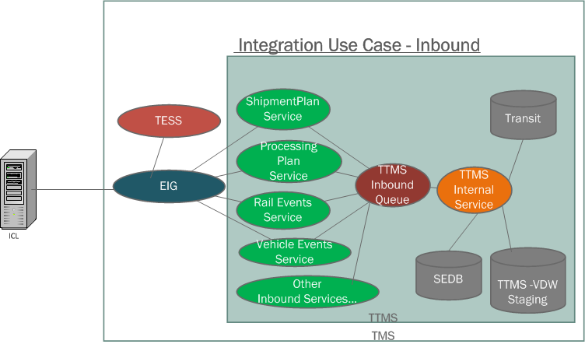

The different actors (Systems) involved in the inbound data flow use cases are

- ICL system sends the inbound service information to TTMS through EIG
- EIG validates the service account of ICL-EIG-Inbound and sends the message to TTMS services.
- TTMS Services is the provider for the inbound services as given in the example (Shipment Plan, Processing Plan, Vehicle Events, and Rail Events, etc. The diagram explains few sample services, please refer the detail list on the below list. The transport acknowledgement will be sent to ICL at the end of the service completion.
- TTMS Inbound Queue, The global inbound queue container will be used in order to maintain the message arrival in the FIFO order. The TTMS internal asynchronous processing start from this point.
- TTMS Internal Service is the internal application or container which has the listener process to consume the messages from the TTMS inbound queue to process the message further.

- Shipment Plan
- Processing Plan
- Vehicle Summary
- Vehicle Events
- Rail Shipments
- Rail Inspections
- Transit
- Invoice Voucher
- VDW
- Vessel ETA
- Shipping Schedule
- Accrual

Please refer the detail communication flow in the Integration view (Section to be updated in Elaboration).

  - Integration Use case - Outbound (TTMS-ICL)

The term Outbound defines the messages are sent from TTMS and the service hosted by ICL.

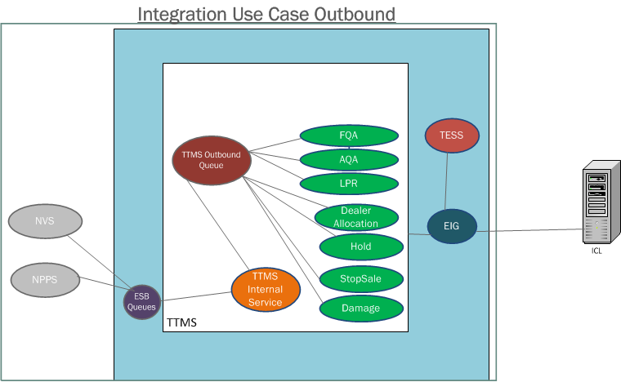
The different actors (Systems) involved in the outbound data flow use cases are,

- NVS, NPPS are the source system which propagate the real-time events to TTMS
- ESB queues are placed in the integration layer which converts from the copy book structure of source systems to TTMS understandable schema structure.
- TTMS Internal Service consumes the messages from the ESB queues and transform into common message structure to all the outbound services.
- TTMS Outbound Queue is the queue designed for outbound communication to ICL in order to maintain the sequence in FIFO order to send.
- The outbound services are being called from outbound queue implementation then the actual messages will be transformed on the service. (FQA, AQA, LPR, Dealer Allocation, Hold, Damage, Stop Sale)
- The EIG validates the TTMS-EIG-Outbound service account against TESS
- EIG finally sends the messages to ICL
- ICL process the messages after validating the ICL-EIG-Outbound service account.

Please refer the source system information in the section for details of TTMS internal integration systems.

  - Low Volume Internal Data Integration
Interfaces that have single record based services will be classified as low volume use case.
CRUD (Create, Read, Update and Delete) services will be used for both data operations and business validations.

The low volume services include:

- Transit
- Shipment Plan
- Processing Plan
- Vehicle Events
- Vehicle Summary
- Rail Events
- Rail Inspection
- Accrual
- Vessel ETA
- Shipping Schedule

  - High Volume Internal Data Integration

Interfaces that have large volume of records that are either received as a single file or a bunch of incremental records are classified as high volume use cases.

The high volume services include:

- VDW
- Voucher

VDW Integration

Interface Name | Source | Expected Frequency | Time | Description | Rationale
VDW | ICL | Every 2 Hours | TBD | VDW will extract the information from the TTMS – VDW staging table at 11:30 pm PT daily | To have minimal/ zero impact on VDW

Voucher Integration

Interface Name | Source | Expected Frequency | Time | Description | Rationale
Voucher | ICL | Once a day  Monday - Friday | 5:30 pm PT | ICL must send the Voucher details to TMS  The voucher information must be current up to 5:00 PM PT and the transmission must be completed by 5:30 PM PT. | To have zero impact on downstream systems
  - Message Exchange Pattern
The message exchange pattern of TTMS simplification is being considered in to two categories, Inbound and outbound. The following diagrams explain the high level flow of inbound and outbound message exchange flow.

Message Exchange Pattern – Inbound

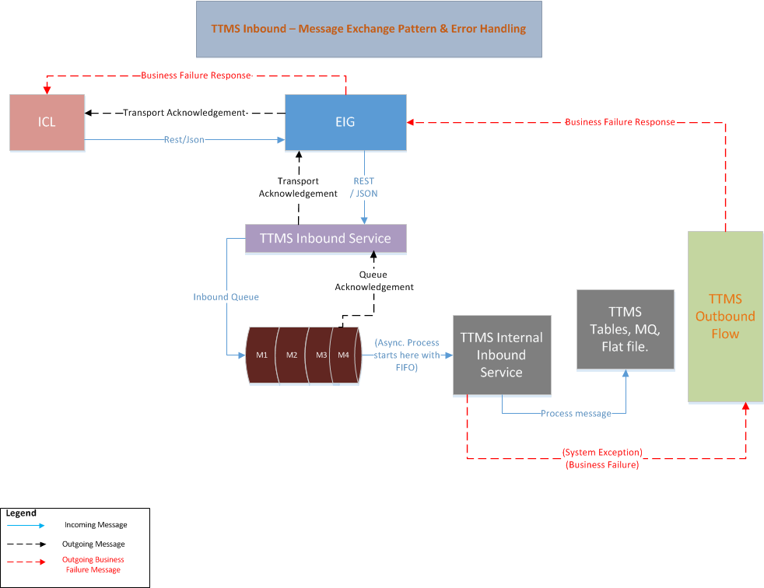

- ICL sends the message to EIG as REST/JSON pattern.
- EIG sends the message to TTMS Inbound services with same REST/JSON format.
- TTMS inbound services receives the messages and place into TTMS inbound queue container in the FIFO order.
- On Successful acknowledgment of message PUT, TTMS inbound services sends the transport acknowledgement to ICL through EIG.
- The new TTMS Internal service component listens the message on the arrival of same order (FIFO).
- TTMS internal service process the required business process and mandatory validations based on the service classification and finally updates into TTMS MQ, Tables or Flat files. The failure response will be sent to ICL through the outbound service flow.

Message Exchange Pattern - Outbound

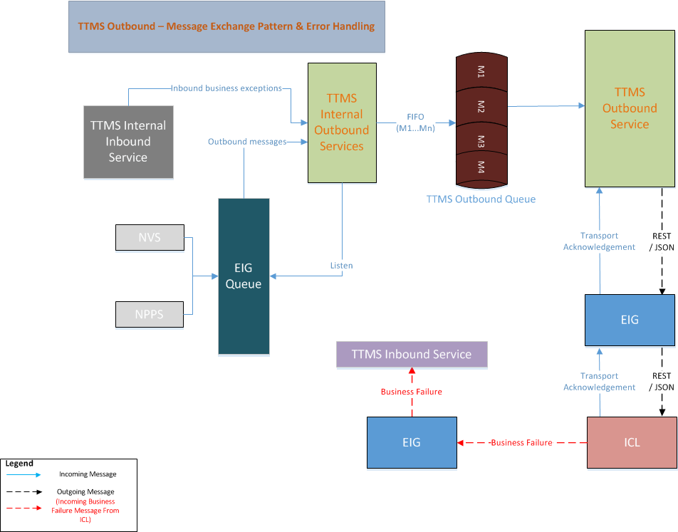
- NVS and NPPS source systems propagates the event message to EIG through P2P communication.
- TTMS outbound services consumes the messages and converts into common message structure understandable by TTMS.
- At the end of the conversion the message will be placed into TTMS outbound queue container.(FIFO Order)
- The TTMS outbound services listens the message and based on the message category calls the respective outbound service.
- The outbound service calls the ICL service through EIG using REST/JSON pattern.
- ICL sends the transport acknowledgement back to TTMS through EIG on the same request.
- If any business failure issues, ICL calls the TTMS inbound service to indicate the failure messages. TTMS resend the failure messages back to ICL if required.
- The internal inbound services is being called from inbound services to handle the failure messages and routed back to the outbound queue to send back to ICL again.
  - ICL TTMS System Integration Error Handling
TTMS, ICL, EIG Systems error handling will be handled in to two parts, Inbound and outbound scenarios as given the diagram in the sub sections. The below categories of errors will be handled part of the integration.

- HTTP Error Codes for network issues and security errors
- JSON Fault code for security, format and business failure scenarios.

Please refer the different down time scenarios and the respective errors are being handled for the different scenarios mentioned in the NFR document .Refer Error handling section of Webservice and MQ patterns.
- Architectural Solution Scenarios
The TTMS Simplification project is followed with the all below options to achieve the overall TLS business solutions.
  - Buy Solution vs. Build from Scratch vs. Enhance Existing System
The TMS decision is to go with Software as a Service (SaaS) solution with ICL based on the POC that has been conduction with ICL to prove they can support TLS needs for finish vehicle logistics system.

The current TTMS OTM COTS product will be replaced with ICL SaaS solution due to the following key constraints are mentioned in the ‘Pros’.

Pros
- OTM was not designed for finished vehicle logistics, resulting in technical and manual workarounds that impact TLS’s ability to meet business requirement.
- Difficult and expensive to maintain due to system integration complexity periodic, resource intensive upgrades.
- Requires resources high priority initiatives (e.g. N.A Export, Transportation Claims automation, etc. to support OTM)
- In-house technical workarounds to meet business needs (e.g. Preliminary tender, Governor and Sequencing)
- Time consuming manual workarounds in place (e.g. Manual re-planning, fictitious routes/carriers, operational delays/disruptions)

Cons
- The high dependency with SaaS will become complicated when plan to switch the vendor or build the proprietary solution.

  - Real Time Integration Vs Batch Mode Integration
This Architecture solution scenario has been influenced by Use Case 4.1 Integration Use case –Inbound(ICL-TTMS)and 4.2 Integration Use case - Outbound (TTMS-ICL) for Inbound and Outbound services.

As per the B2B Integration guidelines and based on the business expected response time defined, All the inbound and outbound services are considered as real time with web service implementation. However based on the volumetric analysis few of interfaces possibly classified into Batch process.

Inbound Services Categorization

No | Interface Name | As Is Process | Business Criticality  (1-5,1-Low,5-High) | Priority | To Be Frequency | To Be Process
1 | Shipment Plan | Real-time | 5 | High | Between 15 to 30 minutes | Real-time
2 | Processing Plan | Real-time | 5 | High | Between 15 to 30 minutes | Real-time
3 | Vehicle Summary | Real-time | 5 | High | Between 15 to 30 minutes | Real-time
4 | Vehicle Events | Real-time | 5 | High | Once a day per unit | Real-time
5 | Rail Shipments | Real-time | 3 | Medium | Maximum 30 minutes | Real-time
6 | Rail Inspections | Real-time | 5 | High | Maximum 15 minutes | Real-time
7 | Transit | Real-time | 4 | Medium | Maximum 60 minutes | Real-time
8 | Invoice Voucher | Batch | 5 | High | Once a day | Real-time vs Batch – Need to analyze the volume
9 | VDW | Batch | 3 | Medium | Every 2 hours | Real-time vs Batch – Need to analyze the volume
10 | Vessel ETA | Batch | 3 | Medium | Once a day | Real-time vs Batch – Need to analyze the volume
11 | Shipping Schedule | Real-time | 3 | Medium | Once a day | Real-time

Outbound Services Categorization

No | Interface Name | As Is Process | Business Criticality  (1-5,1-Low,5-High) | Priority | To Be Frequency | To Be Process
1 | FQA | Real-time | 5 | High | Less than 5 minutes | Real-time
2 | AQA | Real-time | 5 | High | Less than 5 minutes | Real-time
3 | LPR | Real-time | 5 | High | Less than 5 minutes | Real-time
4 | Dealer Allocation | Real-time | 5 | High | Less than 5 minutes | Real-time
5 | Hold | Real-time | 5 | High | Less than 5 minutes | Real-time
6 | Damage | Real-time | 5 | High | Less than 5 minutes | Real-time
7 | Stop Sale | Real-time | 5 | High | Less than 5 minutes | Real-time

  - Incremental vs Complete
This solution scenario has been driven by Use case 4.3 Low Volume Internal Data Integration and 4.4 High Volume Internal Data Integration. The incremental and complete are the two options are being considered to handle the data integration from ICL to TTMS.

- Incremental
- Complete

Option A: ICL will call the TTMS inbound service and add single record at a time or group of records incrementally till the completion of records.

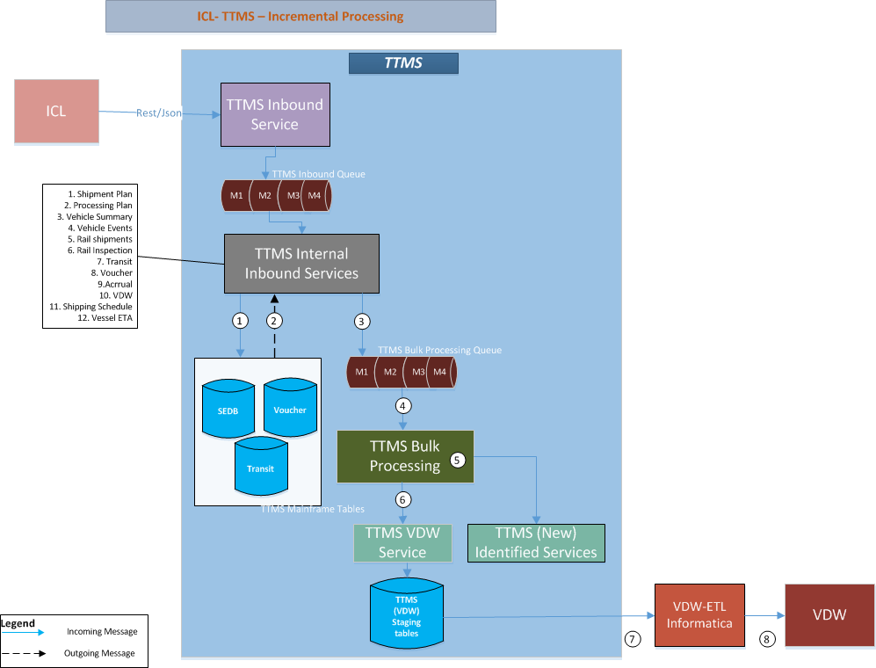

ICL sends the information to TTMS integration application through one of the exposed inbound services. The TTMS inbound services put the messages into the TTMS inbound queue. The below steps explains the high level steps that are involved with sample flow of VDW.

- TTMS inbound internal services process the message and finally add or update the records in TTMS mainframe tables.
- TTMS inbound services receives the transaction completion.
- There are sudden cases, as part of inbound services the copy of the messages need to be updated to the downstream applications (ex VDW). The other possibility would be the highest volume of records need to be processed into separate container. By considering the principle of single chain responsibility. These considerations brings the new queue named “TTMS Bulk Processing queue”. TTMS internal services place the messages into Bulk processing queue.
- TTMS Bulk Processing is a different application or component to be designed to handle the scenarios that are mentioned in the above step 3.
- TTMS Bulk processing calls the respective Bulk processing service based on the service modules (TTMS VDW services, the other services yet to be identified)
- The Bulk processing services example TTMS VDW service updates the information in to the tables. In this example scenario TTMS VDW service (Bulk Processing service) updates the information into TTMS VDW staging tables.
- VDW ETL informatica tool extracts the information from the TTMS staging tables
- VDW ETL tool store the information into VDW tables

Option B: ICL will send the complete records through the inbound service interfaces, in this option the complete flat file will be received from ICL and will be processed in TTMS. The data will be received in the format of JSON payload with required Meta data attributes to know completeness of the data is being received from ICL.TTMS will start the process based on the Meta data indicators.

The below diagram focus how the typical integration applies for flat file integration, the communication between ICL and TTMS will happen through EIG. The transport acknowledgement will be sent to ICL with success or failure acknowledgement once the file has been received at TTMS side.
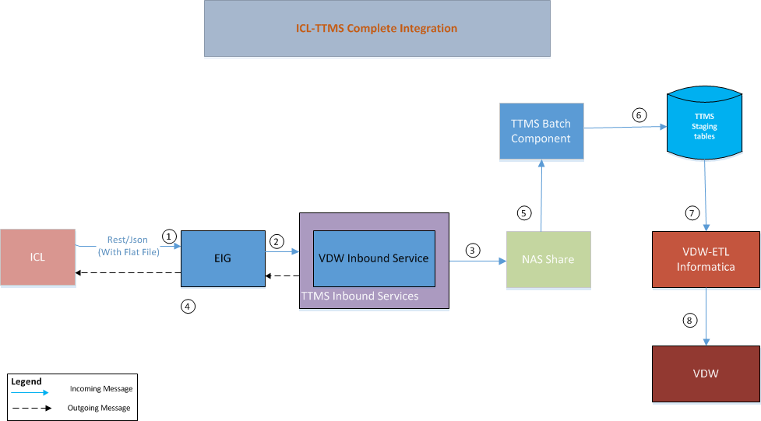

- ICL sends the high volume (complete) information in one single flat file.
- EIG forwards the request to TTMS inbound services after the basic structure validations.
- TTMS inbound services receives the file and places into the NAS share drive assigned to TTMS.
- On successful completion of file placement on the NAS drive, the inbound services sends the acknowledgement to ICL through EIG.
- The TTMS batch component will invoke the file and process the records with basic validations.
- At the end of the batch process the required TTMS tables will be updated. For in this diagram example the VDW batch process will update the records into TTMS VDW staging tables.
- VDW ETL informatica tool extracts the information from the TTMS staging tables.
- VDW ETL tool store the information into VDW tables.

Solution options | Pros | Cons
Incremental | - Performance will be good compare with “Complete” option.  - Avoids building the additional technical framework or platform to build the solution. | - Introduce the complexity of handling multiple transport acknowledgement for high volume records (Voucher, VDW) for same purpose of calls from the consumer side.  - Need to implement the methodology for the completion of processing to mark the expected incremental completion.  - Introduces the complexity of handling when the target system is completely down (this case TTMS is down) during the halfway incremental transmission.
Complete | - Avoids multiple network calls  - Avoids to introduce separate service for delta attributes. | - Introduce the complexity of implementing the file compression.  - The delay in data arrival will be caused when network slowness happened between the windows of transfer process.

  - Synchronous Vs Asynchronous Communication Pattern
This architecture solution scenario is primarily driven by the decision taken for scenario 5.2 Real Time Integration Vs Batch Mode Integration and well supported by Use cases 4.5 Message Exchange Pattern and 4.6 ICL TTMS System Integration Error Handling
Option1: Two-way Synchronous Communication: The client uses exposed service to achieve synchronous communication and receive a response immediately. Upon receiving the request, the server starts processing it while holding the connection with the client open until a response (or an error) is ready to be returned to the client on the open connection. The request can be initiated from both the end (ICL && TTMS) at both the ways from either ICL or from TTMS.

The following diagram explains the sample synchronous communication with one way from ICL to TTMS, The same flow in other way around is being considered to include the option 1 as two way synchronous communication pattern.

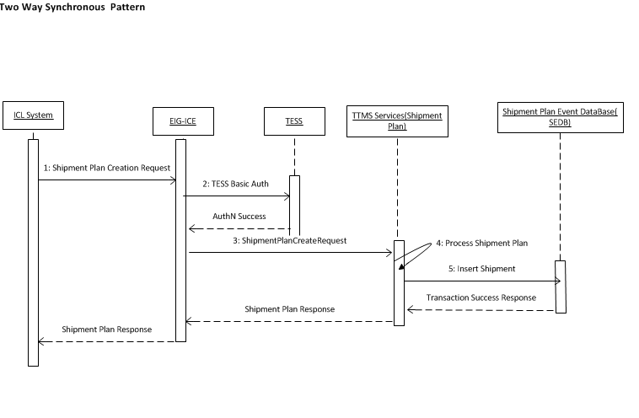

Step 1: The Shipment Plan request is initiated from ICL
Step 2: EIG validates the request headers and authenticate with TESS
Step 2.a: TESS sends the success acknowledgement
Step 3: EIG forward the request to TTMS back end Web Services
Step 4: TTMS performs the business validations and calls the SEDB insert

Step 5: The Shipment Plan is created in SEDB and the success Transaction response sent to ICL

Note: The entire flow is continued as sequential flow and each of the component will wait until the response served with in the request timeout defined in each of the layer.

Option 2: Two-Way Synchronous plus Asynchronous Communication: Two-way asynchronous communication in this document context, when the request is initiated from the client (ICL) then the Provider (TTMS) receives the request and dispatch the request in different new process or container (Queue/Data Store) then sends the successful transport acknowledgement of receiving the message. This case the actual business process may not be completed even though the successful transport acknowledgment is being delivered to the consumer.

The new process will be initiated to complete business transaction and then sends only the failure business transaction acknowledgement. The acknowledgment can be either through web service or any notification mechanism. The communication can be initiated from both the ICL and TTMS vice versa.

The following diagram explains the flow of two way asynchronous pattern but the diagram is drawn for the one-way from ICL to TTMS and the same way the communication will be followed from TTMS to ICL during outbound integration.

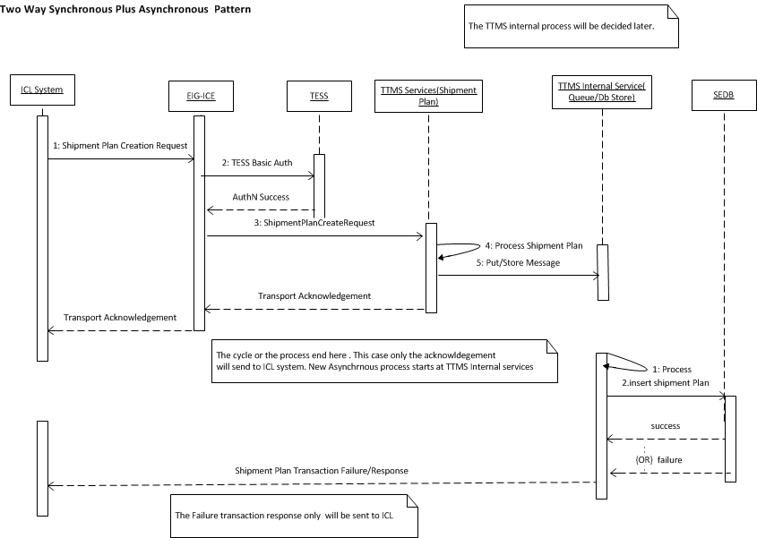

Step 1: The Shipment Plan request is initiated from ICL
Step 2: EIG validates the request headers and authenticate with TESS
Step 2.a: TESS sends the success acknowledgement
Step 3: EIG forward the request to TTMS back end Web Services
Step 4: TTMS performs mandatory message attributes validations
Step 5: TTMS puts the message into TTMS internal service (Queue/DB Store)
Step 6: TTMS services sends back the acknowledgement to ICL back to all the layer to ICL

The below steps are started in TTMS as asynchronous process after end of the step 6.

Step 1: The new process queued or initiated
Step 2: TTMS inserts the shipment plan in SEDB table
Step 3: Sends the actual success/failure business transaction confirmation/notification to ICL with different interface

Solution options | Pros | Cons
1.Two-Way Synchronous Communication | - Provides the clear end to end single span of request and response flow.  - The business transaction acknowledgement will be received by consumer on the same request initiated.  - Avoids consumer not to send the invalid messages to TTMS since the previous response has the successful transaction completion acknowledgment status to decide the business flow.  - Sequencing of the messages will be handled naturally when second transactions follows the completion of first transaction. | - Holds the request until the backend completes the transaction.  - Mostly suitable for less time transactions.  - The acknowledgment may not be sent to consumer even though back end successfully completed the transaction during timeout issues.  - Tight coupling from ICL all the way down to backend systems  - Difficult to scale as volume or # of backend systems rows
2.Two-Way Synchronous Plus Asynchronous Communication | - Meets ‘Single responsibility’ principle(Low coupling)  - The transport layer acknowledgement will be given to consumer in order to process the next events.  - Faster response time to consumer | Increase the business coupling on TTMS layer where consumer did not operate the next event based on the previous web service business transaction sent to TTMS.  TTMS need to build another asynchronous flow after transport layer acknowledgement which introduce additional technical complexity.

  - Soap Web services Vs Restful Web services
This architecture solution scenario originates from the decisions taken for Scenario 5.2 Real Time Integration Vs Batch Mode Integration, 5.3 Incremental vs Complete and 5.4 Synchronous Vs Asynchronous Communication Pattern. The approach will be to have Real-time synchronous processing using web-services. This scenario focuses on the methodologies to be used for web service implementation. The SOAP and Rest web services are considered as the options.

Solution options | Pros | Cons
SOAP | - SOAP use WSDL to define the clear contract design between the provider and consumer.  - SOAP supports other protocols SMTP,FTP,etc other than HTTP  - SOAP supports message level security encryption  - Development and tools support  - Build in error handling and retry mechanism  - Supports MTOM file compression techniques | - SOAP does not support multiple message format whereas RESTful services can be used with JSON or other payload formats.  - Makes tightly coupled with systems together  - Increases the maintenance Cost in order to maintain backward compatibility due to service contract changes.  - Slower performance than REST due to the heavy object binding and marshalling process.
REST | - REST is more dynamic, no need for creating and updating UDDI.  - REST is not restricted to XML format. REST web services can send plain text, JSON, and also XML.  - REST is much more lightweight than SOAP  - REST is providing better performance than SOAP | - Supports only over HTTP  - REST does not support WSDL but supports WADL but does not have the standards compared to SOAP WSDL.  - REST does not support the default error message and Retry handling as SOAP is having in built support  - REST does not support file compression MTOM compared with SOAP  - REST does not support message level encryption and the encryption can only be achieved in Transport layer.
- Architectural Decision Log
The details of various solution options considered, along with qualitative [Pros & Cons] analysis are included in solution scenarios section.
  - Web Service Pattern
Subject Area | Web Service Pattern |  | Topic |  | Rest/JSON Vs SOAP/XML
Issue or Problem Statement |  | The web service pattern need to be identified either SOAP/XML or Rest/JSON based web service pattern.
Related Use Case / Requirements |  | Technical Use case – All the inbound and outbound interfaces
Solution[s] |  | The solution is identified as two options  Rest with JSON  SOAP with XML
Decision |  | The decision is to use Rest Architectural style.  The decision is to use JSON Message format.
Rationale |  | Please refer the Pros and Cons of section 5.5 Soap Web services Vs Restful Web services.  As per the TMS standards REST is the preferred option.
Assumptions |  | The JSON message structure validation will happen at the EIG side.  Payload and key mandatory attributes validation should be done at the TTMS back end services.  JSON supports to send the flat file with traditional formats.
Justification |  | Refer the Pros section of Rest and Cons section of SOAP mentioned in the solution scenario section 5.5 Soap Web services Vs Restful Web services  The below are key considerations that driven to choose the JSON.  - JSON parsing is generally faster than XML parsing  - JSON is a more compact format, meaning it weighs far less on the wire than the more verbose XML.
Implications |  | - The Retry mechanism need to be handled on the consumer side  - The message level security cannot be achieved in REST based pattern, In future the system demands then need to revisit the pattern or wait REST has to emerge with message level security.
Derived requirements |  | - Retry Mechanism need to be implemented across the layers. Please refer 4.5 Message Exchange Pattern  - Application has to build the error handling mechanism and mandatory field’s validations across the layer of ICL, EIG and TTMS. Please refer 4.6 ICL TTMS System Integration Error Handling
  - Message Communication and Acknowledgement Pattern

Subject Area | Message Communication Pattern |  | Topic | Two Way Synchronous Communication | Two Way Asynchronous Communication
Issue or Problem Statement |  | Decide the message communication to use synchronous or asynchronous pattern
Related Use Case / Requirements |  | All the inbound and Outbound interfaces.
Solution[s] |  | The solution is identified as two options  - Two way Synchronous Pattern  - Two way Synchronous plus asynchronous Pattern
Decision |  | The decision is to use Option 2(Two Way Synchronous plus Asynchronous Communication)
Rationale |  | Please refer the Pros and Cons of section 5.4 Synchronous Vs Asynchronous Communication Pattern
Assumptions |  | - ICL sends the messages in built sequence and if any sequence based errors will be handled through error handling process.  Please refer the error handling scenario mentioned 4.6 ICL TTMS System Integration Error Handling
Justification |  | - Faster Response time due to the transport acknowledgement design.  - Loosely Coupled business transaction processing separate from transport acknowledgement process.  Please refer the Solution scenarios section for more details please refer 5.4 Synchronous Vs Asynchronous Communication Pattern
Implications |  | Sometimes the business transaction is almost equal to the transport acknowledgement time where it increases the additional increase of storage that leads to additional store and process design consideration.
Derived requirements |  | Derives the technical requirement to add the new storage of queue or Database to hold and process the message to make the asynchronous communication.
  - IBM MQ Manager Vs Distributed Queue Manager

Subject Area | MQ Queue Manager |  | Topic | Mainframe MQ Manager | Distributed Queue Manager (Other Platform)
Issue or Problem Statement |  | Decide the Queue manager platform
Related Use Case / Requirements |  | All the inbound and Outbound interfaces which are using the MQ integration patterns
Solution[s] |  | The solution is identified as two options  - Mainframe MQ Manager  - Distributed Queue Manager
Decision |  | The decision is to use Option 1(Mainframe MQ Manager)
Rationale |  | Mainframe MQ is Robust.
Assumptions |  | The enterprise will not upgrade or replace the Mainframe queue manager with distributed queue manager.
Justification |  | 1.Use of Existing outbound Mainframe MQ integration with NVS,NPPS  2.To avoid multiple MQ integration Integrations
Implications |  | To avoid multiple queue manager integrations, it leads the new inbound channel also has to adopt the existing Mainframe MQ integration. If the future direction to move away from Mainframe then it makes some effort to move different platform
Derived requirements |  | None
- Logical View
  - Overview
The new TTMS integration modules needs to be developed
- To support the data flow / data integration between the new Freight Planning and Invoice Audit System (ICL) and the existing TTMS mainframe application
- To minimize the impact on all the existing downstream applications that consume information from TTMS mainframe system by reusing existing components in TTMS
- To remove the existing business logic from the integration layer
- In alignment with TMS latest technology landscape

As Is System Context View
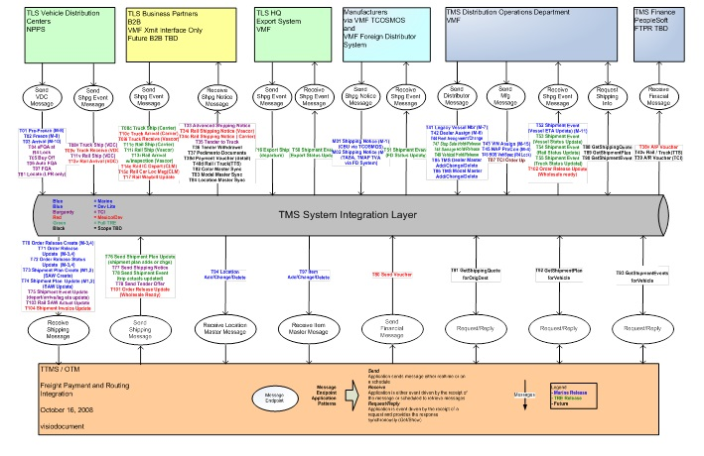

To be System Context View

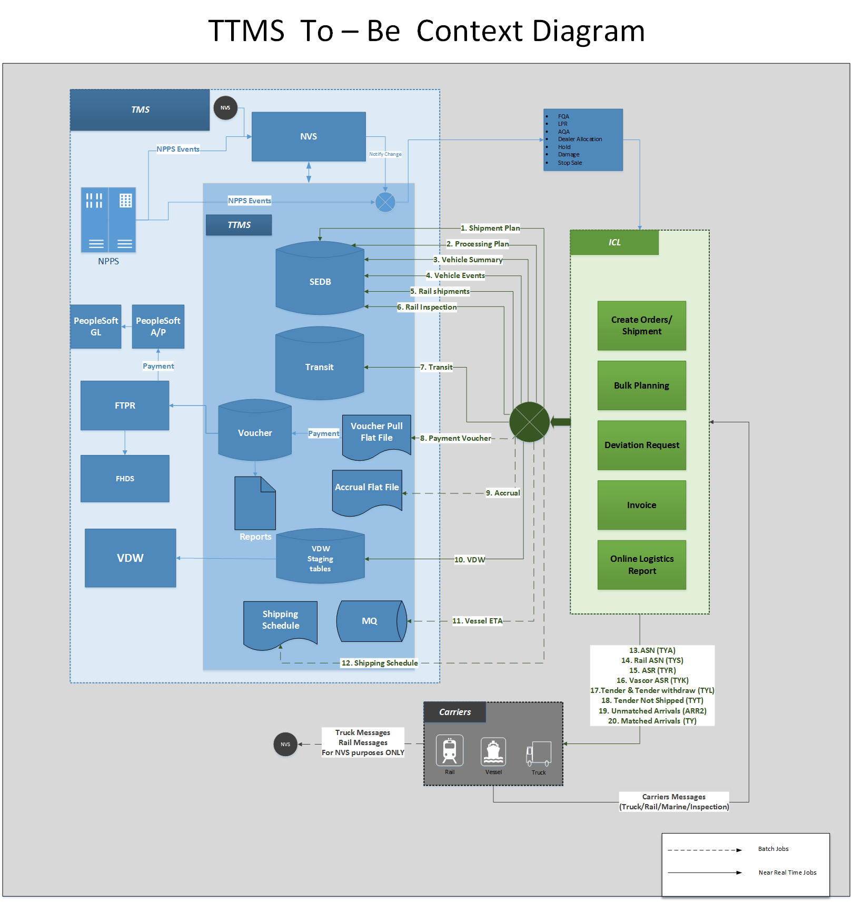

Interfacing Systems and External Data Store

ICL
Description | TTMS interface with ICL for inbound and outbound operations as a web service for Creation of Shipment Plan, Manage Shipment related Events, and Manage Shipment related invoice, Manage Deviation Requests.
Type |  | System
Owners |  | ICL

NVS
Description | NVS sends all the Notify Add and change events to TTMS. TTMS integration outbound module will filter the and send the below events to ICL  - Dealer allocation changes,  - Hold  - Damage  - Stop sale
Type |  | System
Owners |  | TMS

NPPS
Description | NPPS sends the following information to TTMS for BDY, PNT, ASM BUY, AQA, LPR, TS1, RSC, RR1, and RC1.  TTMS integration outbound module will filter and send the below events to ICL  - AQA,  - FQA  - LPR
Type |  | System
Owners |  | TMS

VDW
Description | VDW pulls the Logistics related information from TTMS system through TTMS database. VDW has a Freight data mart used by TLS users which provides information like Shipment, Invoice, Service provider, Location, Vehicles associated with Shipment etc. To populate the Freight data mart, VDW pulls data on a daily basis from TTMS system around 11 PM PT.
Type |  | System
Owners |  | TMS

FTPR
Description | FTPR is the Freight Payment Routing System and interface with TTMS. TTMS sends the Payment information to FTPR
Type | System
Owners | TMS

FHDS
Description | FHDS is the system hosted on the mainframe and pulls in the payment summary information from TTMS through FTP
Type | System
Owners | TMS

  - As Is Conceptual View Architecture
The following diagram explains the as-is representation of existing TTMS applications and their system interaction.
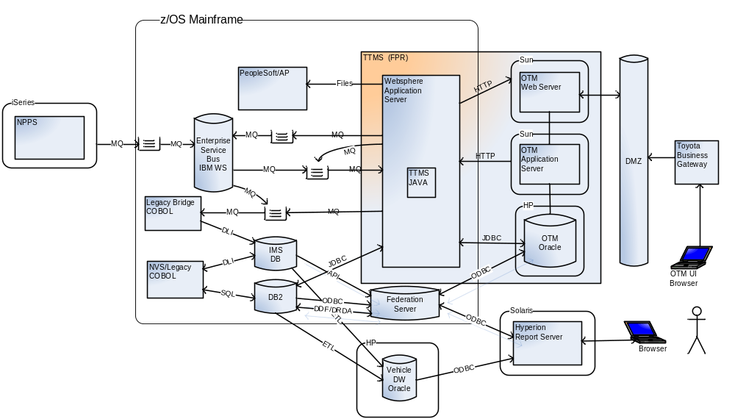
  - To be System Conceptual View
The future FPR system has to be integrated with ICL ASP. Data will be fed to TTMS integration from ICL via Webservice through EIG.
EIG is the enterprise integration gateway between the ICL and TTMS application. EIG is hosted on the Data power. EIG will validate service account details against TESS using OVD/ODSEE. A new TTMS service integration JEE layer has to be introduced on RedhatLinux.
The set of new JEE integration applications have to be designed to provide the webservice implementation and queue based message processing system.
The Queue Manager is hosted on the mainframe ZOS. All the inbound and outbound queues will be hosted on the mainframe queue manager. The new integration will be designed to accommodate the expected data from ICL and will be inserted/updated to the TTMS mainframe/MY SQL tables or pass the data to TTMS downstream systems. Please refer solution overview for more details to know about details of the new JEE applications classification.
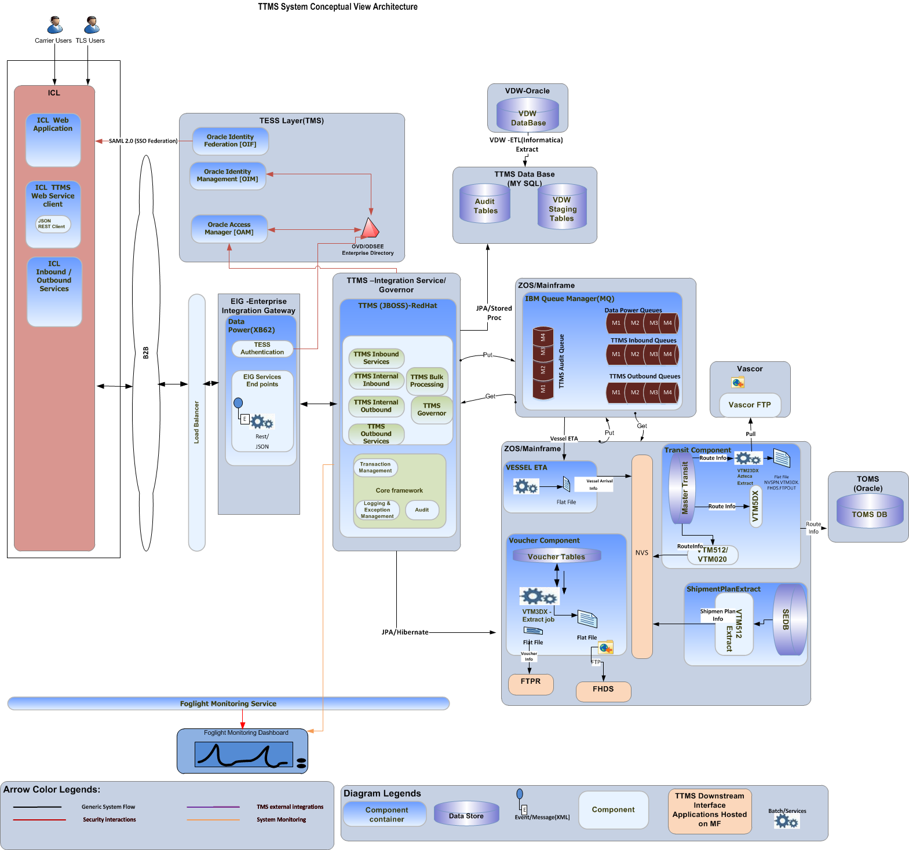
  - To be Logical View
The layered view of TTMS application is shared below. This section describes the overall logical decomposition of layered solution architecture. As articulated in the architectural principles and guidelines of TMS application framework and TTMS application should follow a modular design through the following principles.
- The core design principles including separation of concerns, dependency injection, loose coupling and encapsulation will be adhered.
- The design patterns will be leveraged to reduce coupling, improve abstraction and increase reusability.
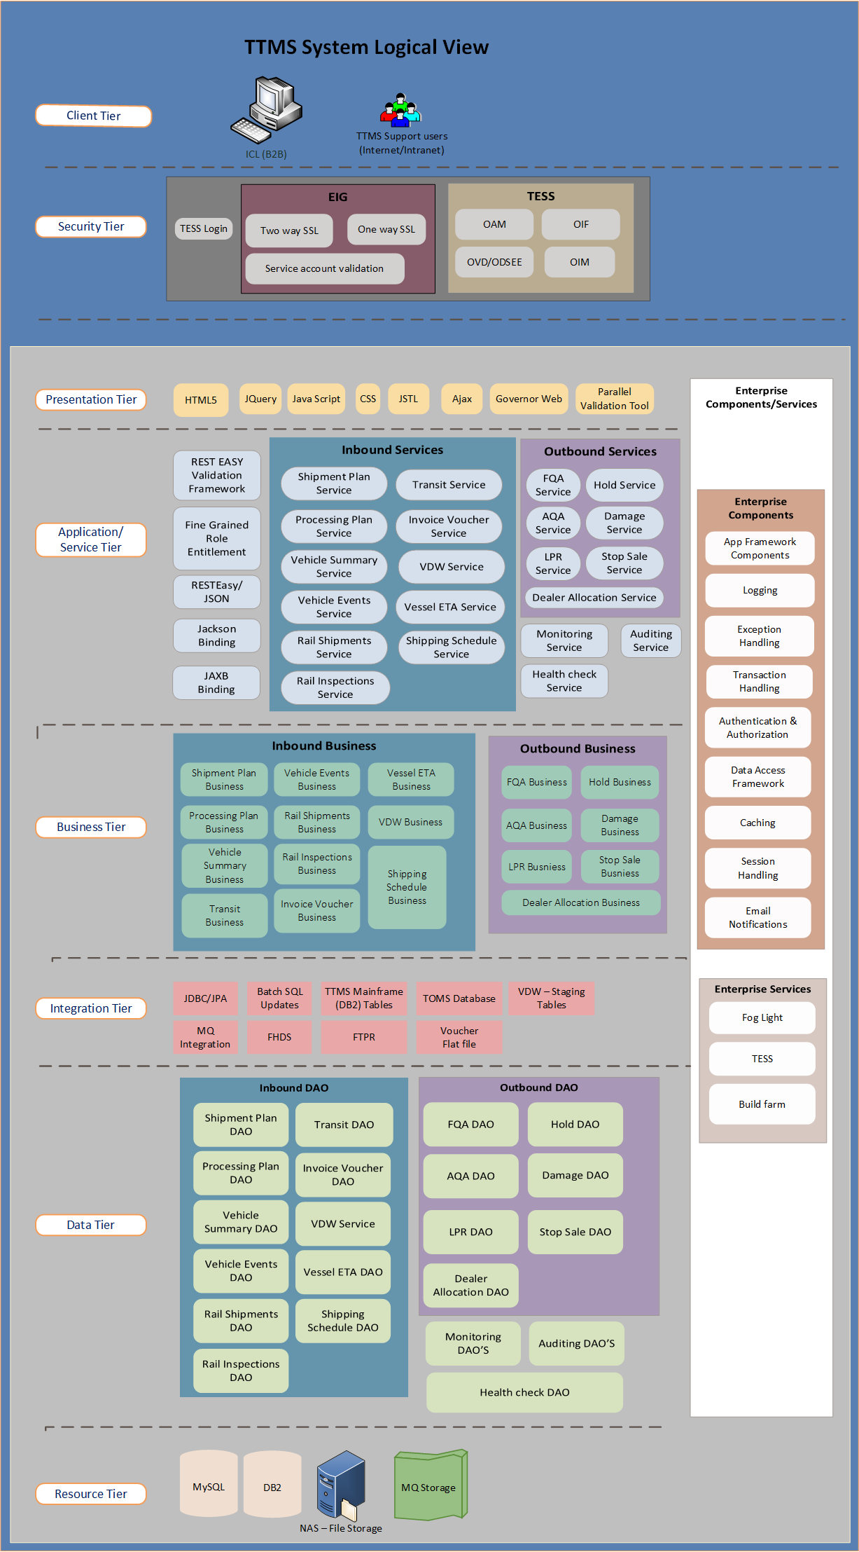

Client Layer
- The TTMS client layer comprise of 2 types.
- 1. ICL will consume the TTMS inbound services.
- 2. TTMS support users who will be accessing the TTMS governor application through Intranet, Internet, VPN access channels.
- The TTMS support users will be using the TMS recommended browser types to access the TTMS Governor application through the secure channel.

Security Layer
- TTMS Governor Application will integrate with Toyota Enterprise Security Services (TESS) for authentication and coarse-grained authorization.
- TESS standard login screen will be used for authentication.
- Two way mutual SSL between ICL and EIG
- One way SSL between EIG and TTMS Integration services
- Service account validation will happen on the EIG layer for TTMS inbound and outbound requests.
- TTMS Governor web application will be accessed through SSL (Secure Socket Layer)
- Fine-grained authorization will be implemented and managed within the application using spring security.

Presentation Layer
- The presentation tier comprises of core UI components of the TTMS governor application.
- The look and feel of the web will be developed using the TMS Application Framework Web UI guidelines.
- All the Web artifacts CSS, html, java script and all the application static content will be placed in the Apache web server and mapped with application context root.
- A NAS/NFS file store will be leveraged to store all the static contents associated with the Governor application.
- Additional flexibility will be provided wherever appropriate.

Application Layer
- The application will be developed on a JEE JBOSS platform by adhering to TMS standards, architecture and technologies.
- Governor application will leverage TESS for single sign-on and application role management and fine grained roles and entitlements.
- The application layer components will interface with the service layer to realize the Monitoring, Health Check and Auditing use cases.
- Fine grained roles or entitlement mappings will be done using Spring security provided by TMS app framework components.
- JAXB Binding will be used to convert the MQ XML (EIG) to JAVA Pojos during outbound communication.
- JACKSON binding will be used to convert the JSON message to Java Pojos during inbound and outbound commination to ICL.

Service Layer
- REST Web Service integration style will be leveraged for service Layer.
- REST Easy JSON with REST EASY validation will be used to do the mandatory fields and data length validations.
- The mandatory, datatype and data length validations will be done at the service layer.
- REST Web service integration style is chosen over embedded style to keep the solution loosely coupled, and also to align with the similar implementation existing methodology without major change of both the sides.
- JSON will be used as the message format
- The service layer is classified into inbound services, outbound services, Monitoring, Health check services and Auditing services.
- The service layer can be developed to use the services across multiple TTMS integration modules.

Service Integration Design Principles
The TTMS web services will follow the web service design principles and guidelines.

Description | Principles and Explanation
Service Loose Coupling | The principle of Service Loose Coupling promotes the independent design and evolution of a service’s logic and implementation while still guaranteeing baseline interoperability with consumers that have come to rely on the service’s capabilities.
Service Abstraction | This principle emphasizes the need to hide as much of the underlying details of a service as possible, Service Abstraction also plays a significant role in the positioning and design of service compositions.
Service Reusability | The principle of Service Reusability emphasizes the positioning of services as enterprise resources with agnostic functional contexts. Numerous design considerations are raised to ensure that individual service capabilities are appropriately defined in relation to an agnostic service context, and to guarantee that they can facilitate the necessary reuse requirements.
Service Autonomy | The principle of Service Autonomy supports the extent to which other design principles can be effectively realized in real world production environments by fostering design characteristics that increase a service’s reliability and behavioral predictability.
Service Statelessness | The management of excessive state information can compromise the availability of a service and undermine its scalability potential.

Business Layer
- The business layer will encapsulate the business functionalities derived from the use cases
- Business services and components should be designed to increase reusability
- Business components in this tier will be responsible for retrieving the data from the data tier through Data Access Object (DAO) and passing the information back to Application Layer
- A flexible domain model will be built to accommodate extensibility in future.

Integration Layer
- TTMS is integrated with TTMS Db2 mainframe tables,TTMS integration system updates the information in tables using JDBC/JPA
- TTMS is integrated with MQ manager to receive the messages from source systems NVS, NPPS. Also the new queues have to be designed to process the web services messages received from ICL in an asynchronous manner.
- TTMS is integrated with VDW system, The VDW will extract the data from TTMS staging tables using ETL tool at every day night.
- TTMS integrated with FTPR, TTMS sends the voucher info in the form of flat file.
- TTMS is integrated with FHDS to send the data from TTMS, FHDS receives the flat file using FTP protocol
- TTMS is integrated with TOMS, TTMS updates the route information in TOM’s database.
- TTMS Governor Application will be integrated with TESS system services for authentication, external user provision and other basic security self-services such as forgot password, change password...etc.
- TTMS will be integrated with EIG services to receive and send the messages with ICL ASP.

Data Layer
- TTMS Integration application will access the DB2 database schema.
- TTMS Integration application will use the MY SQL data base will be used for Auditing, Role Entitlement and VDW requirements
- A NAS/NFS file store will be leveraged to store all the files associated with TTMS integration and Governor Application.
- TTMS Governor Application will use the audit data to display the health check data.
- The Data Access Layer provides domain services and JPA domain entity access.

Resource Layer
- New My SQL database will be used to store the VDW, Audit and application specific master tables information
- The Existing TTMS Db2 and the associates tables are used same as now without major changes.
- The cylinders or the tracks associated with the MQ storage should be increased to hold the additional queue requirements and to hold at least 4 days of backlog data.
- The NAS storage is needed to store the web UI artifacts on the Web server layer. The NAS storage will be mounted with Web server and the JBOSS application server instances.

Common Components
- TMS Application Framework components and guidelines will be leveraged for common features such as
- Exception, logging and caching. TTMS application will use EHCache for application caching.
- TMS Spring security framework will be leveraged to use for TTMS Governor application security integrated with TESS
- TMS App framework will be used to handle the session expiration, idle session time out and Logout warnings.
- TMS Application Framework will also be leveraged for e-mail notification.
- Spring framework will be leveraged for dependency injection/loose coupling.
- JPA 2.0 features will be auto-wired through Spring framework to take care of transaction management and persistence needs. Hibernate will be the ORM to be leveraged.
- Spring REST easy framework will be used for web service data validation and will be generalized to reuse enterprise vice later.

7.4.10.1 Auditing

Enterprise Services
- Quest Fog light will be used for application monitoring
- Quick Build Farm will be used for build deployment
- Quick build sonar will be used to assess the code quality standards
- NAS Share mount will be used to share the files on Web Server by mounting with JBOSS application server.
- Integration View
The integration view of TTMS application is shared below. This section describes the overall Integration patterns involved, integration error handling and the details of systems that are integrated with TTMS.
  - Integration Patterns

B2B Integration Pattern (Internet)
TTMS inbound and outbound web services follows the B2B Integration pattern. ICL and TTMS shares the business information in order to perform the logistics operations. ICL is an ASP providing the software as service in order to perform current TTMS logistics operations. The following diagram depicts the layering view of general TMS B2B Integration view.
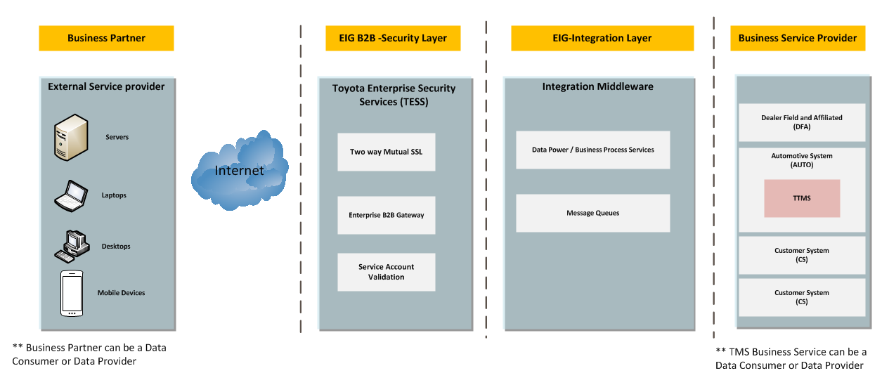

ICL will provide the software and service for TTMS Freight Planning and the Invoice Operations that includes Managing Truck, Rail & Vessel Rates, Manage Processing and Inspection Charges (Master Data management), Creation of Shipment Plan, Manage Shipment related Events, and Manage Shipment related invoice, Manage Deviation Requests, Report Generation and Data Propagation. ICL, a finished vehicle specific SaaS solution, best aligned with our current and future business needs.

The integration with ICL with TTMS simplification has been split into two parts. The inbound integration pattern describes the communication start from ICL to TTMS simplified inbound web service application. The outbound integration pattern describes the communication start from TTMS simplified outbound web service application to ICL.

External Web Service Pattern I – Inbound Services Integration
The following diagram explains the webservice inbound pattern with detailed steps. The request is initiated from ICL and the transport acknowledgement will be provided by TTMS system. It uses the synchronous request reply message exchange pattern.

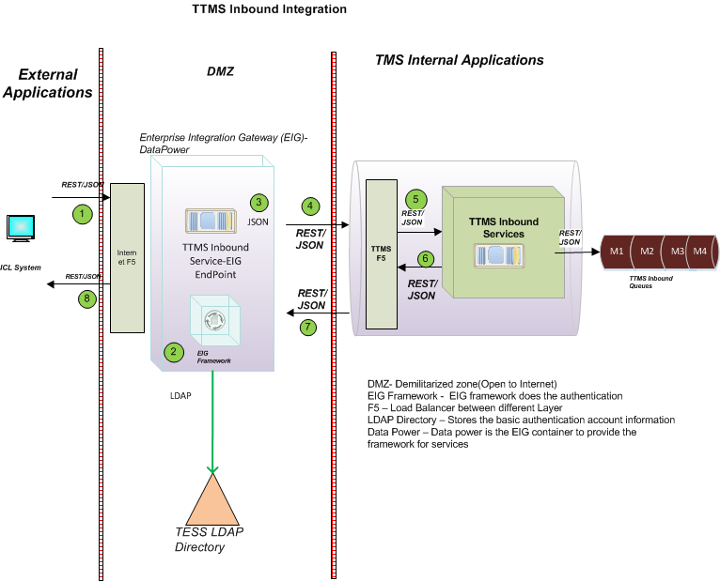

Chronology of Events

- ICL application sends the request in REST/JSON Format to EIG
- EIG Authenticate the request against TESS to validate the service account credentials.
- EIG validates the high level message format.
- EIG sends input request to TTMS Inbound services through TTMS F5.
- TTMS Inbound Services receives the request in (REST/JSON) format and place the message in the TTMS inbound queues.
- EIG receives the transport acknowledgment back from TTMS Inbound back end services.
- EIG send the response/acknowledgement back to ICL.

Note: Please refer the next continuity pattern MQ Inbound Pattern. MQ Inbound Pattern I - TTMS Inbound Web Services publish the messages to TTMS .

External Web Service Pattern I – Bulk Record Pattern
The bulk records processing” web service pattern is an extension of web service inbound integration instead of single record it has the punch of records on the same request.
- ICL or the consumer prepares the punch of records
- Sets the number of records to be sent in the HTTP headers and the JSON payload
- ICL calls the TTMS Inbound bulk processing webservice and sets the punch of records in the requests
- TTMS receives the web service request through EIG
- TTMS sends the transport acknowledgement back to ICL.

VESSEL ETA, Shipping schedules are the sample use cases that are realized for this bulk record pattern implementation.

External Web Service Pattern II – Outbound Services Integration (TTMS-ICL)
The following diagram explains the TTMS outbound web services integration pattern (TTMS → ICL) with detailed steps. The request is initiated from TTMS and the transport acknowledgement will be provided by ICL system. It uses the synchronous request reply message exchange pattern.

Note: Please refer the TTMS internal Web service pattern before start of this pattern Internal Webservice Pattern I – TTMS Internal Outbound calls TTMS Outbound Services.

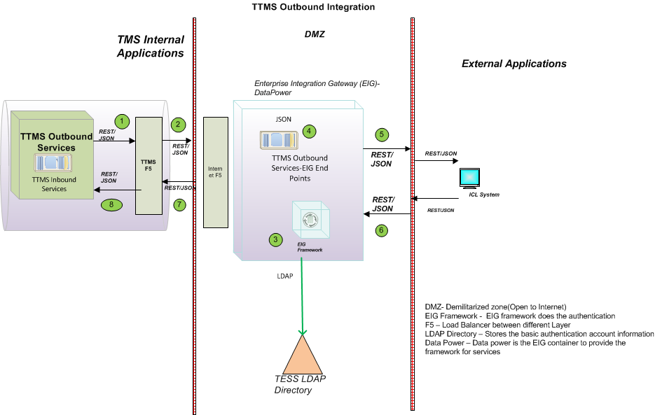

Chronology of Events

- TTMS Internal outbound services sends the request in REST/JSON Format to TTMS F5
- TTMS F5 delegates the request to EIG
- EIG Framework Authenticate the request against TESS to validate the TTMS outbound service account credentials
- On the result of successful authentication, EIG validates the message format.
- EIG sends the request to ICL Web service using Rest/JSON format
- ICL receives the request and validates the TMS Outbound service account.
- ICL sends the transport acknowledgment back to EIG with Rest/JSON pattern.
- TTMS receives the transport acknowledgement.

Web Service Message Exchange Pattern

Synchronous Request Reply (Transport Acknowledgement)
In the synchronous request-reply pattern, when an application sends a message, it expects to receive a message in return. This pattern can be used when one or more senders need to send messages to a single receiver. At TTMS, this pattern will be realized as a Web service, where the message format is JSON In this implementation, the request is addressed to a specific back end service provider (TTMS), which receives the message and responds the transport acknowledgement as part of the same call return.

Decoupling is achieved by making the request to the mediator (EIG in this case) which forwards the request to the TTMS service provider. The service provider endpoint is synchronous. TTMS services will convert the JSON format into java POJO’s to process the message further. This interaction pattern is applicable when near real-time response is required and the processing times to process messages are small but in this case the response is considered as transport acknowledgement.

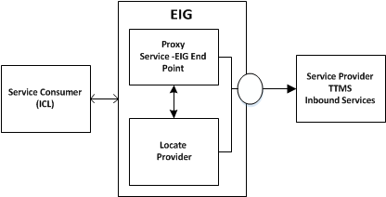

Web Service Pattern - Message Format
Please refer the “TMS API Message Model Standards and Guidelines v 1 “ICE document to follow the guide’s lines to define the message format. Refer the document path in the reference section.

The application area attributes will be set in the http headers. The Data area will hold the actual business pay load based on each service interface by considering the principles of modularity and the expendability. TTMS Web services uses the JSON message format.

BOD ID: The BOD will be generated at ICL side for each inbound service message requests and TMS sends back the same BOD ID during the transport acknowledgement. The same BOD id will be stored in the TTMS audit tables. This BOD id will be used as a reference number between TTMS and ICL for request and response communication.

During the outbound flow, the BOD will be generated at TMS side for each outbound request send to ICL. ICL has to set the same BOD back to TMS in the transport acknowledgement.

Record Id: The record id is the unique id is being used at each record level along with the message id to track the record level communication and status. The record id will be set as part of all inbound service interfaces by ICL. TTMS will store this id in the audit tables. TTMS will also set the record id when it sends the outbound requests to ICL.

Error BOD ID: The Error BOD id will be set only when during the error scenarios, the system that identifies the error either ICL or TTMS should set back the same transmission BOD Id as Error BOD ID which was received earlier. Even though error notification the error transmission should have new BOD ID generated along with the Error BOD.

The following diagram indicates the message format used across the different layer of web service communication.

Web Service Message Format – Inbound Flow
Please find the below diagram for the inbound flow message format.

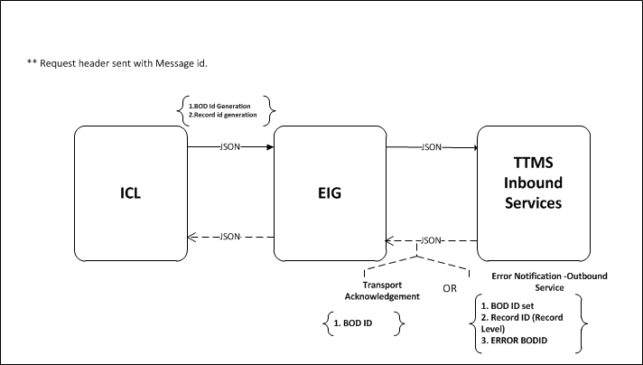

    - The BOD id should be set on both request headers and message payload from ICL side
    - The same BOD id has been reset on the response headers during the transport acknowledgement from TTMS
    - The error notification from TTMS will have the BOD ID. The Error BOD ID has to be set back to ICL when the error notification send from TTMS. The record id will be setback only when the error notification is on the record level.

Message Format – Outbound Flow
Please find the below diagram for the outbound flow message format.
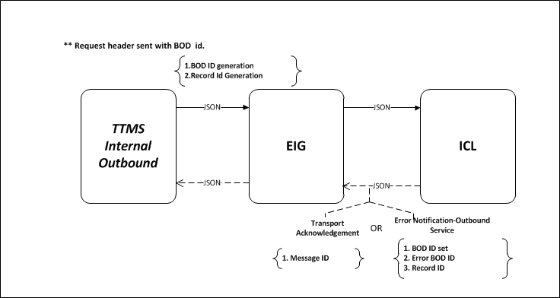

    - The BOD id should be set on both request headers and message payload from TTMS side
    - The same BOD id has been set back on the response headers during the transport acknowledgement from ICL
    - During the Error notification, TTMS will send the same BOD Id that was received from ICL, ICL has to send the error message back with new BOD id considered as a new transmission. But ICL has to set the Error BOD in the payload addition with new BOD ID.
    - TTMS will check if any error BOD ID in the request then it will mark the ERROR BOD ID as logically complete and gives the reference to the new BOD ID that has been received from ICL.

Web Service Pattern - Sequencing / Conversation across Service Calls

Web Service Pattern - Error Handling

Transport level Error Handling

Inbound Transport Error Scenarios

Please refer the below table for the list of inbound error handling scenario at the transport level.

Scenario  No | Downtime Scenario | Source | Target | Expected Response from Provider | Expected Behavior from Source
1 | ICL is not able to send messages –  (Refer Step1 in the picture) | ICL | EIG | 1.TCP/IP Errors  1.a Network issues  1.b F5 and network issues  1.c Data power/framework down  2. HTTP Error code  2.a EIG service is down  3. JSON Fault code & HTTP Error Code  3a.Security errors  3b.Format Errors | 1. Retry the message with number of intervals and number of attempts to be defined. (Except 3a and 3b)  2. Alert should be sent to TTMS support and EIG to address the issue with priority  3. Stop the retry when the retry fails continuous interval and > threshold limit  4.ICL has to stop the inbound flow process until EIG services back to normal
2 | EIG is not able to send messages  (Refer step2 and 4) | EIG | TTMS Web Services, ICL Services | JSON Fault code  3.c. TTMS service down  3.d ICL service down | 1. Alert should be sent to TTMS /ICL support from EIG every 5 minutes to address the issue with priority  2. ICL need to do the retry when TTMS is down
3 | TTMS Web Services is not able to send messages  (Refer Step3) | TTMS Web Services | EIG | 1.TCP/IP Errors  1.a Network issues  1.b F5 and network issues  1.c Data power/framework down | TTMS sends the alert to ICL and EIG support group.

Outbound Transport Error Scenarios

Please refer the below table for the list of inbound error handling scenario at the transport level.
Scenario  No | Downtime Scenario | Source | Target | Expected Response | Expected Behavior (Source)
4 | TTMS Web Services is not able to send messages  (Refer Step1 ) | TTMS Web Services | EIG | 1.TCP/IP Errors  1.a Network issues  1.b F5 and network issues  1.c Data power/framework down  2. HTTP Error code  2.a EIG service is down  3. JSON Fault code & HTTP Error Code  3a.Security errors  3b.Format Errors | 1. Retry the message with number of intervals and number of attempts to be defined. (Except 3a and 3b)  2. Alert should be sent to ICL and EIG to address the issue with priority  3. Stop the retry when the retry fails continuous interval and > threshold limit  4.TTMS web service has to stop the inbound flow process until EIG services back to normal
5 | EIG is not able to send messages  (Refer step2&4) | EIG | ICL,TTMS | 3. JSON Fault code & HTTP Error Code  3.c. TTMS service down  3.d ICL service down | 1. Alert should be sent to ICL /TTMS support from EIG every 5 minutes to address the issue with priority  2. TTMS need to do the retry when ICL is down
6 | ICL is not able to send messages  (Refer step3) | ICL | EIG | 1.TCP/IP Errors  1.a Network issues  1.b F5 and network issues  1.c Data power/framework down | ICL sends the alert to TTMS and EIG support

Business level Error Handling
Please refer the ICE document “TMS API Message Model Standards and Guidelines” to follow the guide’s lines to define business level error handling. The JSON messages should return the exceptions as shown in the below sample. This should include the timestamp, status type, status code & description and details about the exception in details.

- The transport acknowledgement does not have any business error response other than the transport or HTTP error codes and JSON System exceptions. Error notification will send back to the consumer only when the message get started processing from TTMS internal inbound application.
- The BOD ID will be set in the error response.
- The business exception will be sent back to ICL with same request payload. (This need to be discussed case by case)
- TTMS may send consolidated one error message for the bulk records. The decision will be taken case by case. ( The table will be updated later)

Example: Business Exception in JSON Response message format

"ServiceStatus": {
"TimeStamp": "2014-06-19T19:49:03-07:00",
"StatusType": "BUSINESS_EXCEPTION",
"StatusCode": "1",
"StatusDescription": "BUSINESS_EXCEPTION",
"System": "TTMS",
"BusinessException": {
"ErrorCode": "11",
"ErrorDescription": "VIN Entered is Invalid. Please re-enter VIN"
}

MQ Inbound Pattern I - TTMS Inbound Web Services publish the messages to TTMS
TTMS inbound services receives the events from ICL through web service. TTMS inbound web services will write this message to TTMS internal inbound queues. The message will be read by one of TTMS interface application. The MQ inbound pattern is the continuity pattern of Web service inbound pattern Web Service Pattern I – Inbound Services Integration .
The following diagram explains the MQ inbound pattern with detailed steps.

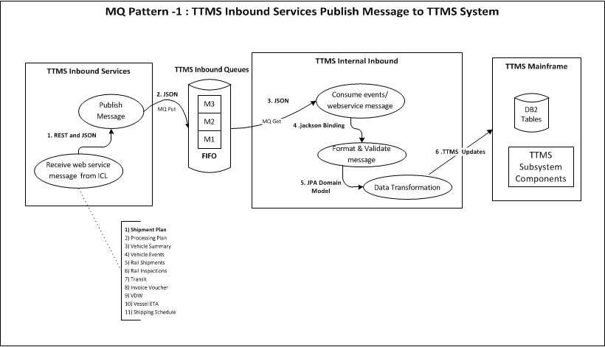
The numbering on the diagram indicates that the message format is being used across between different components.

Chronology of Events

- Receives the Webservice Message : TTMS inbound services receives the web services message from ICL
- Publish the Message: TTMS inbound services publish the event messages to TTMS inbound queues.
- Consume Web service message: Shipment Plan, Vehicle and all inbound events are read from TTMS internal inbound queues by TTMS internal inbound application.
- Format and Validate the message: The message has to be formatted appropriately and marshalling data is read and validated with mandatory fields.
- Data Transformation: Webservice specific message will be transformed to JPA domain specific model.
- DB2 Updates: The transformed message will be updated to TTMS mainframe DB2 tables and TTMS Sub system specific data formats.

MQ Pattern II – NVS Publishes data to TTMS
The Dealer Assignment, Hold, Damage, Stop Sale use case are the example in which NVS publishes the data to TTMS. The NVS publishes vehicle inventory changes and TTMS is subscribed to receive those changes. This is considered to be an abstract integration in that the consumer applications are not aware of the provider data format or data transport protocol.
Please refer the next continue pattern Internal Webservice Pattern I – TTMS Internal Outbound calls TTMS Outbound Services

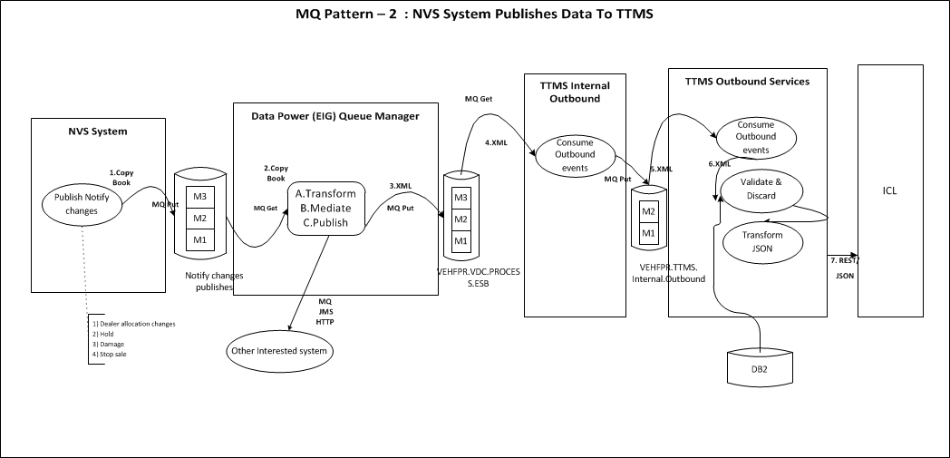

The numbering on the diagram indicates that the message format is being used across between different components.

Chronology of Events

- Publish Notify Change Events: NAP production confirmation (PROCON) change is sourced and published as a copybook on to the ESB.
- EIG Mediation: The EIG reads the message and transforms the message from Copybook to XML and then publishes it to interested parties over multiple platforms. The EIG interaction pattern that is utilized to support this requirement is publish/subscribe. If enrichment of the message published to TTMS is necessary, the EIG mediator Pattern working in conjunction with the Synchronous Request-Reply pattern to invoke a data service that provides the data to enrich the message can be utilized.
- Other Interested Systems: The event can be published to other interested subscribers.
- Consume Notify change message: The TTMS Integration Layer consumes the Dealer allocation, hold, damage and stop sale events.
- Format and Validate the message: TTMS Outbound specific validations and discard may happen specific to the event types and the message is enriched
- Data Transformation: XML message will be transformed JSON message format.
- Post to ICL: sends the JSON message to ICL using REST webservice pattern.

MQ Pattern III – NPPS System feeds Data to TTMS
The AQA, FQA, LPR use case are the examples in which NPPS system feeds data to TTMS through EIG. The NPPS plant and port systems publish event information that is used in the VDC events. TTMS is a subscriber to VDC event data and will be notified via a MQ message when the VDC events are published. It uses publish and subscribe message exchange pattern.

The numbering on the diagram indicates that the message format is being used across between different components. Please refer the next continue pattern Internal Webservice Pattern I – TTMS Internal Outbound calls TTMS Outbound Services

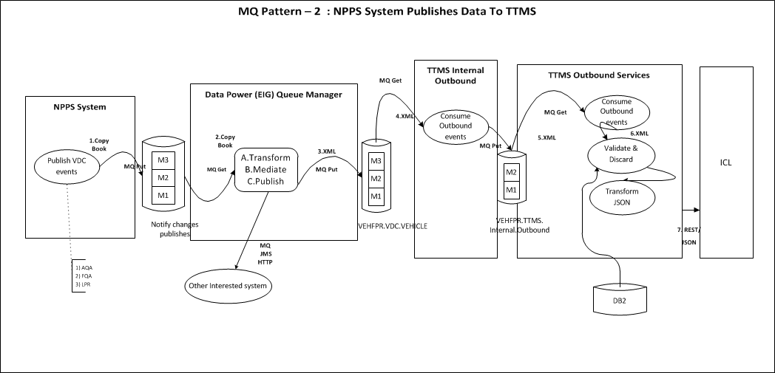

Chronology of Events

- Publish VDC Events: VDC events are sourced and published as a copybook to EIG from NPPS system.
- EIG Mediation: The EIG reads the message and transforms the message from Copybook to XML and then publishes it to interested parties over multiple platforms. The EIG interaction pattern that is utilized to support this requirement is publish/subscribe. If enrichment of the message published to TTMS is necessary, the EIG mediator Pattern working in conjunction with the Synchronous Request-Reply pattern to invoke a data service that provides the data to enrich the message can be utilized.
- Other Interested Systems: The event can be published to other interested subscribers by EIG.
- Consume VDC Events: The TTMS Integration Layer consumes the AQA, FQA and LPR events.
- Format and Validate the message: TTMS Outbound specific validations and discards may happen specific to the event types and the message will be enriched.
- Data Transformation: XML message will be transformed to JSON message format.
- Post to ICL: sends the JSON message to ICL using REST webservice pattern.

MQ Pattern IV – TTMS Bulk Records Splitter
TTMS Bulk Records Processing MQ integration pattern uses the splitter message exchange pattern. VESSEL ETA, VDW use cases are the expected use cases for applying this pattern. The advantage of this pattern to split the messages into single units and process them in a parallel way. It reduces the overall processing time and avoids high memory consumption.

Please find the diagram which is explains the process of bulk record processing pattern.
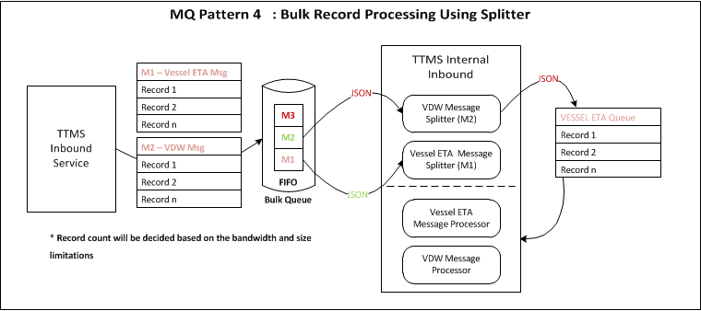

Chronology of Events

- Publish Bulk Record Events: TTMS inbound services publishes the bulk records into the bulk queue through one single message. This bulk will be designed to accept one single bulk message for each different bulk category.
- Bulk Message Type Splitter: Based on the bulk records type (VESSEL WTA, VDW..etc.) , the respective Splitter type has to be configured. This splitter will be responsible for doing the combined record validations before publish single message for each element. Finally the Splitter publishes the single message to respective processing queue.
- Message Processor: The message processor will consume the single message and do the respective business validations subsequently will process the message.

MQ Message Exchange Patterns

MQ Message Exchange Pattern I – Publish Subscribe
Applications that communicate through publish and subscribe paradigm require the sending applications (publishers) to publish messages without explicitly specifying recipients or having knowledge of intended recipients. Similarly, receiving applications (subscribers) must receive only those messages that the subscriber has registered an interest in. This form of asynchronous messaging is a scalable architecture, since message senders need only concern themselves with creating the original message, and can leave the task of servicing recipients to the messaging infrastructure.
A subscriber subscribes to a queue by expressing interest in messages posted to that queue and by using a subject- or content-based rule as a filter. This result in a set of rule-based subscriptions associated with a given queue. At runtime, publishers post messages to various queues. The queue then delivers messages that match the various subscriptions to the appropriate subscribers.
The decoupling between senders and recipients is accomplished by the EIG which resides between the publisher and the subscriber and delivers the message to the appropriate subscribers based on the subscriptions.

The following figure illustrates publish and subscribe functionality.

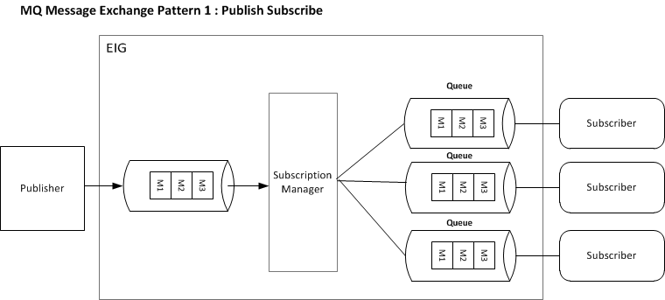

MQ Message Exchange Pattern I I– One Way Notification Pattern
In this pattern, an application sends a request to a target application and then continues its own processing, while the target application handles the request independently. The sender does not have to wait either for the remote processing to complete, or for a reply to come back. Instead, the thread sends the message and continues processing client requests. The target application need not even be “up and running” at the time the sender sends the request. When using asynchronous communication, applications are loosely coupled. The requesting application is not bound to the responding application, or to the communication delivery mechanism. The application must acknowledge the message receipt. This mode gives the application (rather than the JMS provider) complete control over message acknowledgement.

The interaction between the components is shown in the following diagram:

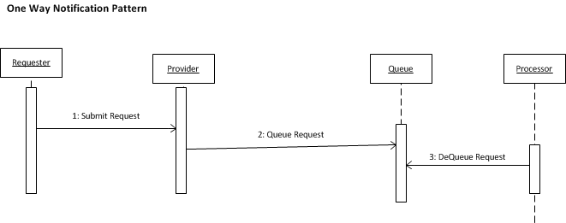

MQ Message Exchange Pattern III – Message Splitter Pattern
Splitter breaks out the composite message into a series of individual messages, each containing data related to one item. In other words Splitter that consumes one message containing a list of repeating elements, each of which can be processed individually. The Splitter publishes a one message for each single element (or a subset of elements) from the original message. This message exchange pattern is being applied in the Bulk Message Integration Pattern.

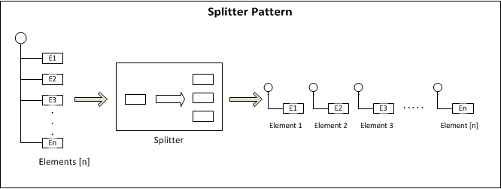

MQ Pattern - Message Format

MQ Pattern – Inbound MQ Message Format
TTMS inbound service has to write the ICL event messages into ttms inbound queues. ICE JSON schema message format is used to write the queue message. It uses the same JSON message structure which is being consumed in the EIG layer. Using same EIG JSON message format avoids the additional transformation. TTMS internal inbound application has to consume the same message format and do the JSON to Java-POJO transformation.

The inbound MQ message format is given in the below diagram.

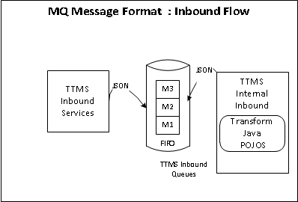

MQ Pattern – Outbound MQ Message Format
Please refer the below diagram for the message format used across during MQ outbound message flow.
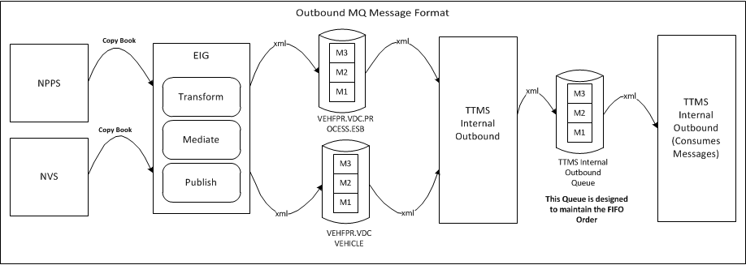

- NPPS and NVS has to send the copy book layout to EIG, It follows the AS IS process.
- EIG has to transform copy book to TTMS XML message schema, same as current process.
- TTMS internal outbound has to consume the xml message and puts into a common outbound queue.
- Again TTMS internal outbound consumes the messages and delegates to the outbound services. EIG has to update the schema to differentiate the different queue events and adopt the error configurations on the top of existing message format.

MQ Pattern - Error Handling

Transport level Error Handling
The transport level error handling for MQ has been arrived with following scenarios.
Scenario  No | Downtime Scenario | Source | Target | Expected Response from Provider | Expected Behavior from Source
1 | NVS and NPPS not able to Post the messages | NVS | EIG | 1.TCP/IP Errors  1.a Network issues  1.b F5 and network issues  1.c Data power/framework down  2.a EIG service is down | Same as current process
2 | EIG is not able to write messages (TTMS Internal Outbound) | EIG | TTMS | 1.TCP/IP Errors  1.a Network issues  1.b Queue Manager is down  1.c Storage is exceeded  1. d Max Queue depth has been reached. | Since the queues have been designed as persistent queues the messages will be retained in the queues  The Governor monitor has to check the queue depth at regular interval and alert the backlog count reached more than the configured limit.  If any Storage issues, The Storage alert need to be sent to EIG and TTMS  EIG has to send the alert if any infrastructure issues
3 | TTMS is not able to Consume messages (TTMS Internal Inbound, TTMS Internal Outbound) | EIG | TTMS | 1.TCP/IP Errors  1.a Network issues  1.b Queue Manager is down  2.a TTMS Internal inbound application is down | Since the queues have been designed as persistent queues the messages will be retained in the queues  The Governor monitor has to check the queue depth at regular interval and alert the backlog count reached more than the configured limit.  If any Storage issues, The Storage alert need to be sent to EIG and TTMS
4 | TTMS is not able to write the messages (TTMS Inbound Services) | TTMS Inbound Services | TTMS Internal Inbound | 1.TCP/IP Errors  1.a Network issues  1.b Queue Manager is down  1.c Storage is exceeded  1. d Max Queue depth has been reached. | Since the queues have been designed as persistent queues the messages will be retained in the queues  The Governor monitor has to check the queue depth at regular interval and alert the backlog count reached more than the configured limit.  TTMS has to send the alert to EIG and Support team.

Business level Error Handling
The Business level errors will be handled in 2 ways.
- The business failure message exceptions will be written into the error queues. The generic error handling and reprocessing design will be applied for each interface.
- ICE schema will be modified to have the error message, status, description and the number of attempt. This will help to automate the error reprocessing and troubleshooting the issues.
  - System Integrations – To be Updated

VDW integration

TOMS integration

Audit Integration
The purpose of audit system is to keep track of the transactions of message. In TTMS application, it will help us in identifying the current status of each messages that flows in and out of the system. Each message will be identified with unique parameters as BOD ID and Record ID.

Both the success and the failure transactions are logged in Audit table. When the message is successfully processed, the status of it is marked as processed. Similarly when the message fails processing. The status will be marked as Error along with the root cause of the error. So In case of any failure, instead of referring application logs or doing manual analysis, auditing table can be referred easily. This is a time saving process and reduces manual effort.

The below diagram represents the generic design of Auditing process.

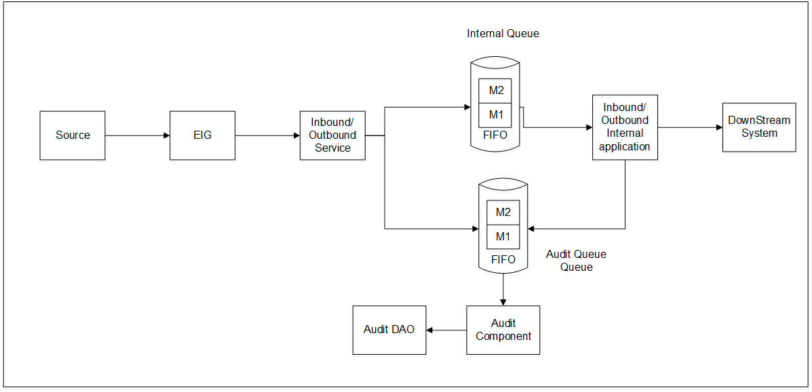

- The message from source will be posted to internal queue and audit queue by internal/outbound service
- The message placed in the audit queue will be consumed by audit component and the details will be updated in audit database
- The messages placed in the internal queue will be consumed by internal application in which the functional validation is done.
- Once the validation is done, the message will be posted to audit queue which in turn is consumed by the audit component and status is updated in the audit table

For detailed description, please refer Auditing Common component design in TTMS Application Design Document.
  - Security Integrations
Refer to security view section 10 for details.
  - DevOps/ITops Integrations

Build Farm Integration
To align with the enterprise strategy, Maven repository will be built for TTMS. Also as part of TTMS simplification (Plain vanilla JEE) applications to the new infrastructure is planned with navigation changes. The build and deployment will be done thorough build farm agents through build farm servers. As part build management process a new stream will be created with Sonar integration to analysis the code quality.

Fog light Integration
The Quest Fog light will be used for application monitoring; it also provides application server health check and performance monitoring. The Fog light integration solution is adopted as part of TMS enterprise service solution.

MQ Integration
IBM MQ will be used for all for all the inbound outbound queue design. The option has been decided to go with IBM MQ hosted on mainframe due to the robust and ease of use existing Mainframe outbound MQ integration.

Host DB2 Integration
TTMS applications, both the inbound and outbound applications will be using the DB2. The design should consider to reuse the existing TTMS tables in order to avoid any impact to the downstream system components or tables.

My SQL Integration
The new MY SQL database s recommended to use as application database by considering the below factors.
- Any Master or reference tables are needed for TTMS application.
- Role and Entitlement Mapping
- VDW staging tables
- Any intermediate staging tables need to store the interface data. (To be decided)

- Deployment View
The deployment view of To-Be system is shared below. The deployment view represents the relationships between the deployable packages and their physical nodes. The physical server and infrastructure design will be updated later with more details.
  - Deployment Domain Overview
The following diagram explains the deployment overview of the application.
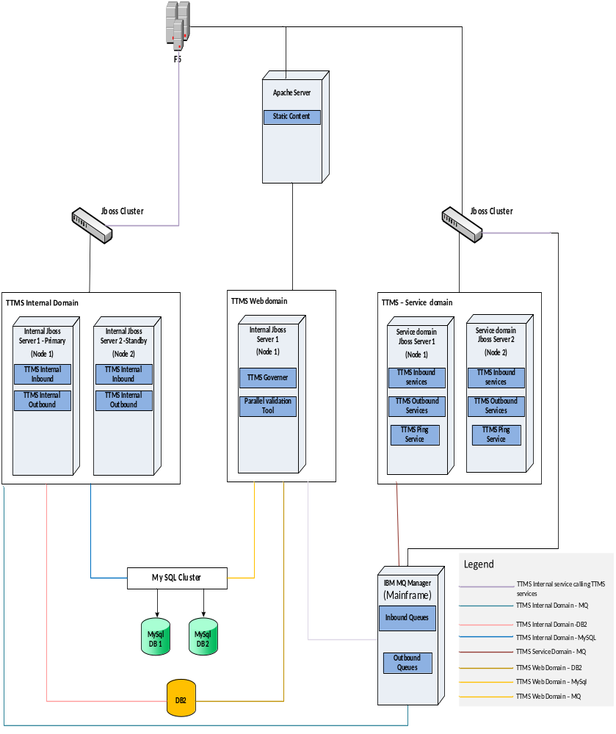
The three new JBOSS domains have to be created in order to achieve the TTMS Deployment Solution.

TTMS Services Domain: TTMS inbound and outbound web services will be hosted on this domain. TTMS Services domain does not use the OHS server. The Load balancing and failover will happen on the F5 Layer. F5 will communicate directly to JBOSS Cluster as given in the domain view diagram. F5 Will act as load balancer and do the failover switch. TTMS should provide a URL ping service that F5 would use to check the health of the application. If F5 detects the URL is not responsive then it routes to the active node. It will follow the standard TMS load balancing and failover pattern with high availability considerations.

TTMS Internal Domain: TTMS internal inbound and outbound applications will be hosted on this domain. At a high level, the idea in this deployment pattern is to clone a single-machine instance and place it as two independent instances with an active-passive configuration. While all the instances are running and ready to serve requests, the MQ Manager will only hand over requests to one of the instances, designated as the primary instance. If MQ Manager detects that the primary instance is unavailable, incoming requests are then redirected to a failover or standby instance. Highly available single-machine deployment with standby instance. Administrators connect to each instance separately. Both instances have an identical copy of the server directories and configuration store.

TTMS Web Domain: TTMS Governor and parallel validation web applications will be deployed in this domain. TTMS Governor needs a separate domain in order to monitor the services and internal domains. Single node server is sufficient since it does not have any business process or high availability requirement. If any future requirement to develop a business web applications then the configurations need to be revisited.

Apache HTTP Server: This server is responsible for routing the requests through Toyota Enterprise Security Services (TESS). The OAM Web Gate agent plug-in installed on this server will be used for routing security requests to TESS components.
  - Deployment Components Overview
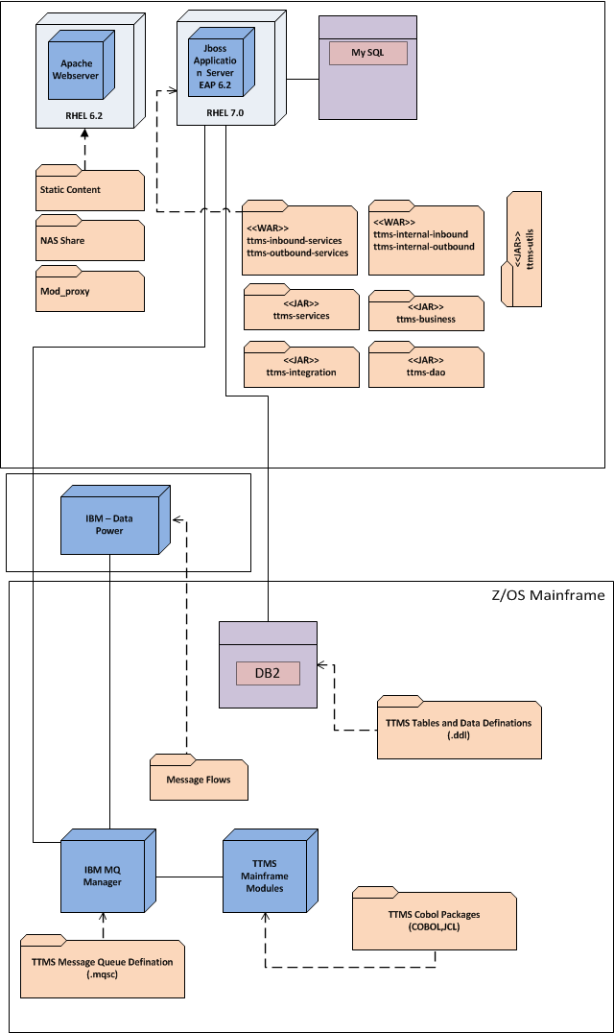
    - Nodes/Servers
The nodes and servers that are relevant to this project are listed in the below.
Node | Server
RHEL | Apache Web Server
RHEL | JBOSS Application Server
? | MY SQL
Mainframe | DB2 DBMS
Mainframe | WebSphere MQ Server
Mainframe | z/OS Batch, CICS

    - Deployable Packages
The deployable artifacts that will be handled during the construction of this project are listed below. These artifacts will be used to deploy and configure the system.
Node | Server
Inbound Services | War file
Outbound Services | War file
Governor | War file
Internal inbound | War file
Internal Outbound | War file
Message Queues | Mstc scripts
COBOL Scripts/packages | Binaries
Parallel Validation Tool | War - Only will be deployed till the QA environment and not in production.

TTMS Web Services: TTMS Rest web service JEE application will be deployed as web module (war).
TTMS Web application (WAR):
- TTMS applications will be deployed as a WAR file on the JBOSS instances.
- A separate WAR file will be created associating the web modules
- The utility will be deployed as a shared library (JAR file)
- The core business and services will be deployed as a shared library (JAR file). External library dependencies will be injected out by creating a separate shared library for external library dependencies (JAR file).

The Final war will assembled with dependencies of JARS deployed as war on the JBOSS server instances. The build will be done using build farm tool with help of Maven build scripts.
  - Code Package View
The following diagram illustrates the high level code view of the application. Please refer the application design document for more details of sub level view during end of the elaboration phase.
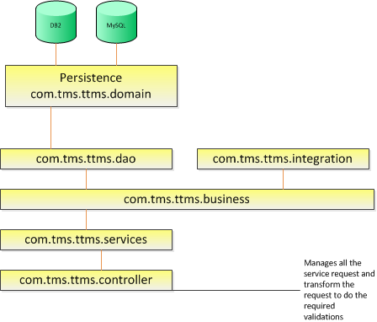

- Security View
Security view for TTMS is shared below. The below sections depicts that the security communication between the external, internal and the application layer and container services.
  - ICL-TESS SSO Integration
As part of ICL SaaS software as a solution to TLS business, TLS users are needed to login and perform the key business operations in the ICL portal .SAML 2.0 protocol will be leveraged to facilitate this functionality.
The TESS federation solution will improve user experience by seamlessly allowing users to transition across domains using SSO and single-sign-off.

TMS will act as both an SP for external users to utilize TMS’s resources and as an IDP to federate internal users to use services in other affiliate domains. This federation service will enable users to authenticate and use authorized resources without the need to enter application credentials multiple times. User identity will be federated, and sessions will be managed to enable single sign on and single sign off across realms. There are 2 patterns are applicable to implement the SSO federation solution as described below sections.
The recommendation is to use SP initiated identity federation over HTTP for ICL to integrate with TESS for TLS users to authenticate the ICL system. The key decisions are
- Use SP-initiated (via SSO SAML) – better supported by HTTP
- IDP initiated doesn't allow for deep linking – May force to put a federation server in the URLs, federate with custom federation services based on Open SAML.
- There should be a custom URL (e.g.: toyota.icl.com) instead of (icl.toyota.com)
- Suggestion to have access to the roles in real-time as the roles change often (as opposed to a nightly feed).
  - Web Service Security Pattern
The following are the key security specification of the TTMS Integration application. The below diagram explains the details of security flow between ICL, EIG and TTMS inbound flow and the outbound flow.

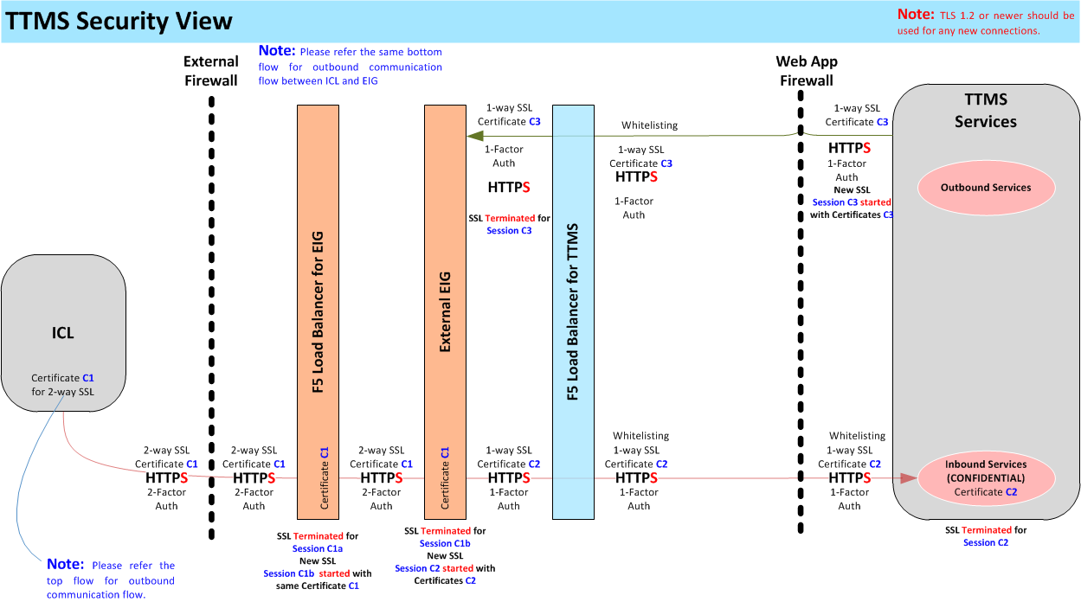

- Two way mutual SSL between ICL and EIG (TMS) (Inbound and Outbound Services)
- One Way SSL between EIG to TTMS Inbound Services, Same way One way SSL between TTMS to EIG for the outbound communication. IP Whitelisting has to be performed on the TTMS back end services to accept the requests that are coming only from EIG.
- EIG has to perform the service account validation for the requests coming from ICL (TTMS Inbound Services)
- ICL has to perform the service account validation for the requests coming from EIG (TTMS outbound)

  - Internal Security Pattern

Internal Web Applications Security Pattern
The new TTMS Governor system is a secure web application which will be using TESS Security Framework for Authentication & Authorization and adheres to most of the security guidelines enforced by the EA team. Communication from the client browser to the web server will be over a Secure Socket Layer (SSL).The Governor System will be accessed in TMS intranet and internet access channels.
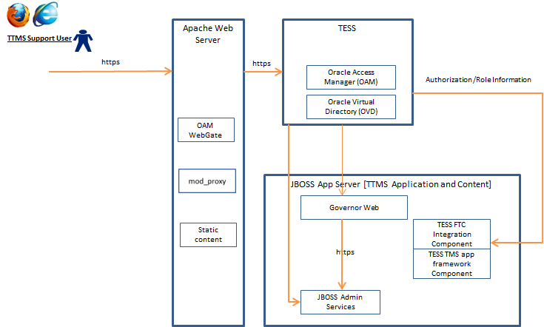

MQ Security Pattern
All the new TTMS integration applications will use the application account created by MQ manager. The account has to be configured in the application server (JBOSS). Each request will be validated for the valid credentials to establish the MQ connection. IP Whitelisting has to be set between MQ manager and the required JBOSS server instances.

Database Security Pattern
All the new TTMS integrations have to use the Database account created from the respective database. The JBOSS servers have to configure the account to do the DB operations. IP Whitelisting has to be set between Database server and the required JBOSS server instances.

- Process View
The solution architecture primarily leverages TMS infrastructure process, the process view is not drawn at application level. This section describes the tasks (processes and threads) involved in the system's execution and their interactions and configurations. The below diagram shows, TTMS Simplification process at high level for both the inbound and outbound process flow:
This diagram shows processes that are involved in TTMS integration application.

  - Inbound Process View
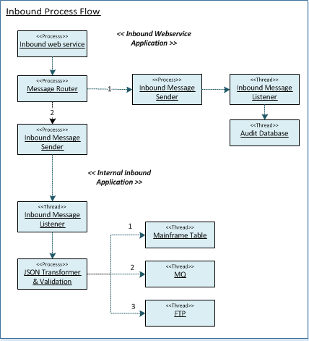

- TTMS Inbound Web Service – This process is responsible for servicing TTMS inbound webservice requests.
- Message Router – Message router is the process to route the same message into two different Audit and functional queue process.
- Audit Message Sender – Audit Message sender is the process to send the message to audit queues for tracking the request.
- Inbound Message Sender – Inbound Message Sender is the process to send the incoming inbound messages to the respective functional inbound queues.
- Inbound Message Listener – Inbound Message Listener is the process in the internal inbound application, the message listener consumes the message from the inbound queues.
- Transformation and Validation Process – This process transform the JSON to Java Model and does the required mandatory and data length validations and finally sends to any one of the process TTMS mainframe tables,MQ or to the FTP server.
  - Outbound Process View
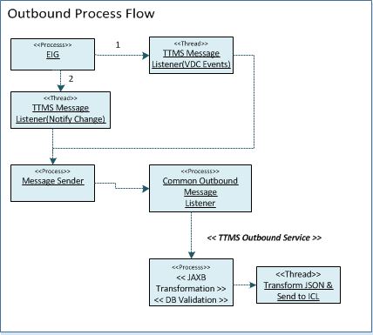
- EIG Mediation Service – This process is responsible for receiving the message from source system and transform the message and put into the TTMS associated queues.
- TTMS Outbound Message Listener – Message Listener is the process to consume the messages from EIG queues.
- TTMS Outbound Message Sender – TTMS Outbound Message sender is the process to send the message to the common outbound queue.
- Common Outbound Message Listener – Common Outbound Message Listener is the process in the TTMS outbound services, the message listener consumes the message from the consolidated outbound queue.
- Transformation and Validation Process – This process transforms the XML to Java Model and does the required mandatory and data length validations and finally sends the message to ICL.
- Implementation View
This section describes the overall structure of the implementation model, and the decomposition of the software into layers and subsystems. The Implementation view depicts the physical composition of the implementation in terms of the components and the tiers that make up the system. The detailed architecture of the various tiers will be documented in the ADD.
  - Solution Overview
An important aspect of the architecture is separation of concern by encapsulating and isolating code in the appropriate layer. The layered approach provides the following benefits.
Improves Reusability: The well-defined boundaries and/or division of responsibility of each layer enable compartmentalization of the components into logical domains. This approach drives reuse.
Reduces Complexity: Aligning each component with a clear and standard division of responsibility (a layer model) renders the overall system more comprehensible. Typical patterns and models can reduce complexity.
Improves Resiliency: Interactions are better defined and localized. The abstraction that is inherent in layering isolates the impact of various types of system changes. Testing can be focused better with increased isolation of target components.
Improves Changeability: This involves grouping responsibilities into standard domains. Utilizing standard APIs for accessing the layer functions allows for easy replacement of components within a layer.
By considering the layering benefits, modularity and easy to extend principles, the following new TTMS JEE applications have been classified.
- TTMS Inbound Services is a web service application. It will receive the request from ICL and put the message in the inbound queues and sends the transport acknowledgement to ICL on the same response. TTMS inbound services will provide the service end point to EIG. JSON will be used as message format and uses the REST Webservice architectural pattern.
- TTMS Internal Inbound is a web application. It will read the messages from the inbound queues and process those messages. The FIFO order will be maintained to process the messages. TTMS internal inbound will provide an MQ inbound endpoint type that can be used by TTMS inbound services. .All data published will be persisted .The preferred data format for message content will be defined in the TTMS JSON message schema. This schema has not been yet developed. More than one MQ Endpoint might be implemented to support messages of different interfaces. Each MQ endpoint or queue will drive its own instance of a JMS Listener in the TTMS Java framework. Some of the data being published by TTMS inbound services will be persisted in DB2 tables.
- TTMS Internal Outbound is a web application. Some of the data being published by Source systems will be consumed by EIG. EIG will read the outbound messages from the EIG queues and transform into TTMS specific message format and put the messages into the TTMS queues. TTMS internal outbound will consume the message. The FIFO order will be maintained to process the messages. All data published will be persisted, format for message content will be defined in the exiting outbound TTMS XML message schema.
- TTMS Outbound Services is a web application. It will consume the message written TTMS internal inbound. TTMS internal outbound sends the input information received from NPPS and NVS system to TTMS outbound services. TTMS outbound services will do the actual discard and business validations and enrich the data required for ICL. Sends the data to ICL using REST and JSON format.
- TTMS Governor is a web application that will provide the monitoring control to the integration service applications. The Governor application also will provide the health check volume report that is being received from different ttms integration services. TESS will be used as security layer as per TMS standards.
VDW system will extract the information from TTMS staging tables through the ETL process.
The following mainframe jobs have been used or integrated with TTMS system to do the completion TLS business and Logistics operations integrated with TTMS system. VJ02DX (VESSEL ETA): It is a Mainframe batch job which extracts the Vessel ETA information and writes into flat file for downstream application to process. It runs at 8.00 PM PT 7 days a week.
The following are the existing TTMS mainframe components and works same as in to be system with minor changes to adopt the ICL data.
VTM3DX ( Payment Voucher) : It is a Mainframe batch Job which pulls approved vouchers from ICL and writes into Voucher and Voucher VIN table. It creates Accounts Payable flat file from Voucher and Voucher VIN table and sends it to FTPR. It creates payment summary file and sends it to FHDS. It runs at 6.30 PM PT Monday thru Friday
VTM512/VTM020 (Route Info): Downstream applications call the Program VTM512 or VTM020 which in turn extracts the route information from Shipment Plan or Transit table.
VTM5DX (Route Info) : It is a Mainframe job which extracts routes from Master Transit Table and loads in TOMS database. It runs Monday thru Friday at 1.00 A.M.
VT23DX (Route extract for VASCOR) : It is a Mainframe job which extracts Salamanca Primary and Secondary routes from Master Transit Table and FTPs to VASCOR, a third party vendor.
VTM4MX (Accruals) : It is a Mainframe batch Job which pulls timing and process accrual records from ICL and writes into Voucher and Voucher VIN table. It creates GL fat file from Voucher and Voucher VIN table and sends it to FTPR. It runs on FIRST DATE OF ACCOUNTING MONTH AT 01:30AM.
  - Architecture Layered Guidelines
Following are the general guidelines followed while designing each layer:
- Every component must be logically placed in exactly one layer. If the responsibilities of a component span those of more than one layer, the component should be decomposed to match the division of responsibility defined by the various layers. This preserves the cohesiveness of both the components themselves as well as of the layer
- Each layer is defined by its domain responsibilities and utilized by an API which is either standard or implements a set of consistent and cohesive API patterns that are intrinsic to the specific domain. No aspect of the layer, other than its well-known API’s, shall be exposed.
- Each layer should be completely abstract from the other layers. Inter-layer dependencies should be limited to layer APIs.
- The layer model classifies components and subsystems into high-level layers, but does not show the layering within each component.
The implementation view is provided in ADD as it describes the implementation of application components through class diagrams and sequence diagrams.
- Technology View
  - Technology Stack

Technology | Supplier | Version | License
JDK | Oracle | 1.7.0_51 | Open Source
Apache Http Server | Apache | To be Updated | Open Source
JBOSS Server | Red Hat | EAP 6.2 | Licensed
Toyota Logging Framework (SLF4J) | Toyota / Apache | tms-eaf-core-3.2.x | Open Source
Toyota Exception Handling Framework | Toyota | tms-eaf-core-3.2.x
Spring Framework | Spring Source | 4.1.4 | Apache Software License
EhCache / Toyota Caching Framework | Toyota / Ehcache | 2.6.9 | Licensed
Transaction Management (JPA) |  | 2.0.0 | Standard Java Library
Hibernate | Red Hat | 4.2.7.SP1 | GNU LGPL
Hibernate Validator | Red Hat | 4.3.1.Final | GNU LGPL
DB/2 Database | IBM | 10.1.5 | Licensed
Toyota Enterprise Security Services (TESS) | Toyota / Oracle | R2 (11.x) | Oracle stack/Licensed
FogLight | Quest Software | 5.6.10 | Licensed
HTML | N/A | 5 | N/A
MY SQL SERVER |  | To be Updated
TMS App Framework | Toyota | 3.2.2-Release
Log back | Log back QOS | 1.1.2 | EPL and LPGL
Junit | Junit | 4.2 | Eclipse Public License
Mockito | To be Updated |  | MIT License
Fasterxml Jackson |  | 2.5.1 | ASL, LGPL
REST Easy | JBoss | 3.0.10 | CDDL v1.1 and GPL v2

  - Foundation Components
This section describes the overall foundation components.
# | Component Name | Trigger | Available in TMS framework
1 | TMS App framework TESS component | To Implement the Enterprise Tess requirement | Yes
2 | E-mail notification | To send e-mails for notification | Yes (Core piece exists)
3 | Role configuration | Establish the core patterns for consistency | No
4 | Record audit | Centralize common audit updates such as 'Updated by', 'Updated on' etc., Also the dedicated common framework has to be used. | Yes, Hibernate Envers but need to develop the dedicated customization for TTMS simplification.
5 | Error message processing and display | Consistency and reuse across the application | No
6 | Utilities | Reuse common validation rules across the modules.  Common date and data formatter utilities. | No
7 | Exception framework | Consistency and reuse across the application | Yes (Core classes exist)
8 | BOD ID Generation | Consistency and reuse across the application | No – Waiting for Confirmation
- Architectural Risks and Impact
This section provides all information necessary to assess the risks and impact of the solution that was selected.
  - Financial Impact and Risks
No | Risk | Impact | Mitigation
1 | Plan of execution from all teams need to be in sync. | This impacts the cost and schedule. Current expected schedule will have delivery date in year 2017. | Come up with better approach of running components in parallel thereby reducing the timeline which intern helps reduce cost.
2 | During the analysis or testing phase, not enough quality data | Might delay/increase the QA & Dev effort | As per the agreed ICL Guidelines, Integration will deliver the JSON output. TMS needs to validate and provide sign-off
  - Potential Business Impact
- There is no roll back plan and hence this is a critical risk to business
  - The mitigation plan is to conduct parallel validation between the current OTM and the new ICL system for three months.
- Real time information flow for Tender and Tender withdraw is critical to business operation
  - Potential System Impact and Risks

Assumptions and Constraints
Does the architecture assume particular data structure or table data are not changed in production during the development? Does the solution design assume no online activities on concerned transactions should happen before the changes go in production? Does the architecture resolve only part of the problem identified and will leave the resolution of other parts to another work? Does the design assume deployment happens before or after a particular date or a particular event? Does the design depend on the correctness of certain portion of analysis or changes made by another development team or project that the current development team has not yet comprehended in full confidence?
Date | Type | Description | Comments
08/07/2015 | Assumption | TMS recommended technology stack and app framework will compatible with the solution scenarios that are identified.
08/07/2015 | Assumption | The existing mainframe components jobs may undergo minor changes.
08/07/2015 | Constraint | The new TTMS solution architecture should adopt the existing downstream components and platform with minor changes.

Dependencies
ICL, EIG and VDW applications changes with respective to build the new TTMS integration application should be aligned with TTMS integration application project timelines.
The other downstream applications are needed to be part of integration testing ensure the “to be” data flow is consistent after the integration with ICL.

Performance Analysis
The performance impact candidates are assessed. The requirements are simplified wherever possible.
Simplify the integration requirements in order to meet the business performance expectations. The POC is required to validate the expected throughput. The scope of the POC is to prove that both the inbound and outbound queue with single instance (for each queue) will meet all the performance requirement.

- Implement critical Use case and do the load testing to validate the framework layering and critical use case performance in order to avoid last minute troubleshooting and spent huge effort to isolate the modules.
- Complete Performance and Integration testing for all the modules to meet the expected response time.

Environment Analysis
No global impact is foreseen however will be evaluated during elaboration phase.

- Risk Log
No |  | Date | Risk Description | Mitigation
1 | 08/06/2015 |  | The high dependency with ASP will become complicated when plan to switch the vendor or build the proprietary solution. | The risk can be minimized by sudden extent by designing the loosely coupled design that can be reused when decide any other options in future.
2 | 08/17/2015 |  | REST pattern does not support message level encryption but when TMS EISP change in decision to adopt message level security that will lead the restructure of service layer. | The risk can be mitigated by designing the service layer as loosely coupled so the redesign would be having minimum effort.
3 | 11/03/2015 |  | The change integration pattern or change in the protocol other than the REST/JSON or Incremental or complete web service model will introduce change in solution and other impacted components.
- Open Items
No | Date | Status | Description | Comments
1 | 08/11/2015 | Open | Move the Services categorization tables to Sup specs and give the reference. | Will be done at end of Elaboration
2 | 08/14/2015 | Closed | In Incremental vs Complete, “Complete” sub options need to be elaborated during the elaboration phase if required. | Decided not to have any File Based transmissions
3 | 08/14/2015 | Completed | POC need to be conducted to identify through put for processing the message one instance at a time. | Talk with PCPS team to decide the POC finalization.  Will be done once the environment is ready
4 | 08/14/2015 | Closed | The decision on sending the success response back to ICL need to be taken and update the sections accordingly.
5 | 08/14/2015 | Open | The volumetric analysis and data needed for making the solution approach decision for VDW and Voucher Use cases. | Will be done at Elaboration
6 | 08/14/2015 | Open | The table caption needs to be placed once we complete majority of the section during elaboration phase. | Will be done at end of Elaboration
7 | 08/17/2015 | Closed | The below POC will be considered only if Flat file is in scope for the project  POC: JSON supports to send the flat file with traditional formats. | Decision to take the incremental and generate the flat file to downstream components
8 | 08/17/2015 | Closed | Add the Acronyms section to add the abbreviation for all the items
9 | 08/17/2015 | Closed | Fill the Risk ,assumption and dependencies as identified for the inception Phase
10 | 08/17/2015 | Open | The high performance expectations significant use case will be added once all the UC’s finalization and that would be the primary candidate for interim Performance testing. | Will be done at end of Elaboration
11 | 08/17/2015 | Closed | The reference to SOAP message transformation will be added on the SOAP pros. Removed the section will be added later by giving the reference. | Removed the appropriate section
12 | 08/17/2015 | Closed | The vehicle summary is still considered to be exposed as a service but during the elaboration it may be decided to use as TTMS internal service categorization | Vehicle Summary will not be exposed as a service to ICL however according to TMS it will be designed as a service.
13 | 08/17/2015 | Open | Decision has to be taken to finalize one outbound service or 7 different outbound services | Will be done at end of Elaboration
14 | 08/17/2015 | Closed | Need to discuss with ICL to avoid looping the error messages by handling manual process update or the defined scenarios to send back to TTMS again. | Have Introduced the Error BOD ID and Error recycling process
15 | 08/24/2015 | Open | Will be elaborated the challenges of the roll back deployment. | Will be updated later
16 | 10/21/2015 | Open | Table to have single business error message for bulk volume records case by case | Will be updated later after completion of all UCs walkthrough.
17 | 11/03/2015 | Closed | Decision to use Mainframe MQ manager or distributed queue Manager | The decision has been confirmed that to use IBM mainframe MQ manager
18 | 11/03/2015 | Closed | The Option has been decided to go with Rest Easy with hibernate validator to support the bean level and data type and length validations and not the structure validations
19 | 11/09/2015 | Closed | EA team has to confirm the security SSL (One way) for internal services communication | Has been confirmed that internal EIG does not need SSL or the service account setup
20 | 11/09/2015 | Closed | BOD Is component Availability | EA has to confirm the timelines for the component availability
21 | 11/09/2015 | Open | Outbound Services will be designed to use as a common use to adopt the future extension | Will be updated later after completion of all UCs walkthrough.
22 | 11/08/2015 | Open | Web Service Sequence across calls | Will be defined at end of the UC’s Walkthrough
23 | 11/20/2015 | Open | Decision log for all the interfaces | Will be done once all the UCS walkthrough have been done.
24 | 11/20/2015 | Open | Add one High Level Use case Realization on Implementation view | Will be don’t at next revision.
25 | 01/06/2015 | Open | Complete the System Integration for VDW and other integrations | Will be updated later after completion of all UCs walkthrough.
- References
No | Description | URLS
1 | NFR | https://teams.toyota.com/sites/tmsisprojects1/TTMS%20Simplification/_layouts/15/start.aspx#/Architecture/Forms/AllItems.aspx
2 | ICE HLD | https://teams.toyota.com/sites/tmsisprojects1/TTMS%20Simplification/_layouts/15/start.aspx#/Architecture/Forms/AllItems.aspx
3 | TMS API Message Models standards and guidelines | https://teams.toyota.com/sites/tmsisprojects1/TTMS%20Simplification/_layouts/15/start.aspx#/Architecture/Forms/AllItems.aspx
4 | TTMS Application Design document

