<<TTMS Simplification>>
Solution Architecture Document

Version 0.1

Template Customization for Project
Blueprint templates should be customized to best meet the needs of the team. When customizing Blueprint templates please document the sections which were modified, added, or removed. Also, make sure the appropriate stakeholders are informed.

Revision History

Date | Version | Description | Author
8/11/2015 | 0.1 | Inception phase | Selva Ganeshan

Approval

Date | Name | Department | Signature

Table of Contents
Revision History 2
Approval 2
1. Introduction 6
1.1. Purpose 6
1.2. Scope 6
1.3. Background 6
1.4. References 6
2. Architectural Representation 6
3. Architectural Goals and Constraints 7
3.1. Architectural Goals 7
3.2. Architectural Constraints 7
4. Architecturally Significant Use-Case View 7
4.1. Integration Use case –Inbound(ICL-TTMS) 8
4.2. Integration Use case - Outbound (TTMS-ICL) 8
4.3. Low Volume Internal Data Integration 9
4.4. High Volume Internal Data Integration 10
4.4.1. VDW Integration 10
4.4.2. Voucher Integration 10
4.5. Message Exchange Pattern 10
4.5.1. Message Exchange Pattern – Inbound 10
4.5.2. Message Exchange Pattern - Outbound 12
4.6. ICL TTMS System Integration Error Handling 13
4.6.1. Inbound Scenarios 13
4.6.2. Outbound Scenarios 14
5. Architectural Solution Scenarios 14
5.1. Buy Solution vs. Build from Scratch vs. Enhance Existing System 14
5.1.1. Pros 14
5.1.2. Cons 15
5.2. Real Time Integration Vs Batch Mode Integration 15
5.2.1. Inbound Services Categorization 15
5.2.2. Outbound Services Categorization 15
5.3. Incremental vs Complete 16
5.4. Synchronous Vs Asynchronous Communication Pattern 16
5.5. Soap Web services Vs Restful Web services 19
6. Architectural Decision Log 20
6.1. Web Service Pattern 20
6.2. Message Communication and Acknowledgement Pattern 21
7. Logical View 22
7.1. Overview 22
7.1.1. As Is System Context View 23
7.1.2. To be System Context View 23
7.1.3. Interfacing Systems and External Data Store 25
7.1.3.1. ICL 25
7.1.3.2. NVS 25
7.1.3.3. NPPS 25
7.1.3.4. VDW 25
7.1.3.5. FTPR 25
7.1.3.6. FHDS 25
7.1.3.7. Architecturally Significant Design Packages 26
8. Process View 26
9. Data View 26
10. Implementation View 26
10.1. Overview 26
10.2. Customize the chosen TAG Blueprint if Needed 26
10.3. Layers 26
10.4. Technology Stack and Frameworks 26
11. Service Allocation to Components 27
11.1. Service Realization Related Architectural Decisions 27
12. Deployment View 27
13. Architectural Risks and Impact 27
13.1. Financial Impact and Risks 28
13.2. Potential Business Impact 28
13.3. Potential System Impact and Risks 28
13.3.1. Assumptions and Constraints 28
13.3.2. Dependencies 28
13.3.3. Performance Analysis 28
13.3.4. Environment Analysis 28
14. Risk Log 28
15. Open Items 29

- Introduction
  - Purpose
The Solution Architecture Document has multiple audiences. These include enterprise architects, technical architects, designers, system engineers, developers, project managers etc.
This document provides the exhaustive architectural overview of the system in the form of different architecture views. It also captures the key architecture decisions taken in defining the system architecture, along with the details of various solution options considered. The merits and demerits of each solution option considered are documented along with the rationale for the solution. To gain complete understanding of the system architecture, this document has to be studied along with business process models/requirements specifications and the use case specifications.
This document should be referred first by the system engineers and software developers before digesting the content of architecture and design document.
  - Scope
The scope of the Solution Architecture Document for the TTMS simplification project provides details describing the architectural overview of the project, the goals and the guiding principles, architecturally significant requirements, solution scenarios, architecture views including logical, security, deployment etc., This document will address technical feasibility and capture multiple high level technical options that are called “solution scenarios.” This document evolves as the solution scenarios transform into candidate architecture, and finally solidify into solution architecture. This is a living document that needs to be updated through the evolution journey till end of the Elaboration phase. This will be revisited (if required) during the construction phase to make any minor modifications as appropriate.
This document is updated for TTMS simplification to define the architecture views for TTMS simplified system. This document will be updated iteratively on an ongoing basis for subsequent releases to make sure that the latest TTMS simplified system SAD is always reflecting the complete As-is solution architecture of TTMS suite of projects.
This document will be base-lined and signed off at the end of Elaboration phase. Any subsequent changes [if required] during the Construction phase will be routed again for approval.
  - Background
Toyota Transport Management system (TTMS) is used by The Toyota Motor Sales (“TMS/USA”) for routing vehicles from VDCs (Ports & Marshaling Yards) to the final dealer to whom the vehicles are assigned and to manage the invoice for vehicle shipments. TTMS creates shipment plan for transporting the finished vehicles from VDC to the final dealer.
TTMS assigns the route and the rate for each shipment order based on the pre-defined business rules. TTMS handles the processing and inspection operations that are carried out during the actual shipment process.
It tracks the shipment events and creates invoices and transmits the invoice to PeopleSoft for final invoice to Carriers & Service providers...”
  - References
- Blueprint Website
- Toyota Reference Architecture Website (http://tv/tra)
- TTMS simplification system Supplementary Specifications
- TTMS simplification system business use cases

- Architectural Representation
There are many different architecture views available for documentation. Following are the different views of the software architecture that will be covered in this document:
# | View | Audience | Area | Purpose
1 | System Context | All | Conceptual understanding of the system and its boundaries | Documents how the system interacts with external entities (systems and end users) in abstract sense [Black box representation]
2 | Logical (Solution) | Designers | Requirements realization | Documents the various layers and components involved in the solution, along with information flow
3 | Implementation | Programmers | Software components | Describes the overall structure of the implementation model and decomposition of the system into code and data artifacts
4 | Deployment | Deployment Leads, Programmers | Physical nodes | Documents the mapping of runtime components/binaries to the computing nodes [OS, Hardware]
5 | Security | Designers, Programmers,  Deployment Leads  Data Administrators | Authentication, Authorization | Documents the security solution applicable to different application tiers and components [Covers solution at all levels including transport, network etc.,]

- Architectural Goals and Constraints

  - Architectural Goals
- To build a platform that responds to business changes quickly
- To build a standard platform that is interoperable with existing data and application/technology components [TTMS and other system components]
- To build a scalable and extensible platform
- To leverage industry standard best practices that includes effective use of appropriate design patterns
- To maximize reuse of the existing and new components to be built
- To reuse use the TMS standards components.
- To build a loosely coupled solution with high degree of extensibility and maintainability
- The Business partner will be required to comply with TMS integration and security patterns.
There could be cases where conflicting goals and/or requirements have to be dealt with. The decision will be taken on a case-by-case basis in accordance with the priority of goals/requirements agreed with the project stakeholders. Any such conflicting technical decisions will be documented with a rationale.
  - Architectural Constraints
- The solution architecture should adhere to guiding principles of the Toyota Reference Architecture (TRA)
- The solution architecture should adhere to the enterprise security and integration standards
- The solution architecture must leverage the enterprise security solution “TESS” (Toyota Enterprise Security Services) for authentication needs.
- The technology choice/recommendation should align with the enterprise guidelines/roadmap where applicable
- The solution architecture is adhere to minimize or not to impact the downstream components

- Architecturally Significant Use-Case View

Below are the criteria to identify architecturally significant Use cases.
- Memory intensive operations
- High performance expectations
- Asynchronous operations
- Real-time and Batch Processing.
- Message Processing
  - Integration Use case –Inbound(ICL-TTMS)
The inbound services terms refers the messages are received from ICL and hosted by TTMS. The below use case diagram depicts different components and systems are considered as actors with the boundary defined.

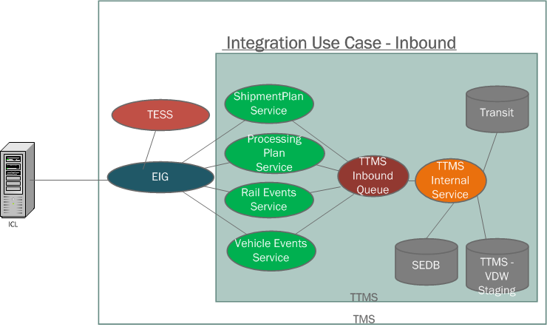

The different actors (Systems) involved in the inbound data flow use cases are

- ICL system sends the inbound service information to TTMS through EIG
- EIG validates the authentication principal against with TESS.
- TTMS Services is the provider for the inbound services as given in the example (Shipment Plan, Processing Plan, Vehicle Events, and Rail Events, etc. The diagram explains few sample services please refer the detail list on the below list. The transport acknowledgement will be sent to ICL at the end of the service completion.
- TTMS Inbound Queue, The global container will be used in order to maintain the FIFO order. The TTMS internal asynchronous processing start from this point.
- TTMS Internal Service is the internal application or container which has the listener process to consume the messages from the TTMS inbound queue to process the message further.

- Shipment Plan
- Processing Plan
- Vehicle Summary
- Vehicle Events
- Rail Shipments
- Rail Inspections
- Transit
- Invoice Voucher
- VDW
- Vessel ETA
- Shipping Schedule

Please refer the detail communication flow in the Integration view (Section to be updated).

  - Integration Use case - Outbound (TTMS-ICL)

The term Outbound defines the messages are sent from TTMS and the service hosted by ICL.

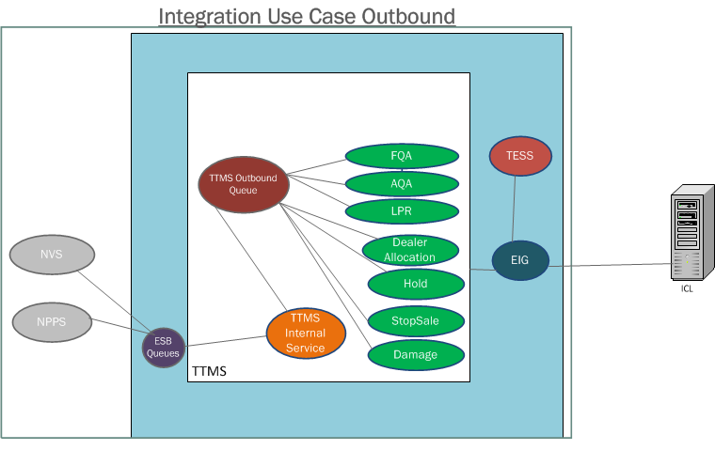
The different actors (Systems) involved in the outbound data flow use cases are,

- NVS, NPPS are the source system which propagate the real-time events to TTMS
- ESB queues are placed in the integration layer which converts from the copy book structure of source systems to TTMS understandable schema structure.
- TTMS Internal Service consumes the messages from the ESB queues and transform into common message structure to all the outbound services.
- TTMS Outbound Queue is the queue designed for outbound communication to ICL in order to maintain the sequence in FIFO order to send.
- The services are being called from outbound queue implementation then the actual messages will be transformed on the service. (FQA, AQA, LPR, Dealer Allocation, Hold, Damage, Stop Sale)
- The EIG validates the TTMS account validation against TESS
- EIG finally sends the messages to ICL.

Please refer the source system information in the section for details of TTMS internal integration systems.

  - Low Volume Internal Data Integration
The low volume architectural use case intended to be defined for the service interfaces that have single unit or VIN key based plain services that get the trigger from ICL. Basically the CRUID services exposed to update the key based insertion, update and delete operations done separately or combined together with business validations.

For example, the shipment Plan service which will be exposed as service to handle the operation for shipment plan creation, update and delete in addition with business validations. The following list is identified to classify as low volume integration use cases.

- Shipment Plan Service
- Processing Plan Service
- Rail Events Service
- Vehicle Events Service
- Transit Service
- Vessel ETA Service
- Shipping Schedule Service

  - High Volume Internal Data Integration
The high volume use cases are the types other than the category of Low volume use cases. Basically TTMS expects huge volume of records as complete one file or the punch of records at incrementally till the completion of records. The below two main system integration modules expected the high volume data flow from ICL in order to update TTMS tables or send the data to the downstream applications through TTMS integration application.

- VDW Integration
- Voucher Integration

VDW Integration
Align with OTM COTS Product, VDW extracts the information from BDM data model where BDM internally extracts the information from OTM COTS product database, the to be process will be changed due to the reason of OTM and OTM driven data model BDM component will be no longer exists.

To be approach, ICL system will send the VDW information to TTMS system. The expected frequency of the information from ICL to TTMS is about 2 hours but the VDW extracts the information every day 11:00 PM around for the consolidated tables. The new TTMS staging tables will be designed to store the VDW expected data from ICL. VDW extracts the data from the TTMS staging tables.

Voucher Integration
ICL system will send the Voucher information to TTMS system everyday (Monday to Friday) at 5:30 PM PST...
The voucher information must be up to 5:00 PM PT and the transmission must be completed by 5:30 PM PT
TTMS system will validate the Voucher information if to check the Voucher information is unique. If the validation is successful then update the information in the Voucher and Voucher VIN tables.

  - Message Exchange Pattern
The message exchange pattern of TTMS simplification is being considered in to two categories, Inbound and outbound. The following diagrams explain the high level flow of inbound and outbound message exchange flow.

Message Exchange Pattern – Inbound

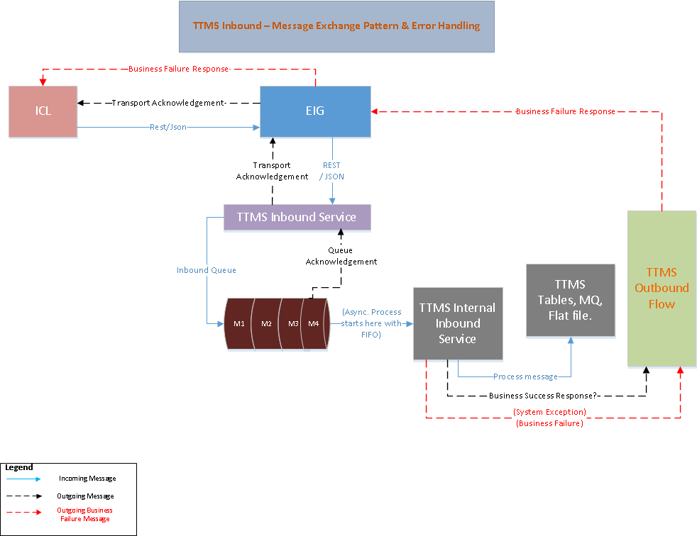

- ICL sends the message to EIG as REST/JSON pattern.
- EIG sends the message to TTMS Inbound services with same REST/JSON format.
- TTMS inbound services receives the messages and place into TTMS inbound queue container in the FIFO order.
- On Successful acknowledgment of message PUT, TTMS inbound sends the transport acknowledgement to ICL through EIG.
- The new TTMS Internal service component listens the message on the arrival of same order (FIFO).
- TTMS internal service process the required business process and mandatory validations based on the service classification. The success response may be sent to certain cases (yet to be decided and will be updated the diagram accordingly). The failure response will be sent to ICL as one of the outbound service designed in TTMS.
- (The performance will be calculated during the POC and the decision will be taken accordingly).

Message Exchange Pattern - Outbound
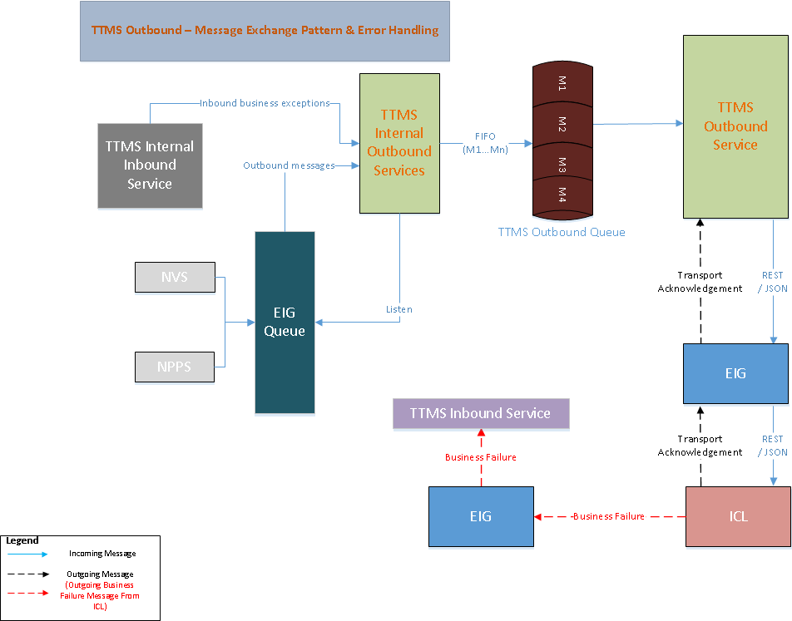

- NVS and NPPS source systems propagates the event message to EIG through P2P communication.
- TTMS outbound services consumes the messages and converts into common message structure understandable by TTMS.
- At the end of the conversion the message will be placed into TTMS outbound queue container.(FIFO Order)
- The TTMS outbound service listens the message and based on the message category calls the respective outbound service.
- The outbound service calls the ICL service through EIG using REST/JSON pattern.
- ICL sends the transport acknowledgement back to TTMS through EIG on the same request.
- If any business failure issues, ICL calls the TTMS inbound notification service to indicate the failure messages to resend the messages back to ICL if required.
- The internal inbound services is being called to handle the failure messages and routed back to the outbound queue to send back to ICL again.
- (The performance will be calculated during the POC and the decision will be taken accordingly).

  - ICL TTMS System Integration Error Handling
TTMS, ICL, EIG Systems error handling will be handled in to two parts, Inbound and outbound scenarios as given the diagram in the sub section. The below categories of errors will be handled part of the integration.

- HTTP Error Codes for network issues and security errors
- JSON Fault code for security, format and business failure scenarios.

Please refer the implementation view for different down time scenarios and the respective errors are being handled for the different scenarios mentioned in the steps 1 through 8.

Inbound Scenarios
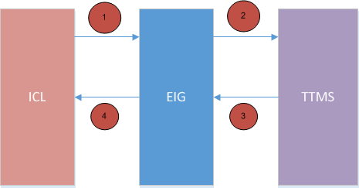

- ICL is not able to send message – EIG has to respond with HTTP/JSON error codes indicating reason for error or ICL has to process TCP/IP level errors if EIG itself is not able to respond. In all scenarios ICL has to communicate the error (to TTMS/EIG) and handle the error (retry attempt).
- EIG is not able to send message to TTMS – EIG has to respond with JSON error codes indicating reason for error. EIG has to communicate the error (to TTMS/ICL) and ICL has to handle the error (retry attempt). TTMS may need to handle duplicate messages.
- TTMS is not able to send message to EIG – EIG has to respond with HTTP/JSON error codes indicating reason for error or TTMS has to process TCP/IP level errors if EIG itself is not able to respond. In all scenarios TTMS has to communicate the error (to ICL/EIG) and handle the error (retry attempt).
- EIG is not able to send message to ICL – EIG has to respond with JSON error codes indicating reason for error. EIG has to communicate the error (to TTMS/ICL) and TTMS has to handle the error (retry attempt). ICL may need to handle duplicate messages.

Outbound Scenarios
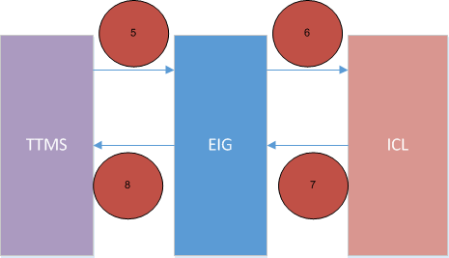

- TTMS is not able to send message to EIG – EIG has to respond with HTTP/JSON error codes indicating reason for error or TTMS has to process TCP/IP level errors if EIG itself is not able to respond. In all scenarios TTMS has to communicate the error (to ICL/EIG) and handle the error (retry attempt).
- EIG is not able to send message to ICL – EIG has to respond with JSON error codes indicating reason for error. EIG has to communicate the error (to TTMS/ICL) and TTMS has to handle the error (retry attempt). ICL may need to handle duplicate messages.
- ICL is not able to send message – EIG has to respond with HTTP/JSON error codes indicating reason for error or ICL has to process TCP/IP level errors if EIG itself is not able to respond. In all scenarios ICL has to communicate the error (to TTMS/EIG) and handle the error (retry attempt).
- EIG is not able to send message to TTMS – EIG has to respond with JSON error codes indicating reason for error. EIG has to communicate the error (to TTMS/ICL) and ICL has to handle the error (retry attempt). TTMS may need to handle duplicate messages.

- Architectural Solution Scenarios
The TTMS Simplification project is followed with the all below options to achieve the overall TLS business solutions.
  - Buy Solution vs. Build from Scratch vs. Enhance Existing System
The TMS decision is to go with Software as a Service (SaaS) solution with ICL based on the POC that has been conduction with ICL to prove they can support TLS needs for finish vehicle logistics system.

The current TTMS OTM COTS product will be replaced with ICL SaaS solution due to the following key constraints are mentioned in the ‘Pros’.

Pros
- OTM was not designed for finished vehicle logistics, resulting in technical and manual workarounds that impact TLS’s ability to meet business requirement.
- Difficult and expensive to maintain due to system integration complexity periodic, resource intensive upgrades.
- Requires resources high priority initiatives (e.g. N.A Export, Transportation Claims automation, etc. to support OTM)
- In-house technical workarounds to meet business needs (e.g. Preliminary tender, Governor and Sequencing)
- Time consuming manual workarounds in place (e.g. Manual re-planning, fictitious routes/carriers, operational delays/disruptions)

Cons
- The high dependency with SaaS will become complicated when plan to switch the vendor or build the proprietary solution.

  - Real Time Integration Vs Batch Mode Integration
This Architecture solution scenario has been influenced by Use Case 4.1 and 4.2 for Inbound and Outbound services.

As per the B2B Integration guidelines and based on the business expected response time defined, All the inbound and outbound services are considered as real time with web service implementation. However based on the volumetric analysis few of interfaces possibly classified into Batch process.

Inbound Services Categorization

No | Interface Name | As Is Process | Business Criticality  (1-5,1-Low,5-High) | Priority | To Be Frequency | To Be Process
1 | Shipment Plan | Real-time | 5 | High | Between 15 to 30 minutes | Real-time
2 | Processing Plan | Real-time | 5 | High | Between 15 to 30 minutes | Real-time
3 | Vehicle Summary | Real-time | 5 | High | Between 15 to 30 minutes | Real-time
4 | Vehicle Events | Real-time | 5 | High | Once a day per unit | Real-time
5 | Rail Shipments | Real-time | 3 | Medium | Maximum 30 minutes | Real-time
6 | Rail Inspections | Real-time | 5 | High | Maximum 15 minutes | Real-time
7 | Transit | Real-time | 4 | Medium | Maximum 60 minutes | Real-time
8 | Invoice Voucher | Batch | 5 | High | Once a day | Real-time vs Batch – Need to analyze the volume
9 | VDW | Batch | 3 | Medium | Every 2 hours | Real-time vs Batch – Need to analyze the volume
10 | Vessel ETA | Batch | 3 | Medium | Once a day | Real-time vs Batch – Need to analyze the volume
11 | Shipping Schedule | Real-time | 3 | Medium | Once a day | Real-time

Outbound Services Categorization

No | Interface Name | As Is Process | Business Criticality  (1-5,1-Low,5-High) | Priority | To Be Frequency | To Be Process
1 | FQA | Real-time | 5 | High | Less than 5 minutes | Real-time
2 | AQA | Real-time | 5 | High | Less than 5 minutes | Real-time
3 | LPR | Real-time | 5 | High | Less than 5 minutes | Real-time
4 | Dealer Allocation | Real-time | 5 | High | Less than 5 minutes | Real-time
5 | Hold | Real-time | 5 | High | Less than 5 minutes | Real-time
6 | Damage | Real-time | 5 | High | Less than 5 minutes | Real-time
7 | Stop Sale | Real-time | 5 | High | Less than 5 minutes | Real-time

  - Incremental vs Complete
This solution scenario has been driven by Use case 4.3 and 4.4 for High Volume and Low Volume Data Integration. The incremental and complete are the two options are being considered to handle the data integration from ICL to TTMS.

- Incremental
- Complete

Option A: ICL will call the TTMS inbound service and add single record at a time or group of records incrementally till the completion of records.
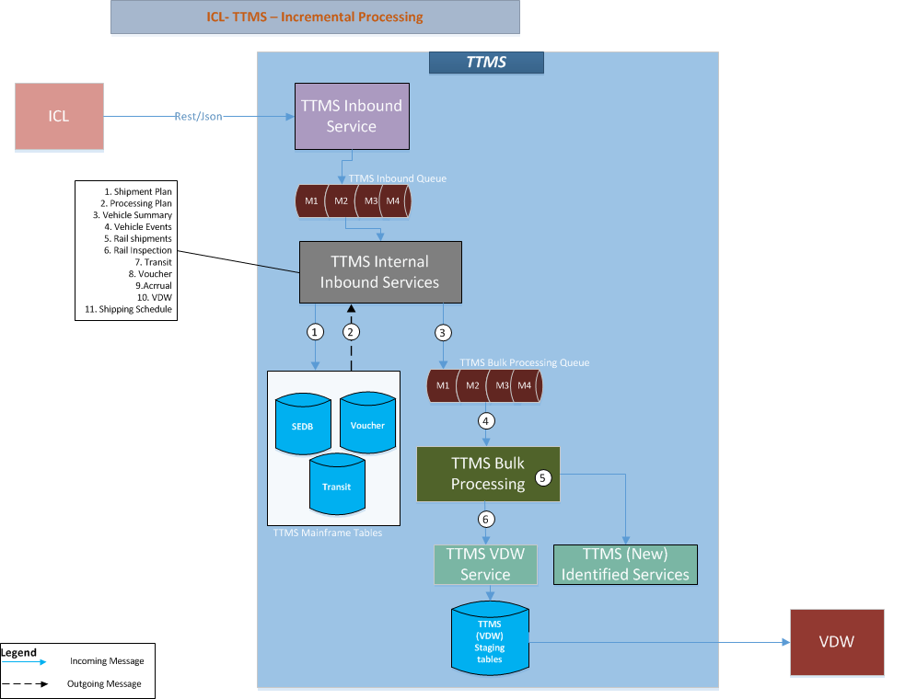

ICL sends the information to TTMS integration application through one of the exposed inbound services. The TTMS services place the messages and put into the TTMS inbound queue.

- TTMS inbound internal services process the messages and add or update the records in TTMS mainframe tables.
- TTMS inbound services receives the transaction completion.
- There are sudden cases, the part of inbound services messages also needed for processing into different system or the internal processing with high volume records, as part of this process TTMS internal services places the copy of the messages into different queue named TTMS bulk processing queue in order to process the same messages into different flow.

Option B: ICL will send the complete records through the inbound service interfaces, in this option the complete flat file will be received from ICL and will be processed in TTMS. The data will be received in the form JSON payload with required Meta data attributes to know completeness of the data before process into TTMS.
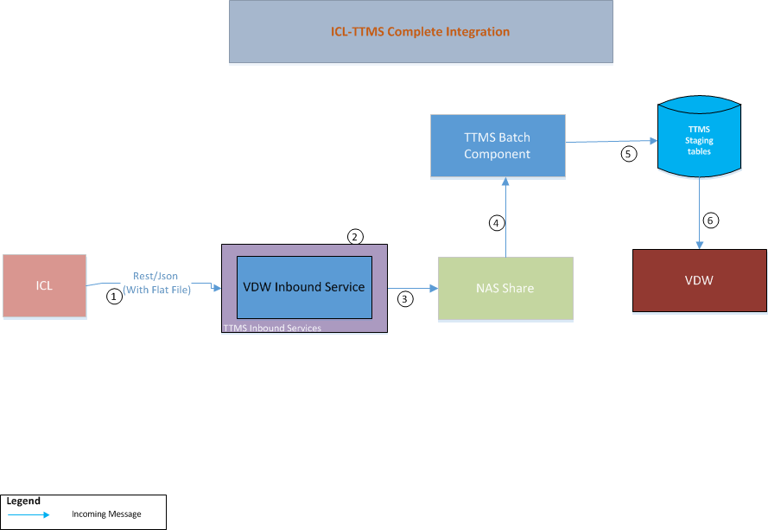
Explain the nos here

(Option B will be split in to further 2 options by considering implementation process, Queue and Batch Processing will be elaborated later)

Solution options | Pros | Cons
Incremental | - Performance will be good compare with “Complete” option.  - Avoids building the additional technical framework or platform to build the solution. | - Introduce the complexity of handling multiple transport acknowledgement for high volume records (Voucher, VDW) for same purpose of calls on the consuming side.  - Need to implement the methodology for the completion of processing.  - Introduces the complexity of consolidated retry logic for high volume services when the target system is completely down (this case TTMS is down)
Complete | - Avoids multiple network calls  - Avoids to introduce separate service for delta attributes. | - Introduce the complexity of implementing the file compression.  - The delay in data arrival will be caused when network slowness/down happened between the windows of transfer process.

  - Synchronous Vs Asynchronous Communication Pattern
This architecture solution scenario is primarily driven by the decision taken for scenario 5.2 – for Real-time processing and well supported by Use cases 4.5 and 4.6 for message exchange and error handling.

Option1: Two-way Synchronous Communication: The client uses exposed service to achieve synchronous communication and receive a response immediately. Upon receiving the request, the server starts processing it while holding the connection with the client open until a response (or an error) is ready to be returned to the client on the open connection. The request can be initiated from both the end (ICL && TTMS) at both the ways from either ICL or from TTMS.

The following diagram explains the sample synchronous communication with one way from ICL to TTMS, The same flow in other way around is being considered to include the option 1 as two way synchronous communication pattern.

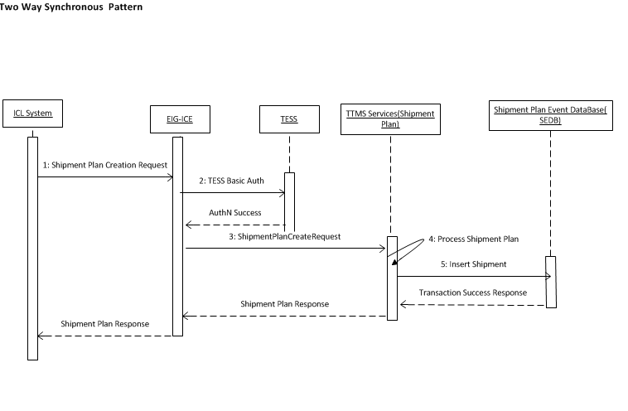

Step 1: The Shipment Plan request is initiated from ICL
Step 2: EIG validates the request headers and authenticate with TESS
Step 2.a: TESS sends the success acknowledgement
Step 3: EIG forward the request to TTMS back end Web Services
Step 4: TTMS performs the business validations and calls the SEDB insert

Step 5: The Shipment Plan is created in SEDB and the success Transaction response sent to ICL

Note: The entire flow is continued as sequential flow and each of the component will wait until the response served with in the request timeout defined in each of the layer.

Option 2: Two-Way Synchronous plus Asynchronous Communication: Two-way asynchronous communication in this document context, when the request is initiated from the client (ICL) then the Provider (TTMS) receives the request and dispatch the request in different new process or container (Queue/Data Store) then sends the successful transport acknowledgement of receiving the message. This case the actual business process may not be completed even though the successful transport acknowledgment is being delivered to the consumer.

The new process will be initiated to complete business transaction and then sends the successful business transaction acknowledgement. The acknowledgment can be either through web service or any notification mechanism. The communication can be initiated from both the ICL and TTMS vice versa.

The following diagram explains the flow of two way asynchronous pattern but the diagram is drawn for the one-way from ICL to TTMS and the same way the communication will be followed from TTMS to ICL during outbound integration.

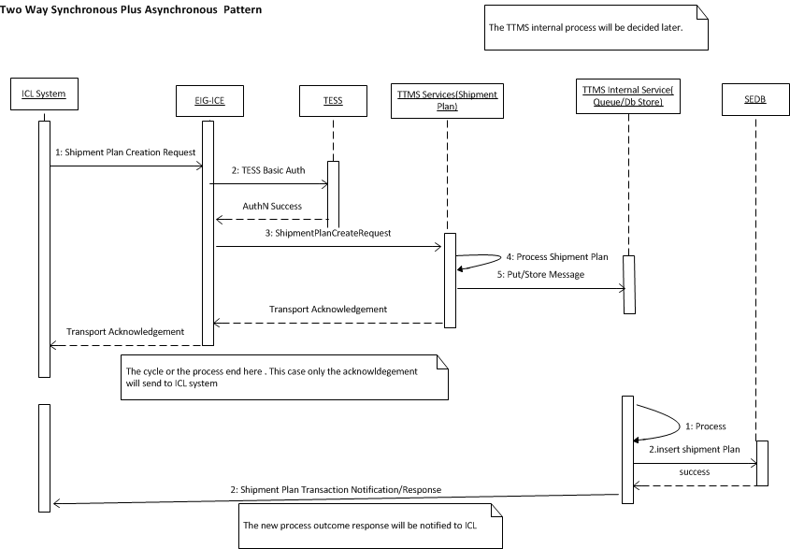

Step 1: The Shipment Plan request is initiated from ICL
Step 2: EIG validates the request headers and authenticate with TESS
Step 2.a: TESS sends the success acknowledgement
Step 3: EIG forward the request to TTMS back end Web Services
Step 4: TTMS performs mandatory message attributes validations
Step 5: TTMS puts the message into TTMS internal service (Queue/DB Store)
Step 6: TTMS services sends back the acknowledgement to ICL back to all the layer to ICL

Step 1: The new process queued or initiated
Step 2: TTMS inserts the shipment plan in SEDB table
Step 3: Sends the actual success/failure business transaction confirmation/notification to ICL with different interface

Solution options | Pros | Cons
1.Two-Way Synchronous Communication | - Provides the clear end to end single span of request and response flow.  - The business transaction acknowledgement will be received by consumer on the same request initiated.  - Avoids consumer not to send the invalid messages to TTMS since the previous response has the successful transaction completion acknowledgment status to decide the business flow.  - Sequencing of the messages will be handled naturally when second transactions follows the completion of first transaction. | - Holds the request until the backend completes the transaction.  - Mostly suitable for less time transactions.  - The acknowledgment may not be sent to consumer even though back end successfully completed the transaction during timeout issues.  - Tight coupling from ICL all the way down to backend systems  - Difficult to scale as volume or # of backend systems rows
2.Two-Way Synchronous Plus Asynchronous Communication | - Meets ‘Single responsibility’ principle(Low coupling)  - The transport layer acknowledgement will be given to consumer in order to process the next events.  - Faster response time to consumer | Increase the business coupling on TTMS layer where consumer did not operate the next event based on the previous web service business transaction sent to TTMS.  TTMS need to build another asynchronous flow after transport layer acknowledgement which introduce additional technical complexity.

  - Soap Web services Vs Restful Web services
This architecture solution scenario originates from the decisions taken for Scenario 5.2, 5.3 and 5.4. The approach will be to have Real-time synchronous processing using web-services. This scenario focuses on the methodologies to be used for web service implementation. The SOAP and Rest web services are considered as the options.

Solution options | Pros | Cons
SOAP | - SOAP use WSDL to define the clear contract design between the provider and consumer.  - SOAP supports other protocols SMTP,FTP,etc other than HTTP  - SOAP supports message level security encryption  - Development and tools support  - Build in error handling and retry mechanism  - Supports MTOM file compression techniques  - XML offers the options for transforming different structure, or format of the data along with actual data but JSON does support only with traditional message format. | - SOAP does not support multiple message format.  - Makes tightly coupled with systems together  - Increases the maintenance Cost due to simple change makes the revision of contract and implementation changes on both the end.  - Slower performance than REST due to the heavy object binding and marshalling process.
REST | - REST is more dynamic, no need for creating and updating UDDI.  - REST is not restricted to XML format. REST web services can send plain text, JSON, and also XML.  - REST is much more lightweight than SOAP  - REST is providing better performance than SOAP | - Supports only over HTTP  - REST does not support WSDL but supports WADL but does not have the standards compared to SOAP WSDL.  - REST does not support message transformation.  - REST does not support the default error message and Retry handling as SOAP is having in built support  - REST does not support file compression MTOM compared with SOAP  - REST does not support message level encryption and the encryption can only be achieved in Transport layer.

- Architectural Decision Log
The details of various solution options considered, along with qualitative [Pros & Cons] analysis are included in solution scenarios section.
  - Web Service Pattern
Subject Area | Web Service Pattern |  | Topic |  | Rest/JSON Vs SOAP/XML
Issue or Problem Statement |  | The web service pattern need to be identified either SOAP/XML or Rest/JSON based web service pattern.
Related Use Case / Requirements |  | Technical Use case
Solution[s] |  | The solution is identified as two options  Rest with JSON  SOAP with XML
Decision |  | The decision is to use Rest Architectural style.  The decision is to use JSON Message format.
Rationale |  | The limitation of Rest is at the message level security where SOAP provides as a default but as per EISP categorization, the 2way SSL with Basic authentication accommodates the EISP security guidelines for confidential data classification.  XML offers the options for transforming different structure, or format of the data along with actual data but JSON does support only with traditional message format.
Assumptions |  | The JSON message structure validation will happen at the EIG side.  JSON supports to send the flat file with traditional formats.
Justification |  | Refer the Pros section of Rest and Cons section of SOAP mentioned in the solution scenario “Rest Vs SOAP”.  The below are the justification points to use JSON  - JSON parsing is generally faster than XML parsing  - JSON is a more compact format, meaning it weighs far less on the wire than the more verbose XML.  - Formatted JSON is generally easier to read than formatted XML.  - JSON specifies how to represent complex datatypes, there is no single best way to represent a data structure in XML.
Implications |  | - The Retry mechanism need to be handled on the consumer side  - The message level security cannot be achieved in Rest based pattern, In future the system demands then need to revisit the pattern or wait Rest has to emerge with message level security.
Derived requirements |  | - Retry Mechanism need to be implemented across the layers  - Application has to build the error handling mechanism and mandatory field’s validations on the application layer.

  - Message Communication and Acknowledgement Pattern

Subject Area | Message Communication Pattern |  | Topic | Two Way Synchronous Communication | Two Way Asynchronous Communication
Issue or Problem Statement |  | Decide the message communication to use synchronous or asynchronous pattern
Related Use Case / Requirements |  | All the inbound and Outbound interfaces.
Solution[s] |  | The solution is identified as two options  - Two way Synchronous Pattern  - Two way Synchronous plus asynchronous Pattern
Decision |  | The decision is to use Option 2(Two Way Synchronous plus Asynchronous Communication) due to the advantage not holding the connection to complete the entire transaction with stateless communication.
Rationale |  | The limitation of Option 2 (Two Way Synchronous plus Asynchronous Communication) will increase the business validations scope in TTMS boundary and the nature of sequence will be removed when ICL sends the next events by assuming the previous events are succeeded but some cases the transaction may fail in TTMS and will make the continued failure of events will lead into manual intervention and error recovery process.
Assumptions |  | ICL sends the messages in built sequence and if any sequence based errors will be handled through error handling process.(Please refer the error handling scenario mentioned ...(To be Updated)
Justification |  | - Faster Response time  - Loosely Coupled business transaction Processing.  Please refer the Solution scenarios section for more details.
Implications |  | Sometimes the business transaction is almost equal to the transport acknowledgement time where it increases the additional increase of storage that leads to additional store and process design consideration.
Derived requirements |  | Derives the technical requirement to add the new storage of queue or Database to hold and process the message to make the asynchronous communication.

- Logical View
[This section describes the architecturally significant parts of the design model, such as its decomposition into subsystems and packages; and for each significant package, its decomposition into classes and class utilities. You should introduce architecturally significant classes and describe their responsibilities, as well as a few very important relationships, operations, and attributes.]
Data Architecture
The logical view includes the data architecture view. The logical view should contain both a combined logical data and system view or a separated data and system view as needed. The data architecture depicts the high level components of a system. The data architecture describes the components supporting persistent data and its transformations. An “as-is” and a “to-be” architecture must be described. A project should start with the existing planning data architecture, if one exists.
The objective of describing the data architecture is to delineated system scope, identify integration points, and show various persistent data stores. All data inputs and outputs to the application must be covered. Integration points must include all external sources of data. Every data requirement should be traceable to components in the data architecture. The data architecture provides a context for understanding the data design.
If the project scope requires decommissioning specific application or data components, this must be illustrated as a difference between the “as-is” and “to-be” data architectures. If the project scope requires reuse of specific data components, this must be illustrated in the “to-be” data architecture. The existence or absence of mandates must be documented as architectural assumptions or constraints..
  - Overview
[This subsection describes the overall decomposition of the design model in terms of its package hierarchy and layers.]
The new TTMS integration application need to be created from the scratch in order to achieve the real time communication and business operations between ICL and TTMS. The reason behind the integration to make the existing downstream components need to consume the outcome of ICL enrichment data to be passed to NVS and VDW and other downstream applications.

The advantage of building the new TTMS integration application are
- The integration layer in TTMS boundary makes the easy interfacing with TMS systems
- Makes the advantage of reusing existing components in TTMS with minor changes.
- Align with TMS latest technology landscape.
- Will be built scalable than the current integration architecture.

    - As Is System Context View
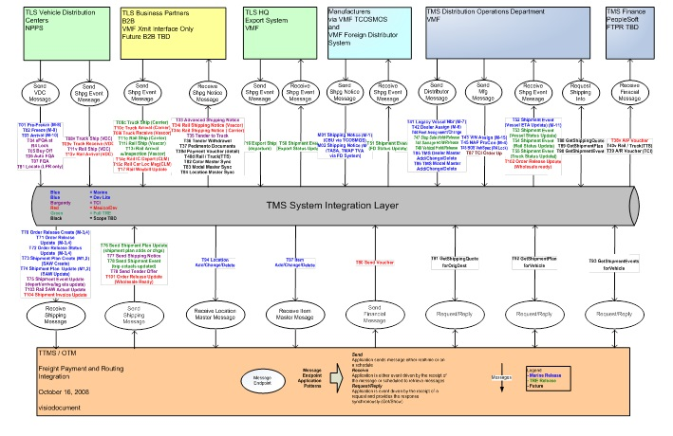
    - To be System Context View

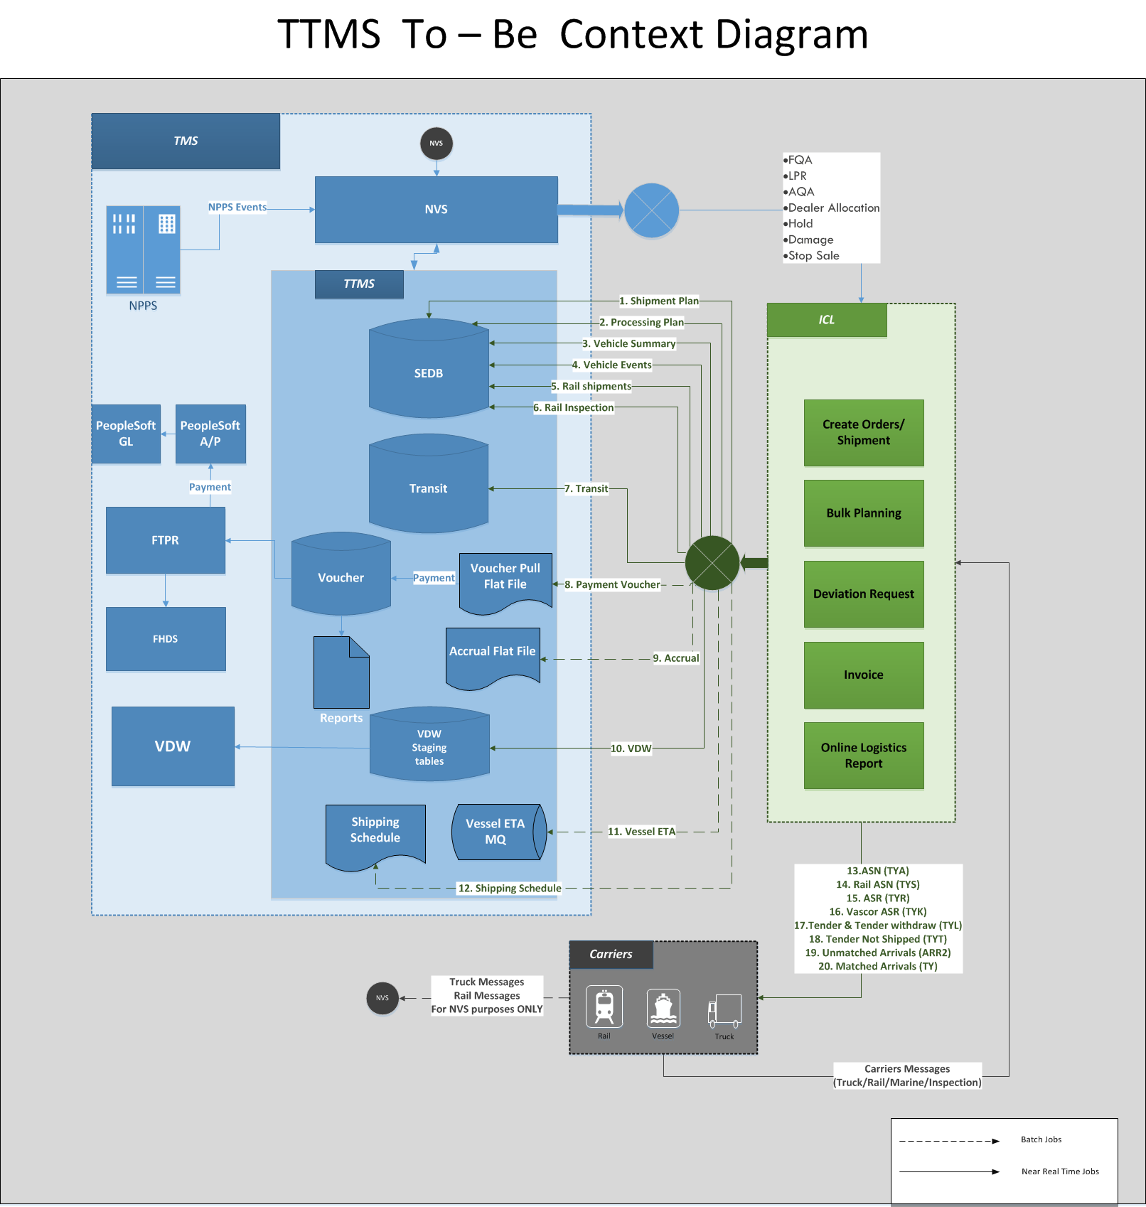

    - Interfacing Systems and External Data Store

      - ICL
Description | TTMS interface with ICL for inbound and outbound operations as a web service for Creation of Shipment Plan, Manage Shipment related Events, and Manage Shipment related invoice, Manage Deviation Requests.
Type | System
Owners | ICL

      - NVS
Description | NVS sends all the Notify Add and change events to TTMS through ESB, In the To be system TTMS expects to handle Dealer allocation changes, Hold, Damage and stop sale events.
Type | System
Owners | TMS

      - NPPS
Description | NPPS system is used at the Vehicle Distribution Centers (VDC) and Vehicle Distribution office (VDO) to do the post production activities including buyoff, PQA, FQA and shipment of vehicles to the dealer’s .NPPS sends the message to TTMS for BDY, PNT, ASM BUY, AQA, LPR, TS1, RSC, RR1, and RC1.  In the To be System, TTMS will receive AQA, FQA and LPR from NPPS and send to ICL.
Type | System
Owners | TMS

      - VDW
Description | VDW pulls the Logistics related information from TTMS system through TTMS database. VDW has a Freight data mart used by TLS users which provides information like Shipment, Invoice, Service provider, Location, Vehicles associated with Shipment etc. To populate the Freight data mart, VDW pulls data on a daily basis from TTMS system.
Type | System
Owners | TMS

      - FTPR
Description | FTPR is the Freight Payment Routing System and interface with TTMS. TTMS sends the Payment information to FTPR
Type | System
Owners | TMS

      - FHDS
Description | FHDS is the system hosted on the mainframe and pulls in the payment summary information from TTMS through FTP
Type | System
Owners | TMS

      - Architecturally Significant Design Packages
[For each significant package, include a subsection with its name, its brief description, and a diagram with all significant classes and packages contained within the package. For each significant class in the package, include its name, brief description, and, optionally, a description of some of its major responsibilities, operations, and attributes.]

- Process View
[This section describes the system's decomposition into lightweight processes (single threads of control) and heavyweight processes (groupings of lightweight processes). Organize the section by groups of processes that communicate or interact. Describe the main modes of communication between processes, such as message passing, interrupts, and rendezvous.]

- Data View
[This section describes all the data flow between all data sources and target and the data integration patterns].

- Implementation View
[This section describes the overall architectural structure of the implementation model, the decomposition of the software into layers and subsystems in the implementation model, and any architecturally significant components. Describe this by using diagrammatical representations of the Architecture.]

  - Overview
[This subsection names and defines the various layers and their contents, the rules that govern the inclusion to a given layer, and the boundaries between layers. Include a component diagram that shows the relations between layers. ]
  - Customize the chosen TAG Blueprint if Needed
  - Layers
[ For each layer, include a subsection with its name, an enumeration of the subsystems located in the layer, and a component diagram.]
  - Technology Stack and Frameworks
[For each technology component, frameworks utilized in the application include the vendor, license, purpose and source location if applicable...]
List of Technologies / Tools / Frameworks used by Application
S. No. | Technology Component / Tools / Framework | Vendor | Version | License | Purpose / Usage | Repository Source / Archive Location
1
2

- Service Allocation to Components
[Allocate services as defined in SDD to components in an iterative fashion. The components can be Service Components defined in SDD or the Functional and Technical Components defined in the previous sections of this document]
Services | Service Components (SC) |  |  | Functional Components (FC) |  |  | Technical Components (TC)
Services | SC 1 | SC 2 | SC n | FC 1 | FC 2 | FC n | TC 1 | TC n
This table is a high-level representation. The detailed information from this table will be captured in the appendix (optional).
[Functional Component: Provide business functionality and collaborate with other functional and technical components as part of a service component to realize business-aligned services.
Service Component: A logical grouping of functionally-cohesive business-aligned services that is important enough to the enterprise to be managed and governed as an enterprise asset. It may be exposed at the edge of the enterprise or business unit. It is used to achieve and maintain service level agreements.
Technical Component: Provide Technical/Infrastructure services that are reusable components that address all operational aspects. These reusable components can be implemented as libraries or shared services.]

  - Service Realization Related Architectural Decisions
[Certain architectural decisions points pertain to services and the services layer. These decisions are documented in detail.]
Decision point | Decision | Services
How service descriptions will be externalized |  | (All or specific list)
How services are exposed (e.g. Web Services)
How messages are formed (i.e., XML, AS2, structured field, proprietary, …)
How/where message transformation will be done
How security will be enforced at the level of the service interface
Service name space issues
Division of responsibility between ESB and enterprise components
<other service related decision point>
(Further details are defined in appendix)
Table NN – Realization Decision Summary table with Example decision points
- Deployment View
[This section describes the overall components and subsystems are distributed across system nodes. Deployment diagrams depict architecturally significant elements such as processor nodes, device nodes, connections, and runtime components (e.g., executables)].

- Architectural Risks and Impact
[This is a mandatory section]
This section provides all information necessary to assess the risks and impact of the solution that was selected.

  - Financial Impact and Risks
[Does this solution have any financial impact to TMS? Please document it briefly any impact. ]
  - Potential Business Impact
[Is there any user training needed? Are there any advices to business users before and after changes are deployed? What are signs of system failure if undesired results produced?]
  - Potential System Impact and Risks
    - Assumptions and Constraints
Does the architecture assume particular data structure or table data are not changed in production during the development? Does the solution design assume no online activities on concerned transactions should happen before the changes go in production? Does the architecture resolve only part of the problem identified and will leave the resolution of other parts to another work? Does the design assume deployment happens before or after a particular date or a particular event? Does the design depend on the correctness of certain portion of analysis or changes made by another development team or project that the current development team has not yet comprehended in full confidence?

    - Dependencies
Does the work depend on or affect other work in progress? Does the work design to change any data or program that warrants no-harm testing on unchanged functionalities? Does the deployment of the changes depend on the start or completion of another project?

    - Performance Analysis
With the designed changes, will application performance change noticeably in memory usage on server, database usage, and processor usage? Will the designed changes increase batch jobs execution time by 10 minutes or more? Is there a need for conducting performance testing such as load testing or stress testing before production deployment?

    - Environment Analysis
With the designed changes, will system and application configurations be changed that may have global impact? This section can outline and hardware and software

- Risk Log
Date | Status | Risk Description | Comments
08/06/2015 | Open | The high dependency with ASP will become complicated when plan to switch the vendor or build the proprietary solution.

- Open Items
Date | Status | Description | Comments
08/11/2015 | Open | Move the Services categorization tables to Sup specs and give the reference.
08/14/2015 | Open | In Incremental vs Complete, “Complete” sub options need to be elaborated during the elaboration phase
08/14/2015 | Open | POC need to be conducted to identify through put for processing the message one instance at a time.
08/14/2015 | Open | The decision on sending the success response back to ICL need to be taken and update the sections accordingly.
08/14/2015 | Open | The volumetric analysis and data needed for making the solution approach decision for VDW and Voucher Use cases.
08/14/2015 | Open | The table caption needed to be placed once we complete majority of the section during elaboration phase.

