## Cleaning of data from elephant GPS collars:

The dataset for the downloaded daily Latitude-Longitude elephant GPS point had missed Lat-long coordinates (wrong coordinates), thus were cleaned to remove the zeros and outliers. Data were saved in the excel-spread sheet (CSV files).

## Loading elephant GPS collars data using Qgis-GUI

1. Data were loaded into QGIS-GUI by clicking the Layer option in the main menu>then selected the Add Delimited Text Layer. Option allowing the loading of the CSV files was checked; i.e. CSV and the x (Long) and y (Lat) option were checked. By clicking OK the points were displayed into QGIS.

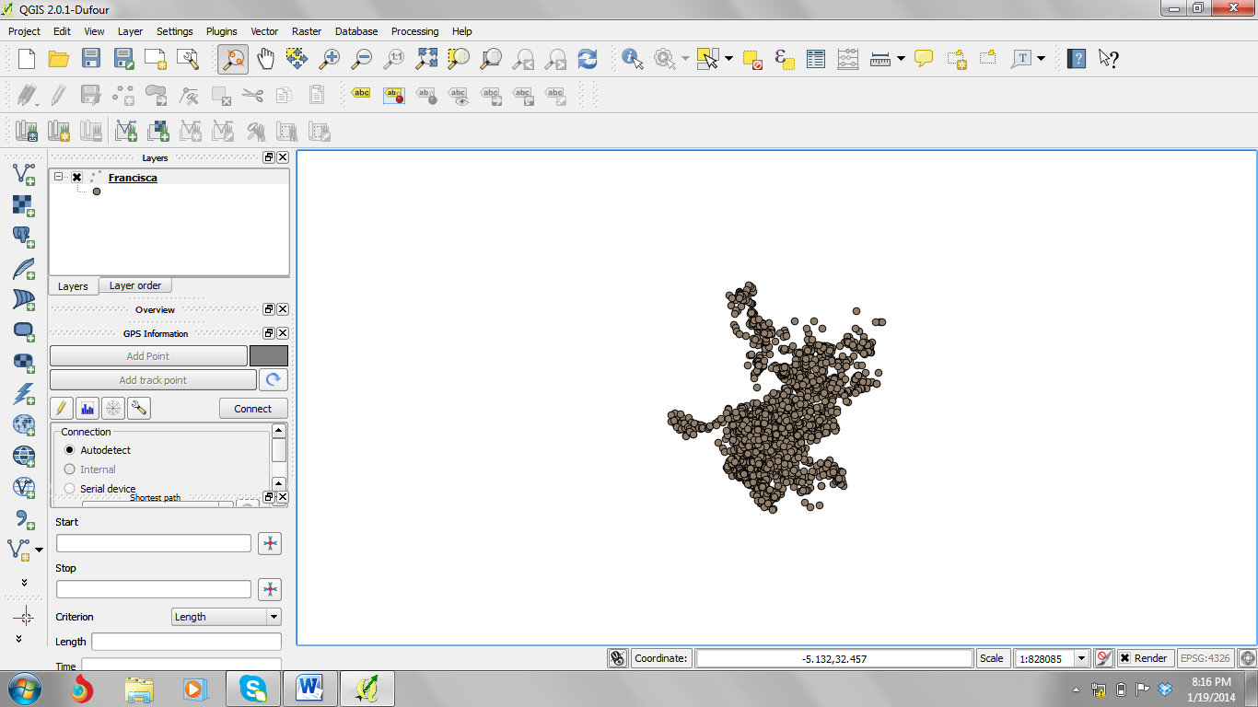

## Transforming the GPS points in shapefiles

-To transform the points into a ESRI shapefile, I had to right click the layers with GPS points, and clicked Save as, then the options for changing the Point file into shapefiles. The coordinate reference system was set to Geographic Lat-Long (WGS84).

## Downloading MODIS HDF files and transforming them into Geotiff

* MODIS HDF images were downloaded manually from glovis.usgs.gov website (put the link)

The Modis Reprojecting Tool (MRT) was used to transform the MODIS HDF into Geotiff. The coordinate reference system was set to Geographic Lat-Long (WGS84).

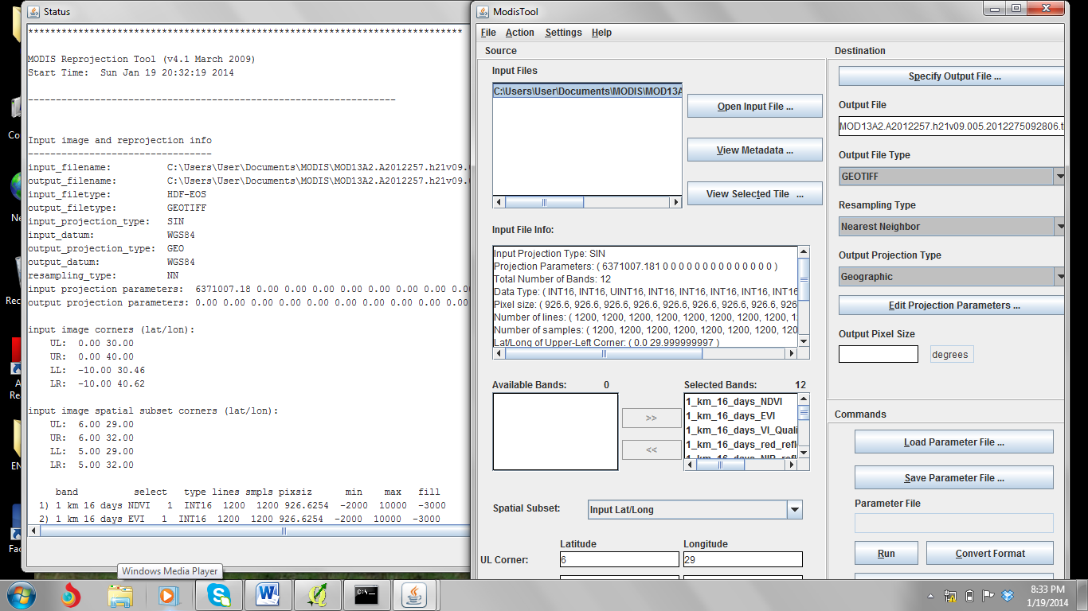

## Reprojecting the MODIS Geotiff and Elephant GPS data

Both the elephant GPS points and the MODIS Geotiff were reprojected in Qgis by right clicking the layer and saving them in a different under the projected coordinate systems (WGS 84/ UTM zone 36S).

## Synchronizing the MODIS Geotiff and the Elephant GPS data so as to extract the NDVI values

**Challenge and the way forward**

1) Even after reprojecting the MODIS Geotiff and the elephant GPS point on the same projection (WGS 84/ UTM zone 36S), the two layers failed to be zoomed to the same extent. ?

2) The use of GUI has opened my eyes to understand the applicability of some scripts in the command line. Each entry in the GUI gives its alternative in the command line.

e.g. Reproject in Qgis

gdalwarp -of GTiff "HDF4_EOS:EOS_GRID:\"C:\\Users\\User\\Documents\\MODIS\\MOD13A2.A2012225.h21v09.005.2012242051121.hdf\":MODIS_Grid_16DAY_1km_VI:1 km 16 days NDVI" "C:/GIS DATA/New Folder/New Folder"

Therefore, the extraction of the NDVI values from the elephant point data will be done by synchronization of the MODIS NDVI images and the elephant GPS points using the **command line!**.