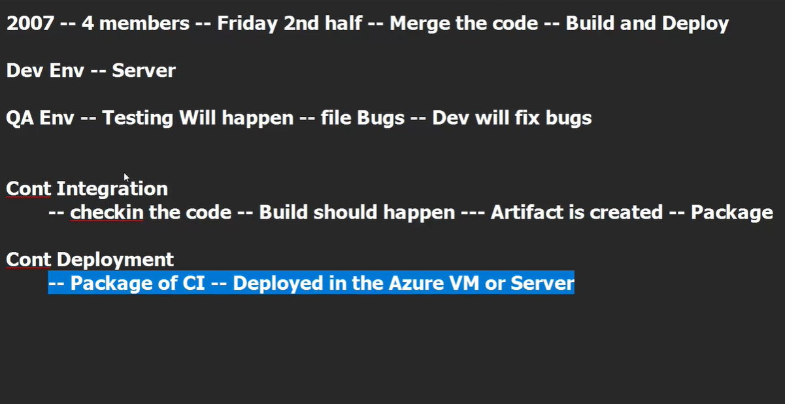
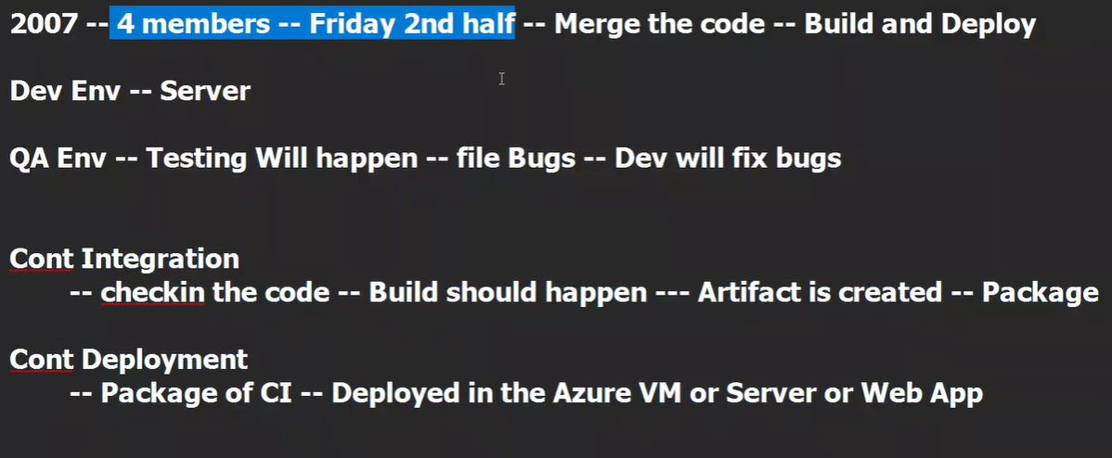
Artifact/ Package – Integrated or Compiled set of code
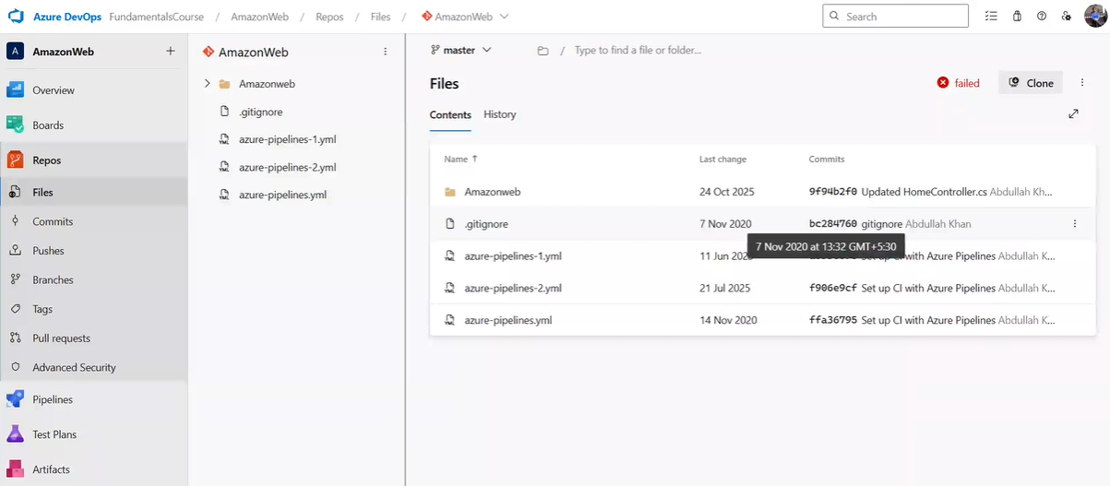
Repo is the complete git setup within devops portal
Nugget in .Net is similar to pip in python – used to install libraries
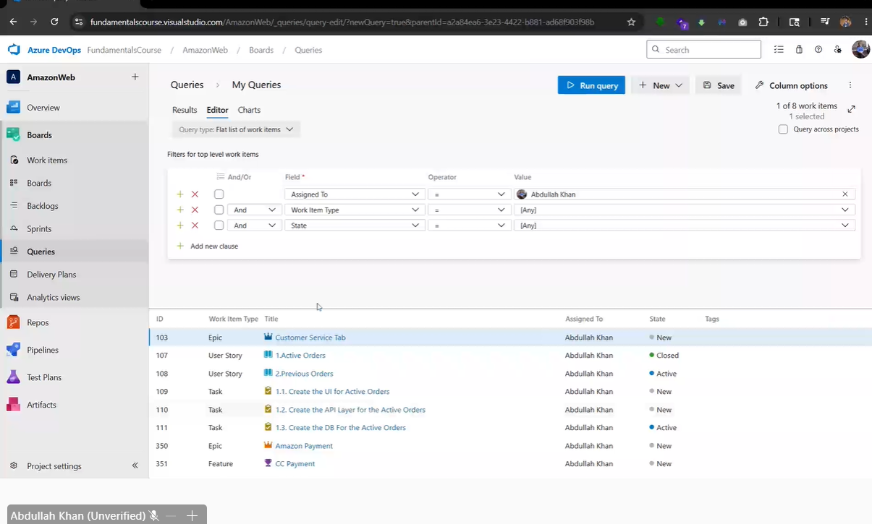
Tasks are assigned in boards and are checked regularly

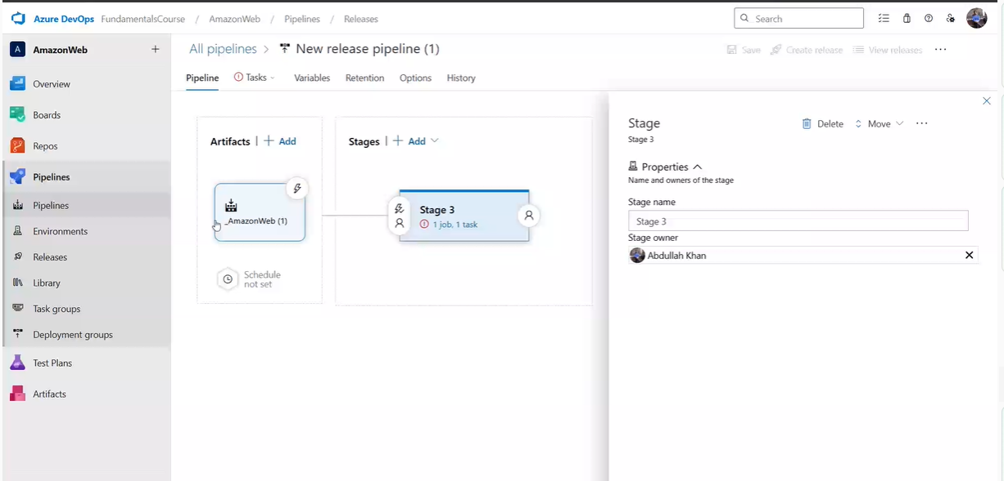
Pipelines – CI
Releases - CD

Automatically every program we code and deploy goes through all phases of CI and then CD of all related tasks begins to run…
Any failures in CD would be notified to everyone in the project, depriving our identity.

