Exploratory Data Analysis (EDA) on Airline Flight Price Dataset

Introduction:
The airline industry is highly dynamic, and flight ticket prices vary based on multiple factors such as airline, route, duration, number of stops, and travel time. Understanding these factors helps both customers and airline companies make informed decisions.
In this project, an Exploratory Data Analysis (EDA) is performed on a flight price dataset collected from online sources. The dataset was cleaned, transformed, and enhanced with new features to make it suitable for analysis. The objective of this analysis is to identify key patterns and relationships that influence flight prices and to extract meaningful insights from the data.

Dataset Description:
Airline: Name of the airline operating the flight.
Date_of_Journey: Date on which the journey is scheduled.
Source: City from where the flight departs.
Destination: City where the flight arrives.
Route: Path followed by the flight from source to destination.
Dep_Time: Scheduled departure time of the flight.
Arrival_Time: Scheduled arrival time of the flight.
Duration: Total travel time of the flight.
Total_Stops: Number of stops between source and destination.
Additional_Info: Additional details related to the flight.
Price: Ticket cost of the flight (target variable).

Data Cleaning & Feature Engineering:
Data Cleaning
- Removed missing and inconsistent values
- Standardized date and time formats
- Converted categorical values into usable formats
Feature Engineering
- Extracted Month and Day of Week from Date_of_Journey
- Converted Duration into Total_Duration_Minute
- Created Departure Time Buckets (Early Morning, Morning, Afternoon, Evening, Night)
- Created Arrival Time Buckets
- Converted Total_Stops into numerical form

Exploratory Data Analysis:
Observation from the descriptive summary
By seeing this output, I was curious to check the flights where the Duration of flight was maximum (2860 minutes), where the Duration of flight was minimum (75 minutes), where the ticket price of flight was highest (Rs.79512), and where the ticket price of flight was lowest (Rs.1759).
Observation from the Airlines with frequencies
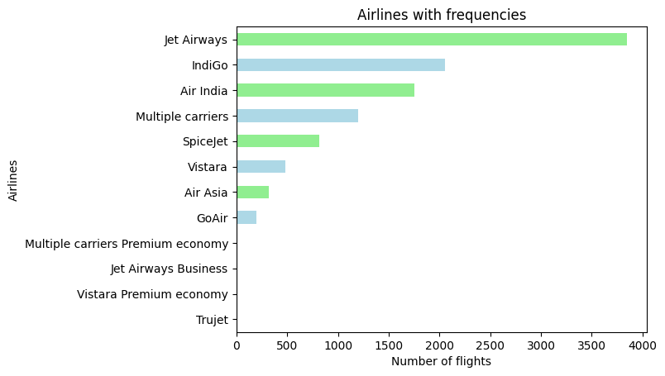
There are 12 airlines in the dataset

Price Analysis
What is the distribution of flight prices:
The flight price distribution is right-skewed, where lower price values have higher frequencies, while higher price values occur less frequently but extend over a wider range.

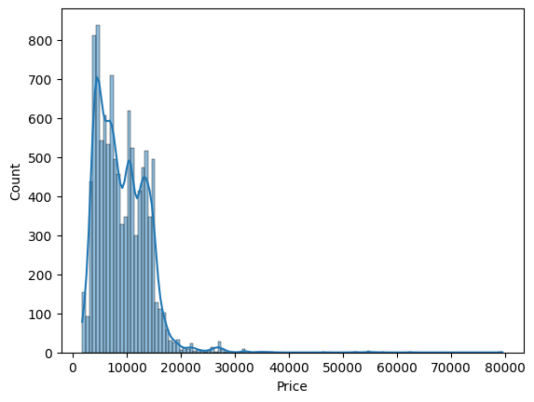

Are there extreme outliers in ticket prices? YES
The boxplot reveals the presence of several upper-end outliers, indicating that a small number of flights are priced significantly higher than the majority.

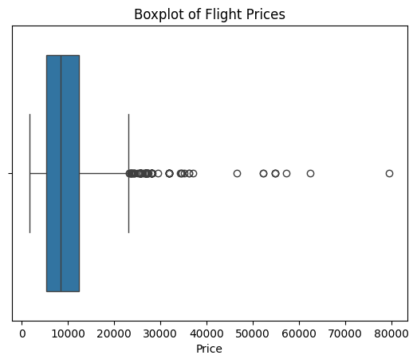

Airline Analysis
What is the average price for each airline
The average ticket price varies significantly across airlines. Budget airlines such as Trujet, SpiceJet, Air Asia, IndiGo, and GoAir have lower average prices, while Jet Airways, Vistara, and Air India fall into a higher price range. Jet Airways Business has the highest average price, which is expected due to premium service offerings.

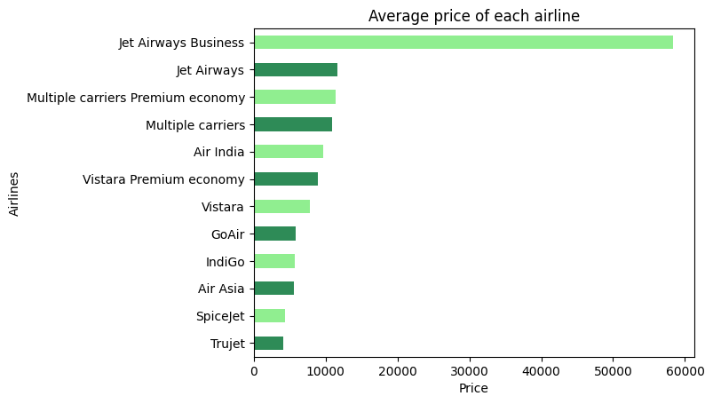

Which airline offers the cheapest flights: Trujet
Which airline shows the highest price variation : Jet Airways Business

Source–Destination Analysis
How does price vary by source city?
Flight prices vary significantly by source city. Chennai and Mumbai have the lowest average fares, while flights originating from Delhi are the most expensive.
Which destination has the highest average ticket price?
Cochin

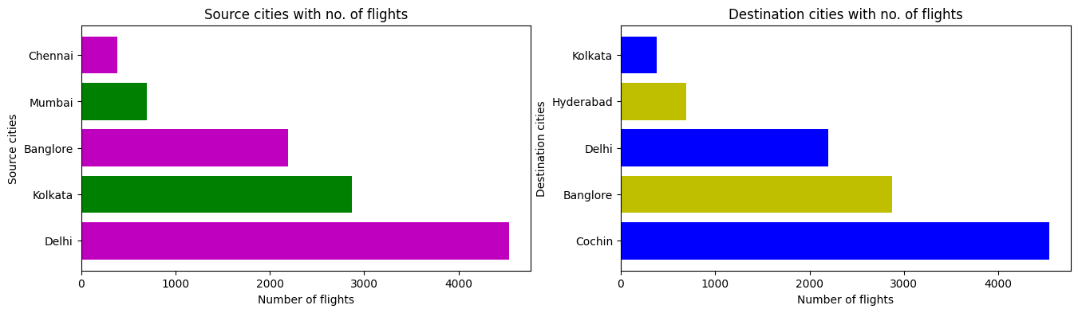
What are the most common source–destination pairs?
The most common source-destination is Delhi and Cochin
Route frequency analysis shows that Delhi–Cochin is the most common flight route, indicating very high demand and connectivity between these two cities. Other frequently used routes include Kolkata–Bangalore and Bangalore–Delhi.
Time Bucket Analysis:
How does price vary by departure time bucket
Flight prices vary significantly by departure time. Late-night flights are the cheapest on average, while morning departures are the most expensive. Prices generally increase from late night to morning hours.

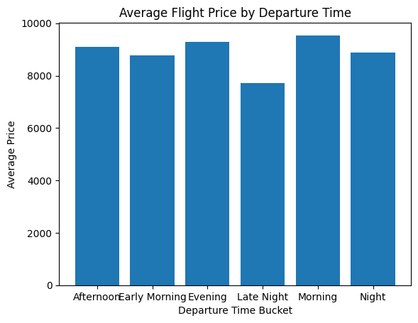

Does arrival time bucket affect ticket pricing?
Yes, arrival time impacts ticket pricing, as flights arriving in the Evening and Late Night have significantly higher average prices compared to Morning and Night arrivals.

Stops & Duration
How does total stops affect flight price?
Flight prices increase as the number of total stops increases. Non-stop flights have the lowest average price, while flights with multiple stops are significantly more expensive, indicating a strong positive correlation between total stops and ticket price.

How does total duration relate to price?
Total duration alone does not clearly define flight pricing. The relationship between duration and price is highly variable, with both short-duration high-price flights and long-duration low-price flights present in the data. This indicates that flight price is influenced by multiple factors beyond duration, such as airline type, route demand, and number of stops.

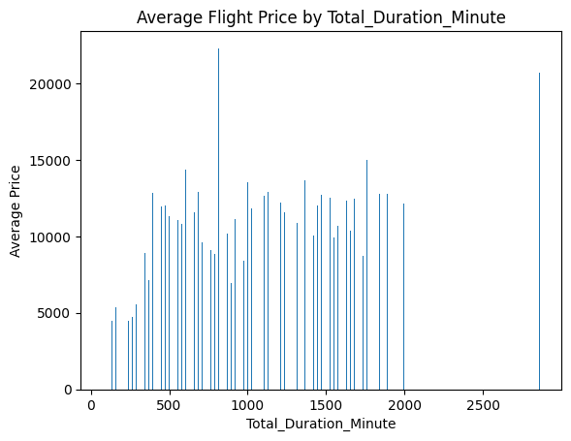

Date & Day Analysis
Does ticket price vary by month?
Yes, ticket prices vary by month.
Prices are lowest in April and increase steadily toward March, indicating seasonal demand effects.

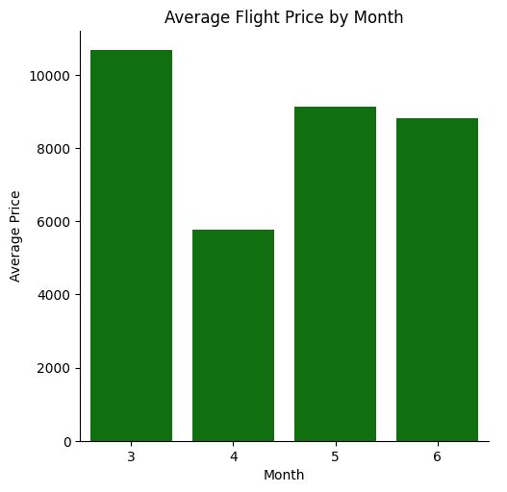
Are weekend flights more expensive than weekday flights?
Weekend flights are expensive than weekday flights.

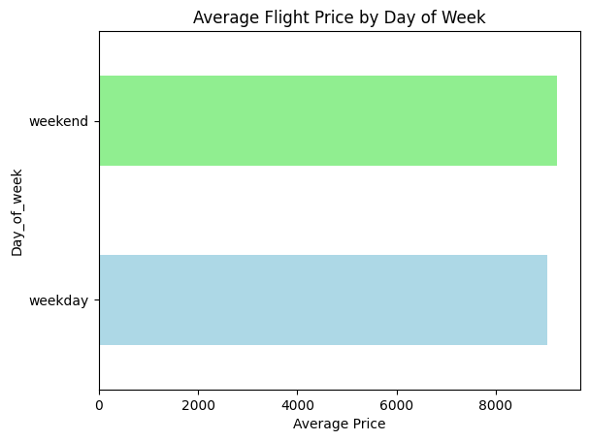

Combined Insights
How does departure time bucket interact with total stops?
The interaction between departure time and total stops shows that 1-stop flights dominate across all time buckets, especially during Morning and Evening, which have the highest flight volumes. while late-night flights are fewer overall. Flights with multiple stops (3 or 4) are rare regardless of departure time, indicating both passenger preference and airline optimization.

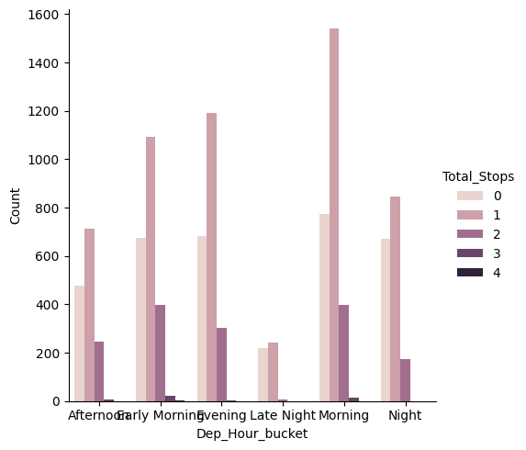
Does airline pricing change based on departure time?
Airline pricing varies significantly by both airline type and departure time. Premium and business-class airlines show strong time-based price fluctuations, with morning and evening flights being the most expensive. Low-cost carriers maintain relatively stable pricing throughout the day, while late-night departures tend to be cheaper across most airlines.

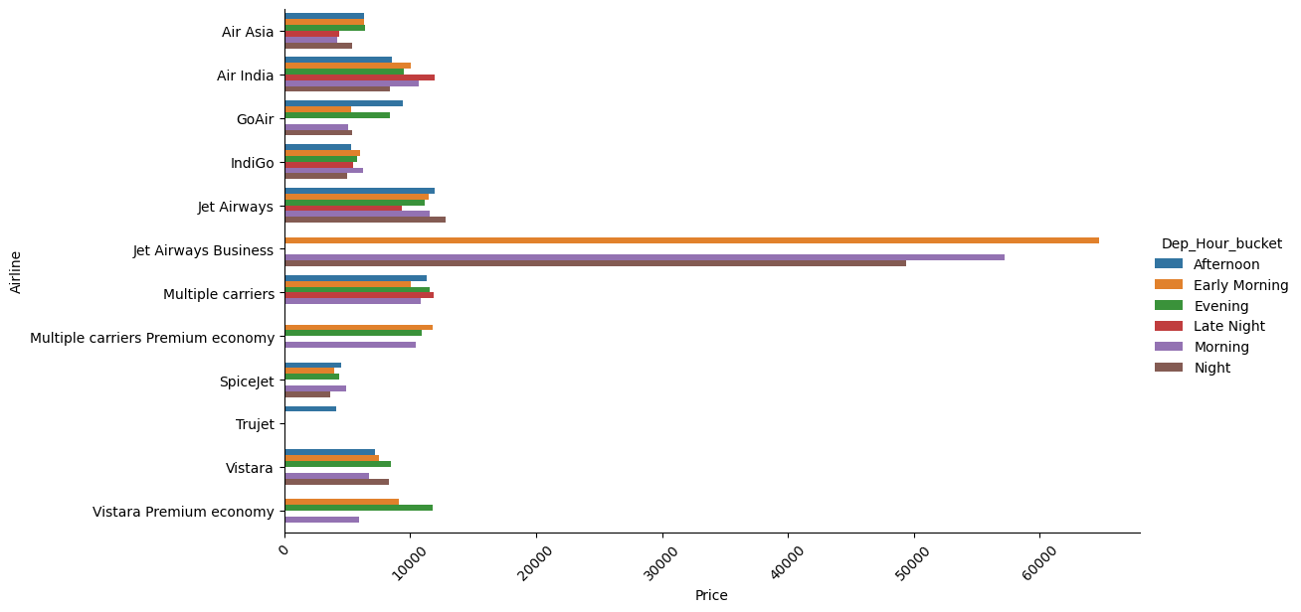

Do long-duration flights tend to have more stops?
Flights with more stops tend to have longer durations, and flights with 4 stops cover the longest duration on average.

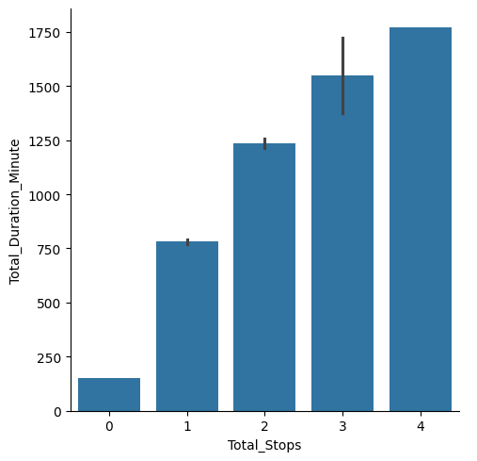

Conclusion

This exploratory data analysis examined various factors influencing flight ticket prices, including airline, route, number of total stops, journey duration, departure time, and travel day type. The analysis revealed that flight prices are strongly influenced by operational characteristics and travel timing. In this dataset, average ticket prices increase as the number of total stops increases, with non-stop flights having the lowest average price and flights with multiple stops being significantly more expensive. Departure time also impacts pricing, with morning and Evening flights generally showing higher average prices. Additionally, weekend flights tend to have slightly higher average prices compared to weekdays, indicating higher demand during weekend days. Overall, the findings suggest that flight pricing in this dataset is driven by route complexity, scheduling patterns, and demand-based factors.

