DAY-9
React Fragment & Keys
TASKS:
1. Introduction to React Fragment
React.Fragment is used to group multiple elements without adding extra HTML elements (like div) to the DOM.
Why it is used
- Avoid unnecessary <div>
- Keep HTML structure clean
- Useful when returning multiple elements
Example problem without fragment:
return (
<div>
<h1>Hello</h1>
<p>Welcome</p>
</div>
)

TASK-2:
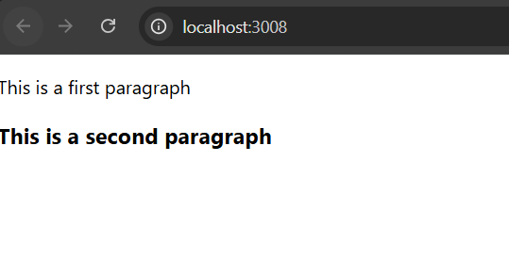
TASK3:
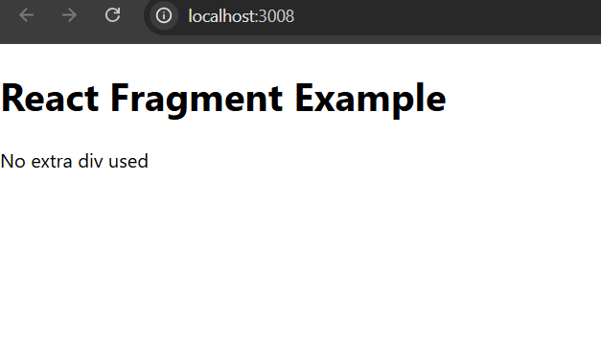
TASK 4:
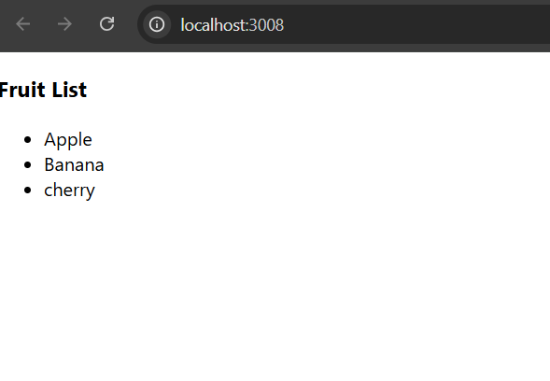
TASK 5:
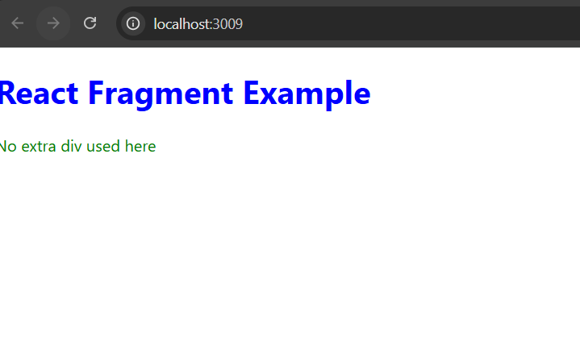
TASK:6

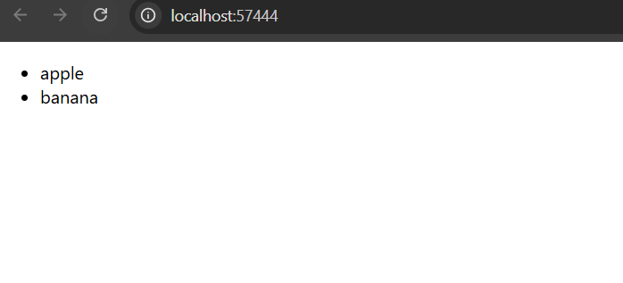
Task:7
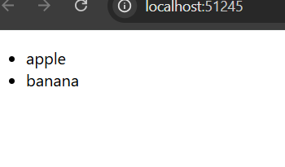
TASK:8
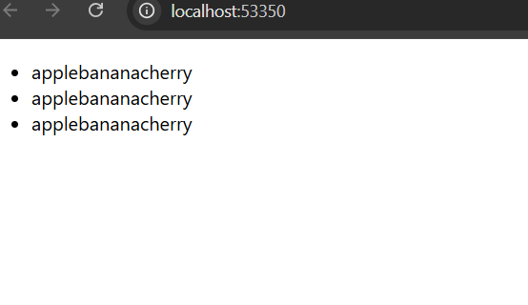
Task 9:
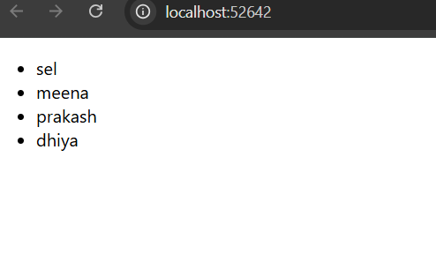
Task 10:
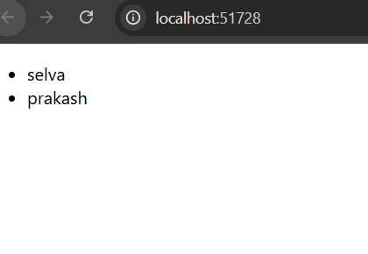
Task 11:
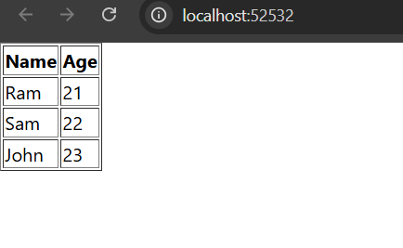
Task 12:
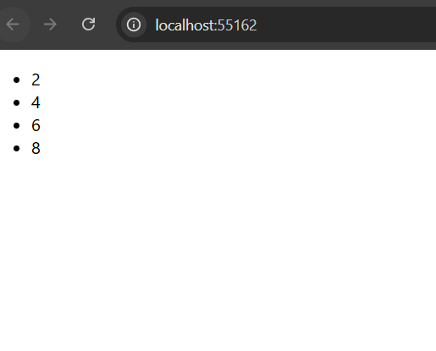
Task 13:
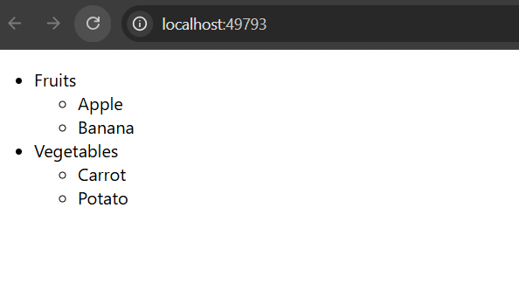
MINIPROJECTS1:
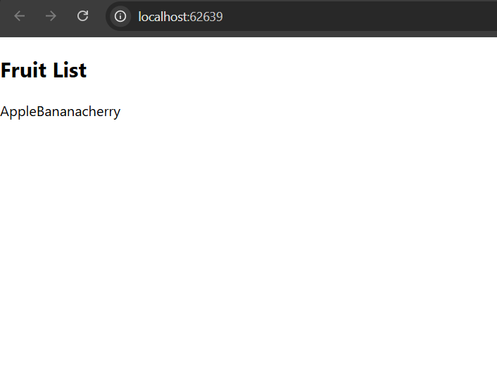
MINIPROJECT-2:
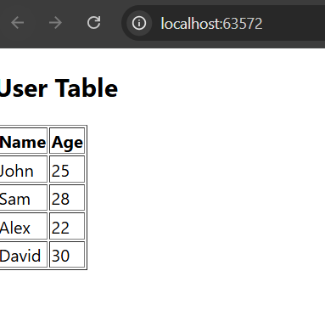
MINIPROJECT-3:
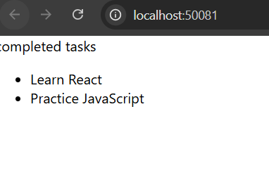
MINIPROJECT-4:
