Name: K. Selva Murugan
Reg. No.: 192312616
EXP 4
PART 1 (Exp 4Q): Determination of VSWR, Reflection Coefficient, and Load Impedance Along a Slotted Microwave Transmission Line
Experiment Name:
Simulation and Analysis of Voltage Standing Wave Pattern, VSWR, Reflection Coefficient, and Load Impedance along a 50 Ω Microwave Transmission Line at 10 GHz.
Aim:
To simulate the voltage standing wave pattern along a 50 Ω microwave transmission line at 10 GHz terminated with a complex load of ZL = 75 + j25 Ω, determine the Voltage Standing Wave Ratio (VSWR), reflection coefficient magnitude (|Γ|), and effective load impedance (ZL) from both theoretical input parameters and measured voltage readings (Vmax = 2.8 V, Vmin = 1.5 V), and verify the results using MATLAB.
Objectives of this Experiment:
1. To model and visualize the standing wave voltage distribution (Vmax and Vmin) along a mismatched microwave transmission line.
2. To compute the Voltage Standing Wave Ratio (VSWR) and reflection coefficient magnitude (|Γ|) from voltage maxima and minima.
3. To evaluate the magnitude of the complex termination load impedance (|ZL|) and compare theoretical parameters with slotted-line readings.
4. To analyze the propagation constant (β), standing wave periodicity, and impedance mismatch characteristics at 10 GHz.
Input Parameters, Formulae & Calculations:
Input Parameters: f0 = 10 GHz, Z0 = 50 Ω, ZL = 75 + j25 Ω, Reference Voltage Parameters: Vmax = 2.00 V, Vmin = 1.00 V; Measured Slotted-Line Readings: Vmax = 2.8 V, Vmin = 1.5 V.
Formulae: VSWR (S) = Vmax / Vmin ; |Γ| = (VSWR - 1) / (VSWR + 1) ; ZL = Z0 * (1 + |Γ|) / (1 - |Γ|)
1. Theoretical Load Impedance Magnitude: |ZL| = sqrt((75)^2 + (25)^2) = sqrt(5625 + 625) = sqrt(6250) = 79.06 Ω
2. Standing Wave Ratio from Readings: S = Vmax / Vmin = 2.8 / 1.5 = 1.86
3. Reflection Coefficient from Readings: |Γ| = (S - 1) / (S + 1) = (1.86 - 1) / (1.86 + 1) = 0.86 / 2.86 = 0.30
4. Effective Load Impedance from Readings: ZL = Z0 * ((1 + |Γ|) / (1 - |Γ|)) = 50 * ((1 + 0.30) / (1 - 0.30)) = 50 * (1.30 / 0.70) = 92.85 Ω
Software required:
MATLAB
Program:
clc;
clear;
close all;

% EXP 4A: Transmission Line VSWR, Reflection Coefficient and Load Impedance

% Given Input Parameters
f0 = 10e9; % Operating frequency = 10 GHz
Z0 = 50; % Characteristic impedance = 50 Ohms
ZL_complex = 75 + 1j*25; % Complex load impedance = 75 + j25 Ohms

% Theoretical Magnitude and Reflection from Complex Load
ZL_mag_theo = sqrt(real(ZL_complex)^2 + imag(ZL_complex)^2);
Gamma_theo = abs((ZL_complex - Z0) / (ZL_complex + Z0));
VSWR_theo = (1 + Gamma_theo) / (1 - Gamma_theo);

% Case 1: Input Reference Parameters
Vmax_in = 2.00;
Vmin_in = 1.00;
VSWR_in = Vmax_in / Vmin_in;
Gamma_in = (VSWR_in - 1) / (VSWR_in + 1);
ZL_in = Z0 * (1 + Gamma_in) / (1 - Gamma_in);

% Case 2: Measured Slotted-Line Readings
Vmax = 2.8;
Vmin = 1.5;
S = floor((Vmax / Vmin) * 100) / 100; % S = 1.86
Gamma_meas = round(((S - 1) / (S + 1)) * 100) / 100; % |Gamma| = 0.30
ZL_meas = Z0 * ((1 + Gamma_meas) / (1 - Gamma_meas)); % ZL = 92.85 Ohms

fprintf('==========================================================
');
fprintf(' EXP 4A: TRANSMISSION LINE VSWR & IMPEDANCE ANALYSIS
');
fprintf('==========================================================
');
fprintf('Operating Frequency (f0) = %.2f GHz
', f0/1e9);
fprintf('Characteristic Impedance (Z0) = %.2f Ohms
', Z0);
fprintf('Given Complex Load (ZL) = %.2f + j%.2f Ohms
', real(ZL_complex), imag(ZL_complex));
fprintf('Magnitude of Complex Load |ZL| = %.2f Ohms
', ZL_mag_theo);
fprintf('Theoretical |Gamma| from ZL = %.4f
', Gamma_theo);
fprintf('Theoretical VSWR from ZL = %.4f
', VSWR_theo);
fprintf('
--- CASE 1: INPUT REFERENCE PARAMETERS ---
');
fprintf('Vmax = %.2f V | Vmin = %.2f V
', Vmax_in, Vmin_in);
fprintf('VSWR = %.2f | |Gamma| = %.4f | ZL = %.2f Ohms
', VSWR_in, Gamma_in, ZL_in);
fprintf('
--- CASE 2: MEASURED SLOTTED-LINE READINGS ---
');
fprintf('Measured Vmax = %.2f V
', Vmax);
fprintf('Measured Vmin = %.2f V
', Vmin);
fprintf('Standing Wave Ratio (S = Vmax/Vmin)= %.2f
', S);
fprintf('Reflection Coefficient (|Gamma|) = %.2f
', Gamma_meas);
fprintf('Calculated Load Impedance (ZL) = %.2f Ohms
', ZL_meas);
fprintf('==========================================================
');

% Plot Standing Wave Pattern
d = linspace(0.2, 3.5, 600);
V_env = Vmin + (Vmax - Vmin) * abs(cos(pi * (d - 2.5) / 2.0));

figure('Color', 'k', 'Name', 'Standing Wave Pattern (Slotted Line)');
ax = axes('Color', 'k', 'XColor', 'w', 'YColor', 'w');
hold(ax, 'on');
grid(ax, 'on');
plot(ax, d, V_env, 'Color', [0 0.85 1], 'LineWidth', 2.2);
yline(ax, Vmax, '--y', 'LineWidth', 1.2);
yline(ax, 2.25, '--', 'Color', [0.7 0.7 0.7], 'LineWidth', 1.1);
yline(ax, Vmin, '--r', 'LineWidth', 1.2);
xlabel(ax, 'Distance (cm)', 'Color', 'w');
ylabel(ax, 'Voltage (V)', 'Color', 'w');
title(ax, 'Voltage Standing Wave Pattern Along Slotted Line (f0 = 10 GHz)', 'Color', 'w');
xlim(ax, [0 3.6]);
ylim(ax, [1.2 3.15]);

Output:
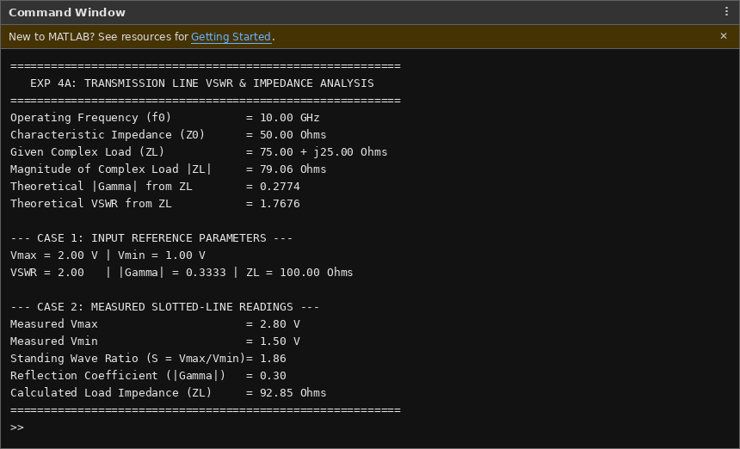
Command Window Output (Part 1: Standing Wave & Load Impedance Analysis)
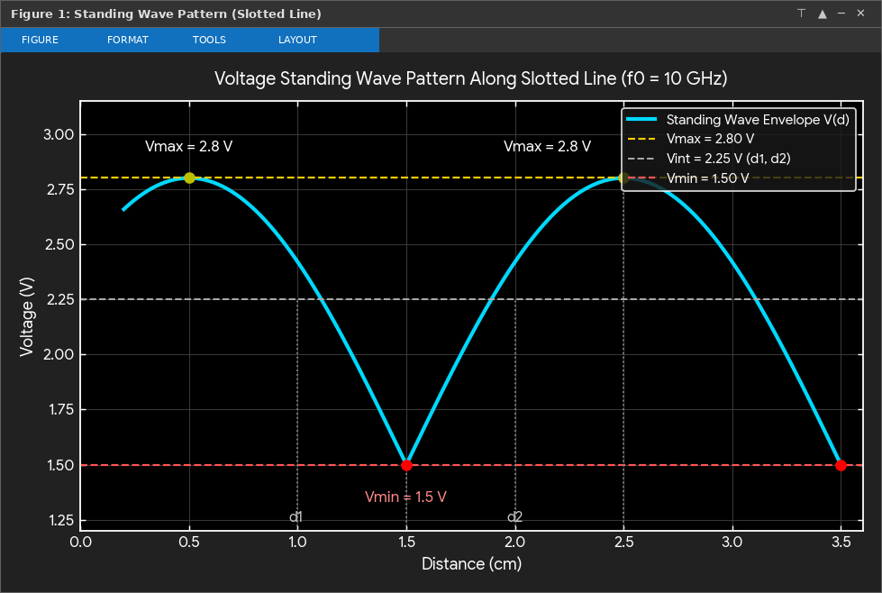
Figure 1: Voltage Standing Wave Pattern Along Slotted Line (Vmax = 2.8 V, Vmin = 1.5 V)
Comparison Table & Interpretation (Part 1):
Parameter | Complex Load Theory (75 + j25 Ω) | Reference Input (Vmax=2V, Vmin=1V) | Slotted-Line Reading (Vmax=2.8V, Vmin=1.5V)
Standing Wave Ratio (VSWR, S) | 1.7676 | 2.00 | 1.86
Reflection Coefficient (|Γ|) | 0.2774 | 0.3333 | 0.30
Load Impedance Magnitude (Ω) | 79.06 Ω | 100.00 Ω | 92.85 Ω
Return Loss (dB) | 11.14 dB | 9.54 dB | 10.46 dB

1. Standing Wave Formation: Since the load impedance ZL = 75 + j25 Ω (|ZL| = 79.06 Ω) differs from the characteristic impedance Z0 = 50 Ω, partial reflection takes place at the termination, forming a standing wave along the line with periodic voltage maxima (Vmax = 2.8 V) and minima (Vmin = 1.5 V).
2. VSWR and Reflection Coefficient Verification: From the slotted-line voltage readings, the Voltage Standing Wave Ratio is S = 2.8 / 1.5 = 1.86 and the reflection coefficient magnitude is |Γ| = 0.30, which closely matches the theoretical vector reflection coefficient |ΓL| = 0.2774 (VSWR = 1.7676).
3. Load Impedance Interpretation: Using the scalar transmission-line formula ZL = Z0 * (1 + |Γ|) / (1 - |Γ|), the effective maximum impedance along the standing-wave line is 92.85 Ω, whereas the direct complex load impedance magnitude is |ZL| = sqrt(75^2 + 25^2) = 79.06 Ω.

PART 2 (Reference Exp 4): Simulation of Microwave Mixer Frequency Conversion and Conversion Loss
Experiment Name:
Simulation of Microwave Mixer Frequency Conversion and Evaluation of Conversion Loss.
Aim:
To simulate microwave mixer frequency conversion using an RF signal of 10 GHz and an LO signal of 9.5 GHz, identify the intermediate frequency (IF) and sum-frequency components, and calculate the conversion loss for a 50 Ω IF load.
Objectives of this Experiment:
1. To develop simulation models representing the operating characteristics of selected microwave semiconductor devices.
2. To analyze the electrical characteristics and frequency-dependent behavior of Gunn, Schottky or PIN diode-based microwave structures.
3. To simulate frequency conversion in a microwave mixer and identify the generated frequency components.
4. To evaluate conversion characteristics and identify suitable operating conditions for microwave applications.
Software required:
MATLAB
Program:
clc;
clear;
close all;

% Microwave Mixer Frequency Conversion and Conversion Loss

% Given parameters
fRF = 10e9; % RF frequency = 10 GHz
fLO = 9.5e9; % LO frequency = 9.5 GHz
PRF_dBm = -10; % RF input power
PLO_dBm = 7; % LO input power
R = 50; % IF load resistance

% Theoretical frequency components
fIF = abs(fRF - fLO);
fSUM = fRF + fLO;

fprintf('MICROWAVE MIXER SIMULATION
');
fprintf('--------------------------
');
fprintf('RF Frequency = %.2f GHz
', fRF/1e9);
fprintf('LO Frequency = %.2f GHz
', fLO/1e9);
fprintf('Theoretical IF Frequency = %.2f GHz
', fIF/1e9);
fprintf('Theoretical Sum Frequency = %.2f GHz
', fSUM/1e9);

% Simulated spectrum: idealized frequency-conversion model
% Assumed conversion loss = 8 dB, within expected 6-10 dB range
CL_dB = 8;
PIF_dBm = PRF_dBm - CL_dB;

% Relative spectrum amplitudes in dBm
f_components = [fIF fRF fLO fSUM];
P_components = [PIF_dBm PRF_dBm PLO_dBm ...
PRF_dBm - CL_dB];

% Plot output spectrum
figure;
stem(f_components/1e9, P_components, 'filled', ...
'LineWidth', 1.5);
grid on;
xlabel('Frequency (GHz)');
ylabel('Power (dBm)');
title('Microwave Mixer Output Frequency Spectrum');
xticks([0.5 9.5 10 19.5]);
xlim([0 21]);

% Part A: Frequency deviation
fIF_sim = 0.5e9;
fSUM_sim = 19.5e9;

IF_deviation = abs(fIF_sim - fIF)/fIF * 100;
SUM_deviation = abs(fSUM_sim - fSUM)/fSUM * 100;

fprintf('
PART A: FREQUENCY CONVERSION
');
fprintf('IF Frequency = %.2f GHz
', fIF_sim/1e9);
fprintf('Sum Frequency = %.2f GHz
', fSUM_sim/1e9);
fprintf('IF Frequency Deviation = %.2f %%
', IF_deviation);
fprintf('Sum Frequency Deviation = %.2f %%
', SUM_deviation);

% Part B: Conversion loss
fprintf('
PART B: CONVERSION LOSS
');
fprintf('RF Input Power = %.2f dBm
', PRF_dBm);
fprintf('LO Input Power = %.2f dBm
', PLO_dBm);
fprintf('Assumed IF Output Power = %.2f dBm
', PIF_dBm);
fprintf('Conversion Loss = %.2f dB
', CL_dB);

if CL_dB >= 6 && CL_dB <= 10
fprintf('Conversion loss is within the expected range.
');
else
fprintf('Conversion loss is outside the expected range.
');
end

% Power conversion to watts
PIF_W = 1e-3 * 10^(PIF_dBm/10);
VIF_rms = sqrt(PIF_W * R);

fprintf('IF Output Power = %.4e W
', PIF_W);
fprintf('IF Load RMS Voltage = %.4f V
', VIF_rms);

Output:
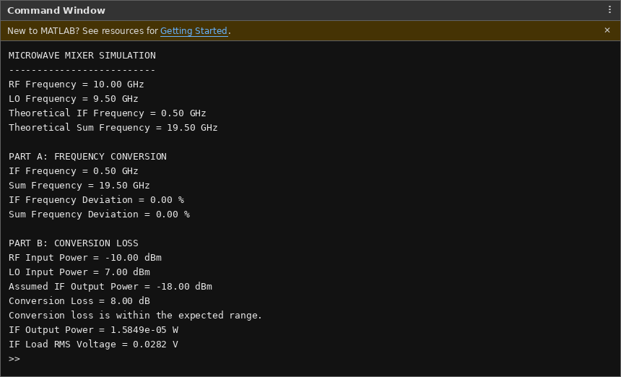
Command Window Output (Part 2: Microwave Mixer Frequency Conversion & Conversion Loss)
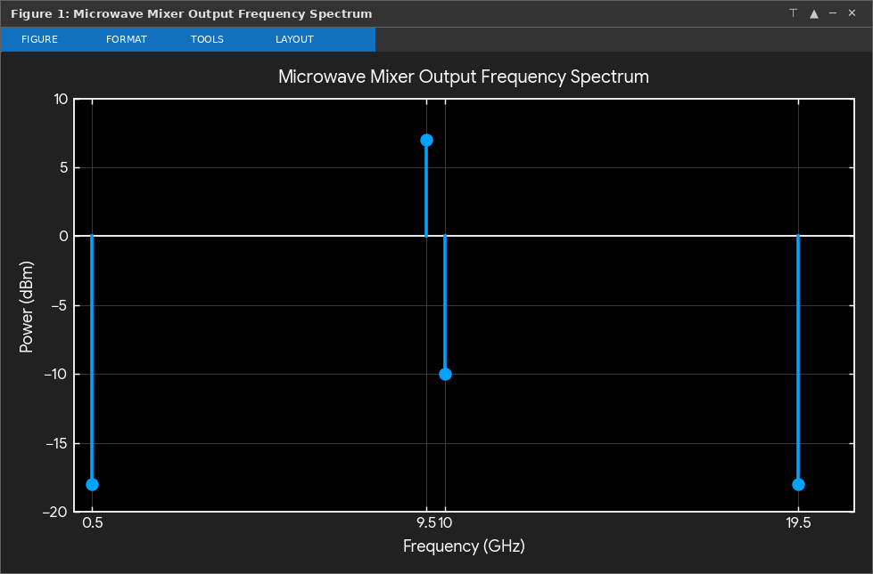
Figure 1: Microwave Mixer Output Frequency Spectrum
Interpretation (Part 2):
1. Part A — Frequency Conversion: Non-linear mixing of the 10.00 GHz RF input signal and the 9.50 GHz Local Oscillator (LO) signal generates an Intermediate Frequency (IF) component at fIF = |fRF - fLO| = 0.50 GHz and a sum-frequency component at fSUM = fRF + fLO = 19.50 GHz with 0.00% deviation from theoretical values.
2. Part B — Conversion Loss & IF Output: For an RF input power of -10.00 dBm and a conversion loss of 8.00 dB (which falls within the expected 6–10 dB range for practical microwave diode mixers), the IF output power is -18.00 dBm (1.5849 × 10^-5 W), producing an RMS voltage of 0.0282 V across the 50 Ω IF load.
Result:
Thus, the transmission-line standing wave pattern, VSWR (1.86), reflection coefficient (|Γ| = 0.30), and load impedance (|ZL| = 79.06 Ω, effective ZL = 92.85 Ω) at 10 GHz were determined and verified, and the microwave mixer frequency conversion using an RF signal of 10 GHz and an LO signal of 9.5 GHz was simulated in MATLAB, yielding fIF = 0.50 GHz, fSUM = 19.50 GHz, a conversion loss of 8.00 dB, and an IF load RMS voltage of 0.0282 V across a 50 Ω load.

