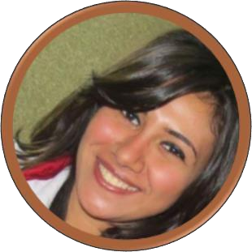

**Selvana Naguib**

**UI/UX Developer – Graphic Designer**

Email: [selvana.naguib4@gmail.com](mailto:selvana.naguib4@gmail.com)| Website: [www.selvana-naguib.com](http://www.selvana-naguib.com/)



Phone: (+02) 012-117 47 667 | Address: 3 Knest El Akbat St., Masarra, Shoubra Misr, Cairo, Egypt

|  |  |  |
| --- | --- | --- |
| **Bachelor of Science** | **Education**  **Secondary School** | **Primary School** |
| Computer Science, Helwan University.  2016 | Hafez Ibrahim  Exp. Language School.  2012 | Ali Ibn Abi Talib Exp. Language School.  2009 |
|  | **Experience** |  |

**UI/UX Developer at Agile Technologies March 2017 - Present**

Responsible for designing websites, android, windows phone and IOS applications, company Brochure and logo, using Angular4, HTML5, CSS3, Bootstrap4, Canvas, SVG, JavaScript, JQuery, Photoshop, Illustrator, sketch & Balsamic.

**UI/UX Developer at Alexon August 2016 – March 2017**

Responsible for designing websites, android, windows phone and IOS applications, using HTML5, CSS3, Bootstrap, Canvas, SVG, JavaScript, JQuery & Photoshop.

**Web Designer at Enjaz Development June 2016 to August 2016**

Responsible for designing Ecommerce website using HTML5, CSS3, Bootstrap, Canvas, SVG, JavaScript & Photoshop.



**Projects**

# Agile Technologies

- Kuwait Capital of Arab Youth Website and mobile application

- E-tender Project

- CMA project (Contract system with Chabot)

- Brochures, Logos

- Agile Portal Website and mobile application

- Dry clean service mobile applications, App Landing Page website & Dashboard

# Alexon Development

- E-commerce application

- Saudi Post Application

# Enjaz Development

- E-commerce website

# Graduation Project

- Health care cloud

# Free-lance

- Car Dealers website

- D-writing application

- Chorus application



**Key Skills**

|  |  |  |
| --- | --- | --- |
| **Professional**  Angular4  HTML5  CSS3  Bootstrap4  SVG  Canvas  JavaScript  JQuery  Photoshop  Illustrator  Sketch  Balsamic | **Personal**  Adaptation  Representation  Team working  Working under stress  Attention to details  Willing to learn  Hard Working | **Languages**  Arabic  English  **Hobbies**  Cycling  Acting  Reading  Poem telling |



**Portfolio**

Please check my portfolio at <http://www.selvana-naguib.com/#portfolio>