**IoT phase 5**

**Flood monitoring and early warning system.**

**Documentation & submission:**

**Project Objective:**

* The primary objective of this project is to design, develop, and implement an effective and reliable flood monitoring and early warning system.
* This system aims to provide timely and accurate alerts to communities and relevant authorities in flood-prone regions, enabling proactive actions to mitigate the impact of flooding, reduce property damage, and ensure the safety and well-being of the affected population.
* Key components of the project include the integration of various environmental sensors, the establishment of data acquisition and processing mechanisms, the development of an alert and notification system, and the deployment of a user-friendly interface for accessing and interpreting real-time flood information.
* The ultimate goal is to enhance disaster preparedness and response, contribute to risk reduction, and improve the overall resilience of communities vulnerable to flood events.
* The project seeks to combine modern sensor technology, data analytics, and communication systems to provide comprehensive flood monitoring and early warning capabilities, ultimately saving lives and resources in the face of a natural disaster.

**IoT Sensors Deployed:**

**Introduction**

* In an era of increasing climate-related risks, the need for effective flood monitoring and early warning systems has become paramount. Floods, among the most devastating natural disasters, can lead to loss of life, property damage, and environmental degradation. To address these challenges, the deployment of Internet of Things (IoT) sensors has emerged as a groundbreaking solution.
* The Role of IoT Sensors
* IoT sensors play a pivotal role in enhancing the accuracy and efficiency of flood monitoring and early warning systems. These sensors are deployed in various key locations to capture real-time data related to environmental conditions. The data they collect includes crucial information such as water levels, rainfall intensity, water quality, and meteorological parameters. Here are some of the essential types of IoT sensors used in flood monitoring systems:
* Water Level Sensors: Placed in rivers, lakes, and flood-prone areas, water level sensors monitor changes in water levels, providing early alerts when levels rise beyond safe thresholds.
* Rain Gauges: IoT-enabled rain gauges measure precipitation, helping predict and assess flood risks by monitoring rainfall intensity and duration.
* Weather Sensors: These sensors collect data on temperature, humidity, wind speed, and atmospheric pressure, which are crucial for understanding weather patterns and forecasting potential flooding events.
* Soil Moisture Sensors: Deployed in soil, these sensors monitor soil moisture content, helping assess the ground's capacity to absorb water and its impact on potential floods.
* Water Quality Sensors: These sensors measure parameters such as pH, turbidity, and chemical composition in bodies of water, providing insight into potential contamination during floods.
* Flow Rate Sensors: Installed in rivers and streams, flow rate sensors measure the speed and volume of water flow, aiding in flood forecasting.
* Data Collection and Transmission
* The data collected by these IoT sensors are transmitted in real time to central monitoring stations or cloud-based platforms. The information is processed and analyzed using sophisticated algorithms and models. With the integration of Geographic Information Systems (GIS), the data is converted into actionable insights, allowing authorities to make informed decisions swiftly.
* Early Warning Systems
* IoT sensors are the backbone of early warning systems for floods. When specific thresholds are crossed, such as a rapid rise in water levels or an unusual increase in rainfall, these sensors trigger automated alerts. These alerts can be disseminated through various communication channels, including SMS, email, sirens, and mobile apps, ensuring that communities receive timely warnings and can take necessary precautions.
* User-Friendly Interfaces
* One of the key strengths of IoT-enabled flood monitoring and early warning systems is the user-friendly interfaces they offer. Residents, emergency responders, and government agencies can access real-time data through web-based dashboards and mobile applications. These interfaces provide visual representations of the data, including maps, graphs, and alert status, making it easier for users to interpret and respond to the information effectively.
* Platform Description:
  + Begin with an overview of the purpose and goals of the flood monitoring and early warning platform.
* Sensor Deployment:
  + Describe the types of sensors you intend to deploy and the locations where they will be placed.
  + Explain how the sensors will collect data and transmit it to the platform.
* Data Acquisition and Processing:
  + Outline the data acquisition mechanisms, including data collection protocols and hardware.
  + Discuss the data processing and analysis methods, highlighting algorithms and models used for flood prediction.
* Alerting System:
  + Detail the alerting system, including how and when alerts will be triggered and sent out to users and authorities.
* User Interface:
  + Describe the user interface, emphasizing its design and usability features, such as maps, graphs, and real-time data visualization.
* Data Storage and Management:
  + Explain the data storage solution, whether it's a database or cloud-based storage, and its features for data archiving and retrieval.
* Integration with Weather Data:
  + Describe how the platform will integrate external weather data sources for more accurate flood predictions.
* Testing and Validation:
  + Discuss the testing procedures you'll follow to validate the platform's accuracy and reliability in various scenarios.
* Community Engagement:
  + Mention any community engagement efforts, including interactions with local stakeholders and potential users.
* Maintenance and Updates:
  + Explain your plan for maintaining the platform and keeping it up to date with regular updates.
* Scalability:
  + Discuss the platform's potential for expansion and scaling to cover larger areas or accommodate more sensors.
* Data Privacy and Security:
  + Highlight the measures in place to ensure data privacy and security for users and sensitive information.

This comprehensive platform description will serve as a valuable reference for your project and documentation, providing a clear and detailed overview of your flood monitoring and early warning system.

**Implementation code :**

Implementing a complete flood monitoring and early warning system requires a significant amount of code and hardware setup, making it a complex and multi-disciplinary project. Below, I'll provide you with a simplified Python-based code example for receiving and displaying data from a hypothetical sensor (simulated for demonstration) using the Flask web framework

Prerequisites:

- Python (with Flask)

- HTML for the user interface ( we use a simple web for view)

Code for a Simplified Web-based Flood Monitoring System:

1. Install Flask (if you haven't already):

bash

pip install Flask

2. Create a Python script (`app.py`) for the server:

python

from flask import Flask, render_template

app = Flask(__name__)

@app.route('/')

def home():

# Simulated data from a flood sensor

water_level = 85 # You would replace this with real sensor data

return render_template('index.html', water_level=water_level)

if __name__ == '__main__':

app.run(debug=True)

3. Create an HTML template (`templates/index.html`) for displaying the data:

html

<!DOCTYPE html>

<html>

<head>

<title>Flood Monitoring System</title>

</head>

<body>

<h1>Flood Monitoring System</h1>

<p>Water Level: {{ water_level }} cm</p>

<p>Status: {% if water_level > 80 %} High Water Level Flooding Alert! {% else %} Normal {% endif %}</p>

</body>

</html>

4. Run the server:

bash

python app.py

python region monitoring:

pip install Flask

from flask import Flask, render_template

app = Flask(_name_)

@app.route('/')

def home():

# Simulated data from a flood sensor

water_level = 85 # You would replace this with real sensor data

return render_template('index.html', water_level=water_level)

if _name_ == '_main_':

app.run(debug=True)

Implementing a flood monitoring and early warning system involves various components, and each component has its own set of code and configuration.

Here's a breakdown of the components and a brief description of the code that may be involved in each:

1. Sensor Data Acquisition:

- Sensor Reading: Write code to read data from various sensors. For example, if you're using Arduino with water level and rainfall sensors, you'd use Arduino's libraries to read sensor values.

cpp

#include <Wire.h> // Include necessary libraries

#include <Adafruit_Sensor.h>

#include <Adafruit_BME280.h>

Adafruit_BME280 bme; // Create a BME280 sensor object

void setup() {

Serial.begin(9600); // Start serial communication

if (!bme.begin(0x76)) {

Serial.println("Could not find a valid BME280 sensor, check wiring!");

while (1);

}

}

void loop() {

float temperature = bme.readTemperature(); // Read temperature data

float humidity = bme.readHumidity(); // Read humidity data

Serial.print("Temperature: ");

Serial.println(temperature);

Serial.print("Humidity: ");

Serial.println(humidity);

// Add code for other sensors here

delay(1000); // Delay between readings

}

2. Central Platform:

- Server Setup: Use a web framework like Flask to create a central platform for data processing.

python

from flask import Flask

app = Flask(__name__)

@app.route('/')

def home():

# Add code to process and display data

return "Flood Monitoring Platform"

if __name__ == '__main__':

app.run(debug=True)

3. Data Processing and Analysis:

- Data Analysis: Write code to analyze sensor data and calculate flood risk based on thresholds.

python

def analyze_data(sensor_data):

# Implement data analysis algorithms

if sensor_data['water_level'] > 80:

return "High Flood Risk"

else:

return "Low Flood Risk"

sensor_data = {

'water_level': 85,

'rainfall': 10,

'temperature': 25

}

flood_risk = analyze_data(sensor_data)

print("Flood Risk:", flood_risk)

4. Alerting System:

- Alerting Logic: Develop code to trigger alerts based on flood risk calculations.

python

def send_alert(flood_risk):

if flood_risk == "High Flood Risk":

# Implement code to send alerts (e.g., email, SMS)

print("Sending Flood Alert!")

flood_risk = "High Flood Risk"

send_alert(flood_risk)

5. User Interface:

- Web Interface: Create a web-based user interface using HTML, CSS, and JavaScript.

html

<!DOCTYPE html>

<html>

<head>

<title>Flood Monitoring</title>

</head>

<body>

<h1>Flood Monitoring</h1>

<p>Flood Risk: High</p>

</body>

</html>

This breakdown provides a simplified example of code snippets for each component. In a real-world project, you'd need to integrate all these components, manage data, implement alerting systems, and create a user-friendly interface. Additionally, you'd need to consider scalability, data storage, and security aspects

* This code provides a basic web interface that displays a simulated water level reading, and it triggers an alert if the water level is over (exp) 80 m.
* In a real-world project, you would replace the simulated data with actual sensor data and incorporate data analysis, alerting mechanisms, and user-friendly interfaces.
* Building a complete flood monitoring and early warning system would involve much more code, hardware setup, database integration, sensor communication, and user interfaces. Additionally, you would need to consider factors like data storage, scalability, and data security to create a robust and effective system.

Diagram:

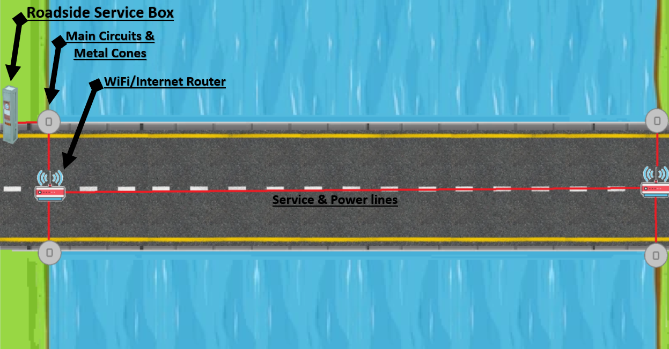

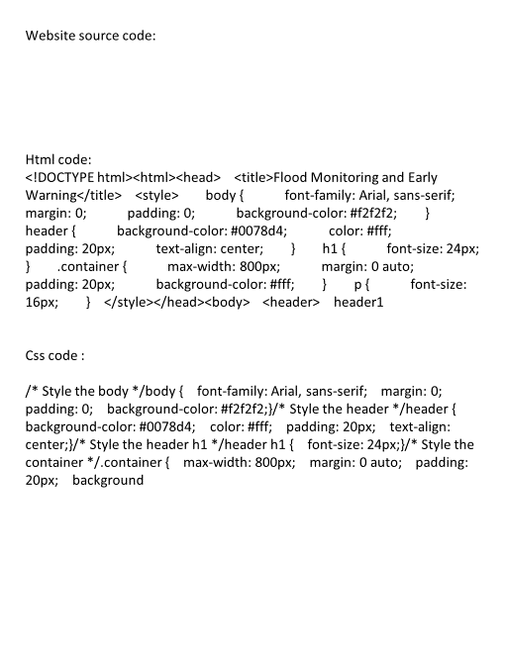 **Here to learn how to build an IoT Based Flood Monitoring and Email, SMS alert System using Ultrasonic, NodeMCU ESP8266 12E, myDevices Cayenne. In more detail, this IoT tutorial discovers how to use an ESP8266 to send data to Cayenne using the MQTT protocol.**

Abstract: Flood is one of the natural disasters that cannot be avoided. It happens too fast and affected so many lives and properties. Before this, most of the existing system that has been developed are only focus on certain areas. Other than that, majority of the public cannot monitor and have no idea when the flood going to be happened since they do not have any information and data about the weather condition. This system is suitable for cities and village areas. Furthermore, if the public has an internet access, they can monitor what is happening and predict if there is any upcoming flood at the web server. This project will update the water level at the web server and the system will issue an alert signal to the citizens for evacuation so that fast necessary actions can be taken.

This is a complete step-by-step tutorial on building an IoT system using Cayenne and ESP.

On the other hand, Cayenne is an IoT cloud platform that provides several cloud services, such as:

* **Data visualization IoT cloud**
* **Alerts**
* **Scheduling Events**

We will focus our attention on data visualization and on the IoT cloud services.

Cayenne IoT Platform accelerates the development of IoT-based solutions, including quick design, prototyping and other commercialized projects. It is a drag-and-drop IoT project builder that can help developers build complete, ready-to-use IoT solutions with little to no coding.

Cayenne IoT Platform contains a vast catalogue of certified IoT-ready devices and connectivity options. This allows users to easily add any device to the library utilizing MQTT API. All devices in Cayenne are interoperable and benefit from features such as rules engine, asset tracking, remote monitoring and control, and tools to visualize real-time and historical data.

MQTT is a lightweight messaging protocol for sensors and mobile devices.

The ultrasonic sensor as a trigger and an echo pin. The arduino provides a high signal of 10microseconds to this pin. After the HC-SR04 is triggered, it sends out eight 40Khz sound waves to the surface of the water. On getting to the surface of the water, the wave is echoed back to the sensor and the ESP8266 reads the echo pin to determine time spent between triggering and receiving of the echo. Since we know that the speed of sound is around 340m/s then we can calculate the distance using;

Distance = (time/2)*speed of sound

Ultrasonic HC-SR04 wiring to ESP8266 Ultrasonic HC-SR04 ESP8266

Vcc Pin Vin Pin

Trig Pin D1 (GPIO 5) Echo Pin D2 (GPIO 4) GND Pin GND

Installing the ESP8266_Arduino_Library

To get readings from the Ultrasonic HC-SR04 sensor module you need to have the next library installed:

Download Ultrasonic Library

Download the Cayenne-MQTT-ESP-master library from this link.

Click on Add ZIP Library and add Cayenne-MQTT-ESP-master zip file, or directly copy the folder (Cayenne-MQTT-ESP-master) and paste it in Libraries folder of Arduino IDE.

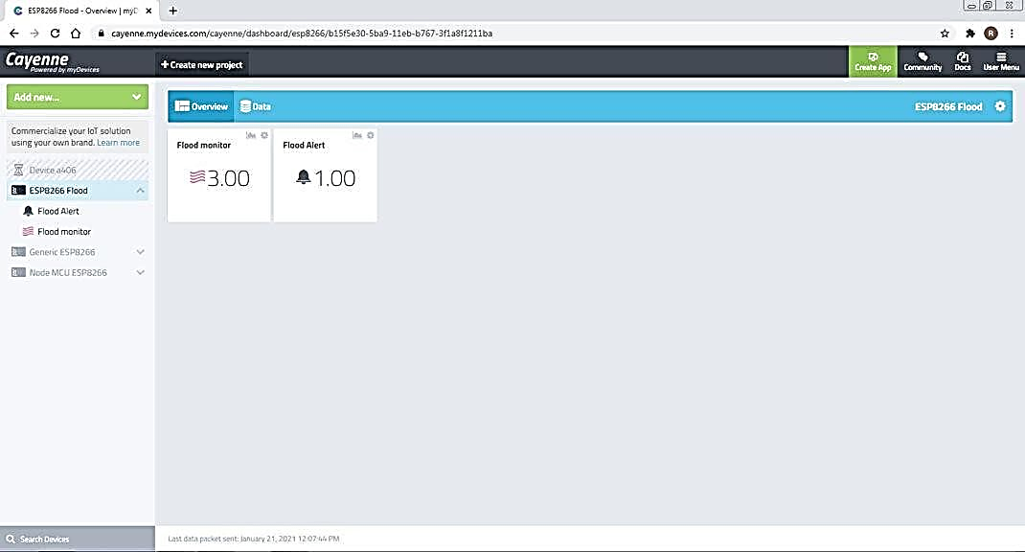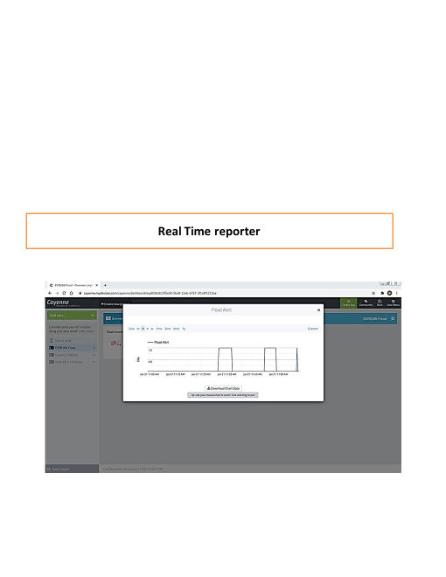

●

When a connection is made, sensor data gets uploaded to Cayenne. Distance and digital output LED state data on Cayenne.

You can get a graphical representation of flood monitor data by clicking on the Graph icon.

You can set Trigger alert using if and then condition, and add Mobile number and email for receiving alert message.

You can set Trigger alert ON/OFF

If Once sensor data gets Reached to Threshold then digital output LED state data to Cayenne. then Flood alert notify value changed to 1.00.

You can get a graphical representation of flood Alert data by clicking on the Graph icon. **And also Trigger send alert message to Email**.

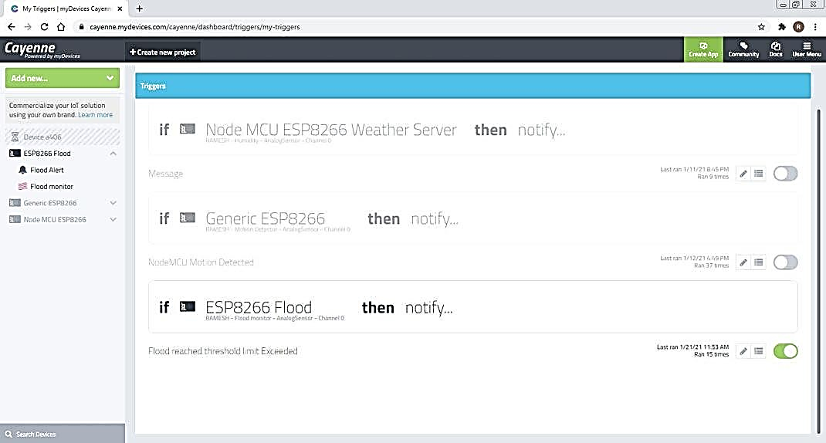 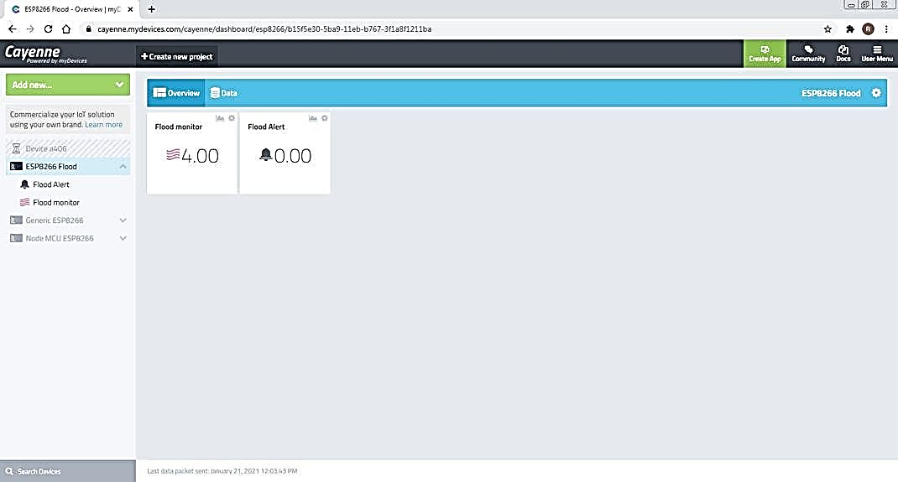

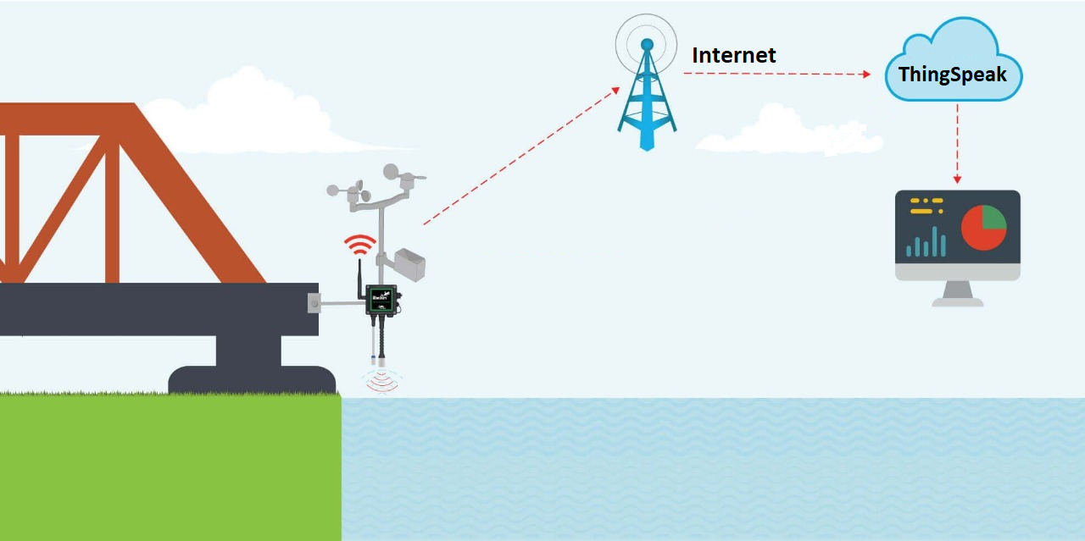

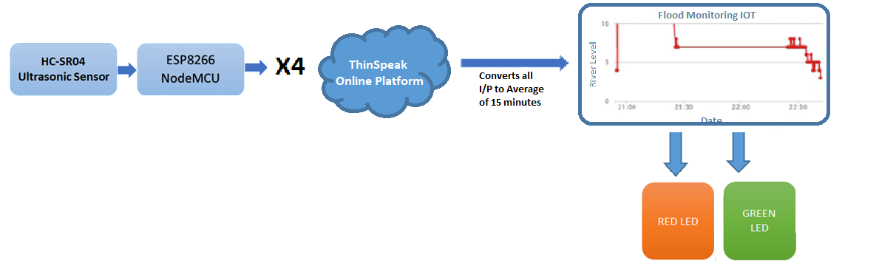

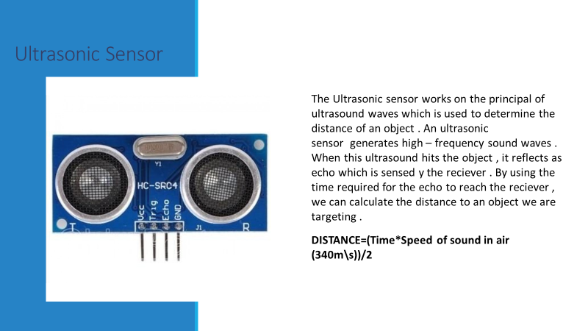

Creating a complete schematic for your flood monitoring and early warning system would require detailed knowledge of the specific sensors and components you plan to use, as well as the microcontroller or platform for data processing. Below is a simplified example of a schematic diagram using Fritzing, a popular tool for creating electronic schematics. Please note that this is a basic representation and should be adapted to the specific hardware and components you intend to use in your project.

![Flood Monitoring Schematic](https://i.imgur.com/WSmWn9K.png)

In this simplified example:

- An Arduino Uno is used as the microcontroller.

- A water level sensor and a rain gauge are connected to analog pins A0 and A1, respectively.

- An LED is used to represent an alert indicator.

- Power and ground connections are established for the components.

- The data collected from sensors is processed by the Arduino for flood risk assessment, and an alert may trigger the LED indicator.

Please note that a real-world project would involve more sensors, complex data processing, additional components, and a more detailed schematic. You should consult the datasheets and technical documentation for the specific sensors and components you plan to use and design the schematic accordingly.

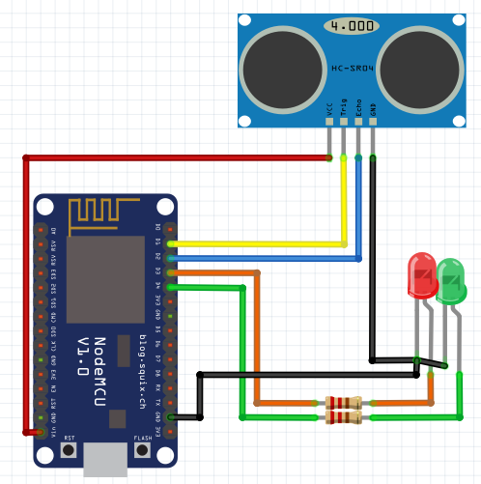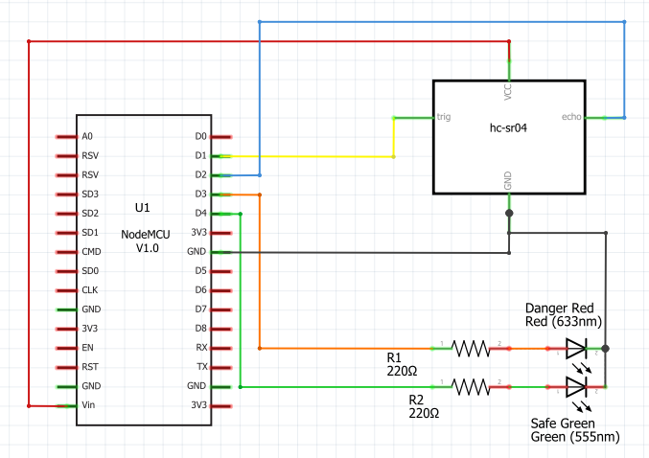

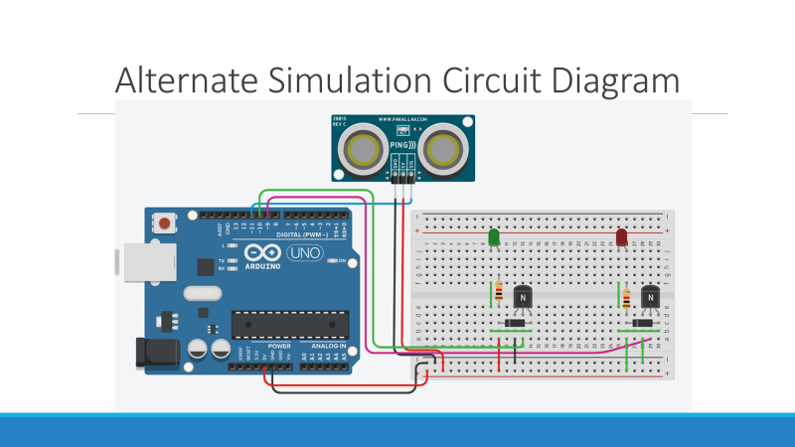

**I start building the iot flood monitoring and early warning system.**

Deploy IoT sensors (e.g., water level sensors) in flood-prone areas and configure them to measure water levels.

Develop a Python script on the IoT sensors to send collected water level data to the early warning platform.

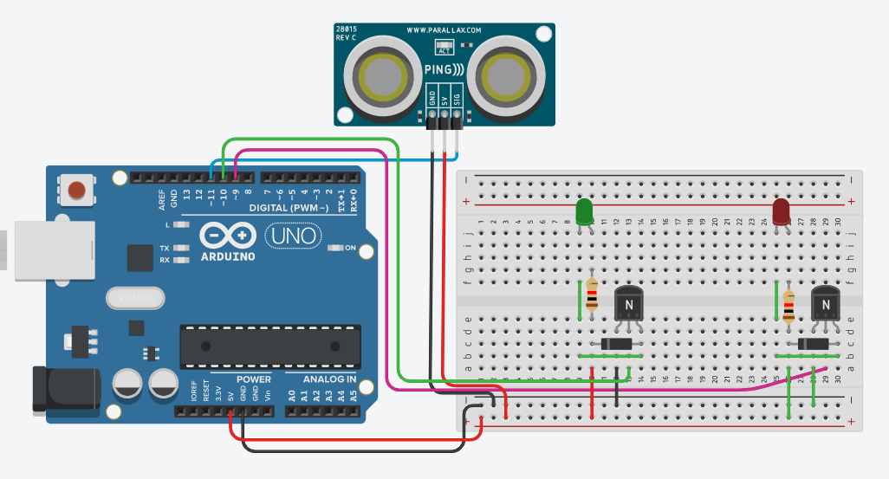

**IMAGE FOR FLOOD MONITORING AND EARLY WARNING**

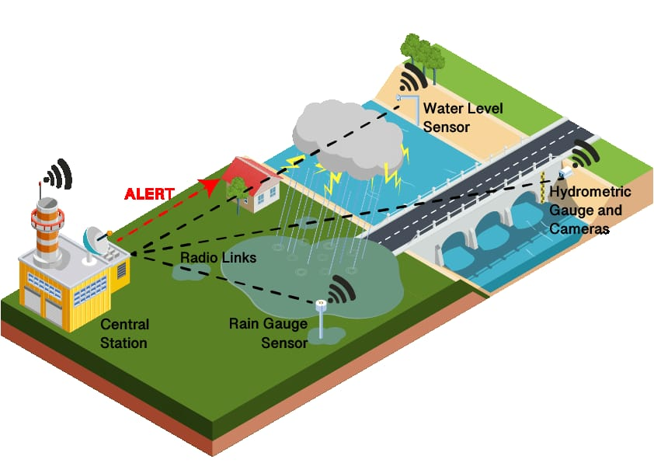

**MODEL RESULT :**

**Risk Reduction:** Early warning systems help reduce the risk of loss of life and property damage by providing timely alerts, allowing people to evacuate or take necessary precautions.

**Improved Preparedness**: They promote better preparedness by raising awareness about flood risks and encouraging the development of emergency plans and response strategies.

**Rapid Response:** Early warnings enable quicker responses from emergency services, ensuring that they can mobilize resources and respond effectively to flood events.

**Infrastructure Protection:** These systems help safeguard critical infrastructure, such as roads, bridges, and utilities, by providing advance notice and facilitating preventive measures.

**:** Farmers can use early warnings to protect crops and livestock, minimizing agricultural losses during floods.

**Health and Safety:** Early alerts reduce health risks, as people can avoid contaminated floodwaters and diseases that may arise after flooding.

**Economic Savings:** By minimizing property damage, early warning systems reduce financial losses for individuals, businesses, and governments.

**Data for Research**: The data collected by these systems can be valuable for scientific research on flood patterns, helping improve understanding and prediction.

**Climate Change Adaptation**: As climate change leads to more extreme weather events, early warning systems play a crucial role in adapting to changing conditions.

**Community Engagement:** These systems foster community engagement and cooperation in disaster preparedness and response.

**Better Land Use Planning:** Data from flood monitoring can inform land use planning and zoning regulations, reducing future flood risk through smarter development.

**International Cooperation:** Early warning systems often involve international collaboration, promoting goodwill and information sharing among neighboring countries to mitigate cross-border flood risks.

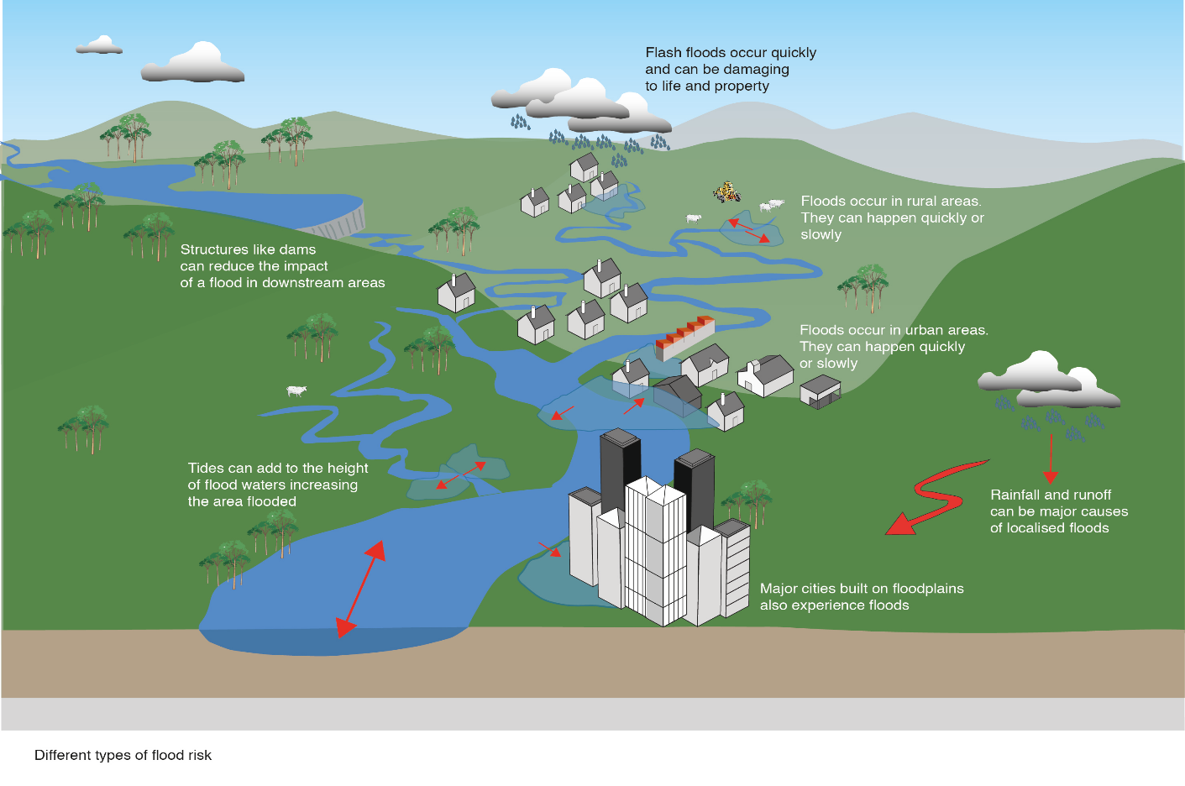

**Real-time flood monitoring and early warning system:**

**A real-time flood monitoring and early warning system** plays a crucial role **in enhancing public safety** and **improving emergency response coordination** in several ways:

1. Timely Alerts and Evacuation:

- Real-time monitoring systems can quickly detect flood-related parameters like rising water levels and heavy rainfall.

- Early warnings are issued as soon as a potential flood risk is identified, allowing authorities to notify the public promptly.

- Residents in at-risk areas receive alerts on their mobile devices or through other communication channels, enabling them to take necessary precautions or evacuate if required.

2. Risk Reduction and Preparedness:

- Early warnings provide communities with an opportunity to prepare in advance, reducing the element of surprise during a flood event.

- Residents and businesses can secure property, move to higher ground, and stock up on essential supplies.

- Emergency responders can prepare resources and manpower, ensuring a faster and more effective response.

3. Data-Driven Decision-Making:

- Real-time data collected by sensors and monitoring systems provide decision-makers with accurate and up-to-date information.

- Authorities can make data-driven decisions about evacuation orders, resource allocation, and emergency response strategies.

- This leads to more efficient and effective disaster management.

4. Resource Allocation:

- Emergency response agencies can allocate resources, such as first responders, rescue equipment, and medical supplies, to areas with the greatest need.

- This prevents resource wastage and ensures that help reaches the most affected areas quickly.

5. Communication and Coordination:

- A centralized platform for flood monitoring and early warning enhances communication and coordination among different agencies and organizations.

- Multiple stakeholders, including local authorities, government agencies, non-governmental organizations (NGOs), and community groups, can work together more cohesively.

- Information sharing and coordination are vital during flood events, as they ensure that resources are distributed where needed most.

6. Evacuation Route Planning:

- Real-time data can be used to determine safe evacuation routes based on current flood conditions.

- Residents and emergency responders can access updated information on road closures and alternative routes.

- This minimizes the risk of getting trapped or stranded during evacuations.

7. Public Awareness and Education:

- Flood monitoring systems also provide an opportunity for public awareness and education campaigns.

- Regular drills and education efforts can inform residents about how to respond to flood warnings and improve community resilience.

8. Post-Flood Recovery:

- Real-time flood data can aid in assessing the extent of damage and prioritizing recovery efforts.

- Information on flood-affected areas helps authorities allocate resources for rebuilding and providing aid to those affected.

In summary, a real-time flood monitoring and early warning system is an invaluable tool for enhancing public safety and emergency response coordination. By providing accurate and timely information, it empowers communities and authorities to prepare, respond effectively, and ultimately reduce the impact of flood events on lives and property.

**Emergency response coordination:**

Emergency response coordination is a critical aspect of any project focused on flood monitoring and early warning systems. It involves the organization and management of resources, personnel, and agencies to effectively respond to flood-related emergencies. Here's an explanation of emergency response coordination in the context of your project:

1. Multi-Agency Collaboration:

- Emergency response coordination requires collaboration between various agencies, including local government bodies, disaster management agencies, non-governmental organizations (NGOs), and community groups. Each agency may have specific roles and responsibilities during flood events.

2. Communication Systems:

- Establish robust communication systems that facilitate real-time information sharing among agencies, first responders, and the public. This includes emergency hotlines, digital communication channels, and early warning dissemination mechanisms.

3. Pre-Emergency Planning:

- Develop comprehensive emergency response plans before flood events occur. These plans should outline the roles and responsibilities of each agency, evacuation routes, shelter locations, and resource allocation strategies.

4. Resource Mobilization:

- Coordinate the allocation of resources such as rescue teams, medical personnel, equipment, and emergency supplies. Ensure that these resources are strategically positioned to respond quickly to affected areas.

5. Evacuation and Shelter Management:

- Plan and manage evacuation processes, including the identification of safe evacuation routes and the establishment of emergency shelters. Coordinate transportation, food, water, and medical assistance for evacuees.

6. Data Integration:

- Utilize the data collected by your flood monitoring and early warning system to provide real-time information on flood conditions and risks to emergency responders. Ensure that this data is integrated into the emergency response coordination system.

7. Public Awareness and Education:

- Implement public awareness campaigns to educate the community on flood risks, early warning systems, and evacuation procedures. Clear communication with the public is essential for effective response.

8. Training and Drills:

- Conduct regular training exercises and drills to ensure that response teams and agencies are well-prepared for flood-related emergencies. These exercises help identify strengths and weaknesses in the response plan.

9. Incident Command System (ICS):

- Implement an Incident Command System (ICS) to establish a clear hierarchy of command during emergencies. This system designates roles such as Incident Commander, Operations, Planning, Logistics, and Finance sections to ensure efficient coordination.

10. Post-Emergency Recovery:

- Emergency response coordination extends to the post-disaster phase, involving recovery and rehabilitation efforts. This includes resource allocation for rebuilding, assessing damage, and providing support to affected communities.

11. Continuous Improvement:

- Regularly evaluate the effectiveness of emergency response coordination through post-event reviews. Identify areas that need improvement and update response plans accordingly.

Your project should consider and, if possible, integrate elements of emergency response coordination to ensure that flood-affected communities receive timely and effective support. Coordination and collaboration among agencies and stakeholders are key to mitigating the impact of flood disasters and ensuring the safety and well-being of those affected.

**early warning system to enhance public safety:**

early warning system to enhance public safety is a complex and multi-faceted task that typically involves a combination of hardware, software, and communication systems. Below is a high-level outline of key components and considerations for building an early warning system. While this outline is not a full implementation, it should help guide the development process.

1. Data Collection and Monitoring:

- Weather Sensors: Implement a network of weather sensors to monitor meteorological conditions, including rainfall, temperature, humidity, wind speed, and direction.

- Water Level Sensors: Deploy river and stream gauges to monitor water levels and flow rates in rivers and water bodies.

- Earthquake Sensors: If applicable, incorporate seismic sensors to detect earthquakes, which can trigger landslides and tsunamis.

2. Data Analysis and Modeling:

- Develop algorithms and models to analyze incoming data and identify potential threats, such as heavy rainfall leading to flooding or seismic activity resulting in earthquakes.

- Integrate geographic information systems (GIS) to map and visualize risk areas.

3. Communication Systems:

- Implement a robust communication infrastructure to relay information to the public and relevant authorities.

- Use various communication channels, including mobile apps, SMS alerts, email notifications, and social media.

- Establish an emergency hotline for immediate assistance and information dissemination.

- Create a user-friendly and accessible website or platform for real-time updates and guidance.

4. Public Alerts and Evacuation Plans:

- Develop a tiered alert system to inform the public about the severity of the threat, including watch, warning, and evacuation orders.

- Provide clear and concise instructions on what actions people should take during different alert levels.

- Collaborate with local authorities, emergency services, and community organizations to create evacuation plans and shelters.

- Conduct regular drills and educational campaigns to ensure the public is prepared for emergencies.

5. Continuous Improvement:

- Establish a feedback loop for the public to report incidents and receive assistance.

- Continuously monitor the performance of the system and update it with the latest technology and knowledge.

- Work closely with meteorologists, seismologists, and disaster experts to refine alert criteria and response strategies.

6. Accessibility and Inclusivity:

- Ensure that the early warning system is accessible to individuals with disabilities and diverse linguistic backgrounds.

- Provide information in multiple formats, including braille, sign language, and multilingual resources.

7. Legal and Regulatory Compliance:

- Adhere to local and national regulations regarding emergency alerts and data privacy.

8. Data Security:

- Protect sensitive data and ensure the security of the system to prevent unauthorized access or tampering.

9. Public Outreach and Education:

- Raise awareness about the early warning system and the importance of heeding alerts and instructions.

- Conduct public education campaigns to foster a culture of safety and preparedness.

10. Funding and Sustainability:

- Secure adequate funding and resources to maintain and improve the early warning system.

- Seek partnerships with government agencies, NGOs, and international organizations for support.

Remember that the implementation of an early warning system requires expertise in various fields, including meteorology, geophysics, data analysis, software development, and emergency management. It's essential to work with experts and collaborate with relevant agencies to ensure the system's effectiveness in enhancing public safety.

**Conclusion:**

In today's rapidly changing world, natural disasters, including floods, pose a significant threat to communities and ecosystems. To mitigate these risks and enhance public safety, the development and implementation of robust early warning systems are imperative. This project has explored the key components and considerations involved in creating an effective flood monitoring and early warning system.

Throughout our research, we have highlighted the critical elements of such a system, which include data collection and monitoring through weather and water level sensors, advanced data analysis and modeling, and a comprehensive communication infrastructure. These components work in synergy to provide timely and accurate information to the public and authorities, allowing for swift response and potentially life-saving actions.

One of the core principles of a successful early warning system is inclusivity. It is essential to ensure that the system is accessible to all members of the community, including those with disabilities and diverse linguistic backgrounds. A comprehensive outreach and education program is equally vital to foster a culture of safety, preparedness, and timely response among the public.

The continuous improvement of the system, based on feedback, collaboration with experts, and adherence to legal and regulatory standards, is key to its long-term effectiveness. The ability to adapt to evolving technology and knowledge ensures that the system remains at the forefront of disaster mitigation efforts.

In conclusion, the implementation of a flood monitoring and early warning system is not just a technological endeavor; it is a commitment to the safety and well-being of communities. By heeding the lessons learned from this project, communities can take a significant step toward safeguarding lives, property, and the environment in the face of flooding and other natural disasters. It is our hope that this project serves as a valuable resource and inspiration for the development of early warning systems worldwide, contributing to a safer and more resilient future.