FLOOD MONITORING AND EARLY WARNING

**Sensors**:

* Water Level Sensors
* Rain Gauges
* Weather Sensors
* Soil Moisture Sensors
* Remote Sensing Technologies
* Water Quality Sensors
* Flow Rate Sensors
* Early Warning System Components

**Datasets:**

**Historical Flood Data:** A dataset containing records of past flood events, including dates, locations, and severity.

**River Water Level Data:** Real time or historical data showing water levels in rivers and streams.

**Rainfall Data:** Datasets providing information on rainfall patterns and intensity in the area of interest.

**Weather Data:** Meteorological data including temperature, humidity, wind speed, and atmospheric pressure.

**Soil Moisture Data**: Information on soil moisture levels, which can influence flooding.

**Water Quality Data:** Data on water quality parameters like pH, turbidity, and chemical composition.

**Flow Rate Data:** Records of water flow rates in rivers and streams.

**Early Warning System Alerts:** Data on alerts issued by early warning systems during past flood events.

**Satellite and Remote Sensing Imagery:** Remote sensing data for flood extent mapping.

**Community Response Data:** Information on community responses to flood warnings and actions taken during flood events.

**Storm Surge Data :** Data related to storm surge events, particularly in coastal regions, which can compound flooding during extreme weather events.

**Flood Damage and Economic Impact Data :**  Records of economic losses, property damage, and insurance claims related to past flood events.

**Emergency Response and Evacuation Plans :** Information on emergency response plans, evacuation routes, and shelter locations during flood events.

**Historical Flood Data** : A dataset containing records of past flood events, including dates, locations, and severity.

**River Water Level Data** : Real time or historical data showing water levels in rivers and streams.

**Rainfall Data :** Datasets providing information on rainfall patterns and intensity in the area of interest.

**Weather Data :** Meteorological data including temperature, humidity, wind speed, and atmospheric pressure.

**Soil Moisture Data :** Information on soil moisture levels, which can influence flooding.

**Water Quality Data** : Data on water quality parameters like pH, turbidity, and chemical composition.

**Flow Rate Data** : Records of water flow rates in rivers and streams.

**Early Warning System Alerts** : Data on alerts issued by early warning systems during past flood events.

**Satellite and Remote Sensing Imagery** : Remote sensing data for flood extent mapping.

**Community Response Data** : Information on community responses to flood warnings and actions taken during flood events.

**Topography and Terrain Data** : Elevation and terrain information, such as digital elevation models (DEMs), can help in understanding how local geography influences flooding.

**Historical Land Use and Land Cover Data** : Information on changes in land use and land cover over time can be important in studying how urbanization and deforestation affect flooding.

**Flood Vulnerability Assessment Data** : Data on the vulnerability of communities and infrastructure to flooding, including information on population density, building types, and critical infrastructure.

**Hydrological Models Output :** Data from hydrological models used for flood forecasting and analysis, which can help in understanding flood dynamics.

**Social Media and Crowdsourced Data** : Data from social media, citizen reports, and crowdsourcing platforms that can provide real time information during flood events.

**River Basin and Watershed Boundaries** : Geographic data defining the boundaries of river basins and watersheds, which are essential for hydrological analysis.

**Historical Climate Data :** Past climate records can provide insights into long term climate trends and their impact on flood patterns.

**Water Infrastructure Data :** Information on dams, reservoirs, and flood control structures, including their capacity and condition.

**Historical Flood Insurance Data :** Data on flood insurance policies, claims, and coverage in a given region.

**Vegetation and Land Erosion Data** : Data on vegetation cover and soil erosion, as they play a role in flood mitigation and water retention.

**Historical Flood Relief and Recovery Data** : Information on relief efforts, aid distribution, and recovery initiatives following flood events.

**Geospatial and GIS Data :** Geographic Information System (GIS) data layers, such as land parcels, transportation networks, and land use, can be used for spatial analysis.

**Water Resource Management Plans** : Data related to water resource management and policies, as it can influence flood risk.

**Urban Planning and Development Records** : Records of urban planning and development permits, which can highlight potential flood prone areas.

**Community Surveys and Perceptions** : Data from surveys and interviews with community members about their experiences, perceptions, and preparedness regarding floods.

**Historical Flood Reports and Documentation** : Reports, studies, and publications related to past flood events in the region.

**Critical Infrastructure Data :** Information on the location and condition of critical infrastructure, such as power plants, hospitals, and communication hubs, which can impact response and recovery efforts.

**I start building the iot flood monitoring and early warning system.**

Deploy IoT sensors (e.g., water level sensors) in flood-prone areas and configure them to measure water levels.

Develop a Python script on the IoT sensors to send collected water level data to the early warning platform.

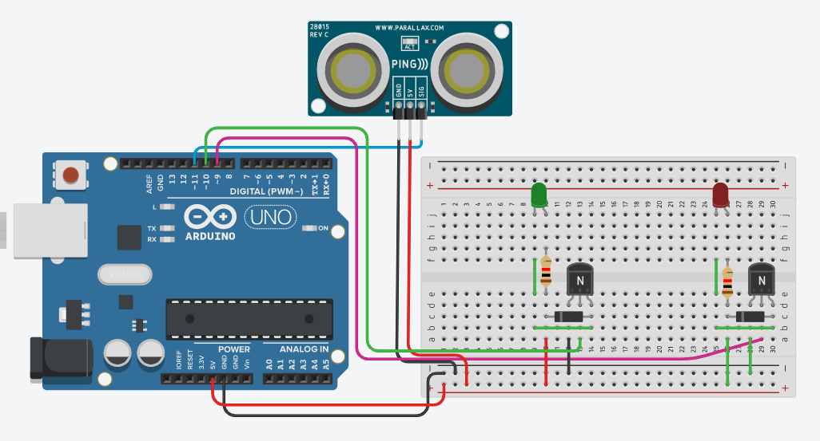

**IMAGE FOR FLOOD MONITORING AND EARLY WARNING**

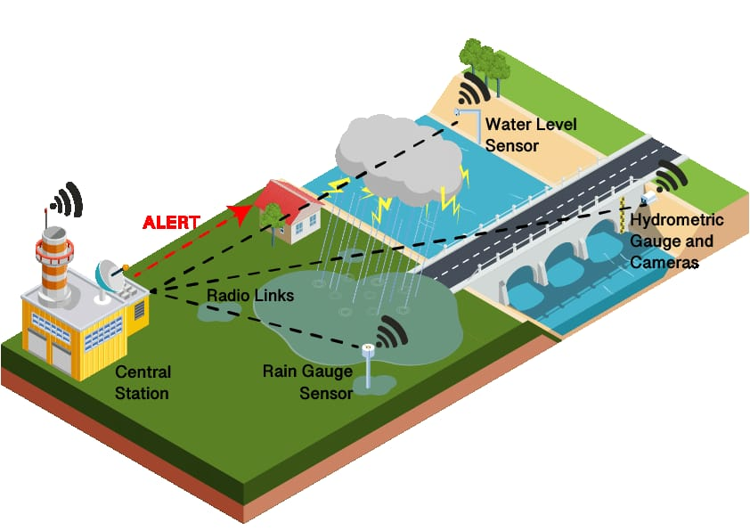

**MODEL RESULT :**

**Risk Reduction:** Early warning systems help reduce the risk of loss of life and property damage by providing timely alerts, allowing people to evacuate or take necessary precautions.

**Improved Preparedness**: They promote better preparedness by raising awareness about flood risks and encouraging the development of emergency plans and response strategies.

**Rapid Response:** Early warnings enable quicker responses from emergency services, ensuring that they can mobilize resources and respond effectively to flood events.

**Infrastructure Protection:** These systems help safeguard critical infrastructure, such as roads, bridges, and utilities, by providing advance notice and facilitating preventive measures.

**:** Farmers can use early warnings to protect crops and livestock, minimizing agricultural losses during floods.

**Health and Safety:** Early alerts reduce health risks, as people can avoid contaminated floodwaters and diseases that may arise after flooding.

**Economic Savings:** By minimizing property damage, early warning systems reduce financial losses for individuals, businesses, and governments.

**Data for Research**: The data collected by these systems can be valuable for scientific research on flood patterns, helping improve understanding and prediction.

**Climate Change Adaptation**: As climate change leads to more extreme weather events, early warning systems play a crucial role in adapting to changing conditions.

**Community Engagement:** These systems foster community engagement and cooperation in disaster preparedness and response.

**Better Land Use Planning:** Data from flood monitoring can inform land use planning and zoning regulations, reducing future flood risk through smarter development.

**International Cooperation:** Early warning systems often involve international collaboration, promoting goodwill and information sharing among neighboring countries to mitigate cross-border flood risks.

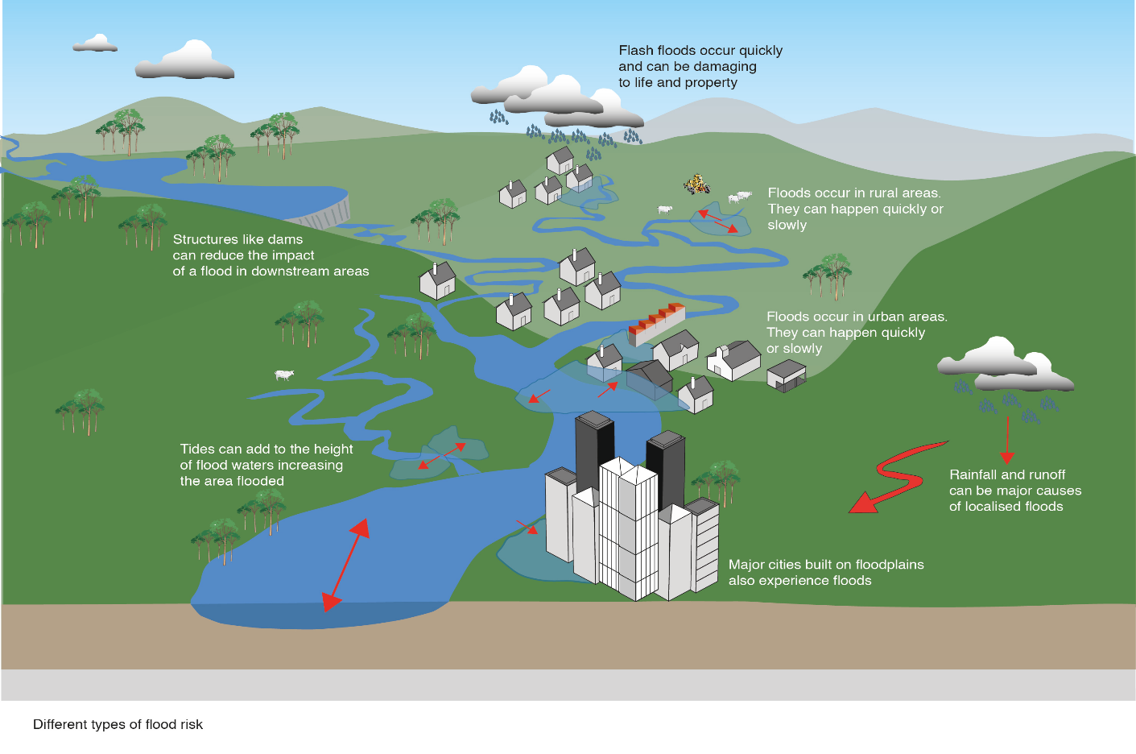

**Example**

In this example, we have various parameters and their corresponding readings. These readings represent data collected from different sensors or measurements in a given environment or system.

In India, floods can be caused by various factors, including heavy monsoon rains, cyclones, or even the release of water from overflowing dams. Here are a few districts in India and the state of Tamil Nadu that are prone to flooding**:**

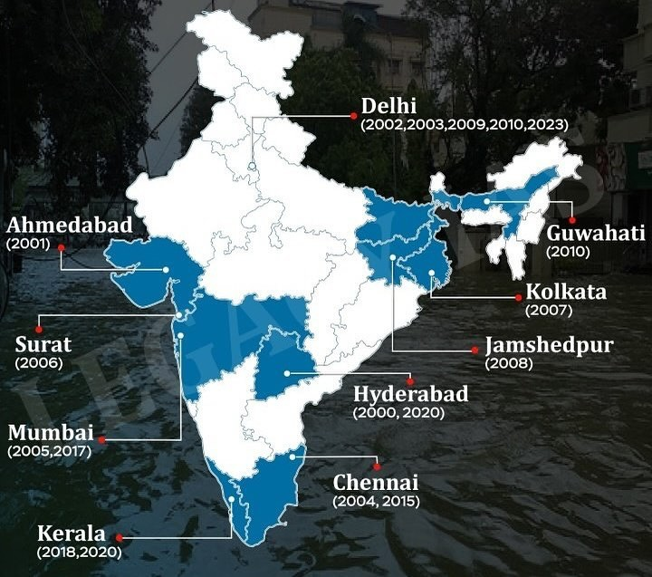

**Kerala:** In the southern state of Kerala, districts like Alappuzha and Kottayam are particularly susceptible to flooding due to their low-lying geography, a network of rivers, and heavy monsoon rainfall.

**Assam**: Assam in northeastern India faces annual floods, primarily caused by the Brahmaputra River. Districts like Dhubri and Barpeta are often affected, impacting the lives and livelihoods of many in the region.

**Uttarakhand**: This northern state is prone to flash floods, often triggered by cloudbursts or glacial lake outburst floods. The Chamoli district experienced a devastating flash flood event in 2021.

**Bihar:** Several districts in Bihar, including Darbhanga and Muzaffarpur, are flood-prone due to the overflow of major rivers like the Ganges and Kosi during the monsoon season.

**Tamil Nadu**: In Tamil Nadu, districts such as Chennai and Cuddalore can experience flooding during monsoon seasons. Urbanization and inadequate drainage systems can exacerbate the problem.

It's important to note that flooding can occur in various parts of India, and the severity and causes can vary by region. Measures such as flood monitoring and early warning systems are critical in these areas to mitigate the impacts of floods and provide timely alerts to communities at risk.