AI Newsletter Bot – n8n Automation

Workflow Screenshot:

Workflow Successful Execution screenshot:

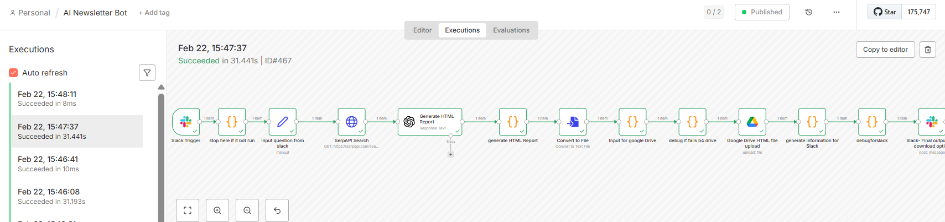

Output Screenshot & html output attached:
