In Keras LSTM(n) means "create an LSTM layer consisting of LSTM units. The following picture demonstrates what layer and unit (or neuron) are, and the rightmost image shows the internal structure of a single LSTM unit.

[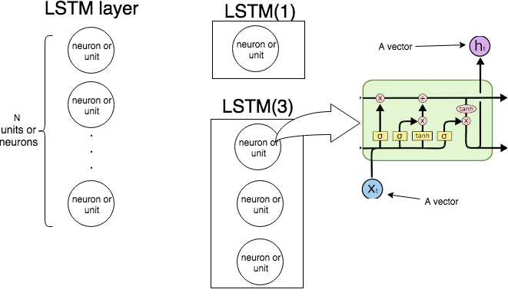](https://i.stack.imgur.com/swN2l.png)

The following picture shows how the whole LSTM layer operates.

[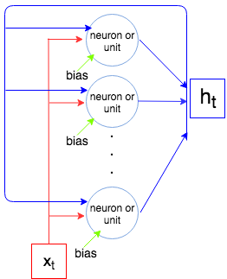](https://i.stack.imgur.com/qXjnM.png)

As we know an LSTM layer processes a sequence, i.e, x1,…,xNx1,…,xN. At each step tt the layer (each neuron) takes the input xtxt, output from previous step ht−1ht−1, and bias bb, and outputs a vector htht. Coordinates of htht are outputs of the neurons/units, and hence the size of the vector htht is equal to the number of units/neurons. This process continues until xNxN.

Now let's compute the number of parameters for LSTM(1) and LSTM(3) and compare it with what Keras shows when we call model.summary().

Let inpinp be the size of the vector xtxt and outout be the size of the vector htht (this is also the number of neurons/units). Each neuron/unit takes input vector, output from the previous step, and a bias which makes inp+out+1inp+out+1 parameters (weights). But we have outout number of neurons and so we have out×(inp+out+1)out×(inp+out+1) parameters. Finally each unit has 4 weights (see the rightmost image, yellow boxes) and we have the following formula for the number of parameters:

4out(inp+out+1)4out(inp+out+1)

Let's compare with what Keras outputs.

**Example 1.**

t1 = Input(shape=(1, 1))

t2 = LSTM(1)(t1)

model = Model(inputs=t1, outputs=t2)

print(model.summary())

Layer (type) Output Shape Param #

=================================================================

input_2 (InputLayer) (None, 1, 1) 0

_________________________________________________________________

lstm_2 (LSTM) (None, 1) 12

=================================================================

Total params: 12

Trainable params: 12

Non-trainable params: 0

_________________________________________________________________

Number of units is 1, the size of input vector is 1, so 4×1×(1+1+1)=124×1×(1+1+1)=12.

**Example 2.**

input_t = Input((4, 2))

output_t = LSTM(3)(input_t)

model = Model(inputs=input_t, outputs=output_t)

print(model.summary())

_________________________________________________________________

Layer (type) Output Shape Param #

=================================================================

input_6 (InputLayer) (None, 4, 2) 0

_________________________________________________________________

lstm_6 (LSTM) (None, 3) 72

=================================================================

Total params: 72

Trainable params: 72

Non-trainable params: 0

Number of units is 3, the size of the input vector is 2, so 4×3×(2+3+1)=72