**01 View Medicines Screen with all the columns**

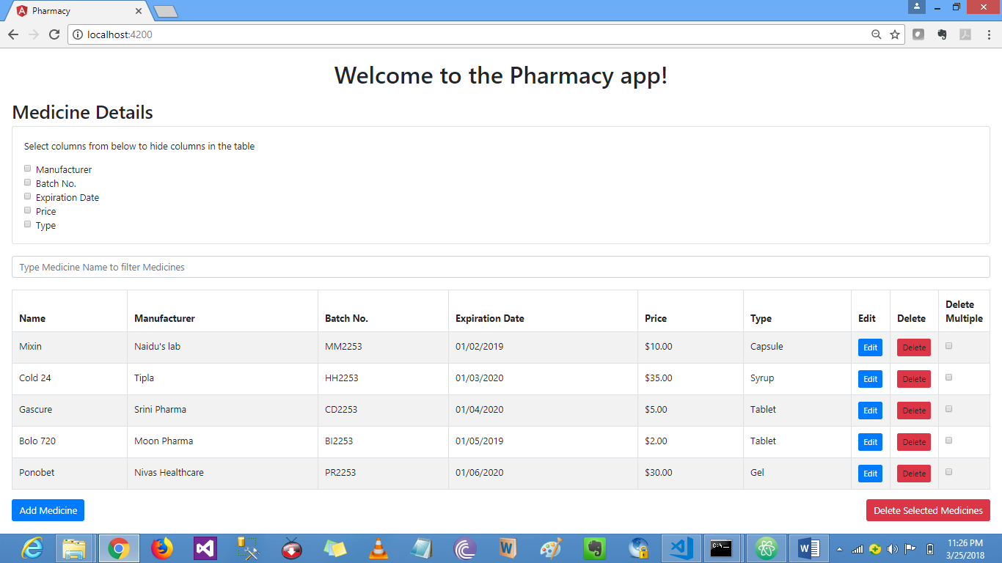

**02 View Medicines Screen with subset of columns**

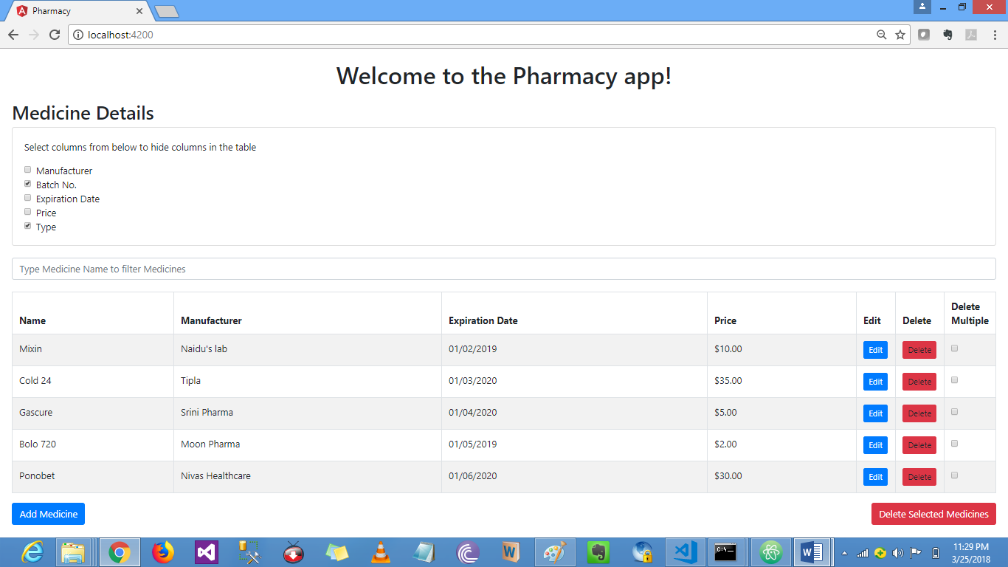

**03 View Medicines screen with substring filter**

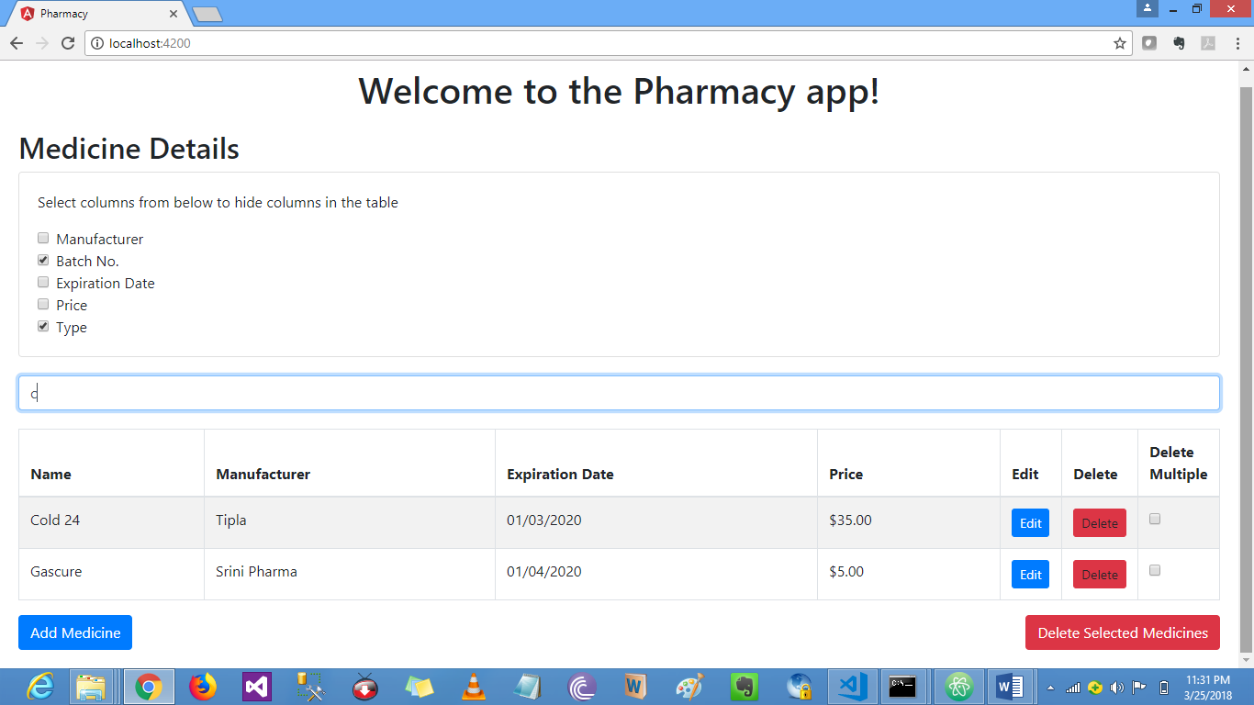

**04 Add Medicine Form**

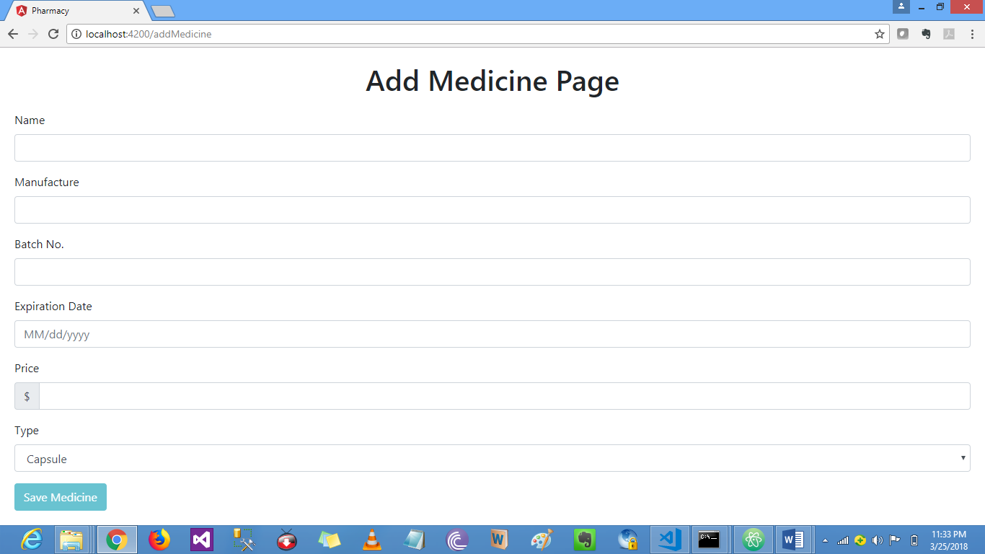

**05 Edit Medicine Form**

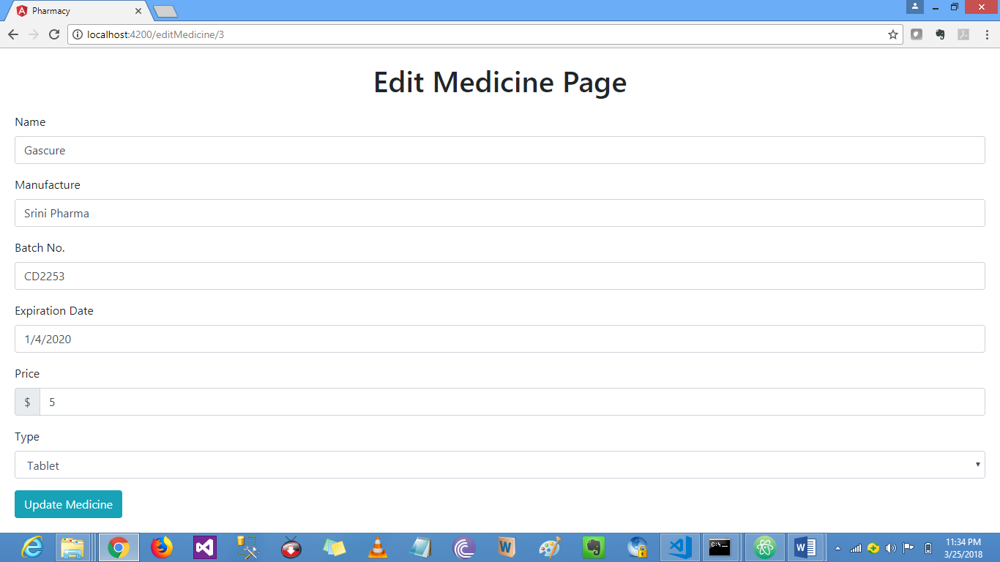

**06 Medicines before deleting**

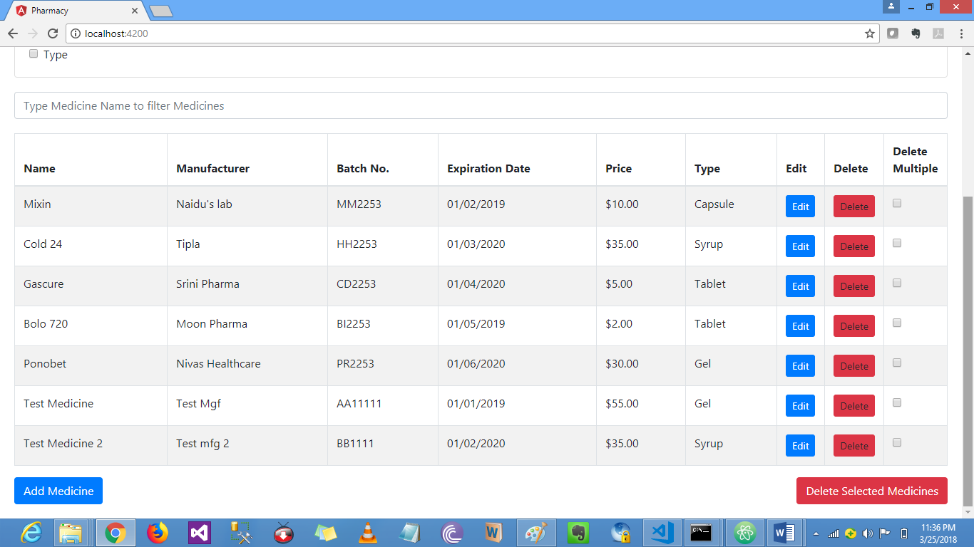

**07 After deleting a medicine**

