

**Tech Saksham Case Study Report**

**Data Analytics with Power BI**

**“360-degree Business Analysis of Online Delivery App”**

**“Aditanar College of Arts and Science”**

|  |  |
| --- | --- |
| **NM ID** | **NAME** |
| CE5A5A83740FB61957F498C5718A1D89 | S.SELVA UDHAYAM |

|  |  |
| --- | --- |
|  |  |
|  | **Trainer Name : R.UMAMAHESWARI** |
|  | **Master Trainer: R.UMAMAHESWARI** |

**ABSTRACT**

This project conducts a comprehensive “360-degree business analysis of Zomato”, a prominent online food delivery and restaurant discovery platform, utilizing Power BI for data visualization. By amalgamating diverse datasets from internal records, market research, and external sources, the analysis provides holistic insights into customer behavior, restaurant performance, market trends, and financial metrics. Through interactive dashboards and data visualizations, key performance indicators (KPIs) such as customer preferences, order trends, geographical distribution, revenue streams, and competitive dynamics are illuminated. The study identifies Zomato's strengths, weaknesses, opportunities, and threats within the competitive food delivery market through transaction patterns, customer satisfaction metrics, and sentiment analysis. Strategic recommendations are proposed to enhance user experience, optimize operational efficiency, and sustain competitive advantage. This project underscores the efficacy of Power BI in extracting actionable insights from vast datasets, facilitating informed, data-driven decision-making crucial for success in the dynamic landscape of the food delivery industry.

**INDEX**

|  |  |  |
| --- | --- | --- |
| **Sr. No.** | **Table of Contents** | **Page No.** |
| 1 | Chapter 1: Introduction | 4 |
| 2 | Chapter 2: Services and Tools Required | 6 |
| 3 | Chapter 3: Project Architecture | 7 |
| 4 | Chapter 4: Modeling and Result | 8 |
| 5 | Conclusion | 15 |
| 6 | Future Scope | 16 |
| 7 | References | 17 |
| 8 | Links | 18 |

**CHAPTER 1**

**INTRODUCTION**

* 1. **Problem Statement**

Zomato faces challenges in sustaining its market leadership amidst evolving customer preferences, rising competition, and operational inefficiencies. Without a comprehensive analysis of its business operations, including customer behavior, restaurant performance, market trends, and financial metrics, the company risks stagnation or decline in market share. Thus, there is a critical need to identify key areas for improvement and formulate strategic recommendations to address these challenges effectively, ensuring Zomato's continued growth and competitiveness in the dynamic online food delivery and restaurant discovery industry.

* 1. **Proposed Solution**

Utilizing Power BI's analytics capabilities, Zomato can create dynamic dashboards and reports presenting insights on customer ratings, restaurant distribution, cuisine diversity, costs, and top-rated venues. These visualizations can inform personalized recommendations for users, optimize pricing strategies, and identify expansion opportunities. By integrating Power BI's predictive analytics, Zomato can forecast market trends, enabling proactive decision-making. Seamless integration of Power BI empowers Zomato to enhance user satisfaction, streamline operations, and drive growth in the competitive food delivery and restaurant discovery sector.

* 1. **Feature**
* **Customer Ratings Analysis**: Assess trends and patterns in customer ratings across restaurants.
* **City-wise Restaurant Distribution**: Compare restaurant performance and popularity in various geographical locations.
* **Cuisine Diversity Insights**: Determine the demand for specific cuisines and identify emerging trends.
* **Average Cost for Two Persons**: Identify restaurants offering competitive pricing or value for money.
  1. **Advantages**
* **Robust Data Visualization:** Power BI enables Zomato to create visually compelling dashboards and reports, making it easier to interpret complex data and derive actionable insights efficiently.
* **Seamless Integration:** Power BI seamlessly integrates with various data sources, allowing Zomato to consolidate data from multiple platforms and databases into one unified view for comprehensive analysis.
* **Real-time Analytics:** With Power BI's real-time data processing capabilities, Zomato can analyze and visualize data as it's generated, enabling timely decision-making and proactive responses to market changes.
* **Scalability and Flexibility:** Power BI scales effortlessly to handle Zomato's growing data volumes and evolving analytical requirements, ensuring the platform can adapt to changing business needs without compromising performance.
  1. **Scope**

The project lays a foundation for ongoing advancements and expansions, offering opportunities for innovation and growth. Future iterations could integrate machine learning for predictive analytics, enhance user profiling for personalized recommendations, and incorporate geospatial analysis for optimized location strategies. Exploring technologies like augmented reality (AR) or virtual reality (VR) could elevate the user experience with immersive dining previews. Moreover, expanding the analysis to international markets or forging partnerships with additional data providers could provide valuable insights for global expansion. By embracing innovation and adaptation, the project will continue to drive data-driven decision-making and foster Zomato's sustained success in the evolving food delivery landscape.

**CHAPTER 2**

**SERVICES AND TOOLS REQUIRED**

**2.1 Services Used**

* **Data Collection and Storage Services:** Zomato gathers and stores diverse datasets in real-time. Azure Data Factory or AWS Kinesis facilitate real-time data collection, while Azure SQL Database or AWS RDS provide reliable storage solutions.
* **Data Processing Services:** Azure Stream Analytics or AWS Kinesis Data Analytics process the real-time data, enabling Zomato to derive actionable insights efficiently.

**2.2 Tools and Software used**

**Tools**:

* **PowerBI**: The main tool for this project is PowerBI, which will be used to create interactive dashboards for real-time data visualization.
* **Power Query**: This is a data connection technology that enables you to discover, connect, combine, and refine data across a wide variety of sources.

**Software Requirements**:

* **PowerBI Desktop**: This is a Windows application that you can use to create reports and publish them to PowerBI.

**CHAPTER 3**

**PROJECT ARCHITECTURE**

**3.1 Architecture**

**USER FRONTEND BACKEND**

|  |  |  |
| --- | --- | --- |
|  | **HTML 5** | **NODEJS 14.0**  **Database** |

Here’s a high-level architecture for the project:

1. **Data Collection:** Zomato collects real-time data from various sources such as customer interactions, restaurant transactions, and market trends. This is achieved using services like Azure Event Hubs or AWS Kinesis, ensuring seamless and efficient data ingestion.
2. **Data Storage:** The collected data is stored in a centralized database for further processing and analysis. Zomato utilizes platforms like Azure SQL Database or AWS RDS to store large volumes of data securely and reliably.
3. **Data Processing:** Real-time data processing is conducted to derive actionable insights and perform analytics tasks using services such as Azure Stream Analytics or AWS Kinesis Data Analytics.
4. **Machine Learning:** Zomato builds predictive models based on processed data to forecast customer behavior, personalized recommendations, and optimize business operations.
5. **Data Visualization:** Processed data and insights from machine learning models are visualized in real-time using Power BI.
6. **Data Access:** The dashboards and reports created in Power BI are accessible through various platforms such as Power BI Desktop, Power BI Service (online) and Power BI Mobile for accessing dashboards on-the-go, ensuring seamless access to data insights across devices and locations.

The architecture employs real-time data collection through Azure Event Hubs or AWS Kinesis, followed by storage in Azure SQL Database or AWS RDS. Data is processed using Azure Stream Analytics or AWS Kinesis Data Analytics, facilitating machine learning model development with Azure Machine Learning or AWS SageMaker. Insights are visualized using Power BI for intuitive analysis and accessible across platforms.

**CHAPTER 4**

**MODELING AND RESULT**

**Manage relationship**

**Zomato_India Table:** This table serves as the primary table containing information about restaurants in India. It includes attributes such as Restaurant ID (presumably the primary key), country (India in this case), and cuisines offered by each restaurant.

**Sub Tables (e.g., KPIs):** You might have additional tables such as KPIs that contain performance metrics or other related data for restaurants in the Zomato_India table.

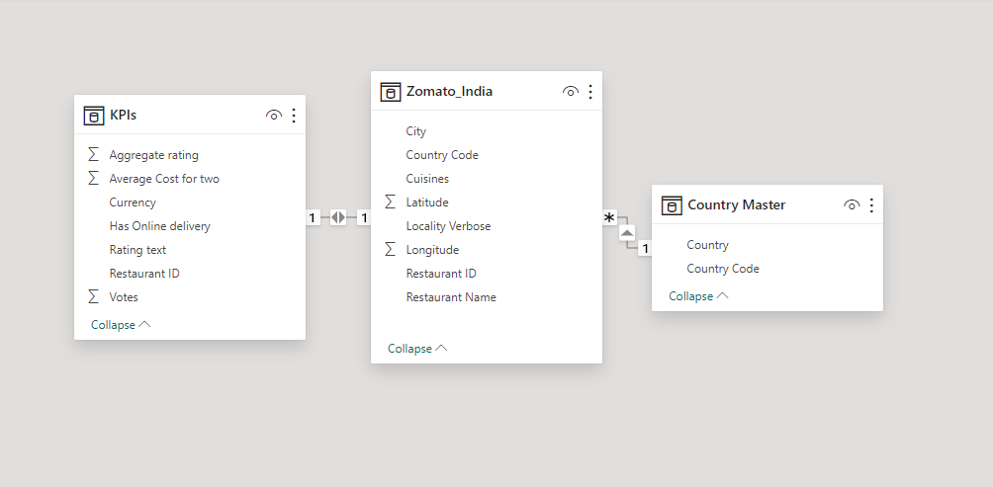

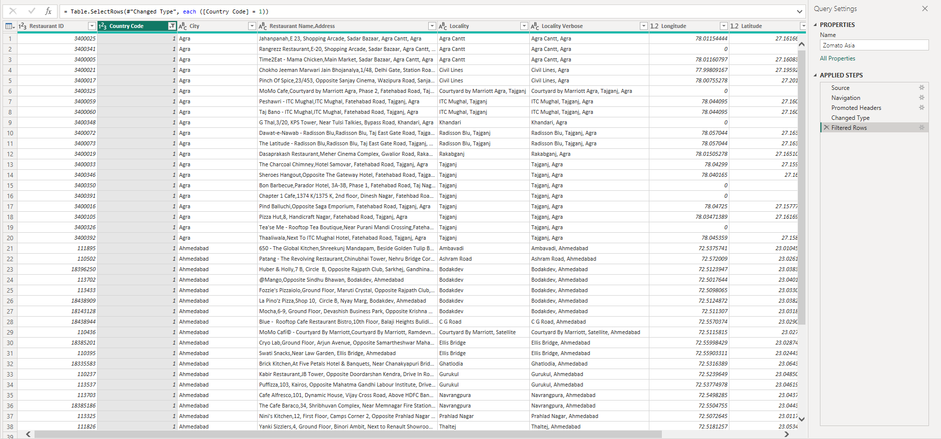

**Modeling for Country Code**

As we notice the dataset contains different country data. Now we need to select the country of India alone as we are concentrating only on it in this analysis. By filtering the data and choosing the country code ‘**1’** for selecting India.



**Removing and Replacing and Values:**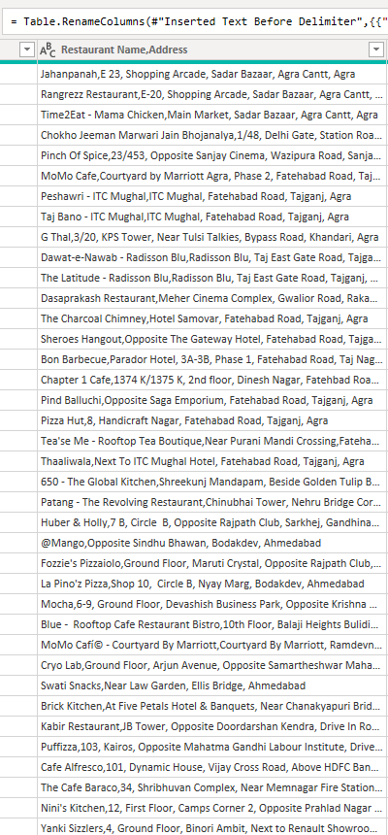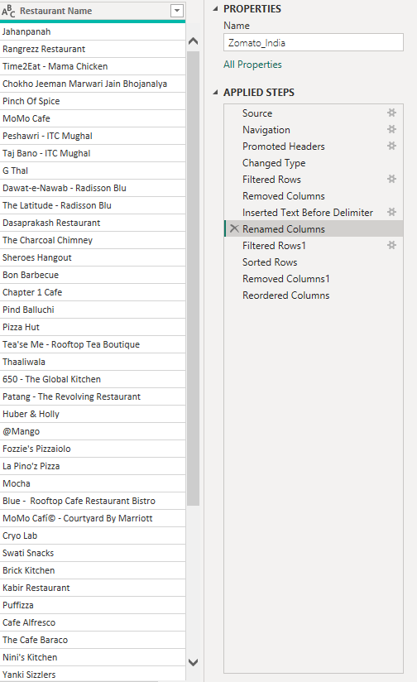

Here we have the restaurant name and address in the same field which was too clumsy to analyze. So we have decided to split the field and add a new column naming **“Restaurant Name”** and adding the values to it. Hence we can remove the old column data which is clumsy.

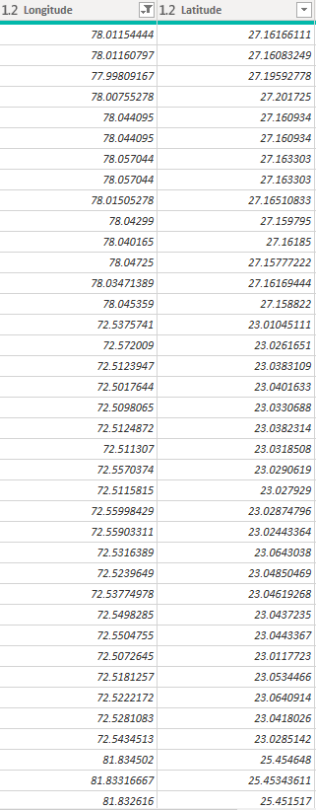

We have removed restaurants with latitude and longitude values containing 0. Thus we cleaned the main Zomato_India table.

**Modified Table**

The modified table contains the restaurant_id, restaurant_name,latitude and longitude values,cuisine,city and country_code

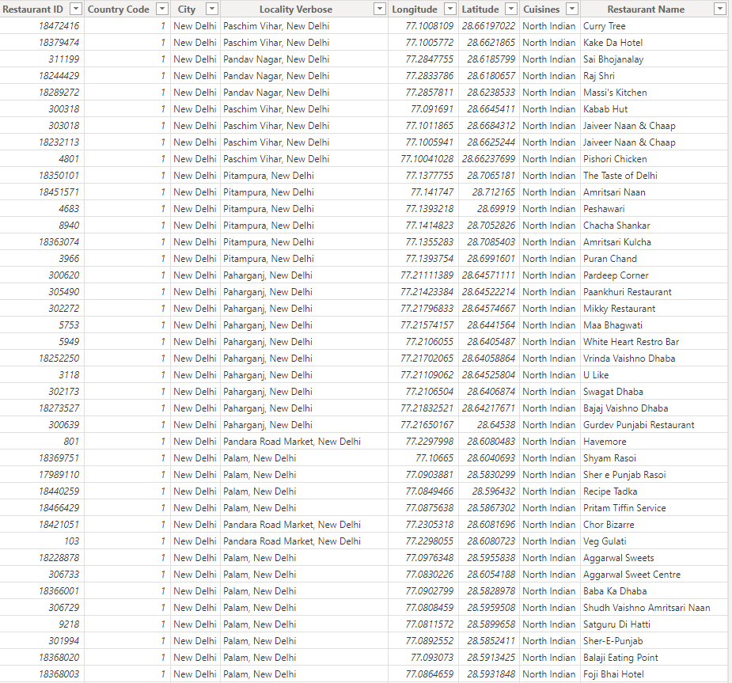

**Filtering KPI Table:**

This contains some of the important metrics of the analysis. Here we have the aggregate of votes of different restaurants,rating text and aggregate rating of restaurants, restaurant_id and average cost for two people. We have removed data which are not needed for the analysis and also filtered the data for India only.

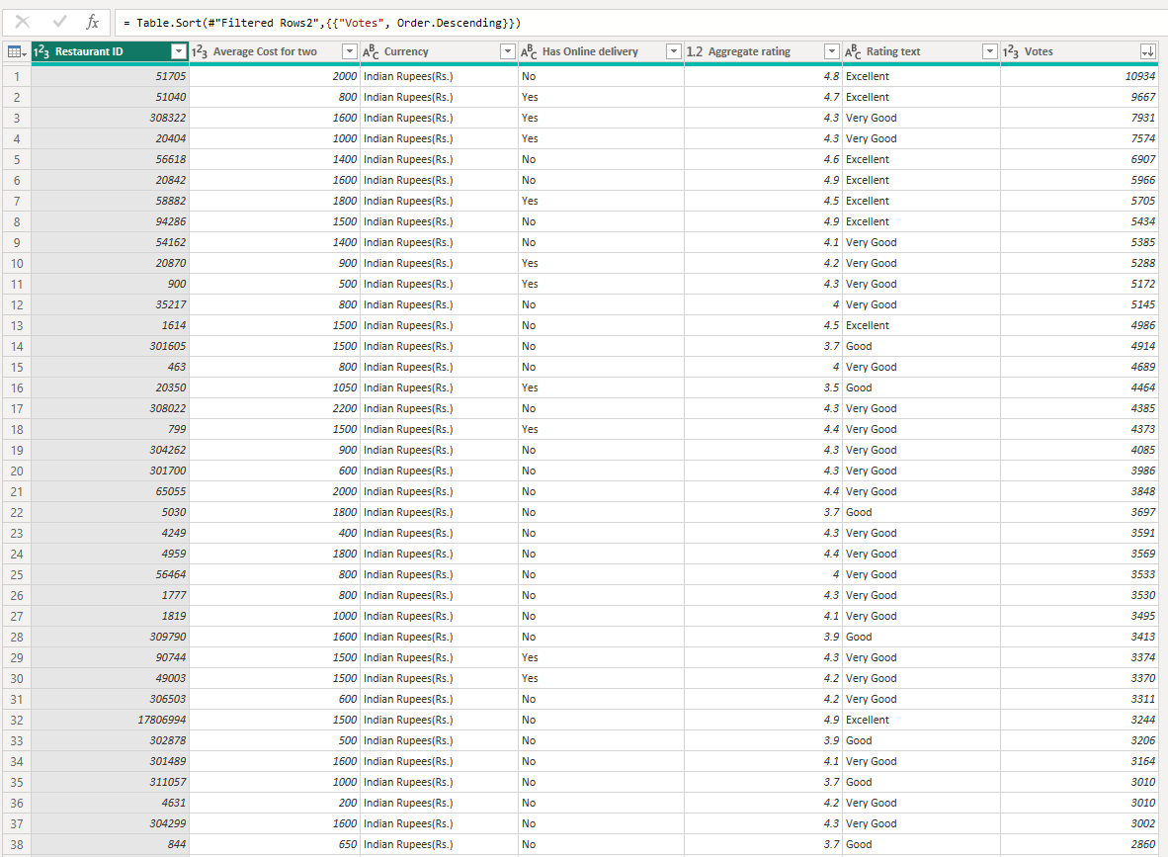

**Dashboard**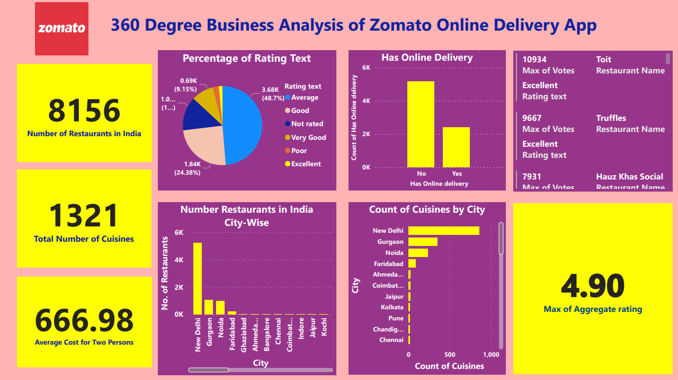

The Power BI dashboard analytics report provides a comprehensive overview of restaurant data, offering valuable insights at a glance. Through a combination of charts, graphs, and cards, the dashboard highlights key metrics such as the maximum rating and highest voted restaurants, total number of restaurants, and variety of cuisines available. Users can easily identify top-performing restaurants based on ratings and votes, enabling them to make informed decisions about dining choices. Additionally, the dashboard presents the average cost

for two people, giving users an understanding of the expected expenses when dining out. With its intuitive design and summarizing capabilities, the dashboard empowers stakeholders to quickly grasp essential information and drive strategic actions within the restaurant industry.

**CONCLUSION**

In conclusion, the Power BI report on Zomato provides a comprehensive 360-degree analysis of the online delivery app's performance. Through various visualizations like charts, graphs, and cards, the dashboard illuminates key insights such as the highest-rated and most popular restaurants, total restaurant count, cuisine diversity, and average cost for two people. This detailed analysis empowers stakeholders to gain a deep understanding of Zomato's market position, customer preferences, and operational dynamics. With this actionable intelligence at their disposal, decision-makers can devise strategic initiatives to further enhance Zomato's offerings, optimize operational efficiency, and drive sustained growth in the competitive online food delivery landscape.

**FUTURE SCOPE**

Looking ahead, the future scope for Zomato presents exciting opportunities for growth and innovation within the online food delivery industry. As technology continues to evolve and consumer preferences shift, Zomato can capitalize on several avenues to expand its market presence and enhance user experience. Firstly, leveraging advanced data analytics and machine learning algorithms can enable Zomato to personalize recommendations, streamline delivery logistics, and improve overall service efficiency. Additionally, strategic partnerships with local restaurants and culinary ventures can further diversify Zomato's cuisine offerings, catering to a broader spectrum of tastes and preferences. Moreover, investing in seamless integration with emerging technologies like augmented reality (AR) and voice-enabled assistants can elevate the app's user interface, providing an immersive and intuitive ordering experience. Furthermore, expanding into untapped markets, both domestically and internationally, can unlock new revenue streams and consolidate Zomato's position as a global leader in online food delivery. By embracing innovation, forging strategic alliances, and prioritizing customer-centric solutions, Zomato can navigate the dynamic landscape of the food delivery ecosystem and continue to thrive in the years to come.

**REFERENCES**

<https://iide.co/case-studies/business-model-of-zomato/>

<https://www.linkedin.com/pulse/online-food-ordering-delivery-market-growth-research-h5ate/>