IMPACT OF JOB SATISFACTION OF EMPLOYEES IN TATA

CONSULTANCY SERVICE

00 S. SELVENDRAN 1 & S. SEDEESHWAR 2

1 B.TECH INFORMATION TECHNOLOGY & 2 B.TECH BIOMEDICAL ENGINEERING,

SAVEETHA SCHOOL OF ENGINEERING, CHENNAI

ABSTRACT

Job satisfaction is one of the important factors which have drawn attention of managers in the organization as well as academicians Various Studies have been conducted t0find out the factors which determine job Satisfaction and the way influences productivity the organization Though is no conclusive evidence that job satisfaction affects productivity directly since productivity depends many variables, is Still prime concern for managers Job satisfaction is the mental of favorableness which an individual has about his is often Said that happy employee is productive employee Job satisfaction is very important because most of the people spend major portion of their life at their working place Moreover; Satisfaction has impact on the general life of the employees also, because satisfied employee is contented and happy human 4 highly satisfied worker has better physical and mental well The Study tries to evaluate how human resource factors affect the satisfaction level of employees in TATA CONCULTANCY SERVICES It assesses how far welfare and financial factors motivate the employees in the company: The study also attempts t0 analyze the opinion of employees towards the working life in the company:

KEY WORDS: Job Satisfaction; Employee Turnover; Job Security, Job Rotation

INTRODUCTION

Human resource is considered to be the most valuable asset in any organization. It is the sum total of inherent abilities acquired knowledge and skills represented by the talents and aptitude of the employed persons who comprise executives supervisors and the rank and file employees It may be noted here that human resource should be utilized to the maximum possible extent in order to achieve individual and organizational It is thus the employee's performance, which ultimately decides and attainment of goals However the employee performance is to a large extent influenced by motivation and job satisfaction The term relates to the total relationship between an individual and the employer for which he is paid. Satisfaction does mean the simple state accompanying the attainment of any goal the end state is feeling accompanying the attainment by an impulse of its objective Job satisfaction does mean absence of motivation at work Research workers differently described the factors contributing a job satisfaction and job dissatisfaction: The survey made regarding the job satisfaction will facilitate and enables the management to know the perceptions and inner ~feelings regarding the job they are performing on day-to-day basis. The term job satisfaction reveals and focuses on the likes and dislikes of the employees_ this particular study the researchers tries to identify the causes for satisfaction and dissatisfaction among the employees So this is the most effective and selective instrument for diagnosing and peeping into the employee's problems Job satisfaction survey can give the most valuable information the perceptions and causes For satisfaction/dissatisfaction among the employees attitude towards job satisfaction may be either positive or negative This positive feeling can be re-in forced and negative feelings can be rectified This survey can be treated as the most effective and efficient way; which makes the workers to express their inner and real feelings undoubtedly For any future course of action development which involves employee's participation, is considered: The management will a picture their employee'$ acceptance and readiness. This survey also enables to avoid misinterpretations and helps management in solving problems effectively It is observed during study some of the employees accepted the proposal survey research A perfectly contentment and satisfaction motivate an employees to be confident with a high morale it Is an asset to organization as a whole: Thus the high motivation and morale of an employee make him to remain in the organization and encourage him to face cut throat competition and gives him enough dynamism to face challenges goals.

Job satisfaction is a general attitude which is the result of many specific attitude in three areas, namely (i) specific job factors; (ii) individual characteristics; and (iii) group relationship outside the job. These factors can never be isolated from each other for analysis. The approach which since to be opted is that job satisfaction is the favorableness’ or unfavorable ness with which employees view their works. It results when job requirements suit to the wants and expectation of the employees. However, a more comprehensive approach requires that many additional factors be included before a complete understanding of job satisfaction can be obtained. Such factors, such as; the employee’s age, health, temperament, desires and level of aspiration should be considered. Further, his family relationships, social status, recreational outlets, activity in organizational labor -political or purely social, contribute ultimately to the job satisfaction.

Job satisfaction is considered as the amount or degree of gratification and contentment that an employee fosters towards his/her overall job factoring into that equation his/her satisfaction with the job itself the peers at the job, the supervisors and the policies at work. Various research studies have highlighted the importance of focusing on the issue of employee job satisfaction as it plays a critical role in overall firm success or demise: Additionally the importance of employee job satisfaction has been largely emphasized in the literature because of its positive affect on employee job performance The productivity of the work force in any organization is a major driver which leads to achieving organizational This stresses on the importance of further on job satisfaction as an essential concern for family firms and corporations equally . Recently organizations have focused on maximizing productivity in order to maintain their competitive stance and better deal with emerging trends such as globalization. Nowadays, the general direction which firms take when expanding is into international markets that reveal potentially rewarding new opportunities However whether it is answering to customer needs or developing goals focusing large

A satisfied employee is always important for an organization as he/she aims to deliver the best of their capability. Every employee wants a strong career growth and work life balance at workplace. If an employee feels happy with their company & work, they look to give back to the company with all their efforts.



Fig.1 Important factors of job satisfaction

IMPORTANCE OF JOB SATISFACTION

Importance of job satisfaction can be seen from two perspectives:

For Employees

Job satisfaction from an employee perspective is to earn a good gross salary, have job stability, have a steady career growth, get rewards & recognition and constantly have new opportunities.

For Employers

For an employer, job satisfaction for an employee is an important aspect to get the best out of them. A satisfied employee always contributes more to the company, helps control attrition & helps the company grow. Employers needs to ensure a good job description to attract employees and constantly give opportunities to individuals to learn and grow.

The positive effects of job satisfaction include:

1. More efficiency of employees of workplace if they are satisfied with their job.

2. Higher employee loyalty leading to more commitment.

3. Job satisfaction of employees eventually results in higher profits for companies.

4. High employee retention is possible if employees are happy



Fig.2 Importance of job satisfaction

BENIFITS OF JOB SATISFACTION

1. Increased profits

This is one any manager and employee might appreciate. Keeping employees satisfied can lead to higher sales, lower costs, and a stronger bottom line.

2. Higher productivity

Irrespective of their job titles or salary, employees who are more satisfied with their job, whether they feel satisfied with the organizational culture, with the rewards they are getting, or with recognition, can produce more and do it more efficiently.

3. Lower turnover

If employees are more satisfied with their job, they are less likely to leave. It also helps to recruit better quality talent as new talent sees employee staying power as added value.

4. Loyalty

When employees feel there is a growth path for them, they are more satisfied. In turn, because they feel the organization has their best interests at heart, they tend to support the organization’s mission and objectives. When this happens, employees may tell their friends or relatives about the good nature of the organization, which helps spread organizational goodwill.

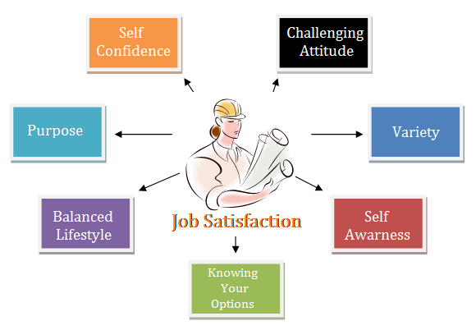

Fig.3 Benefits of job satisfaction

JOB SATISFACTION FACTORS

Job satisfaction is related to the psychology of an employee. A happy & content employee at a job is always motivated to contribute more. On the other hand, a dissatisfied employee is lethargic, makes mistakes & becomes a burden to the company. The elements & factors which contribute to job satisfaction are:

1. Compensation & Working conditions

One of the biggest factors of job satisfaction are the compensation and benefits given to an employee. An employee with a good salary, incentives, bonuses, healthcare options etc. is happier with their job as compared to someone who doesn’t have the same. A healthy workplace environment also adds value to an employee.

2. Work life balance

Every individual wants to have a good workplace which allow them time to spend with their family & friends Job satisfaction for employees is often due a good work life balance policy, which ensures that an employee spends quality time with their family along with doing their work. This improves the employee's quality of work life.

3. Respect & Recognition

Any individual appreciates and feels motivated if they are respected at their workplace. Also, if they are awarded for their hard work, it further motivates employees. Hence recognition is one of the job satisfaction factors.

4. Job security

If an employee is assured that the company would retain them even if the market is turbulent, it gives them immense confidence. Job security is one of the main reasons for job satisfaction for employees.

5. Challenges

Monotonous work activities can lead to dissatisfied employees. Hence, things like job rotation, job enrichment etc.. can help in job satisfaction of employees as well.

6. Career Growth

Employees always keep their career growth part as a high priority in their life. Hence, if a company helps groom employees and gives them newer job roles, it enhances the job satisfaction as they know they would get a boost in their career

TIPS TO INCREASE JOB SATISFACTION

In today’s working life, employees seek to be happy in their workspace, to join a good team, and to be satisfied with the tasks that correspond to them, that is, to be satisfied with their employment.

Job satisfaction plays an essential role for the staff and the company because when the workers are happy, there is greater productivity. Here are some tips to improve it.

Provide opportunities for employees to put their skills and knowledge into practice.

Open communication between employees and managers.

Promote relationships with your immediate bosses.

Invest in compensation and benefits.

Provide as much job security as possible.

How can we make someone feel happy, relaxed, valued, and motivated at work? The key is to create an internal company culture focused on employee experience. Great companies always use the available data to understand where their culture is today and how to improve it.

METHODOLOGY

Lots of people use the term “job satisfaction” as nothing more than a buzzword, but it can be really important to look deeper into what it means and how important it is.

There are so many jobs and career types out there. Some jobs might be stable with good pay, while others might be more exciting. While some jobs are about helping people, others let you learn and improve yourself. But what kind of job suits different types of people? And how can job satisfaction affect employee performance

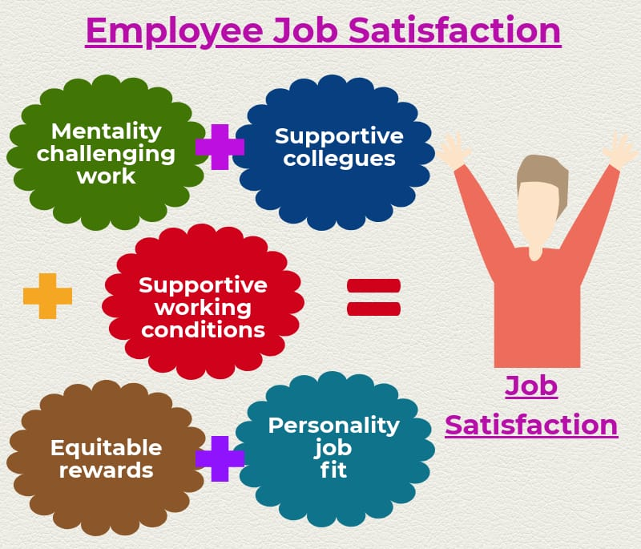

Fig.4 how can a employee get job satisfaction

Job design aims to enhance job satisfaction and performance methods include job rotation job enlargement and job enrichment. Other influences on satisfaction include the management style and culture, employee involvement, empowerment and autonomous workgroups.

At a conceptual level, there are two approaches to measuring job satisfaction ; evaluation and experience

intrinsic and extrinsic job satisfaction. Intrinsic job satisfaction is the contentment with the type of work the employee is doing, while extrinsic job satisfaction encompasses the environment that the job is being completed in.

Job satisfaction can be measured in cognitive (evaluative), affective (or emotional), and behavioural components.

RESULT AND DISSCUSSION

A public survey is conducted in order to know if people are aware of the factors and components that makes impact in job satisfaction of employees. evaluating the results

That most people are aware of job satisfaction factors and components.

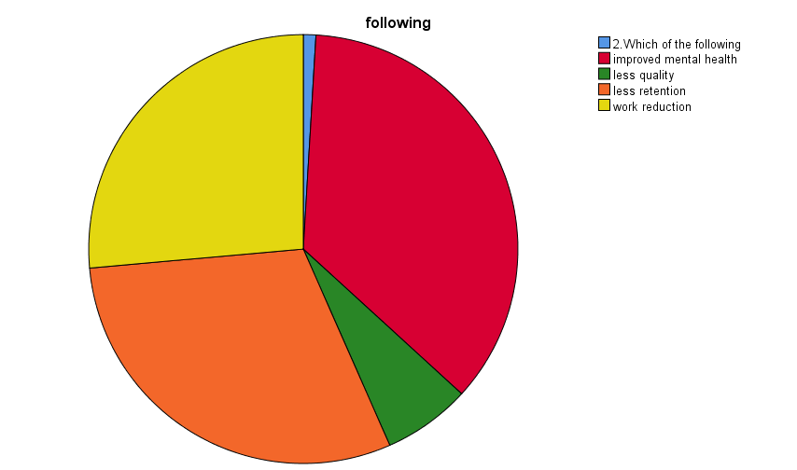

Fig.5 survey of the benefits of job satisfaction

Fig 5 is about the benefits of job satisfaction of employees. Red indicates ‘improved mental health’ , green indicates ‘less quality’ , orange indicates ‘less retention’ , yellow indicates ‘ work reduction’. According to public survey, most of the people think improved mental health is a benefit of job satisfaction and the answer is correct.

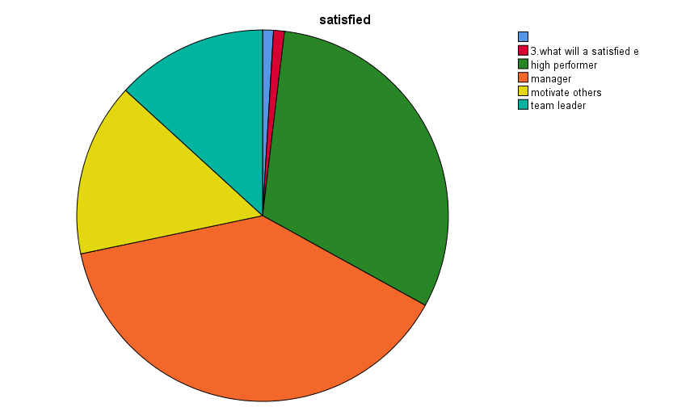

Fig.6 what will a satisfied employee do

Fig 6 is about public opinion regarding what will a satisfies employee do. green indicates ‘high performer’, orange indicates ‘manager’, yellow indicates ‘motivate others’, blue indicates ‘team leader’. Most of the people think high performer and the answer is correct.

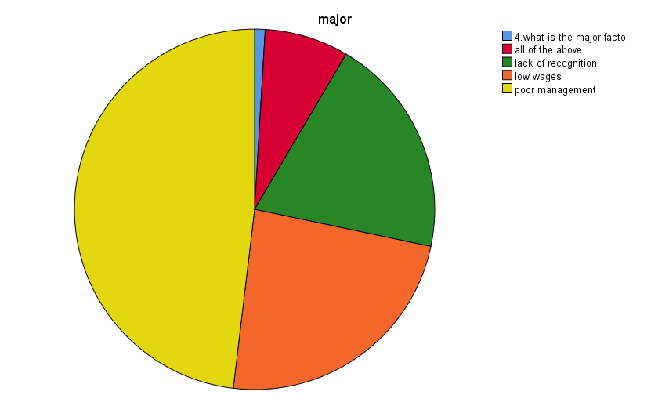

Fig.7 major factor contributing to job satisfaction

Fig 7 is about the major factor contributing to job satisfaction. Yellow indicates ‘poor management’, green indicates ‘lack of recognition’, red indicates ‘all of the above’.

Most people think that poor management is the major factor contributing to job satisfaction but all the options given contribute .

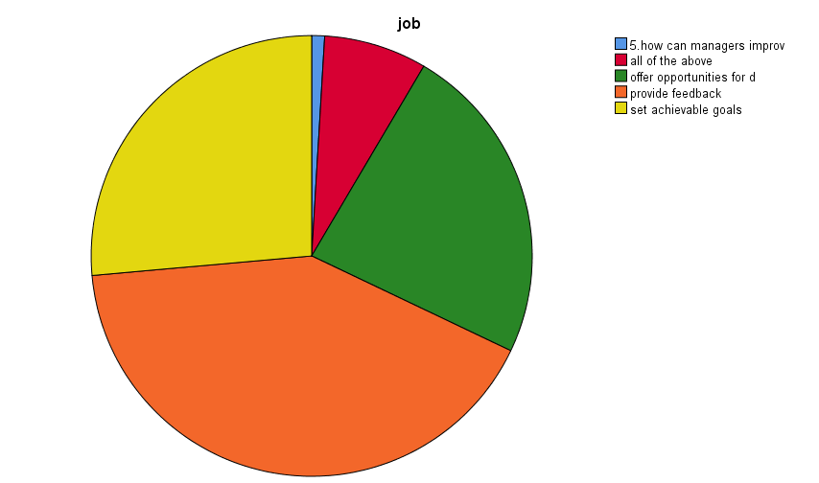

Fig 8 things done for improving job satisfaction of employees

Fig 8 is about how managers can improve the job satisfaction of employees.

Green indicates ‘offer opportunities for development’, orange indicates ‘provide feedbacks’, yellow indicates ‘ set achievable gaols’, red indicates ‘all of the above’. most people think providing feedback will improve job satisfaction and the answer is correct.

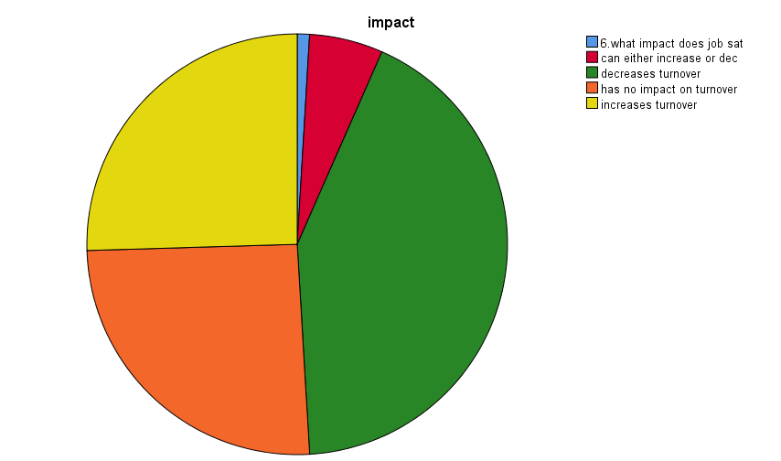

Fig 9 impact of job satisfaction in turnover of employees

Fig 9 is about the impact of job satisfaction of employees in turnover. Green indicates ‘decreases turnover’, orange indicates ‘has no impact’, yellow indicates ‘increases turnover’, red indicates ‘can either decrease or increase’. Most people think decrease turnover but all of the above is correct

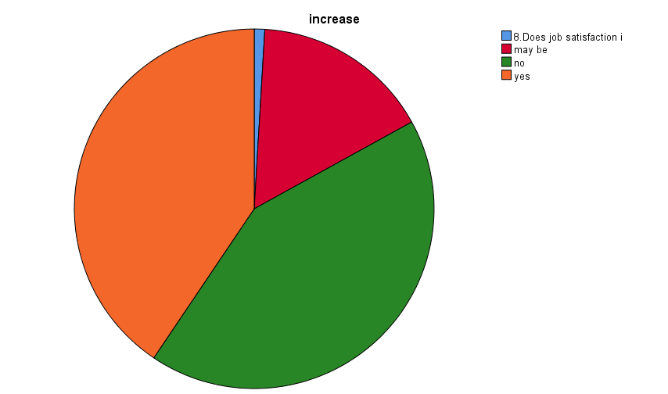

Fig 10 job satisfaction on productivity

Fig 10 is about does job satisfaction increases job productivity. Red indicates ‘may be’, green indicates ‘no’, orange indicates ‘yes’. Most people think job satisfaction increases productivity and the answer is correct.

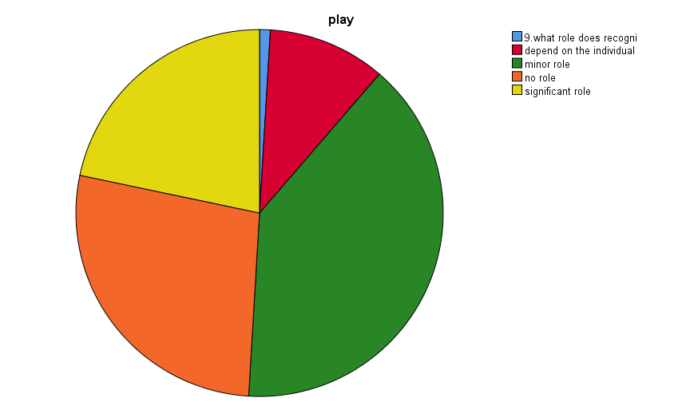

Fig 11 role of recognition in job satisfaction

Fig 11 is about what role does recognition plays in job satisfaction. Red indicates ‘ depends on the individual’, yellow indicates ‘significant role’, green indicates ‘minor role’, orange indicates ‘no role’. most people think recognition plays minor role but it plays a very significant role.

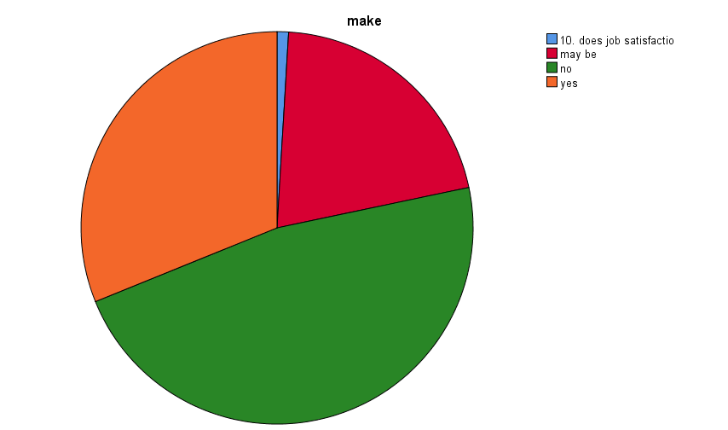

Fig 12 employee engage with their work

Fig 12 is about does job satisfaction makes people to engage with their work. Red indicates ‘may be’, green indicates ‘no’, orange indicates ‘yes’. Most people think no but the correct answer is yes.

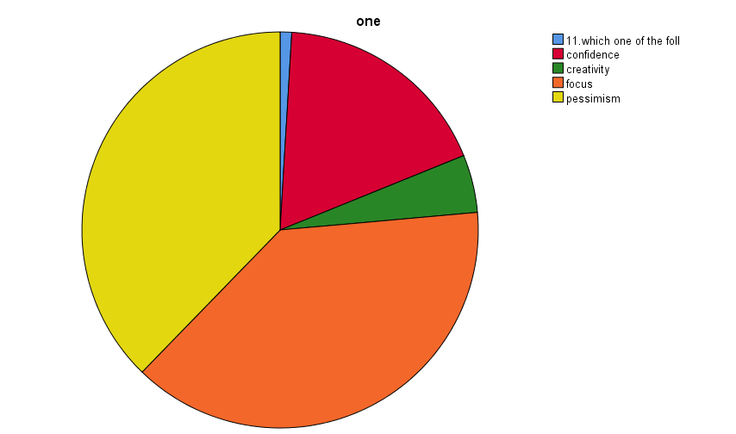

Fig 13 capability of employee having positive attitude

Fig 13 is about which one of the following is not a capability of employee having positive attitude. Red indicates ‘ confidence’, orange indicates ‘focus’, yellow indicates ‘pessimism’, Green indicates ‘creativity’. Most people think pessimism and the answer is correct.

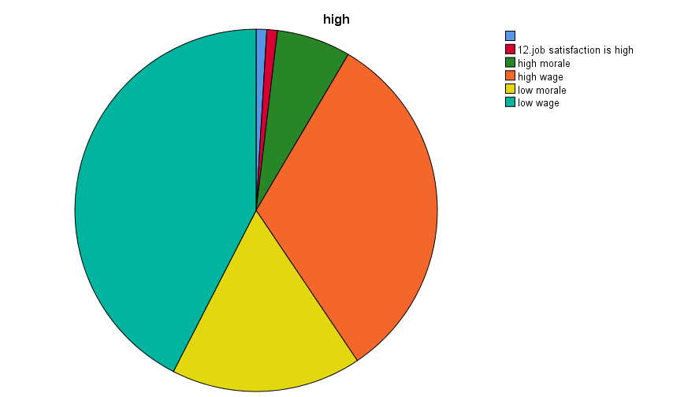

Fig 14 when job satisfaction will be high

Fig 14 is about when will job satisfaction is high. Green indicates ‘high wage’, yellow indicates ‘low morale’, blue indicates ‘low wage’, yellow indicates ‘low morale’.most people think low wage and the answer is correct.

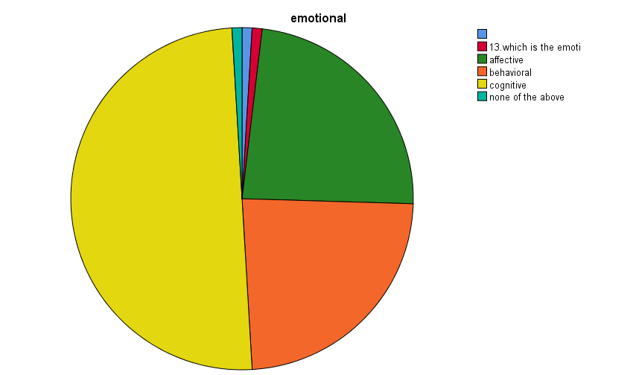

Fig 15 emotional response to job satisfaction

Fig 15 is about the emotional response to the job satisfaction. Green indicates ‘affective’, orange indicates ‘behavioural’, yellow indicates ‘cognitive’, blue indicates ‘none of the above’. Most people think cognitive is a emotional response to job satisfaction and the answer is correct

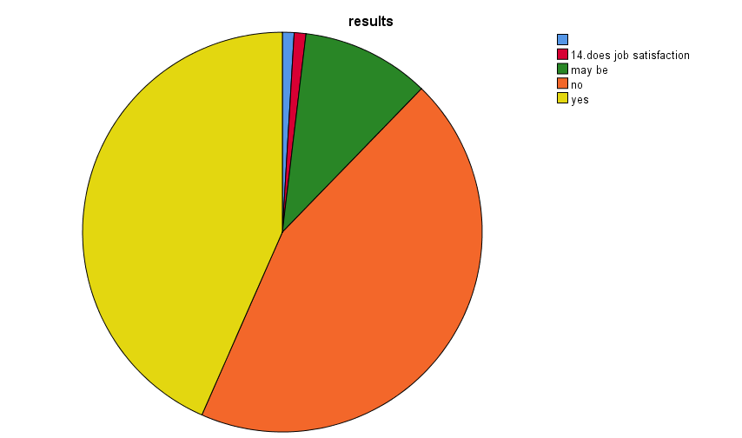

Fig 15 result of job satisfaction

Fig 15 is about does job satisfaction results in positive attitude of employees. orange indicates ‘no’, yellow indicates ‘yes’, green indicates ‘may be’. Most people think yes and the answer is correct.

CONCLUSION

In conclusion, job satisfaction is a very important factor of a company’s growth and productivity. Most of the employees are satisfied with welfare measures. The company can concentrate on the other non-statutory measures to boost the employer morale. The management should take necessary conditions to improve the working environment so that the employees should feel that the organization is the better place to work.

Today's organizations need to be more flexible so that they are equipped to develop their workforce and enjoy their commitment. Therefore, organizations are required to adopt a strategy to improve the employee's quality of work life to satisfy both the organizational objectives and employee needs.

The study reveals the respondents with different marital, experience, income group and having different size of family are influenced by stress at workplace is prevailing always and presence of indifferent behaviour of male superiors and colleagues. The absence at work has significant influence on age, marital status, and family members.

It is concluded from the average score analysis that the majority of the respondents have high hindrance towards conducive work atmosphere, provide with yearly master health check-up, superior encourages his/her subordinates to update and develop in their work, superior encourages his/her subordinates to update and develop in their work, stress related to work environment considered increased responsibilities results mental pressure, adverse family relations and miss out any quality time with family or friends because of pressure of work.

Women employees are more likely to express a strong desire to have a harmonious balance among career, family life and leisure activities. Most of the women feel to spend quality time with family to improve work and personal life satisfaction. The factor analysis results that satisfaction with working life is depends on comfortable personal work space, prevalence of effective employee grievance redressal systems and provide with yearly master health check-up. Workers who give greater priority to seeking a balance between work and non-work life shows