1)find the Circle ?
Image1) 
a) 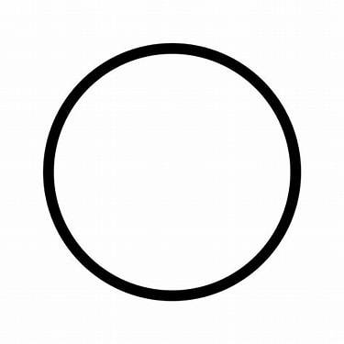
b)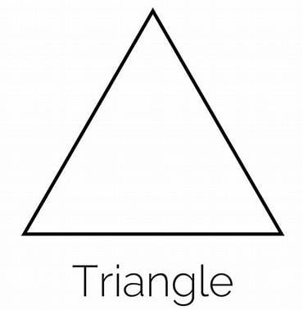
c)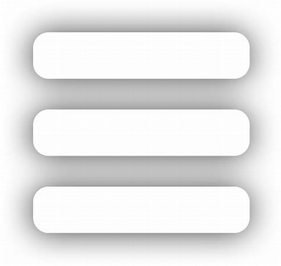
d)

c_ans: A
e_ans: bowbow
mark:1
difficulty_level:Easy

2) Which letter replaces the question mark?

Image2)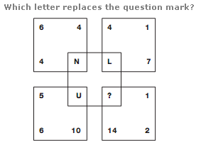
a)M
b)F
c)D
d)S
c_ans: B
e_ans: testing
mark:1
difficulty_level:Intermediate

3)
Image3)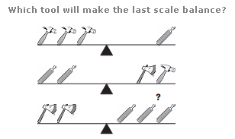

a)30
b)50
c)34
d)28
c_ans: B
e_ans: testing
mark:1
difficulty_level: Challenging

4)
Image4)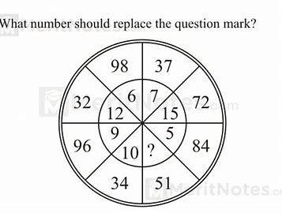

a)30
b)50
c)34
d)28
c_ans: B
e_ans: testing
mark:1
difficulty_level: Company_Specific

5) Replace the underlined word in the following sentence with the most suitable option.
It was time to be stood on her own two feet.
Which number is missing from the middle of the triangle?
Image5)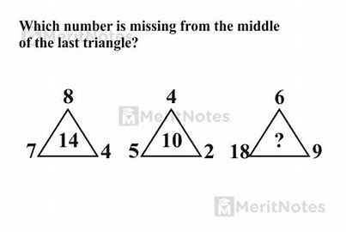
a)3
b)5
c)4
d)2
c_ans: A
e_ans: testing
mark:1
difficulty_level:Easy

6) Who is known as the father of the C programming language?
a) Bjarne Stroustrup
b)James Gosling
c)Dennis Ritchie
d)Guido van Rossum
c_ans: A
e_ans:test
mark:1
difficulty_level:Easy
7) Which of the following is the correct file extension for C programs?

a).cp
b)cpp
c)class
d)cl
c_ans:C
e_ans:anser
mark:1
difficulty_level:Easy

