Creating Repository in GitHub

Step 1 Click new nearby repository

Step 2 Give the repository name

Step 3 select the "Add README"

Step 4 Click Create Repository

Adding Content to README file

Step 1 Open the repository create

Step 2 Open README.md in edit mode and add the content

Step 3 Click commit changes

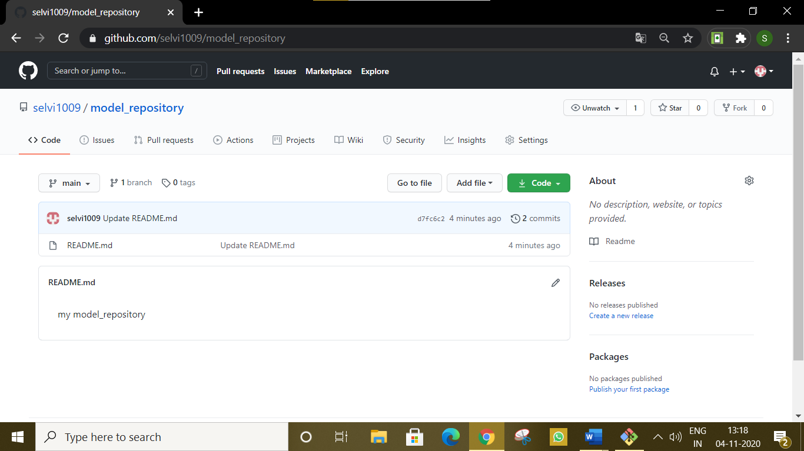

Cloning Repository:

selvi erulappan@selvi MINGW64 ~

$ ls

'3D Objects'/

AppData/

'Application Data'@

Contacts/

Cookies@

Desktop/

Documents/

Downloads/

Favorites/

IBA_IOAPDATA/

Links/

'Local Settings'@

Music/

'My Documents'@

NetHood@

NTUSER.DAT

ntuser.dat.LOG1

ntuser.dat.LOG2

NTUSER.DAT{53b39e88-18c4-11ea-a811-000d3aa4692b}.TM.blf

NTUSER.DAT{53b39e88-18c4-11ea-a811-000d3aa4692b}.TMContainer00000000000000000001.regtrans-ms

NTUSER.DAT{53b39e88-18c4-11ea-a811-000d3aa4692b}.TMContainer00000000000000000002.regtrans-ms

ntuser.ini

Pictures/

PrintHood@

Recent@

'Saved Games'/

Searches/

SendTo@

'Start Menu'@

Templates@

Videos/

selvi erulappan@selvi MINGW64 ~

$ git clone https://github.com/selvi1009/model_repository.git

Cloning into 'model_repository'...

remote: Enumerating objects: 6, done.

remote: Counting objects: 100% (6/6), done.

remote: Compressing objects: 100% (2/2), done.

remote: Total 6 (delta 0), reused 0 (delta 0), pack-reused 0

Unpacking objects: 100% (6/6), 1.20 KiB | 2.00 KiB/s, done.

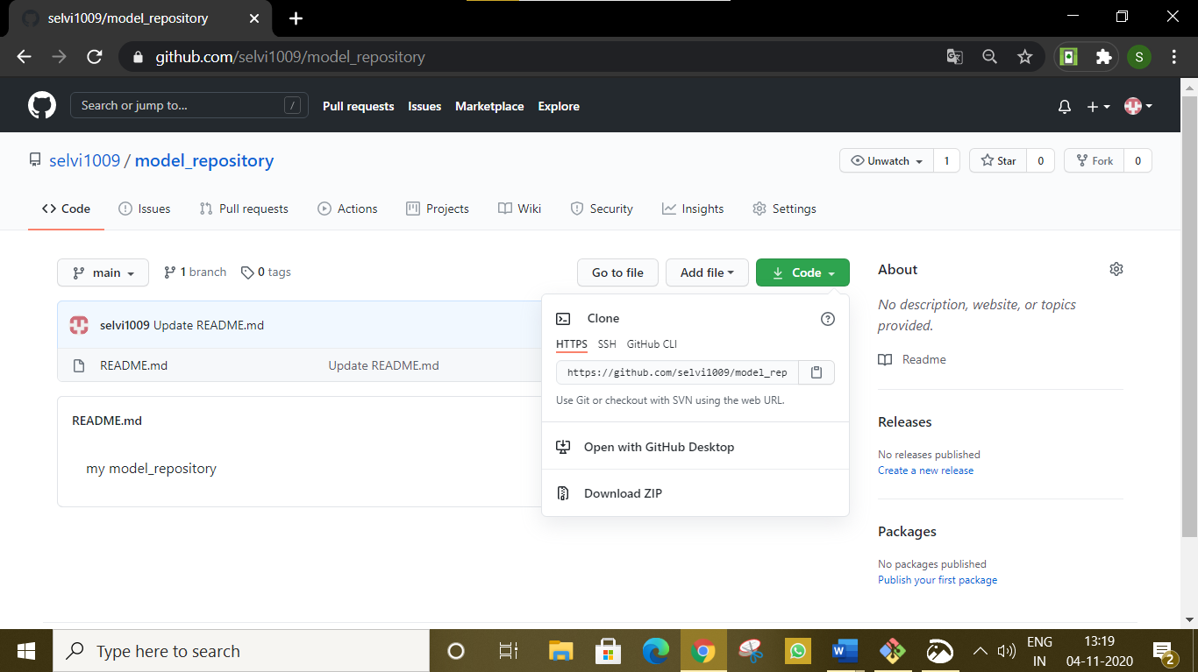

selvi erulappan@selvi MINGW64 ~

$ ls

'3D Objects'/ 'Local Settings'@ ntuser.ini

AppData/ model_repository/ Pictures/

'Application Data'@ Music/ PrintHood@

Contacts/ 'My Documents'@ Recent@

Cookies@ NetHood@ 'Saved Games'/

Desktop/ NTUSER.DAT Searches/

Documents/ ntuser.dat.LOG1 SendTo@

Downloads/ ntuser.dat.LOG2 'Start Menu'@

Favorites/ NTUSER.DAT{53b39e88-18c4-11ea-a811-000d3aa4692b}.TM.blf Templates@

IBA_IOAPDATA/ NTUSER.DAT{53b39e88-18c4-11ea-a811-000d3aa4692b}.TMContainer00000000000000000001.regtrans-ms Videos/

Links/ NTUSER.DAT{53b39e88-18c4-11ea-a811-000d3aa4692b}.TMContainer00000000000000000002.regtrans-ms

Moving to the repository:

selvi erulappan@selvi MINGW64 ~

$ pwd

/c/Users/ELCOT

selvi erulappan@selvi MINGW64 ~

$ cd model_repository

Adding files to repository-Add command:

selvi erulappan@selvi MINGW64 ~/model_repository (main)

$ ls

observation.docx

README.md

selvi erulappan@selvi MINGW64 ~/model_repository (main)

$ git add observation.docx

selvi erulappan@selvi MINGW64 ~/model_repository (main)

$ git status

On branch main

Your branch is up to date with 'origin/main'.

Changes to be committed:

(use "git restore --staged <file>..." to unstage)

new file: observation.docx

Pushing the content from local database to cloud:

selvi erulappan@selvi MINGW64 ~/model_repository (main)

$ git config--global user.email"selvishree1999@gmail.com"

git: 'config--global' is not a git command. See 'git --help'.

selvi erulappan@selvi MINGW64 ~/model_repository (main)

$ git config--global user.email"selvishree1999@gmail.com"

selvi erulappan@selvi MINGW64 ~/model_repository (main)

$ git commit -m 'first version of observation.docx'

[main 3b05793] first version of observation.docx

1 file changed, 0 insertions(+), 0 deletions(-)

create mode 100644 observation.docx

selvi erulappan@selvi MINGW64 ~/model_repository (main)

$ git status

Changes to be committed:

(On branch main

Your branch is ahead of 'origin/main' by 1 commit.

(use "git push" to publish your local commits)

nothing to commit, working tree clean

selvi erulappan@selvi MINGW64 ~/model_repository (main)

$ git push

Enumerating objects: 4, done.

Counting objects: 100% (4/4), done.

Delta compression using up to 4 threads

Compressing objects: 100% (3/3), done.

Writing objects: 100% (3/3), 121.41 KiB | 8.09 MiB/s, done.

Total 3 (delta 0), reused 0 (delta 0), pack-reused 0

To https://github.com/sherin1206/my_doc.git

4419596..3b05793 main -> main

Undoing changes:

Revert command:

Fun.txt(content):

angry=input("Are you angry")

if angry=='yes';

printf('eat chocolate')

printf('be cool')

else:

printf('do the lab ex')

selvi erulappan@selvi MINGW64 ~/model_repository (main)

$ git status

On branch main

Your branch is up to date with 'origin/main'.

Untracked files:

(use "git add <file>..." to include in what will be committed)

fun.txt

nothing added to commit but untracked files present (use "git add" to track)

selvi erulappan@selvi MINGW64 ~/model_repository (main)

$ git add fun.txt

selvi erulappan@selvi MINGW64 ~/model_repository (main)

$ git status

On branch main

Your branch is up to date with 'origin/main'.

Changes to be committed:

(use "git restore --staged <file>..." to unstage)

new file: fun.txt

selvi erulappan@selvi MINGW64 ~/model_repository (main)

$ git commit -m 'first fun.txt'

[main 65c54d5] first fun.txt

1 file changed, 5 insertions(+)

create mode 100644 fun.txt

selvi erulappan@selvi MINGW64 ~/model_repository (main)

$ git commit -m 'be cool'

[main deb1c2f] be cool

1 file changed, 2 insertions(+), 1 deletion(-)

selvi erulappan@selvi MINGW64 ~/model_repository (main)

On branch main

Your branch is ahead of 'origin/main' by 2 commits.

(use "git push" to publish your local commits)

nothing to commit, working tree clean

selvi erulappan@selvi MINGW64 ~/model_repository (main)

$ git log

commit deb1c2fdf29c8a211feb1ad837f51a1fcd6d1fba (HEAD -> main)

Author: Selvi E <selvishree1999@gmail.com>

Date: Wed Nov 4 13:27:49 2020 +0530

be cool

commit 65c54d529214d4c4f2753d83e6a92f3f97e1b661

Author: Selvi E <selvishree1999@gmail.com>

Date: Wed Nov 4 13:32:24 2020 +0530

first fun.txt

commit 22e8d1e33268f86c6d00ef597e69b99690493f6e (origin/main, origin/HEAD)

Author: Selvi E <selvishree1999@gmail.com>

Date: Wed Nov 4 13:40:10 2020 +0530

this is my first even.txt

commit db5de0265d48d15fd081164558f8ce87d9bc398b

Author: selvi1009 <72974990+selvi1009@users.noreply.github.com>

Date: Wed Nov 4 13:43:41 2020 +0530

Update README.md

commit e4f50eb8f39f8a874d4a77038551c6fa3e959901

Author: selvi1009 <72974990+selvi1009@users.noreply.github.com>

Date: Wed Nov 4 13:48:08 2020 +0530

Initial commit

selvi erulappan@selvi MINGW64 ~/model_repository (main)

$ git revert deb1c2fdf29c8a211feb1ad837f51a1fcd6d1fba

[main 695f279] Revert "be cool"

1 file changed, 1 insertion(+), 2 deletions(-)

selvi erulappan@selvi MINGW64 ~/model_repository (main)

$ git revert deb1c2fdf29c8a211feb1ad837f51a1fcd6d1fba

[main 4caed23] Revert "be cool"

1 file changed, 1 insertion(+), 2 deletions(-)

selvi erulappan@selvi MINGW64 ~/model_repository (main)

Delete repository:

Used to delete t