Continuous Integration – Jenkins

Introduction:
Continuous Integration (CI) is a development practice that requires developers to integrate code into a shared repository several times a day. Each check-in is then verified by an automated build, allowing teams to detect problems early.

Continuous Integration tools:
  - Jenkins
  - Teamcity
  - Bamboo.. etc

Jenkins:
Jenkins is an award-winning, cross-platform, continuous integration and continuous delivery application that increases your productivity. Jenkins is used to build and test your software projects continuously making it easier for developers to integrate changes to the project, and making it easier for users to obtain a fresh build. It also allows you to continuously deliver your software by providing powerful ways to define your build pipelines and integrating with a large number of testing and deployment technologies.

Features:
Jenkins offers the following major features out of the box, and many more can be added through plugins:

- Easy installation: Just run java -jar jenkins.war, deploy it in a servlet container. No additional install, no database. Prefer an installer or native package? We have those as well.
- Easy configuration: Jenkins can be configured entirely from its friendly web GUI with extensive on-the-fly error checks and inline help.
- Rich plugin ecosystem: Jenkins integrates with virtually every SCM or build tool that exists. View plugins.
- Extensibility: Most parts of Jenkins can be extended and modified, and it's easy to create new Jenkins plugins. This allows you to customize Jenkins to your needs.
- Distributed builds: Jenkins can distribute build/test loads to multiple computers with different operating systems. Building software for OS X, Linux, and Windows.

Installation:
Use one of the platform-specific package/installer links on the Jenkins site to install Jenkins on your system.
You can download jenkins.war directly(https://jenkins.io/) and launch it by executing java -jar jenkins.war. This is basically the same set up as the test drive, except that the output will go to console, not to a window. On Windows, you can even choose to install Jenkins as a service afterwards.

CI Workflow:
Please see the below picture which shows the CI workflow

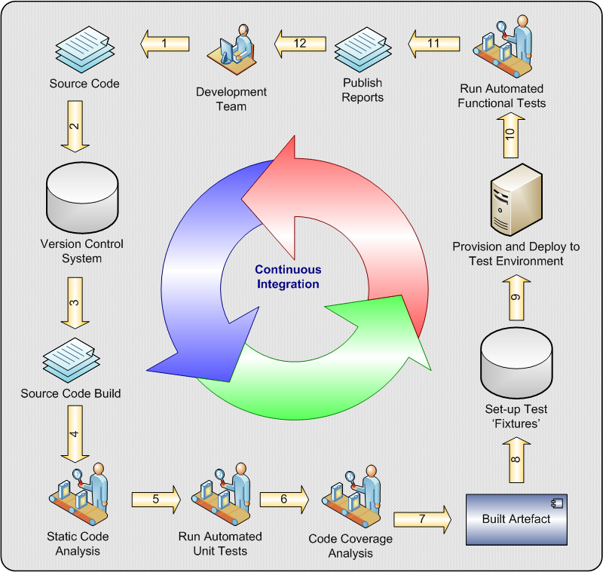

This document covers the integration parts as below. First lets create a new job in jenkins and proceed with the below steps:
- Git, ant and Apache Tomcat with jenkins
- Github, Jira and Jenkins
- Master and Slave integration.

Git, ANT, Tomcat with jenkins integration:

- Before creating a job in jenkins configure and install all the necessary plugins and tools:
- From Jenkins Dashboard page, select Manage Jenkins → Manage Plugin

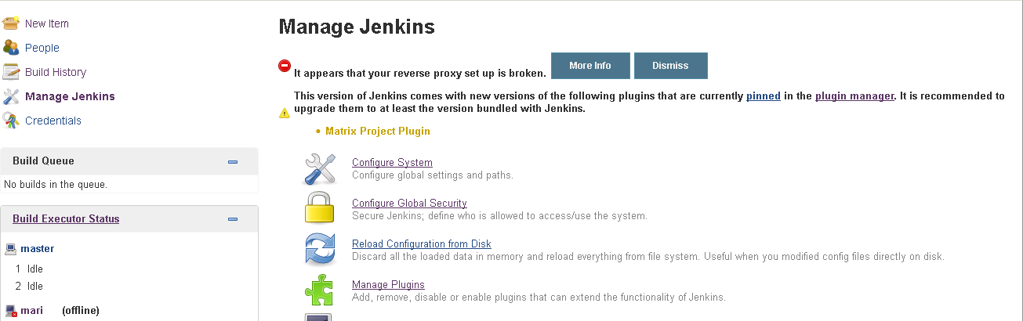

- Select Git, Ant, Deploy to container plugin. If you want to configure many tools, include all the necessary plugins.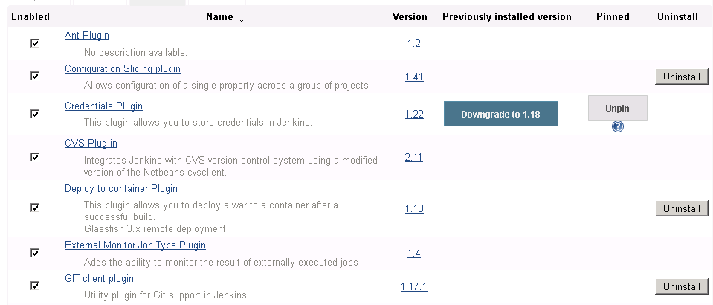
- Configure all the necessary information in the jenkins configure system. Jenkins home page → Manage Jenkins → Configure system
- Enter all the necessary information like path to Git.exe path..etc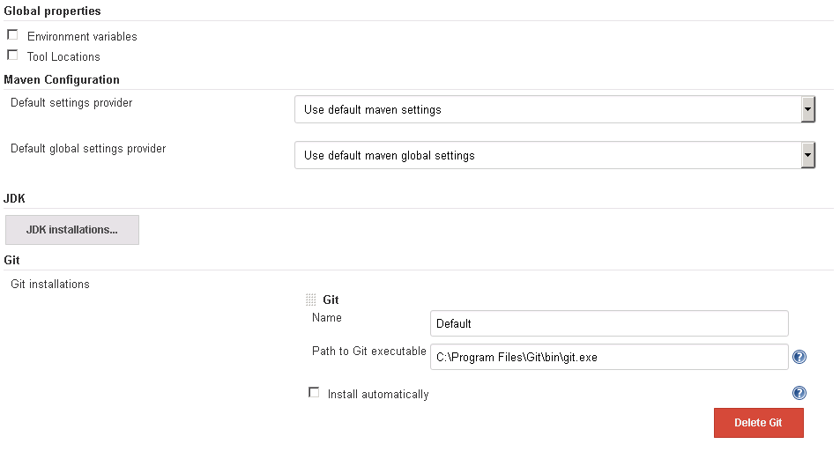

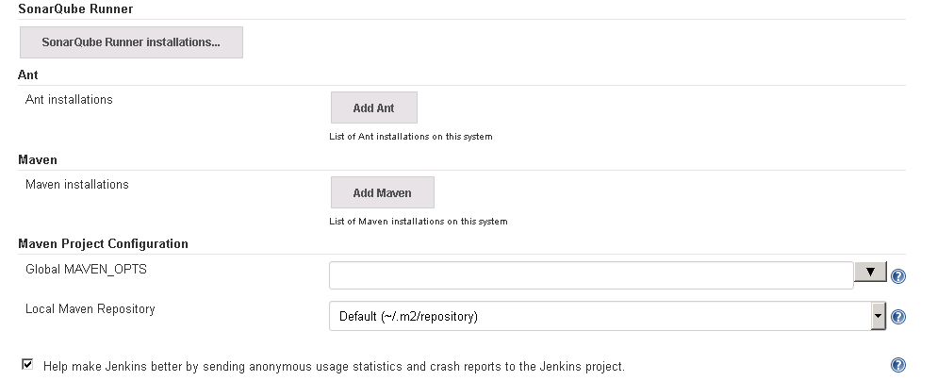

- Creating a new Job in Jenkins
- Jenkins home page → New Item
- Enter the Item Name and select appropriate project type based on your requirement(This project comes under Freestyle project) and select ok.
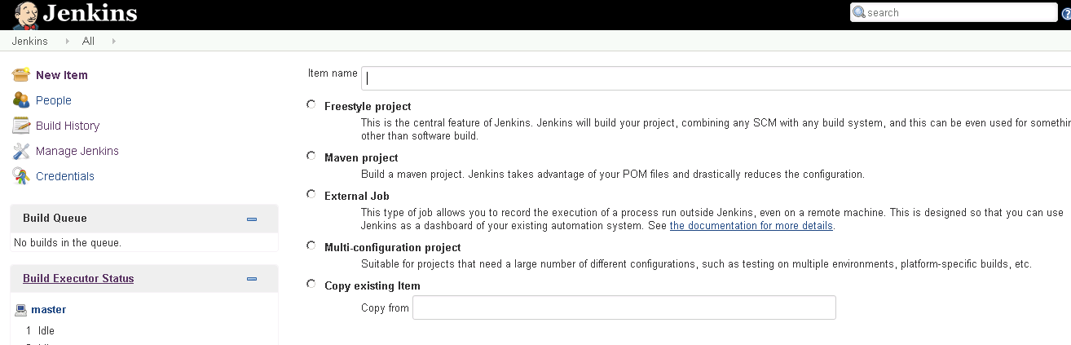
- In the next page enter all the necessary information about the tools that you are going to use for this project.
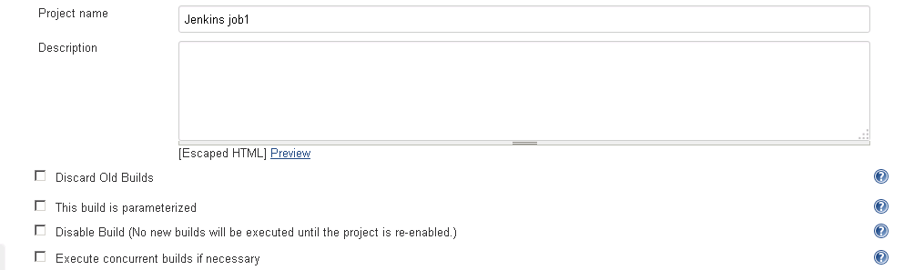

- Enter the Git repository url (credential will be required once we use git hub project).
- Enter Tomcat url user name and password for deploying the package into the server.

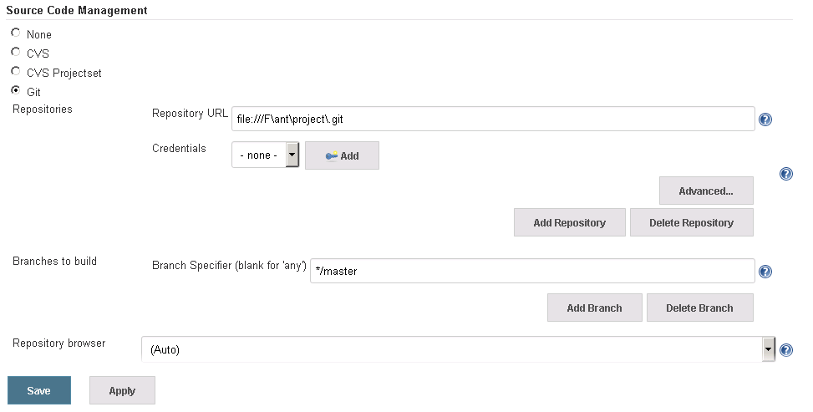

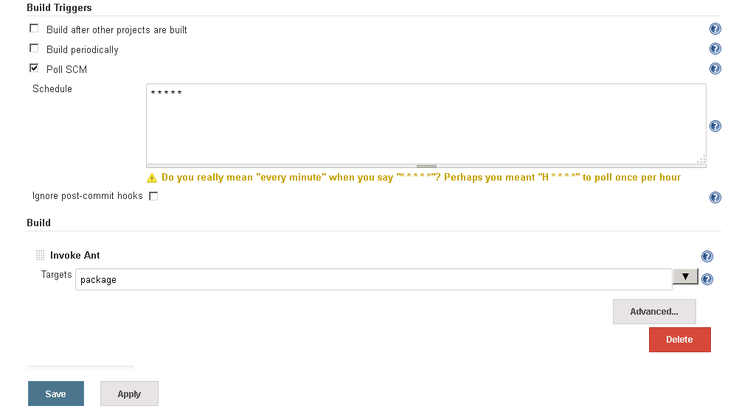

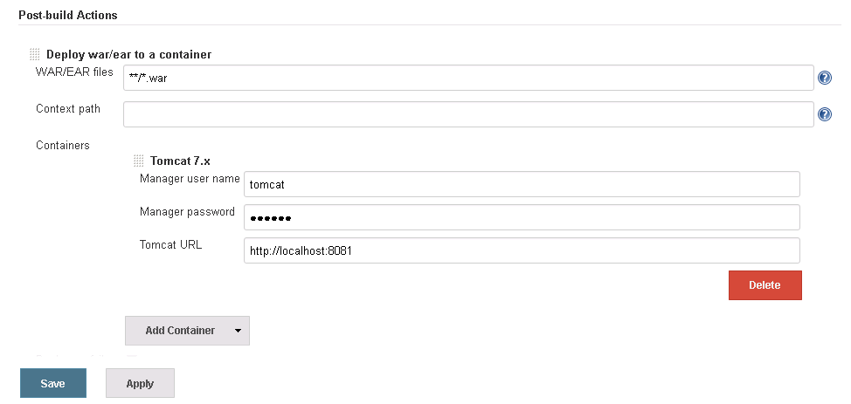

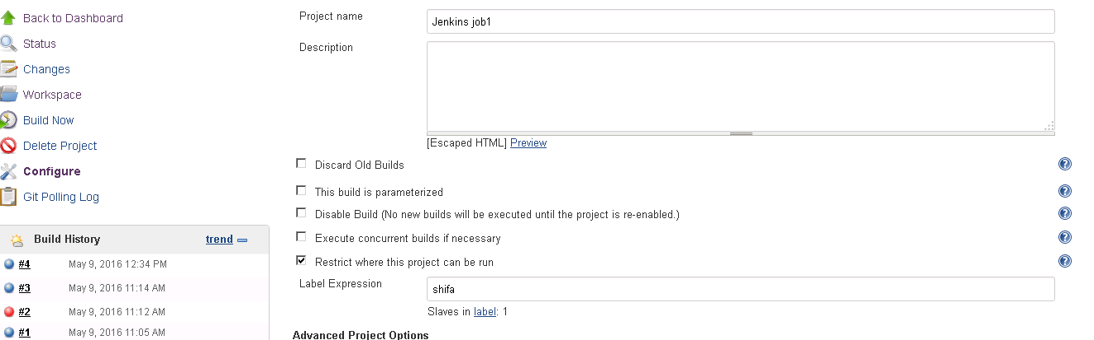

- Once you done with all the source code, commit the code using git.

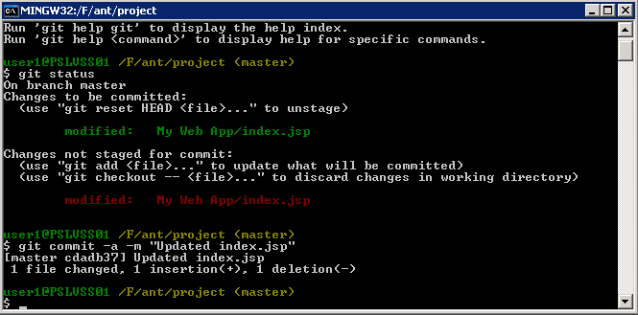
- Build gets triggered automatically after the commit.
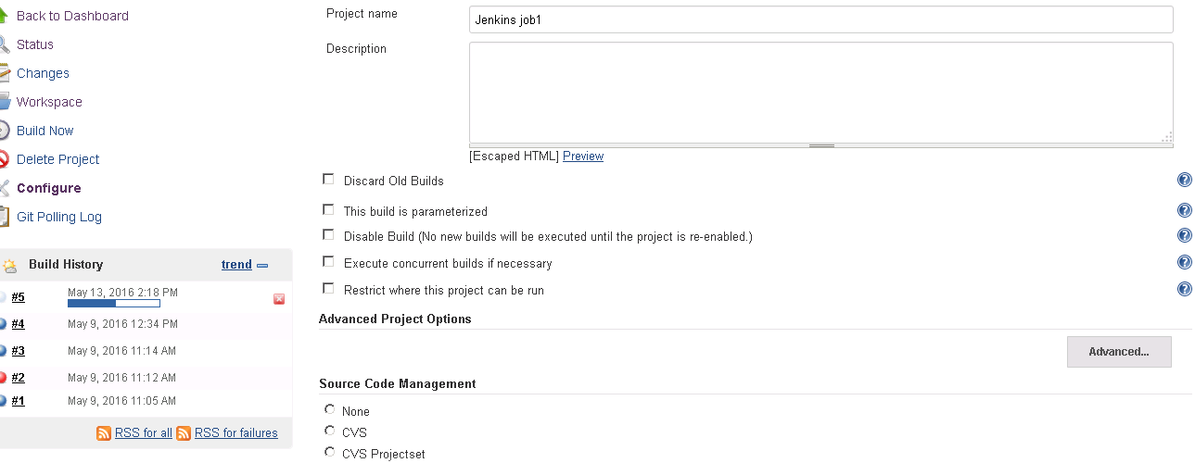

- The build is successful and the package gets deployed into Tomcat server.
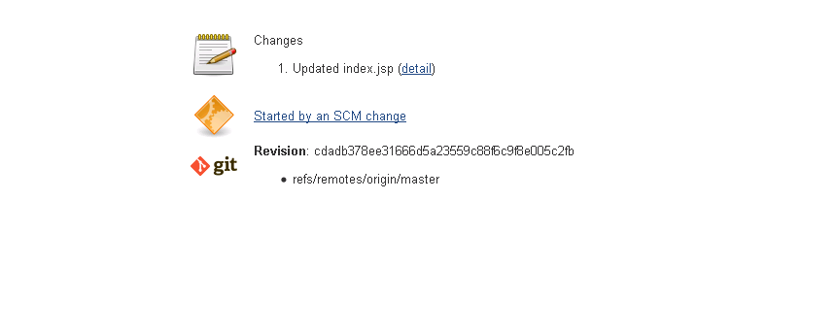

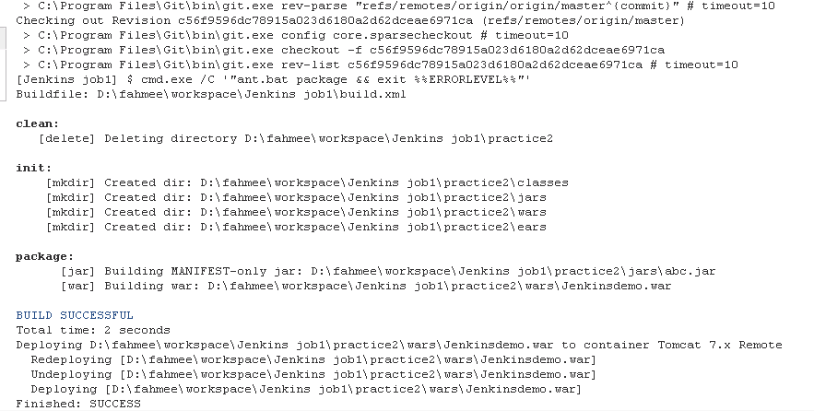

Master and Slave:
Note: There is no need to install Jenkins on the slave machine.

A "master" operating by itself is the basic installation of Jenkins and in this configuration the master handles all tasks for your build system. In most cases installing a slave doesn't change the behavior of the master. It will serve all HTTP requests, and it can still build projects on its own. Once you install a few slaves you might find yourself removing the executors on the master in order to free up master resources (allowing it to concentrate resources on managing your build environment) but this is not a necessary step. If you start to use Jenkins a lot with just a master you will most likely find that you will run out of resources (memory, CPU, etc.). At this point you can either upgrade your master or you can setup slaves to pick up the load. As mentioned above you might also need several different environments to test your builds. In this case using a slave to represent each of your required environments is almost a must.
A slave is a computer that is set up to offload build projects from the master and once setup this distribution of tasks is fairly automatic. The exact delegation behavior depends on the configuration of each project; some projects may choose to "stick" to a particular machine for a build, while others may choose to roam freely between slaves. For people accessing your Jenkins system via the integrated website (http://yourjenkinsmaster:8080), things work mostly transparently. You can still browse javadoc, see test results, download build results from a master, without ever noticing that builds were done by slaves. In other words, the master becomes a sort of "portal" to the entire build farm.
Since each slave runs a separate program called a "slave agent" there is no need to install the full Jenkins (package or compiled binaries) on a slave. There are various ways to start slave agents, but in the end the slave agent and Jenkins master needs to establish a bi-directional communication link (for example a TCP/IP socket.) in order to operate.

- Select Jenkins homepage → Manage Nodes
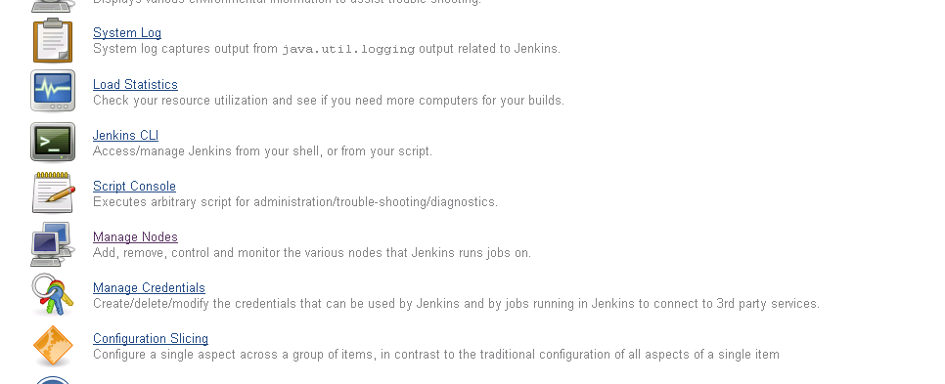
- Select New Node for creating new nodes in jenkins.
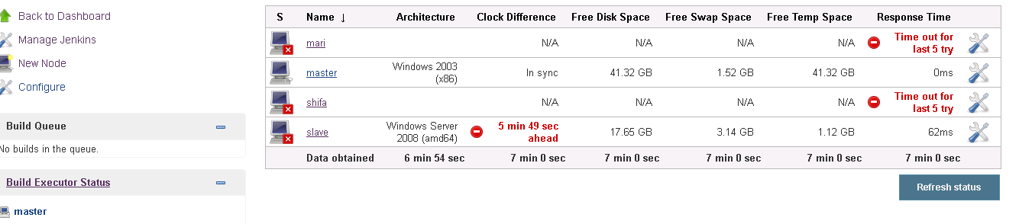
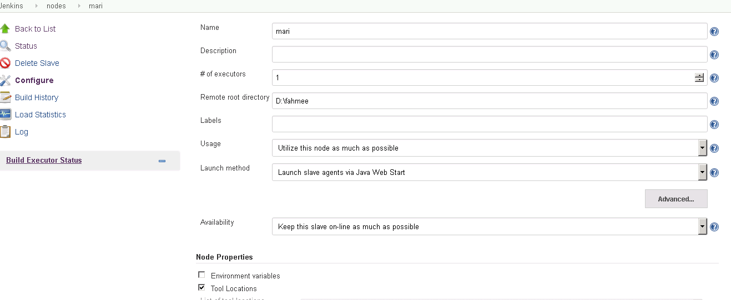

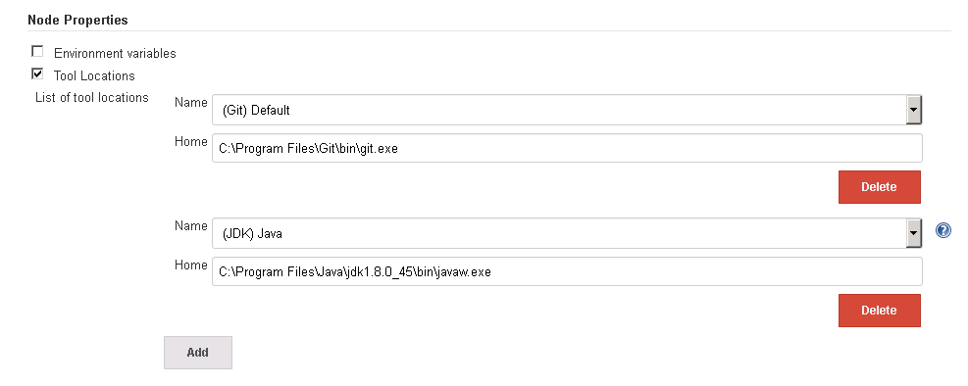

- Go to slave machine and access the jenkins path and select the slave that we created from the master.

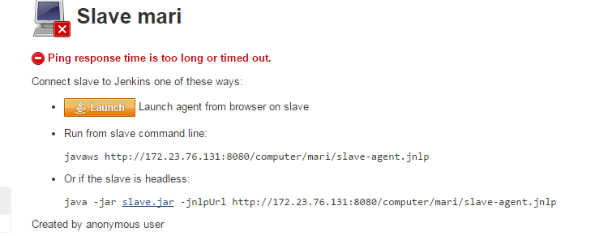
- Download the slave agent and slave.jar from the page and store it in the path that we mentioned in the slave local directory.

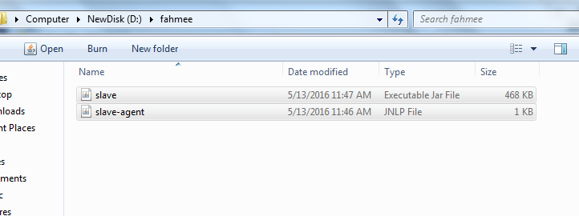
- run the slaveagent and slave.jar using the url mentioned in the slave homepage.
Cmd “java -jar slave.jar -jnlpUrl http://172.23.76.131:8080/computer/mari/slave-agent.jnlp”

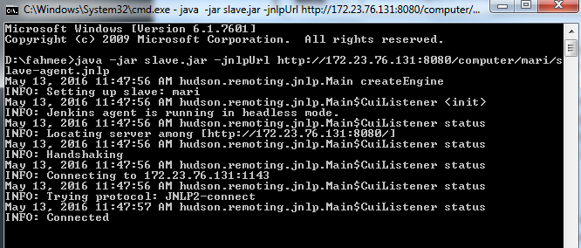

- Once you get the Connected messge in the command prompt which indicated the master and slave machine gets connected and the Node will become online.
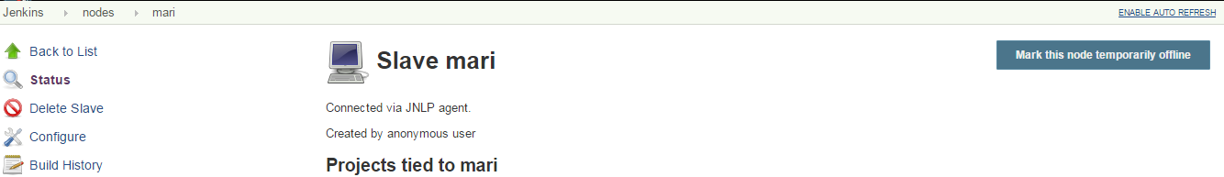

- We can assign the job in jenkins to the slave machine by selecting “Restrict where this project can be run” and selecting the slave machine.

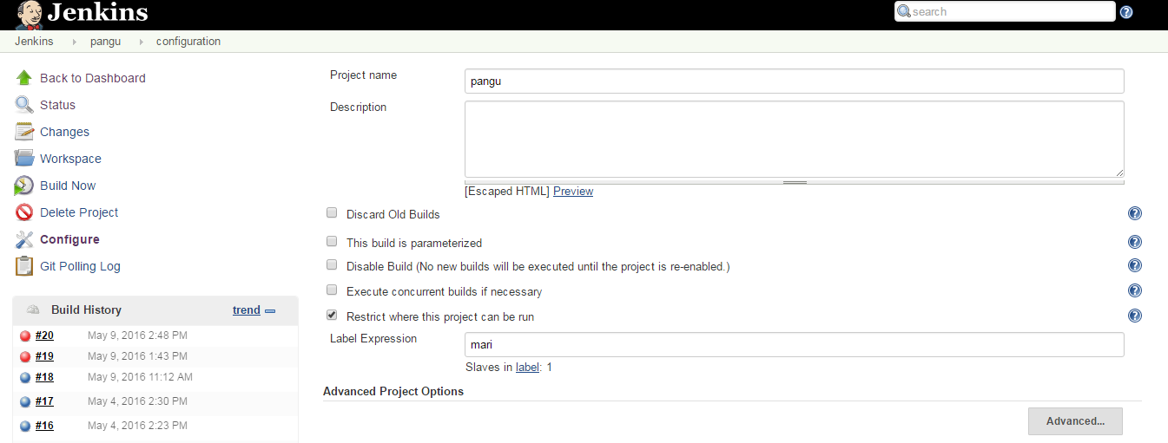
Once you build the project in the console output you can see the message as “Building remotely on mari in the workspace D:\fahmee\workspace\pangu”

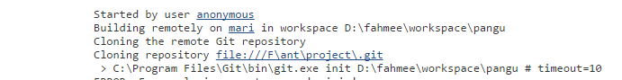
- The workspace gets created in the slave machine once the job gets completed.

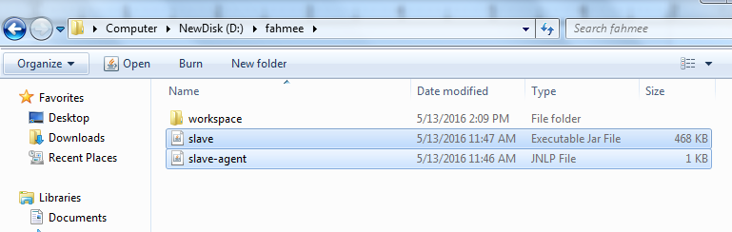

Git Hub, Jenkins ,Jira Integration:

workflow for a developer:
- You find a ticket to work on and claim it.
- You do your work.
- You type a single command to submit a pull request for your work.
- You receive a direct message indicating whether your work was merged.

JIRA is up to date. GitHub is up to date. Jenkins is up to date.
That’s it! Notice what you didn’t do. You didn’t update JIRA. You didn’t kick off automated tests in Jenkins or push to multiple remotes in GitHub. You didn’t even log in to a website to check the status of your pull request or ticket. That’s how the world should work.
What magic happened?
- Tickets moved on their own in JIRA. The tickets contained references to your code and pull requests.
- Comments were made on JIRA indicating that tests passed or failed.
- Tests were run automatically.
- Code was pushed to the right places
- You received a direct message.

GitHub project:

- Inorder to integrate Jira with DVCS we need have an account either on GitHub / Bitbucket.

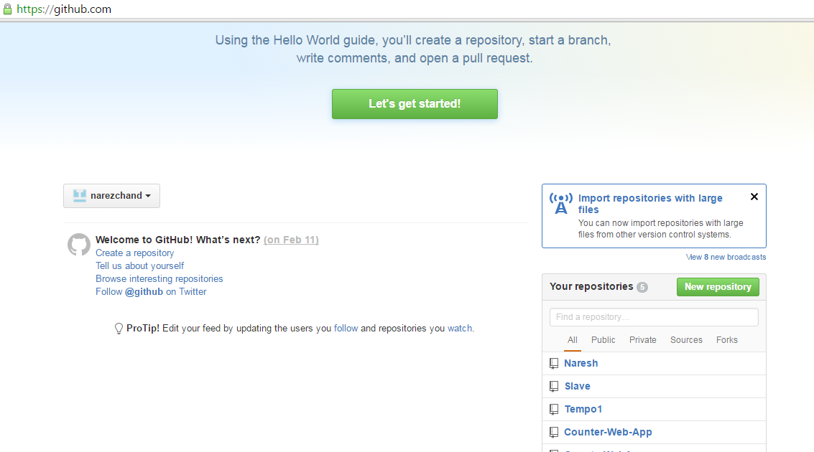We are going to use Github for the demo.
- I have created a repository in the github and i'm going to build the source code using this repository (Repository name → Naresh)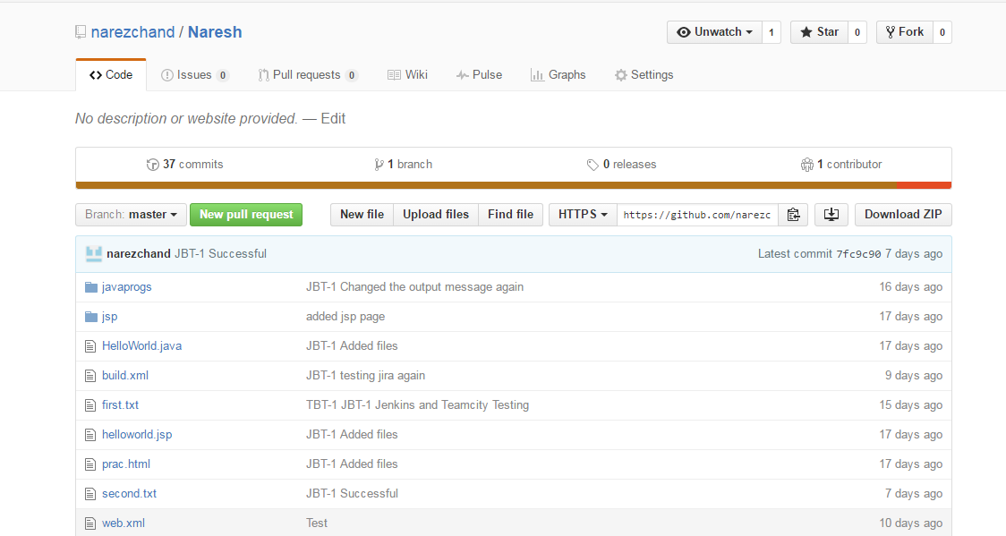

Jenkins setup:

- Add the github and Jira integertion in Jenkins.

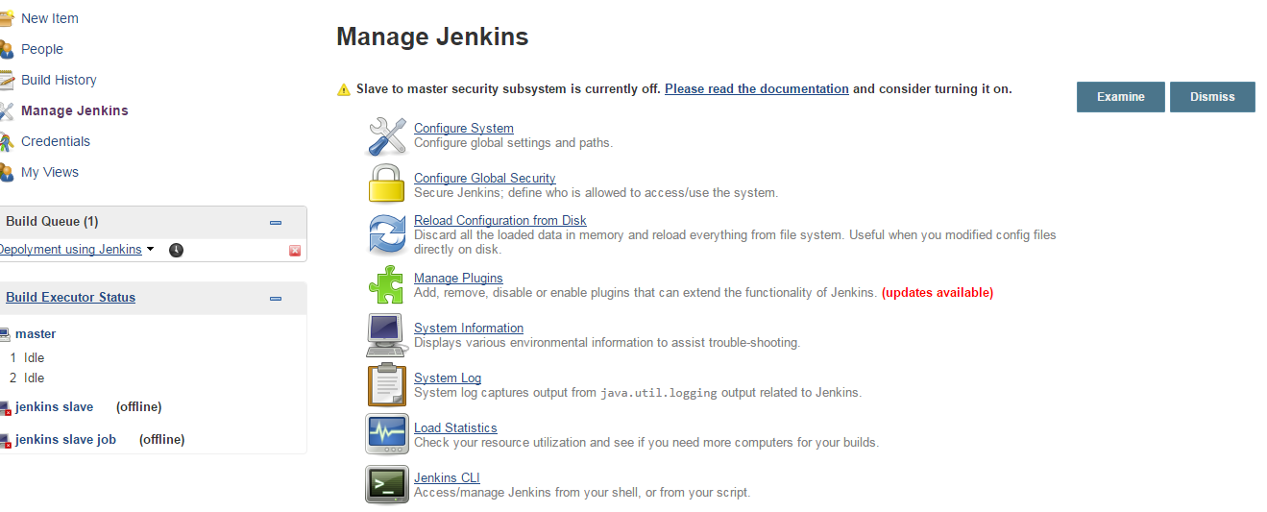
- Select Installed tab and search for github and jira and install the required plugin.
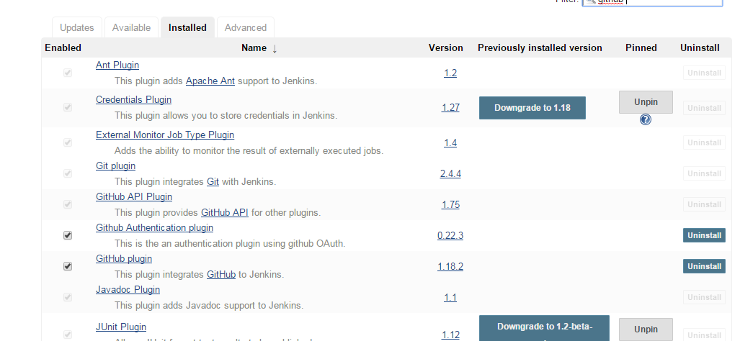
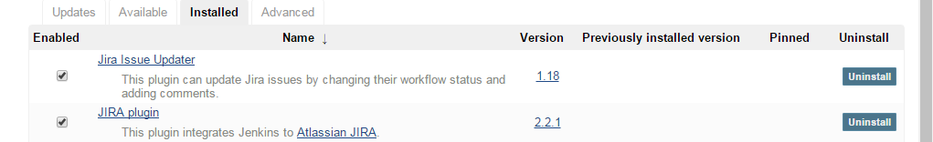
- Select Manage Jenkins → Configure System and configure necessary Git and Jira information as below.
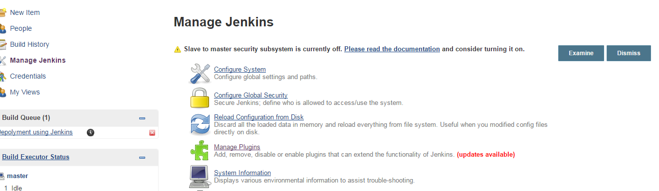
- Enter Jira url, Link url, username and password.

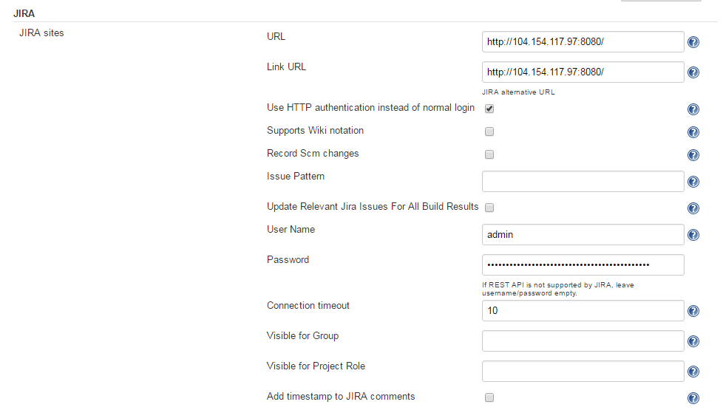

Jira Configuration:

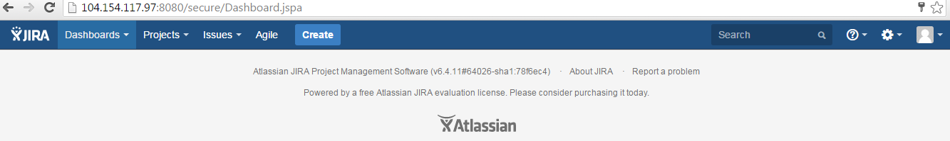

- Configuring Jenkins , Git hub in Jira.
- Select Settings-> Add-ons-> Add Add-ons
- Search for Jenkins plugin for JIRA
- Install the plugin
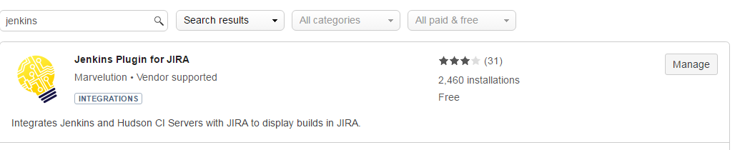
- Refresh the page and now the Jenkins Configuration will be available in the left pane. Select Jenkins configuration.
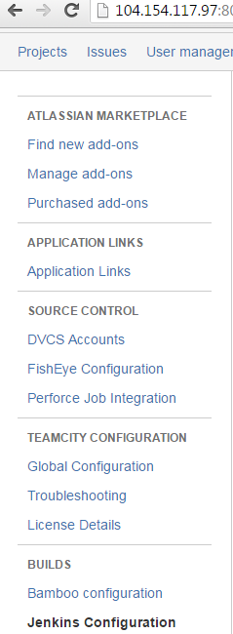

- Select Add site and enter th jenkins information such as name, url, name and password.
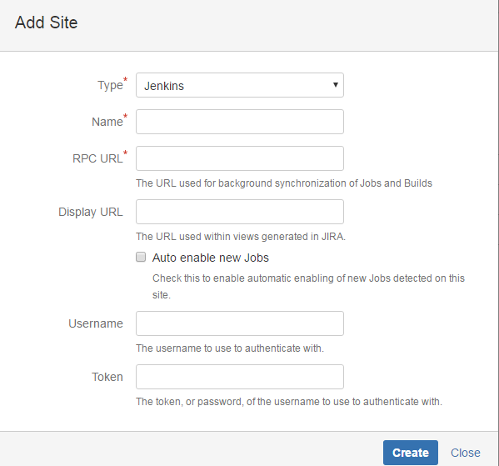

Jira- Github integration:

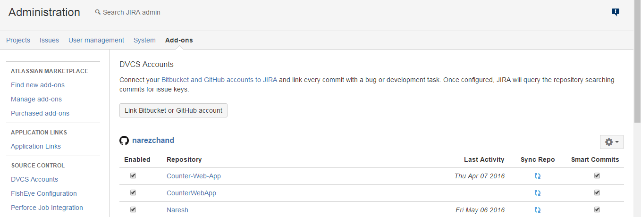
- Integrating Jira with Github.
- Select DVCS Accounts → select Link Bitbucket or GitHub account.
- Select the host as “GitHub”
- User name in “Team or User Account”.
- We can get the OAuth key and secret in the gitHub account.
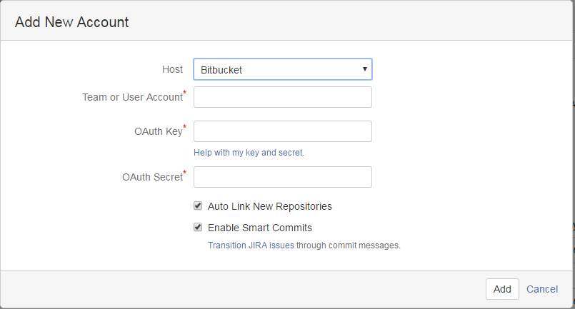

- In the GitHub select settings → OAuth applications → Develper applications

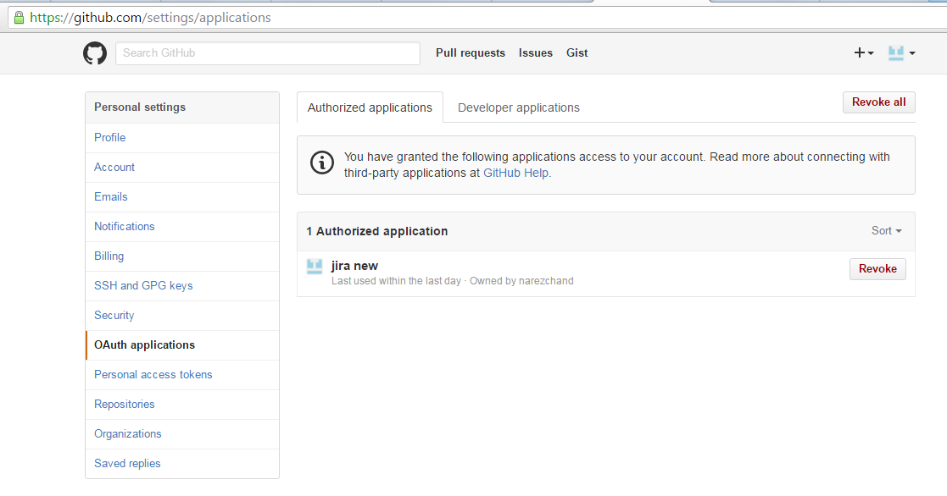

- Enter the application Name as Jira
- Enter Jira url in the Homepage url and Authorized callback url
- Click RegisterApplication.
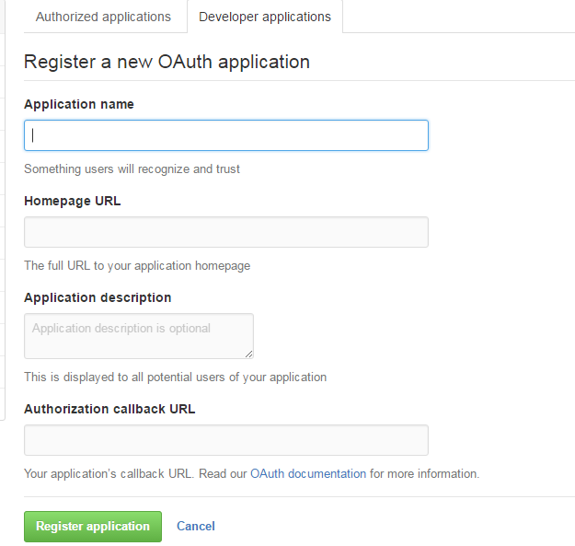

- You will get OAuth key and secret key and enter those information in Jira and select Save.
- You can see all the git hub projects in Jira.

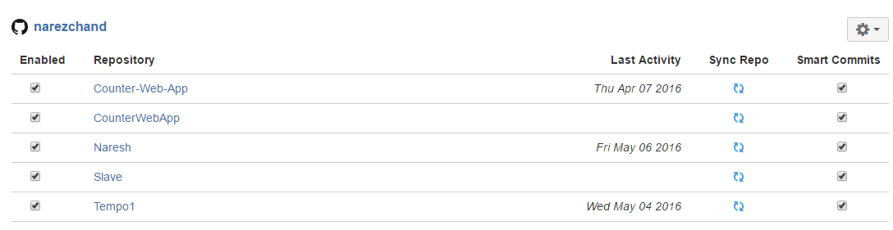

Creating a job in jenkins and configuring Jira and Github:
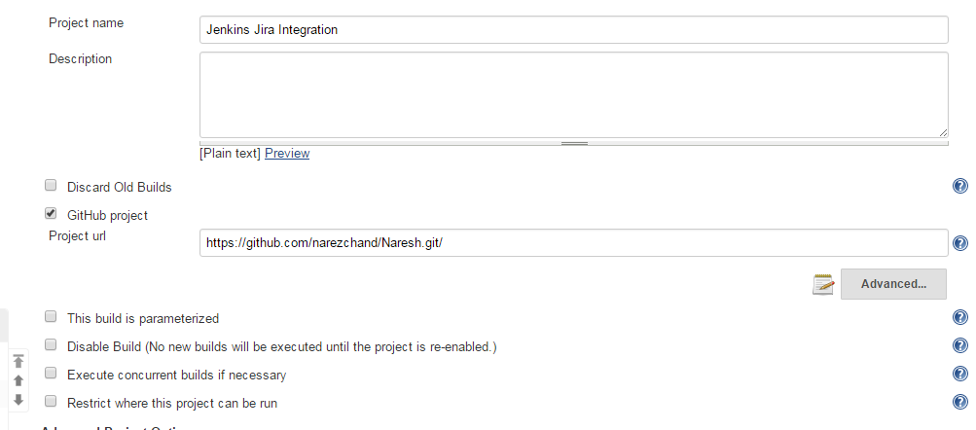

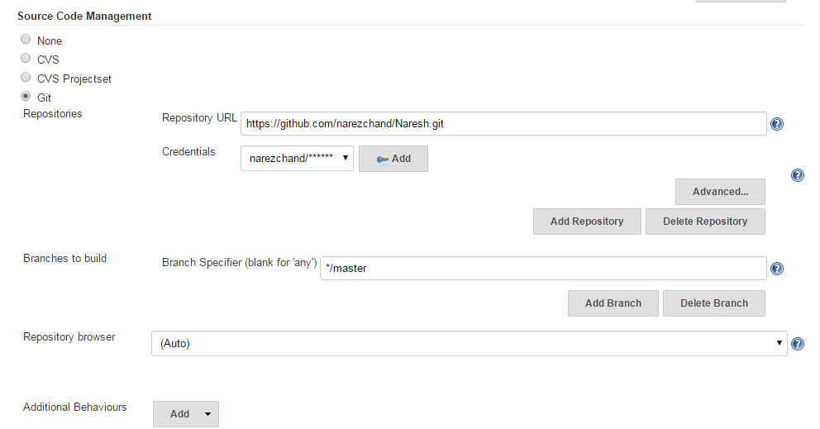

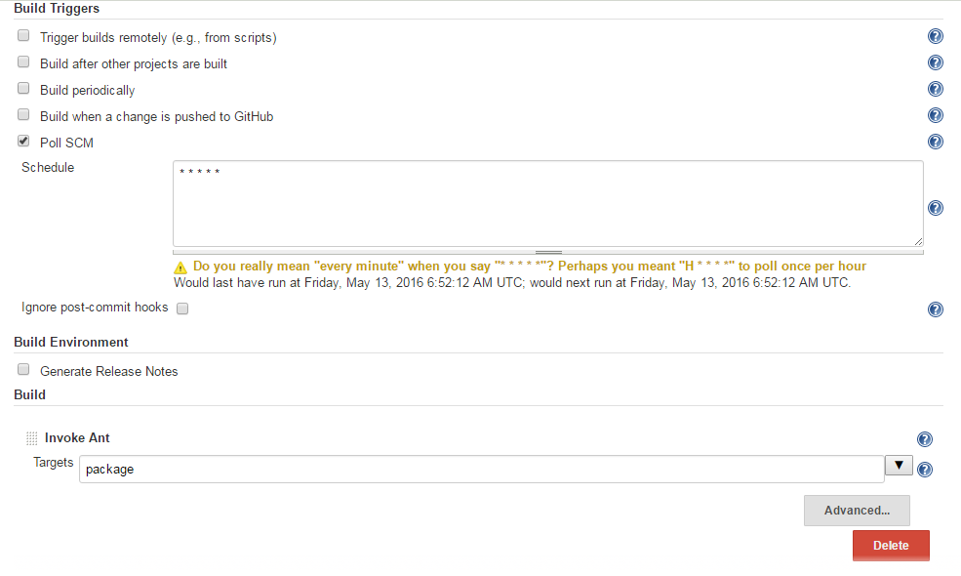

- Select Jira information as below.
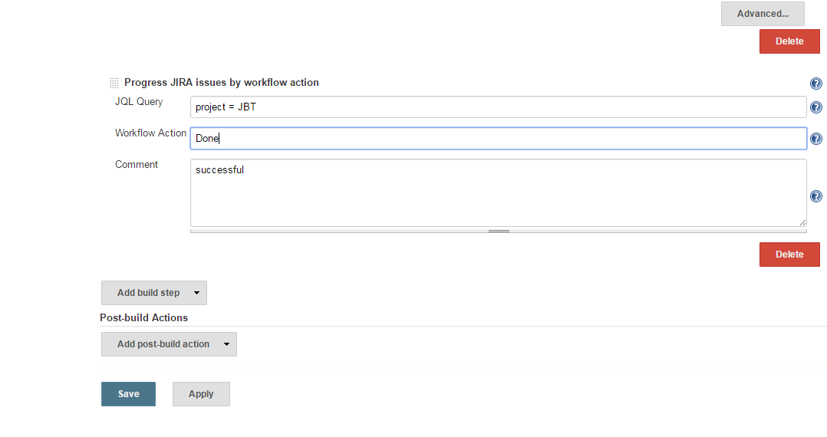

- After necessary change in source code. Commit the code.
- Enter the Defect Id in the beginning of the commit message followed by the commit message.
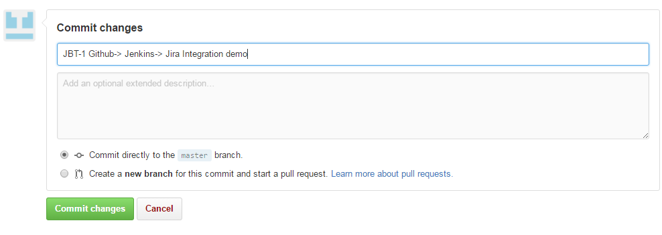

- Build gets automatically trigerred after the commit in GitHub.

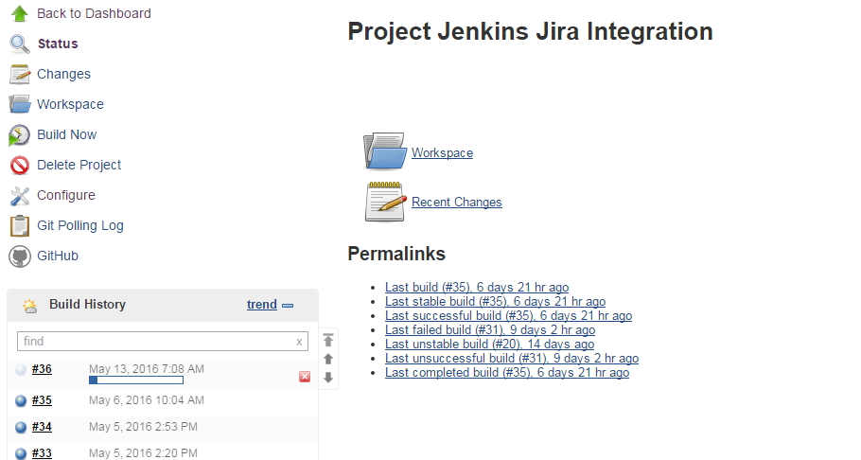
- Commit message gets displayed in the build

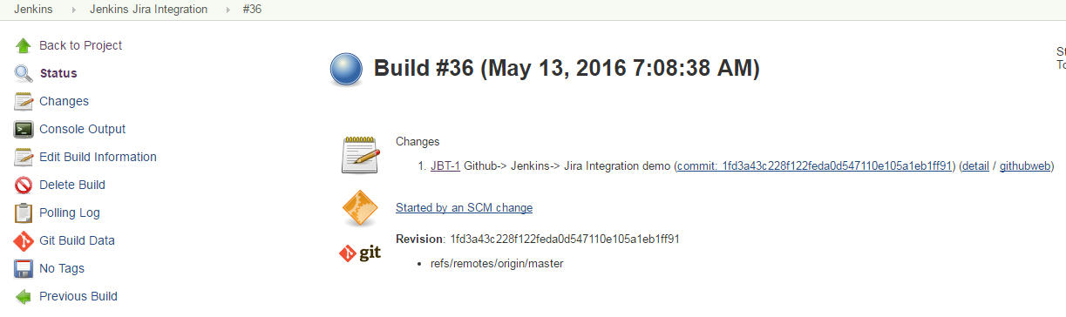

- The Defect gets updated with commit message from GitHub and from Jenkins jira defect gets updated with latest status and also the comments.

- Defect status gets automatically updated from TODO to DONE
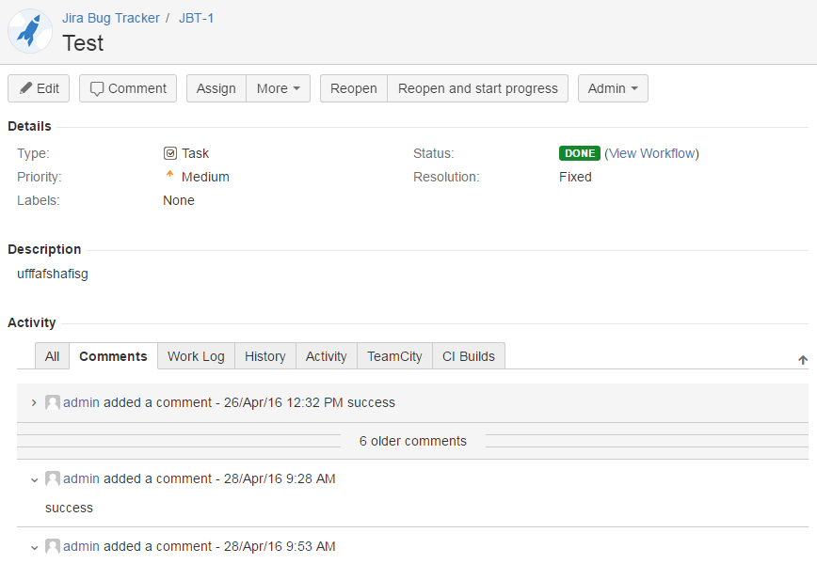

- Commit message
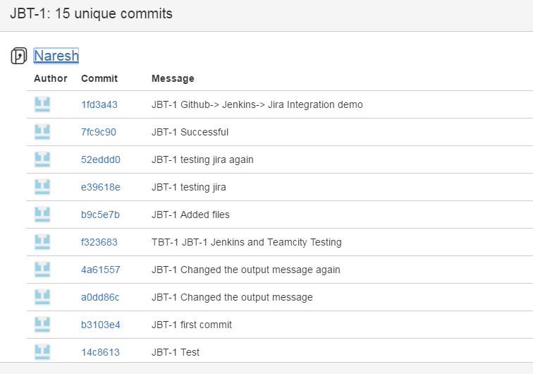

- Jira Defect gets updated with jenkins command message.
