**ME Financial Transaction** **Document**

ME Financial transaction system is developed with spring boot & Rest based webservices.

Please load the below url in the browser, this will load the html controls to get the input for the AccountID, From Date and To Date.

<http://localhost:8080/meBankTransactions>

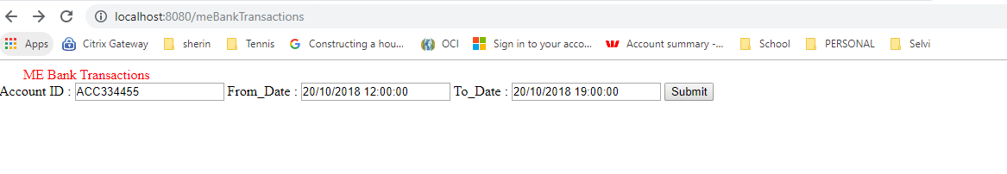

When you press the submit button by loading the above url in the browser , this will call the below url to process the submitted request.

<http://localhost:8080/meBankTransactionsSubmit>

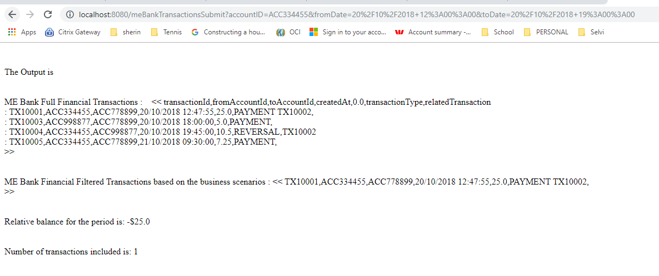

**Technical Document**

As mentioned earlier the assignment is developed using Spring boot & webservices as a maven project, import the code from github to any IDE (Eclipse, Netbeans or Intellij). Run spring main class as Java application Run as -> Java Applicatoon. Please find the below class name with the package name.

https://github.com/selviroselin/MEBankingTransactionsSpringBootRESTWebservices.git

<https://github.com/selviroselin/MEBankingTransactionsSpringBootRESTWebservices>

com.mebankcompany.mebankfinancetransaction -> MEBankFinanceTransMain.class

Rest services are implemented in the controller class and find the below class name with the package name.

com.mebankcompany.mebankfinancetransaction.controller -> MEBankFinanceTransController.class

Code is tested with JUnit and the find the below test class with the description

MEBankFinanceTransMainTest -> Tested successful and failure scenarios of spring boot main classes (MEBankFinanceTransMain.class)

MEBankFinancialTransactionsParameterizedTest -> parameterized testing with successful and failure scenarios.

MEBankControllerIT -> This is mocking the HTTP Request, using Spring Boot to write the simple full stack integration test.

MEBankFinanceTransControllerTest -> Mocked the rest based webservice request and tested the below api with Junit framework.

/meBankTransactions

/meBankTransactionsSubmit