Practical 7
Part A — Practice Programs (Hour 1) :
Problem Defination :
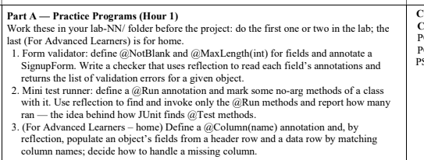Solution:
import java.lang.annotation.*;
import java.lang.reflect.Field;
import java.util.*;

@Retention(RetentionPolicy.RUNTIME)
@Target(ElementType.FIELD)
@interface NotBlank {
}
@Retention(RetentionPolicy.RUNTIME)
@Target(ElementType.FIELD)
@interface MaxLength {
int value();
}
class SignupForm {
@NotBlank
@MaxLength(20)
String username;

@NotBlank
@MaxLength(50)
String email;
@MaxLength(10)
String mobile;

SignupForm(String username, String email, String mobile) {
this.username = username;
this.email = email;
this.mobile = mobile;
}
}
class FormValidator {
public static List<String> validate(Object obj) {
List<String> errors = new ArrayList<>();

for (Field field : obj.getClass().getDeclaredFields()) {
field.setAccessible(true);

try {
Object value = field.get(obj);
String fieldName = field.getName();

if (field.isAnnotationPresent(NotBlank.class)) {
if (value == null || value.toString().trim().isEmpty()) {
errors.add(fieldName + " must not be blank");
}
}
if (field.isAnnotationPresent(MaxLength.class) && value != null) {
int max = field.getAnnotation(MaxLength.class).value();

if (value.toString().length() > max) {
errors.add(fieldName + " must not exceed " + max + " characters");
}
}
} catch (IllegalAccessException e) {
errors.add("Unable to access " + field.getName());
}
}

return errors;
}
}
public class Main {
public static void main(String[] args) {
SignupForm form = new SignupForm(
"",
"verylongemailaddress@example.com",
"12345678901"
);

List<String> errors = FormValidator.validate(form);

for (String error : errors) {
System.out.println(error);
}
}
}
OUTPUT :

2. Mini test runner: define a @Run annotation and mark some no-arg methods of a class
with it. Use reflection to find and invoke only the @Run methods and report how many
ran — the idea behind how JUnit finds @Test methods.
Solution :
import java.lang.annotation.*;
import java.lang.reflect.*;

@Retention(RetentionPolicy.RUNTIME)
@Target(ElementType.METHOD)
@interface Run {
}

class TestCases {

@Run
public void testLogin() {
System.out.println("Login Test");
}

@Run
public void testSignup() {
System.out.println("Signup Test");
}

public void normalMethod() {
System.out.println("Normal Method");
}

@Run
public void testDashboard() {
System.out.println("Dashboard Test");
}
}

public class Main2 {
public static void main(String[] args) throws Exception {
TestCases obj = new TestCases();
int count = 0;

for (Method method : TestCases.class.getDeclaredMethods()) {
if (method.isAnnotationPresent(Run.class)
&& method.getParameterCount() == 0) {

method.invoke(obj);
count++;
}
}

System.out.println("Tests Ran: " + count);
}
}

OUTPUT:
