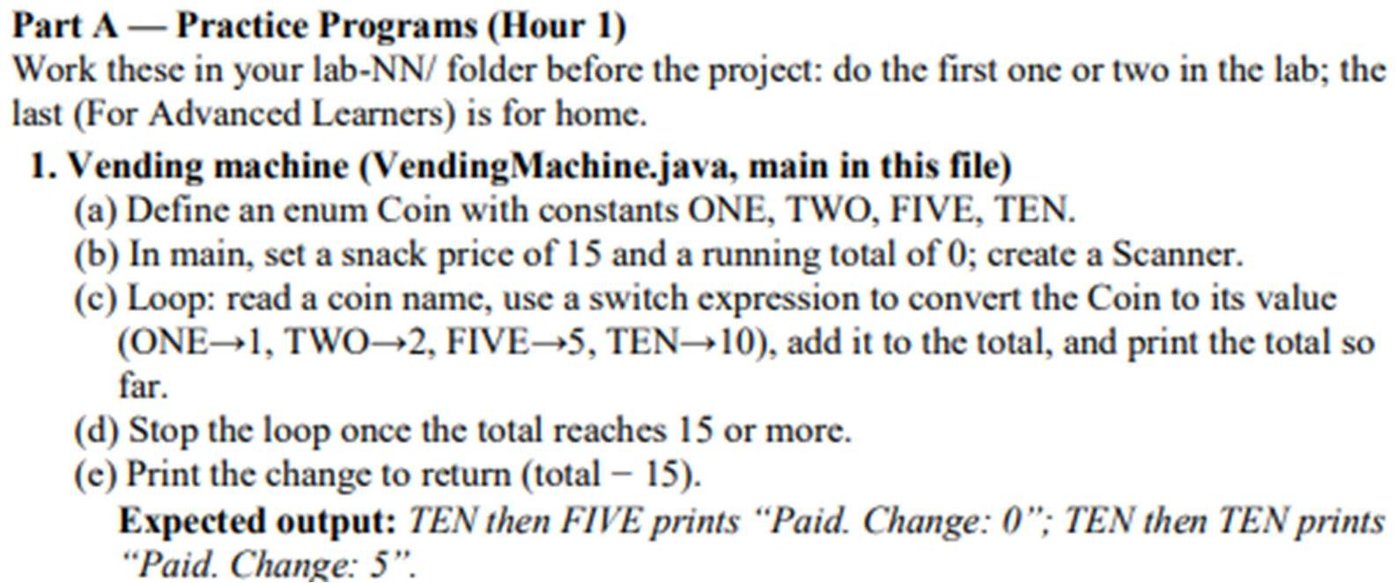

CODE:

import java.util.Scanner;

public class VendingMachine {

enum Coin {
ONE, TWO, FIVE, TEN
}

public static void main(String[] args) {

Scanner sc = new Scanner(System.in);

int price = 15;
int total = 0;

while (total < price) {

System.out.print("Enter coin (ONE, TWO, FIVE, TEN): ");
String input = sc.nextLine().toUpperCase();

Coin coin;

try {
coin = Coin.valueOf(input);
} catch (Exception e) {
System.out.println("Invalid coin");
continue;
}

int value = switch (coin) {
case ONE -> 1;
case TWO -> 2;
case FIVE -> 5;
case TEN -> 10;
};

total += value;

System.out.println("Total: " + total);
}

System.out.println("Paid. Change: " + (total - price));

sc.close();
}
}

OUTPUT:

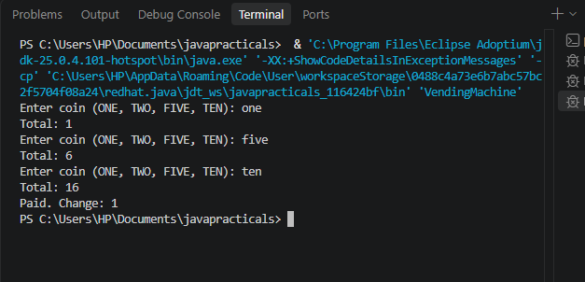
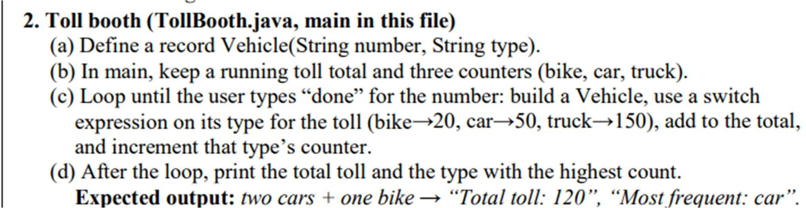

CODE:

import java.util.Scanner;

public class TollBooth {

record Vehicle(String number, String type) {}

public static void main(String[] args) {

Scanner sc = new Scanner(System.in);

int totalToll = 0;
int bike = 0;
int car = 0;
int truck = 0;

while (true) {

System.out.print("Enter vehicle number (or done): ");
String number = sc.nextLine();

if (number.equalsIgnoreCase("done"))
break;

System.out.print("Enter vehicle type (bike/car/truck): ");
String type = sc.nextLine().toLowerCase();

Vehicle v = new Vehicle(number, type);

int toll = switch (v.type()) {
case "bike" -> {
bike++;
yield 20;
}
case "car" -> {
car++;
yield 50;
}
case "truck" -> {
truck++;
yield 150;
}
default -> 0;
};

if (toll == 0) {
System.out.println("Invalid vehicle type");
} else {
totalToll += toll;
}
}

String mostFrequent;

if (bike >= car && bike >= truck)
mostFrequent = "bike";
else if (car >= bike && car >= truck)
mostFrequent = "car";
else
mostFrequent = "truck";

System.out.println("Total toll: " + totalToll);
System.out.println("Most frequent: " + mostFrequent);

sc.close();
}
}

Output:

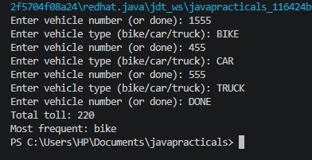

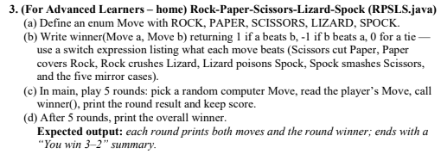

Solution:
import java.util.Random;
import java.util.Scanner;

public class RPSLS {

enum Move {
ROCK, PAPER, SCISSORS, LIZARD, SPOCK
}

static int winner(Move a, Move b) {

if (a == b)
return 0;

return switch (a) {
case SCISSORS -> (b == Move.PAPER || b == Move.LIZARD) ? 1 : -1;
case PAPER -> (b == Move.ROCK || b == Move.SPOCK) ? 1 : -1;
case ROCK -> (b == Move.SCISSORS || b == Move.LIZARD) ? 1 : -1;
case LIZARD -> (b == Move.SPOCK || b == Move.PAPER) ? 1 : -1;
case SPOCK -> (b == Move.SCISSORS || b == Move.ROCK) ? 1 : -1;
};
}

public static void main(String[] args) {

Scanner sc = new Scanner(System.in);
Random random = new Random();

int playerScore = 0;
int computerScore = 0;

for (int round = 1; round <= 5; round++) {

Move computer = Move.values()[random.nextInt(5)];

System.out.println("\nRound " + round);
System.out.print("Enter your move (ROCK, PAPER, SCISSORS, LIZARD, SPOCK): ");

String input = sc.nextLine().toUpperCase();

Move player;

try {
player = Move.valueOf(input);
} catch (Exception e) {
System.out.println("Invalid move! Try again.");
round--;
continue;
}

int result = winner(player, computer);

System.out.println("You played: " + player);
System.out.println("Computer played: " + computer);

if (result == 1) {
System.out.println("Round winner: You");
playerScore++;
} else if (result == -1) {
System.out.println("Round winner: Computer");
computerScore++;
} else {
System.out.println("Round winner: Tie");
}
}

System.out.println("\n--- Final Result ---");
System.out.println("Your score: " + playerScore);
System.out.println("Computer score: " + computerScore);

if (playerScore > computerScore)
System.out.println("You win " + playerScore + "-" + computerScore);
else if (computerScore > playerScore)
System.out.println("Computer wins " + computerScore + "-" + playerScore);
else
System.out.println("It's a tie: " + playerScore + "-" + computerScore);

sc.close();
}
}

Output:

