Practical 6
Part A — Practice Programs (Hour 1) :
Problem Defination :
1 Remote control: an interface Switchable with on()/off() and a default toggle(); Fan and Light implement it. Loop over a Switchable[] toggling each. Then add a functional interface that decides, given a device and an hour, whether it may switch on, and supply it once as an anonymous class and once as a lambda.
Solution:
interface Switchable {
void on();
void off();

default void toggle() {
on();
}
}

class Fan implements Switchable {
public void on() {
System.out.println("Fan ON");
}

public void off() {
System.out.println("Fan OFF");
}
}

class Light implements Switchable {
public void on() {
System.out.println("Light ON");
}

public void off() {
System.out.println("Light OFF");
}
}

@FunctionalInterface
interface SwitchPolicy {
boolean maySwitchOn(Switchable device, int hour);
}

public class Main {
public static void main(String[] args) {
Switchable[] devices = {
new Fan(),
new Light()
};

for (Switchable device : devices) {
device.toggle();
}

SwitchPolicy anonymousPolicy = new SwitchPolicy() {
public boolean maySwitchOn(Switchable device, int hour) {
return hour >= 6 && hour <= 22;
}
};

SwitchPolicy lambdaPolicy =
(device, hour) -> hour >= 6 && hour <= 22;

System.out.println("Anonymous: " +
anonymousPolicy.maySwitchOn(devices[0], 10));

System.out.println("Lambda: " +
lambdaPolicy.maySwitchOn(devices[1], 23));
}
}
OUTPUT :
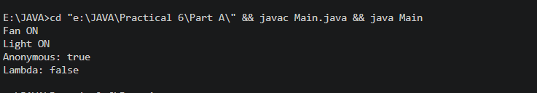

2. Notification senders: a functional interface Notifier with send(String); make email and SMS senders as lambdas, hold them in an array, and broadcast one message through all. Add a marker interface Urgent and send twice for senders marked urgent..
Solution :
@FunctionalInterface
interface Notifier {
void send(String message);
}

interface Urgent {
}

class EmailSender implements Urgent {
}

class SMSSender {
}

public class Main2 {
public static void main(String[] args) {
EmailSender email = new EmailSender();
SMSSender sms = new SMSSender();

Notifier emailNotifier = message ->
System.out.println("Email: " + message);

Notifier smsNotifier = message ->
System.out.println("SMS: " + message);

Notifier[] notifiers = {
emailNotifier,
smsNotifier
};

Object[] senders = {
email,
sms
};

String message = "Your account has been updated.";

for (int i = 0; i < notifiers.length; i++) {
notifiers[i].send(message);

if (senders[i] instanceof Urgent) {
notifiers[i].send(message);
}
}
}
}

OUTPUT:
