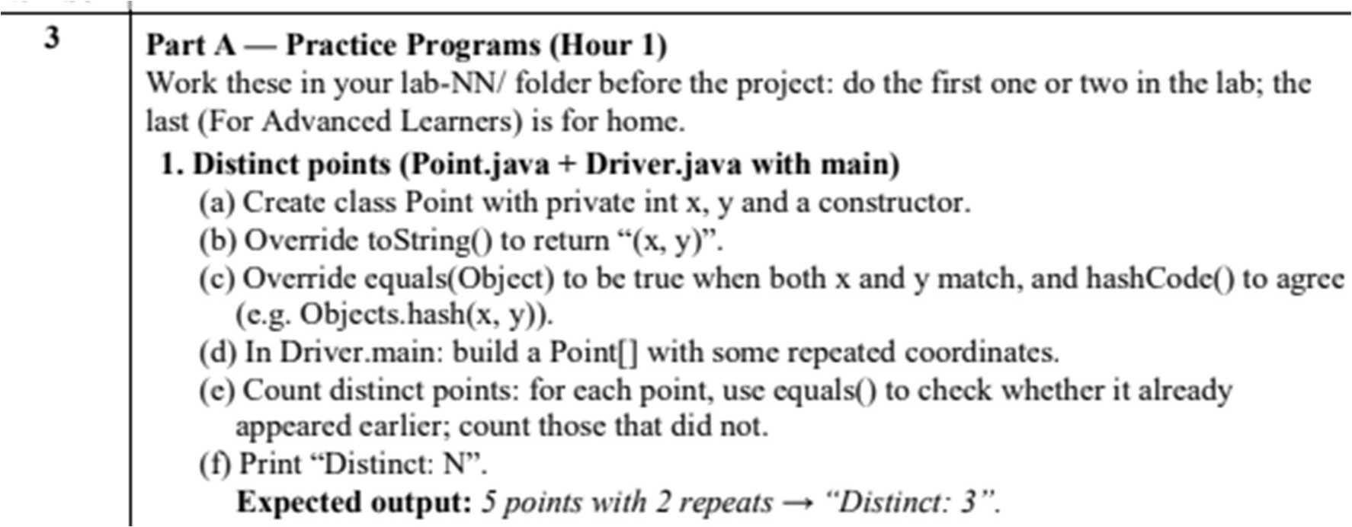
PRACTICAL – 3

CODE:
- Pointer.java

import java.util.Objects;

public class Point {

private int x;
private int y;

public Point(int x, int y) {
this.x = x;
this.y = y;
}

@Override
public String toString() {
return "(" + x + ", " + y + ")";
}

@Override
public boolean equals(Object obj) {
if (this == obj)
return true;

if (!(obj instanceof Point))
return false;

Point p = (Point) obj;

return this.x == p.x && this.y == p.y;
}

@Override
public int hashCode() {
return Objects.hash(x, y);
}
}

- Driver.java
- public class Driver {

- public static void main(String[] args) {

- Point[] points = {
- new Point(2, 3),
- new Point(5, 6),
- new Point(2, 3),
- new Point(7, 8),
- new Point(5, 6)
- };

- int distinct = 0;

- Point[] unique = new Point[points.length];

- for (Point p : points) {

- boolean found = false;

- for (int i = 0; i < distinct; i++) {
- if (p.equals(unique[i])) {
- found = true;
- break;
- }
- }

- if (!found) {
- unique[distinct] = p;
- distinct++;
- }
- }

- System.out.println("Distinct: " + distinct);
- }
- }

OUTPUT:

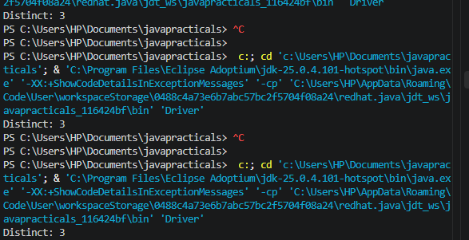

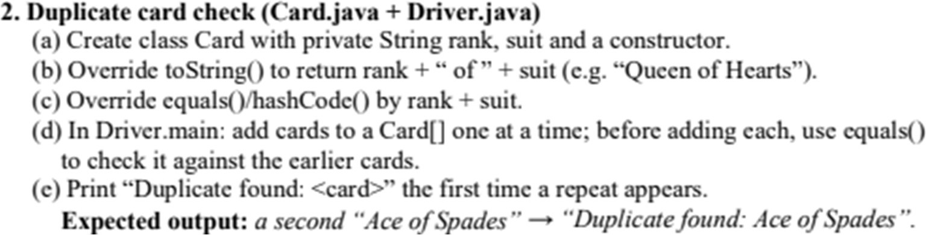
CODE:
Card.java

import java.util.Objects;

public class Card {

private String rank;
private String suit;

public Card(String rank, String suit) {
this.rank = rank;
this.suit = suit;
}

@Override
public String toString() {
return rank + " of " + suit;
}

@Override
public boolean equals(Object obj) {
if (this == obj)
return true;

if (!(obj instanceof Card))
return false;

Card c = (Card) obj;

return rank.equals(c.rank) && suit.equals(c.suit);
}

@Override
public int hashCode() {
return Objects.hash(rank, suit);
}
}

Driver.java

public class Driver {

public static void main(String[] args) {

Card[] cards = new Card[10];

int count = 0;

Card[] input = {
new Card("Ace", "Spades"),
new Card("King", "Hearts"),
new Card("Queen", "Clubs"),
new Card("Ace", "Spades"),
new Card("Jack", "Diamonds")
};

for (Card newCard : input) {

boolean duplicate = false;

for (int i = 0; i < count; i++) {

if (newCard.equals(cards[i])) {
duplicate = true;
System.out.println("Duplicate found: " + newCard);
break;
}
}

if (!duplicate) {
cards[count] = newCard;
count++;
}
}
}
}

OUTPUT:
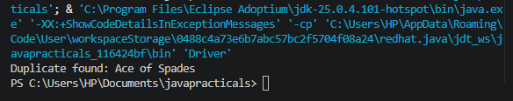

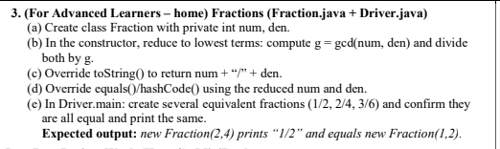

Solution:
Fracction class:

public class Fraction {

private int num;
private int den;

public Fraction(int num, int den) {

int g = gcd(num, den);

this.num = num / g;
this.den = den / g;
}

private int gcd(int a, int b) {

a = Math.abs(a);
b = Math.abs(b);

while (b != 0) {
int temp = b;
b = a % b;
a = temp;
}

return a;
}

public String toString() {
return num + "/" + den;
}

public boolean equals(Object obj) {

if (this == obj)
return true;

if (!(obj instanceof Fraction))
return false;

Fraction f = (Fraction) obj;

return num == f.num && den == f.den;
}

public int hashCode() {
return 31 * num + den;
}
}

Driver class:
public class Driver{

public static void main(String[] args) {

Fraction f1 = new Fraction(1, 2);
Fraction f2 = new Fraction(2, 4);
Fraction f3 = new Fraction(3, 6);

System.out.println("f1 = " + f1);
System.out.println("f2 = " + f2);
System.out.println("f3 = " + f3);

System.out.println("f1 equals f2: " + f1.equals(f2));
System.out.println("f2 equals f3: " + f2.equals(f3));
System.out.println("f1 equals f3: " + f1.equals(f3));

System.out.println("new Fraction(2,4) prints " + new Fraction(2, 4));

System.out.println("equals new Fraction(1,2): "
+ new Fraction(2, 4).equals(new Fraction(1, 2)));
}
}

Output:

